**Riverina Murray Region – What’s the Housing Demand?**

This Housing Snapshot looks at aspects of housing demand in the Riverina Murray, particularly from the 2016 Census to the 2021 Census – including population, age profile, household type, household size, income (change in low, moderate and high income households and low income rental households), homelessness, Indigenous residents and people with disability.

There have been challenges across Australia and in this region since the 2016 Census, including the pandemic - which have impacted the community and the demand for housing. Subsequent significant floods in this region, in addition to cost of living pressures, including inflation, rising interest rates and tightening of the rental market also have significant impacts on the demand for housing.

**Population Forecast**

* Changes in population will impact on the demand for housing.
* Between 2016 and 2021, the population of the Riverina Murray grew by 5.4% or 14,470, from 268,590 to 283,060, using ABS Census population data.
* However, not every LGA in the region experienced population growth over this period.
* Bland, Edward River, Hay, Murrumbidgee, Narrandera and Temora all experienced a loss of population over this five year period, while all the remaining LGAs in the region saw population growth.
* Changes in population between 2016 and 2021 ranged from a 10.0% increase in Murray River to -12.6% decline in Murrumbidgee. In terms of numbers, Wagga Wagga had the largest increase with an additional 5,216 people, followed by Albury with 5,013, Griffith with 1,451 and Murray River with 1,168.
* Wagga Wagga has the largest population of the Riverina Murray LGAs with 67,609, followed by Albury with 56,093 (together comprising 43.7% of the region’s population). Carrathool (2,866) and Hay (2,882) have the smallest population (together comprising 2.0% of the region’s population).
* The Department of Planning and Environment have prepared population projections for every LGA in the region. Their projections forecast growth for Albury (1.59% per annum), Berrigan (0.61%), Coolamon (1.33%), Federation (0.27%), Greater Hume (1.07%), Griffith (0.78%), Lockhart (1.5%), Murray River (1.1%), Murrumbidgee (0.13%), Temora (0.46%) and Wagga Wagga (0.54%).
* Additionally, Bland is projected to be stable (0.01% growth per annum) while Carrathool (-0.13%), Gundagai Regional (-0.02%), Edward River (-0.03%), Leeton (-0.11%), Narrandera (-0.37%) and Snowy Valley (-0.02%) are all predicted to lose a little population.
* Albury, Coolamon, Greater Hume, Lockhart and Murray River are the only LGAs in the Riverina Murray predicted to have a stronger annual growth rate than the average for NSW of 0.95% per annum.
* Numerically the largest increase in population forecast to 2041 is predicted for Albury, followed by Wagga Wagga, Griffith and Murray River.
* The table below shows the population change for each Riverina Murray LGA and the region from 2016 to 2021, using ABS Census data.



**Age**

* The age profile of the region and particularly each LGA will impact on housing need and demand, including number of bedrooms, affordability, location and dwelling type.
* The median age of the population of the Riverina Murray LGAs at the 2021 Census ranges between 35 years (Wagga Wagga) and 52 (Berrigan). Carrathool and Griffith (37), Leeton (38) and Albury (39), like Wagga Wagga have a younger median age while Federation (51), Cootamundra-Gundagai Regional and Murray River (49) like Berrigan, have an older median age. The other LGAs in the region fall between these two extremes. This compares to the median age for the Rest of NSW (excluding Sydney) of 43 years.
* Given the range in the median age, it is unsurprising that there is variation in the age profiles of Riverina Murray LGAs.
* As a region, Riverina Murray has a higher proportion of 0-4, 5-14, 15-19, 20-24 and 25-34 year olds than the Rest of NSW average, the same proportion of 35-44 year olds and lower proportions of older age groups. However, not every LGA in the region follows this pattern.
* Generally, Berrigan, Bland, Coolamon, Cootamundra-Gundagai, Edward River, Federation, Lockhart, Murray River, Narrandera, Snowy Valleys and Temora have higher proportions of cohorts aged over 55 years than the Rest of NSW average. Albury, Leeton and Wagga Wagga have higher proportions of cohorts under 35 years than the Rest of NSW average. The remaining LGAs tend to have a mix of younger and older age cohorts.
* The graph below shows the proportion of the population in each key age cohort in the Riverina Murray LGAs as well as the region and the Rest of NSW.

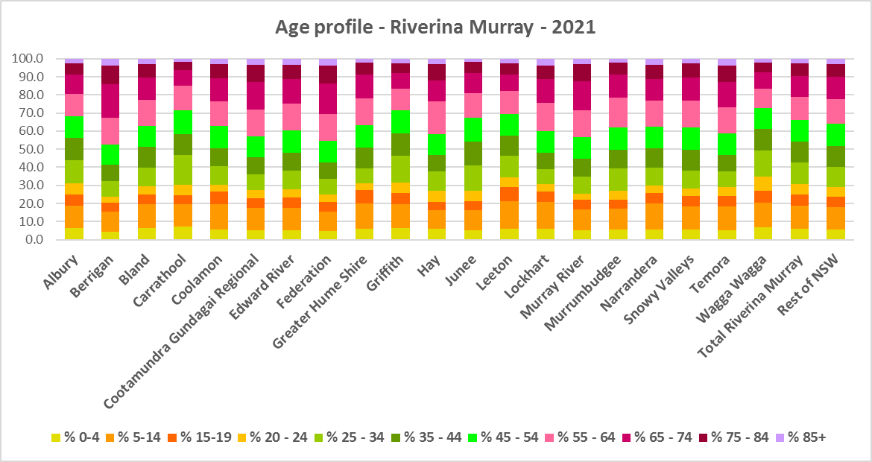

* The table below gives more detail of the breakdown of age cohorts by LGA, by region and for the Rest of NSW.



* The Department of Planning and Environment forecast increases in residents aged over 65 to 2041 in every Riverina Murray LGA with the exception of Hay.
* The Department also projects an increase in younger age groups in Albury, Carrathool and Murray River; no change in younger age groups in Edward River, Greater Hume, Griffith, Junee, Leeton, Lockhart, Narrandera, Snowy Valleys, Temora and Wagga Wagga; and a decrease in younger age groups in Berrigan, Bland, Coolamon, Cootamundra-Gundagai, Federation and Hay.
* The diversity of age groups requires a range of different housing to meet the needs of the community throughout the housing life cycle. However the higher median age and higher proportions of older age cohorts in some of the region’s LGAs indicates that there is a need for housing to suit older residents. Increasingly this will be the case in all the Riverina Murray LGAs as the number in older age groups grows.
* As the Australian Institute for Health and Welfare (AIHW) note:

Many older Australians prefer to age in place, meaning they wish to stay in their local home or community. However, their capacity to do so can be influenced by:

* + the appropriateness and quality of their home (for example, size, layout)
  + their ability to modify their home to suit their functional requirements
  + the cost and availability of suitable housing
  + their need for formal care and assistance
  + their proximity to services and social support.
* Although the majority of older Australians own their own home, this number is declining. About 15% of older Australians are renters. These people are generally a highly vulnerable and economically disadvantaged group, particularly single person households, with older women being the fastest growing demographic of people experiencing homelessness. There is therefore a need for more adaptable, accessible dwellings, well located, secure, low maintenance and affordable to meet the needs of seniors and frail aged in particular, within their communities. Those most in need are households in the private rental market, who struggle to afford housing on an Aged Pension or inadequate superannuation. (Source: "Housing Decisions of Older Australians" Productivity Commission December 2015).
* Given the very high proportions of low income households across this region, affordability is a key issue for all age groups, including older residents, and particularly tenants.
* The Australian Housing and Urban Research Institute (AHURI) has undertaken research on “What is the ideal home for older Australians?”
  + “Older Australians and the housing aspirations gap” and
  + “Understanding the housing aspirations of older Australians”
* This research is part of a broader study on “Housing aspirations and constraints for lower income Australians.” AHURI’s research demonstrates that one of the most valued aspects of older residents housing is the location – that the neighbourhood feels safe and secure; that there is good (including walkable) access to services such as health, shopping, recreational amenities, public open space; and that it is close to family and friends.

**Household Type**

* A look at household types and average household size gives some insight into the type of housing – particularly number of bedrooms – that is likely to be appropriate to meet the housing needs of the community.
* Household types in the Riverina Murray largely follow the trend for the Rest of NSW in terms of which household types predominate but differ somewhat from the actual average proportions in each household type in the Rest of NSW.
* At the 2021 Census in the Rest of NSW, couple families without children (27.7%) and lone person households (26.1%) are the largest two household types.
* For the Riverina Murray region there are equal proportions of lone person households and couple families without children (27.2%).
* Thirteen of the twenty Riverina Murray LGAs have couple families without children and lone person households as the largest two household types (Albury, Berrigan, Bland, Coolamon, Cootamundra-Gundagai, Edward River, Federation, Hay, Junee, Murrumbidgee, Narrandera, Snowy Valleys and Temora).
* Carathool and Wagga Wagga are the only two Riverina Murray LGAs to have couple families with children and lone person households as the largest two household types.
* Greater Hume, Griffith, Lockhart and Murray River have couple families without children and couple families with children as the two largest household types, while Leeton has couple families without children as the largest household type and then equal proportions of couple families with children and lone person households.
* Fifteen of the twenty Riverina Murray LGAs have higher proportions of other household types than the Rest of NSW – this includes multi-family households.
* There has been a small shift since the 2016 Census, with an increase in the proportion of couple family without children households in the Rest of NSW (0.7%), a decline in the proportion of couple families with children households (-0.6%) and a small increase in the proportion of lone person households (0.5%).
* For the Riverina Murray region as a whole, the changes were not dissimilar to the Rest of NSW – with a slightly smaller increase in the proportion of couple family without children households (0.3%), the same decline in the proportion of couple families with children households (-0.6%) and a slightly larger increase in the proportion of lone person households (0.8%).
* Changes in individual LGAs are not all in line with this trend:
  + For couple families without children, all LGAs experienced a decline in the proportion in this household type between 2016 and 2021 except for Snowy Valleys, which had no change. Murrumbidgee had the strongest decline with -5.0%.
  + For couple families with children, changes ranged from a -3.0 decline in the proportion of this household type in Carrathool to a 2.8% increase in Murrumbidgee.
  + For lone person households, changes ranged from a 3.0% increase in the proportion of this household type in Murrumbidgee to a -0.9% decline in Greater Hume.
* This data should be compared with the data on local bedroom numbers to determine if there is a good fit between household types and housing stock.
* Although there should be plenty of housing suitable for families of different sizes, there is also a need for a variety of dwellings with different bedroom numbers to suit couples and single person households.
* The graph and table below show the proportion in each key household type for every Riverina Murray LGA, for the region and for the Rest of NSW at the 2021 Census.

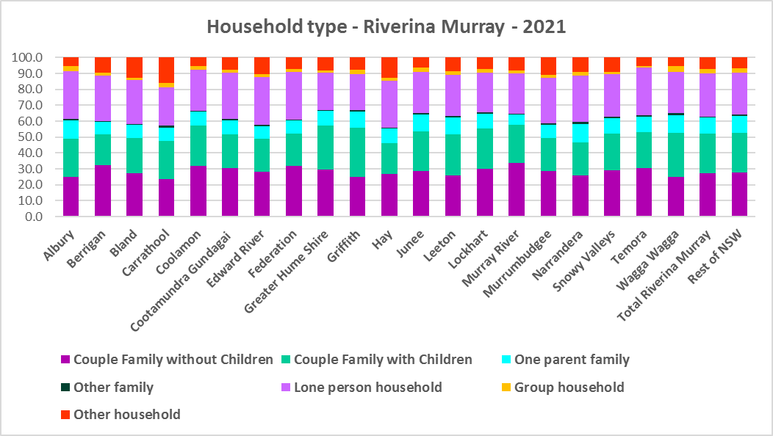



**Household Size**

* At the 2021 Census, the average household size for the Rest of NSW was 2.4 persons per household – unchanged from 2016 and 2011.
* Average household size in the Riverina Murray ranges from 2.2 persons per household in Berrigan, Edward River, Federation and Hay to 2.7 persons per household in Griffith.
* In line with the trend in the Rest of NSW, between 2016 and 2021, average household size was stable in the Riverina Murray region as a whole and ten of the twenty LGAs in the region – although Bland, Edward River, Federation, Hay, Junee, Murrumbidgee and Temora experienced a decline in the number of persons per household, while Carrathool, Murray River and Snowy Valleys had an increase.
* The table below gives the average household size in each of the Riverina Murray LGAs as well as the Rest of NSW for 2011, 2016 and 2021.



**Income**

* At the 2021 Census, low income households comprise the largest proportion of all households in the Rest of NSW, in the Riverina Murray as a whole and in all but two of the region’s LGAs (Albury and Carrathool were the exceptions).
* Thirteen of the twenty LGAs in the region have a higher proportion of low income households than the average for the Rest of NSW of 49.3% (the exceptions being Albury, Carrathool, Greater Hume, Griffith, Temora and Wagga Wagga).
* The Riverina Murray region has a slightly lower proportion (48.9%) of low income households than the average for the Rest of NSW. Across the region the proportion of low income households ranges from 37.1% in Carrathool to 61.9% in Narrandera.
* Moderate income households in the Rest of NSW comprise 21.5% of all households and 22.3% for the Riverina Murray as a whole, while the LGAs of the region range from 18.6% in Berrigan to 24.4% in Wagga Wagga.
* High income households comprise 29.2% of all households in the Rest of NSW, 28.8% on average across the Riverina Murray region and range from 17.2% of households in Federation to 42.0% in Carrathool.
* The graph and table below show the proportion of low, moderate and high income households in all the Riverina Murray LGAs, compared with the region and Rest of NSW at the 2021 Census.

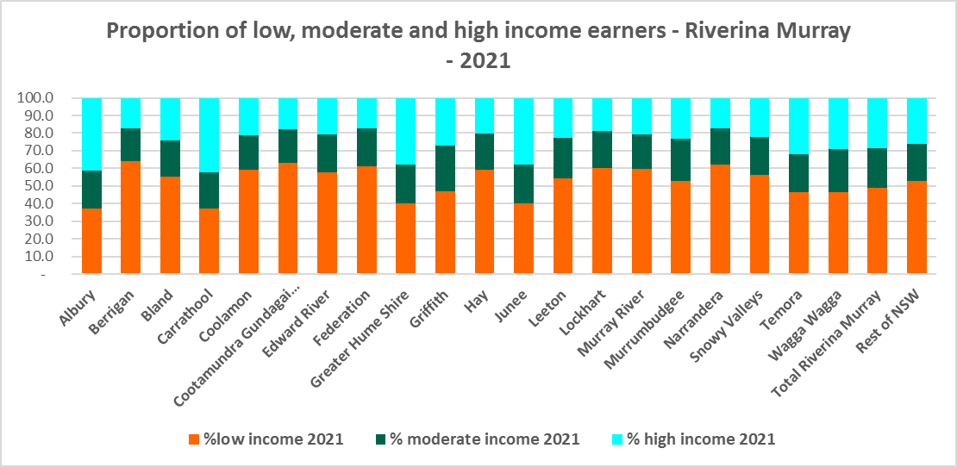



* Between 2016 and 2021 the number of low income households increased in the Riverina Murray region and most LGA’s except Albury, Carrathool, Greater Hume, Junee and Temora, which all experienced a decline in the number of low income households.
* Over the same period, the number of moderate income households increased in the Riverina Murray as a whole yet declined in most LGAs in the region – with increases in Albury, Bland, Federation, Greater Hume, Griffith, Junee, Leeton, Snowy Valleys and Wagga Wagga and no change in Hay.
* The number of high income households increased overall in the region but declined in fifteen of the twenty LGAs in the region, increasing only in Albury, Carrathool, Greater Hume, Junee and Temora.
* The graph below shows the change in the number of low (including very low), moderate and high income households from 2016 to 2021 in the Riverina Murray region.

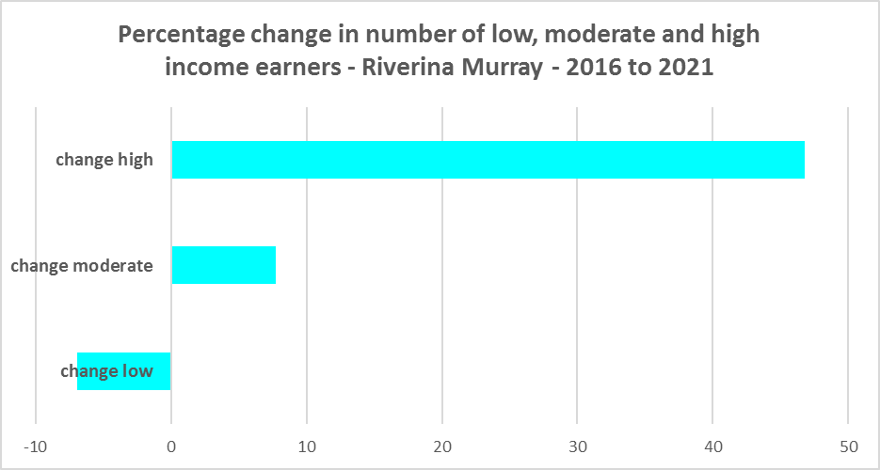

* Along with the decline in the number of low income households between 2016 and 2021, the Riverina Murray region as a whole (-23.8%) and every LGA in the region experienced a decline in very low income **rental** households over the same period, varying between a -55.3% decline in Bland and a -9.7% decline in Cootamundra-Gundagai.
* The region as whole experienced an increase in low income **rental** households over the same period, with six LGAs experiencing a decline (Bland, Federation, Griffith, Hay, Leeton and Murrumbidgee) and the majority having an increase. Junee had the largest proportional increase of 71.0% and Murrumbidgee had the largest proportional decline with -21.2%.
* The reduction in both very low (-1,325) and increase in low income renters (205) across the Riverina Murray region is likely due to the additional Commonwealth financial assistance to renters during the pandemic and may therefore be temporary, as this has subsequently been discontinued, as explained in the What’s Happening in the Housing Market” snapshot for Riverina Murray.
* This underlines the need to consider tenure as well as price point when considering responses to meet housing need.
* The graph below shows the change in the number of very low and low income **renters** between 2016 and 2021 in the Riverina Murray.

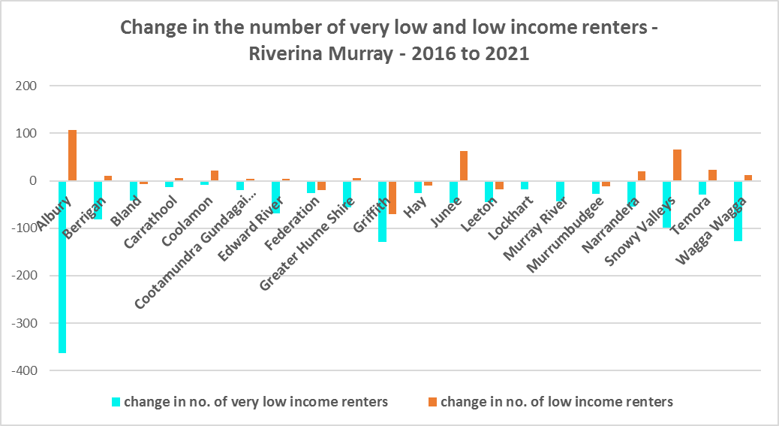

* Carrathool, Griffith and Wagga Wagga have a higher median household weekly income at 2021 than the Rest of NSW ($1,434) while the rest of the LGAs in the Riverina Murray region have a lower median household income. Griffith ($1738) has the highest median weekly income in the region while Berrigan has the lowest ($1128).



**Homelessness**

* People experiencing homelessness and those at risk of homelessness are among Australia’s most socially and economically disadvantaged. State, Commonwealth and some local governments fund services to support people who are homeless, or at risk of homelessness. Services are delivered mainly by non–government organisations, some of which specialise in delivering services to specific groups (such as young people or people experiencing domestic violence).
* Inadequate income and inability to access affordable housing are significant contributing factors to homelessness, along with individual factors such as experience of family and domestic violence, ill health and disability.
* The ABS identifies someone as homeless “where they do not have suitable accommodation alternatives and their current living arrangement:
  + Is in a dwelling that is inadequate;
  + Has no tenure or their initial tenure is short and not extendable; or
  + Does not allow them to have control of and access to space for social relations.”
* The ABS uses “six operational groups for presenting estimates of people experiencing homelessness on Census night:
  + People living in improvised dwellings, tents or sleeping out
  + People living in supported accommodation for the homeless
  + People staying temporarily with other households
  + People living in boarding houses
  + People in other temporary lodgings
  + People living in ‘severely’ overcrowded dwellings.”
* The ABS “also compiles estimates from Census data for the following three groups of people who may be marginally housed but are not classified as homeless:
  + People living in other crowded dwellings
  + People in other improvised dwellings
  + People marginally housed in caravan parks.”
* The table below shows that ABS 2021 Census data for the Central Coast on the homeless and marginally housed.
* Note that due to additional assistance provided during the pandemic, the number of people counted as homeless on Census night in 2021 is lower than at the 2016 Census across Australia. Nevertheless, there were 974 people counted as homeless in the Riverina Murray at the 2021 Census and a further 773 who were counted as marginally housed.
* Of those who were counted as homeless, the largest number were people living in severely overcrowded dwellings (315 or 32.3%), followed by people staying in supported accommodation for the homeless (230 or 23.6%), then people staying temporarily with other households (204 or 20.9%). Note that Griffith has a very high number of people living in severely overcrowded dwellings (127 or 40.1% of the total number for the region) and marginally housed in other crowded dwellings (213 or 32.7% of the regional total).
* Of those who were counted as marginally housed, the overwhelming majority were people living in other crowded dwellings (651 or 84.2%).
* This clearly indicates the need for more affordable rental housing.



* The 2023 NSW street count, the NSW Government’s fourth annual rough sleeping street count, was completed between 2 February and 27 February 2023.
* The table below gives the street count results for the Riverina Murray region locations.
* Over 300 local organisations either consulted in the planning phase or participated in the delivery of street counts. Organisation which partnered with the Department of Communities and Justice (DCJ) included Community Housing Providers, local councils and Specialist Homelessness Services, as well Aboriginal organisations, Local Health Districts, local community groups, and Police.
* 1,623 people were counted sleeping rough during these street counts, a 34% increase from 2022.
* Street counts took place in more than 350 towns in 76 LGAs, compared to 71 LGAs in 2021 and 65 LGAs in 2020.



## People with Disability

* According to the Australian Institute of Health and Welfare (AIHW) and data from the 2018 Australian Bureau of Statistics (ABS) Survey of Disability, 18% of people in Australia have disability. Another 22% have a long term health condition but not disability.
* Nearly one third (32%) of people with disability have severe or profound disability. This means needing help with daily self-care, mobility or communication activities, having difficulty understanding or being understood by family or friends, or communicating more easily using sign language or other non-spoken forms of communication.
* The survey data shows:
  + 7.6% of children aged 0–14 have disability
  + 9.3% of people aged 15–24 have disability
  + 13% of people aged 15–64 have disability
  + 50% of people aged 65 and over have disability (ABS 2019b).
* For about 3 in 4 (77%) people with disability, the main type of disability is physical, while for the remaining 1 in 4 (23%), the main type of disability is mental or behavioural.
* Clearly housing is a significant factor in the health and wellbeing of people with disability. The availability of affordable, sustainable and appropriate housing helps people with disability to participate in the social, economic and community aspects of everyday life. Someone without access to affordable, secure and appropriate housing is more likely to experience homelessness, poor health, and lower rates of employment and education.
* While most people with disability live at home in the community (96% in private dwellings), some live in cared accommodation.
* Cared accommodation is usually long term and may be institutional in style, including hospitals, residential aged care, cared components of retirement villages, aged care hostels, psychiatric institutions and group homes for people with disability. The more severe a person’s disability is, the more likely they are to live in cared accommodation and the less likely they are to live in the community.
* There has been a significant shift towards supporting people with disability to live in private dwellings, rather than being in institutional care over recent decades. Largely this has been driven by changes for young people with disability.

## Additional Data

More detailed housing data and tables used in this Snapshot are available from the Local Government Housing Kit Database on the FACS website at:

<https://www.facs.nsw.gov.au/resources/nsw-local-government-housing-kit/chapters/local-government-housing-kit-database>

More information on the housing needs of older Australians and people with disability:

The Australian Institute of Health and Welfare – Older Australians Housing and Living Arrangements on the AIHW website at:

<https://www.aihw.gov.au/reports/older-people/older-australians/contents/housing-and-living-arrangements>

The Australian Institute of Health and Welfare – People with Disability in Australia

<https://www.aihw.gov.au/reports/disability/people-with-disability-in-australia/contents/people-with-disability/prevalence-of-disability>

and relating to housing needs

<https://www.aihw.gov.au/reports/disability/people-with-disability-in-australia/contents/housing>

The Productivity Commission’s report Housing Decisions of Older Australians is at:

<https://www.pc.gov.au/research/completed/housing-decisions-older-australians>

More detailed information on population, household and dwelling projections is available on the Department of Planning and Environment website at:

<https://www.planning.nsw.gov.au/Research-and-Demography/Population-Projections/Projections>

<https://pp.planningportal.nsw.gov.au/populations>

More data on homelessness, specifically homelessness service data is available on the Homelessness NSW website at:

<https://homelessnessnsw.org.au/resource/specialist-homelessness-service-data/>

And from the AIHW website here:

<https://www.aihw.gov.au/reports/australias-welfare/homelessness-and-homelessness-services>

The 2023 Street Count result is at the DCJ/ FACS website here:

<https://www.facs.nsw.gov.au/reforms/homelessness/premiers-priority-to-reduce-street-homelessness/street-count>

Further information on ABS estimation of homelessness is available at the ABS website:

<https://www.abs.gov.au/statistics/people/housing/estimating-homelessness-census/2021>