**Riverina Murray Region – What’s Happening with Housing Supply and is it a good match?**

This Housing Snapshot looks at aspects of housing supply in the Riverina Murray, particularly from the 2016 Census to the 2021 Census – including dwelling type, bedroom mix, tenure, as well as social housing supply and waiting times for public housing. It also looks at aspects of the gap between housing demand and supply, including what’s happening with low income rental households and affordable rental supply, comparing household type with bedroom mix and who needs affordable housing.

Across much of NSW housing supply has not kept pace with demand, with significant outmigration from cities to regional areas during Covid, record levels of migration post Covid, with rapid increases in construction costs and skilled labour shortages contributing to longer term tight rental vacancy rates, insufficient affordable housing and a lack of housing diversity to meet local need.

Infrastructure Australia delivered a report “2022 Regional Strengths and Infrastructure Gaps” which cites housing – the availability, affordability and diversity of housing – as a key infrastructure gap in both the Riverina and Murray.

**Dwelling Type**

* At the 2021 Census there were 118,501 dwellings in the Riverina Murray region, up from 112,876 in 2016.
* Of these, 89.6% were occupied (up from 87.1% in 2016), just over the 89.0% average percentage occupied in the Rest of NSW.
* This means that 10.4% were unoccupied (down from 12.9% in 2016) compared to 11.0% in the Rest of NSW.
* The reasons homes are unoccupied vary and include (according to a report by the Australian Housing and Urban Research Institute “Are there 1 million empty homes and 13 million unused bedrooms?”):
  + homes are being renovated
  + homes being sold as vacant possession
  + newly built or bought homes where no one has moved in yet
  + rental homes awaiting new tenants
  + people living away temporarily from home during the census count (travelling or visiting other homes)
  + homes are deemed unliveable
  + subject to a probate application or other legal proceedings
  + holiday homes
  + homes owned by people currently living overseas
  + homes being land banked, that is held vacant until the local area economics (or personal circumstances) make it more profitable to sell or redevelop the property.

And particularly in rural and regional areas:

* dwellings on rural properties where owners have moved into local towns (particularly as owners age);
  + regional and rural areas which have experienced population decline;
  + and areas where people have a beach or rural retreat house that will only be occupied for short periods of the year
* The graph below shows the proportion of occupied and unoccupied dwellings in the Riverina Murray LGAs at the 2021 Census.

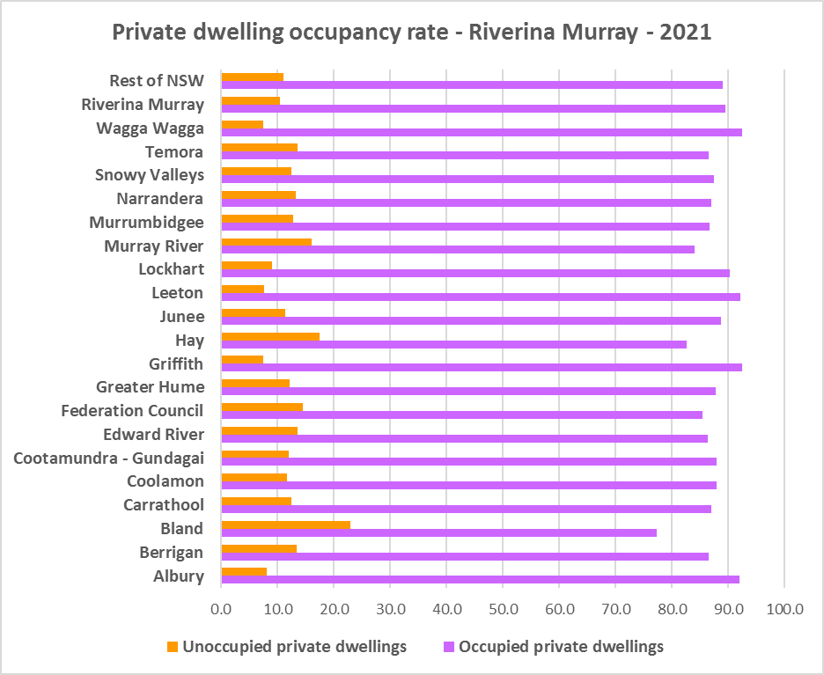

* Note that within the Riverina Murray, Griffith and Wagga have the highest proportion of occupied dwellings with 92.5% and Bland the lowest with 77.3%.
* At the 2021 Census, the clear majority of occupied dwellings in the Riverina Murray were separate houses, comprising 87.2% of all occupied dwellings, compared to 82.5% in the Rest of NSW. The proportion of separate houses within the region ranges from 97.0% in Coolamon to 80.5% in Albury.
* A further 7.7% of occupied homes in the Riverina Murray were semi-detached, terrace or town houses, (compared to 6.3% in the Rest of NSW) and ranging from 17.5% in Albury to 0.0% in Coolamon.
* Just 4.1% of occupied homes in the region were flats (compared to 9.9% in the Rest of NSW), ranging from 10.0% in Griffith to 0.1% in Greater Hume.
* In common with the Rest of NSW, the region lacks diversity in dwelling types.
* The graph and table below show the proportion of dwelling types for the Riverina Murray LGAs at the 2021 Census.

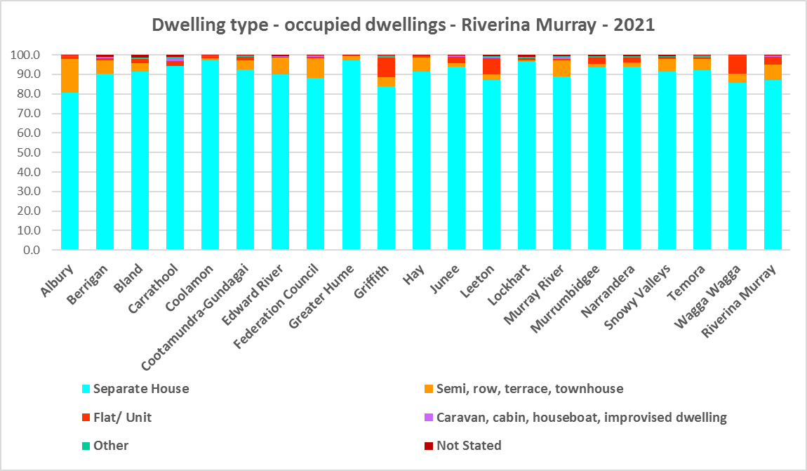



* The next graph compares the proportion of different occupied dwelling types for the Riverina Murray with that for the Rest of NSW.

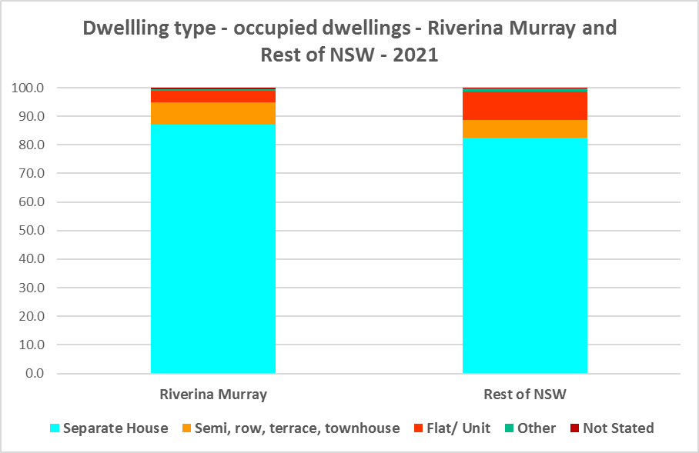

* Other types of dwellings comprised just 0.6% of occupied dwellings in the region and include caravans, cabins, houseboats, improvised dwellings and flats attached to shops or offices. Census data shows 154 households living in caravans, 160 living in cabins or houseboats, 26 living in improvised dwellings and 295 in flats attached to shops or offices in the region.
* Note that at the 2021 Census there were a total of 314 households living in caravan, cabin/houseboat accommodation, down from 566 in 2016 and down again from 724 in 2006. Albury had the highest number of households living in caravan, cabin/houseboat accommodation in 2021 with 57 (down from 65 in 2016), followed by Murray River with 52 (down from 78 in 2016) and Griffith with 43 (down from 51).
* While people living in caravans are included in the homeless data in the Census, caravan or residential parks are one of the few remaining affordable housing options for lower income earners. The loss of this accommodation reduces options for lower income households and reduces flexibility to deal with seasonal workers.
* The region also has 26 improvised dwellings. According to the ABS;
  + “Persons in other improvised dwellings are those people who were enumerated on Census night in the dwelling category of an improvised dwelling, tent or sleepers out who reported either being 'at home' on Census night or having no usual address, and are not considered, on balance, to be homeless. Under the ABS definition they are not classified as homeless because they have accommodation alternatives, and in many living situations, the dwelling will be adequate. They are however included in marginal housing and may be at risk of homelessness.”

**Bedroom Mix**

* The overwhelming majority of housing in the region would have been built at a time when couple families with children were the dominant household type. Now smaller households (couples and single person households) predominate and are expected to continue to increase across the region, particularly as the population ages.
* Consequently the region (and the Rest of NSW generally) also has little variation in the number of bedrooms per dwelling. Across the Riverina Murray 42.1% of dwellings have three bedrooms and a further 36.2% have four or more bedrooms, totalling 78.4%. Only 0.3% of homes are studios, 2.0% have one bedroom and 16.6% have two bedrooms.
* This compares to 0.5% of studio homes, 4.0% one bedroom 17.3% two bedroom, 40.9% three bedroom and 35.7% four or more bedrooms in the Rest of NSW.
* Within the region,
  + Bland and Coolamon have the highest proportion of studio dwellings with 0.8% and Edward River the lowest with 0.1%;
  + Temora has the highest proportion of one bedroom homes with 4.2% and Murray River the lowest with 2.2%;
  + Albury has the highest proportion of two bedroom homes with 20.9% and Greater Hume the lowest with 12.1%;
  + Snowy Valleys has the highest proportion of three bedroom homes with 47.3% and Wagga Wagga the lowest with 38.7%; and
  + Wagga Wagga has the highest proportion of four or more bedroom homes with 41.3% and Federation the lowest with 30.5%.
* The graph and table below show the proportion of studio, one, two, three and four or more bedroom occupied dwellings in the Riverina Murray at the 2021 Census.

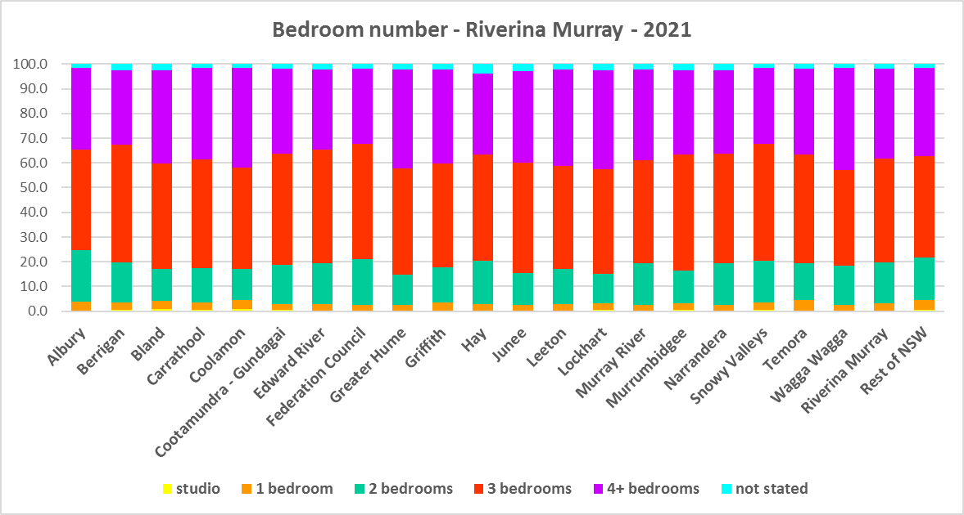



* Given that lone person and couple only households comprised 52.1% of all households in the Riverina Murray, the fact that studio and one bedroom homes combined comprise just 3.2% of the housing stock shows a mismatch between household type and dwelling size and a significant lack of housing choice for smaller households.
* The forecast increase in older age groups in the region is likely to increase the demand for smaller, more manageable and affordable homes. It is important for older residents to be able to downsize from larger family dwellings to smaller dwellings that are easier to manage and in which they may retain their independence.
* There needs to be a closer match between household size and bedroom number to offer some housing choice for residents. Two bedroom dwellings in particular offer the most flexibility, given they are also suitable for small families and allow older residents to have family members or carers to stay while giving them a more manageable size home to maintain.
* It is worth noting that new dwelling construction comprises around 1% of total dwellings (depending on the location and stage in the residential development cycle) with the remaining 99% of homes being existing established dwellings. Consequently additions to existing stock can have a significant impact on the bedroom mix and long term suitability of housing stock to meet housing need, including household size and affordability.

**Tenure**

* At the 2021 Census, the most common tenure type in the Riverina Murray was households owning their home outright – comprising 37.6% of all households. Within the region this ranged from 50.1% in Lockhart to 30.0% in Wagga Wagga.
* The next largest tenure type was households with a mortgage – comprising 31.0% of all households. The proportion in this tenure ranged from 36.3% in Greater Hume to 20.5% in Carrathool, within the region.
* Rental households comprised a total of 28.6% of all households in the Riverina Murray, ranging between 34.6% in Albury and 15.7% in Lockhart.
* Households renting from a real estate agent comprise 17.0% of all households in the Riverina Murray – with Albury having the highest proportion at 24.8% and Carrathool the lowest with just 4.3% of households renting though a real estate agent.
* The remainder of rental households are comprised of households renting from the state housing authority (2.6% in the region), community housing providers (0.7%) and other landlords (8.2%).
* The graph and table below give the tenure composition for the region and individual LGAs at the 2021 Census.

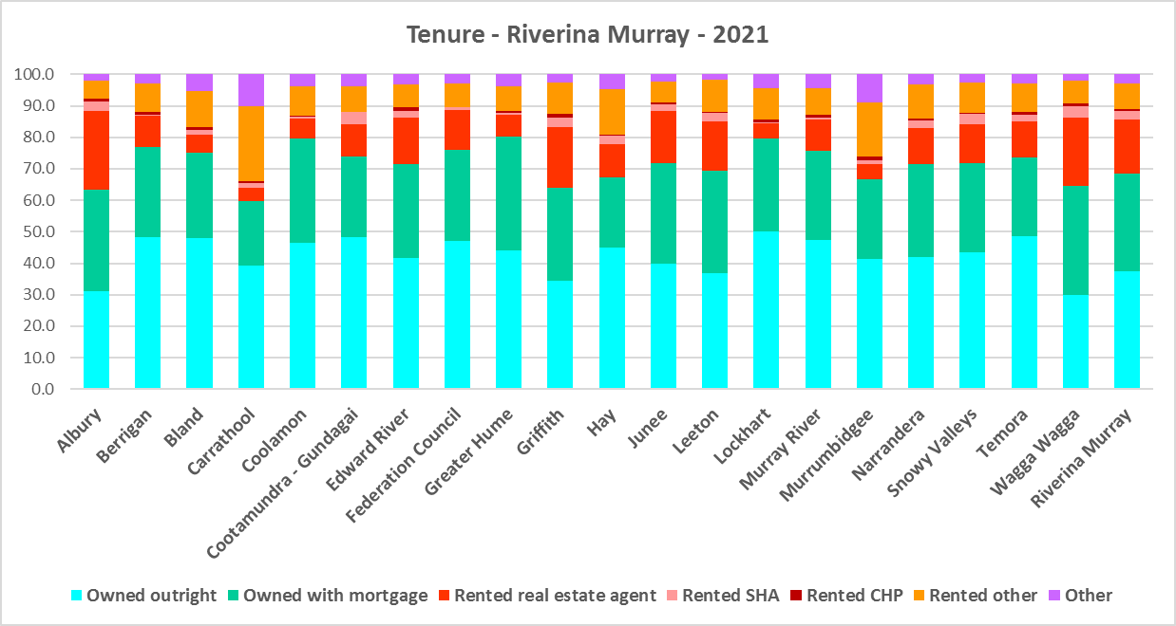



* The general trend is for increasing numbers of households relying on the private rental market as a long term tenure rather than a transitional one between leaving home and buying a home, as housing costs have increased much faster than wages. While the Riverina Murray is more affordable than metropolitan and coastal areas of the state, there has been a growing trend to making a tree change to take advantage of more affordable housing and lifestyle/amenity in regional areas. In addition, anecdotal evidence indicates that this was particularly pronounced during Covid with the increased flexibility of working remotely/from home.
* This has the potential to bid up housing prices in regional areas and make it more difficult for locals to afford housing.
* Noting that the rental market in the Riverina Murray – and NSW generally – is very tight (see the Housing Snapshot on What’s Happening in the Housing Market) it is therefore important to encourage tenure diversity and a range of price points to meet local needs, including facilitating increased social and affordable housing.

**Social Housing**

* Social housing is secure and affordable rental housing for people on low incomes with housing needs. It includes public, community and Aboriginal housing. Public housing is managed by DCJ while community housing is managed by non-government organisations.
* As at June 2022, there are 154,600 social housing dwellings in NSW, with 96,712 managed by public housing, 48,264 managed by community housing and 9,624 managed exclusively for Aboriginal people – of these the Aboriginal Housing Office (AHO) are responsible for 4,120 and Aboriginal Community Housing Providers (ACHP) manage 5,504.
* The table below shows the number of public housing properties in the Riverina Murray region at June 2022. Most public housing is in Albury, Griffith, Gundagai, Leeton, Snowy Valleys and Wagga Wagga. Note that Census data on public housing is not totally accurate, as public housing tenure is under-reported in the Census. The figures below do not include community housing properties.



* In addition, community housing providers manage a significant number of properties in the Riverina Murray region – including social housing, affordable housing, transitional housing and crisis accommodation, as outlined in the table below.
* Note that affordable housing is not the same as social housing. Affordable housing is open to a broader range of household incomes than social housing. Households do not have to be eligible for social housing to apply for affordable housing, though people who are eligible for social housing may also be eligible for affordable housing properties.
* Affordable housing is managed more like a private rental property, but there are eligibility criteria and the managers are mostly not for profit community housing providers.



* The next table gives the number of AHO homes and the number managed by ACHPs in Murrumbidgee as at June 2022.



* Note that there are 3 types of social housing available for Aboriginal people:
  + Public housing – these properties are managed by the Department of Communities and Justice (DCJ).
  + Aboriginal Housing Office homes – these are properties owned by the Aboriginal Housing Office and managed by DCJ.
  + Community housing properties – these properties are managed by community housing providers and Aboriginal community housing providers.
* The table below shows the expected waiting times for general housing approved social housing applicants (not for priority housing applicants) by bedroom category in the Riverina Murray region as at 30 June 2022. It also gives the number of general and priority applicants by allocation zone.



* Additional information on expected waiting times is available on the website at

<https://www.facs.nsw.gov.au/housing/help/applying-assistance/expected-waiting-times>

**The Gap**

* While the Riverina Murray has been more affordable for both rental and purchase than coastal and metropolitan areas of NSW, it has become increasingly more expensive to purchase and to rent housing in this region.
* SGS Economics and Planning in their November 2022 Rental Affordability Index[1] report, point out that regional areas of NSW:
  + have been subject to several natural disasters from widespread bushfires in 2020 to flooding in 2022. These have affected both existing rental stock and new development, limiting supply and increasing rental rates.
  + have seen the combined impact of these factors on renters resulting in homelessness, having to move away from family and support for more affordable housing, moving into poor quality or insecure housing, or having to forgo other essentials.
  + were spared the worst of pandemic response measures. However the impacts of outward-migrating city residents (driven by COVID-19 restrictions in capital cities and the ability to work remotely), on housing and rental affordability has caused concern. This is clear in the November 2022 data, which shows that affordability has worsened in the regional areas of every state, even more so than in the capital cities.
  + have become far less affordable to the average rental household over the last year, including inland towns.
* In summary demand for housing increased, supply has been insufficient to meet demand and there have been impacts on affordability, particularly rental affordability, and on lower income tenants.
* There has been a decline in the number of private rental properties which are affordable to low income rental households in the Riverina Murray, as the graph below demonstrates.

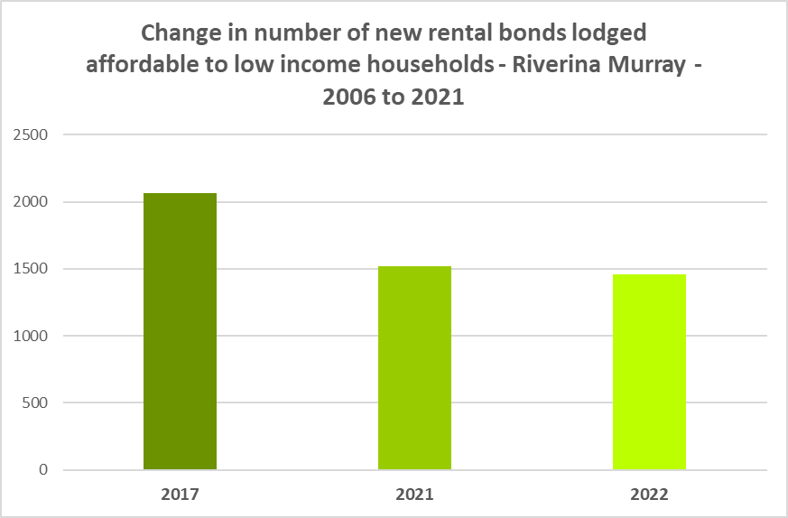

* The graph below shows the decline in the number of new rental bonds lodged which are affordable to low income households in each of the LGAs in the region. Every LGA experienced a loss of affordable private rental between 2017 and 2022. Wagga Wagga had the largest numerical decline from 2017 (113 fewer affordable bonds lodged in 2022 than in 2017) while Cootamundra Gundagai had the largest proportional decline (65.2% fewer affordable rental bonds lodged in 2022 than in 2017).

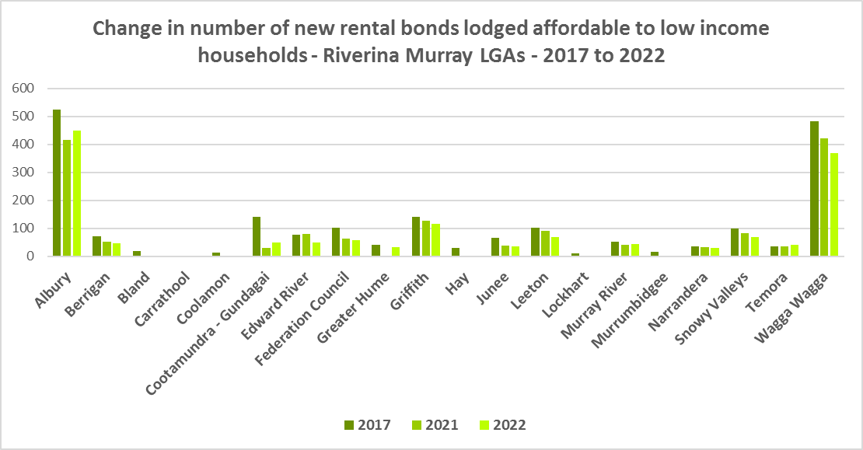

* The next graph compares change in median income with change in median rents and median sales price in the Riverina Murray LGAs between 2016 and 2021 for income and 2017 to 2022 for rent and sales price.

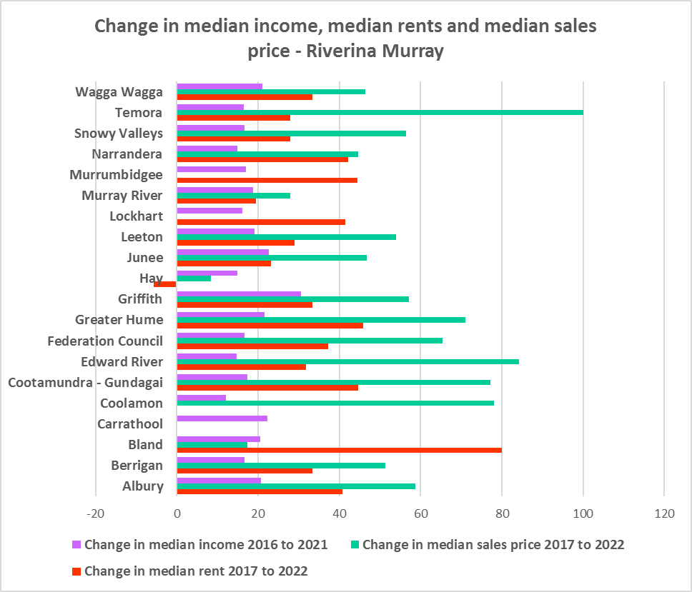

* It demonstrates that housing costs have increased faster than income in every Riverina Murray LGA over that time period (excepting Hay). This has been the case for decades, with housing costs increasing at a much greater rate than incomes. According to Core Logic “While wages increased 81.7% in the past 20 years, Australian home values have grown 193.1%”[2]
* Median rents have increased most strongly in Bland, Greater Hume, Cootamundra Gundagai and Murrumbidgee, while sales prices have increased at the greatest rate in Temora, Edward River, Coolamon and Cootamundra Gundagai while median income increased most in Griffith, Carrathool, Junee and Wagga Wagga. Some of the LGAs with the largest rate of increase in median rents and sales price were coming off a comparatively low base. In dollar terms median rents increased most strongly in Bland, Albury, Greater Hume, Griffith and Wagga Wagga and for median sales price in Temora, Griffith, Albury, Federation, Edward River and Wagga Wagga.
* Low income households are the dominant income group across the Riverina Murray and in every single LGA in the region (excepting Albury and Carrathool), comprising 48.9% of all households in the region (just below the Rest of NSW average of 49.3%) and ranging from 37.1% in Carrathool to 63.9% in Berrigan.
* Furthermore, the number of low income households is increasing across the region – by 13.2% between 2016 and 2021. The graph below shows the change in the number of low income households in each of the Riverina Murray LGAs between 2016 and 2021. The majority of LGAs in the region had an increase in low income households over this period, while Temora, Junee, Greater Hume and Albury all experienced a decline in low income households – noting that Temora saw a strong increase in median sales price, Greater Hume in median rents, Junee in median income and Albury in both median rent and sales price.

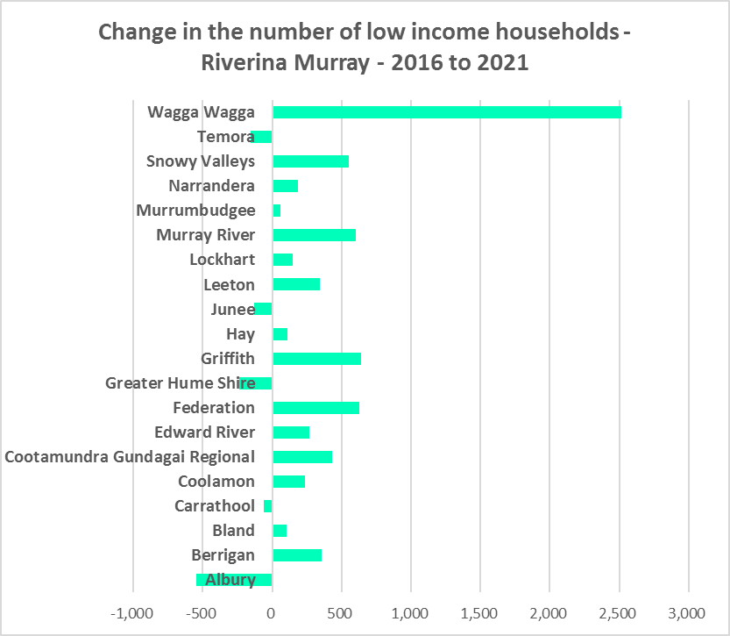

* Due to the changes to income assistance during and subsequent to the COVID-19 pandemic, it is difficult to see what has happened with renters and low income renters in particular between 2016 and 2021. However, it is clear that rents have increased faster than incomes and that the supply of affordable private rental is declining.
* There is a clear need for more affordable rental accommodation to begin to address the demand supply imbalance, particularly for lower income households and the increasing number of seniors and frail aged.
* The vacancy rate in the Riverina Murray has been below 3% for over three years, indicating a chronic shortage of rental accommodation. At April 2023 the vacancy rate was just 0.8% in Albury, 0.9% in the Riverina and 1.5% in Murrumbidgee.
* Considered together, the strong increase in rental levels, decline in rental affordability for lower income earners and decline in affordable rental properties, combined with the increase in low income households (or displacement of low income households), demonstrates the need to increase the supply of affordable rental housing for long term tenants.
* As well as the gap between supply and demand for affordable rental, there is a significant gap between dwelling size (bedroom numbers) and household size, particularly for smaller households.
* The graph below compares the number of smaller household types - lone person and couple only – with the amount of studio and one bedroom accommodation available in the Riverina Murray. It is clear that if smaller households wished to live in smaller housing, they have very little opportunity to do so. While 54.4% of households in the Riverina Murray are lone person or couple only (above the 53.8% average for the Rest of NSW), only 3.2% of dwelling stock is studio or one bedroom (below the 4.5% on average in the Rest of NSW).
* This mismatch can impact on affordability, with smaller households required to consume more housing than they need or to share housing because of lack of choice.
* It also limits the opportunity for empty nesters or older single households to downsize to smaller more manageable homes within their communities. This can impact on the independence of older residents and their ability to age in place. This will become increasingly important as the population of the Riverina Murray is forecast to have an increase in older age groups.

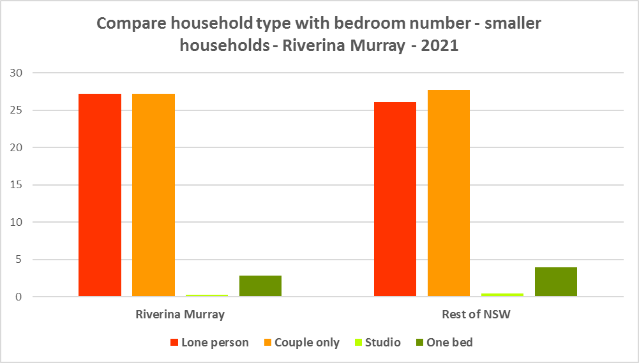

* Between 2016 and 2021 the Riverina Murray actually experienced a decline in the number of studio dwellings. While there has been a small increase in one bedroom homes since the 2016 Census, the number is significantly outweighed by the enormous increase in the number of four plus bedroom homes, as seen in the graph below.

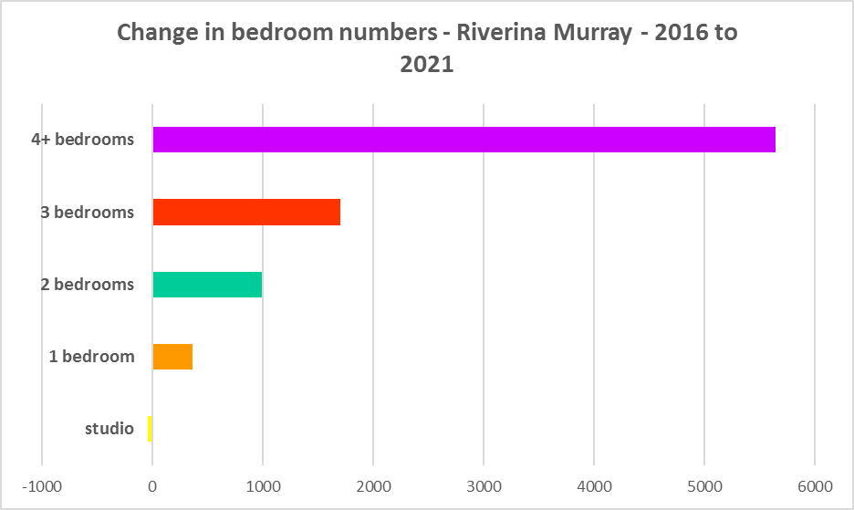

* A proactive approach is required to encourage an increase in studio, one and two bedroom homes. Two bedroom homes potentially suit both single person and couple only households as well as smaller families and small group households and consequently provide some flexibility in the housing stock.
* A focus on increasing the number of smaller homes is important given that annually the addition of new dwellings represents around 1% of the total dwelling stock – so change occurs very slowly. There is also a need to take into account the impact of alterations and additions to existing stock, for example, adding extra bedrooms to two and three bedroom houses. Given the current overwhelming supply of three and four bedroom homes and the significant increase in these since 2016, strong incentives/requirements would need to be put in place to ensure a better balance and more diversity to meet housing need.
* New generation boarding houses would also help fulfil some of this demand – particularly as they cannot be subdivided and must provide rental accommodation. This type of accommodation is suitable for single people and also couples, for key workers and students. It also has potential to assist in providing accommodation/meeting additional housing demand for seasonal workers. Note that the NSW Community Housing Industry Association has an Affordable Housing Tool Kit to help deal with community resistance to affordable housing, which is available on their website. They also have a couple of excellent vimeos showcasing new generation boarding house developments and their tenants.
* The next graph compares larger household types – couple family with children, one parent family and group households – with the amount of two, three and four or more bedroom accommodation available. It is clear that there is a more than adequate supply of larger homes for families and group households in the Riverina Murray.

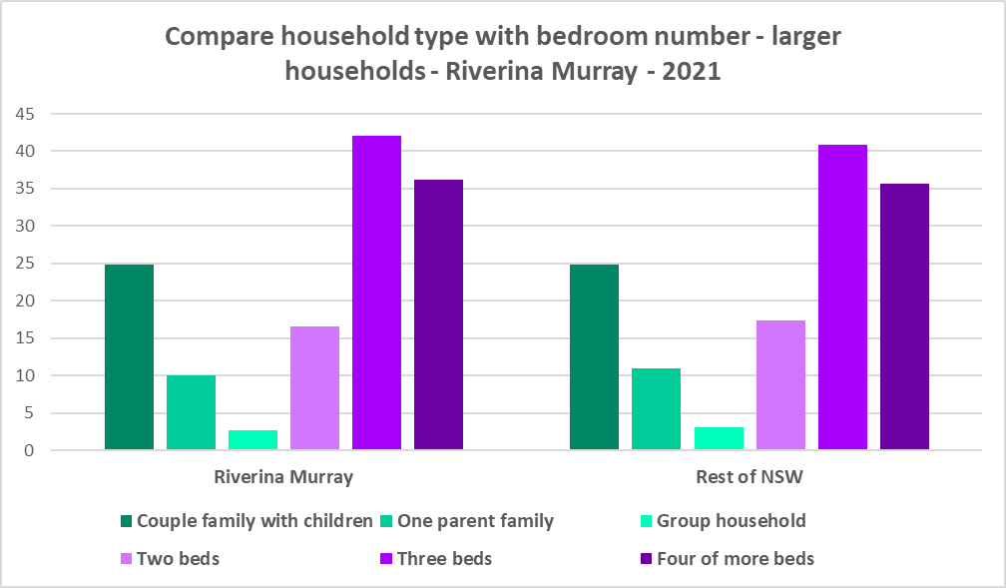

* As couple only households comprise 27.2% of all households in the Riverina Murray, it is important to continue to encourage provision of one and two bedroom stock as well as studios, new generation boarding houses and secondary dwellings, to maintain a balance to meet local need, particularly where there are higher proportions of seniors and frail aged. This will give older residents opportunity to downsize into more manageable and appropriate homes.
* Enabling the provision of more semi-detached, terrace and town houses could help fulfil some of this demand.
* Also, secondary dwellings suit a range of groups including small households, young people, frail aged and people with disability needing support from family. They may be readily encouraged on larger lots with reasonable access to centres providing a range of services and facilities.

**Who needs affordable housing**

* A wide range of people need affordable housing. Single income earners who fall into the low income category include aged care and disability workers, retail sales assistants, production workers, receptionists and early career child care workers.
* People working in accommodation and food services comprise 6.5% of the workforce living in the Riverina Murray and are amongst the lowest paid workers. Similarly retail trade employs 9.1% of workers living in the region. Health care and social assistance is the largest employment sector of residents in the Riverina Murray (employing 14.5%). A 2017 survey of NSW Nurses and Midwives Association (NSWMA) members showed that thirty six per cent of respondents moved home or changed jobs in the previous 12 months because of housing affordability issues.
* For example:
  + Households earning $790 per week gross (broadly indicative of a wage for a laundry worker) could afford to pay just $237 per week in rent before being in housing stress.
  + Households earning $960 (broadly indicative of wages for a commercial cleaner, delivery driver and entry level firefighter) could afford to pay just $288 per week in rent before being in housing stress.
  + Agriculture is the second largest employment sector of Riverina Murray residents and employs a further 10.8% of residents in this region. The average farmhand salary in Australia is $57,311 per annum or $1,102 per week. A household on that salary could afford to pay $330 per week in rent before being in housing stress.
  + Households with an income of $1,150 (broadly indicative of the wage for an enrolled nurse, child care worker and ICT support technician) can afford to pay just $345 per week in rent before being in housing stress.
  + At a weekly income of $1,450/$1,500 (an indicative wage for an early career Registered Nurse), a household could afford to pay $435 to $450 per week in rent before being in housing stress.
* At March 2023, there were insufficient new bonds lodged to calculate a median rent for studio dwellings in any LGA in the Riverina Murray, or to calculate a median rent for one bedroom homes in 15 of the 20 LGAs in the region - which speaks to lack of supply.
* At March 2023, the median rent for a one bedroom home ranged between $170 per week in Edward River and $300 per week in Junee; for a two bedroom home ranged between $220 per week in Berrigan and $355 per week in Wagga Wagga; for a three bedroom home ranged between $320 per week in Narrandera and $495 per week in Murray River and for a four or more bedroom home ranged between $430 per week in Cootamundra-Gundagai and $570 per week in Wagga Wagga. Note that Hay had insufficient bonds to calculate any median rent and Carrathool, Coolamon, Greater Hume, Lockhart and Murrumbidgee only had sufficient bonds lodged to calculate the median rent for all dwellings combined (which ranged between $290 and $350 per week).
* This demonstrates that there is insufficient rental accommodation more generally in much of the region and that in some local government areas, lower income households would struggle to find affordable private rental housing.
* Single income households in particular are less able to compete in the housing market.
* Increasing numbers of older single women are homeless or at risk of homelessness due to the lack of available affordable rental housing. In fact, they are the fastest growing cohort of the homeless population.
* Partnering or collaborating with community housing providers is one effective way to meet some of the local need for appropriate affordable housing. Not for profit community housing providers are owners, managers and developers of affordable rental housing for lower income households and residents with specific housing needs. They work with partners, investors and government to provide housing and deliver support for tenants. For more information about community housing providers, see the NSW Community Housing Industry Association website.
* Note that Griffith Council has recently partnered with Argyle Community Housing to undertake an affordable housing development.

**Additional Data**

Housing data and tables used in this Snapshot are available from the Local Government Housing Kit Database on the Housing NSW website at:

<https://www.facs.nsw.gov.au/resources/nsw-local-government-housing-kit/chapters/local-government-housing-kit-database>

More information on Expected Waiting Times for Public Housing is available on the DCJ/FACS website by region at:

<https://www.facs.nsw.gov.au/housing/help/applying-assistance/expected-waiting-times>

Additional data on social housing dwellings and delivery is available on the FACS website at:

<https://www.facs.nsw.gov.au/resources/statistics/social-housing-residential-dwellings/facs-quarterly-statistics-social-housing-dwellings>

or go straight to the dashboard:

<https://public.tableau.com/app/profile/facs.statistics/viz/Social_Housing_Residential_Dwellings/Dashboard>

and

<https://www.facs.nsw.gov.au/resources/statistics/social-housing-delivery2/interactive-dashboard>

The Australian Housing and Urban Research Institute (AHURI) has written a paper explaining the reasons for unoccupied homes:

<https://www.ahuri.edu.au/research/brief/are-there-1-million-empty-homes-and-13-million-unused-bedrooms>

The SGS Economics and Planning Rental Affordability Index is here:

<https://sgsep.com.au/projects/rental-affordability-index>

More information about community housing providers is available on the NSW CHIA (Community Housing Industry Association) website:

NSW CHIA Snapshot of the Community Housing Sector in NSW:

<https://communityhousing.org.au/wp-content/uploads/2022/08/Community-Housing-Snapshot-2022.pdf>

Data on community housing properties is available from the NSW CHIA Dashboard at:

<https://communityhousing.org.au/our-impact/data-dashboard/>

CHIA NSW affordable housing tool kit. The Tool Kit is based on extensive research about reasons for community resistance to affordable housing, and effective ways of building support for affordable housing:

https://communityhousing.org.au/toolkit/theplatform.html

The NSW Registrar of Community Housing website is here:

<https://www.rch.nsw.gov.au/>

1. <https://sgsep.com.au/projects/rental-affordability-index>
2. <https://www.corelogic.com.au/news-research/news/archive/how-much-has-house-price-growth-outstripped-growth-in-wages#:~:text=Comparing%20the%20wage%20price%20index,193.1%25%20(figure%202)>.