# **Western City District – What’s the Housing Demand**

This Housing Snapshot looks at aspects of housing demand, particularly from the 2016 Census to the 2021 Census – including population, age profile, household type, household size, income (change in low, moderate and high income households and low income rental households), homelessness and people with disability.

There have been challenges across Australia and in this region since the 2016 Census, including the pandemic and subsequent surge in immigration - which have impacted the community and the demand for housing.

## Population

* Changes in population will impact on the demand for housing.
* Between 2016 and 2021, the population of Western City grew by 12.7% or 130,270, from 1,024,448 to 1,154,718 (using ABS Census population data).
* However, not every LGA in the District has grown at the same rate.
* Changes in population between 2016 and 2021 within Western City ranged from a 52.5% increase in Camden to a 1.6% increase in the Blue Mountains.
* In terms of numbers, Camden had the largest increase with an additional 41,101 people, followed by Liverpool with 29,116, then Penrith with 21,600 and Campbelltown with 19,518.
* Note that Camden had the largest percentage population increase in the state between 2016 and 2021, by a considerable margin, with The Hills Shire second with a 22.0% increase. In numeric terms, Camden was second in the state after Blacktown and Liverpool was fifth (after The Hills and Parramatta), Penrith 6th (after Canterbury-Bankstown) and Campbelltown 7th – indicating that Western City has experienced significant population growth, along with Central City.
* Liverpool has the largest population in the District in 2021 with 233,446, followed by Penrith with 217,664, and Fairfield with 208,475. Wollondilly has the smallest population in the District with 53,961.
* The Department of Planning and Environment have prepared population projections for every LGA in the district. Camden (3.07% per annum), Wollondilly (2.6%), Liverpool (1.5%), Campbelltown (1.37%) and Penrith (1.13%) are all forecast to have a higher growth rate than the average for NSW of 0.95% per annum, while Fairfield (0.81%), Hawkesbury (0.68%) and Blue Mountains (0.28%) have lower projected growth rates.
* Numerically the largest increase in population forecast to 2041 is predicted for Camden (89,827), followed by Liverpool (80,350), Campbelltown (54,640) and Penrith (54,402).
* Blue Mountains has the lowest projected population increase to 2041 in the District, with a forecast of an additional 4,578 residents.
* The table below shows the population change for each Western City LGA and the district from 2016 to 2021, using ABS Census data.



## Age

* The age profile of the region and particularly each LGA will impact on housing need and demand, including number of bedrooms, affordability, location (for example, in relation to services and facilities) and dwelling type.
* The median age of the population of the Western City LGAs at the 2021 Census ranges between 33 years in Camden and 45 in the Blue Mountains, compared to the average of 37 for Greater Sydney. The Blue Mountains has a much higher median age than the rest of the LGAs in Western City, with Fairfield and Hawkesbury the next highest with a median age of 39.
* The table below gives the median age for all the Western City LGAs and Greater Sydney.



* Generally, Western City has higher proportions of 0-4, 5-14 and 15-19 year olds, the same proportion of 20-24 and 65-74 year olds and lower proportions of 25-34, 35-44, 45-54, 55-64, 75-84 and 85+ year olds than the average for Greater Sydney.
* However, there is variation in the age profiles of the Western City LGAs:
  + Blue Mountains, Fairfield and Hawkesbury have lower proportions of 0-4 and along with Penrith, 5-14 year olds than the other LGAs in Western City, the District as a whole and the average for Greater Sydney.
  + Camden, Campbelltown, Liverpool and Penrith have higher proportions of 25-34 year olds than the other LGAs in Western City, the District and the average for Greater Sydney.
  + Camden and Campbelltown also have higher proportions of 35-44 year olds.
  + Blue Mountains, Fairfield, Hawkesbury and Wollondilly have higher proportions of 45-54, 55-64, 65-74 year olds and for Blue Mountains, Fairfield and Hawkesbury, also 75-84 year olds.
  + Blue Mountains has a higher proportion of 85+ year olds than the other LGAs in Western City, the District and the average for Greater Sydney.
* The graph below shows the proportion of the population in each key age cohort in the Western City LGAs as well as the District and Greater Sydney.

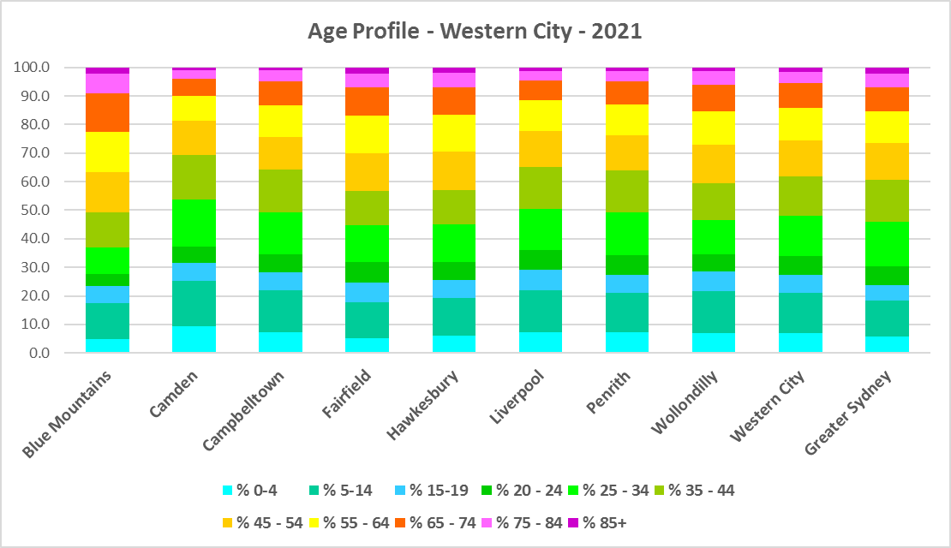

* The table below gives more detail of the breakdown of age cohorts by LGA, for Western City and for Greater Sydney.



* The Department of Planning and Environment forecast increases in older age groups in every Western City LGA to 2041.
* They also forecast an increase in younger age groups for Camden, Campbelltown, Liverpool, Penrith and Wollondilly, a decline in younger age groups in Blue Mountains and no change in Fairfield and Hawkesbury.
* The diversity of age groups requires a range of different housing to meet the needs of the community throughout the housing life cycle.
* There will be an increasing need for housing to suit seniors and frail aged residents as the number of residents in these age groups grows.
* As the Australian Institute for Health and Welfare (AIHW) note:

Many older Australians prefer to age in place, meaning they wish to stay in their local home or community. However, their capacity to do so can be influenced by:

* + the appropriateness and quality of their home (for example, size, layout)
  + their ability to modify their home to suit their functional requirements
  + the cost and availability of suitable housing
  + their need for formal care and assistance
  + their proximity to services and social support.
* Although the majority of older Australians own their own home, this number is declining. About 15% of older Australians are renters. These people are generally a highly vulnerable and economically disadvantaged group, particularly single person households, with older women being the fastest growing demographic of people experiencing homelessness. There is therefore a need for more adaptable, accessible dwellings, well located, secure, low maintenance and affordable to meet the needs of seniors and frail aged in particular, within their communities. Those most in need are households in the private rental market, who struggle to afford housing on an Aged Pension or inadequate superannuation. (Source: "Housing Decisions of Older Australians" Productivity Commission December 2015).
* There are significant numbers of low income households and lower income rental households in this District. Therefore affordability is a key issue for all age groups, including older residents, and particularly tenants.
* The Australian Housing and Urban Research Institute (AHURI) has undertaken research on “What is the ideal home for older Australians?”
  + “Older Australians and the housing aspirations gap” and
  + “Understanding the housing aspirations of older Australians”
* This research is part of a broader study on “Housing aspirations and constraints for lower income Australians.” AHURI’s research demonstrates that one of the most valued aspects of older residents housing is the location – that the neighbourhood feels safe and secure; that there is good (including walkable) access to services such as health, shopping, recreational amenities, public open space; and that it is close to family and friends.

## Household Type

* A look at household types and average household size gives some insight into the type of housing – particularly number of bedrooms – that is likely to be appropriate to meet the housing needs of the community.
* At the 2021 Census in Greater Sydney, couple families with children are the largest household type, comprising 34.4% of all households, followed by couple family without children households (23.3%) and lone person households (22.2%). One parent family households (10.5%), other family households (1.2%), group households (4.0%) and other households (4.3%) make up the remainder.
* Household types in the Western City District conform to the pattern of the average for Greater Sydney, with couple families with children being the largest household type, followed by couple families without children and lone person households. However, there is some variation in individual LGAs in the District.
* Western City as a District has lower proportions of couple families without children (20.8%), much higher proportions of couple families with children (39.1%) and lower proportions of lone person households (16.2%) than the average for Greater Sydney. Western City District also has higher proportions of one parent families (13.9%) and other household types (4.5%) (which include multi-family households), the same proportion of other family types (1.2%) and lower proportions of group households (2.1%) than the average for Greater Sydney.
* Individual LGAs in the District differ somewhat from this pattern:
  + Blue Mountains, Hawkesbury and Wollondilly have higher proportions of couple families without children than the District and Greater Sydney.
  + Blue Mountains has a lower proportion of couple families with children and a higher proportion of lone person households.
  + Blue Mountains and Wollondilly have lower proportions of one parent families.
  + Campbelltown, Fairfield, Liverpool and Penrith have higher proportions of other household types.
* The graph and table below show the proportion in each key household type for every Western City LGA, for the District and for Greater Sydney at the 2021 Census.

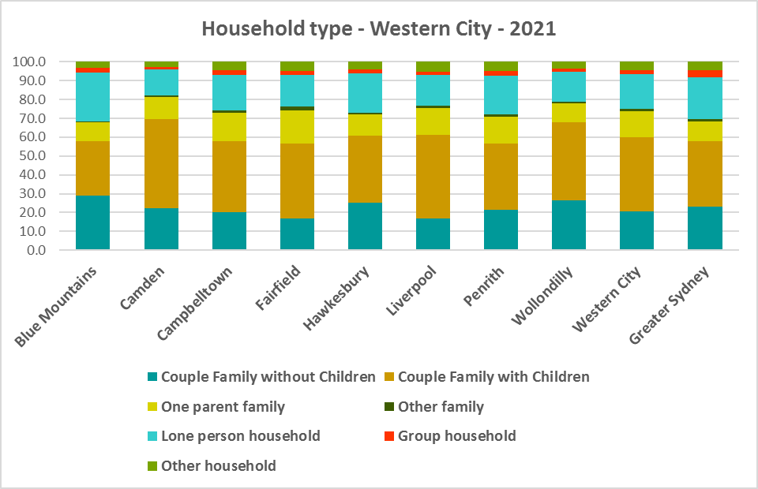

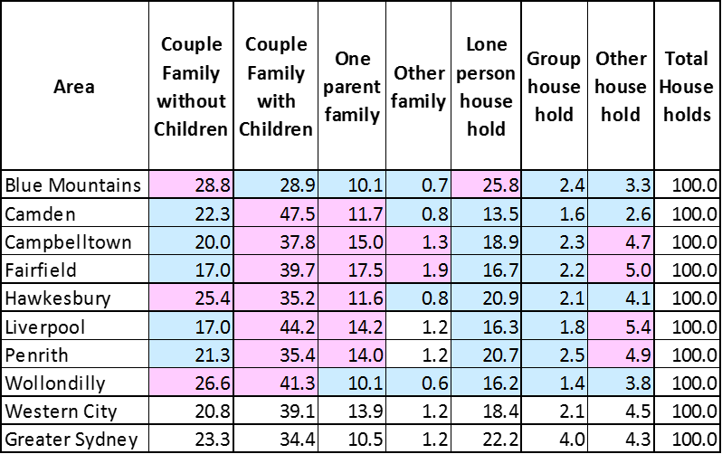

* There has been a shift in the proportions of different household types since the 2016 Census, with an increase in the proportion of lone person households in Greater Sydney (1.8%) and couple family without children households (0.9%), and declines in the proportion of couple family with children households (-0.9%), other household types (-1.3%) and group households (-0.5%).
* The changes in household type from 2016 to 2021 in Western City District were a little different, with a slightly larger decline in the proportion of couple family with children households (-1.0%), smaller increases in the proportion of couple family without children (0.4%) and lone person households (1.4%), a decline in the proportion of one parent families (-0.2%) and other households (-0.5%), and no change in the proportion of other family and group households (0.0%).
* Changes in individual LGAs are not all in line with this trend:
  + Fairfield (-2.6%), Wollondilly (-2.0%), Penrith (-1.8%), Liverpool (-1.5%) and Blue Mountains (-1.4%) had a much stronger decline in the proportion of couple families with children than Greater Sydney, while Camden had a strong increase of 1.2%, against the trend.
  + Camden (-1.2%), Penrith (-0.4%) and Campbelltown (-0.1%) had reductions in the proportion of couple families without children against the trend in Greater Sydney, while Blue Mountains (2.1%) and Hawkesbury (1.8%) had much stronger increases.
  + Penrith (2.5%) had a much stronger increase in the proportion of lone person households than Greater Sydney, while all the other LGAs in the District had weaker increases.
  + Fairfield had a 1.0% increase in the proportion of other households against the trend in Greater Sydney and all the other LGAs in the District.
  + Camden (0.2%) and Campbelltown (0.1%) experienced slight increases in the proportion of group households against the trend to decline elsewhere.
* This data on household types and changes in household types between the last two Census should be compared with the data on bedroom numbers to determine if there is a good fit between household types and housing stock and what the future housing needs are likely to be.
* Although there should be plenty of housing suitable for families of different sizes, there is also a need for a variety of dwellings with different bedroom numbers to suit couples and single person households.

## Household Size

* At the 2021 Census, the average household size for Greater Sydney was 2.7 persons per household – down from 2.8 persons per household in 2016 and the same as 2.7 persons per household in 2011.
* Average household size in Western City ranges from 2.4 persons per household in the Blue Mountains to 3.2 persons per household in Fairfield and Liverpool. Camden (3.1), Wollondilly (3.0), Campbelltown (2.9), Hawkesbury and Penrith (2.8) also have a larger average household size than the average for Greater Sydney, leaving Blue Mountains as the only LGA in Western City with a smaller average household size.
* Average household size declined in Blue Mountains, Campbelltown, Fairfield and Penrith between 2016 and 2021, while remaining stable in the other Western City LGAs.
* The table below gives the average household size in each of the Western City LGAs as well as Greater Sydney for 2011, 2016 and 2021.



## Income

* At the 2021 Census, high income households comprise the largest proportion of all households in Greater Sydney – unlike the Rest of NSW, where low income households predominate.
* However, unlike the average for Greater Sydney, Western City has a much higher proportion of low income households (39.3% compared to 32.1%), higher proportions of moderate income households (21.5% compared with 18.2%) and much lower proportions of high income households (39.2% compared to 49.7%).
* Not all LGAs in Western City conform to this pattern.
  + Blue Mountains (31.2%), Camden (22.2%), Hawkesbury (28.7%), Penrith (29.3%) and Wollondilly (27.0%) all have lower proportions of low income households than the average for Greater Sydney.
  + Camden (58.8%), Hawkesbury (51.8%), Penrith (50.0%) and Wollondilly (51.4%) all have higher proportions of high income households than the Greater Sydney average.
* Campbelltown has the highest proportion of both low and moderate income households (50.5% and 24.7% respectively), closely followed by Liverpool (50.3% and 23.0%) and Fairfield (50.3% and 21.1%).
* Camden has the highest proportion of high income households (58.8%), followed by Wollondilly (53.4%) and Hawkesbury (51.8%).
* The graph and table below show the proportion of low, moderate and high income households in all the Western City LGAs, compared with the District and Greater Sydney at the 2021 Census.

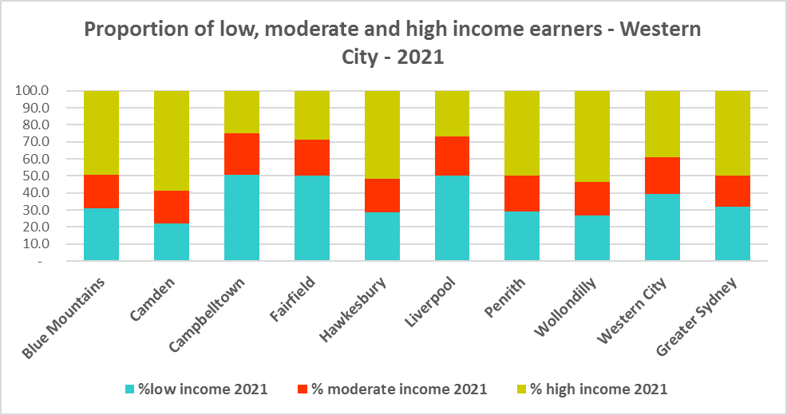



* Between 2016 and 2021 the number of low income households declined in Western City District as a whole (by -3.7%) but not in every LGA. Low income households declined in Blue Mountains (-23.7%), Fairfield (-14.8%), Hawkesbury (-22.7%), Penrith (-17.9%) and Wollondilly (-18.5%) and increased in Camden (3.9%), Campbelltown (18.4%) and Liverpool (19.0%).
* Over the same period, the number of moderate income households increased in the District (19.5%) but again not in every LGA. Moderate income households increased in Camden (19.5%), Campbelltown (16.1%), Fairfield (13.0%) and Liverpool (19.8%), but declined in Blue Mountains (-5.5%), Hawkesbury (-14.4%), Penrith (-5.0%) and Wollondilly (-9.5%)
* High income households (33.8%) increased in Western City as a whole and in every LGA in the District.
* The two graph below shows the change in the number of low (including very low), moderate and high income households from 2016 to 2021 in Western City as a District and then in the individual LGAs in the District.

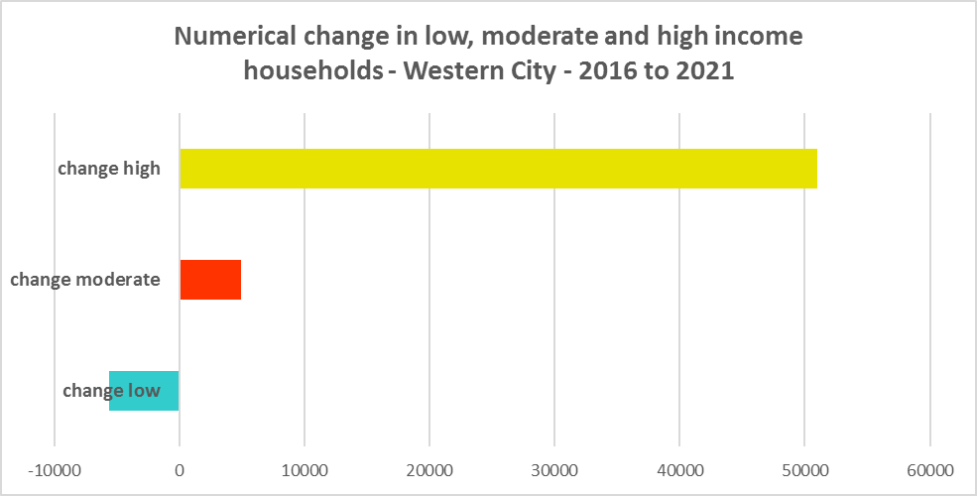

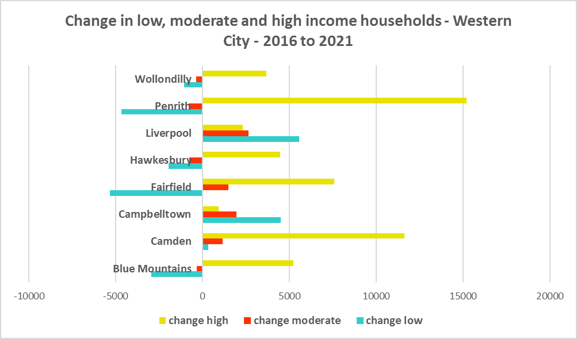

* Over the same period, the number of very low income **renters** and low income **renters** increased in Western City as a whole by 32.4% and 35.3% respectively, as well as increasing in every LGA in the District.
* The increase in very low income **renters** ranged from 78.4% in Camden to 8.1% in the Blue Mountains and for low income **renters** from 112.0% in Camden to 3.9 in Blue Mountains.
* In numeric terms, the largest increase in very low income **renters** was in Liverpool (1,686) while for low income **renters** the largest increase occurred in Penrith (1,430).
* The increase in very low (6,449) and low income **renters** (5,991) across Western City underlines the need to consider tenure as well as price point when considering responses to meet housing need.
* The graph below shows the change in the number of very low and low income **renters** between 2016 and 2021 in Western City LGAs.

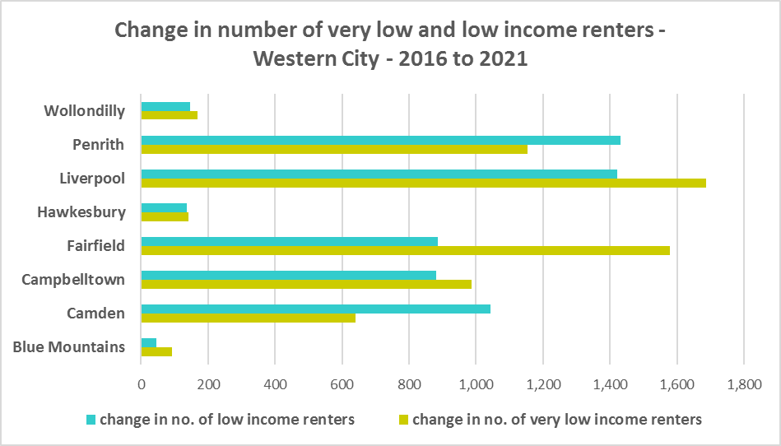

* Camden and Wollondilly have a higher median household weekly income at 2021 than the average for Greater Sydney ($2,077), while the remaining LGAs in Western City have a lower median income. Camden ($2,353) has the highest median weekly income in the District while Fairfield has the lowest ($1,390).



## Homelessness

* People experiencing homelessness and those at risk of homelessness are among Australia’s most socially and economically disadvantaged. State, Commonwealth and some local governments fund services to support people who are homeless, or at risk of homelessness. Services are delivered mainly by non–government organisations, some of which specialise in delivering services to specific groups (such as young people or people experiencing domestic violence).
* Inadequate income and inability to access affordable housing are significant contributing factors to homelessness, along with individual factors such as experience of family and domestic violence, ill health and disability.
* The ABS identifies someone as homeless “where they do not have suitable accommodation alternatives and their current living arrangement:
  + Is in a dwelling that is inadequate;
  + Has no tenure or their initial tenure is short and not extendable; or
  + Does not allow them to have control of and access to space for social relations.”
* The ABS uses “six operational groups for presenting estimates of people experiencing homelessness on Census night:
  + People living in improvised dwellings, tents or sleeping out
  + People living in supported accommodation for the homeless
  + People staying temporarily with other households
  + People living in boarding houses
  + People in other temporary lodgings
  + People living in ‘severely’ overcrowded dwellings.”
* The ABS “also compiles estimates from Census data for the following three groups of people who may be marginally housed but are not classified as homeless:
  + People living in other crowded dwellings
  + People in other improvised dwellings
  + People marginally housed in caravan parks.”
* The table below shows ABS 2021 Census data for Western City on the homeless and marginally housed.
* Note that due to additional assistance provided during the pandemic, the number of people counted as homeless on Census night in 2021 is lower than at the 2016 Census. Nevertheless, there were 4,804 people counted as homeless in Western City at the 2021 Census and a further 6,925 who were counted as marginally housed.
* Of those who were counted as homeless, the largest number were people living in severely overcrowded dwellings (3,038 or 63.2%), followed by people in supported accommodation for the homeless (868 or 18.1%), then people staying temporarily with other households (436 or 9.1%). Of those who were counted as marginally housed, the overwhelming majority were people living in other crowded dwellings (6,755 or 97.5%).
* This clearly indicates the need for more affordable rental housing.



* The 2023 NSW street count, the NSW Government’s fourth annual rough sleeping street count, was completed between 2 February and 27 February 2023.
* Over 300 local organisations either consulted in the planning phase or participated in the delivery of street counts. Organisation which partnered with the Department of Communities and Justice (DCJ) included Community Housing Providers, local councils and Specialist Homelessness Services, as well Aboriginal organisations, Local Health Districts, local community groups, and Police.
* 1,623 people were counted sleeping rough during these street counts, a 34% increase from 2022.
* Street counts took place in more than 350 towns in 76 LGAs, compared to 71 LGAs in 2021 and 65 LGAs in 2020.
* The table below gives the street count results for the Western City district locations.



## People with Disability

* According to the Australian Institute of Health and Welfare (AIHW) and data from the 2018 Australian Bureau of Statistics (ABS) Survey of Disability, 18% of people in Australia have disability. Another 22% have a long term health condition but not disability.
* Nearly one third (32%) of people with disability have severe or profound disability. This means needing help with daily self-care, mobility or communication activities, having difficulty understanding or being understood by family or friends, or communicating more easily using sign language or other non-spoken forms of communication.
* The survey data shows:
  + 7.6% of children aged 0–14 have disability
  + 9.3% of people aged 15–24 have disability
  + 13% of people aged 15–64 have disability
  + 50% of people aged 65 and over have disability (ABS 2019b).
* For about 3 in 4 (77%) people with disability, the main type of disability is physical, while for the remaining 1 in 4 (23%), the main type of disability is mental or behavioural.
* Clearly housing is a significant factor in the health and wellbeing of people with disability. The availability of affordable, sustainable and appropriate housing helps people with disability to participate in the social, economic and community aspects of everyday life. Someone without access to affordable, secure and appropriate housing is more likely to experience homelessness, poor health, and lower rates of employment and education.
* While most people with disability live at home in the community (96% in private dwellings), some live in cared accommodation.
* Cared accommodation is usually long term and may be institutional in style, including hospitals, residential aged care, cared components of retirement villages, aged care hostels, psychiatric institutions and group homes for people with disability. The more severe a person’s disability is, the more likely they are to live in cared accommodation and the less likely they are to live in the community.
* There has been a significant shift towards supporting people with disability to live in private dwellings, rather than being in institutional care over recent decades. Largely this has been driven by changes for young people with disability.

## Additional Data

More detailed housing data and tables used in this Snapshot are available from the Local Government Housing Kit Database on the FACS website at:

<https://www.facs.nsw.gov.au/resources/nsw-local-government-housing-kit/chapters/local-government-housing-kit-database>

More information on the housing needs of older Australians and people with disability:

The Australian Institute of Health and Welfare – Older Australians Housing and Living Arrangements on the AIHW website at:

<https://www.aihw.gov.au/reports/older-people/older-australians/contents/housing-and-living-arrangements>

The Australian Institute of Health and Welfare – People with Disability in Australia

<https://www.aihw.gov.au/reports/disability/people-with-disability-in-australia/contents/people-with-disability/prevalence-of-disability>

and relating to housing needs

<https://www.aihw.gov.au/reports/disability/people-with-disability-in-australia/contents/housing>

The Productivity Commission’s report Housing Decisions of Older Australians is at:

<https://www.pc.gov.au/research/completed/housing-decisions-older-australians>

More detailed information on population, household and dwelling projections is available on the Department of Planning and Environment website at:

<https://www.planning.nsw.gov.au/Research-and-Demography/Population-Projections/Projections>

<https://pp.planningportal.nsw.gov.au/populations>

More data on homelessness, specifically homelessness service data is available on the Homelessness NSW website at:

<https://homelessnessnsw.org.au/resource/specialist-homelessness-service-data/>

And from the AIHW website here:

<https://www.aihw.gov.au/reports/australias-welfare/homelessness-and-homelessness-services>

The 2023 Street Count result is at the DCJ/ FACS website here:

<https://www.facs.nsw.gov.au/reforms/homelessness/premiers-priority-to-reduce-street-homelessness/street-count>

Further information on ABS estimation of homelessness is available at the ABS website:

<https://www.abs.gov.au/statistics/people/housing/estimating-homelessness-census/2021>