# North District – What’s happening with Supply and is it a good match

This Housing Snapshot looks at dwelling type, bedroom mix, tenure, social housing supply and the gaps between demand and supply, with a focus on lower income households.

There have been significant changes in North District since the 2016 Census and further developments impacting housing supply since the 2021 Census.

The Australian Bureau of Statistics reported that across Australia for January 2023, "approvals for private sector houses fell by 13.8 per cent, the fifth consecutive drop, to be the lowest result recorded since June 2012". Further, total dwelling approvals decreased in New South Wales by -49.0 per cent.

At a time when immigration is surging and there is strong demand for housing, there is a critical shortage of private rental accommodation as well as a skills shortage in the building sector. This suggests that it is likely to be some time before supply pressures ease.

## Dwelling Type

* At the 2021 Census there were 358,508 dwellings in North District.
* Of these 91.6% were occupied, (the same as in 2016), just below the 92.0% average percentage occupied in Greater Sydney.
* Consequently 8.4% were unoccupied compared to 8.0% in Greater Sydney.
* The reasons homes are unoccupied vary and include (according to a report by the Australian Housing and Urban Research Institute “Are there 1 million empty homes and 13 million unused bedrooms?”):
  + homes are being renovated
  + homes being sold as vacant possession
  + newly built or bought homes where no one has moved in yet
  + rental homes awaiting new tenants
  + people living away temporarily from home during the census count (travelling or visiting other homes)
  + homes are deemed unliveable
  + subject to a probate application or other legal proceedings
  + holiday homes
  + homes owned by people currently living overseas
  + homes being land banked, that is held vacant until the local area economics (or personal circumstances) make it more profitable to sell or redevelop the property.
* However, in parts of North District the impact of Airbnb and short term lettings generally has been significant.
* In 2023, according to Inside Airbnb, there are 22,659 listings in Sydney (of which 69.6% are entire homes). Of these, 6,168 or 27.2% are in North District, with 3,405 in Northern Beaches (which represents 15% of the Airbnb listings in Sydney) and 823 in North Sydney (followed by Ryde with 448, Willoughby with 371, Hornsby with 348, Mosman with 315, Ku-ring-gai with 238, Lane Cove with 189 and Hunters Hill with 31). There is some confluence between LGAs with high numbers of Airbnb with high proportions of unoccupied dwellings at the 2021 Census – for example Northern Beaches has 7.5% unoccupied homes; Mosman has 11.3% unoccupied homes; and North Sydney has 13.8% unoccupied homes.
* The impact of Airbnb is further discussed in the North District Snapshot of What’s Happening in the Housing Market, as well as the section below on Tenure.
* The graph below shows the proportion of occupied and unoccupied dwellings in North District and Greater Sydney at the 2021 Census.

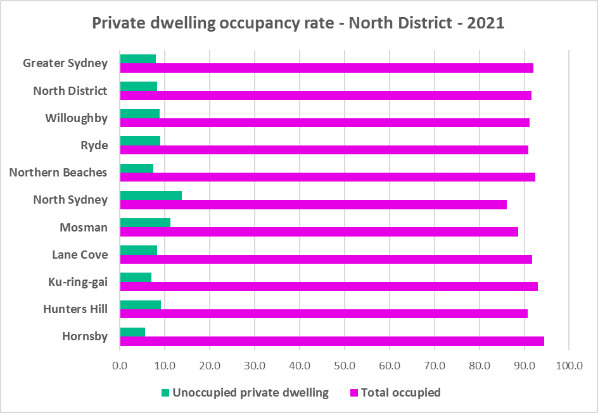

* North District has a different dwelling mix to the average for Greater Sydney.
* At the 2021 Census, separate houses comprised 50.9% of all occupied dwellings, below the average of 55.4% for Greater Sydney. Within the District the proportion of separate houses ranges from 69.5% in Hornsby to 11.1% in North Sydney.
* Unlike most other parts of Sydney and NSW, flats comprise the next largest proportion of dwellings in North District with 39.4% compared to 12.9% in Greater Sydney. Within North District the proportion of flats ranges from 75.7% in North Sydney to 21.9% in Hornsby and Hunters Hill.
* A further 9.2% of occupied homes in North District were semi-detached, terrace or town houses compared to 31.0% in Greater Sydney. Within North District the proportion of semi-detached, terrace or town houses ranges from 15.7% in Hunters Hill to 3.9% in Ku-ring-gai.
* The graph and table below show the proportion of dwelling types for North District at the 2021 Census.

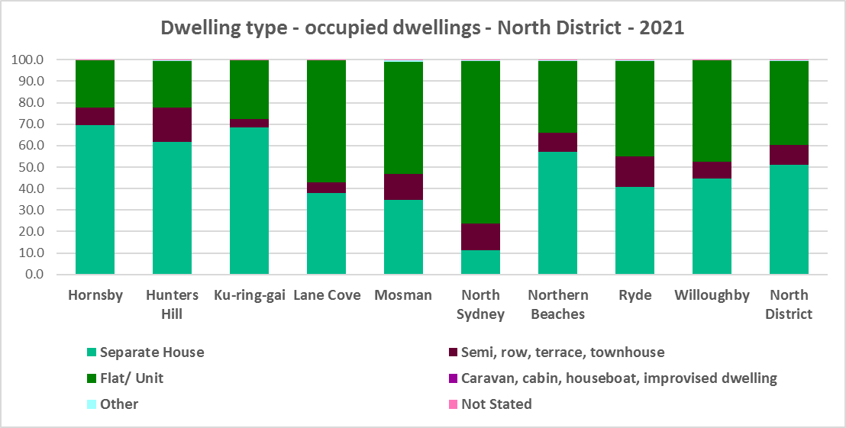



* The graph below compares the proportion of dwelling types in North District with the average for Greater Sydney.

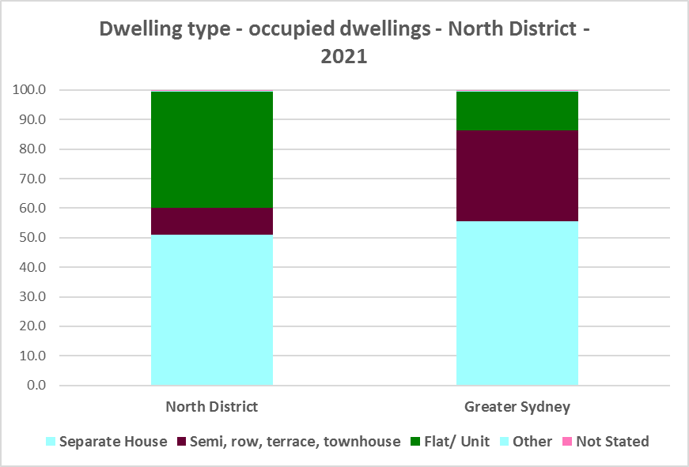

* Other types of dwellings comprised just 0.3% of occupied dwellings in North District at the 2021 Census and include caravans, cabins, houseboats, improvised dwellings and flats attached to shops or offices. Census data shows 35 households living in caravans, 115 living in cabins or houseboats, 6 living in improvised dwellings and 847 in flats attached to shops or offices in North District.

## Bedroom Mix

* Three and four bedroom homes comprise the overwhelming majority of homes on average in Greater Sydney and the Rest of NSW, but North District generally has a little more diversity in bedroom mix.
* At the 2021 Census, North District had 0.9% studio dwellings, 10.7% one bedroom homes, 27.5% two bedroom homes, 26.1% three bedroom homes and 34.0% four or more bedroom homes.
* This compares to 0.9% studios, 8.1% one bedroom, 25.9% two bedroom, 31.0% three bedroom and 32.8% four or more bedroom homes in Greater Sydney as a whole.
* Within North District,
  + North Sydney has the highest proportion of studio dwellings with 2.9% and Ku-ring-gai the lowest with 0.2%;
  + North Sydney similarly has the highest proportion of one bedroom homes with 22.3% and Ku-ring-gai again has the lowest with 4.7%;
  + North Sydney also has the highest proportion of two bedroom homes with 41.4% and again Ku-ring-gai the lowest with 16.3%;
  + Hunters Hill has the highest proportion of three bedroom homes with 29.8% and Lane Cove the lowest with 23.1%; and
  + Ku-ring-gai has the highest proportion of four or more bedroom homes with 52.7% and North Sydney the lowest with 7.9%.
* The graph and table below show the proportion of studio, one, two, three and four or more bedroom occupied dwellings in North District compared with Greater Sydney at the 2021 Census.

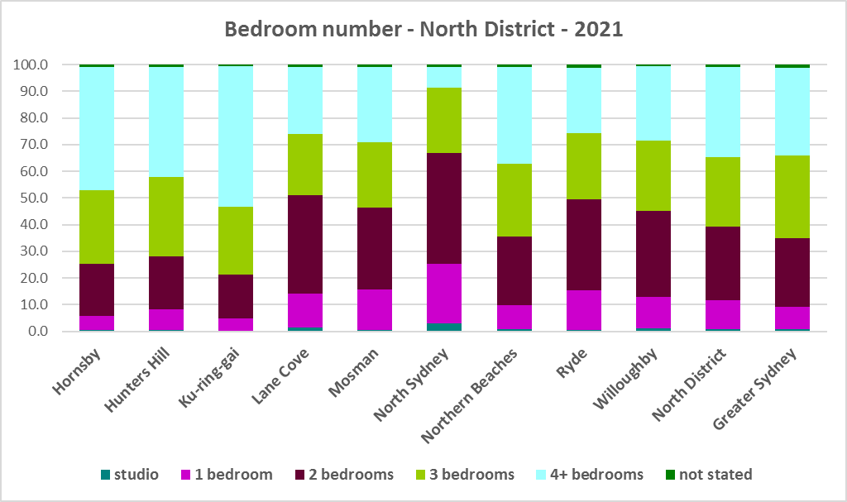



* While North District as a whole has a higher proportion of one and two bedroom homes than the average for Greater Sydney, this is not the case in every LGA in the district. Ideally there would be a better match between household type and bedroom number across all the LGAs in the District. By way of example, 59.1% of households in North District are single person or couples without children yet only 11.8% of the stock is studio or one bedroom, limiting house choice for smaller households. In Kur-ring-gai 62.3% of households are single person or couples without children and only 4.9% of homes are studio or one bedroom.
* The forecast increase in older age groups in North District is likely to increase the demand for smaller, more manageable and affordable homes. Two bedroom dwellings in particular offer the most flexibility, given they are also suitable for small families and allow older residents to have family members or carers to stay while giving them a more manageable size home to maintain. Providing choice in the number of bedrooms enables them to downsize and stay in their community and more broadly may help with affordability. Affordability is an issue and ensuring accessibility for older residents is important.
* Note that new dwelling stock generally represents 1 – 2% of the total dwelling stock while established dwellings represent the remaining 98 – 99% of stock – so alterations and additions to existing stock has a significant impact on bedroom mix.
* When considering the fit of housing stock to household type into the future, this is an important consideration.

## Tenure

* At the 2021 Census, the most common tenure type in North District was households owning their home outright (unlike Central City where owning a home with a mortgage is the most common tenure or Eastern City where rental is the largest tenure) – comprising 33.4% of all households. Within the district this ranged from 41.1% in Hunters Hill to 26.0% in North Sydney.
* The next largest tenure type in North District was households owning their home with a mortgage – comprising 33.1% of all households. The proportion in this tenure ranged from 40.2% in Hornsby to 20.7% in North Sydney, within the district.
* Rental households comprised a total of 32.4% of all households in North District, ranging between 53.0% in North Sydney and 20.2% in Ku-ring-gai.
* Households renting from a real estate agent comprise 25.5% of all households in North District – with North Sydney having the highest proportion at 44.5% and Hunters Hill the lowest with 16.0% of households renting though a real estate agent.
* The remainder of rental households are comprised of households renting from the state housing authority (1.0% in the region), community housing providers (0.8%) and other landlords (5.1%).
* The graph and table below give the tenure composition for the district and individual LGAs at the 2021 Census.

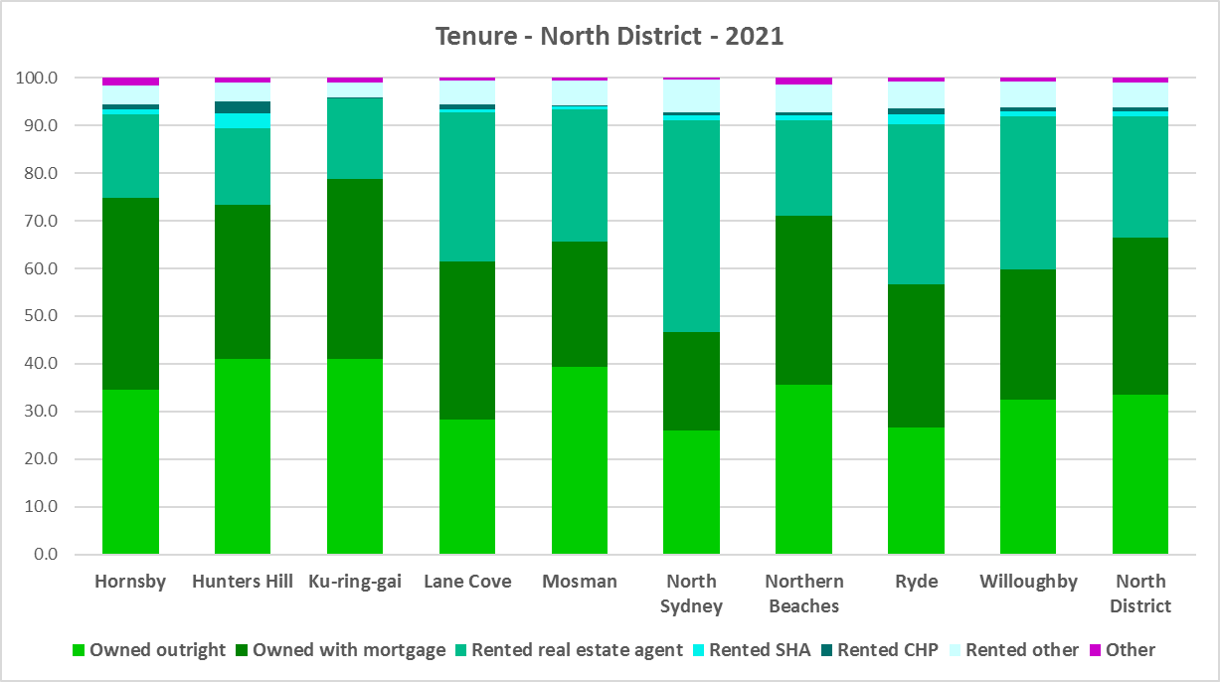



* The general trend is for increasing numbers of households relying on the private rental market as a long term tenure rather than a transitional one between leaving home and buying a home, as housing costs have increased much faster than wages.
* Subsequent high interest rates and high inflation levels have made it increasingly difficult for lower income households in particular to manage housing costs.
* In addition, research suggests the proliferation of Airbnb has resulted in a disruption in the long term housing market which provides an additional difficulty for long term renters to find affordable rental housing[1]. This issue further highlights the need for housing strategies that account for local issues and a commitment to development flexible, affordable and appropriate private rental accommodation (see the Housing Snapshot on What’s Happening with Demand as well as the section on Dwelling Type above).
* The increase in and concentration of Airbnb in North District, particularly in the Northern Beaches, has the potential to take long term rental accommodation out of the market, bid up housing prices and make it more difficult for locals to find and afford housing.
* The table below shows the number of Airbnb properties by LGA according to Inside Airbnb at 2023 and compares this to the latest Census data on rental properties. It shows that Airbnb is a significant proportion of rental properties in many North District LGAs.



* Noting that the rental market in Sydney (and NSW generally) is very tight (see the section on the Vacancy Rate in the Housing Snapshot on What’s Happening in the Housing Market) it is therefore important to encourage tenure diversity and a range of price points to meet local needs, including facilitating social and affordable housing development.
* The lack of housing affordability has had a significant impact on tenure, with younger households unable to afford to purchase a home. Long term private rental accommodation provides flexibility in the housing market and is essential in a subregion with significant employment of key workers (see the section on Key Workers in the Housing Snapshot on What’s Happening in the Housing Market).

**Social Housing**

* Social housing is secure and affordable rental housing for people on low incomes with housing needs. It includes public, community and Aboriginal housing. Public housing is managed by DCJ while community housing is managed by non-government organisations.
* As at June 2022, there are 154,600 social housing dwellings in NSW, with 96,712 managed by public housing, 48,264 managed by community housing and 9,624 managed exclusively for Aboriginal people – of these the Aboriginal Housing Office (AHO) are responsible for 4,120 and Aboriginal Community Housing Providers (ACHP) manage 5,504.
* The table below shows the number of public housing properties in the Central West and Orana region LGAs as at June 2022. Please note that Census data on public housing is not totally accurate, as public housing tenure is under reported in the Census. The figures below do not include community housing properties.



* In addition, community housing providers manage a significant number of properties in North District – including social housing, affordable housing, transitional housing and crisis accommodation, as outlined in the table below.
* Note that affordable housing is not the same as social housing. Affordable housing is open to a broader range of household incomes than social housing. Households do not have to be eligible for social housing to apply for affordable housing, though people who are eligible for social housing may also be eligible for affordable housing properties.
* Affordable housing is managed more like a private rental property, but there are eligibility criteria and the managers are mostly not for profit community housing providers.



* The next table gives the number of AHO homes and the number managed by ACHPs in Northern Sydney as at June 2022.



* Note that there are 3 types of social housing available for Aboriginal people:
  + Public housing – these properties are managed by the Department of Communities and Justice (DCJ).
  + Aboriginal Housing Office homes – these are properties owned by the Aboriginal Housing Office and managed by DCJ.
  + Community housing properties – these properties are managed by community housing providers and Aboriginal community housing providers.
* The table below shows the expected waiting times for general housing approved social housing applicants (not for priority housing applicants) by bedroom category in the Northern District at June 2022. This District has a lower than average amount of social housing compared to other Sydney Districts and waiting times for general housing are between 5-10 years or 10+ years depending on allocation zone or bedroom numbers.



More information on Expected Waiting Times for Public Housing is available on the DCJ website by region at: <http://www.housingpathways.nsw.gov.au/How+to+Apply/Expected+Waiting+Times/>

## The Gap

* Low income (including very low income) as well as moderate income households have declined in number in North District while high income households have increased significantly across the district and are clearly the dominant income group. Between 2016 and 2021 low income households declined by -20.1%, moderate income households declined by -34.0% and high income households increased by 32.3%.
* Despite the fact that between 2016 and 2021 North District lost low income households, there was an increase in low income rental households and low income rental households in housing stress.
* There has also been a significant increase in rents, tightening of the rental market and decline in affordable private rental in North District.
* There is a large and growing gap between the increasing number of low income earners in the private rental market and the declining number of private rental properties that are affordable for low income households. There is also no option for low income purchasers to buy a home in North District.
* Affordable private rental housing, as measured by new rental bonds lodged that were affordable to low income households, declined by 10.2% in North District between 2021 and 2022.
* There is a clear need for more affordable rental accommodation to begin to address the significant demand supply imbalance, particularly for lower income households as well as the increasing number of seniors and frail aged.
* The vacancy rate in Sydney and regional areas of NSW has been tight for over a year, indicating a chronic undersupply of rental accommodation. At March 2023 the vacancy rate was just 1.3% in Sydney overall, with 1.4% in the inner ring, 0.8% in the middle ring and 1.7% in the outer ring.
* The strong increase in rental levels, decline in rental affordability for lower income earners and loss of affordable private rental properties, combined with the significant increase in both low income rental households and low income households in rental stress, demonstrates the need to increase the supply of affordable rental housing for long term tenants. In addition, there is some evidence that short term rental for tourists is negatively impacting the availability of longer term rental housing for tenants in parts of North District.
* The graph below shows the decline in the number of new bonds lodged that were affordable to rent for low income households in North District between 2021 and 2022.

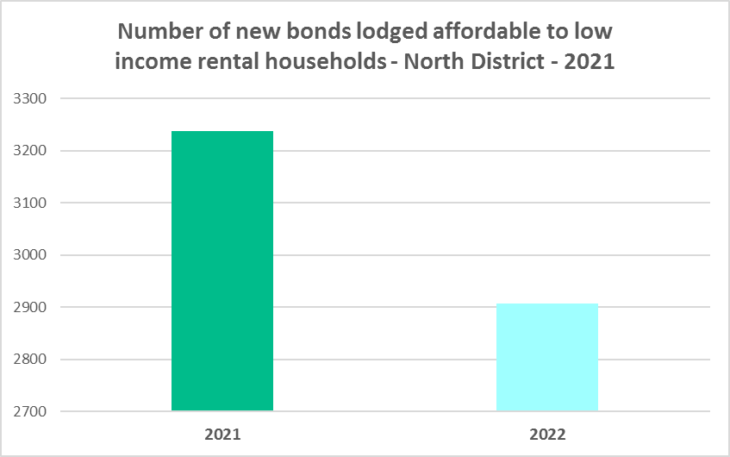

* The next graph compares changes in population, income, renters and housing stress between 2016 and 2021. The graph shows that low income households declined while population has increased between 2016 and 2021 in North District. Yet low income **rental** households have increased as have low income rental households in housing stress. In addition, the number of CRA recipients and the number of CRA recipients in housing stress are growing more quickly than the population generally in North District.
* This comparative data demonstrates the increase in demand and need for affordable rental housing in North District, despite the decline in the number of low income households.

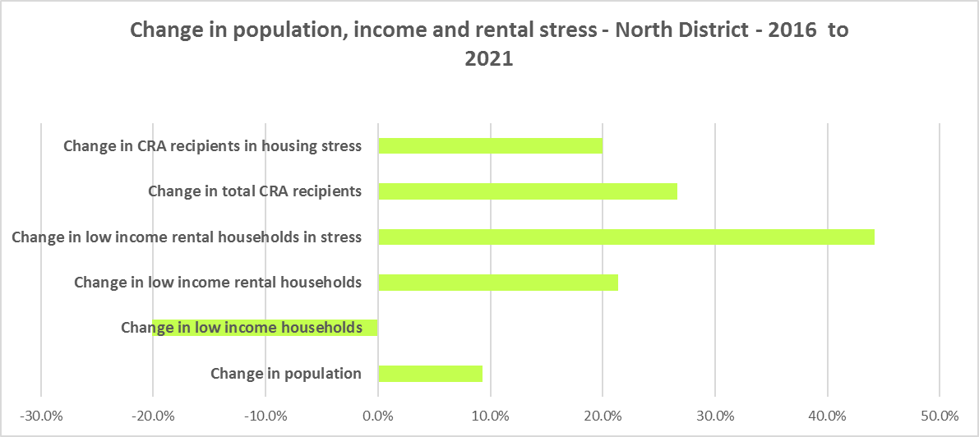

* There is a gap between dwelling size (bedroom numbers) and household size in North District. The graph below compares the number of smaller household types - lone person and couple only – with the amount of studio and one bedroom accommodation available. It is clear that if smaller households wished to live in smaller housing, they have very little opportunity to do so (although some LGAs have a better supply of smaller homes than others). While 49.0% of households in North District are lone person or couple only (above the 45.5% average in Greater Sydney), only 11.6% of dwelling stock is studio or one bedroom (compared to 10.0% in Greater Sydney).
* This mismatch can impact on affordability, with smaller households required to consume more housing than they need or to share because of lack of choice.
* With an aging population and significant affordability issues, it is important to ensure a range of housing and a good bedroom mix to meet current and future demand. The mismatch limits the opportunity for empty nesters or older single households to downsize to smaller more manageable homes within their communities. This can impact on the independence of older residents and their ability to age in place. Increasingly this will be an important issue, as North District is forecast to have an increase in older age cohorts.
* Two bedroom dwellings are the most flexible, given they can suit lone person, couple only, small family and small share households. North District has a slightly higher proportion of two bedroom homes than the Greater Sydney average. An increase in the number and proportion of two bedroom homes is encouraged as it also is helpful for older single and couple households, allowing them to downsize to a more manageable home with an extra bedroom for family, visitors or carers to stay.

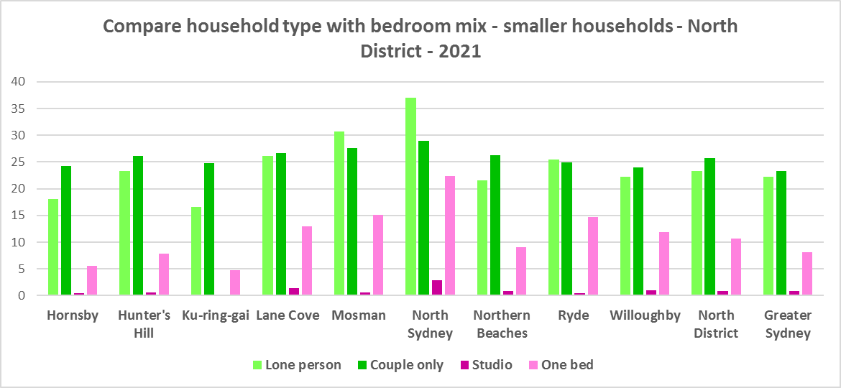

* While there has been an increase in studio and particularly one bedroom homes since the 2016 Census (a total of 7,654 combined), the number is outweighed by the increase in the number of three and four and more bedroom homes (a total of 12,758), as indicated in the graph below. The graph shows there has been a strong increase in two bedroom properties, which helps provide flexibility in housing supply.

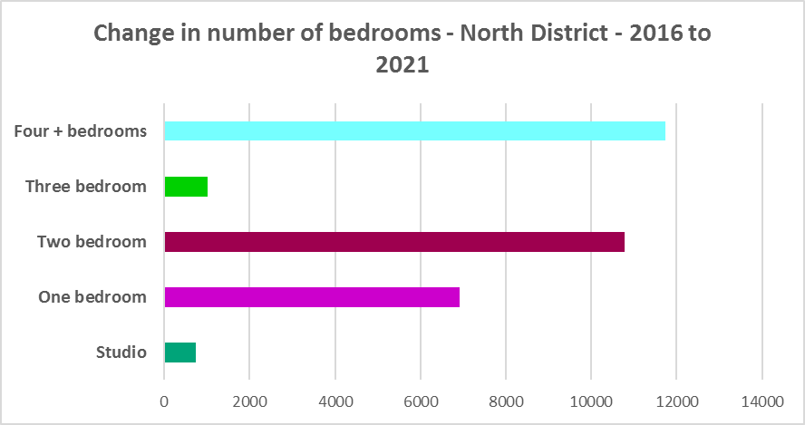

* A proactive stance is required to encourage an increase in studio and one bedroom properties. This is important given that annually the addition of new dwellings represents around 1% of the total dwelling stock – so change occurs very slowly. There is also a need to take into account the impact of alterations and additions to existing stock, for example, adding extra bedrooms to two and three bedroom houses. Continuing to encourage development of two bedroom homes is helpful.
* New generation boarding houses would also help fulfil some of this demand – particularly as they cannot be subdivided and must provide rental accommodation. Note that the NSW Community Housing Industry Association has an Affordable Housing Tool Kit to help deal with community resistance to affordable housing available on their website. They also have a couple of excellent vimeos showcasing new generation boarding house developments and their tenants.
* The next graph compares larger household types – couple family with children, one parent family and group households – with the amount of two, three and four or more bedroom accommodation available. The two graphs comparing household type with bedroom mix demonstrate that North District has a similar bedroom mix to the average for Greater Sydney and that some LGAs in the District have a better match between household size and bedroom number than others. Overall there is a need for more studio and one bedroom homes in particular, as well as two bedroom homes, to offer housing choice to smaller households in North District.

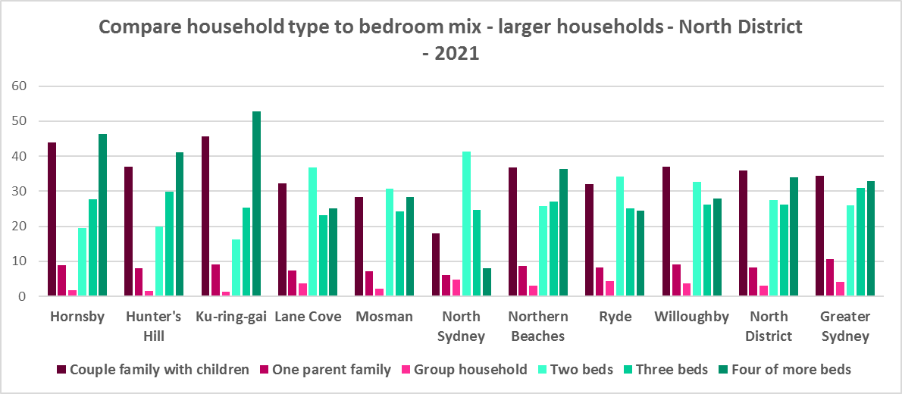

**Who needs affordable housing**

* A wide range of people need affordable housing. Single income earners who fall into the low income category include aged care and disability workers, retail sales assistants, production workers, receptionists and early career child care workers.
* People working in accommodation and food services comprise around 4.9% of the workforce living in North District at the 2021 Census and are amongst the lowest paid workers. Similarly retail trade employs 7.7% of workers living in North District.
* Health care and social assistance employs 12.9% of the workforce living in North District. A 2017 survey of NSW Nurses and Midwives Association (NSWMA) members showed that thirty six per cent of respondents moved home or changed jobs in the previous 12 months because of housing affordability issues.
* For example, households earning $790 per week gross (broadly indicative of a wage for a laundry worker) could afford to pay just $237 per week in rent before being in housing stress. Households earning $960 (broadly indicative of wages for a commercial cleaner, delivery driver and entry level firefighter) could afford to pay just $288 per week in rent before being in housing stress. Households with an income of $1,150 (broadly indicative of the wage for an enrolled nurse, child care worker and ICT support technician) can afford to pay just $345 per week in rent before being in housing stress.
* At a weekly income of $1,450/$1,500 (an indicative wage for an early career Registered Nurse), a household could afford to pay $435 to $450 per week in rent before being in housing stress.
* At December 2022, the median rent for a studio dwelling in North District ranged between $420 per week in North Sydney and $450 per week in Willoughby (note that North Sydney and Willoughby were the only two LGAs in North District with sufficient new bonds lodged to calculate a median rent – indicative of the lack of supply in many of the other North District LGAs); the median rent for a one bedroom home in North District ranged between $425 per week in Hunters Hill and $550 per week in Lane Cove; for a two bedroom home ranged between $525 per week in Hornsby and $750 per week in North Sydney; for a three bedroom home ranged between $700 per week in Hornsby and $1325 in Mosman; and for a four or more bedroom home ranged between $900 per week in Hornsby and $2800 per week in Mosman. Clearly it is extremely difficult for single income lower paid households to afford to rent in North District.
* Single income households in particular are less able to compete in the housing market.
* Increasing numbers of older single women are homeless or at risk of homelessness due to the lack of available affordable rental housing. In fact they are the fastest growing cohort of the homeless population.
* Partnering or collaborating with community housing providers is one effective way to meet some of the local need for appropriate affordable housing. Not for profit community housing providers are owners, managers and developers of affordable rental housing for lower income households and residents with specific housing needs. They work with partners, investors and government to provide housing and deliver support for tenants. For more information about community housing providers, see the NSW Community Housing Industry Association website.

**Additional Data**

Housing data and tables used in this Snapshot are available from the Local Government Housing Kit Database on the Housing NSW website at:

<https://www.facs.nsw.gov.au/resources/nsw-local-government-housing-kit/chapters/local-government-housing-kit-database>

More information on Expected Waiting Times for Public Housing is available on the DCJ/FACS website by region at:

<https://www.facs.nsw.gov.au/housing/help/applying-assistance/expected-waiting-times>

Additional data on social housing dwellings and delivery is available on the FACS website at:

<https://www.facs.nsw.gov.au/resources/statistics/social-housing-residential-dwellings/facs-quarterly-statistics-social-housing-dwellings>

or go straight to the dashboard:

<https://public.tableau.com/app/profile/facs.statistics/viz/Social_Housing_Residential_Dwellings/Dashboard>

and

<https://www.facs.nsw.gov.au/resources/statistics/social-housing-delivery2/interactive-dashboard>

More information about community housing providers is available on the NSW CHIA (Community Housing Industry Association) website:

NSW CHIA Snapshot of the Community Housing Sector in NSW:

<https://communityhousing.org.au/wp-content/uploads/2022/08/Community-Housing-Snapshot-2022.pdf>

Data on community housing properties is available from the NSW CHIA Dashboard at:

<https://communityhousing.org.au/our-impact/data-dashboard/>

CHIA NSW affordable housing tool kit. The Tool Kit is based on extensive research about reasons for community resistance to affordable housing, and effective ways of building support for affordable housing:

https://nswfha-my.sharepoint.com/personal/josha_communityhousing_org_au/_layouts/15/onedrive.aspx?ga=1&id=%2Fpersonal%2Fjosha%5Fcommunityhousing%5Forg%5Fau%2FDocuments%2FAffordable%20Housing%20Toolkit%2FFiles

1. “Technological disruption in private housing markets: the case of AirBnB” *AHURI* October 2018 (Crommelin et al)