**Riverina Murray Region – What’s Happening in the Housing Market?**

This Housing Snapshot looks at aspects of the housing market in the Riverina Murray, particularly from the 2016 Census to the 2021 Census – including rents, vacancy rate, affordable private rental for very low and low income households, rental stress for low income households, number of new bonds lodged affordable to low income households, sales price, purchase affordability for very low and low income households and purchase stress for low income households.

The Riverina Murray region covers twenty local government areas and 114,309 square kilometres, with several regional centres including Albury, Wagga Wagga and Griffith. Historically this region has been more affordable relative to coastal regions within the state, however, the housing market is not uniform across the region. There are significant differences in population growth and decline, as well as rent and purchase price and affordability. The low vacancy rates in the private rental market indicate an undersupply of private rental housing and some LGAs have high proportions of residents in rental stress.

***Housing Market - Rental***

**Rents**

* Looking at all residential rentals combined (houses, units and all bedroom types), clearly median rents have increased across the region, particularly since 2005. However, the period from 2019 to 2022 has been more varied and complex.
* The graph below shows the increase in median rents for all dwellings (including all bedroom categories) in each Central West and Orana LGA from June 1990 to June 2022.

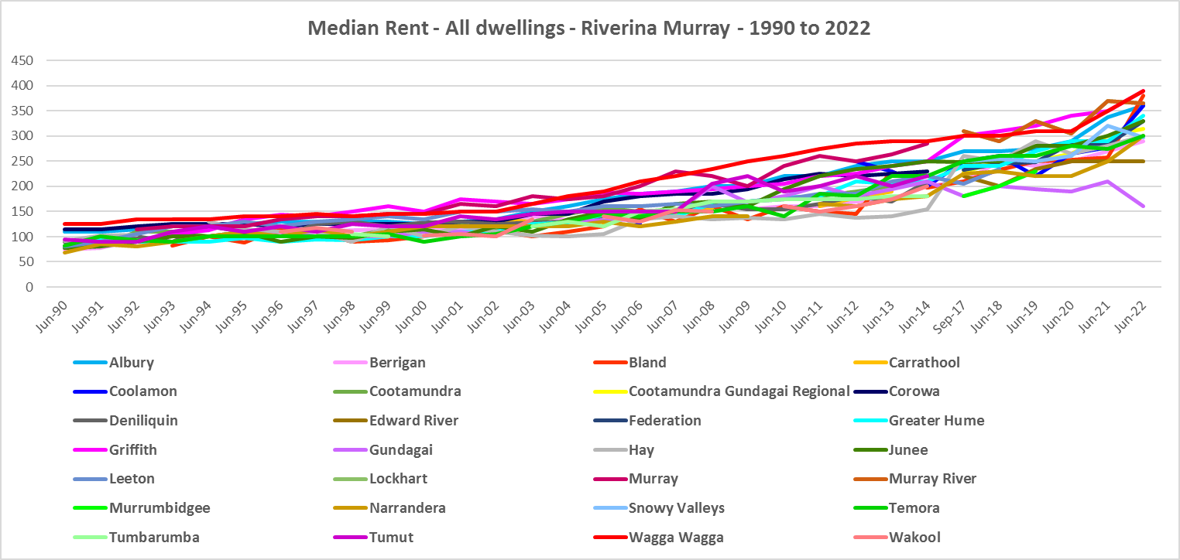

* Between 2017 and 2022 median rents increased across the region, except for Hay which declined by -5.6% and noting insufficient data in Carathool and Coolamon to calculate median rents. In the remaining LGA’s, increases ranged between 19.4% in Murray River and 80.0% in Bland, with the largest increases in dollar terms being in Bland ($168 per week increase between 2017 and 2022), Albury and Greater Hume ($110 per week), Gundagai ($102) and Griffith and Wagga Wagga ($100).
* The table below shows the change in median rents across the Riverina Murray LGAs between September 2017 and September 2022.



* However, the changes to median rents over this period were more nuanced than the table above indicates. Between 2019 and 2020 when Covid lockdowns were introduced, there were generally lower increases, and in some cases decreases in median rents. In this 12 month period, declines in median rents occurred in Albury (-1.3%), Berrigan (-17.6%), Snowy Valleys(-1.5%) and Wagga Wagga (-1.7%) for four bedroom homes; in Greater Hume (-1.8%), Junee (-3.4%), Leeton (-5.0%), Narrandera (-2.0%) and Wagga Wagga (-3.0%) for three bedroom homes; and in Murray River (-11.5%) and Snowy Valleys (-4.3%) for two bedroom homes.
* Nevertheless, over the same period Edward River experienced strong median rental increases particularly for one (16.7%) and two bedroom properties (25.0%), along with Lockhart (15.0% for two bed), while some LGAs saw no change at all in median rents in some bedroom categories (Berrigan, Bland, Federation).
* The table below gives the weekly median rents in dollar terms and the changes between 2019 and 2020 for Riverina Murray LGAs.



* Between June 2020 and June 2022 a more varied pattern emerges. While every LGA in Riverina Murray, excepting Berrigan, experienced a decline in median rents for three bedroom homes (ranging between -1.6% in Albury and -17.9% in Edward River), every other bedroom category saw growth in median rents across the region. Increases ranged between 3.2% for two bedroom homes in Griffith to 40.6% for four bedroom homes in Federation.
* At June 2022, median rents for one bedroom homes were highest in Junee ($300 per week); in Griffith for two and three bedroom homes (both $320); and in Wagga Wagga for four or more bedroom homes ($500 per week).



**Vacancy Rate**

* A vacancy rate of 3% is understood to represent a balance between supply and demand in the rental market. Vacancy rates below 3% represent a tight rental market while longer term vacancy rates below 2% represent a chronic undersupply of rental housing.
* According to REINSW data, vacancy rates have been below 3% for Murrumbidgee since January 2012, for Albury since 2017 and for the Riverina since 2018. For much of that time the vacancy rate has been below 2% - indicating a prolonged shortage of rental accommodation.
* At April 2023 the vacancy rate in Albury was 0.8%, for the Riverina was 0.9% and in Murrumbidgee was 1.5%.
* Almost universally, vacancy rates across regional and metropolitan NSW are tight. At April 2023, the vacancy rate in the Central West was 1.6%, in Orana was 1.4%, in the South Coast was 2.1% and in Sydney was 1.3%.
* Anecdotally there are reports of the difficulties tenants are experiencing finding and retaining rental accommodation – strong competition for properties, rent bidding and significant increases in rents, tenants paying too much of their income in rent, facing evictions and potential homelessness.
* The graph below shows the longer term rental vacancy rate in Albury, the Murrumbidgee and Riverina.

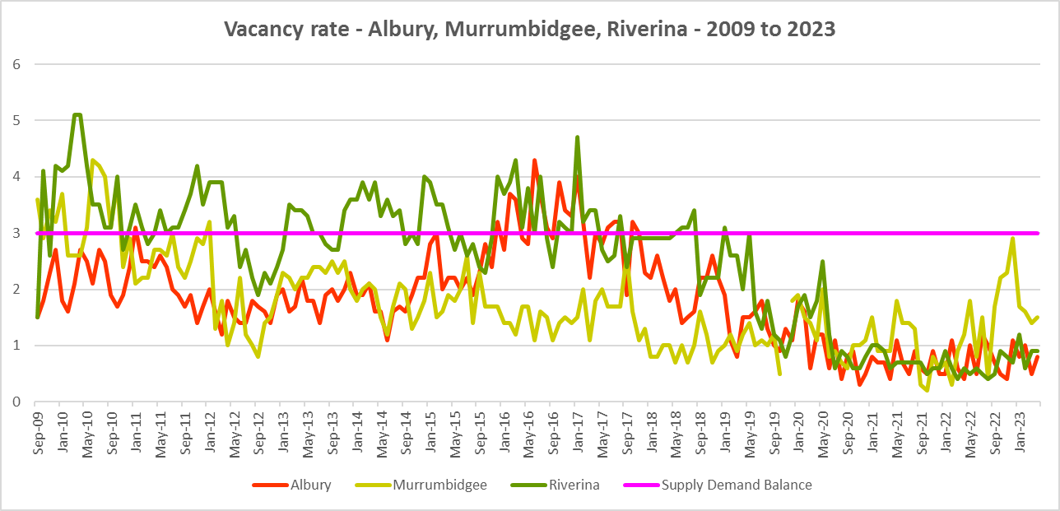

**Affordable Rental**

* Note that floods in late 2022 in the region would have seriously impacted the availability/supply of private rental accommodation. Affordability data for the impacted period is not yet available.
* The general trend across Sydney and NSW has been for a decline in the proportion of rental stock which is affordable for very low, low and moderate income earners.
* Generally, this has also been the trend in the Riverina Murray, although along with elsewhere in NSW, there were more complex factors at play between 2019 and 2022.
* Across the Rest of NSW, the proportion of affordable rental for very low income households stayed at the 2018 level of 22.0% for 2019, improved slightly to 21.7% in 2020 and again to 21.9% in 2021 then declined in line with the longer term trend to 17.0% in 2022.
* In the Riverina Murray this pattern was more varied. Between 2018 and 2019 rental affordability for very low income households improved in Albury, Berrigan, Griffith, Snowy Valleys and Wagga Wagga and declined in Federation, Greater Hume, Gundagai-Cootamundra, Leeton, Murray River and Narrandera.
* Between 2019 and 2020 the proportion affordable for rental by very low income households declined in Albury, Federation, Greater Hume, Griffith and Snowy Valleys and improved in Berrigan, Gundagai-Cootamundra, Leeton, Murray River, Narrandera and Wagga Wagga.
* Between 2020 and 2021 rental affordability improved in Federation, Griffith, Leeton and Temora and declined in Albury, Berrigan, Gundagai-Cootamundra, Junee, Murray River, Narrandera, Snowy Valleys and Wagga Wagga.
* Between 2021 and 2022 rental affordability for very low income households declined in Albury, Berrigan, Federation, Griffith, Gundagai-Cootamundra, Leeton, Narrandera, Temora and Wagga Wagga and improved in Junee, Murray River and Snowy Valleys.
* At June 2022, none of the Riverina Murray LGAs had a lower proportion of affordable rental for very low income households than the average of 17.0% for the Rest of NSW. Griffith had the lowest proportion in the region with 20.5%, followed by Wagga Wagga with 25.4% and Albury with 30.9%.
* The table and graph below show the change in the proportion of private rental accommodation affordable to **very low income** households in the Riverina Murray between 2017 and 2022. Note there are not always sufficient new bonds lodged in a local government area to reliably calculate the proportion – so no data will be recorded where this is the case and there are a few LGAs missing from the table and graph.

Proportion private rental affordable for very low income households

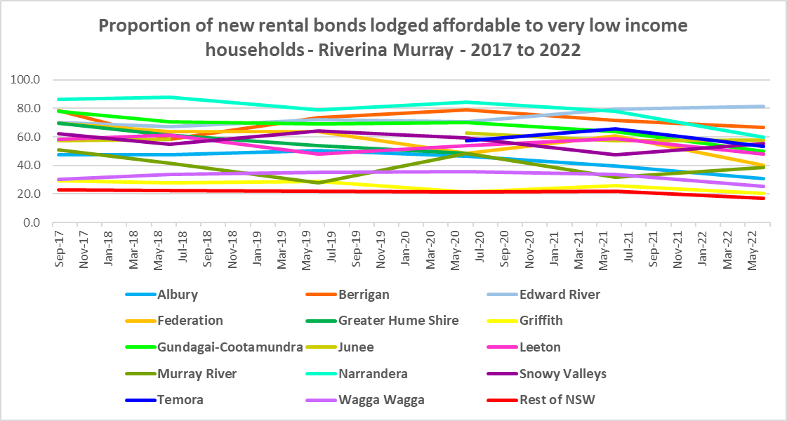

* The proportion of rental affordable for **low income** households has declined recently in every Riverina Murray LGA (except Edward River) compared with 2017.
* However, between 2018 and 2020 the proportion of rental affordable for low income households increased gently from 54.1% to 55.2% between 2018 and 2020 and then declined again to 45.4% in June 2022 in the Rest of NSW.
* Again the picture in the Riverina Murray was more varied.
* Albury, Junee, Leeton, Murray River, Narrandera and Wagga Wagga have a lower proportion of affordable private rental in 2022 than in 2018 (and for Temora than in 2020), but experienced rises and falls over that time frame rather than a continuous decline.
* Berrigan, Edward River and Snowy Valleys actually have a higher proportion of private rental affordable to low income households in 2022 than in 2018 while there are data gaps for the remaining LGAs.
* None of the Riverina Murray LGAs have a lower proportion of affordable private rental for low income households than the Rest of NSW average of 45.3% at June 2022. Wagga Wagga has the lowest proportion with 66.7%, followed by Murray River with 72.6% and Albury with 77.5%.
* The table and graph below show the change in the proportion of private rental accommodation affordable to **low income** households in Riverina Murray between 2017 and 2022.

Proportion private rental affordable for low income households



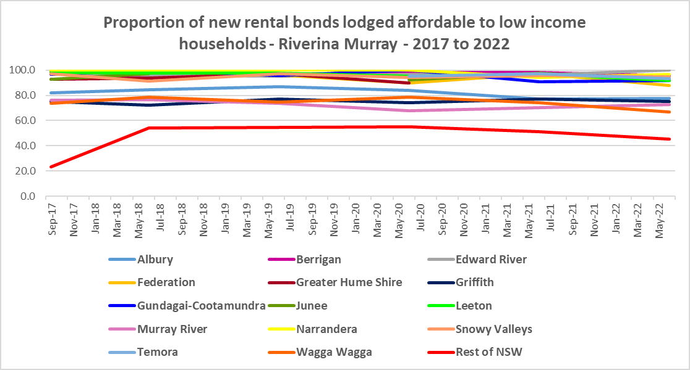

* The University of Sydney Urban Housing Lab undertook a study and prepared a report for the Australian Coastal Councils on short term holiday rentals: “Planning responses to online short term holiday rental platforms” - Research Project for Australian Coastal Councils Association Inc. September 2018 by Nicole Gurran, Yuting Zhang, Pranita Shrestha, Catherine Gilbert.
* The study found (p7) “that there has been a rapid growth in online holiday rental listings overall and in coastal Australia in particular. Since Airbnb was launched in Australia, the number of listings has risen to over 130,000 properties, amounting to 3.5% of rental accommodation.
* This is impacting communities in a number of ways – by increasing competition for purchase for investment in Airbnb properties, purchase prices are increasing as are rents. This impacts both home purchasers and long term renters, with evidence of lower income renters being priced out of some communities.
* More recently, research by SQM showed that between July 2019 and July 2020 Hay had a 100% increase in listings of short term rentals, Narrandera had a 29% increase, Berrigan 10%, Tumut 2%, a decline of -8% in Wagga Wagga, -10% in Albury, -12% in Griffith, -17% in Snowy River, -20% in Gundagai-Cootamundra and -37% in Greater Hume.
* Since 2020 it is likely that Airbnb listings have picked up again in the Riverina Murray, except in those areas hit by floods.

**Rental Stress**

* Households regarded as being in rental stress are renting in the private rental market and paying more than 30% of their income in rent. Lower income households in rental stress will struggle to pay for other essential household costs, such as medical or educational expenses, food, transport and energy costs.
* At June 2021 the proportion of very low income households in rental stress in the Rest of NSW (that is, excluding Sydney) was 91.7%. Within the Riverina Murray region, the average was 86.3%, with the proportion varying from 91.8% in Albury to 64.6% in Bland.
* Albury was the only Riverina Murray LGA which had a higher proportion of very low income households in rental stress than the average for the Rest of NSW.
* For the Rest of NSW at 2021 the proportion of low income households in rental was 68.3%, with Riverina Murray on average much lower with 49.0%. Across the region the proportion of low income households in stress ranged from 56.9% in Wagga Wagga to 20.4% in Bland. Wagga Wagga and Albury (56.3%) were the only two LGAs in the region with a higher proportion of low income households in rental stress than the Rest of NSW.
* Between 2016 and 2021 only three Riverina Murray LGAs experienced a decline in the proportion of **very low income** rental households in stress (Bland, Hay and Wagga Wagga), while all other LGAs in the region saw an increase, in line with the average for the Rest of NSW.
* For **low income** rental households between 2016 and 2021, the proportion in stress increased in every Riverina Murray LGA, in line with the average for the Rest of NSW, excepting Bland and Carathool.
* Below is a graph of the proportion of very low and low income households in rental stress in each Central West and Orana LGA at 2021 and a table showing the change in the proportion of very low and low income households in stress between 2016 and 2021.

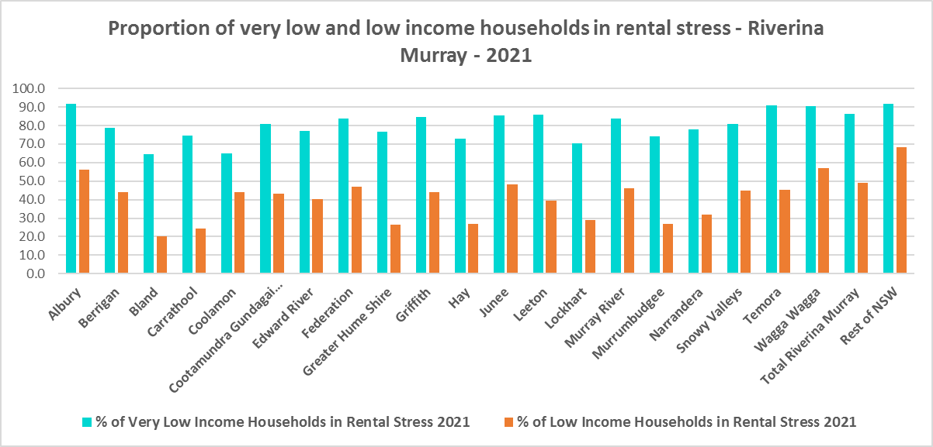

* At June 2021 there were 6,554 very low and low income renters in housing stress across the Riverina Murray. Albury had the highest number of very low and low income renters in stress with 1,933, followed by Wagga Wagga with 1,772, then Griffith with 460.
* Below is a table comparing the proportion of very low and low income households in rental stress in Riverina Murray and the Rest of NSW in 2016 and in 2021.



* Over the same period (2016 to 2021) that the Region experienced an increase in the proportion of very low and low income households in rental stress, the actual numbers in stress for very low income households have declined in the region.
* In Carathool the number of **very low income** households in stress stayed unchanged, while the number increased in Gundagai-Cootamundra and Wagga Wagga but declined in every other Riverina Murray LGA.
* Only Bland and Murrumbidgee experienced a decline in the number of **low income** households in rental stress over the same period, while every other LGA had an increase.
* The next table shows the change in the number of very low and low income households in rental stress at 2016 and at 2021.
* Again Covid has had an impact on the rental market and on tenants. A look at CRA (Commonwealth Rent Assistance) recipients in housing stress gives some further information on what has been happening with lower income households in rental stress over this time frame.



**Commonwealth Rent Assistance**

* In line with other parts of NSW, between 2016 and 2020, the total number of CRA recipients in the Riverina Murray increased significantly, while the number in stress actually declined. However, between 2020 and 2021 the number of CRA recipients declined while the number in stress increased.
* The number of CRA recipients in housing stress has increased from the June 2020 figures as the temporary Coronavirus Supplement ended on 31 March 2021.
* The Coronavirus Supplement was $550 per fortnight for new and existing recipients of JobSeeker Payment, Parenting Payment, Youth Allowance for jobseekers, Farm Household Allowance and Special Benefit. The temporary supplement almost doubled the maximum payment rate for a JobSeeker Payment recipient. Hence it made rent more affordable for some CRA recipients in June 2020 and resulted in a lower proportion of CRA recipients in rental stress than usual.
* Since the end of Covid restrictions, the number of people in employment has increased, so fewer people are relying on rent assistance from the Commonwealth.
* The two graphs below clearly demonstrate this experience in the Riverina Murray.

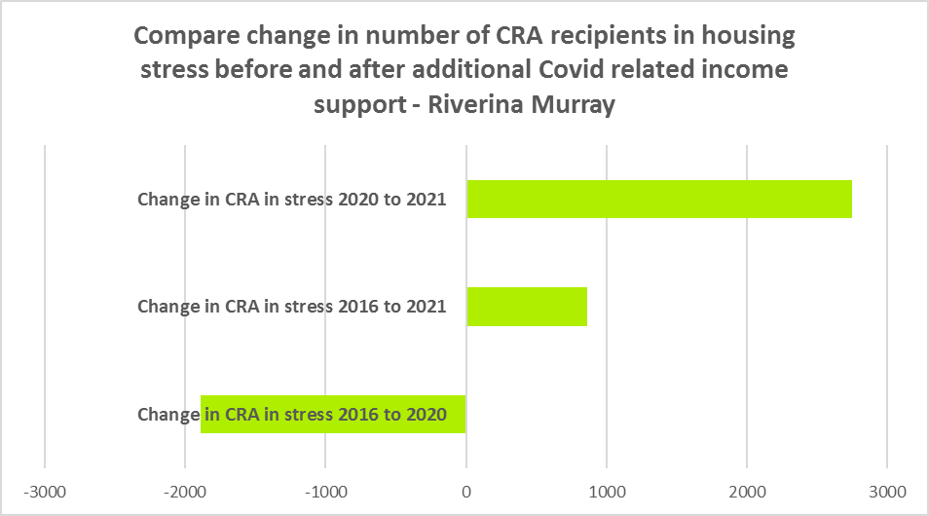

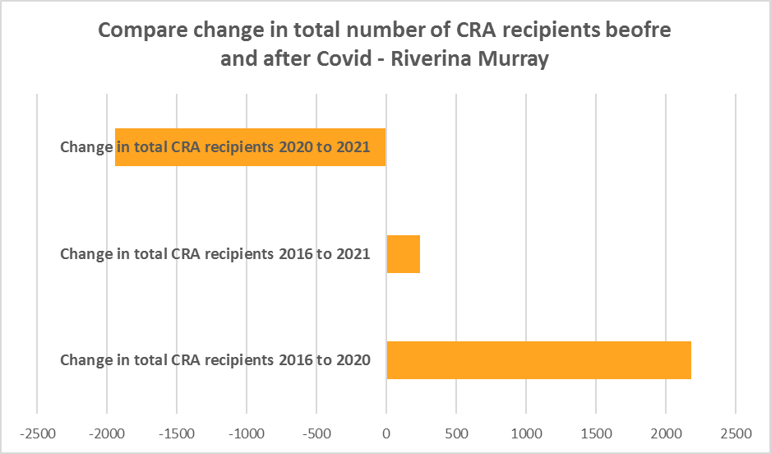

* The table below shows the number and proportion of tenants in the Riverina Murray region who are in the private rental market, are in receipt of Commonwealth Rent Assistance, and even with this additional income support, are in housing stress.
* There were a total of 5,697 tenants in receipt of CRA and in housing stress across the region in 2021, up from 4,837 in 2016. In 2016, 26.4% of CRA recipients in the Riverina Murray were in stress, increasing to 30.7% in 2021.
* This indicates that this region is becoming less affordable for lower income tenants.
* The Riverina Murray region (30.7%) has a lower proportion of CRA recipients in housing stress than the Rest of NSW average (39.2%). No LGA in the region has a higher proportion of CRA recipients in housing stress than the Rest of NSW average. Wagga Wagga has the highest proportion of CRA recipients in housing stress in the region with 38.8%, followed by Albury with 34.5% and Griffith with 31.5%.



**Loss of Affordable Housing Stock**

* DCJ has calculated the number of new bonds lodged with the Rental Bond Board that were affordable to low income earners in the Riverina Murray 2017, 2021 and 2022. The region experienced a significant decline in affordable bonds lodged, and consequently loss of affordable housing between 2017 and 2022 – with -600 or -29,1% fewer affordable bonds lodged.
* The table below shows the number of new bonds lodged that were affordable to low income households (including very low income households) in 2017, 2021 and 2022 in each of the Riverina Murray LGAs as well as the total for the Region.
* It is clear from the table that Albury (-699), Wagga Wagga (-381), Griffith (-355) had the largest numeric losses. Snowy Valleys (-242), Edward River (-222) and Leeton (-195) also lost a significant number of affordable dwellings.
* Proportionately, Carathool experienced the largest decline – losing 100% of affordable rental, followed by Bland (84.4%), Hay (75.0%), Edward River (74.0%), Temora (73.2%), Narrandera (73.1%), Griffith (71.6%) and Snowy Valleys (70.8%).

Number of affordable rental properties (new bonds lodged) affordable to low income households



***Housing Market - Purchase***

**Sales Price**

* The following graph for the median sales price trend for all dwellings by LGA shows that there has been some variation in the median sales price trends over the period from 1991 to 2022 with strong recent increases (since 2020).
* Wagga Wagga, Albury, Griffith and Murray River have consistently had the highest median sales prices in the region. At December 2022, the median sales price in Albury was $519,000, in Griffith was $570,000, in Murray River was $453,000 and in Wagga Wagga was $559,000.

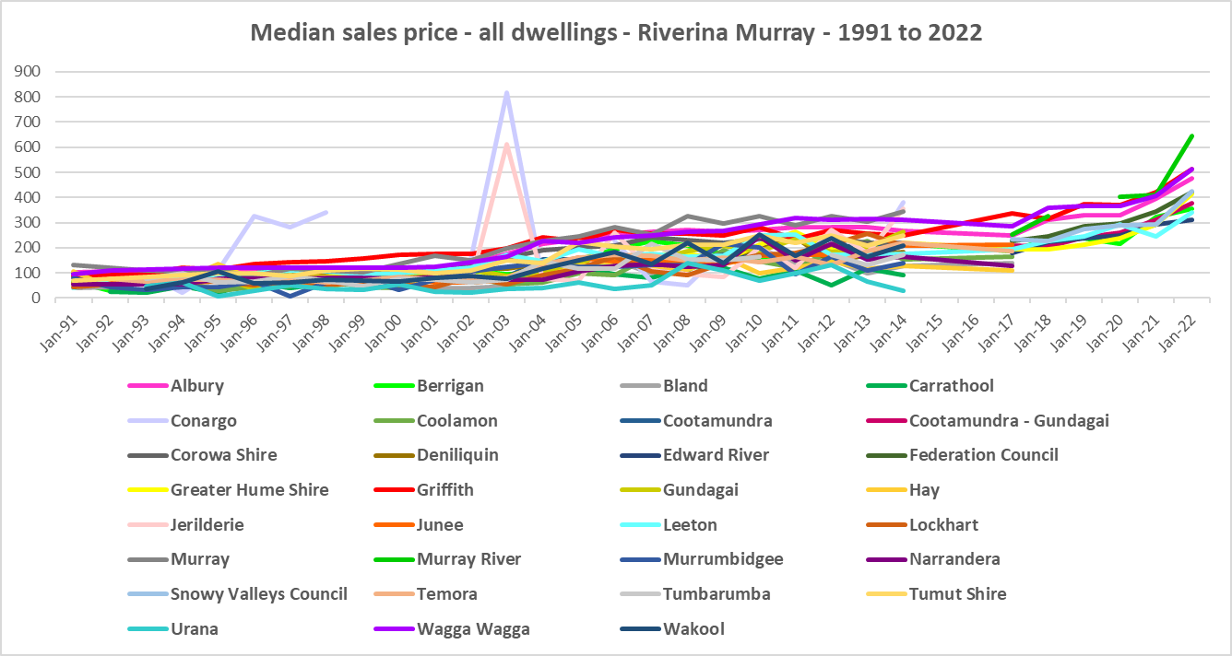

* The table below gives the median sales price for all dwellings by LGA for the Riverina Murray from September 2017 to September 2022. There was strong growth in the median sales price in most LGAs, with the highest proportionate increases in Temora (100%), Edward River (84.2%), Coolamon (78.0%), Cootamundra-Gundagai (77.2%) and Greater Hume (71.1%). The greatest increases in dollar terms were in Temora ($200,000), Griffith ($180,000), Albury ($176,000), Federation ($170,000) and Edward River and Wagga Wagga (both $160.000).
* Note that there were insufficient sales in some LGAs to calculate a median sales price.



* However, between 2019 and 2022 there were clear impacts from Covid, creating more complex changes in the market, as the table below demonstrates.
* Between March 2019 and 2020 median house prices experienced comparatively low growth in most LGAs in the region, with the median dwelling price change varying between -8.9% in Berrigan and 19.7% in Leeton. Most LGAs (with sufficient sales data to calculate the median) seeing much smaller increases than Leeton. In dollar terms, changes in the median sale price ranged between a decline of -$21,000 in Berrigan and an increase of $48,000 in Leeton.
* Between March 2021 and March 2022 there was strong growth in median house prices in every Riverina Murray LGA. Increases in the median sales price for houses ranged between 57.3% in Murray River and 6.1% in Edward River. The biggest increase in dollar terms occurring in Murray River ($235,000), followed by Snowy Valleys ($132,000), Greater Hume ($118,000) and Wagga Wagga ($103,000), while the smallest increase was in Leeton ($18,000).



* At March 2023, the median sales price for houses is highest in Murray River ($637,000), Griffith ($546,000), Wagga Wagga ($539,000) and Albury ($531,000).

**Purchase Affordability**

* While the region is generally more affordable than the average for the Rest of NSW, purchase affordability for very low income earners in the Riverina Murray region has declined since 2017 and in some LGAs for low income households as well.
* Both Berrigan and Griffith had a lower proportion of sales affordable for purchase by very low income households at June 2021 than the Rest of NSW average of 7.5%, while Albury was just above with 9.3% and the remainder of LGAs in the region were more affordable.
* The graph and table below show the proportion of sales affordable for purchase by very low income households for the Riverina Murray LGAs from 2017 to 2021. Note that many LGAs in the region had insufficient sales to determine affordability.

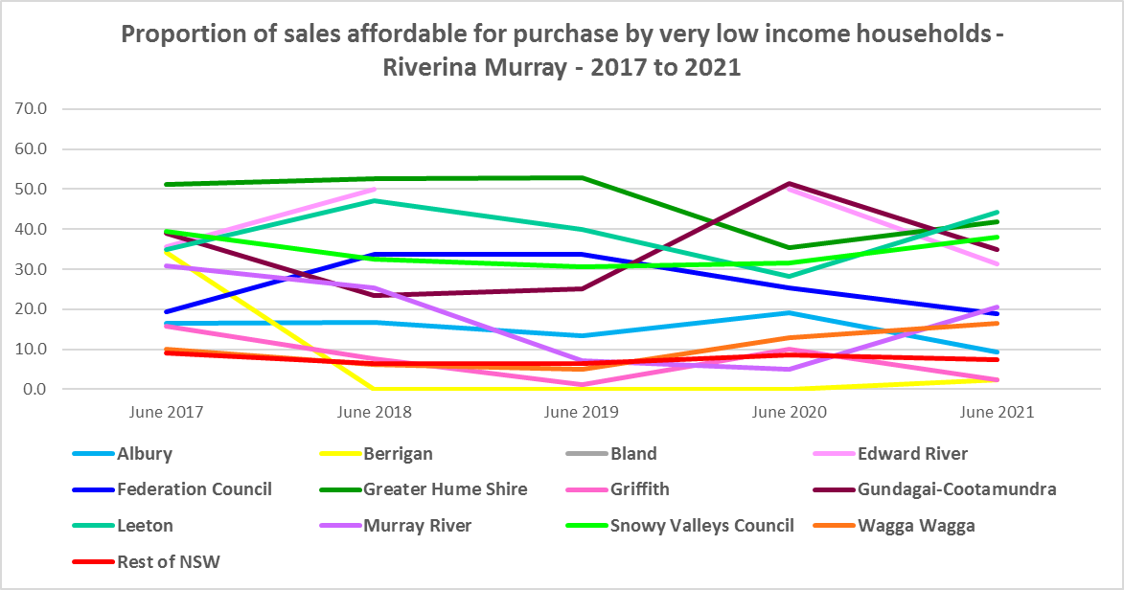

Proportion of sales affordable to very low income households



* All the Riverina Murray LGAs have a higher proportion of sales affordable for purchase by low income households at June 2021 than the average for the Rest of NSW of 23.8%, with the exception of Berrigan with 15.9% and Griffith was just above with 25.3%.
* The graph and table below show the proportion of sales affordable for purchase by low income households for the Riverina Murray LGAs from 2017 to 2021. Again many LGAs in the region had insufficient sales to determine affordability.

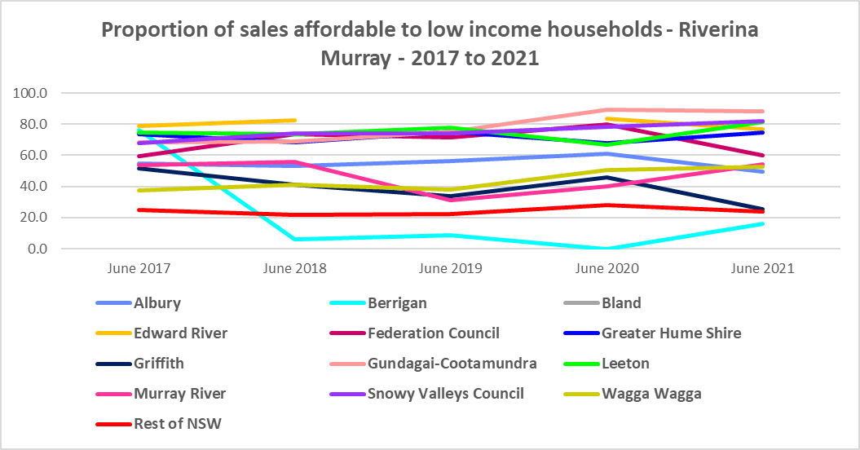

Proportion of sales affordable to low income households

|  |  |  |  |  |  |
| --- | --- | --- | --- | --- | --- |
| **Area** | **June 2017** | **June 2018** | **June 2019** | **June 2020** | **June 2021** |
| Albury | 54.9 | 52.9 | 56.4 | 60.8 | 49.6 |
| Berrigan | 76.3 | 5.9 | 8.7 | 0.0 | 15.9 |
| Bland | 81.5 |  |  |  | 100.0 |
| Edward River | 78.6 | 82.5 |  | 83.3 | 76.5 |
| Federation Council | 59.6 | 73.5 | 71.6 | 79.7 | 60.0 |
| Greater Hume Shire | 73.3 | 68.4 | 75.0 | 67.6 | 74.5 |
| Griffith | 51.4 | 41.3 | 33.8 | 45.7 | 25.3 |
| Gundagai-Cootamundra | 68.5 | 68.6 | 75.0 | 89.2 | 88.3 |
| Leeton | 74.4 | 73.6 | 78.0 | 66.7 | 81.4 |
| Murray River | 53.8 | 55.9 | 31.0 | 40.0 | 54.4 |
| Snowy Valleys Council | 67.6 | 74.3 | 74.2 | 78.3 | 81.8 |
| Wagga Wagga | 37.4 | 41.0 | 38.2 | 50.4 | 52.8 |
| **Rest of NSW** | 24.7 | 21.9 | 22.5 | 28.0 | 23.8 |

**Purchase Stress**

* In 2021 there were 1,968 very low and low income purchasers in housing stress across the Riverina Murray, representing 36.5% of all very low and low income purchasers in the region. This is a lower proportion than the Rest of NSW average of 43.9%.
* Murray River had the highest proportion with 42.0%, closely followed by Wagga Wagga with 41.1%, Griffith with 40.9% and Albury with 40.1%.
* Albury and Wagga Wagga had the highest number in stress, both with 355, followed by Griffith with 135.

Proportion of very low and low income purchasers in stress at 2021



* However the number of very low and low income purchasers in stress is significantly lower than the number of very low and low income renters in stress in the region, as the graph below demonstrates.

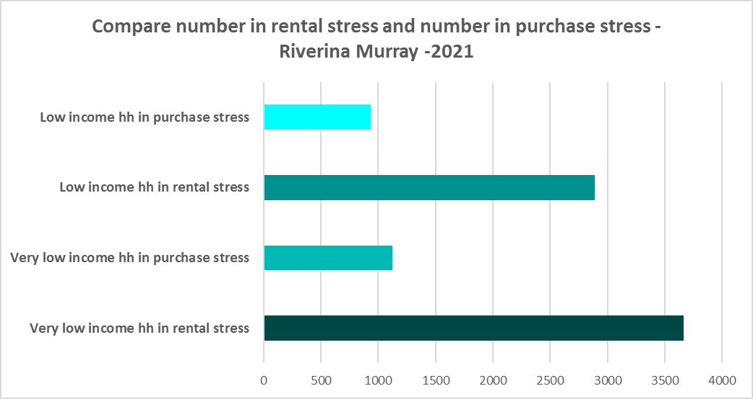

**Additional Data**

Additional data on rents and sale prices, including both current and historical data, is available from the Rent and Sales Report and the interactive Dashboard on the Housing NSW website at:

<https://www.facs.nsw.gov.au/resources/statistics/rent-and-sales/dashboard>

More detailed housing data and tables used in this Snapshot are available from the Local Government Housing Kit Database on the Housing NSW website at:

<https://www.facs.nsw.gov.au/resources/nsw-local-government-housing-kit/chapters/local-government-housing-kit-database>

More information on vacancy rates is available from the Real Estate Institute of NSW website:

<https://www.reinsw.com.au/Web/Web/Members/Property_data/Vacancy_Rates_Survey.aspx>

The Rental Affordability Index is at

<https://sgsep.com.au/projects/rental-affordability-index>