# **Eastern City District – What’s the Housing Demand**

This Housing Snapshot looks at aspects of housing demand, particularly from the 2016 Census to the 2021 Census – including population, age profile, household type, household size, income (change in low, moderate and high income households and low income rental households), homelessness and people with disability.

There have been challenges across Australia and in this district since the 2016 Census, including the pandemic - which have impacted the community and the demand for housing. Subsequent cost of living pressures, including inflation, rising interest rates and low wage growth have impacted affordability and access to housing. In addition increased housing demand due to record immigration and inadequate housing supply have led to tightening of the rental market and further impacted the demand for housing.

.

## Population

* Changes in population will impact on the demand for housing.
* Between 2016 and 2021, the population of the Eastern City District grew by 2.8% or 27,651, from 973,323 to 1,000,974.
* However, this figure masks considerable variation in population change amongst the LGAs of the District.
* Changes in population between 2016 and 2021 ranged from a 13.1% increase in Strathfield to a -4.6% decline in Randwick. Woollahra (-1.4%) was the only other Eastern City LGA to lose population over this period.
* In terms of numbers, Bayside had the largest increase with an additional 19,123 people, followed by Strathfield with 5,280. Sydney has the highest population (211,632) in the region, followed by Inner West (182,818) and Bayside (175,184) while Burwood has the smallest population with 41,201.
* Note that in numeric terms, Randwick had the largest population decline of any LGA in the state between 2016 and 2021, with Woollahra in third place behind Walgett.
* The Department of Planning and Environment have prepared population projections for every LGA in the district, however only Burwood (1.74% per annum) and Sydney (1.07%) are forecast to have a higher growth rate than the average for NSW of 0.95% per annum.
* Numerically the largest increase in population forecast to 2041 is predicted for Sydney (56,891) followed by Bayside (18,782), Burwood (16,977) and Randwick (15,255).
* The table below shows the population change for each Eastern City LGA and the district as a whole from 2016 to 2021, using ABS Census data.



## Age

* The age profile of the region and particularly each LGA will impact on housing need and demand, including number of bedrooms, affordability, location and dwelling type.
* The median age of the population of the Eastern City LGAs at the 2021 Census ranges between 33 years (Strathfield) and 41 (Woollahra). Burwood and Sydney (34) have the next youngest median age and Canada Bay (39) has the next oldest. This compares with the median age for Greater Sydney of 37 years. The table below gives the median age for all the Eastern City LGAs and Greater Sydney.



* There is a similarity in the age profiles of the Eastern City LGAs.
* All the Eastern City LGAs have a lower proportion of 0-4, 5-14 and 15-19 year olds than the Greater Sydney average. They also all have a higher proportion of 25-34 year olds than the Greater Sydney average.
* However, there are also some differences in their age profiles, as suggested by the range of median age in the District.
  + Bayside, Burwood, Randwick, Strathfield and Sydney have higher proportions of 20-24 year olds than the Greater Sydney average;
  + Bayside, Canada Bay, Inner West, Randwick, Sydney and Waverley have higher proportions of 35-44 year olds than the Greater Sydney average;
  + Canada Bay, Inner West, Randwick, Waverley and Woollahra have higher proportions of 45-54 year olds than the Greater Sydney average;
  + Canada Bay and Woollahra have higher proportions of 55-64 and 65-74 year olds than the Greater Sydney average;
  + Bayside, Burwood, Canada Bay, Randwick and Woollahra have higher proportions of 75-84 and 85+ year olds than the Greater Sydney average.
* The graph below shows the proportion of the population in each key age cohort in the Eastern City LGAs as well as the District and Greater Sydney.

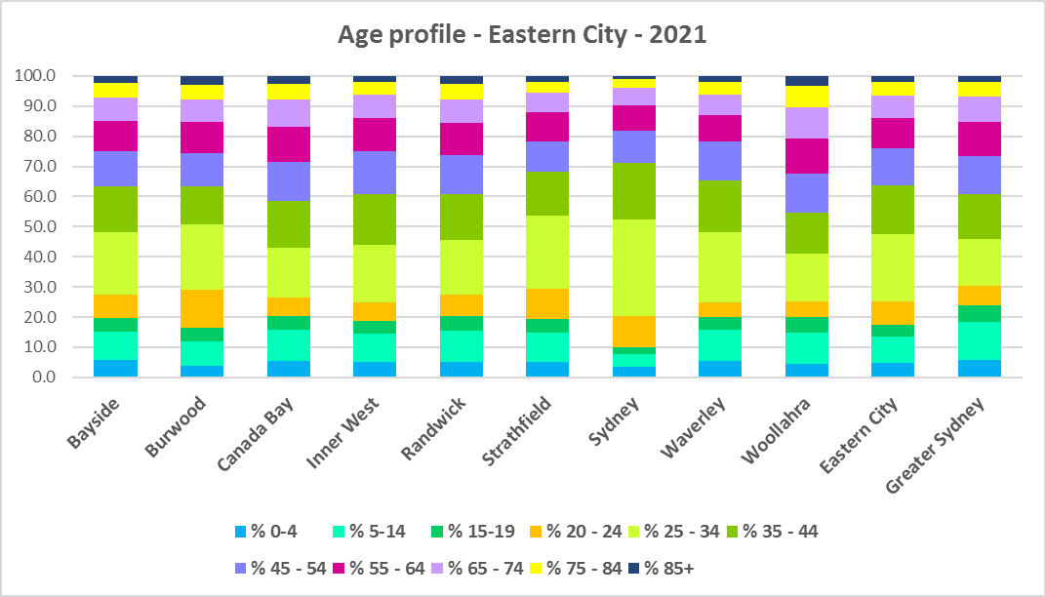

* The table below gives more detail of the breakdown of age cohorts by LGA, for the Eastern City District and for Greater Sydney.



* The Department of Planning and Environment forecast increases in residents aged over 65 to 2041 in every Eastern City LGA.
* The Department also projects an increase in younger age groups in Strathfield and Sydney and no change in younger age groups in all the other LGAs in the District.
* The diversity of age groups requires a range of different housing to meet the needs of the community throughout the housing life cycle. However, the higher median age and higher proportions of older age cohorts in many of the Eastern City LGAs, indicates that there is a need for housing to suit older residents. Increasingly this will be the case in all the Eastern City LGAs as the number in older age groups grows.
* As the Australian Institute for Health and Welfare (AIHW) note:

Many older Australians prefer to age in place, meaning they wish to stay in their local home or community. However, their capacity to do so can be influenced by:

* + the appropriateness and quality of their home (for example, size, layout)
  + their ability to modify their home to suit their functional requirements
  + the cost and availability of suitable housing
  + their need for formal care and assistance
  + their proximity to services and social support.
* Although the majority of older Australians own their own home, this number is declining. About 15% of older Australians are renters. These people are generally a highly vulnerable and economically disadvantaged group, particularly single person households, with older women being the fastest growing demographic of people experiencing homelessness. There is therefore a need for more adaptable, accessible dwellings, well located, secure, low maintenance and affordable to meet the needs of seniors and frail aged in particular, within their communities. Those most in need are households in the private rental market, who struggle to afford housing on an Aged Pension or inadequate superannuation. (Source: "Housing Decisions of Older Australians" Productivity Commission December 2015).
* Although the proportions of low income households are not high in this District, the actual numbers are significant. Therefore affordability is a key issue for all age groups, including older residents, and particularly tenants.
* The Australian Housing and Urban Research Institute (AHURI) has undertaken research on “What is the ideal home for older Australians?”
  + “Older Australians and the housing aspirations gap” and
  + “Understanding the housing aspirations of older Australians”
* This research is part of a broader study on “Housing aspirations and constraints for lower income Australians.” AHURI’s research demonstrates that one of the most valued aspects of older residents housing is the location – that the neighbourhood feels safe and secure; that there is good (including walkable) access to services such as health, shopping, recreational amenities, public open space; and that it is close to family and friends.

## Household Type

* A look at household types and average household size gives some insight into the type of housing – particularly number of bedrooms – that is likely to be appropriate to meet the housing needs of the community.
* Household types in the Eastern City vary from the average for Greater Sydney.
* At the 2021 Census in Greater Sydney, couple families with children are the largest household type, comprising 34.4% of all households, followed by couple family without children households (23.3%) and lone person households (22.2%). One parent family households (10.5%), other family households (1.2%), group households (4.0%) and other households (4.3%) make up the remainder.
* Across the Eastern City District, there are generally higher proportions of couple families without children (26.1%), lower proportions of couple families with children (23.0%), higher proportions of lone person households (29.0%), lower proportions of one parent families (7.4%), slightly higher proportions of other family households (1.4%), significantly higher proportions of group households (7.4%) and higher proportions of other households (which include multi-family households) (5.0%).
* However, individual LGAs in the District vary from this pattern.
  + Bayside, Burwood, Canada Bay and Strathfield have couple family with children and couple family without children as the largest two household types, followed by lone person households.
  + Inner West, Sydney, Waverley and Woollahra have lone person and couple family without children as the largest two household types.
  + Randwick has couple family with children and lone person households as the largest two household types.
  + Sydney, Burwood and Waverley have the highest proportions of group households in the District.
  + Sydney, Waverly and Bayside have the highest proportions of other household types in the District.
* There has been a shift in the proportions of different household types since the 2016 Census, with an increase in the proportion of lone person households in Greater Sydney (1.8%) and couple family without children households (0.9%), and declines in the proportion of couple family with children households (-0.9%), other household types (-1.3%) and group households (-0.5%).
* The changes in household type from 2016 to 2021 in Eastern City were a little different, with larger increases in the proportion of lone person (3.6%) and couple family without children households (2.1%), a lesser decline in the proportion of couple family with children households (-0.4%) and larger declines in the proportion of group households (-1.5%) and other household types (-3.6%).
* These changes suggest a need for an increase in smaller dwellings to suit the growing proportion of smaller household types – lone person and couple families without children.
* Changes in individual LGAs are not all in line with this trend:
  + City of Sydney, Waverley and Woollahra all experienced small increases in the proportion of couple families with children.
  + Burwood and Strathfield had increases in the proportion of other family households and in group households.
* This data should be compared with the data on bedroom numbers to determine if there is a good fit between household types and housing stock.
* Although there should be plenty of housing suitable for families of different sizes, there is also a need for a variety of dwellings with different bedroom numbers to suit couples and single person households.
* The graph and table below show the proportion in each key household type for every Eastern City LGA, for the district and for Greater Sydney at the 2021 Census.

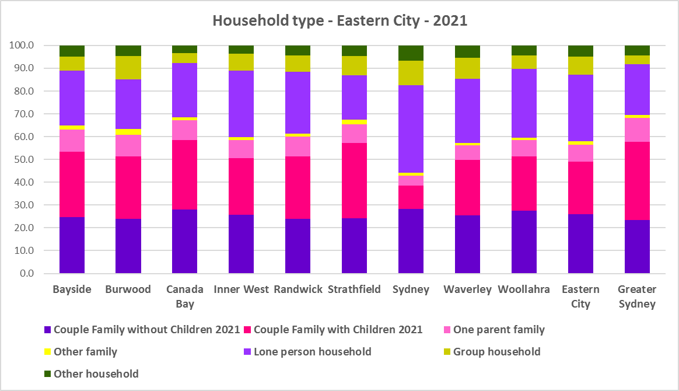



## Household Size

* At the 2021 Census, the average household size for Greater Sydney was 2.7 persons per household – down from 2.8 persons per household in 2016 and the same as 2.7 persons per household in 2011.
* Average household size in the Eastern City ranges from 1.9 persons per household in Sydney to 2.7 persons per household in Strathfield. With the exception of Burwood and Strathfield, Eastern City LGAs have lower average household sizes than the average for Greater Sydney.
* Average household size declined in every Eastern City LGA except for Woollahra between 2016 and 2021, with both Strathfield (3.0 down to 2.7 persons per household) and Burwood (2.9 down to 2.7 persons per household) having the most significant reductions.
* The table below gives the average household size in each of the Eastern City LGAs as well as Greater Sydney for 2011, 2016 and 2021.



## Income

* At the 2021 Census, high income households comprise the largest proportion of all households in Greater Sydney – unlike the Rest of NSW, where low income households predominate.
* Eastern City District has a much higher proportion of high income households (62.6% compared to 49.7%) and much lower proportions of low (23.4% compared to 32.1%) and moderate income households (14.0% compared to 18.2%) than the average for Greater Sydney.
* Burwood is the only LGA in Eastern City which differs from this pattern – having the same proportion of low income households, a higher proportion of moderate income households and lower proportion of high income households than Greater Sydney.
* Waverley has the highest proportion of high income households in Eastern City with 74.1%, followed by Sydney with 68.0%, Woollahra with 67.7% and Inner West with 67.4%.
* The graph and table below show the proportion of low, moderate and high income households in all the Eastern City LGAs, compared with the District and Greater Sydney at the 2021 Census.

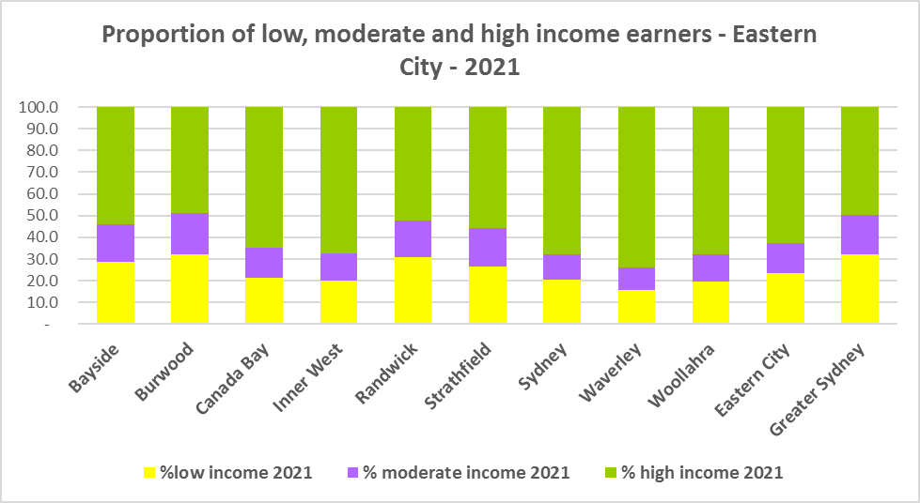



* Between 2016 and 2021 the number of low income households declined in the Eastern City and every LGA except Woollahra, which experienced an increase in the number of low income households.
* Over the same period, the number of moderate income households also declined in the Eastern City as a whole and every LGA in the District.
* The number of high income households increased overall in the District and every LGA in Eastern City.
* The graph below shows the change in the number of low (including very low), moderate and high income households from 2016 to 2021 in the Eastern City District.

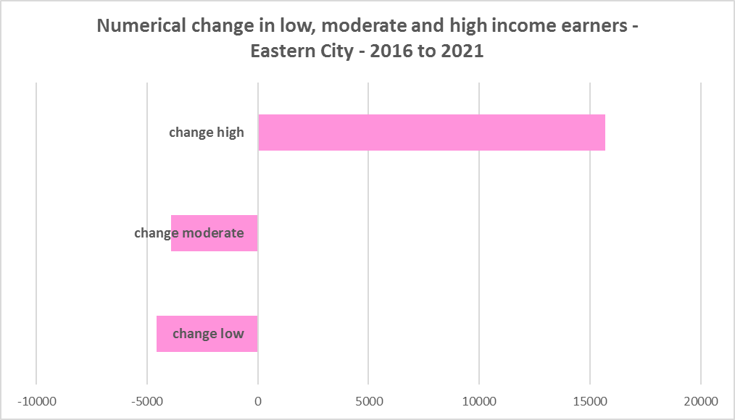

* Along with the decline in the number of low income households between 2016 and 2021, the Eastern City District as a whole (-2.9%) and four of the LGAs (Randwick -35.0%, Canada Bay -16.7%, Waverley -4.1% and Sydney -3.5%) experienced a decline in very low income **rental** households over the same period. However the remaining LGAs all experienced an increase in very low income **rental** households (Bayside 18.1%, Woollahra 16.3%, Strathfield 13.4%, Burwood 10.4% and Inner West 4.2%).
* The District as whole experienced an increase (20.5%) in low income **rental** households over the same period, with Waverley (-4.1%) the only LGA in Eastern City to experience a decline. The remaining LGAs also had an increase in low income **rental** households, ranging from a 59.0% increase in Burwood to a 2.4% increase in Randwick.
* The reduction in very low (-629) and increase in low income renters (3,800) across the Eastern City District underlines the need to consider tenure as well as price point when considering responses to meet housing need. It is likely that the loss of very low income rental households is temporary and due to the additional Commonwealth financial assistance to renters during the pandemic – which has subsequently been discontinued, as explained in the What’s Happening in the Housing Market” snapshot for Eastern City. This has certainly been the case in other parts of the state. It is also likely that the losses indicate that lower income rental households have been priced out of the region and that the loss of long term rental to short term rental or home purchase/ownership has had an impact. The snapshot of What’s Happening in the Housing Market shows the significant decline in the proportion of private rental that is affordable to very low income households.
* The graph below shows the change in the number of very low and low income **renters** between 2016 and 2021 in the Eastern City LGAs. Note that Randwick has experienced a significant loss of very low income renters and considered together with the loss of population – points to the impact of the pandemic on the number of students living in that local government area.

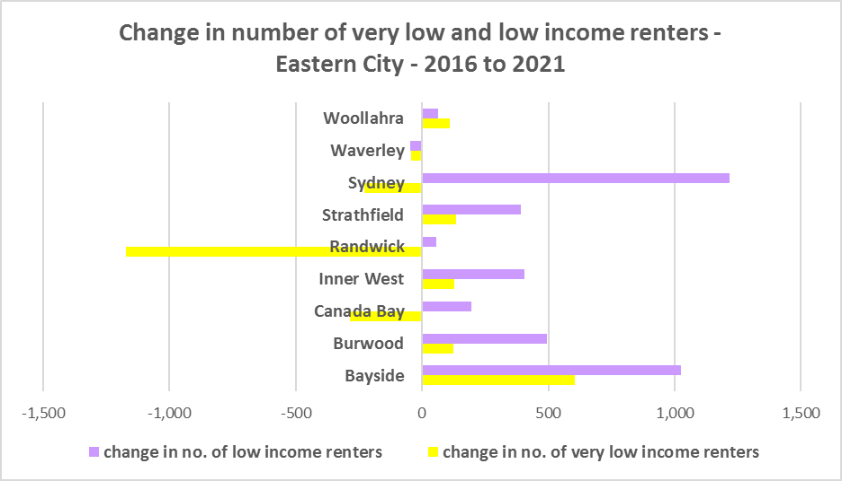

* Every LGA in Eastern City, excepting Bayside and Burwood, have a higher median household weekly income at 2021 than the average for Greater Sydney ($2,077). Woollahra ($3,192) has the highest median weekly income in the District while Burwood has the lowest ($1,867).



## Homelessness

* People experiencing homelessness and those at risk of homelessness are among Australia’s most socially and economically disadvantaged. State, Commonwealth and some local governments fund services to support people who are homeless, or at risk of homelessness. Services are delivered mainly by non–government organisations, some of which specialise in delivering services to specific groups (such as young people or people experiencing domestic violence).
* Inadequate income and inability to access affordable housing are significant contributing factors to homelessness, along with individual factors such as experience of family and domestic violence, ill health and disability.
* The ABS identifies someone as homeless “where they do not have suitable accommodation alternatives and their current living arrangement:
  + Is in a dwelling that is inadequate;
  + Has no tenure or their initial tenure is short and not extendable; or
  + Does not allow them to have control of and access to space for social relations.”
* The ABS uses “six operational groups for presenting estimates of people experiencing homelessness on Census night:
  + People living in improvised dwellings, tents or sleeping out
  + People living in supported accommodation for the homeless
  + People staying temporarily with other households
  + People living in boarding houses
  + People in other temporary lodgings
  + People living in ‘severely’ overcrowded dwellings.”
* The ABS “also compiles estimates from Census data for the following three groups of people who may be marginally housed but are not classified as homeless:
  + People living in other crowded dwellings
  + People in other improvised dwellings
  + People marginally housed in caravan parks.”
* The table below shows ABS 2021 Census data for Eastern City on the homeless and marginally housed.
* Note that due to additional assistance provided during the pandemic, the number of people counted as homeless on Census night in 2021 is lower than at the 2016 Census. Nevertheless, there were 9,585 people counted as homeless in Eastern City at the 2021 Census and a further 4,554 who were counted as marginally housed.
* Of those who were counted as homeless, the largest number were people living in boarding houses (5,530 or 57.7%), followed by people living in severely overcrowded dwellings (2,293 or 23.9%), then people in supported accommodation for the homeless (981 or 10.2%). Of those who were counted as marginally housed, the overwhelming majority were people living in other crowded dwellings (4,582 or 99.4%).
* This clearly indicates the need for more affordable rental housing.



* The 2023 NSW street count, the NSW Government’s fourth annual rough sleeping street count, was completed between 2 February and 27 February 2023.
* Over 300 local organisations either consulted in the planning phase or participated in the delivery of street counts. Organisation which partnered with the Department of Communities and Justice (DCJ) included Community Housing Providers, local councils and Specialist Homelessness Services, as well Aboriginal organisations, Local Health Districts, local community groups, and Police.
* 1,623 people were counted sleeping rough during these street counts, a 34% increase from 2022.
* Street counts took place in more than 350 towns in 76 LGAs, compared to 71 LGAs in 2021 and 65 LGAs in 2020.
* The table below gives the street count results for the Eastern City district locations.



## People with Disability

* According to the Australian Institute of Health and Welfare (AIHW) and data from the 2018 Australian Bureau of Statistics (ABS) Survey of Disability, 18% of people in Australia have disability. Another 22% have a long term health condition but not disability.
* Nearly one third (32%) of people with disability have severe or profound disability. This means needing help with daily self-care, mobility or communication activities, having difficulty understanding or being understood by family or friends, or communicating more easily using sign language or other non-spoken forms of communication.
* The survey data shows:
  + 7.6% of children aged 0–14 have disability
  + 9.3% of people aged 15–24 have disability
  + 13% of people aged 15–64 have disability
  + 50% of people aged 65 and over have disability (ABS 2019b).
* For about 3 in 4 (77%) people with disability, the main type of disability is physical, while for the remaining 1 in 4 (23%), the main type of disability is mental or behavioural.
* Clearly housing is a significant factor in the health and wellbeing of people with disability. The availability of affordable, sustainable and appropriate housing helps people with disability to participate in the social, economic and community aspects of everyday life. Someone without access to affordable, secure and appropriate housing is more likely to experience homelessness, poor health, and lower rates of employment and education.
* While most people with disability live at home in the community (96% in private dwellings), some live in cared accommodation.
* Cared accommodation is usually long term and may be institutional in style, including hospitals, residential aged care, cared components of retirement villages, aged care hostels, psychiatric institutions and group homes for people with disability. The more severe a person’s disability is, the more likely they are to live in cared accommodation and the less likely they are to live in the community.
* There has been a significant shift towards supporting people with disability to live in private dwellings, rather than being in institutional care over recent decades. Largely this has been driven by changes for young people with disability.

## Additional Data

More detailed housing data and tables used in this Snapshot are available from the Local Government Housing Kit Database on the FACS website at:

<https://www.facs.nsw.gov.au/resources/nsw-local-government-housing-kit/chapters/local-government-housing-kit-database>

More information on the housing needs of older Australians and people with disability:

The Australian Institute of Health and Welfare – Older Australians Housing and Living Arrangements on the AIHW website at:

<https://www.aihw.gov.au/reports/older-people/older-australians/contents/housing-and-living-arrangements>

The Australian Institute of Health and Welfare – People with Disability in Australia

<https://www.aihw.gov.au/reports/disability/people-with-disability-in-australia/contents/people-with-disability/prevalence-of-disability>

and relating to housing needs

<https://www.aihw.gov.au/reports/disability/people-with-disability-in-australia/contents/housing>

The Productivity Commission’s report Housing Decisions of Older Australians is at:

<https://www.pc.gov.au/research/completed/housing-decisions-older-australians>

More detailed information on population, household and dwelling projections is available on the Department of Planning and Environment website at:

<https://www.planning.nsw.gov.au/Research-and-Demography/Population-Projections/Projections>

<https://pp.planningportal.nsw.gov.au/populations>

More data on homelessness, specifically homelessness service data is available on the Homelessness NSW website at:

<https://homelessnessnsw.org.au/resource/specialist-homelessness-service-data/>

And from the AIHW website here:

<https://www.aihw.gov.au/reports/australias-welfare/homelessness-and-homelessness-services>

The 2023 Street Count result is at the DCJ/ FACS website here:

<https://www.facs.nsw.gov.au/reforms/homelessness/premiers-priority-to-reduce-street-homelessness/street-count>

Further information on ABS estimation of homelessness is available at the ABS website:

<https://www.abs.gov.au/statistics/people/housing/estimating-homelessness-census/2021>