Team sport and exercise: Participation and interest among older people in NSW

Prepared for NSW Family and Community Services

10 October 2017

Authors: Hannah Wood   
 Hannah Race   
 Nathan Rath

Contact address:Level 13, 168 Walker St

NORTH SYDNEY   
 NSW 2060

Office phone:(02) 9900 5113

Email:[hannah.wood@ipsos.com](mailto:hannah.wood@ipsos.com)

[hannah.race@ipsos.com](mailto:hannah.race@ipsos.com)

[nathan.rath@ipsos.com](mailto:nathan.rath@ipsos.com)

Table of contents

1 Executive Summary 4

Objectives and methodology 4

Key findings 4

2 Background and objectives 9

3 Methodology 9

3.1 Qualitative research 10

3.2 Quantitative research 10

3.3 Interpreting the findings 12

4 Findings 13

4.1 Participation in general physical activity 13

4.1.1 Changes in activity levels over time 14

4.1.2 Benefits of staying active 20

4.1.3 Barriers to staying active 22

4.2 Participation in organised sports 24

4.2.1 Benefits of sport participation 30

4.2.2 Barriers to participation 32

4.3 Sourcing information on participation 36

4.4 Modified sports 38

4.4.1 Interest in modified sports 39

4.4.2 The appeal of modified sports 40

4.4.3 Concerns about modified sports 44

4.4.4 Reactions to specific concepts 47

4.4.5 Local club involvement 47

4.5 Segments 48

4.5.1 Segmentation overview 48

4.5.2 Segment 1: Sports stars 49

4.5.3 Segment 2: Good intentions, but lacking confidence 51

4.5.4 Segment 3: On the fence 52

4.5.5 Segment 4: Inactive and uninterested 54

5 Recommendations and conclusions 56

5.1.1 Current physical activity 56

5.1.2 Participation in organised sport 56

5.1.3 Modified sports 57

5.1.4 Further research 58

6 Appendices 59

6.1 Discussion guide (exploratory focus groups) 59

6.2 Discussion guide (modified sports concept testing) 63

6.3 Questionnaire 67

# Executive Summary

Objectives and methodology

Health and wellbeing is a priority area in the implementation of the NSW Ageing Strategy 2016-2020. A key activity for 2016-17 is the ‘Getting active plan’, a program that will highlight the health, wellbeing and social benefits of regular sport and exercise, to encourage older people to make exercise a part of their routine. This study was commissioned by FACS to gain a better understanding of the appetite for organised sport participation among older people, barriers to participation, and to explore what strategies could be used to increase participation rates.

The research adopted a qualitative-quantitative-qualitative approach. Two exploratory focus groups were conducted, followed by an online survey of n=600 people aged 50 and over, which was followed by another two focus groups that tested some more refined ideas around strategies that may be successful.

Key findings

Physical activity in general

**Over half (53%) of 50-plus year olds believe they are doing less physical activity** than they were five years ago, and this increases among those in their 70s and in regional areas. Fear of injury and loss of confidence have led to this reduction in activity levels. A significant minority (16%) believe they are doing more physical activity than they were five years ago. More time, health scares, and recognition of the increasing importance of activity to stay healthy in old age have been drivers to increased activity among these people.

**Older people are participating in a wide range of physical activities**, with walking (91%), gardening (79%), swimming (44%) and home exercise (37%) being the most common. Given the nature of the activities participated in, most people are doing so on a casual basis (as opposed to being part of a group, team or club).

**The benefits of physical activity are widely recognised**, and sentiment towards exercise is generally positive. The physical health benefits of staying active are perceived to be the main benefit (76%). The mental health benefits (54%) and fun and enjoyment (49%) are also seen as benefits to many. Most feel a sense of achievement after exercising (66%) and wish they were more active (66%). Recognition of the benefits and positivity towards exercise increases among those who have become more active and who currently participate in a sport. For example, 66% of those who currently play a sport recognise the social benefits of physical activity, as opposed to 22% of those who do not play a sport (overall, 30% recognise the social benefits of physical activity. This compares to 67% recognising the social benefits of organised sport, discussed below).

**For most older people, there are no major barriers to participation in physical activity**. Exercise feeling like a chore (32%), a lack of time (24%) and competing priorities (20%) are all factors that make it difficult for some older people to exercise, however none of these present a barrier for the majority of people. Those who do not currently participate in sports are more likely to view physical activity as a chore (35%; compared with 18% of those who do participate). Among those who do no physical activity at all, lack of mobility is the main reason.

Organised sports

**Nearly a fifth (17%) of older people participate in organised sport,** rising to 27% of men. Golf (9%) and tennis (4%) are most commonly participated in. Many sports were played by participants in the past but no longer are, including squash (45%), netball (24%), rugby (22%) and baseball/softball (18%). Key reasons for this (revealed by the qualitative research) are injuries and/or disabilities.

Most sports participation is a combination of casual and as part of a club/league, but most are paying per session/game (61%).

**Fun and enjoyment and social benefits are perceived as the main benefits** to participation in organised sport (79% and 67%), with the physical health benefits being less prominent than when asked to consider the benefits of physical activity in general (64%, compared with 76%). Organised sports are typically seen as a good way to remain sociable as people age.

**Low interest in competition is a key reason for those not taking part in organised sport** (52%). Lack of confidence in their own skills (21%), particularly among women (25%) is also a barrier. A reluctance to make a long-term commitment of time (21%), or commit to the cost of a membership or subscription was also a deterrent for some.

Information sources used

**Over a third (35%) had looked for information about sports or physical activity** they would like to take part in, with the local newspaper being the most commonly used source (19%). Most of these people had looked for information about the locations (80%), costs (68%) and times (59%) of activities available.

Modified sports

**There is some interest in modified sports**, with almost one third (29%) interested in participating in modified sports, with interest highest among those in their 50s (35%) and those who are more physically able and who are already sports inclined.

**The promotion of sport to encourage anyone to participate is a popular idea** (62%), as is participation free of change (67%). There is, however, an expectation that there would be some cost associated with taking part in sport. Two thirds (66%) agreed that more social play, rather than competition, should be encouraged; however, removing all element of competition is seen as unrealistic and unappealing. Similarly, while flexibility of membership options is an appealing notion for most (70%), it was agreed that there needs to be some degree of commitment or accountability to be able to form teams each session.

In terms of the actual modifications that were most appealing shorter games/matches (56%), reducing the speed of the game (46%), and limiting physical contact (44%) are the most likely to encourage participation.

The qualitative research revealed that **there are some concerns about modified sports**. Some believe they have the potential to be boring if they are not challenging enough, lacking the mental and physical benefits of physical exertion. For this reason, the idea of shorter games or matches received mixed reactions.

**Both walking netball and walking football concepts were popular**, with particular appeal among those who were very active in the past and had been unable to maintain it to the same level in recent years, as well as those who had remained active into their 50s and beyond. Walking netball had more instant appeal than walking football, mainly because many participants (all female) had played netball in the past and most (men and women) tended to be more familiar with netball than football. Collaboration with community organisations and sports clubs is seen as important in encouraging participation in modified sports.

Segments

The research found those aged over 50 in NSW fall into four distinct segments in terms of their physical activity and sports participation. The diagram below outlines how the population falls out into these segments.

Figure 1: Segment overview

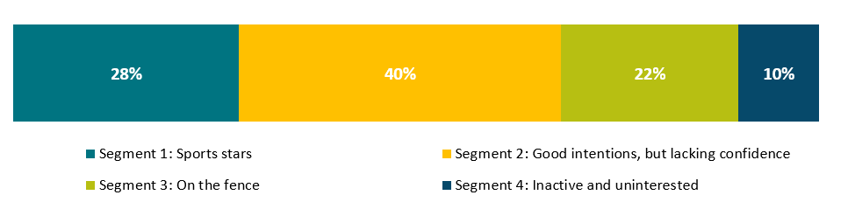

Segment 1: Sports stars

**The most active of the four segments,** Segment 1 are more likely to recognise the physical (91%) and mental (75%) health benefits of physical activity. They tend to perceive themselves as being more active than their peers (79%). Members of Segment 1 are more inclined than others to participate in cycling, going to the gym, running, strength training and swimming. In addition to these physical activities, one third (33%) of Segment 1 currently participate in organised sport.

Despite the relatively high engagement with physical activity and sports, Segment 1 are still interested in modified sports (41%). However, this segment is not keen on the idea of adjusting the rules to encourage participation. Half (50%) of Segment 1 have looked for information on physical activities or sports, including locations, costs and timetables. This information tends to be sought via local sources, including newspapers, council and community newsletters, and club notice boards.

Segment 2: Good intentions, but lack confidence

Segment 2 generally perceive themselves to be less active than five years ago (74%), but there is a **strong desire to increase their activity** levels (84%). There is concern among Segment 2 that they are too old to try a new sport (57%), and about the potential risk of injury (42%).

Segment 2 are most inclined to take part in dancing, bush walking, swimming, home exercise, and gardening. While a relatively small proportion are currently participating in organised sports (11%), over one third (35%) say they would be interested in modified sports.

Over one third (36%) have looked for information on physical activity or sports. Segment 2 tends to seek information on costs, locations, timetables and membership offers. Information is sought through online searches, newspapers, and council and community newsletters.

Segment 3: On the fence

Segment 3 are **ambivalent towards physical activity.** Less than half wish they were more active (44%). However, most believe they are about as active as they were five years ago and about as active as their peers. Segment 3 do not have strong opinions about physical activity and sport, lacking a strong desire to get more involved, but not feeling strongly against the idea of doing more either.

Segment 3 are most inclined to participate in walking, hiking, gardening, and swimming. There is a low level of interest in modified sports (10%) among this segment.

Generally, Segment 3 are not actively looking for information on physical activity or sports.

Segment 4: Inactive and uninterested

The majority of Segment 4 are doing the same amount or less activity than they were five years ago (81%), and they recognise that they are probably less active than their peers (42%). There is some desire to be more active (63%), but significantly more of this segment than any other do *not* wish to be more active (27%), or believe they have too many other priorities to spend time exercising.

Only 7% of Segment 4 are currently participating in organised sports, and this segment does not perceive sports participation to be a good way to stay social as they age.

Segment 4 members are generally not looking for information on physical activity or sports.

# Background and objectives

FACS is currently delivering the NSW Ageing Strategy 2016-2020. This Strategy features a number of initiatives designed to support older people in NSW as well as to cater to the state’s ageing population. Priority area one, from the Strategy’s year one implementation plan, is health and wellbeing. Within this sits a range of key activities for the course of 2016-17, one of which is the ‘Getting active plan.’ Specifically, this involves, in partnership with the private sector and sporting organisations, and with other government agencies, developing a program to encourage older people to make exercise a normal part of their routine. The program will highlight the health, wellbeing and social benefits of regular sport and exercise activities for older people.

Research objectives

As an extension from the Ageing Strategy Research, FACS wanted to conduct a study to focus on participation in organised sport among these older age groups. In particular, FACS wanted to understand the appetite for such participation, any barriers that currently exist and what strategies can be used to overcome these and increase the level of participation.

# Methodology

Research was conducted in three distinct phases as outlined below.

**Figure 2: Research design**

## Qualitative research

Exploratory focus groups

Two focus groups were held with Sydney residents aged over 50 years. The two groups were split by gender, with one group held with each gender. This was considered important to increase homogeneity and encourage open and honest discussion in the groups. Recruitment ensured that both groups contained a mix of those in their 50s, 60s, and 70s to reflect activity changes across the age cohorts. A discussion guide (Appendix 6.1) was designed to explore the following:

* participation in both general physical activity and organised sports;
* attitudes towards physical activity;
* benefits and barriers to physical activity; and
* benefits and barriers to sports participation

The groups were held in Parramatta on the 30th of March 2017. The focus groups were 1.5 hours in duration and participants received $80 to thank them for their time.

Modified sports concept testing

Following the online survey another two focus groups were held with Sydney residents aged over 50. Once again the groups contained a mix of gender and ages. However, this time recruitment was based on current physical activity levels to ensure we were speaking with those who have a genuine interest in physical activity, and thus more likely to participate in modified sports.

The discussion guide for these groups (Appendix 6.2) was used to explore potential interest in the concept of modified sports. More specifically it covered:

* strategies or messages that could be used to encourage participation in modified sports;
* understand the key benefits that should be communicated;
* understand which barriers need to be overcome by communications; and
* gather ideas on which sports participants would like modified, what modifications should be performed and why

The groups were held 15th of June 2017 in Parramatta and were 1.5 hours in duration. Participants again received $80 to thank them for their time.

## Quantitative research

An online survey of n=600 NSW residents aged over 50 years was conducted between the 8th and 15th of May 2017.

Questionnaire design

The questionnaire (Appendix 6.3) was developed out of findings from the two exploratory focus groups. More specifically it covered:

* past and present physical activity levels;
* physical activities and sports participated in, participation type, and frequency of participation;
* barriers and motivations for participation;
* participation information sought after and the sources of information; and
* interest in modified sports.

Sample characteristics

To capture a representative sample of those aged over 50 in NSW, non-interlocking quotas were placed on age, gender and location (Greater Sydney[1] and the remainder of NSW). These quotas were based on Australian Bureau of Statistics population estimates and data from 2011 Census. The following section outlines the targeted quotas and achieved sample for each age cohort.

Figure 3: Sample Structure

|  |  |  |  |
| --- | --- | --- | --- |
|  |  | **Quota (n=)** | **Achieved (n=)** |
| Gender | Male | 287 | 296 |
| Female | 313 | 304 |
| Age | 50-54 | 113 | 114 |
| 55-59 | 107 | 109 |
| 60-64 | 95 | 91 |
| 65-69 | 85 | 86 |
| 70+ | 200 | 200 |
| Location | Greater Sydney | 350 | 358 |
| Rest of NSW | 250 | 242 |
| **TOTAL** | | **n=600** | **n=600** |

Weighting

To ensure the final sample was representative of the NSW population, weights were applied to age, gender and location. As with the survey quotas these were based on ABS Census data.

## Interpreting the findings

Statistically significant differences between cohorts

Where statistically significant differences[2] are observed between subgroups, these differences are commented on below charts or displayed in tables within the report. Where tables are used to display differences between cohorts, the data is shown as per the demonstration below.

|  |  |  |  |
| --- | --- | --- | --- |
|  | **50-60 (n=xx)** | **61-69 (n=xx)** | **70-79 (n=xx)** |
| Option X | 28%↑ | 16%↓ | 4%↓ |
| Option Y | 29%↑ | 18%↓ | 9%↓ |
| Option Z | 20%↑ | 10%↓ | 8%↓ |

*↑↓ Denotes significant difference. Note table displays top-two box (very likely + somewhat likely) score.*

Figures are shown for the proportions of each group that provided that response. If this proportion is significantly different from the total or other age cohort, it is signified with an upwards or downwards arrow. An upwards arrow represents a significantly higher value and a downward arrow, a significantly lower value.

It should be noted, however, that not all significant differences identified in the analysis have been reported. Instead, those that have been included have been selected based on their contribution to the insights generated by this research (e.g. findings that might be deemed obvious or of no consequence have been omitted).

Percentages in charts

In some charts, response categories shown may not sum to 100% due to rounding of the numbers displayed. It should also be noted that for questions where multiple responses were allowed response categories may sum to more than 100%.

Quotes for illustration

Quotes in this report represent the opinions of those interviewed. All responses to the survey are based on the perceptions of participants, based on their experiences and perceived knowledge. They are not necessarily statements of fact. Some verbatim quotes in the report do, however, read as if they were statements of fact. While commentary and context are provided in text surrounding the quotes, readers should keep in mind that views expressed are based on individuals’ perceptions of the issue.

# Findings

## Participation in general physical activity

**Over half (53%) of 50-plus year olds believe they are doing less physical activity** than they were five years ago, and this increases among those in their 70s and in regional areas. Fear of injury and loss of confidence have led to this reduction in activity levels. A significant minority (16%) believe they are doing more physical activity than they were five years ago. More time, health scares, and recognition of the increasing importance of activity to stay healthy in old age have been drivers to increased activity among these people.

**Older people are participating in a wide range of physical activities**, with walking (91%), gardening (79%), swimming (44%) and home exercise (37%) being the most common. Given the nature of the activities participated in, most people are doing so on a casual basis (as opposed to being part of a group, team or club).

**The benefits of physical activity are widely recognised**, and sentiment towards exercise is generally positive. The physical health benefits of staying active are seen as the main benefit (76%). The mental health benefits (54%) and fun and enjoyment (49%) are also seen as benefits to many. Most feel a sense of achievement after excising (66%) and wish they were more active (66%). Recognition of the benefits and positivity towards exercise increases among those who have become more active and who currently participate in a sport.

**For most older people, there are no major barriers to participation in physical activity**. Exercise feeling like a chore (32%), a lack of time (24%) and competing priorities (20%) are all factors that make it difficult for some older people to exercise, however none of these present a barrier for the majority of people. Those who do not currently participate sports are more likely to view physical activity as a chore (35%; compared with 18% of those who do participate). Among those who do no physical activity at all, lack of mobility is the main reason.

### Changes in activity levels over time

Activity levels have changed over time for most participants, with over half (53%) feeling they are less active now than five years ago. In the qualitative research, some respondents reflected on how they used to engage in a lot of regular activity and organised sports but no longer do. The reasons for change are varied but injury or fear of injury, and a loss of confidence in their physical ability has promoted much of it.

Not all are doing less now, 16% say they are more active than they were five years ago. Among those who are doing more, key life milestones tend to have driven this. During the focus groups, some of the younger respondents noted they had more time since their children had left home. For a few, health scares have prompted an increase in activity, and many acknowledged that exercise is increasingly important to keep the body healthy as they age.

Figure 4: Activity levels compared to 5 years ago

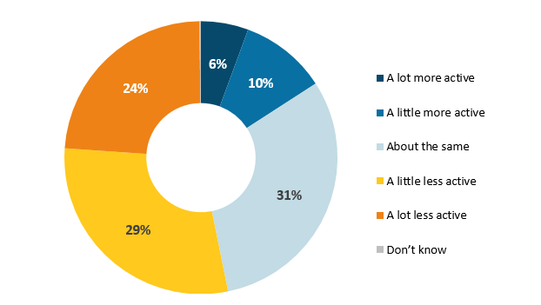

*Q1. Thinking about your level of physical activity 5 years ago, would you say you are now…? (Base: All respondents n=600)*

When comparing activity levels to five years ago, the following groups were more likely to identify themselves as being **less** active now:

* those in their 70s (64%; compared with 48% of those in their 50s and 60s);
* those outside of Sydney (58%; compared with 49% of Greater Sydney residents); and
* retirees (61%; compared with 43% of those who are currently employed).

Perceived activity levels compared to others

Despite a relatively small proportion saying they are more active now than 5 years ago (16%), more than one third (39%) still perceive themselves to be more active than others of the same age. Although, almost one third perceive themselves to be about the same (30%) or less active (30%) than their peers.

Figure 5: Activity levels compared to others of the same age

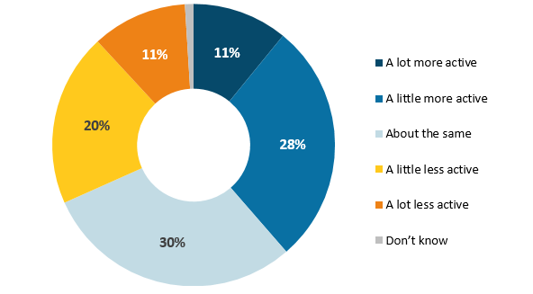

*Q2. And compared to other people your age would you say you are…? (Base: All respondents n=600)*

The following groups are more likely to consider themselves **more** active than others their age:

* those who say they are more active than five years ago (71%; compared 53% of those who are about the same, and 22% who are less active) and
* Greater Sydney residents (44%; compared to 33% of the rest of NSW).
* Despite being more likely to say they are more active than five years ago, those in their 50s are more likely to consider themselves less active than their peers (32%; compared with 43% of those in their 60s, and 45% of those in their 70s).

Activities participated in

The types of physical activities those aged over 50 are participating in varies greatly. Participants in the focus groups spoke about a range of activities including; walking and hiking, swimming, aqua-aerobics, squash, cycling, pilates, yoga, gym classes, dancing, tennis, golf, lawn bowls, running, garden, canoeing/kayaking and touch rugby.

The quantitative data reflect the same findings, with walking (91%), gardening (79%), swimming (44%) and home exercise (37%) being the most common physical activities of those aged over 50.

Figure 6: Most common physical activities

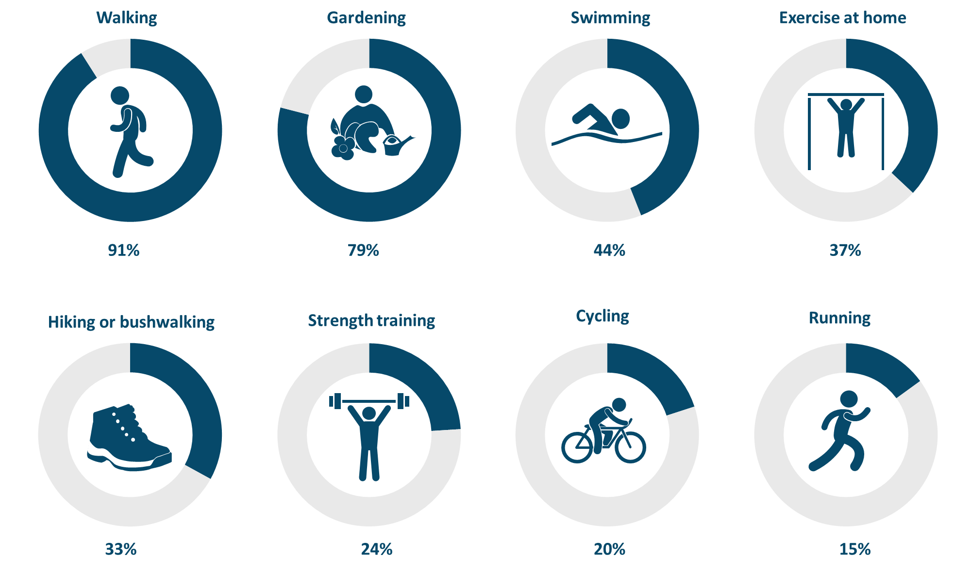

*Q3. How often, if at all, do you currently participate in the following activities?* *(Base: All respondents n=600)*

Men are more likely to participate in cycling (27%; compared with 14% of women).

Those in their 50s are more likely to:

* exercise at home (44%; compared with 30% of those in their 60s, and 36% of those aged over 70);
* cycle (25%; compared with 20% of those in their 60s, and 15% of those aged over 70); and
* jog or run (20%; compared with 15% of those in their 60s, and 9% of those aged over 70).

Participation frequency

Walking is the most frequently conducted activity with 70% doing so at least once a week, followed by gardening (35%) and exercising at home (18%). Despite being relatively popular activities, due to their seasonal nature, participation in swimming and hiking or bush walking is generally less frequent with many participating monthly or less (33% and 27%, respectively).

Figure 7: Frequency of participation in physical activities



*Q3. How often, if at all, do you currently participate in the following activities?* *(Base: All respondents n=600)*

Women are more likely to participate in the following activities:

* dancing (17%; compared with 6% of men); and
* aquacise (16%; compared with 6% of men).

The qualitative research found that routines for physical activity tended to vary based on gender, activity levels and the extent of other commitments. Women were more likely to have a routine for staying physically active and generally exercised alone or with one or two friends. Most activities were low impact and were centred around stress-relief and the physical health benefits. Men, overall, were less active than women. While a few suggested that previously, exercise was part of their routine, many no longer have a set physical exercise routine. One man stated that he regularly did yoga and another that he played regular organised touch football. Like the women, most exercise was undertaken alone.

Participation type

Participation in the majority of activities in generally done on a casual basis. However, activities that are often associated as being group orientated are more commonly done as part of a group, team, or club, in addition to casual participation. These include gym classes (49%), yoga (41%), aquacise (31%) and general exercise in a gym (32%).

Figure 8: Participation type by activity

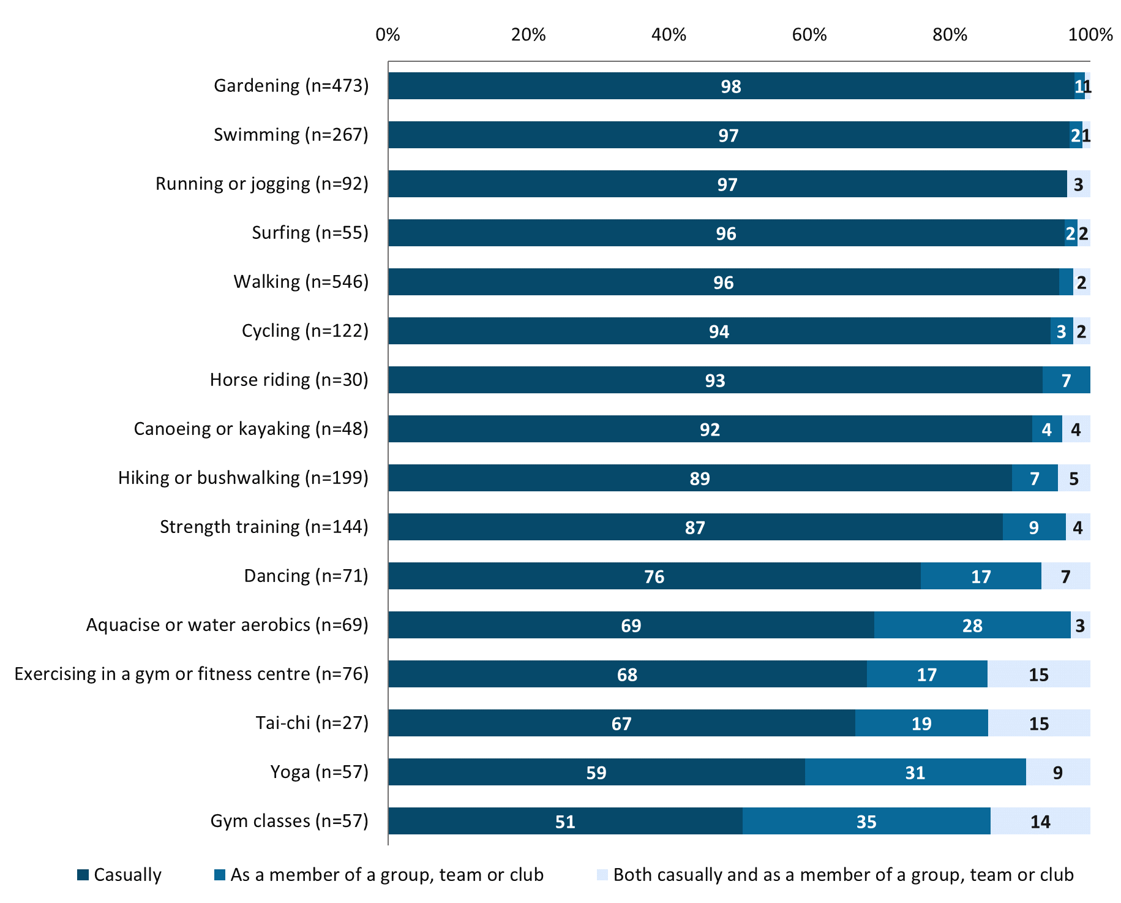

*Q4. Do you participate in this activity or these activities on a casual basis or as a member of a group/ team/ club, or both? (Base: Those who participate in each activity, individual base sizes displayed on chart for each activity)*

No significant differences in participation type were observed between demographic subgroups.

Individual versus social

The extent to which activities are participated in individually or socially varies by activity. Strength training (83%), gardening (76%) and running or jogging (74%) are predominantly solo activities. Whereas dancing (79%) and hiking or bushwalking (75%) are much more likely to be social activities, done with friends or family.

Figure 9: Individual or social activity

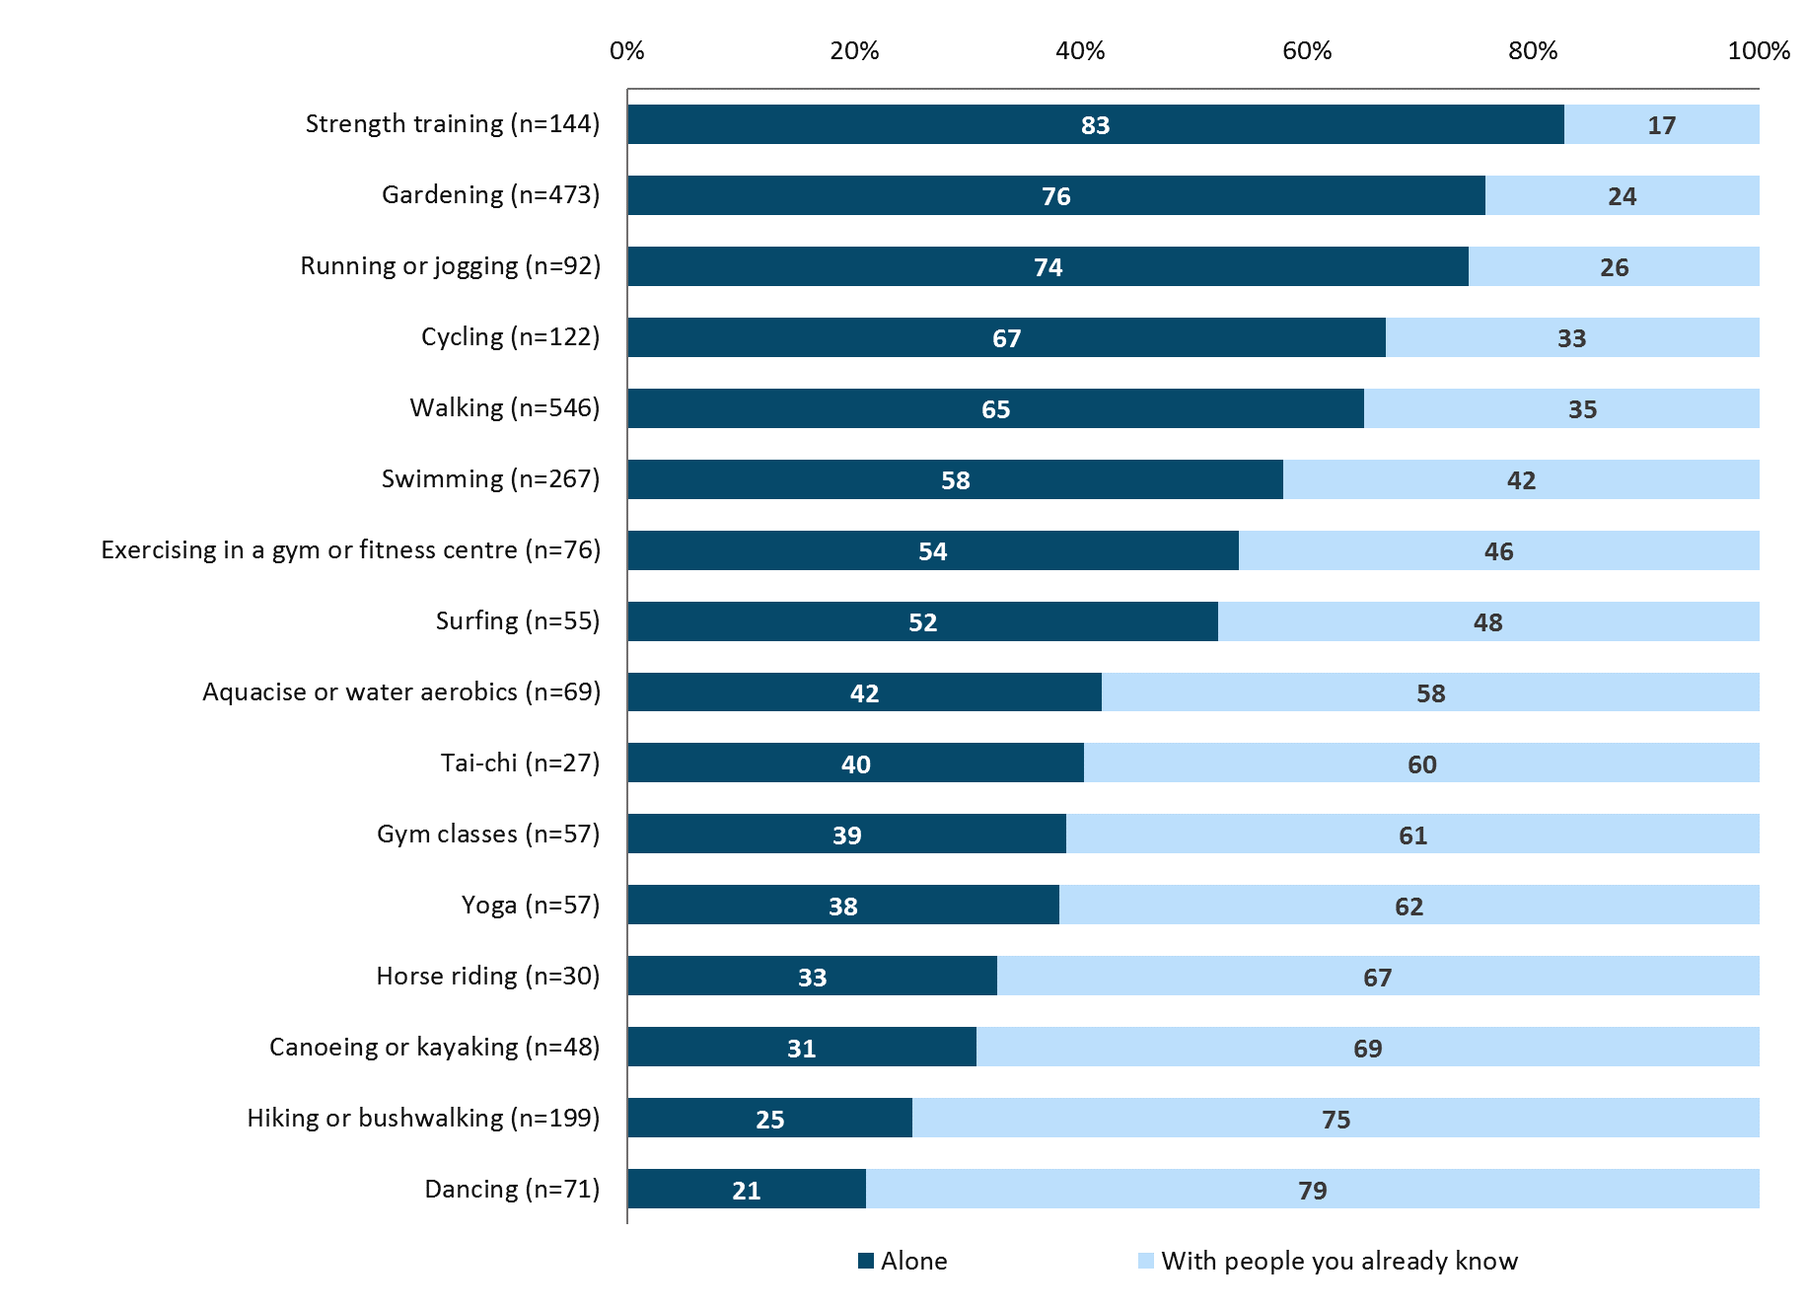

*Q5. And of the activity or activities you take part in, do you usually do these alone or with other people you already know? (Base: Those who participate in each activity, individual base sizes displayed on chart for each activity)*

Women are more likely to participate in gardening alone (81%; compared with men 70%), while men are more likely to go hiking or bushwalking alone (35%; compared with 15% of women).

### Benefits of staying active

There were a range of perceived benefits of physical activity mentioned by each of the groups, with all agreeing that staying active is important. Three quarters (76%) of those aged over 50 identified physical health benefits as being a key reason for their participation in physical activity. The nuances of physical health benefits were revealed by the qualitative research. Many felt physical activity keeps them young, active, fit and energised. Weight loss was also cited as a benefit, especially for women after menopause.

Over half (54%) recognise the mental health benefits of physical activity. This finding is reinforced by the focus group findings, with those who were still working finding that exercise is a way to clear their heads and keep stress levels down. Mental health benefits were also acknowledged by those who practice yoga and tai chi due to the emphasis on mindfulness, the breath and balance. For some of the men who have had trouble adjusting to life in retirement, going for their morning walk gave them a routine, a sense of achievement and something to look forward to each day.

In addition to the physical and mental health benefits, fun and enjoyment (49%) and social benefits (30%) came through relatively strongly in both the qualitative and quantitative findings as key reasons for taking part in physical activity.

Reducing the risk of falls (22%), was noted as a participation driver for women and those aged over 70 in particular. Both groups were significantly more likely to cite this as a reason for taking part in physical activity (27% and 38%, respectively).

Figure 10: Benefits of physical activity

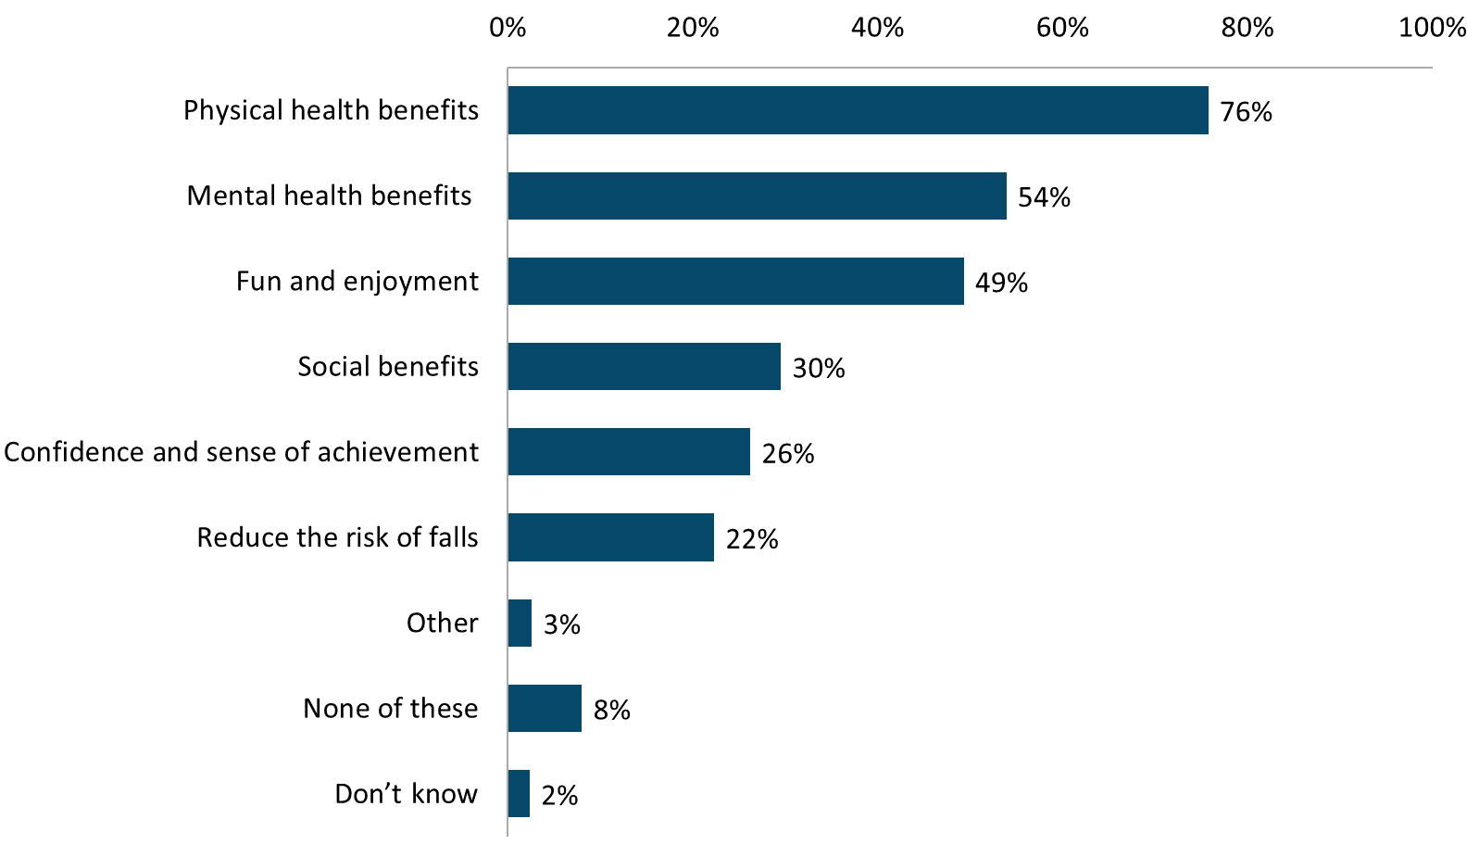

*Q11. Which, if any, of the following best describe the reasons that you take part in physical activity? (Base: those who participate in at least one activity listed in Q3 or Q6 n=578)*

Those who currently play an organised team or individual sport are more likely to identify all of the benefits listed in Q11, with the exception of reducing the risk of falls, as being motivators for participating in physical activity.

Table 1: Reasons for taking part in physical activity by organised sport participation

|  |  |  |
| --- | --- | --- |
|  | **Currently play a sport (n=104)** | **Do not play a sport (n=474)** |
| Fun and enjoyment | 89%↑ | 41%↓ |
| Physical health benefits | 84%↑ | 74%↓ |
| Social benefits | 66%↑ | 22%↓ |
| Mental health benefits | 65%↑ | 52%↓ |
| Confidence and sense of achievement | 44%↑ | 22%↓ |

Positive sentiments towards physical activity

Two thirds (66%) feel a sense of achievement after exercising, and over half (55%) agree physical activity is an important part of their routine. However, two thirds (66%) of those over 50 wish they were more active; and is significantly higher among those in their 50s (73%). As highlighted in the focus groups, many of those in their 50s struggle to balance the competing demands of work, family and leisure.

Figure 11: Positive sentiments towards physical activity

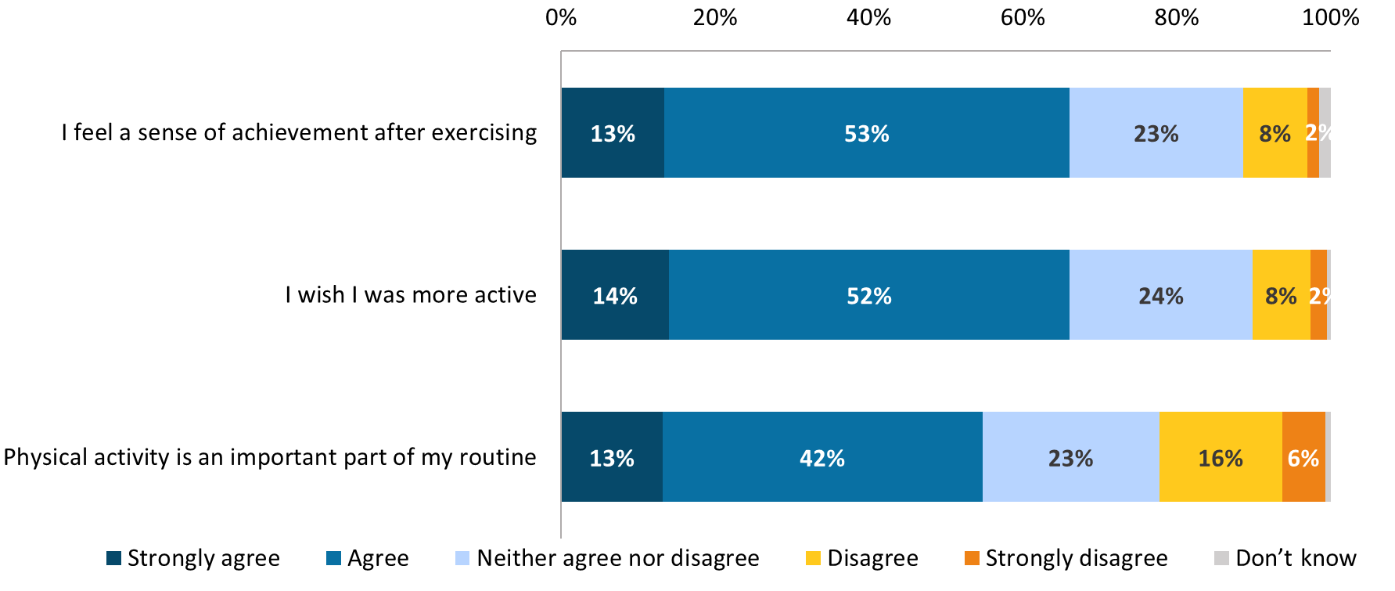 *Q14. To what extent do you agree or disagree with the following statements about physical activity? (Base: All respondents n=600)*

Those in the more active cohorts are more likely to feel a sense of achievement after exercising:

* those who are more active than they were five years ago (86%; compared with 67% who are about the same, and 60% of those who are less active); and
* those who currently participate in a sport (76%; compared with 64% of those who do not).

Those in the more active cohorts are also more likely to say exercise is an important part of their routine:

* those who are more active than they were five years ago (84%; compared with 69% who are about the same, and 38% of those who are less active); and
* those who currently participate in a sport (77%; compared with 50% of those who do not).

### Barriers to staying active

There are a number of factors that make it difficult for some older people to exercise, however none of them present a barrier for the majority. For almost one third (32%) exercise is a chore. Participants in the focus groups who shared this view described it as being ‘boring’ and deriving no enjoyment out of it. While not significantly different in the quantitative findings, the qualitative research found that men were more inclined to view exercise as a chore.

One in five (20%) found that competing priorities prevent them from spending time exercising, with the figure being significantly higher among those who are working full time (34%) and those in their 50s (29%). This was also described as a barrier by focus group participants.

A small proportion (15%) said they only want to do physical activity with friends or family. The qualitative research shed light on some of the reasons for preferring to exercise with others. Some women described unwelcoming cliques that were often present in group fitness classes (aquafit classes in particular), which had put them off attending alone. One woman said that once she felt she knew enough of the aquafit exercises she stopped attending the classes and practiced on her own in the pool, in order to avoid the unfriendly group atmosphere. For these women, they felt they would only consider re-joining such classes if they were with friends or attended an open day for new participants where everyone is new to the class.

Figure 12: Factors making physical activity participation difficult

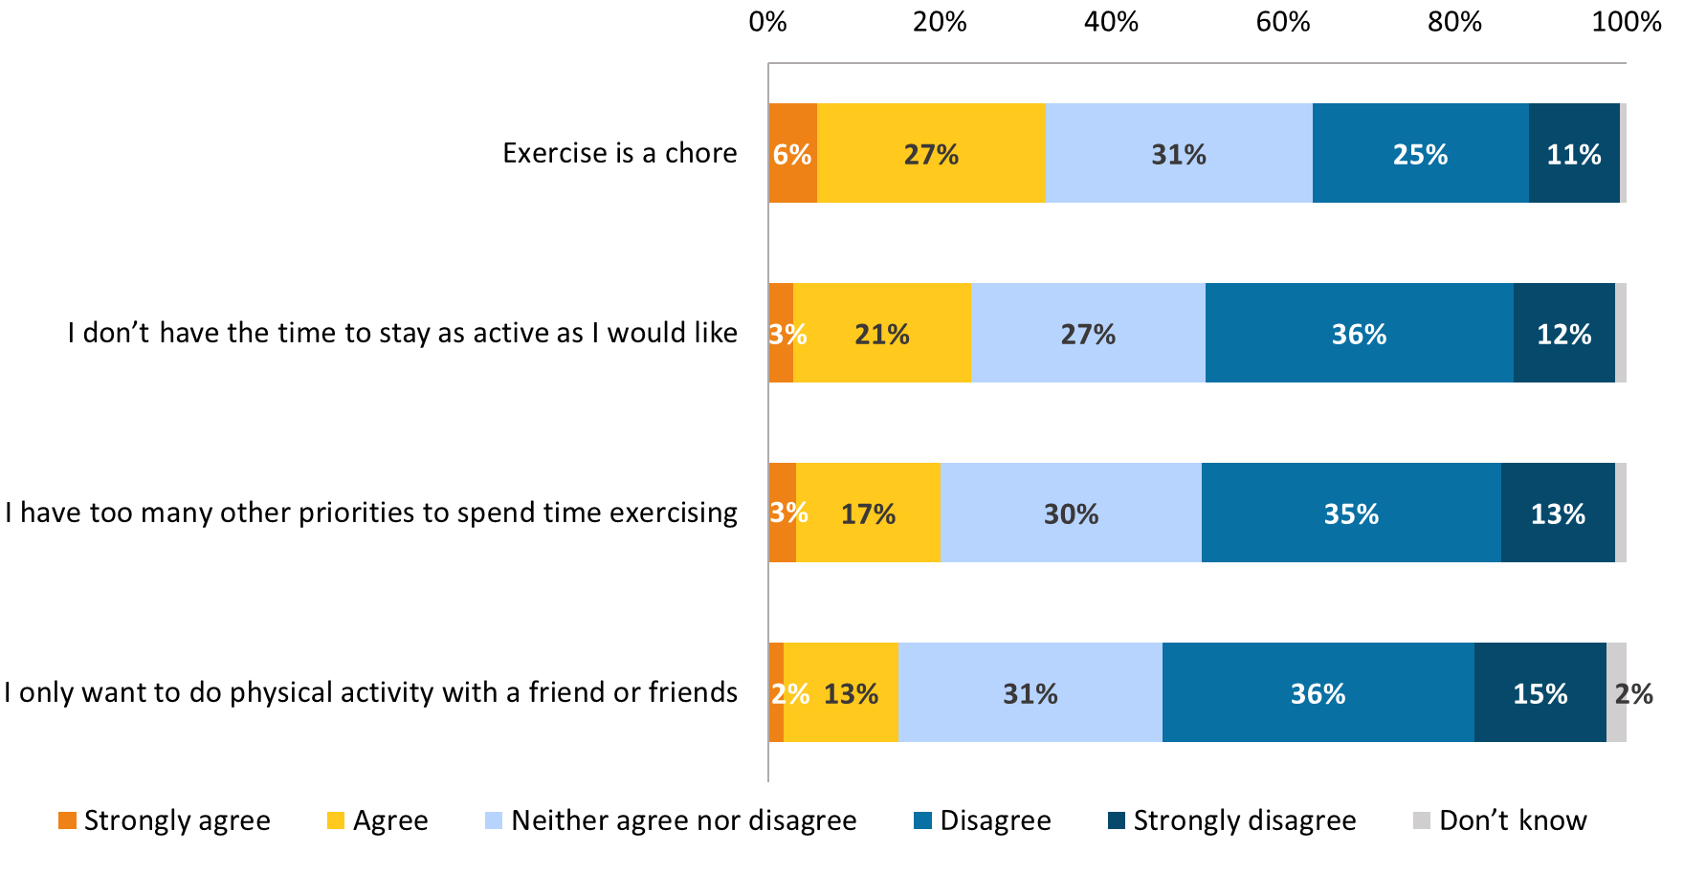

*Q14. To what extent do you agree or disagree with the following statements about physical activity? (Base: All respondents n=600)*

Those who do not currently participate in individual or team sports are more likely to view physical activity as a chore (35%; compared with 18% of those who do participate).

Reasons for not participating in any physical activity

Among those who do not participate in any physical activity at all, reasons are generally centred around mobility (n=15), lack of fitness (n=12) and poor health (n=12). However, these figures should be treated as indicative only due to the low base size of this question (n=22).

Figure 13: Barriers to participating in physical activity



*Q13. Which, if any, of the following puts you off or makes it difficult for you to participate in physical activity? (Base: those who do not participate in any of the activities listed in Q3 or Q6 n=22) *Caution low base sizes, treat data as indicative only*

## Participation in organised sports

**Nearly a fifth (17%) of older people participate in organised sport**, rising to 27% of men. **Golf** (9%) and **tennis** (4%) are most commonly participated in. Many sports were played by participants in the past but no longer are, including squash (45%), netball (24%), rugby (22%) and baseball/softball (18%). Key reasons for this (revealed by the qualitative research) are injuries and/or disabilities.

**Most sports participation is a combination of casual and as part of a club/league**, but most are paying per session/game (61%).

**Fun and enjoyment and social benefits are perceived as the main benefits** to participation in organised sport (79% and 67%), with the physical health benefits being less prominent than when asked to consider the benefits of physical activity in general (64%, compared with 76%). Organised sports are typically seen as a good way to remain sociable as people age.

**Low interest in competition is a key reason for those not taking part in organised sport** (52%). Lack of confidence in their own skills (21%), particularly among women (25%) is also a barrier. A reluctance to make a long-term commitment of time (21%), or commit to the cost of a membership or subscription is also a deterrent for some.

**Over a third (35%) had looked for information about sports or physical activity** they would like to take part in, with the local newspaper being the most commonly used source (19%). Most of these people had looked for information about the locations (80%), costs (68%) and times (59%) of activities available.

Nearly one in five (17%) people aged over 50 participate in individual or team organised sports.

Figure 14: Currently participate in organised individual or team sports

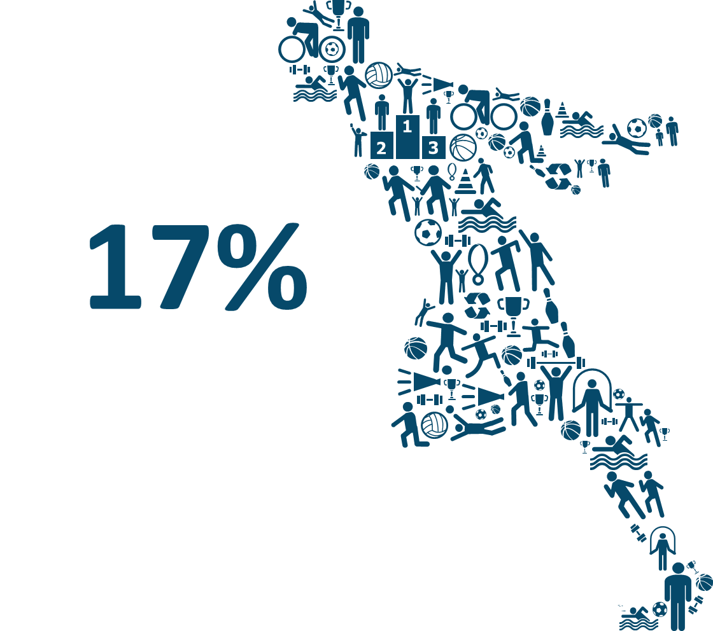

*Q6. Which, if any, of the following sports do you currently take part in, or have you taken part in in the past? (Base: All respondents n=600)*

The following groups are more likely to currently take part in at least one sport:

* men (27%; compared with 8% of women); and
* those who perceive themselves as being more active than others their age (24%; compared with 18% who are about the same, and 8% who are less active).

Types of sports participated in

Golf (9%) and tennis (4%) are the sports most commonly participated in among those aged over 50. This reflects the sports most commonly participated in the past, with tennis (51%) and golf (30%) again being among the most common, along with squash (45%). Despite being popular among participants when they were younger, people are not continuing to play squash into their 50s and beyond. The same pattern can be seen for many sports, including netball (24%), rugby (22%) and baseball/softball (18%). Participants in the qualitative research reflected on how they had played various team sports in the past including, rugby league, cricket, hockey, netball and soccer but have had to since give them up due to injuries or disability.

Figure 15: Past and current participation in sports

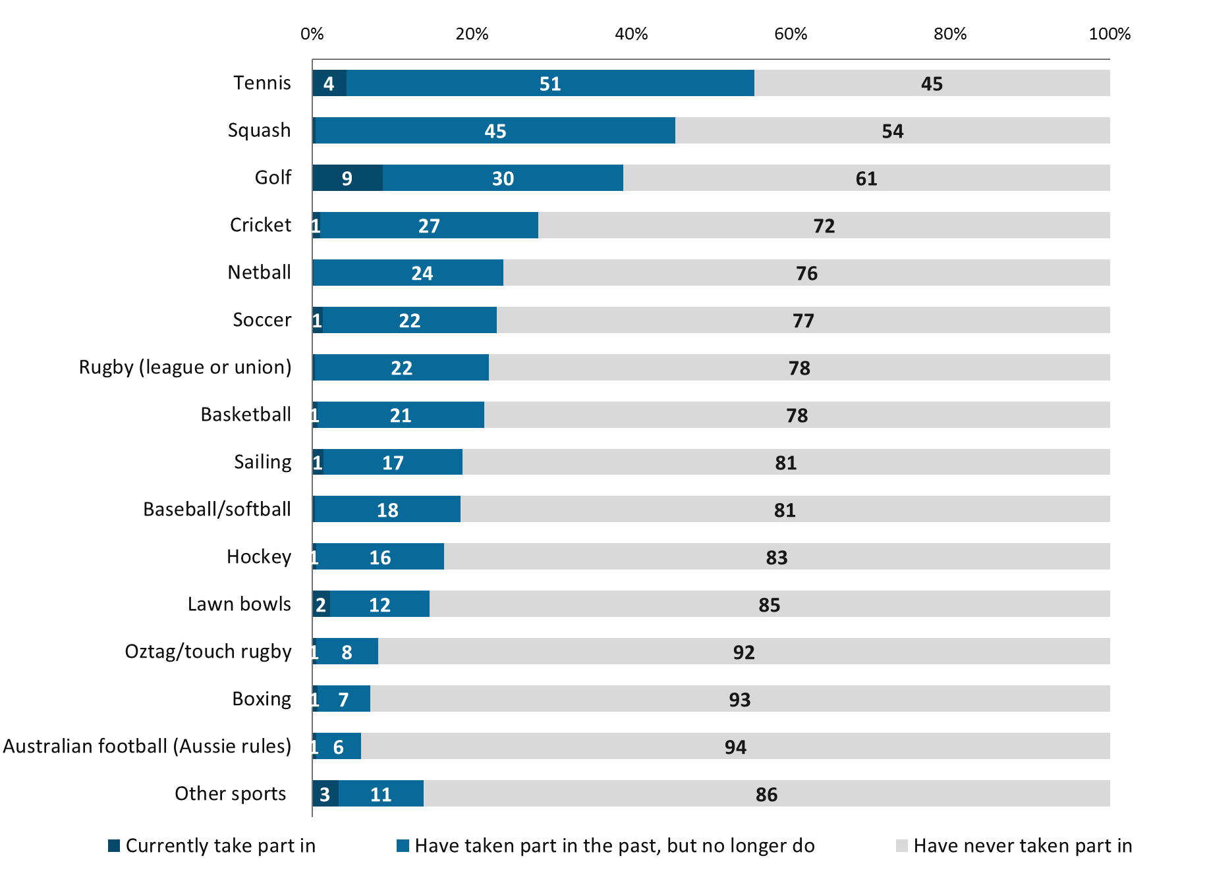

*Q6. Which, if any, of the following sports do you currently take part in, or have you taken part in in the past? (Base: All respondents n=600)*

The types of sport previously participated in vary significantly by gender as outlined in Table 2 below. With the exception of netball and baseball/softball, men were more likely than women to participate in all types of sports.

Table 2: Past participation in sports by gender

|  |  |  |
| --- | --- | --- |
|  | **Men (n=296)** | **Women (n=304)** |
| Squash | 53%↑ | 38%↓ |
| Cricket | 48%↑ | 8%↓ |
| Rugby (league or union) | 44%↑ | 2%↓ |
| Netball | 3%↓ | 43%↑ |
| Golf | 42%↑ | 20%↓ |
| Soccer | 39%↑ | 6%↓ |
| Sailing | 27%↑ | 8%↓ |
| Baseball/softball | 14%↓ | 23%↑ |
| Lawn bowls | 18%↑ | 7%↓ |
| Oz tag/touch rugby | 13%↑ | 3%↓ |
| Australian football | 10%↑ | 2%↓ |
| Boxing | 10%↑ | 3%↓ |

*Note: Only sports with a significant gender difference in previous participation are displayed in this table*

Frequency of sport participation

Among those who participate in tennis, golf and lawn balls, participation is fairly frequent. The majority of players participate at least once a fortnight (65%, 68%, and 70% respectively).

Figure 16: Participation frequency



*Q7. Approximately how often do you participate in each of these sports (including training and playing/competing)? (Base: Those who currently participate in each sport. Individual base sizes displayed in chart) *Caution: Low base sizes, treat as indicative only*

Organised or casual participation

Most sports are being done on both a casual basis and as part of a club/league. The only sports being done on a purely casual basis are tennis, golf, lawn bowls, sailing and cricket.

Figure 17: Type of participation by sport

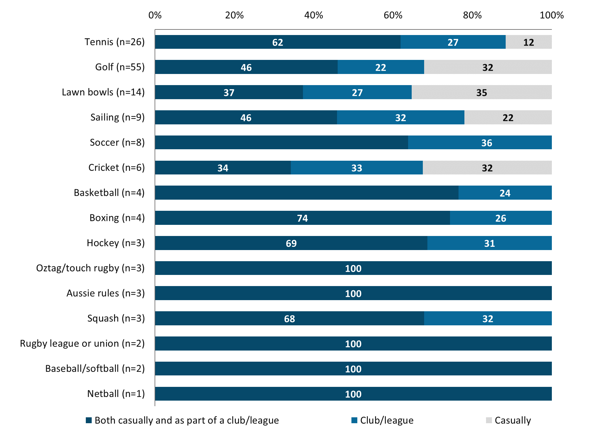

*Q8. Thinking about the sport(s) you currently participate in, do you do this on a casual basis, or as part of a club/league?* *(Base Those who currently participate in each sport. Individual base sizes displayed in chart) *Caution: Low base sizes, treat as indicative only*

Payment methods

The majority of those participating in sports are paying per session or game (61%) and almost half (49%) are paying for a membership or subscription.

Figure 18: Payment methods for sports currently participated in

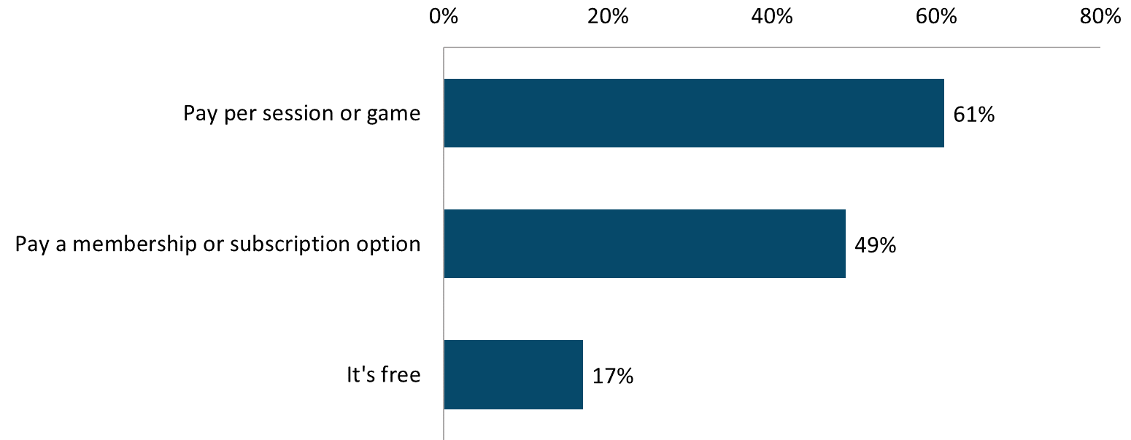

*Q9. On what basis do you pay for the sports you take part in, if at all? (Base: Those who participate in individual or team sports n=105) *Note all sports have been combined due to low individual base sizes*

Those aged over 70 are more likely to pay a membership fee or subscription for the sports they participate in (65%; compared with 40% of those in their 50s, and 36% of those in their 60s).

### Benefits of sport participation

Consistent with general participation in general physical activity, the benefits of sports participation outlined in the groups were wide-ranging. Fun and enjoyment (79%) and social interaction (67%) are the main benefits identified, in addition to physical health benefits (64%) (which was the key benefit identified in relation to physical activity in general).

The qualitative research showed that among those who derive enjoyment out of sports participation, one of the main reasons is friendly competition and team spirit that you don’t necessarily get out of general physical activity. For others, the opportunity to make business and social contacts is important.

Almost one third (30%) feel motivated by committing to a team or schedule. The qualitative findings show that while some see this as a barrier, others feel the commitment makes you accountable as you do not want to be viewed as letting the team down. It was felt that this level accountability provides the basic structure for routine people are more likely to stick to.

Figure 19: Benefits of sports participation

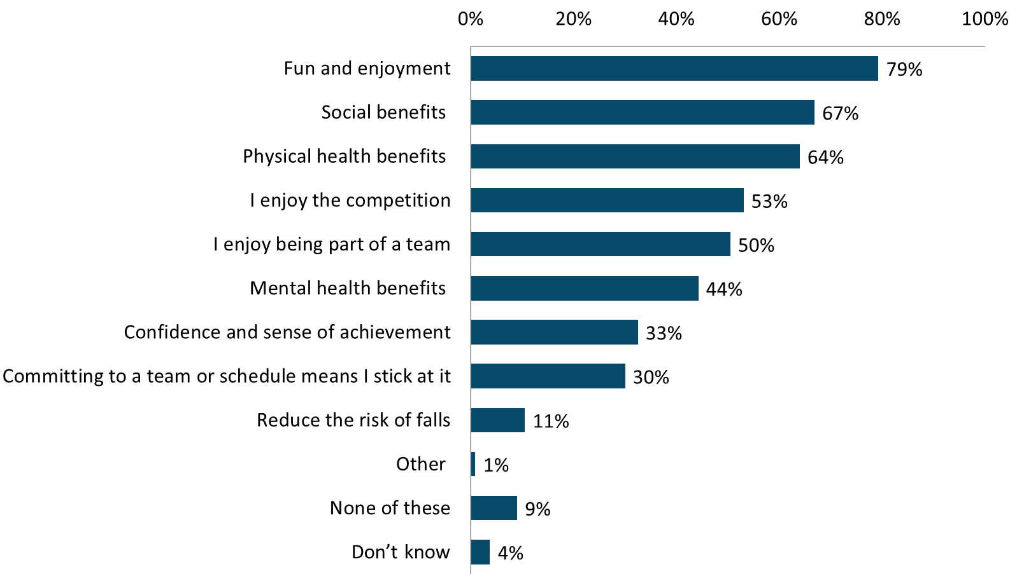

*Q12. Which, if any, of the following best describe the reasons that you take part in organised/team sport? (Base: those who participate in at least one of the individual or team sports listed in Q6 n=111)*

There were no significant differences found between demographic subgroups and the benefits of sports participation.

Attitudes towards organised sports

Just over half (54%) agree that participating in sports is a good way to stay sociable as you age. This was also reflected on in the focus groups, during which respondents noted that many sports are social in nature.

“That’s what team sport is, you don’t feel like you’re exercising.” – Female, 60-70 years

However, there were respondents, particularly those still working full time, who were more inclined to participate in physical activity alone as way of unwinding from the stresses of work and family. As a result, they did not express any desire to participate with others and were happy to keep doing their own thing.

Two in five (42%) say they feel a sense of achievement from completing a sporting goal, and this came through strongly in the group discussions. Those who were more active generally felt that a sense of achievement goes hand-in-hand with sport.

Figure 20: Positive sentiments towards organised sports

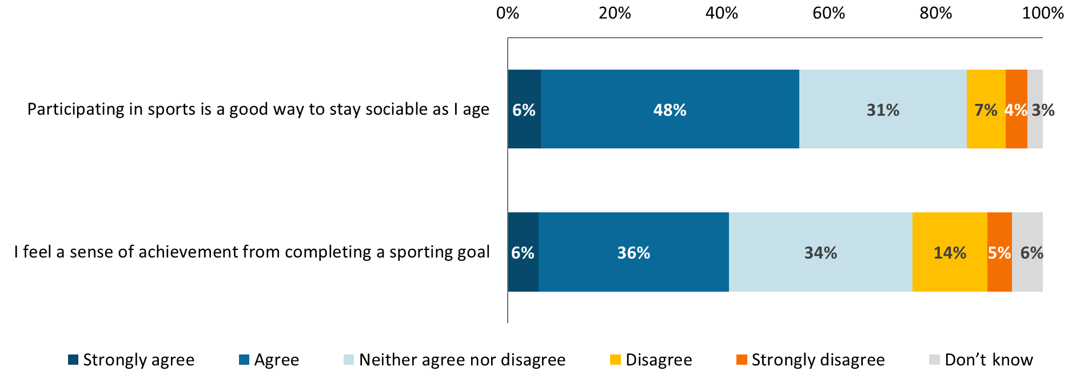

*Q15. To what extent do you agree or disagree with the following statements about organised individual or team sports? (Base: All respondents n=600)*

The following groups were more likely to agree that participating in a team sport is a good way to stay sociable as they age:

* those who currently participate in organised sport (88%; compared with 47% of those who do not);
* those who believe they are more active now than 5 years ago (70%; compared with 52% of those who are about the same, and 51% of those who are less active);
* men (60%; compared with 50% of women); and
* those in their 50s (62%; compared with 49% of those in their 60s, and 50% of those in their 70s).

These groups were also more likely to say they feel sense of achievement from completing a sporting goal:

* those who currently participate in organised sport (75%; compared with 34% of those who do not);
* those who believe they are more active now than 5 years ago (57%; compared with 40% of those who are about the same, and 38% of those who are less active);
* men (48%; compared with 36% of women); and
* those in their 50s (48%; compared with 39% of those in their 60s, and 36% of those in their 70s).

### Barriers to participation

The reasons why some people are not participating in organised or team sports are numerous and wide ranging. The key reason is a lack of interest in competition (52%). A third feel they are not fit enough (36%) and/or and not in good health (32%). A third attribute their non-participation to having other priorities.

One fifth (21%) said that they don’t take part as they don’t have the skills, and this was higher among women (25%). The qualitative research highlighted that a perceived lack of ability was a barrier for some (again, particularly among women), and that many felt pressure to perform for the team and/or competitively. Some also feared starting something new in old age.

One fifth (21%) said that they don’t want to make a long-term commitment of their time. The qualitative research found that this was a particular issue among men, who in general wanted to be free from commitments and remain spontaneous. One man stated that he wanted such flexibility to be able to *“go on a cruise on Thursday”.* In addition to the commitment, focus groups participants also described how some sporting clubs (an example was bowls) take it too seriously to the point where it is no longer enjoyable.

Figure 21: Reasons for not participating in organised sport

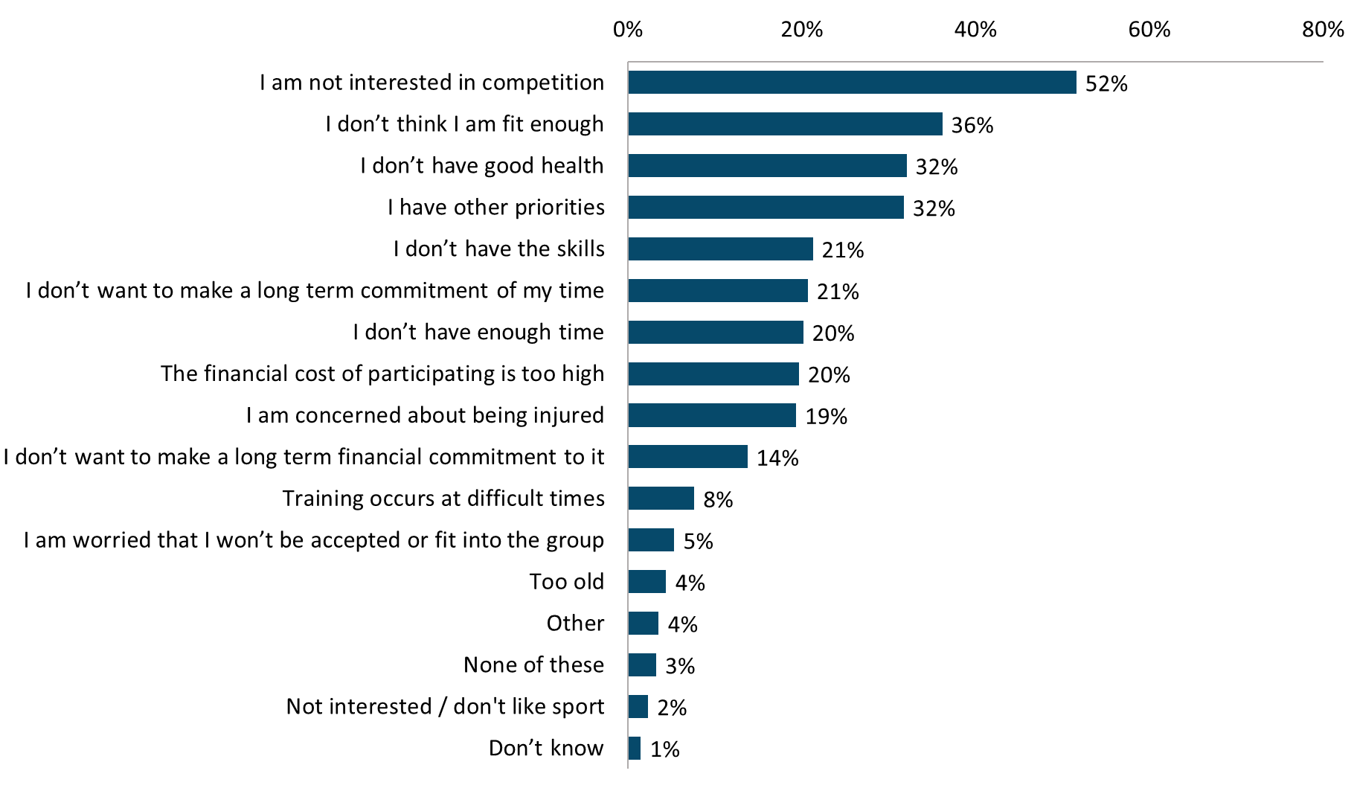

*Q10. Which, if any, of the following describe your reasons for not currently participating in organised/team sport? (Base: Those who are not currently participating in organised team sport n=489)*

Time is more likely to be a concern for those who are working full time:

* I have other priorities (42%; compared with 40% of part time workers and 25% of retirees);
* I don’t have enough time (33%; compared with 26% of part time workers and 13% of retirees); and
* Training occurs at difficult times (14%; compared with 6% of part time workers and 4% of retirees).

Women are less likely to participate in organised sports for several reasons, as outlined in Table 3 below.

Table 3: Reasons for not participating in organised sport by gender

|  |  |  |
| --- | --- | --- |
|  | **Women (n=281)** | **Men  (n=214)** |
| I am not interested in competition | 55%↑ | 45%↓ |
| I don’t have the skills | 25%↑ | 15%↓ |
| I am concerned about being injured | 24%↑ | 13%↓ |
| I don’t want to make a long-term commitment of my time | 24%↑ | 16%↓ |
| The financial cost of participating is too high | 23%↑ | 15%↓ |

Negative sentiments towards organised sports

Two in five (42%) believe they are too old to try a new sport, and/or that they don’t have the skills or ability to play (39%). This sentiment was also evident in the qualitative research, with mention of negative stereotypes about being the ‘old person’ in the team who is perceived to be slow or not know what they are doing. Many felt that unless you had played the sport at a high level for most of your life, then team sports are not geared towards older people.

A further two in five (39%) are concerned about the level of commitment involved in organised sports. Although, in the groups this was also true of physical activity that would require a monetary investment. There was a lack of willingness or reluctance to sign up for a membership or contract that was any longer than 6 months, in case it wasn’t for them or competing priorities got in the way. Among those who were less active, the general consensus is that they do not want to be locked into a long-term contract.

“What if I decide I want to go on an overseas cruise next week?” – Male, 60-70 years

Figure 22: Negative sentiments towards organised sport

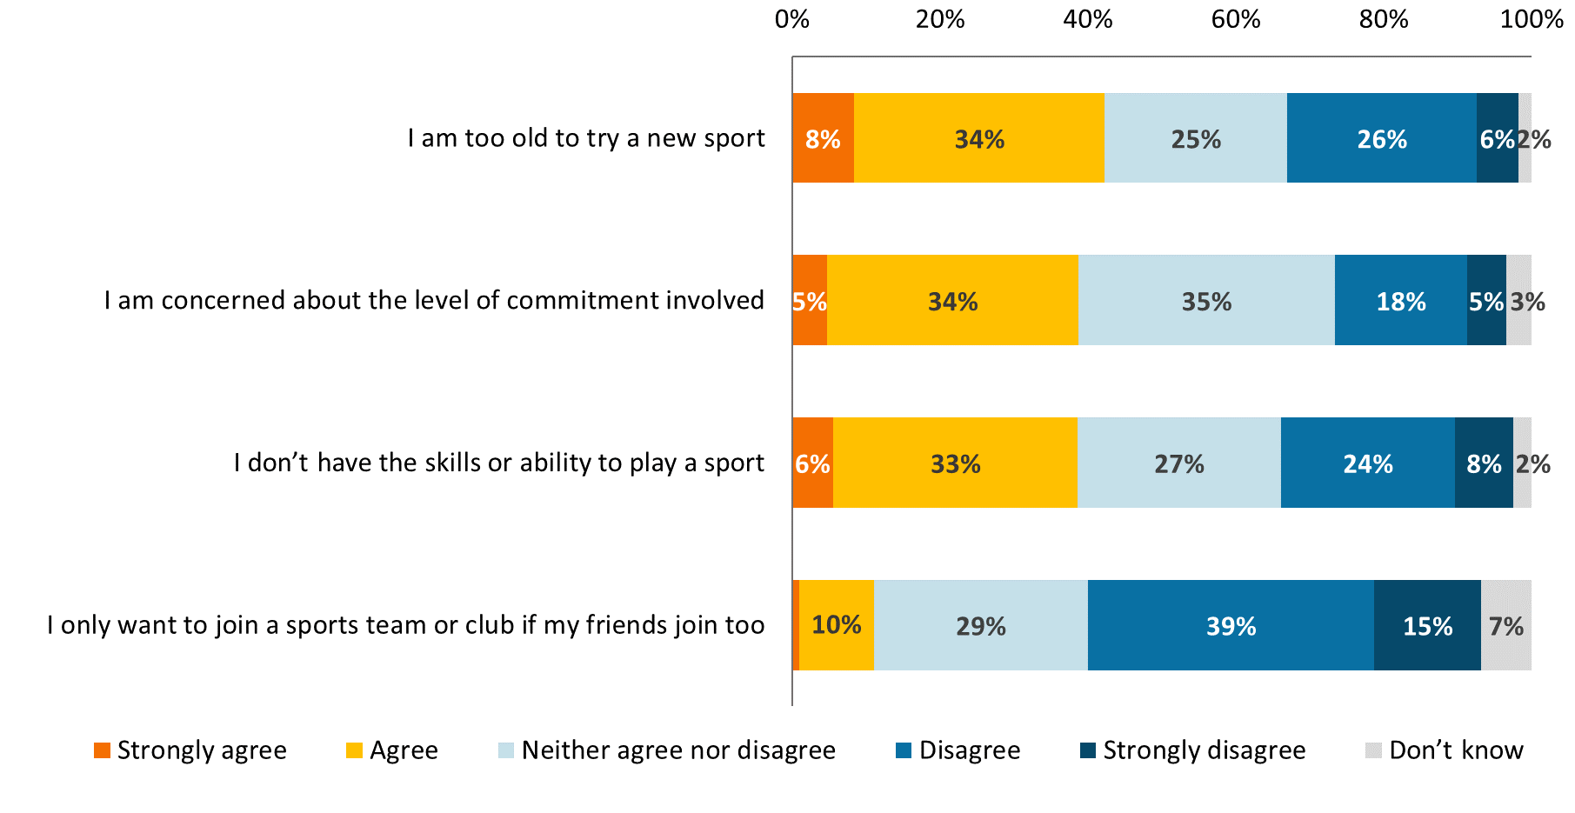

*Q15. To what extent do you agree or disagree with the following statements about organised individual or team sports? (Base: All respondents n=600)*

Women are more likely to believe they don’t have the skills or ability to play a sport (49%; compared with 28% of men). They are also more likely be concerned about the level of commitment that would be involved (45%; compared with 31% of men).

Those who do not currently participate in team or individual sports are more likely to be concerned about the following:

* being too old to try a new sport (47%; compared with 18% who currently participate);
* the commitment involved (44%; compared with 13% who currently participate); and
* not having the skills or ability (45%; compared with 13% who currently participate).

Retirees are more likely to think they are too old to try a new sport (49%; compared with 29% who are working fulltime, and 35% working part time). However, they are less likely to be concerned about the level of commitment involved (33%; compared with 40% who are working fulltime, and 45% working part time).

Those in their 50s are more likely to say they would only join a sports team or club if their friends join too (19%; compared with 8% of those in their 60s and 3% of those aged over 70).

## Sourcing information on participation

Over one third (35%) of those over 50 have looked for information about sports or physical activities they would like to take part in. Among those who have searched, the local newspaper (19%) is the most common information source. Some participants in the qualitative research said they found it difficult to find information about the types of activities they are interested in. One woman mentioned that she was interested in joining a social ten-pin bowling club but was not able to find any information about this.

“Maybe I’m not looking in the right places, but I find it hard to find information about any of these kinds of things.” – Female, 50-60 years.

Figure 23: Channels used to search for physical activity and sports related information

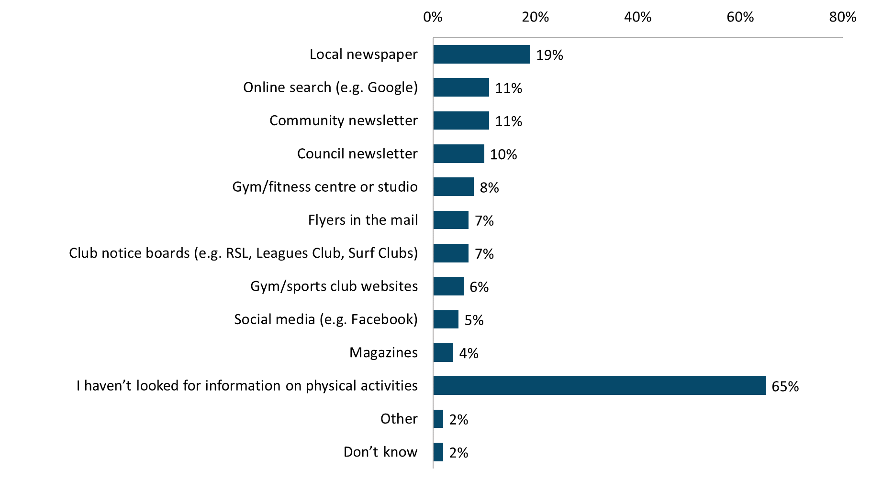

*Q16. Where have you looked for information on physical activity or sport to take part in, if at all? (Base: All respondents n=600)*

Those who currently participate in an organised sport are more likely to have searched for information (46%; compared to 33% of those who do not). Table 4 below outlines the channels they are more likely to have used.

Table 4: Information sources by organised sport participation

|  |  |  |
| --- | --- | --- |
|  | **Currently play a sport (n=105)** | **Do not play a sport  (n=475)** |
| Local newspaper | 28%↑ | 17%↓ |
| Club notice boards (e.g. RSL, Leagues Club, Surf Clubs) | 16%↑ | 5%↓ |
| Council newsletter | 16%↑ | 9%↓ |
| Gym/sports club websites | 15%↑ | 5%↓ |
| Gym/fitness centre or studio | 14%↑ | 6%↓ |

Information searched for

Among those who have searched for information, locations (80%), costs (68%) and timetables (59%) are most commonly sought after. This was reflected in the group discussions, with location being a deciding factor for many, as they were not inclined to spend too long travelling to an activity. Cost was also an influence for some as there are ancillary costs to think about such as parking.

“I pay for aqua aerobics per turn, but it’s not just that, you’ve got to pay for parking too and that adds another $6.” – Female, over 70 years

Figure 24: Types of information searched for

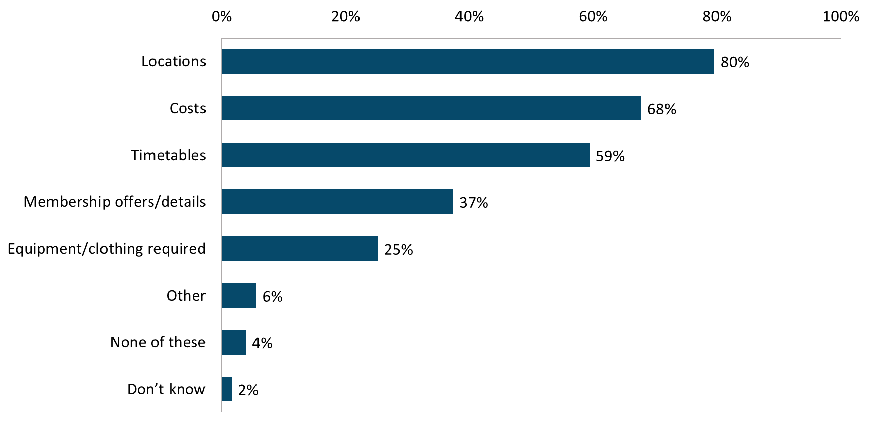

*Q17. What sort of information have you looked for? (Base: Those who have looked for participation information about physical activity or team sports n=200)*

Women are more likely to have looked for timetabling information (67%; compared with 51% of men). While men are more likely to have searched for information about the equipment or clothing required (33%; compared with 19% of women).

Other groups who are more likely to have searched for information about the equipment or clothing required include:

* those who are CALD (48%; compared with 21% of those who are not CALD); and
* those who currently play a sport (37%; compared with 22% of those who do not).

## Modified sports

**Almost one third (29%) are interested in participating in modified sports**, with interest highest among those in their 50s (35%) and those who are more physically able and who are already sports inclined.

**The promotion of sport to encourage anyone to participate is a popular idea** (62%), as is making participation free of change (67%). There is, however, an **expectation that there would be some cost** associated with taking part in sport. Two thirds (66%) agreed that more social play, rather than competition, should be encouraged; however, **removing all element of competition is seen as unrealistic and unappealing**. Similarly, while flexibility of membership options is an appealing notion for most (70%), it was agreed that there **needs to be some degree of commitment** or accountability to be able to form teams each session.

In terms of the actual modifications that were most appealing shorter games/matches (56%), **reducing the speed of the game** (46%), and **limiting physical contact** (44%) are the most likely to encourage participation.

**There are some concerns about modified sports**. Some believe they have the potential to be boring if they are not challenging enough, lacking the mental and physical benefits of physical exertion. For this reason, the idea of shorter games or matches received mixed reactions.

**Walking netball had more instant appeal than walking football**, mainly because many participants (all female) had played netball in the past and most (men and women) tended to be more familiar with netball than football. **Both concepts were popular**, with particular appeal among those who were very active in the past and had been unable to maintain it to the same level in recent years, as well as those who had remained active into their 50s and beyond. Collaboration with community organisations and sports clubs is seen as important in encouraging participation in modified sports.

### Interest in modified sports

Almost one third (29%) say they would be interested in participating in modified individual or team sports. A further two in five (40%) are not sure whether or not they would be interested. As identified during the focus groups this may be contingent on the specific types of modifications that are made. Age plays a role in the level of interest in modified sports, with those in their 50s being significantly more likely to say they are interested (35%; compared with 26% of those in their 60s and 70s).

Figure 25: Interested in modified sports

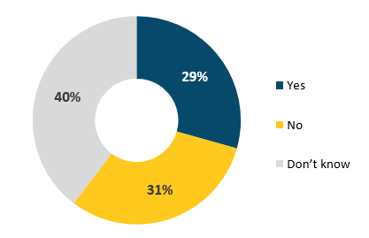

*Q19. Would you be interested in participating in individual or team sports that have been modified to make the activity safer, more accessible and more appropriate for people with a reduced physical capability? (Base: All respondents n=600)*

In addition to age, interest is generally higher among those who are more able and sports inclined. Almost half (45%) of those who currently participate in organised sport would be interested in modified sports, compared with 26% of those who do not currently participate. During the focus groups, a number of the more physically active participants expressed a desire to get back into sports they had played in the past or to give something new a try, with modified sports being identified as a great environment to do this in.

The qualitative research found that the idea of modified sports was not entirely new to some. As illustrated in the quotes below, some participants gave personal examples of how they had already modified physical activities to suit their capabilities and needs.

“I have a prosthetic arm that I bowl with, as I have vertigo so I can’t bend over without falling flat on my face.” – Female, 70-80 years

“I’m not physically able to actually swim, but I just walk up and down the pool and I really enjoy that – that’s my swimming.” - Female, 50-60 years

### The appeal of modified sports

Increasing interest in participation

The majority (62%) believe **changing the way sports are promoted to show anyone can participate** would encourage more people their age to take up a team or individual sport. This notion was also generally viewed in a positive light during the groups as it conveys a message of inclusivity and accessibility. It is also seen as a way of broadening the appeal of sports to those who have not played before, and those looking to do more physical activity, which we know from the quantitative findings makes up a significant proportion of older people (66%).

The idea of **making participation free of charge** is very popular, with two thirds (67%) saying they think this would increase organised sports participation amongst others their age. Three quarters (75%) of carers believe making participation free of charge would encourage more people their age to take up a team or individual sport (compared with 66% of non-carers). Most participants in the qualitative research thought it would be very enticing, especially for pensioners or those on a low income to make the sports free. However, they also acknowledged that is not likely to be realistic nor sustainable in the long term. There is an expectation that there would be a cost, but the general consensus was that it would be worthwhile running free trials or intro sessions to hook people in (who could then start paying if interested in further participation), and perhaps offering lower cost options for pensioners.

The qualitative research found that there was a positive reaction to the idea of modified sports **taking place at a range of times** to suit those aged over 50. When asked about what times these would be, aside from those who work, this is generally day time on weekdays. This time is most convenient for a number of reasons including, less traffic on the roads, no other commitments, and the facilities are not in use as they would likely be in the evenings and weekends. Once a week was the preferred frequency, more often and the questions around commitment levels come into play. In terms of the venue itself, most would prefer to play indoors as it is better for all seasons and the softer surfaces have less impact on the joints.

Figure 26: Measures to increase the appeal of organised sports

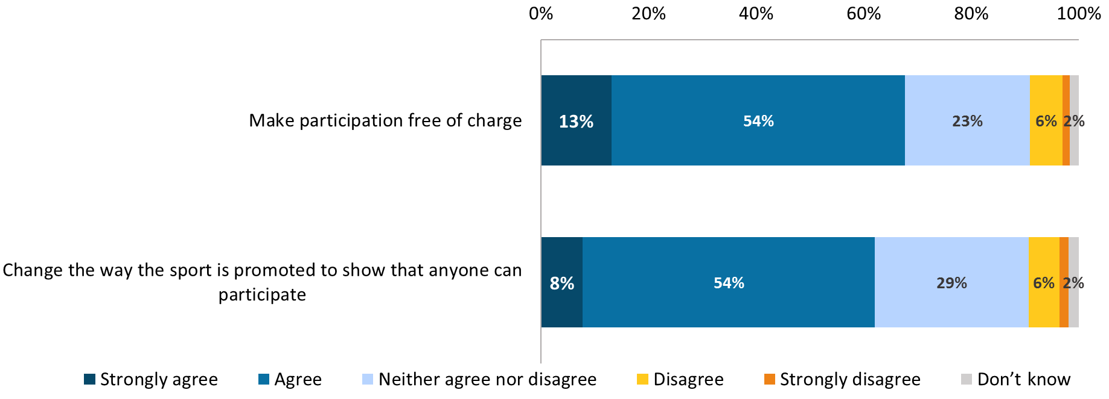

*Q18. Thinking specifically about organised individual or team sports, to what extent do you agree or disagree that the following would increase participation by people your age? (Base: All respondents n=600)*

Reducing competition

Two thirds (66%) believe **encouraging social play over competition** would increase participation among people their age. Participants in the focus groups tended to also agree with this, but while the majority did not see themselves as being overly competitive, they were unanimously against the idea of stripping all competitive elements out of modified sports. They generally felt that if there were to be no competition at all it would be demotivating. However, there was a broader appeal towards removing the traditional league or on-going weekly standings and just keep scores on the night. This sentiment was summed up by the quotes below:

“At the end of the day everyone knows who has won, people will still keep score.” - Male, 60-70 years

*“You want to play to win so the beer at the end of the game tastes a bit sweeter. – Male, 50-60 years*

*“Some sports are nothing without the competition.” – Female, 50-60 years*

In addition to only keeping score on the night, participants generally felt that making the **sports age and skill appropriate** would reduce a fair bit of the over competitive nature often associated with organised sport. The majority of participants did not express any desire to play against people half their age, or those of a similar age who had played at a top grade level for many years. Thus, it was agreed that by changing the objectives and the way the sport is positioned you would *“keep the machos and the high flyers off the field”*.

Figure 27: Agreement with measures to reduce competitive elements of organised sports

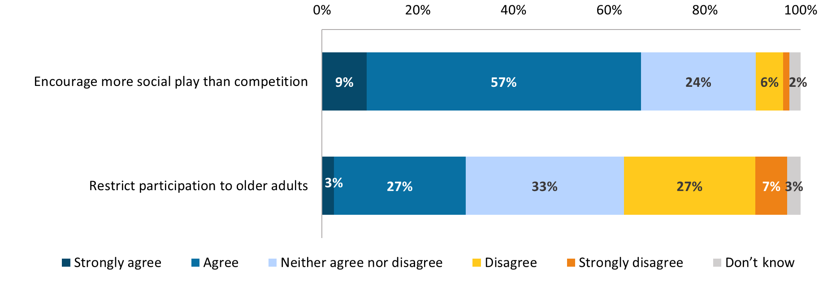

*Q18. Thinking specifically about organised individual or team sports, to what extent do you agree or disagree that the following would increase participation by people your age? (Base: All respondents n=600)*

Those who are more active than five years ago are more likely to agree encouraging social play over competition would increase participation amongst others their peers (79%; compared with 58% of those who are about the same, and 68% of those who are less active).

The following groups are more likely to agree restricting modified sports to older adults would increase participation among those aged over 50:

* women (37%; compared with 22% of men);
* those who are less active than they were five years ago (35%; compared with 27% of those who are more active, and 24% of those who are about the same); and
* those who do not currently participate in organised sport (33%; compared with 15% of those who do).

Potential modifications

In terms of specific modifications, the qualitative research found that changes that would lessen the impact on joints such as extra steps to slow down, walking instead of running, lighter or softer equipment, and softer ground rather than concrete, would be popular. The quantitative research found that there is support for shorter games (56%), as well as reducing the speed of games (46%) and limiting physical contact (44%). The focus groups included discussion of a desire for non-contact rules to reduce the chance of injury.

Figure 28: Desired modifications

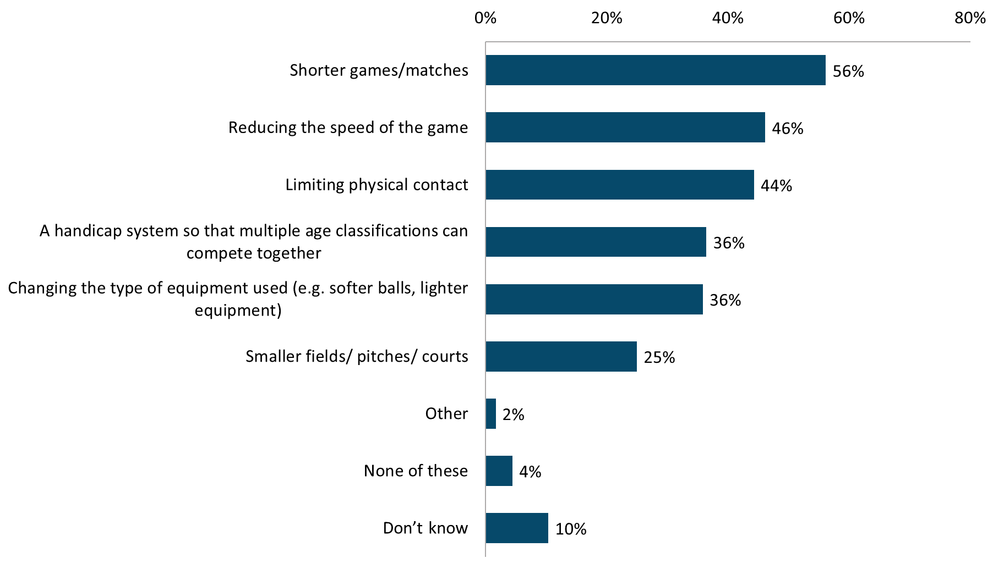

*Q20. Which, if any, of the following would make you more likely to participate in individual or team sports? (Base: Those who are interested in modified sports n=176)*

The following groups are more interested in having a handicap system implemented to that multiple age groups can compete together:

* those who currently participate in organised sport (57%; compared with 29% of those who do not); and
* Men (50%; compared to 23% of women).

### Concerns about modified sports

Extent of modification

The main concern raised in the qualitative research was the potential for modified sports to be boring or too slow. This was particularly an issue for those who are already quite active. These participants were concerned that they may not feel any real fitness benefit from a sport that has been heavily diluted.

“I want it to be a little bit demanding.” – Female, 50-60 years

In the first round of focus groups some of the less active participants were quick to complain that modified sports are “not the real thing’, so what is the point?”. Additionally, men wanted to avoid being perceived or stereotyped as an older person playing sport, particularly if they had enjoyed some success at this sport when they were younger.

Among those who are less physically able due to disability or previous injury, there was some unease around the notion of modified sports. They felt that it gave off a vibe of being rehab related particularly if word ‘modified’ is used in the name. For them there is a fine line between being open and accessible to all, versus being condescending and putting people with disabilities into a box because they are unable to participate in the ‘real thing’. This was particularly true for one participant who had lost his arm in an accident a number of years ago. He lamented the fact he had been an avid sailor for much of his life up until this point, and would have loved to be able to get back into it. With this in mind he tried a sailing group for people with disabilities but was disappointed to find that despite his vast experience and knowledge, they would not allow him to do anything other than drop the anchor due to his disability. For him this experience was very demeaning and has left him wary of activities that are supposedly modified for the people with disabilities.

“It feels like we’re being put out to pasture because we’re either too old or too disabled”

– Female, 70-80 years

“It doesn’t cater to all skill levels does it? It caters to those who cannot play the real thing”. – Male, 60-70 years

A third (32%) agreed that adjusting the rules would increase participation in organised sport among older people, and a further 45% neither agreed nor disagreed, reflecting feedback received in the qualitative research that details about exactly what adjustments would be made being important before being able to judge whether it would be appealing or not.

Figure 29: Adjusting the rules would increase participation in organised sports among older people

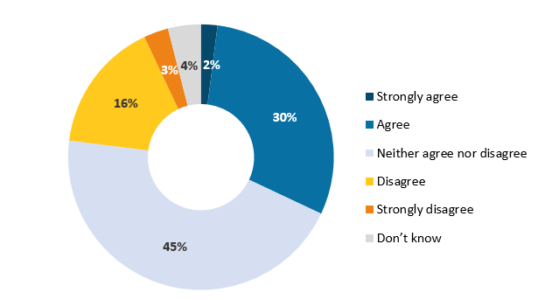

*Q18. Thinking specifically about organised individual or team sports, to what extent do you agree or disagree that the following would increase participation by people your age? – Adjust the rules (Base: All respondents n=600)*

Level of commitment

Most are in favour of something more casual than committing to an ongoing competition or league. Seven in ten (70%) think increasing the flexibility of membership options, with no long-term commitment would increase sport participation amongst others their age.

The qualitative research found that the general consensus was that there needs to be some degree of accountability or commitment to ensure at least two full teams would be available each week. This was largely driven by the fact that if they have made the effort to turn up only to find there was not enough players and the game had been cancelled, they would probably not bother to go back. To combat this, some felt a large pool of players would be required for each team, or just generally if teams were decided on the night. This would allow people the flexibility of skipping a week without letting others down.

“Having a flexibility is appealing as long as there are enough people in the team.” – Female, 50-60 years

Figure 30: Agreement with increasing the flexibility of membership options

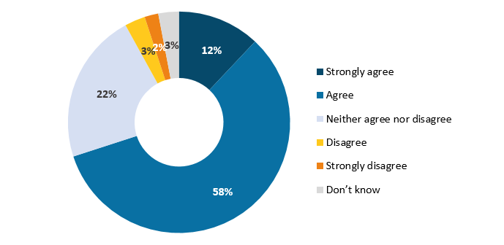

*Q18. Thinking specifically about organised individual or team sports, to what extent do you agree or disagree that the following would increase participation by people your age? -* *Increase flexibility of membership options, with no long-term commitment (Base: All respondents n=600)*

Women are more likely to agree that increasing the flexibility of membership options will increase participation amongst others their age (75%; compared with 65% of men).

Shorter matches

Participants raised concerns about the idea of shorter matches as many questioned whether it would be worthwhile attending. This was influenced by several factors, including the time taken to get to the venue. For example, one woman noted that she would be reluctant to travel an hour each way just to play one twenty minute or half-hour game. Many participants shared this sentiment, particularly those who would be relying on public transport as this could mean additional waiting periods.

Another area of concern was that being modified, coupled with shorter matches, may result in a complete absence of exertion or physical benefit. As previously mentioned, even those who are not physically capable of playing sports in their full form still expressed a desire for some level of exertion. They want to feel they have done some exercise and the sense of achievement that is associated with this.

### Reactions to specific concepts

Reactions to the walking netball and walking football (soccer) concepts were generally positive, particularly among the more active group. There is a genuine desire among those who are still quite active, to pick up sport again in an accessible and safe way. Interest levels were a bit higher for modified netball. However, this in part was due to the fact many of the women had played when they were younger. The term football was also met with some confusion, initially misinterpreted as Australian rules and rugby to begin with.

Walking netball

Walking netball received positive reactions from both men and women, particularly those who are already quite active. A few of the men noted they had never considered playing netball, but they would be willing to give something like this a go. When asked about the types of modifications they would expect to see, lower goals, a larger hoop and softer surface were all suggested.

Some questioned why netball would be chosen as a modified sport given the perceived high risk of ankle injuries. However, it was suggested that proper warm up and cool downs could be held prior to the games in order to reduce the risk of injury.

Walking football

The groups were more sceptical towards walking football. Most felt that it would need to be distinguished from traditional football to ensure overly serious and aggressively competitive players are kept off the field. However, this led to some concern that it may come across as being too childish. In terms of expected modifications, larger and softer balls, smaller pitches, smaller nets were all suggested.

“Reminds me a bit of little kids and them playing soccer with the smaller nets.” – Male, 60-70 years

### Local club involvement

The general consensus among focus group participants was that modified sports should be run through the local clubs as they have the facilities and expertise to run the games. However, those in the groups who are committee members or involved with sports clubs recognised that the Government would need to incentivise the clubs to encourage them to get on board. This was largely due to great concern about clubs’ willingness to take on liability or insurance for these sports.

Half of participants (51%) believe that collaboration with community organisations would increase organised sports participation among those aged over 50.

Figure 31: Collaboration with community organisations would increase participation

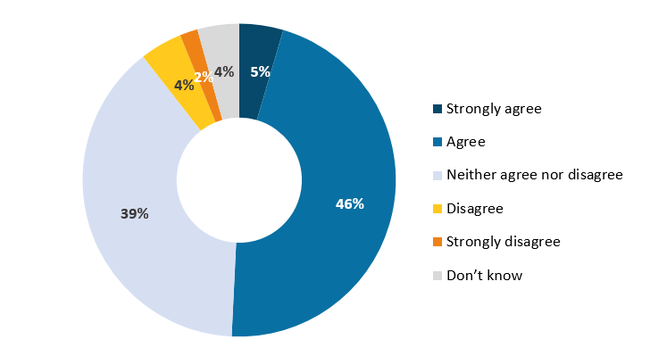

*Q18. Thinking specifically about organised individual or team sports, to what extent do you agree or disagree that the following would increase participation by people your age? – Collaboration with community organisations (Base: All respondents n=600)*

Those who say they are more active than five years ago are more likely to believe collaboration with community organisations would increase organised sports participation of those aged over 50 (62%; compared with 42% of those who are about the same, and 53% of those who are less active).

## Segments

### Segmentation overview

A latent class analysis was conducted to develop activity profiles of NSW residents aged over 50. Latent class analysis is a statistical modelling technique used to identify subgroups, or segments, within a data set. The analysis used responses to the attitudinal questions (Q1, Q2, Q14, Q15 and Q18) in the quantitative survey to classify respondents. The analysis yielded a total of four activity segments, outlined in Figure 31 below.

Figure 32: Segment overview

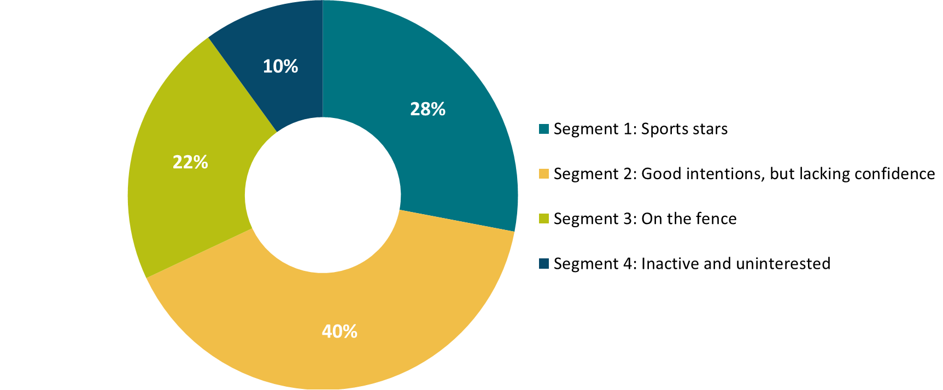

### Segment 1: Sports stars



Segment 1 comprises 28% of over-50-year olds. This segment is more likely than other segments to be university educated (35%), live in Sydney (65%) and have an annual income of over $100,000. All age groups feature equally in this segment.

Segment 1 is the only segment that is more active (32%) or equally active (39%) as they were 5 years ago, and see themselves as being a lot more active than others their age (79%). Members of this segment are more inclined to participate in cycling, going to the gym, home exercise, aquacise, running, strength training, swimming, gardening, walking, and hiking.

This segment is more likely than any other to recognise the benefits of physical activity, with reasons for participation being improved physical (91%) and mental health (75%), fun (76%), increased confidence (47%), social benefits (49%), and reduced risk of falls (31%). Exercise is not viewed as being a chore for this segment (only 13% view it as a chore), instead it is an important part of their routine (96%) and they feel a strong sense of achievement after exercising (96%).

As well as being more physically active than other segments, Segment 1 is also more likely to participate in organised sport (33%). Reasons for participation in organised sport include being part of a team (62%), commitment to a schedule (46%), and the sense of achievement that it brings (76%). Segment 1 also see participation in sport as a good way to stay sociable as they age (83%).

Despite already being a very active group, Segment 1 is interested in the idea of modified sports. They view encouraging social play over competition as a way to increase participation among others their age, and believe that collaboration with community organisations would encourage more people their age to participate. However, Segment 1 do not like the idea of adjusting the rules to encourage participation.

Half (50%) of Segment 1 have looked for information on physical activity or sports to take part in, significantly more than Segment 3 and Segment 4. Segment 1 currently find information about physical activity and sport through local sources, including local newspapers, council and community newsletters, and club notice boards; and look online.

### Segment 2: Good intentions, but lacking confidence



Two-fifths (40%) of over 50 year olds sit in Segment 2. Over half are female (57%), and nearly three quarters (71%) are in their 50s or 60s. Most of those in Segment 2 live in Sydney (59%), and over two fifths (42%) have an annual income of less than $50,000.

Segment 2 tend to be less active than they were 5 years ago (74%) and generally view themselves as being less active than others their age (42%). The physical activities Segment 2 are most inclined to take part in are dancing, home exercise, swimming, gardening, walking, and hiking/bushwalking.

Segment 2 are inclined to view exercise as a chore to some extent (44%), but there is a strong desire to be more active (84%).

Just over one in ten (11%) of Segment 2 currently take part in organised sport. Segment 2 are more likely than others to have several reasons for not participating in sports, including concern about the risk of injury (42%), a lack of skill (56%), health conditions (41%), and poor fitness levels (52%). This segment is also likely to feel they are too old to try a new sport (57%).

Despite their reservations about participating in organised sport, Segment 2 believe that if the way sports is promoted was changed (to show that anyone can participate), it may encourage more people their age to participate (74%). Segment 2 are interested in modified sports. They are in favour of restricting participation to older people (44%), encouraging more social play over competition (81%), shorter games (63%), reduced speed (55%), and adjusting the rules (45%). This segment also supports making participation free of charge (83%) an increasing in the flexibility of membership options with no long-term commitments to encourage more people their age to participate (86%); this would address their concerns about committing to regular participation in a sport.

Segment 2 look up information about physical activity and sports in local newspapers and via online searches.

### Segment 3: On the fence



Around a fifth (22%) of over-50 year olds fit into Segment 3. This segment is split across all the age groups, and both Sydney and regional NSW (although Regional NSW is over-represented, 47%). This segment has the lowest proportion with a University degree (18%), and like Segment 2, over two fifths (43%) have an annual income of under $50,000; and they are less likely than other segments to be working (33%).

Segment 3 tend to be equally active as they were 5 years ago (48%), and perceive themselves to be about as active as their peers (43%). Activities this segment are inclined to participate in are walking (89%), gardening (76%), swimming (31%), and hiking/bushwalking (27%).

Segment 3 are ambivalent about physical activity, with only 44% agreeing that they wished they were more active and 44% neither agreeing nor disagreeing; and almost half (48%) neither agreeing nor disagreeing about whether exercise is a chore (29% agree that it is). This segment is less likely than any of the other segments to feel a sense of achievement after exercising (39%) and less likely to have exercise as part of their routine (45%).

Only 13% of Segment 3 currently participate in organised sport. Rather than seeing themselves as too old to try a new sport (only 20% think this), Segment 3 are more likely to lack an opinion on this, with 39% saying their neither agree nor disagree with this. They also do not have a view on whether playing sport is a good way to stay sociable as they age (62% neither agree nor disagree with this). Segment 3 are similarly ambivalent when it comes to concern about the commitment involved with organised sport (54%) and whether they have the skills to participate (51% neither agree nor disagree).

Segment 3 are unsure whether changing the way sport is promoted would increase participation (68% neither agree nor disagree), whether making participation free of charge (64%), or whether increasing flexibility of membership options would do so (67%).

As with all other aspects of physical activity and sport, this segment has no strong opinions about modified sports. Most neither agree nor disagree that adjusting the rules (81%), restricting participation to older adults (66%), and encouraging more social play than competition (63%) would increase participation by their age group.

This segment is not actively looking for information on physical activity or sports.

### Segment 4: Inactive and uninterested

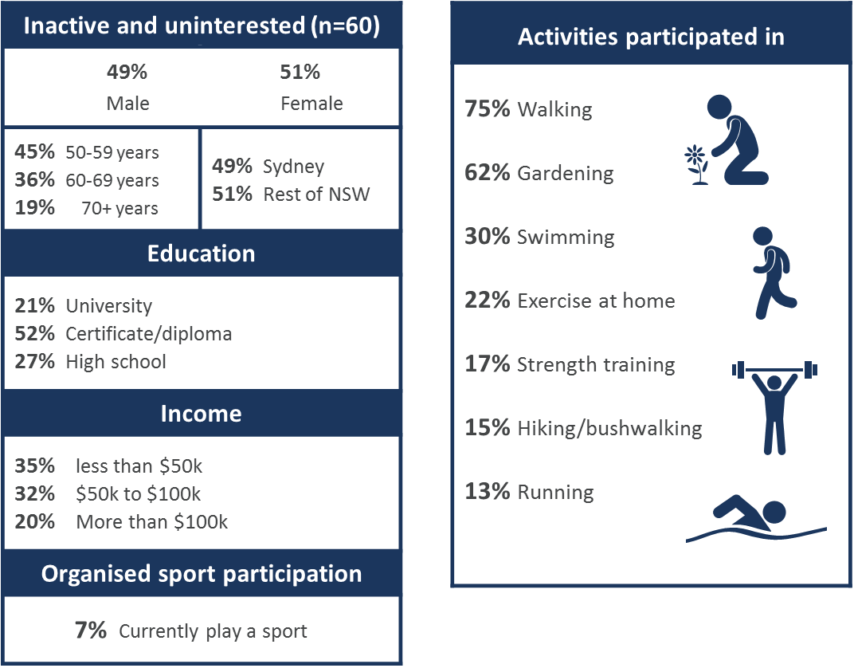

One in ten (10%) over-50-year old’s in the sample fall into Segment 4, the inactive and uninterested. All ages appear in this segment; however, it is primarily made up of people in their early 50s (45%). Segment 4 are slightly more likely to live in regional NSW (51%) than in Sydney. Both genders feature equally in this segment.

Most are doing the same amount or less activity than they were 5 years ago (81%). This segment is one of the most likely (along with Segment 2) to say they are less active than other people their age (42%). This segment is fairly unlikely to have physical activity as an important part of their routine. The activities they are most inclined to do are gardening and walking.

Segment 4 are likely to have the time to stay active (65% disagree that they don’t have the time to stay as active as they would like), but believe they have too many other priorities to spend time exercising (37%, significantly higher than segments 1 and 3).

They are more likely to find exercise a chore (45%, significantly more likely than Segments 1 and 3) and are less likely to feel a sense of achievement after exercising (48%, significantly less likely than segments 1 and 2). There is also some concern about risk of injury (37%).

There is some desire to be more active (63%), but significantly more of this segment than others do *not* wish to be more active (27%).

Only 7% of Segment 4 currently participate in organised sport (the lowest participation rate of all the segments), and this segment does not view participation in sports as a good way to stay sociable as they age (only 32% agree that it is). In terms of modified sports, they do not think that restricting participation to older adults would increase participation (only 22% think that it would).

Segment 4 members are generally not looking for information on physical activity or sports.

# Recommendations and conclusions

### Current physical activity

This research has found that almost all people aged over 50 are doing some physical activity, with only 4% not undertaking any physical activity at all. At the very least, almost all are walking (91%), with 70% doing so at least once a week. Physical activity has declined for most (53%), since they were younger, with fear of injury and loss of confidence leading to lower participation rates as people age. Life events such as children leaving home and health scares appear to prompt an increase in physical activity. Older people are participating in a wide range of physical activities, with walking (91%) and gardening (79%), being the most common. Given the nature of the physical activities participated in, most participation is done on a casual basis (as opposed to being part of a group, team or club).

The benefits of physical activity are widely recognised, and sentiment towards exercise is generally positive. The physical health benefits of staying active are seen as the main benefit (76%), and most feel a sense of achievement after excising (66%) and wish they were more active (66%). Those who have become more active in recent years and who currently participate in a sport more readily recognise the benefits of and feel positively towards physical activity, unsurprisingly, and this could be working both ways: participation leading to a realisation of the benefits, as well as recognition of the benefits increasing a person’s propensity to participate.

For most older people, there are no major barriers to participation in physical activity, but exercise feeling like a chore (32%), a lack of time (24%) and competing priorities (20%) can all make it more difficult. Among those who do no physical activity at all, lack of mobility is the main reason.

### Participation in organised sport

Nearly a fifth (17%) of older people participate in organised sport, with more men than women taking part (27%). Most sports participation is a combination of casual and as part of a club/league, but most are paying per session/game (61%). Golf (9%) and tennis (4%) are most commonly participated in. Many high impact sports have been given up, such as squash, netball and rugby.

The benefits of participation in organised sport are also widely recognised, with fun and enjoyment and social benefits being seen as benefits specific to organised sport.

Low interest in competition is the main reason given by those who do not participate in organised sport (52%). Lacking confidence in their own skills is also a key reason for not participating in organised sport (21%), particularly among women. The commitment perceived to be required, in terms of time and money, is also off-putting to some.

### Modified sports

Given that only 17% are currently participating in organised sport, there is certainly scope to increase sports participation among those aged over 50. There a genuine interest in the concept of modified sports (29%), especially among those who played sports in the past and those in their 50s (35%); furthermore, two thirds (66%) of those over 50 wish they were more active.

The research established that for most there are no significant barriers to taking part in modified sports. The feeling among the qualitative research participants was that if you are genuinely interested then you will find the time to participate. However, getting people there for the first time was perceived to be the main challenge. Time of day, location and cost all play a role in attracting prospective participants. It was generally felt that free sessions or trials would be an enticing way to get people along for the first couple of weeks. Once hooked in, most said they would be happy to pay as they realise there are costs involved in running sports activities and events.

Walking netball had more instant appeal than walking football, mainly because people were more familiar with netball than football. Both concepts were popular, with particular appeal among those who were very active in the past and had been unable to maintain their physical activity to the same level in recent years, as well as those who had remained active into their 50s and beyond.

Modified sports should retain some element of competition, the idea of removing all competitiveness from the sports was met with resistance. Some were concerned that an ongoing league or competition may require too much commitment. However, it was felt that on the night, games need to have a winner in order to instil motivation or a reason to play. The one caveat being there needs to be a large enough pool of players to structure the games without an ongoing competition. Many remarked they would be hesitant to return if games are cancelled due to a lack of players.

Views on the degree to which modifications should be made varied, with those who are more physically capable being concerned the sports could be boring if they are too diluted. However, most agreed that participation should be restricted to those over 50, and should also take skill into account (i.e. graded based on skill level).

The general consensus is that modified sports should be organised through local clubs. They are perceived to have the expertise and facilities to run the games. There is a desire among those not working for games to be held during the day when traffic is lighter and existing sports facilities are generally not in use.

Positioning

The notion of promoting modified sports by focusing on their physical and mental health benefits was very appealing. Some felt that if you include social benefits then it covers the ‘full package’: *“having fun and getting exercise”*. It was thought that promotion via clubs, seniors’ magazines, and newspapers would be most effective.

Wording should be considered carefully. There was some resistance to using the word ‘modified’, particularly among those who had physical disabilities. For them the word had very negative connotations and emphasised the fact they are not capable of playing the real thing. For others, it brought to mind rehabilitation from injury, rather than more positive associations. Again, the word ‘handicap’, even in the context of scoring was upsetting for those who are less able. These participants found it demeaning and felt as though they are being ‘put into box’. Among these participants positive wording is preferred. The term ‘relaxed sports’ was suggested as an alternative.

### Further research

There are a number of other factors to consider in terms of modified sports development that were not considered during this piece of research, including:

* Are mixed or single gender teams preferred? This could have an impact on the likelihood of participation for some.
* While the idea of grading based on skill was popular in the groups, it was not determined how this would work, particularly if games are one-offs rather than an ongoing competition.
* Promotion and communications, including how best to frame modified sports positively in the language used.

# Appendices

## Discussion guide (exploratory focus groups)

**INTRODUCTION 10 MINS**

* Thanks for taking the time to be part of this project.
* It’ll be a pretty relaxed discussion and will take 1½ to 2 hours.
* My name is… I work for Ipsos, an independent research agency.
* We’re interested in your thoughts and experiences in relation to physical activity and exercise participation.
* A few things to note before we start…
  + No right or wrong answers, just after your honest opinions.
  + Opinions differ – this makes it interesting! So make sure you have your say.
  + One person speaks at a time
  + We have a lot to cover so I may pull you back on track if you get away from the areas we want to talk about. Don’t be offended if I pull you back on track.
  + Confidential - report won’t include names, all responses combined, anonymous quotes.
  + Audio/video (if applicable) recording permission. Colleagues in another room, working on the project too.
  + Mobiles off please
  + Help yourselves to refreshments
  + Location of toilets and exits
* Any questions?
* Introduce yourselves: your name / where you live / your favourite hobby or pastime

**Exploration of physical activity**  **30 MINS**

Do you have a current routine for staying physically active?

* + Current activities
    - [Probe if necessary: walking, swimming, yoga, tennis, dancing etc.]

Who with? Alone or others?

* + Solo activities in a group environment? E.g. yoga, aquacise, gym classes
  + Alone? e.g. hiking, walking dog, swimming, cycling
  + Team sports? E.g. netball, soccer, basketball, Aus-tag/touch rugby, hockey etc.

How often?

* + Has your routine changed over time? If so, why do you think it has changed?

What are your thoughts and feelings towards staying physically active?

*If physically active:* Why do you take part in these activities?

* + Positive e.g. feel a sense of achievement? Do you enjoy it?
  + Negative e.g. is it a chore? / feel like they have to do it because it is good for them? Time consuming?

What are the **benefits** of staying active?

* + Maintaining physical health
  + Maintaining mental health
  + Flow-on effects e.g. better sleep, mood improvement
  + Fun/enjoyment
  + Social interaction

Is there anything that makes it difficult for you to stay physically active, or puts you off? *Ensure responses from those who are and those who are not physically active.*

* + Poor health/existing medical conditions;
  + risk of injury;
  + negative stereotypes/perceptions e.g. too old
  + negative expectations around the perceived benefits of exercise; and
  + lack of motivation
  + confidence
  + fitness level
  + Cost
  + Lack of appropriate opportunities/options that align with interest
  + Time
  + Transport

**Organised sports** **30 MINS**

We are now going to spend a bit of time talking about more specifically about organised sports.

Prompt if necessary: E.g. netball, soccer, basketball, Aus-tag/touch rugby, hockey etc.

Do you participate in any sports?

*If yes*: What sports?

What types of organised sport most interest you?

* individual activities where you participate as part of a club (e.g. athletics, archery, club swimming, gymnastics, cycling, lawn bowls)
* team sports where you participate as part of a club in a team (e.g. netball, football, hockey, rugby league)

*FOR THOSE WHO DO NOT PARTICIPATE IN ORGANISED SPORTS:* Have you ever participated in organised sports? If yes, why did you stop? If no, why not?

* + Risk of injury?
  + Decline in capability?
  + Negative stereotypes/perceptions? E.g. too old, felt excluded
  + Lack of opportunity? E.g. do not cater to people your age?
  + Do not enjoy it / not a competitive person

Can you see any perceived **benefit** in participating specifically in **organised sports**? If so, what would you say are the main benefits?

* + Social interaction
  + Building/maintaining social connections e.g. sense of belonging to a club
  + Maintaining physical health
  + Maintaining mental health
  + Fun/enjoyment

Is there anything that makes it difficult for you to take part in organised sport, or puts you off?

* + Lack of appropriate opportunities/options that align with interest
  + Lack of capability;
  + Risk of injury;
  + Negative stereotypes/perceptions e.g. too old
  + Lack of motivation
  + Fitness level
  + Care-giving responsibilities
  + Access – time/day/location

How do you think participation in organised team sport differs from individual organised activities? E.g. yoga, aquacise, dance or gym classes

* + Do you prefer solo activities over team sport? Why/Why not?
  + What about informal activities, not part of a club?
  + Probe fully.

**Encouraging physical activity** **15 MINS**

Where/how (if at all) do you find out about information on physical activities?

* + Online e.g. club/gym websites, general google
  + Social media
  + Friends/family
  + Community groups
  + Community notice boards
  + Newspaper ads

What sort of information do you look for?

* + Clubs/leagues to join?
  + Timetables for fitness classes?
  + New activities to try?
  + Costs involved
  + Time and location

What do you think would encourage more people in your age group to take part in:

* + Physical activity in general?
  + Organised sport?

What would encourage **you** to take part in more physical activity / organised sport?

What would make physical activity / organised sport more appealing?

* + - Development / modification of sport opportunities for older adults that are low impact or low/non-contact?

Would you be more inclined to participate if...?

* + Sports clubs or leagues collaborated with senior organisations to provide more opportunities for older adults to play sport with others of the same age?
    - Why/why not?

**Closing up**  **10 MINS**

* Having discussed physical activity generally, and team sports, is there anything else that you think would encourage older people to participate?
* Any other thoughts or comments?
* Thanks very much for your time tonight.
* *Hand out incentives and signature sheets*

## Discussion guide (modified sports concept testing)

**INTRODUCTION 10 MINS**

* Thanks for taking the time to be part of this project.
* It’ll be a pretty relaxed discussion and will take 1½ to 2 hours.
* My name is… I work for Ipsos, an independent research agency.
* We’re interested in your thoughts and experiences in relation to physical activity and exercise participation
* A few things to note before we start…
  + No right or wrong answers, just after your honest opinions
  + Opinions differ – this makes it interesting! So make sure you have your say
  + One person speaks at a time
  + We have a lot to cover so I may pull you back on track if you get away from the areas we want to talk about. Don’t be offended if I pull you back on track
  + Confidential - report won’t include names, all responses combined, anonymous quotes
  + Audio/video (if applicable) recording permission. Colleagues in another room, working on the project too
  + Mobiles off please
  + Help yourselves to refreshments
  + Location of toilets and exits
* Any questions?
* Introduce yourselves: your name / where you live / your favourite hobby or pastime

**Benefits and barriers 10 MINS**

*Brief exploration of the types of sports participants are most interested in for later reference, and the benefits and barriers (to inform subsequent discussion on specific ways to overcome these by modifying sports).*

* What types of organised sports most interest you?
  + individual activities where you participate as part of a club (e.g. athletics, archery, club swimming, gymnastics, cycling, lawn bowls)
  + team sports where you participate as part of a club in a team (e.g. netball, football, hockey, rugby league)
* Can you see any perceived **benefit** in participating specifically in **organised sports** at your age?
  + If so, what would you say are the main benefits?
* Is there anything that makes it difficult for you to take part in organised sport, or puts you off? PROBE:
  + Physical barriers, social barriers, transport/access, economic barriers/cost of participation, cultural barriers

**Potential modifications**  **20 MINS**

* Would you be more inclined to participate if these sports were modified to be more appropriate for older adults?
  + E.g. for older adults to be low impact or low/non-contact?
  + What modifications would make these sports more appropriate for older adults? Why?
* What sports would you be interested in participating in if they were to be modified?
  + Netball
  + Basketball
  + Hockey
  + Soccer
  + Cricket
  + Oztag/touch rugby
  + Australian football (Aussie rules)
  + Rugby (league or union)
  + Sailing
  + Tennis
  + Lawn bowls
  + Golf
  + Boxing
  + Baseball/softball
  + Squash
* How, specifically, would you anticipate these sports being modified?
  + Why these changes? What would they achieve?
* What changes to these sports would you consider being too extreme?
  + Why? What problems would these changes cause?

**Reactions to modified football and netball**  **20 MINS**

*Moderator to describe walking football and modified netball (order to be swapped between groups) and gather feedback after each sport.*

* Initial reactions?
  + Likes or dislikes?
* What do you feel or think when you hear this? Why?
* What is good about it?
* What’s not so good?
* Who do you think it is aimed at? Why?
* Is it relevant to you? Why/why not?
* Would you consider participating? Why? / Why not?
* Would it be successful? Why? / Why not?
* Who would you expect to organise this?
* Where would you like to see it being held?
* How would you improve this sport?

**Benefits**  **60 MINS**

We’re helping the NSW Department of Family and Community Services to encourage participation in modified sports.

I have some statements to show you – these aren’t ads, but they are a series of potential benefits of participating in modified sports that may encourage people like you to take part.

*The order of the benefits is to be randomised (note that benefits appear below in alphabetical order).*

1. **Modified sports are not physically demanding. They use smaller fields/pitches/courts, softer and lighter equipment, a reduced game speed and shorter matches**
2. **Modified sports don’t keep score, which minimises the competitive element and caters to all skill levels**
3. **Modified sports have little or no cost**
4. **Modified sports take place at a range of times to suit you**
5. **Playing modified sport allows you to be more active, which has both physical and mental health benefits**
6. **Playing modified sport allows you to meet new people and spend time with friends**
7. **Playing modified sport doesn’t require a long term commitment of your time. You can simply attend and start playing whenever you like, and stop whenever you like**
8. **Playing modified sport is fun and enjoyable, and takes the chore out of exercise**
9. **Playing modified sport provides you with confidence and a sense of achievement**
10. **Modified sport matches are short, allowing them to fit into a busy schedule**
11. **Modified sport uses a handicap system so that multiple age groups can compete together fairly**
12. **Modified sports are run by your local community organisations**
13. **Modified sports are safer than regular sports. You have a very low risk of being injured. Rules limit physical contact, and equipment is softer and lighter**
14. **Only older people are allowed to play modified sports**
15. **Playing modified sport provides an outlet for your competitive side**
16. **There are many different types of modified sports you can play**
17. **You can play modified sports at a location near you**
18. **You can play single player modified sports (such as sailing, tennis, golf and boxing), meaning you don’t need to be part of a team or make social commitments**

**SHOW EACH BENEFIT & READ OUT**

* Initial reactions?
  + Likes or dislikes?
* What do you feel or think when you hear this? Why?
* Is this believable? Why/why not?
* What’s it saying or suggesting to you personally?
  + What’s your response to that?
  + Is it relevant to you?
  + Why/why not?
* Did it make you think of anything you hadn’t initially thought of?
* How would you improve this benefit?

**REVIEW IDEAS**

So which of these benefits we’ve discussed is the best to communicate? Why?

* Is that the one most likely to encourage you to participate?
* And which would you be most likely to remember if I called and spoke to you in a few days’ time?

**Closing up**  **5 MINS**

* Any other thoughts or comments?
* Thanks very much for your time tonight.
* *Hand out incentives and signature sheets*

## Questionnaire

SECTION A: SCREENER QUESTIONS

S1. Are you…?

{SINGLE RESPONSE}

[RECRUIT TO QUOTA, randomise ROWS]

|  |  |  |
| --- | --- | --- |
| Female | 1 |  |
| Male | 2 |  |
| Prefer not to say | 3 | TERMINATE |

S2. In what year were you born?

{NUMERICAL}

|  |  |  |  |
| --- | --- | --- | --- |
|  |  |  |  |

[RECRUIT TO QUOTA, TERMINATE IF UNDER 50 YEARS OLD, I.E. BORN IN YEARS 1968-2017]

|  |  |  |
| --- | --- | --- |
| I’d prefer not to say {EXCLUSIVE} | 98 | TERMINATE |

S3. And what is the postcode where you live?

[RECRUIT 2000-2999 ONLY, TERMINATE IF NOT 2000-2999]

{NUMERICAL}

|  |  |  |  |
| --- | --- | --- | --- |
|  |  |  |  |

[RECRUIT TO QUOTA]

|  |  |  |
| --- | --- | --- |
| Don’t know/not applicable {EXCLUSIVE} | 99 | TERMINATE |

SECTION B: Current activity

**Physical activity**

1. Thinking about your level of physical activity 5 years ago, would you say you are now…?

[reverse codes 1-5 for half of respondents]

{SINGLE response}

|  |  |
| --- | --- |
| A lot more active | 1 |
| A little more active | 2 |
| About the same | 3 |
| A little less active | 4 |
| A lot less active | 5 |
| Don’t know | 99 |

1. And compared to other people your age would you say you are…?

[reverse codes 1-5 for half of respondents]

{SINGLE response}

|  |  |
| --- | --- |
| A lot more active | 1 |
| A little more active | 2 |
| About the same | 3 |
| A little less active | 4 |
| A lot less active | 5 |
| Don’t know | 99 |
|  |  |

1. How often, if at all, do you currently participate in the following activities?

Please select one answer per row.

{single RESPONSE per row}

[RANDOMISE ROWS 1-19 but keep 5 above 6] [reverse scale for 50%]

|  |  |  |  |  |  |  |  |
| --- | --- | --- | --- | --- | --- | --- | --- |
|  | |  | Once a week or more | About once every 2 weeks | About once a month | Less than once a month | Never |
| 1 | | Cycling | 1 | 2 | 3 | 4 | 5 |
| 2 | | Dancing [IF CODE 1-4 ASK What type of dancing? [Write in] | 1 | 2 | 3 | 4 | 5 |
| 3 | | Yoga | 1 | 2 | 3 | 4 | 5 |
| 4 | | Tai-chi | 1 | 2 | 3 | 4 | 5 |
| 5 | | Exercising in a gym/fitness centre (not including gym classes) | 1 | 2 | 3 | 4 | 5 |
| 6 | | Exercising at home (using home fitness equipment) | 1 | 2 | 3 | 4 | 5 |
| 7 | | Aquacise/water aerobics | 1 | 2 | 3 | 4 | 5 |
| 8 | | Gym classes | 1 | 2 | 3 | 4 | 5 |
| 9 | | Jogging/running | 1 | 2 | 3 | 4 | 5 |
| 10 | Martial arts | | 1 | 2 | 3 | 4 | 5 |
| 11 | | Strength training (using free weights or machines) | 1 | 2 | 3 | 4 | 5 |
| 12 | | Swimming | 1 | 2 | 3 | 4 | 5 |
| 13 | | Horse riding | 1 | 2 | 3 | 4 | 5 |
| 14 | | Canoeing/kayaking | 1 | 2 | 3 | 4 | 5 |
| 15 | | Gardening | 1 | 2 | 3 | 4 | 5 |
| 16 | | Walking | 1 | 2 | 3 | 4 | 5 |
| 17 | | Hiking/bushwalking | 1 | 2 | 3 | 4 | 5 |
| 18 | | Surfing | 1 | 2 | 3 | 4 | 5 |
| 19 | | Gymnastics | 1 | 2 | 3 | 4 | 5 |
| 20 | | Other physical activity– please specify [SPECIFY] | 1 | 2 | 3 | 4 | 5 |

[ASK IF Q3= 1-4 at any row 1-20]

1. Do you participate in this activity or these activities on a casual basis or as a member of a group/ team/ club, or both?

Please select one answer per activity.

{single RESPONSE per row}

[KEEP SAME ROW ORDER AS Q3, ONLY SHOW THOSE WITH COLUMN 1-4 RESPONSE AT Q3]

|  |  |  |  |  |
| --- | --- | --- | --- | --- |
|  |  | Casually | As a member of a group/ team/ club | Both casually and as a member of a group/ team/ club |
| 1 | Cycling | 1 | 2 | 3 |
| 2 | Dancing | 1 | 2 | 3 |
| 3 | Yoga | 1 | 2 | 3 |
| 4 | Tai-chi | 1 | 2 | 3 |
| 5 | Exercising in a gym/fitness centre (not including gym classes) | 1 | 2 | 3 |
| 6 | Exercising at home (using home fitness equipment) | 1 | 2 | 3 |
| 7 | Aquacise/water aerobics | 1 | 2 | 3 |
| 8 | Gym classes | 1 | 2 | 3 |
| 9 | Jogging/running | 1 | 2 | 3 |
| 10 | Martial arts | 1 | 2 | 3 |
| 11 | Strength training (using free weights or machines) | 1 | 2 | 3 |
| 12 | Swimming | 1 | 2 | 3 |
| 13 | Horse riding | 1 | 2 | 3 |
| 14 | Canoeing/kayaking | 1 | 2 | 3 |
| 15 | Gardening | 1 | 2 | 3 |
| 16 | Walking | 1 | 2 | 3 |
| 17 | Hiking/bushwalking | 1 | 2 | 3 |
| 18 | Surfing | 1 | 2 | 3 |
| 19 | Gymnastics | 1 | 2 | 3 |
| 20 | Other physical activity– [PIPE IN RESPONSE FROM Q3 Other] | 1 | 2 | 3 |

[ASK IF Q3= 1-4 at any row 1-20]

1. And of the activity or activities you take part in, do you **usually** do these alone or with other people you already know?

Please select one answer per activity.

{SINGLE RESPONSE PER ROW}

[KEEP SAME ROW ORDER AS Q3, ONLY SHOW RESPONSES SELECTED AT Q3]

|  |  |  |  |
| --- | --- | --- | --- |
|  |  | Alone | With people you already know |
| 1 | Cycling | 1 | 2 |
| 2 | Dancing | 1 | 2 |
| 3 | Yoga | 1 | 2 |
| 4 | Tai-chi | 1 | 2 |
| 5 | Exercising in a gym/fitness centre | 1 | 2 |
| 6 | Exercising at home (using home fitness equipment) | 1 | 2 |
| 7 | Aquacise/water aerobics | 1 | 2 |
| 8 | Gym classes | 1 | 2 |
| 9 | Jogging/running | 1 | 2 |
| 10 | Martial arts | 1 | 2 |
| 11 | Strength training (using free weights or machines) | 1 | 2 |
| 12 | Swimming | 1 | 2 |
| 13 | Horse riding | 1 | 2 |
| 14 | Canoeing/kayaking | 1 | 2 |
| 15 | Gardening | 1 | 2 |
| 16 | Walking | 1 | 2 |
| 17 | Hiking/bushwalking | 1 | 2 |
| 18 | Surfing | 1 | 2 |
| 19 | Gymnastics | 1 | 2 |
| 20 | Other [PULL IN RESPONSE FROM Q3 Other] | 1 | 2 |

**Team or competitive sports**

1. Which, if any, of the following sports do you currently take part in, or have you taken part in in the past?

Please select one answer per row.

{SINGLE RESPONSE PER ROW}

[RANDOMISE ROWS 1-15]

|  |  |  |  |  |
| --- | --- | --- | --- | --- |
|  |  | Currently take part in | Have taken part in the past, but no longer do | Have never taken part in |
| 1 | Netball | 1 | 2 | 3 |
| 2 | Basketball | 1 | 2 | 3 |
| 3 | Hockey | 1 | 2 | 3 |
| 4 | Soccer | 1 | 2 | 3 |
| 5 | Cricket | 1 | 2 | 3 |
| 6 | Oztag/touch rugby | 1 | 2 | 3 |
| 7 | Australian football (Aussie rules) | 1 | 2 | 3 |
| 8 | Rugby (league or union) | 1 | 2 | 3 |
| 9 | Sailing | 1 | 2 | 3 |
| 10 | Tennis | 1 | 2 | 3 |
| 11 | Lawn bowls | 1 | 2 | 3 |
| 12 | Golf | 1 | 2 | 3 |
| 13 | Boxing | 1 | 2 | 3 |
| 14 | Baseball/softball | 1 | 2 | 3 |
| 15 | Squash | 1 | 2 | 3 |
| 16 | Other sports – please specify [SPECIFY] | 1 | 2 | - |

[ASK IF Q6=1 for any row 1-16]

1. Approximately how often do you participate in each of these sports (including training and playing/competing)?

Please select one answer per sport.

{SINGLE RESPONSE PER ROW}

[KEEP SAME ROW ORDER AS Q6, ONLY SHOW RESPONSES where Q6=1 in COLUMN]

|  |  |  |  |  |  |
| --- | --- | --- | --- | --- | --- |
|  |  | Once a week or more | About once every 2 weeks | About once a month | Less than once a month |
| 1 | Netball | 1 | 2 | 3 | 4 |
| 2 | Basketball | 1 | 2 | 3 | 4 |
| 3 | Hockey | 1 | 2 | 3 | 4 |
| 4 | Soccer | 1 | 2 | 3 | 4 |
| 5 | Cricket | 1 | 2 | 3 | 4 |
| 6 | Oztag/touch rugby | 1 | 2 | 3 | 4 |
| 7 | Australian football (Aussie rules) | 1 | 2 | 3 | 4 |
| 8 | Rugby league | 1 | 2 | 3 | 4 |
| 9 | Sailing | 1 | 2 | 3 | 4 |
| 10 | Tennis | 1 | 2 | 3 | 4 |
| 11 | Lawn bowls | 1 | 2 | 3 | 4 |
| 12 | Golf | 1 | 2 | 3 | 4 |
| 13 | Boxing | 1 | 2 | 3 | 4 |
| 14 | Baseball/softball | 1 | 2 | 3 | 4 |
| 15 | Squash | 1 | 2 | 3 | 4 |
| 16 | Other – please specify [PULL IN RESPONSE FROM Q6 Other] | 1 | 2 | 3 | 4 |

[ASK IF Q6=1 for any row 1-16]

1. Thinking about the sport(s) you currently participate in, do you do this on a casual basis, or as part of a club/league?

Please select one answer per sport.

{SINGLE RESPONSE PER ROW}

[KEEP SAME ROW ORDER AS Q6 ONLY SHOW RESPONSES where Q6=1 IN COLUMN]

|  |  |  |  |  |
| --- | --- | --- | --- | --- |
|  |  | Casually | Club/league | Both casually and as part of a club/league |
| 1 | Netball | 1 | 2 | 3 |
| 2 | Basketball | 1 | 2 | 3 |
| 3 | Hockey | 1 | 2 | 3 |
| 4 | Soccer | 1 | 2 | 3 |
| 5 | Cricket | 1 | 2 | 3 |
| 6 | Oztag/touch rugby | 1 | 2 | 3 |
| 7 | Australian football (Aussie rules) | 1 | 2 | 3 |
| 8 | Rugby league | 1 | 2 | 3 |
| 9 | Sailing | 1 | 2 | 3 |
| 10 | Tennis | 1 | 2 | 3 |
| 11 | Lawn bowls | 1 | 2 | 3 |
| 12 | Golf | 1 | 2 | 3 |
| 13 | Boxing | 1 | 2 | 3 |
| 14 | Baseball/softball | 1 | 2 | 3 |
| 15 | Squash | 1 | 2 | 3 |
| 16 | Other – please specify [PULL IN RESPONSE FROM Q6 Other] | 1 | 2 | 3 |

[ASK IF Q6=1 for any row 1-16]

1. On what basis do you pay for the sports you take part in, if at all?

Please select all that apply.

[SHOW TEXT IF MORE THAN ONE SPORT CHOSEN AT Q6=1] Please click right arrow to show next sport

{multiple RESPONSE PER ROW for codes 1 and 2, codes 3 and 97 exclusive}

[KEEP SAME ROW ORDER AS Q6, ONLY SHOW RESPONSES where Q6=1 IN COLUMN]

|  |  |  |  |  |  |
| --- | --- | --- | --- | --- | --- |
|  |  | Pay a membership fee/subscription | Pay per game/session attended | It’s free | Don’t know/ not sure |
| 1 | Netball | 1 | 2 | 3 | 97 |
| 2 | Basketball | 1 | 2 | 3 | 97 |
| 3 | Hockey | 1 | 2 | 3 | 97 |
| 4 | Soccer | 1 | 2 | 3 | 97 |
| 5 | Cricket | 1 | 2 | 3 | 97 |
| 6 | Oztag/touch rugby | 1 | 2 | 3 | 97 |
| 7 | Australian football (Aussie rules) | 1 | 2 | 3 | 97 |
| 8 | Rugby league | 1 | 2 | 3 | 97 |
| 9 | Sailing | 1 | 2 | 3 | 97 |
| 10 | Tennis | 1 | 2 | 3 | 97 |
| 11 | Lawn bowls | 1 | 2 | 3 | 97 |
| 12 | Golf | 1 | 2 | 3 | 97 |
| 13 | Boxing | 1 | 2 | 3 | 97 |
| 14 | Baseball/softball | 1 | 2 | 3 | 97 |
| 15 | Squash | 1 | 2 | 3 | 97 |
| 16 | Other – please specify [PULL IN RESPONSE FROM Q6 Other] | 1 | 2 | 3 | 97 |

[ASK IF Q6~=1 FOR ALL ROWS 1-16]

1. Which, if any, of the following describe your reasons for not currentlyparticipating in organised/team sport?

Please select all that apply.

{MULTIPLE RESPONSE codes 1-97}

[RANDOMIZE ROWS 1-13, but keep 8 above 9]

|  |  |
| --- | --- |
| I don’t want to make a long term commitment of my time | 1 |
| I am concerned about being injured | 2 |
| I don’t have enough time | 3 |
| Training occurs at difficult times | 4 |
| I am not interested in competition | 5 |
| I have other priorities | 6 |
| The financial cost of participating (e.g. membership fees) is too high | 8 |
| I don’t want to make a long term financial commitment to it | 9 |
| I am worried that I won’t be accepted or fit into the group | 10 |
| I don’t have the skills | 11 |
| I don’t have good health | 12 |
| I don’t think I am fit enough | 13 |
| Other – please specify [SPECIFY] | 97 |
| None of these | 98 |
| Don’t know | 99 |

SECTION C: Motivation and barriers

<ASK IF Q3= 1-4 at any row 1-20>

1. Which, if any, of the following best describe the reasons that you take part in physical activity?

Please select all that apply.

{MULTIPLE RESPONSE}

[RANDOMISE ROWS 1-6]

|  |  |
| --- | --- |
| Physical health benefits (e.g. reduce risk of diseases, weight loss) | 1 |
| Mental health benefits (e.g. reduction of stress) | 2 |
| Confidence and sense of achievement | 3 |
| Social benefits (e.g. meeting new people or spending time with friends) | 4 |
| Reduce the risk of falls | 5 |
| Fun and enjoyment | 6 |
| Other (please specify) [SPECIFY] | 97 |
| None of these {EXCLUSIVE} | 98 |
| Don’t know {EXCLUSIVE} | 99 |

<ASK IF Q6=1 at any row 1-16>

1. Which, if any, of the following best describe the reasons that you take part in organised/team sport?

Please select all that apply.

{MULTIPLE RESPONSE}

[RANDOMISE ROWS 1-9]

|  |  |
| --- | --- |
| Physical health benefits (e.g. reduce risk of diseases, weight loss) | 1 |
| Mental health benefits (e.g. reduction of stress) | 2 |
| Confidence and sense of achievement | 3 |
| Social benefits (e.g. meeting new people or spending time with friends) | 4 |
| Reduce the risk of falls | 5 |
| Fun and enjoyment | 6 |
| I enjoy the competition | 7 |
| I enjoy being part of a team | 8 |
| Committing to a team/schedule means I stick at it | 9 |
| Other (please specify) [SPECIFY] | 97 |
| None of these {EXCLUSIVE} | 98 |
| Don’t know {EXCLUSIVE} | 99 |

[ASK IF Q3= 5 at All rows 1-20]

1. Which, if any, of the following puts you off or makes it difficult for you to participate in physical activity?

Please select all that apply.

{multiple response}

[Randomise rows 1-11]

|  |  |
| --- | --- |
| Risk of injury | 1 |
| Lack of motivation | 2 |
| Not enough time | 3 |
| Competing priorities (e.g. household and community obligations) | 4 |
| Lack of fitness | 5 |
| Poor health | 6 |
| Lack of mobility | 7 |
| The financial cost of participating (e.g. membership fees) | 8 |
| Inappropriate facilities | 9 |
| Exercise classes are not held at times that suit me | 10 |
| Lack of options in my local area | 11 |
| Other (please specify) [SPECIFY] | 97 |
| None of these {EXCLUSIVE} | 98 |
| Don’t know {EXCLUSIVE} | 99 |

1. To what extent do you agree or disagree with the following statements about physical activity?

Please select one answer per statement.

{SINGLE RESPONSE per row}

[RANDOMISE ROWS 1-8]

|  |  |  |  |  |  |  |  |
| --- | --- | --- | --- | --- | --- | --- | --- |
|  |  | Strongly agree | Agree | Neither agree nor disagree | Disagree | Strongly disagree | Don’t know/not applicable |
| 1 | Exercise is a chore | 1 | 2 | 3 | 4 | 5 | 99 |
| 2 | I don’t have the time to stay as active as I would like | 1 | 2 | 3 | 4 | 5 | 99 |
| 3 | I am concerned about the risk of injury | 1 | 2 | 3 | 4 | 5 | 99 |
| 4 | I feel a sense of achievement after exercising | 1 | 2 | 3 | 4 | 5 | 99 |
| 5 | Physical activity is an important part of my routine | 1 | 2 | 3 | 4 | 5 | 99 |
| 6 | I wish I was more active | 1 | 2 | 3 | 4 | 5 | 99 |
| 7 | I only want to do physical activity with a friend or friends | 1 | 2 | 3 | 4 | 5 | 99 |
| 8 | I have too many other priorities to spend time exercising | 1 | 2 | 3 | 4 | 5 | 99 |

1. To what extent do you agree or disagree with the following statements about organised individual or team sports?

Please select one answer per statement.

{SINGLE RESPONSE per row}

[RANDOMISE ROWS 1-6]

|  |  |  |  |  |  |  |  |
| --- | --- | --- | --- | --- | --- | --- | --- |
|  |  | Strongly agree | Agree | Neither agree nor disagree | Disagree | Strongly disagree | Don’t know/not applicable |
| 1 | I am too old to try a new sport | 1 | 2 | 3 | 4 | 5 | 99 |
| 2 | Participating in sports is a good way to stay sociable as I age | 1 | 2 | 3 | 4 | 5 | 99 |
| 3 | I feel a sense of achievement from completing a sporting goal | 1 | 2 | 3 | 4 | 5 | 99 |
| 4 | I only want to join a sports team or club if my friends join too | 1 | 2 | 3 | 4 | 5 | 99 |
| 5 | I am concerned about the level of commitment involved | 1 | 2 | 3 | 4 | 5 | 99 |
| 6 | I don’t have the skills or ability to play a sport | 1 | 2 | 3 | 4 | 5 | 99 |

Section D: Information

1. Where have you looked for information on physical activity or sport to take part in, if at all?

Please select all that apply  
{multiple RESPONSE}

[randomise CODES 1-10]

|  |  |
| --- | --- |
| Online search (e.g. Google) | 1 |
| Gym/sports club websites | 2 |
| Club notice boards (e.g. RSL, Leagues Club, Surf Clubs) | 3 |
| Local newspaper | 4 |
| Council newsletter | 5 |
| Social media (e.g. Facebook) | 6 |
| Flyers in the mail | 7 |
| Community newsletter | 8 |
| Gym/fitness centre or studio | 9 |
| Magazines | 10 |
| Other (please specify) [SPECIFY] | 11 |
| I haven’t looked for information on physical activities | 98 |
| Don’t know | 99 |

<ASK IF Q16 = CODES 1-11>

1. What sort of information have you looked for?

Please select all that apply.

{multiple RESPONSE}

[randomise 1-5]

|  |  |
| --- | --- |
| Costs | 1 |
| Equipment/clothing required | 2 |
| Membership offers/details | 3 |
| Timetables | 4 |
| Locations | 5 |
| Other (please specify) [SPECIFY] | 96 |
| None of these | 98 |
| Don’t know | 99 |

Section E: Strategies to increase participation

1. Thinking specifically about organised individual or team sports, to what extent do you agree or disagree that the following would increase participation by people your age?

Please select one answer per statement.

{multiple response}

[RANDOMISE ROWS 1-7]

|  |  |  |  |  |  |  |  |
| --- | --- | --- | --- | --- | --- | --- | --- |
|  |  | Strongly agree | Agree | Neither agree nor disagree | Disagree | Strongly disagree | Don’t know/not sure |
| 1 | Change the way the sport is promoted to show that anyone can participate | 1 | 2 | 3 | 4 | 5 | 99 |
| 2 | Encourage more social play than competition | 1 | 2 | 3 | 4 | 5 | 99 |
| 3 | Increase flexibility of membership options, with no long term commitment | 1 | 2 | 3 | 4 | 5 | 99 |
| 4 | Collaborate with community organisations | 1 | 2 | 3 | 4 | 5 | 99 |
| 5 | Adjust the rules | 1 | 2 | 3 | 4 | 5 | 99 |
| 6 | Make participation free of charge | 1 | 2 | 3 | 4 | 5 | 99 |
| 7 | Restrict participation to older adults | 1 | 2 | 3 | 4 | 5 | 99 |

1. Would you be interested in participating in individual or team sports that have been modified to make the activity safer, more accessible and more appropriate for people with a reduced physical capability?

{SINGLE RESPONSE}

[Reverse ORDER OF 1-2 for half of participants]

|  |  |
| --- | --- |
| Yes | 1 |
| No | 2 |
| Don’t know/not sure | 99 |

[ASK IF Q19=1]

1. Which, if any, of the following would make you more likely to participate in individual or team sports?

Please select all that apply.

{MULTIPLE RESPONSE}

[RANDOMIse Rows 1-6]

|  |  |
| --- | --- |
| Smaller fields/ pitches/ courts | 1 |
| A handicap system so that multiple age classifications can compete together | 2 |
| Limiting physical contact | 3 |
| Changing the type of equipment used (e.g. softer balls, lighter equipment) | 4 |
| Shorter games/matches | 5 |
| Reducing the speed of the game | 6 |
| Other – please specify [SPECIFY] | 97 |
| None of these | 98 |
| Don’t know/not applicable | 99 |

DEMOGRAPHICS

1. Which of the following best describes your work status?

{single RESPONSE}

[REVERSE 1-4 FOR HALF OF PARTICIPANTS]

|  |  |
| --- | --- |
| Working full time (more than 30 hours per week) | 1 |
| Working part time (less than 30 hours per week) | 2 |
| Unemployed | 3 |
| Retired | 4 |
| Don’t know | 99 |

1. What is your approximate annual household income before tax? That is, the combined income of all members of your household.

{SINGLE RESPONSE}

[REVERSE 1-6 FOR HALF OF PARTICIPANTS]

|  |  |
| --- | --- |
| Less than $25,000 | 1 |
| Between $25,000 and $49,999 | 2 |
| Between $50,000 and $74,999 | 3 |
| Between $75,000 and $99,999 | 4 |
| Between $100,000 and $149,999 | 5 |
| $150,000 or more | 6 |
| I’d prefer not to say | 98 |

1. What is the highest level of education that you have completed?

{SINGLE RESPONSE}

[REVERSE 1-8 FOR HALF OF PARTICIPANTS]

|  |  |
| --- | --- |
| Postgraduate Degree (Masters, PhD) | 1 |
| Graduate Diploma or Graduate Certificate | 2 |
| Bachelor Degree (Undergraduate, Honours) | 3 |
| Advanced Diploma or Diploma | 4 |
| Certificate (TAFE) | 5 |
| Year 12 | 6 |
| Year 11 | 7 |
| Year 10 or under | 8 |
| I’d prefer not to say | 98 |

1. Do you speak a language other than English at home?

{SINGLE RESPONSE}

|  |  |
| --- | --- |
| Yes – please specify [SPECIFY] | 1 |
| No, but my parents speak/spoke a language other than English at home – please specify [SPECIFY] | 2 |
| No | 3 |
| I’d prefer not to say | 98 |

1. Do you identify as being of Aboriginal origin, Torres Strait Islander origin, or both?

{SINGLE RESPONSE}

[REVERSE 1-3 FOR HALF OF PARTICIPANTS]

|  |  |
| --- | --- |
| Yes, Aboriginal | 1 |
| Yes, Torres Strait Islander | 2 |
| Yes, both Aboriginal and Torres Strait Islander | 3 |
| No | 4 |
| I’d prefer not to say | 98 |

1. Are you currently a carer for any of the following?

By ‘carer’, we mean providing regular care for someone. For example, a grandchild or grandchildren, or providing ongoing support for someone who needs it because of disability, mental illness, a chronic health condition, dementia or ageing.

Please select all that apply.

{multiple RESPONSE}

[RANDOMISE ROWS 1-6]

|  |  |
| --- | --- |
| Your parent/parents | 1 |
| Your older relative (e.g. aunt, uncle) | 2 |
| Your spouse or partner | 3 |
| Your child/children | 4 |
| Your grandchild/grandchildren | 5 |
| Your friend/friends | 6 |
| Someone else – please specify [SPECIFY] | 97 |
| None of these {exclusive} | 98 |
| Don’t know {exclusive} | 99 |

1. Based on Australian Bureau of Statistics 2011 Census data – Sydney (Urban Centre/Locality).
2. Where the difference between subgroups cannot be explained by chance alone – the difference is judged to be statistically significant if the probably of error value is 0.05 or less, i.e. there is only a 5% chance or less of this difference occurring by chance alone.