**Central West and Orana Region – What’s Happening with Housing Supply and does it match Demand?**

This Housing Snapshot looks at aspects of housing supply in the Central West and Orana, particularly from the 2016 Census to the 2021 Census – including dwelling type, bedroom mix, tenure, as well as social housing supply and waiting times for public housing. It also looks at aspects of the gap between housing demand and supply, including what’s happening with low income rental households and affordable rental supply, comparing household type with bedroom mix and who needs affordable housing.

Across much of NSW housing supply has not kept pace with demand, with significant outmigration from cities to regional areas during Covid, record levels of migration post Covid, with rapid increases in construction costs and skilled labour shortages contributing to longer term tight rental vacancy rates, insufficient affordable housing and a lack of housing diversity to meet local need.

The majority of households in the Central West and Orana are lone person or couple households, yet the housing stock is overwhelmingly detached homes with three or four bedrooms. This housing was built at a time when families were the predominant household type. Generally the region has insufficient diversity in housing type or bedroom mix and the mismatch will worsen, particularly given the forecast for an increase in older age cohorts, unless proactive measures are taken to increase the supply of smaller dwellings.

**Dwelling Type**

* At the 2021 Census there were 120,893 dwellings in the Central West and Orana region, up from 115,539 in 2016.
* Of these, 88.7% were occupied (up from 87.0% in 2016), just under the 89.0% percentage occupied on average in the Rest of NSW.
* Therefore 11.3% were unoccupied (down from 13.0% in 2016) and compared to 11.0% in the Rest of NSW.
* The reasons homes are unoccupied vary and include (according to a report by the Australian Housing and Urban Research Institute “Are there 1 million empty homes and 13 million unused bedrooms?”):
  + homes are being renovated
  + homes being sold as vacant possession
  + newly built or bought homes where no one has moved in yet
  + rental homes awaiting new tenants
  + people living away temporarily from home during the census count (travelling or visiting other homes)
  + homes are deemed unliveable
  + subject to a probate application or other legal proceedings
  + holiday homes
  + homes owned by people currently living overseas
  + homes being land banked, that is held vacant until the local area economics (or personal circumstances) make it more profitable to sell or redevelop the property.

And particularly in rural and regional areas:

* dwellings on rural properties where owners have moved into local towns (particularly as owners age);
  + regional and rural areas which have experienced population decline;
  + and areas where people have a beach or rural retreat house that will only be occupied for short periods of the year
* The graph below shows the proportion of occupied and unoccupied dwellings in the Central West and Orana LGAs at the 2021 Census.

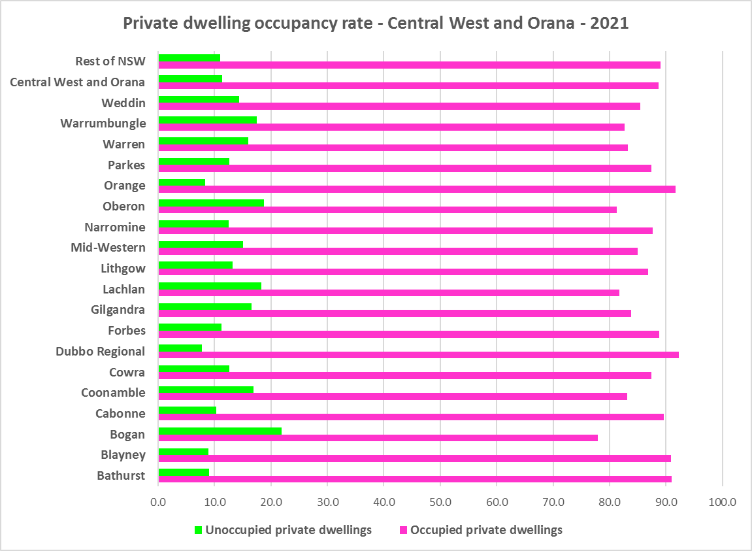

* Note that within the Central West and Orana, Dubbo Regional has the highest proportion of occupied dwellings with 92.2% and Bogan has the lowest with 78.0%.
* At the 2021 Census, the overwhelming majority of occupied dwellings in the Central West and Orana were separate houses, comprising 88.8% of all occupied dwellings, compared to 82.5% in the Rest of NSW. The proportion of separate houses within the region ranges from 95.1% in Blayney and Warrumbungle to 84.8% in Bathurst.
* A further 6.7% of occupied homes in the Central West and Orana were semi-detached, terrace or town houses, (compared to 6.3% in the Rest of NSW) and ranging from 10.2% in Bathurst to 1.1% in Warrumbungle.
* 3.4% of occupied homes in the region were flats (compared to 9.9% in the Rest of NSW), ranging from 6.0% in Dubbo Regional to 0.7% in Bogan.
* The region lacks diversity in dwelling types.
* The graph and table below show the proportion of dwelling types for the Central West and Orana LGAs at the 2021 Census.

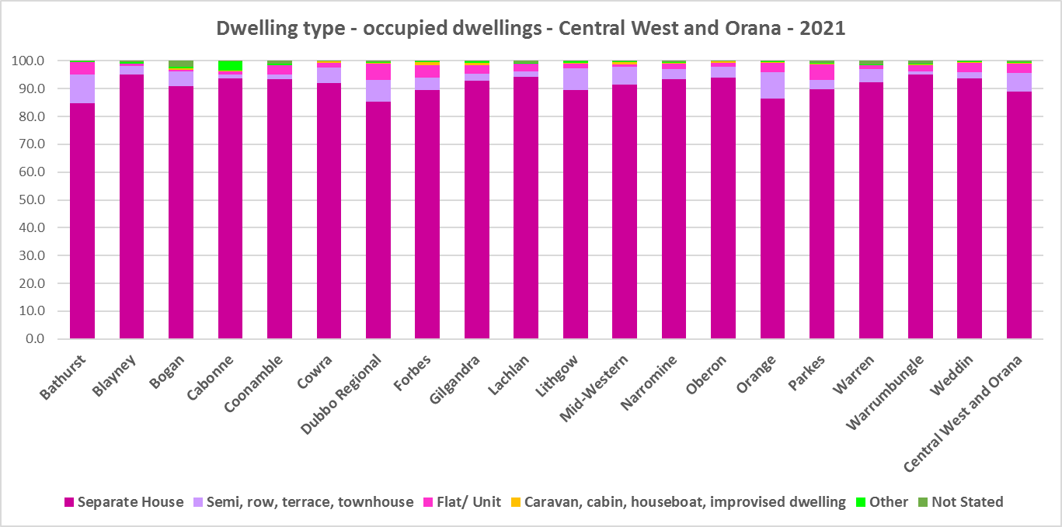

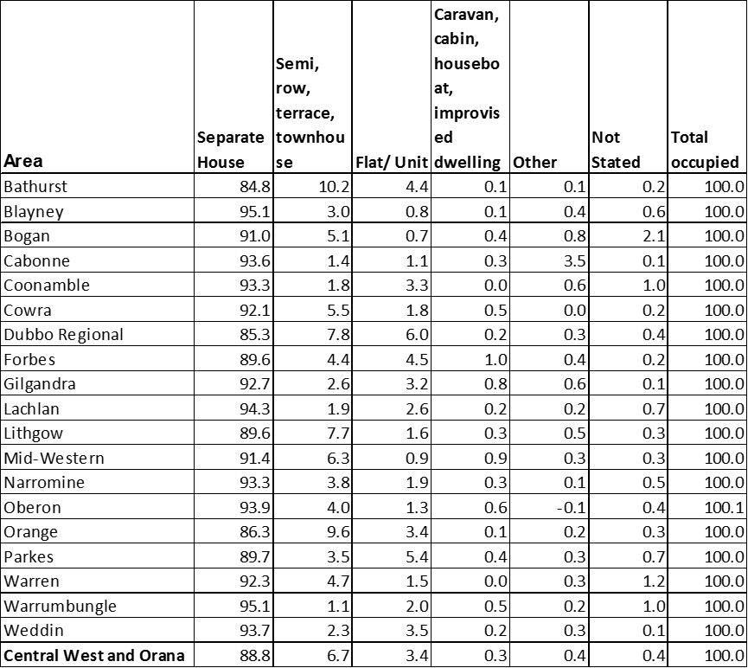

* The next graph compares the proportion of different occupied dwelling types for the Central West and Orana with that for the Rest of NSW. While regional NSW also lacks diversity in dwelling types, it generally has greater diversity than the Central West and Orana.

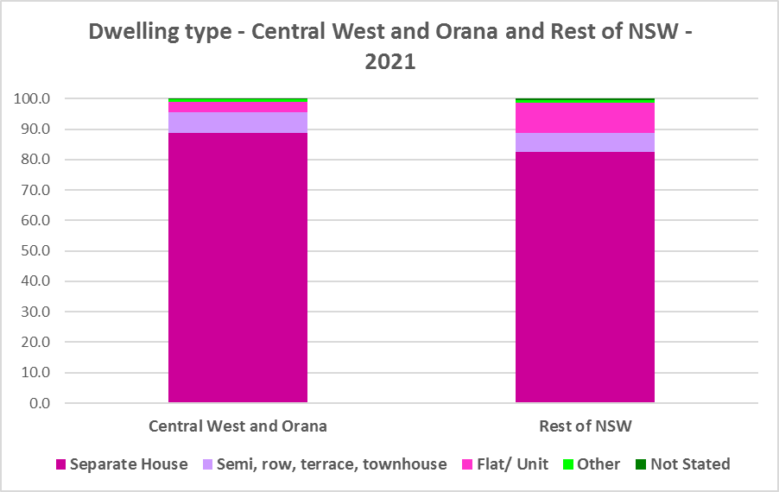

* Other types of dwellings comprised 0.7% of occupied dwellings in the region and include caravans, cabins, houseboats, improvised dwellings and flats attached to shops or offices. Census data shows 217 households living in caravans, 117 living in cabins or houseboats, 17 living in improvised dwellings and 410 in flats attached to shops or offices in the region.
* Note that at the 2021 Census there were 334 households living in caravan, cabin/houseboat accommodation, down slightly from 358 in 2016. This is down from 517 at the 2011 Census and 695 at the 2006 Census.
* While people living in caravans are included in the homeless data in the Census, caravan or residential parks are one of the few remaining affordable housing options for lower income earners. The loss of this accommodation reduces options for lower income households and reduces flexibility to deal with seasonal workers and changes in mining workforces. Mid-Western Regional (38 down from 93 in 2016) had the highest remaining numbers of caravan, cabin/ houseboat dwellings in the region at 2016, followed by Dubbo Regional (31 down from 59 in 2016).
* There were also 17 people living in improvised dwellings. According to the ABS;
  + “Persons in other improvised dwellings are those people who were enumerated on Census night in the dwelling category of an improvised dwelling, tent or sleepers out who reported either being 'at home' on Census night or having no usual address, and are not considered, on balance, to be homeless. Under the ABS definition they are not classified as homeless because they have accommodation alternatives, and in many living situations, the dwelling will be adequate. They are however included in marginal housing and may be at risk of homelessness.”

**Bedroom Mix**

* The overwhelming majority of housing in the region would have been built at a time when couple families with children were the dominant household type. Now smaller households (couples and single person households) predominate and are expected to continue to increase across the region, particularly as the population ages.
* As well as a lack of diversity in dwelling type, the region (and the Rest of NSW generally) has little variation in the number of bedrooms per dwelling, with 40.0% of dwellings having three bedrooms and a further 39.3% having four or more bedrooms. Only 0.4% of homes are studios, 3.3% have one bedroom and 15.0% have two bedrooms in the Central West and Orana.
* This compares to 0.5% of studio homes, 4.0% one bedroom, 17.3% two bedroom, 40.9% three bedroom and 35.7% four or more bedrooms in the Rest of NSW.
* It is important to note that this is an improvement in diversity in the Central West and Orana from 2016, when studios made up just 0.1% of dwellings; one bedroom homes comprised 1.0% and two bedrooms 9.6% of residential stock on average across the region.
* Within the region,
  + Weddin has the highest proportion of studio dwellings with 0.9% and Warren the lowest with 0.0%;
  + Warrumbungle has the highest proportion of one bedroom homes with 4.4% and Forbes the lowest with 2.6%;
  + Lithgow has the highest proportion of two bedroom homes with 20.1% and Blayney the lowest with 12.0%;
  + Cowra has the highest proportion of three bedroom homes with 44.4% and Bathurst the lowest with 36.5%; and
  + Cabonne has the highest proportion of four or more bedroom homes with 45.2% and Lithgow the lowest with 29.9%.
* The graph and table below show the proportion of studio, one, two, three and four or more bedroom occupied dwellings in the Central West and Orana at the 2021 Census.

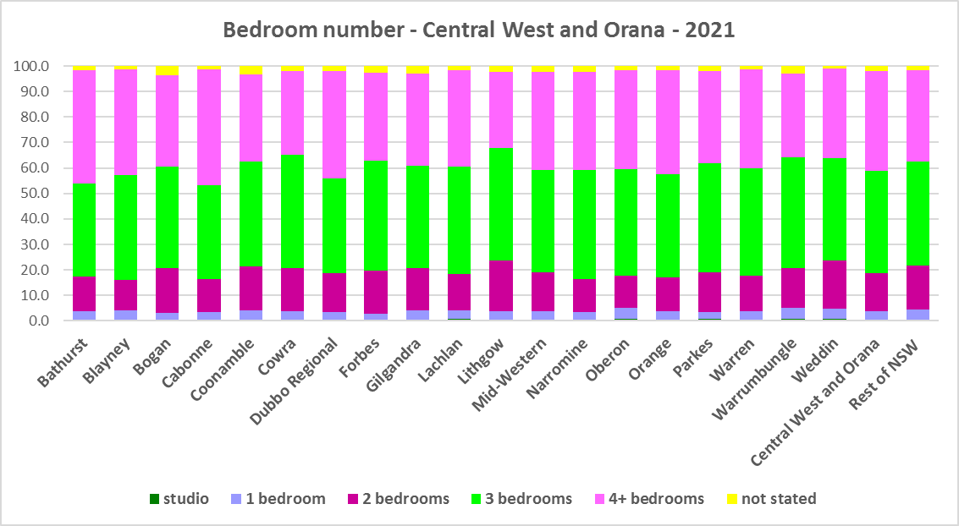



* Given that lone person and couple only households comprised 51.4% of all households in the Central West and Orana, the fact that studio and one bedroom homes combined comprise just 3.7% of the housing stock shows a significant mismatch between household type and dwelling size and an extraordinary lack of housing choice for smaller households.
* While it is encouraging that there have been increases in the proportion of studio, one and two bedroom homes between the 2016 and 2021 Census, ideally there should be a closer match between household size and bedroom number to offer some housing choice for residents.
* The forecast increase in older age groups in the region is likely to increase the demand for smaller homes. It is important for older residents to be able to downsize from larger family dwellings to smaller dwellings that are easier to manage and in which they may retain their independence.
* Two bedroom dwellings in particular offer the most flexibility, given they are also suitable for small families and allow older residents to have family members or carers to stay while giving them a more manageable size home to maintain.
* It is worth noting that new dwelling construction comprises around 1% of total dwellings (depending on the location and stage in the residential development cycle) with the remaining 99% of homes being existing established dwellings. Alterations and additions to existing stock – for example adding more bedrooms to two and three bedroom homes - can have a significant impact on the bedroom mix and long term suitability of housing stock to meet housing need, including household size and affordability.

**Tenure**

* At the 2021 Census, the most common tenure type in the Central West and Orana was households owning their home outright – comprising 37.6% of all households. Within the region this ranged from 44.7% in Warren to 31.0% in Dubbo Regional.
* The next largest tenure type was households with a mortgage – comprising 31.7% of all households. The proportion in this tenure ranged from 34.9% in Cabonne to 22.5% in Warren, within the region.
* Rental households comprised a total of 28.3% of all households in the Central West and Orana, ranging between 33.7% in Orange and 15.9% in Cabonne.
* Households renting from a real estate agent comprise just 16.3% of all households in the Central West and Orana – with Orange having the highest proportion at 22.3% and Bogan the lowest with just 4.7% of households renting though a real estate agent.
* The remainder of rental households are comprised of households renting from the state housing authority (3.4% in the region), community housing providers (1.0%) and other landlords (7.7%).
* The graph and table below give the tenure composition for the region and individual LGAs at the 2021 Census.

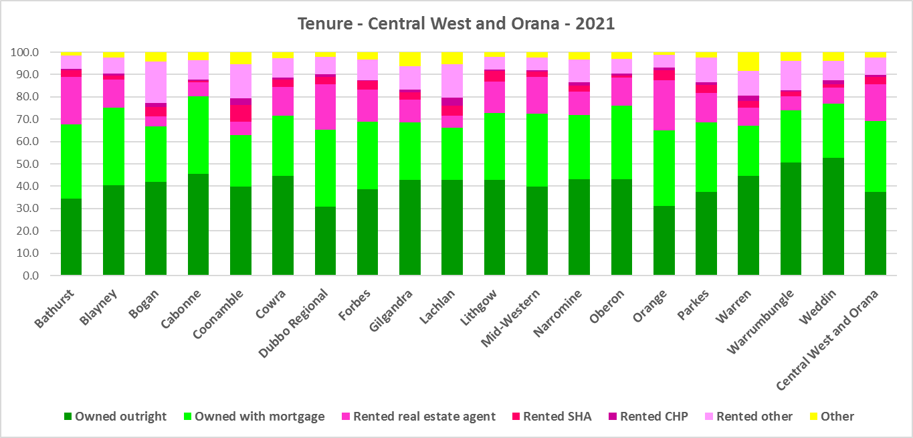



* The general trend is increasing numbers of households relying on the private rental market as a long term tenure rather than a transitional one between leaving home and buying a home, as housing costs have increased much faster than wages. While the Central West and Orana is more affordable than metropolitan and coastal areas of the state, there has been a growing trend to making a tree change to take advantage of more affordable housing in regional areas. In addition, anecdotal evidence indicates that this was particularly pronounced during Covid with the increased flexibility of working remotely/from home.
* This has the potential to bid up housing prices in regional areas and make it more difficult for locals to afford housing.
* Noting that the rental market in the Central West and Orana – and NSW generally – is very tight (see the Housing Snapshot on What’s Happening in the Housing Market) it is therefore important to encourage tenure diversity and a range of price points to meet local needs.

**Social Housing**

* Social housing is secure and affordable rental housing for people on low incomes with housing needs. It includes public, community and Aboriginal housing. Public housing is managed by DCJ while community housing is managed by non-government organisations.
* As at June 2022, there are 154,600 social housing dwellings in NSW, with 96,712 managed by public housing, 48,264 managed by community housing and 9,624 managed exclusively for Aboriginal people – of these the Aboriginal Housing Office (AHO) are responsible for 4,120 and Aboriginal Community Housing Providers (ACHP) manage 5,504.
* The table below shows the number of public housing properties in the Central West and Orana region LGAs as at June 2022. Please note that Census data on public housing is not totally accurate, as public housing tenure is under reported in the Census. The figures below do not include community housing properties.



* In addition, community housing providers manage a significant number of properties – including social housing, affordable housing, transitional housing and crisis accommodation in the Central West and Orana region, as outlined in the table below.
* Note that affordable housing is not the same as social housing. Affordable housing is open to a broader range of household incomes than social housing. Households do not have to be eligible for social housing to apply for affordable housing, though people who are eligible for social housing may also be eligible for affordable housing properties.
* Affordable housing is managed more like a private rental property, but there are eligibility criteria and the managers are mostly not for profit community housing providers.



* The next table gives the number of AHO homes and the number managed by ACHPs in Western NSW as at June 2022.



* Note that there are 3 types of social housing available for Aboriginal people:
  + Public housing – these properties are managed by the Department of Communities and Justice (DCJ).
  + Aboriginal Housing Office homes – these are properties owned by the Aboriginal Housing Office and managed by DCJ.
  + Community housing properties – these properties are managed by community housing providers and Aboriginal community housing providers.
* The table below shows the expected waiting times for general housing approved social housing applicants (not for priority housing applicants) by bedroom category in the Central West and Orana Region as at 30 June 2022. It also gives the number of general and priority applicants in each allocation zone.



* Information on Expected Waiting Times for Public Housing is available on the FACS website by region at:

<https://www.facs.nsw.gov.au/housing/help/applying-assistance/expected-waiting-times>

## The Gap

* Historically the Central West and Orana has been more affordable for both rental and purchase than metropolitan and coastal regions of NSW.
* SGS Economics and Planning in their November 2022 Rental Affordability Index[1] report, point out that regional areas of NSW:
  + have been subject to several natural disasters from widespread bushfires in 2020 to flooding in 2022. These have affected both existing rental stock and new development, limiting supply and increasing rental rates.
  + have seen the combined impact of these factors on renters resulting in homelessness, having to move away from family and support for more affordable housing, moving into poor quality or insecure housing, or having to forgo other essentials.
  + were spared the worst of pandemic response measures. However the impacts of outward-migrating city residents (driven by COVID-19 restriction in capital cities and the ability to work remotely), on housing and rental affordability has caused concern. This is clear in the November 2022 data, which shows that affordability has worsened in the regional areas of every state, even more so than in the capital cities.
  + have became far less affordable to the average rental household over the last year, including inland towns such as Orange and Mudgee.
* In summary demand for housing increased, supply has been insufficient to meet demand and there have been impacts on affordability, particularly rental affordability, and on lower income tenants.
* There has been a decline in the number of private rental properties which are affordable to low income rental households in the Central West and Orana, as the graph below demonstrates.

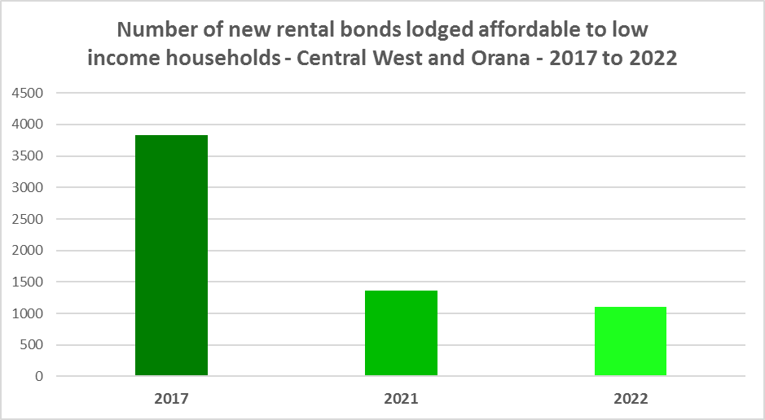

* The next graph compares change in median income with change in median rents and median sales price in eight Central West and Orana LGAs between 2016 and 2021 for income and 2017 to 2022 for rent and sales price.

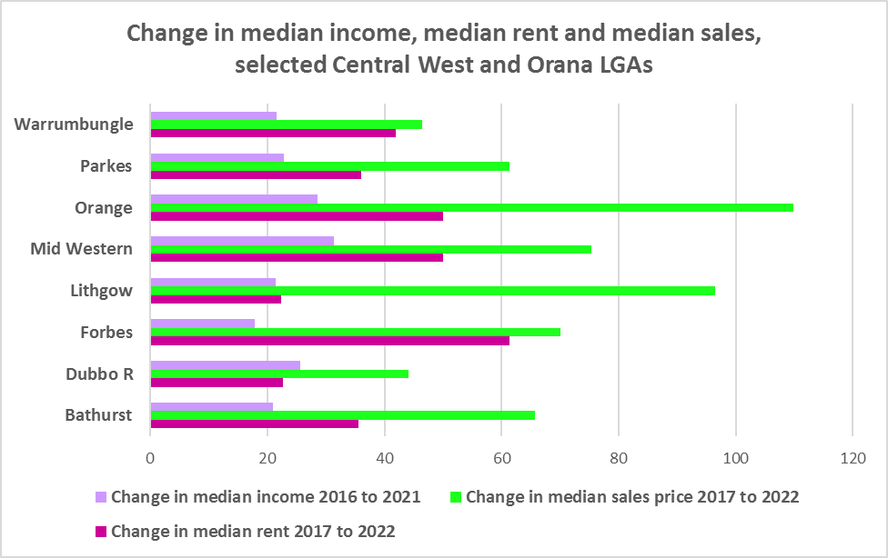

* Note that with the exception of rents in Dubbo Regional, all the LGA’s experienced stronger increases in both median rents and median sales price than the increase in median income over that five year period.
* It demonstrates that housing costs have increased faster than income over that time period. This has been the case for decades, with housing costs increasing at a much greater rate than incomes. According to Core Logic “While wages increased 81.7% in the past 20 years, Australian home values have grown 193.1%”[2]
* Low income households are the dominant income group across the Central West and Orana and in every single LGA in the region, comprising 51.4% of all households in the region (above the Rest of NSW average of 49.3%) and ranging from 42.1% in Parkes to 67.2% in Weddin.
* Furthermore, the number of low income households is increasing across the region – by 12.4% between 2016 and 2021. The graph below shows the change in the number of low income households in each of the Central West and Orana LGAs between 2011 and 2021. The majority of LGAs in the region had an increase in low income households over this period and certainly all the LGAs with major regional centres saw an increase.

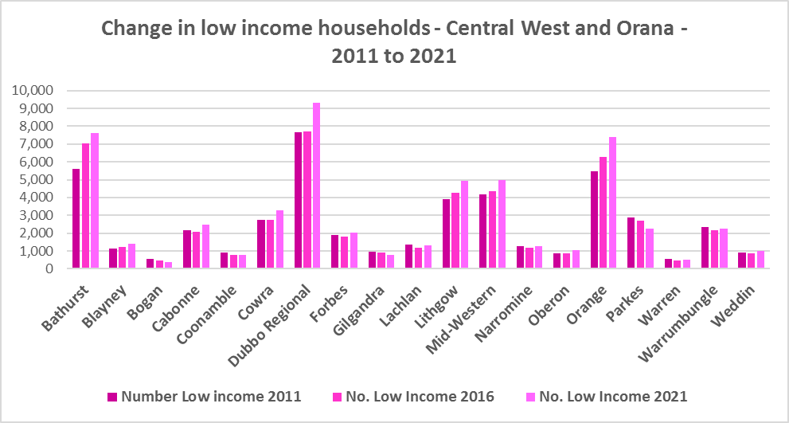

* Due to the changes to income assistance during and subsequent to the COVID-19 pandemic, it is difficult to see what has happened with renters and low income renters in particular between 2016 and 2021. However, it is clear that rents have increased faster than incomes and that the supply of affordable private rental is declining.
* There is a clear need for more affordable rental accommodation to begin to address the demand supply imbalance, particularly for lower income households and the increasing number of seniors and frail aged.
* The vacancy rate in the Central West and Orana has been tight for over a year, indicating a chronic shortage of rental accommodation. At April 2023 the vacancy rate was just 1.6% in the Central West and 1.4% in Orana.
* Considered together, the strong increase in rental levels, decline in rental affordability for lower income earners and decline in affordable rental properties, combined with the increase in low income households, demonstrates the need to increase the supply of affordable rental housing for long term tenants.
* As well as the gap between supply and demand for affordable rental, there is a significant gap between dwelling size (bedroom numbers) and household size, particularly for smaller households. The graph below compares the number of smaller household types - lone person and couple only – with the amount of studio and one bedroom accommodation available in the Central West and Orana. It is clear that if smaller households wished to live in smaller housing, they have very little opportunity to do so. While 52.9% of households in the Central West and Orana are lone person or couple only (just below the 53.8% average for the Rest of NSW), only 3.7% of dwelling stock is studio or one bedroom (below the 4.5% on average in the Rest of NSW).
* This mismatch can impact on affordability, with smaller households required to consume more housing than they need or to share housing because of lack of choice.
* It also limits the opportunity for empty nesters or older single households to downsize to smaller more manageable homes within their communities. This can impact on the independence of older residents and their ability to age in place. This will become increasingly important as the population of the Central West and Orana is forecast to have an increase in older age groups.

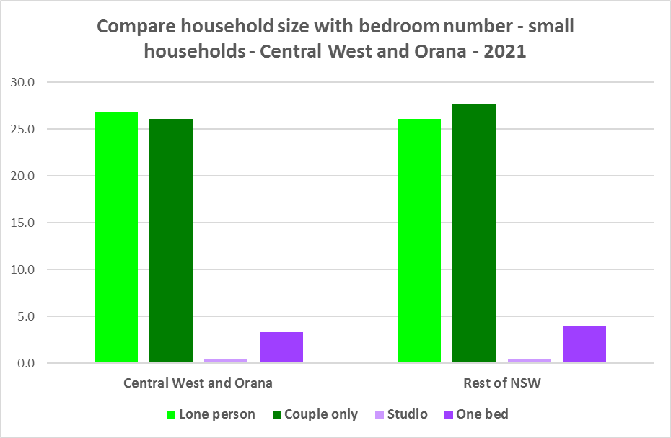

* While there has been an increase in studio and one bedroom homes since the 2011 Census, the number is significantly outweighed by the enormous increase in the number of three and four and more bedroom homes, as seen in the graph below. Of note however, is the substantial increase in two bedroom homes, which potentially suit both single person and couple only households as well as smaller families and small group households.

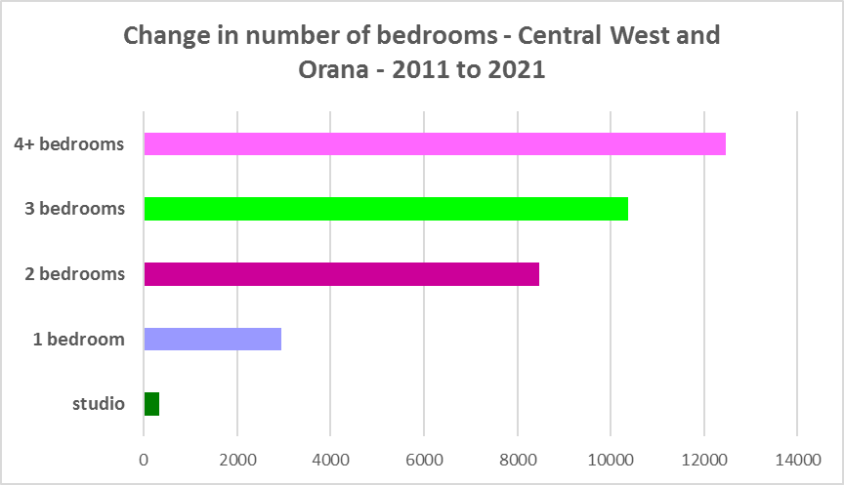

* A proactive approach is required to encourage an increase in studio, one and two bedroom properties.
* This is important given that annually the addition of new dwellings represents around 1% of the total dwelling stock – so change occurs very slowly. There is also a need to take into account the impact of alterations and additions to existing stock, for example, adding extra bedrooms to two and three bedroom houses. Given the current overwhelming supply of and increase in three and four plus bedroom homes, strong incentives/requirements would need to be put in place to ensure a better balance and more diversity to meet housing need. Continuing to encourage development of two bedroom homes is helpful.
* New generation boarding houses would also help fulfil some of this demand – particularly as they cannot be subdivided and must provide rental accommodation. This type of accommodation is suitable for single people and also couples, for key workers and students. It also has potential to assist in providing accommodation/meeting additional housing demand for seasonal workers and mine workers. Note that the NSW Community Housing Industry Association has an Affordable Housing Tool Kit to help deal with community resistance to affordable housing, which is available on their website. They also have a couple of excellent vimeos showcasing new generation boarding house developments and their tenants.
* The next graph compares larger household types – couple family with children, one parent family and group households – with the amount of three and four or more bedroom accommodation available. It is clear that there is more than adequate supply of larger homes for families and group households in the Central West and Orana region.

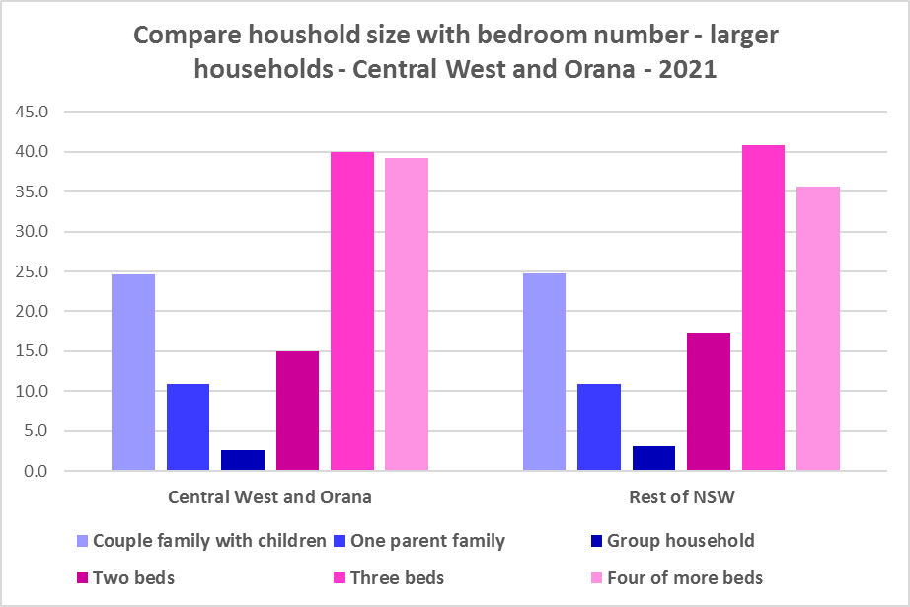

* As couple only households comprise a little over 26% of all households in the Central West and Orana, it is important to continue to encourage provision of one and two bedroom stock as well as studios, new generation boarding houses and secondary dwellings, to maintain a balance to meet local need, particularly where there are higher proportions of seniors and frail aged. This will give older residents opportunity to downsize into more manageable and appropriate homes.
* Enabling the provision of more semi-detached, terrace and town houses could help fulfil some of this demand.
* Also, secondary dwellings suit a range of groups including small households, young people, frail aged and people with disability needing support from family. They may be readily encouraged on larger lots with reasonable access to centres providing a range of services and facilities.

**Who needs affordable housing**

* A wide range of people need affordable housing. Single income earners who fall into the low income category include aged care and disability workers, retail sales assistants, production workers, receptionists and early career child care workers.
* People working in accommodation and food services comprise 6.6% of the workforce living in the Central West and Orana and are amongst the lowest paid workers. Similarly retail trade employs 8.9% of workers living in the Central West and Orana. Health care and social assistance is the largest employment sector of residents in the Central West and Orana (employing 15.6%). A 2017 survey of NSW Nurses and Midwives Association (NSWMA) members showed that thirty six per cent of respondents moved home or changed jobs in the previous 12 months because of housing affordability issues.
* For example:
  + Households earning $790 per week gross (broadly indicative of a wage for a laundry worker) could afford to pay just $237 per week in rent before being in housing stress.
  + Households earning $960 (broadly indicative of wages for a commercial cleaner, delivery driver and entry level firefighter) could afford to pay just $288 per week in rent before being in housing stress.
  + Agriculture employs a significant 9.1% of residents in this region. The average farmhand salary in Australia is $57,311 per annum or $1,102 per week. A household on that salary could afford to pay $330 per week in rent before being in housing stress.
  + Households with an income of $1,150 (broadly indicative of the wage for an enrolled nurse, child care worker and ICT support technician) can afford to pay just $345 per week in rent before being in housing stress.
  + At a weekly income of $1,450/$1,500 (an indicative wage for an early career Registered Nurse), a household could afford to pay $435 to $450 per week in rent before being in housing stress.
* At December 2022, there were insufficient new bonds lodged to calculate a median rent for studio dwellings in any LGA in the Central West and Orana, and Bathurst and Orange were the only LGAs in the region with a median rent for one bedroom homes– which speaks to lack of supply.
* At December 2022, the median rent for a one bedroom home in Bathurst was $283 per week and in Orange was $325 per week; for a two bedroom home ranged between $245 per week in Cowra and $400 per week in Orange; for a three bedroom home ranged between $350 in Cowra and $500 per week in Mid-Western Regional and Orange; and for a four or more bedroom home ranged between $500 per week in Cowra and Parkes and $605 per week in Mid-Western Regional. Several LGAs had insufficient new bonds lodged to calculate a median rent for different bedroom numbers but did have median rents for all dwellings – ranging from $228 per week in Coonamble to $360 in Oberon.
* This demonstrates that lower income households would struggle to find affordable rental housing in a number of LGAs in the region.
* Single income households in particular are less able to compete in the housing market.
* Increasing numbers of older single women are homeless or at risk of homelessness due to the lack of available affordable rental housing. In fact they are the fastest growing cohort of the homeless population.
* Partnering or collaborating with community housing providers is one effective way to meet some of the local need for appropriate affordable housing. Not for profit community housing providers are owners, managers and developers of affordable rental housing for lower income households and residents with specific housing needs. They work with partners, investors and government to provide housing and deliver support for tenants. For more information about community housing providers, see the NSW Community Housing Industry Association website.

**Additional Data**

Housing data and tables used in this Snapshot are available from the Local Government Housing Kit Database on the Housing NSW website at:

<https://www.facs.nsw.gov.au/resources/nsw-local-government-housing-kit/chapters/local-government-housing-kit-database>

More information on Expected Waiting Times for Public Housing is available on the DCJ/FACS website by region at:

<https://www.facs.nsw.gov.au/housing/help/applying-assistance/expected-waiting-times>

Additional data on social housing dwellings and delivery is available on the FACS website at:

<https://www.facs.nsw.gov.au/resources/statistics/social-housing-residential-dwellings/facs-quarterly-statistics-social-housing-dwellings>

or go straight to the dashboard:

<https://public.tableau.com/app/profile/facs.statistics/viz/Social_Housing_Residential_Dwellings/Dashboard>

and

<https://www.facs.nsw.gov.au/resources/statistics/social-housing-delivery2/interactive-dashboard>

The Australian Housing and Urban Research Institute (AHURI) has written a paper explaining the reasons for unoccupied homes:

<https://www.ahuri.edu.au/research/brief/are-there-1-million-empty-homes-and-13-million-unused-bedrooms>

The SGS Economics and Planning Rental Affordability Index is here:

<https://sgsep.com.au/projects/rental-affordability-index>

More information about community housing providers is available on the NSW CHIA (Community Housing Industry Association) website:

NSW CHIA Snapshot of the Community Housing Sector in NSW:

<https://communityhousing.org.au/wp-content/uploads/2022/08/Community-Housing-Snapshot-2022.pdf>

Data on community housing properties is available from the NSW CHIA Dashboard at:

<https://communityhousing.org.au/our-impact/data-dashboard/>

(Note that this is not a full data set as CHIA does not represent all community housing providers in NSW).

CHIA NSW affordable housing tool kit. The Tool Kit is based on extensive research about reasons for community resistance to affordable housing, and effective ways of building support for affordable housing:

https://communityhousing.org.au/toolkit/theplatform.html

The NSW Registrar of Community Housing website is here:

<https://www.rch.nsw.gov.au/>

1. <https://sgsep.com.au/projects/rental-affordability-index>
2. <https://www.corelogic.com.au/news-research/news/archive/how-much-has-house-price-growth-outstripped-growth-in-wages#:~:text=Comparing%20the%20wage%20price%20index,193.1%25%20(figure%202)>.