# Eastern City District – What’s Happening in the Housing Market

This Housing Snapshot looks at rents, vacancy rate, affordable rental, rental stress, loss of affordable rental stock, impact on key workers, sales price, purchase affordability and purchase stress in Eastern City – particularly changes between 2016 and 2021.

## There have been changes across Eastern City since the 2021 Census, with Covid having an impact on the housing market. Recent additional cost of living pressures, including rising inflation and interest rates with continued low wage growth, have created further difficulties for lower income earners and their capacity to manage housing costs. In addition, the rental market has tightened and additional housing supply has stalled despite rising demand, due to a range of factors included skilled labour shortages and significantly increased costs of materials. The popularity of and growth in short term rentals such as Airbnb has also had an impact here.

## Wage growth has lagged well behind house price growth for decades. In 1984 the average Australian could buy a home that costs 3.3 times their annual income. By 2022 the average Australian needed 10 times their income to buy a home. Further, the real value of wages declined by 4.5% in 2022, the largest documented deterioration. With annual inflation running at 6.0 per cent, wages need to be growing by 6.0 per cent to maintain their purchasing power.

Consequently households are increasingly struggling with housing costs – saving a deposit, taking on a mortgage, competing for rental properties, paying rising rents – as well as a wide range of other goods, such as food, power, medication, education, transport. There are many anecdotal reports of tenants having to choose between paying the rent and paying for medication, their education or food as well as rising homelessness.

## *Housing Market Rental*

## Rents

* Rents in Eastern City are well above the Greater Sydney median. For the March quarter 2023, the median rent for houses ranged between $650 per week in Strathfield and $1200 per week in Woollahra compared to $630 per week for Greater Sydney as a whole. For units the median ranged between $593 per week in Strathfield to $850 per week in both Waverley and Woollahra, compared to $609 per week for Greater Sydney.
* There has been strong growth in median rents for all dwellings (including all housing types and all bedroom categories) in the Eastern City District for a long time, as the graph below shows. It tracks the change in median rent (for all dwellings) for all the Eastern City LGAs from June 1990 to June 2022 (from 2017 for Inner West and Bayside).
* Note from the graph that clearly there was a recent significant dip in median rents in 2020, before a strong recovery.

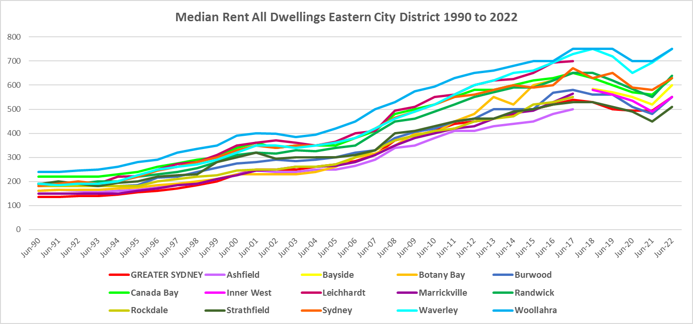

* The table below shows the change in median rent for all dwellings in the Eastern City LGAs between 2017 and 2023. It shows relatively strong growth in median rents over that period, with the strongest increase occurring in Bayside.
* At June 2023 median rent for all dwellings was highest in Woollahra at $875 per week and lowest in the Inner West and Strathfield at $650 per week.



* However, changes in median rents over that time frame were more nuanced. Between 2019 and 2020 when Covid lockdowns were introduced, median rents in the Eastern City District local government areas generally dropped, as the table below demonstrates.
* During that period, the largest percentage drop in median rents occurred in Randwick for studios/bedsits (-29.0%), showing the impact of the lockdown on student accommodation in that LGA. There was also a decline of -14.7% in the median rent for bedsits in neighbouring Waverley.
* Over the same time frame, median rents for one bedroom homes dropped most in Woollahra (-14.5%) and Sydney (-10.5%); for two bedroom homes -15.4% in Sydney and -9.8% in Burwood; for three bedroom homes -13.2% in Waverley and -12.5% in Sydney; and for four or more bedroom homes the largest drop in median rents was -11.5% in Strathfield and -7.3% in Burwood.



* However, between 2020 and 2022 when Covid restrictions were relaxed, there were strong increases in median rents across the District, as the table below shows
* Randwick had the strongest increase in median rents to studio/bedsitters with 42.6%, followed by 10.2% in Waverley. A few LGAs actually experienced declines in median rents for studio/bedsit homes over this time frame (Bayside, Burwood, Inner West and Sydney).
* The strongest increase in median rents for one bedroom homes occurred in Waverley (14.3%), followed by 12.2% in Canada Bay and Randwick. For two bedroom homes the strongest increase occurred in Sydney (17.4%), followed by Waverley (13.0%); for three bedroom homes 30.9% in Waverley and 20.0% in Burwood and Sydney; and for four bedroom properties 33.3% in Waverley and 32.4% in Woollahra.
* At June 2022, median rents for studio/bedsits ranged between $425 per week in Randwick and $300 in Burwood; for one bedroom homes ranged between $600 per week in Waverley and $410 in Inner West; for two bedroom homes between $780 in Waverley and $510 in Strathfield; for three bedroom homes between $1,295 in Woollahra and $630 in Strathfield; and for four or more bedroom properties between $2,450 in Woollahra and $830 in Strathfield.
* Note that Canada Bay (and Strathfield at June 2020) has insufficient studio/bedsits to determine the median rent, which speaks to lack of supply.



## Vacancy Rate

* A vacancy rate of 3% is understood to represent a balance between supply and demand. Vacancy rates below 3% represent a tight rental market while longer term vacancy rates below 2% represent a chronic undersupply of rental housing.
* According to REINSW data, vacancy rates were below 3% for the inner, middle and outer rings of Sydney for almost all of the period from 2006 through to 2018.
* At April 2023 the vacancy rate in Sydney was 1.3%, in the inner ring of Sydney was 1.5% and for the middle ring was 1.2%, indicating a tight rental market across Sydney and most particularly in the middle ring.
* Vacancy rates are tight across almost all of NSW, indicating a significant undersupply of rental accommodation. At April 2023, the vacancy rate on the Central Coast was 1.7%, in Wollongong was 1.3%, for the Illawarra was 1.7%, in Newcastle was 1.5%, in the rest of the Hunter was 2.0% and in the Central West was 1.6%.
* Anecdotal information on the current vacancy rate underlines the difficulty tenants are facing finding and retaining rental accommodation - the fierce competition for rental housing, rent bidding and the rapid increase in rents – with tenants facing eviction, homelessness, overcrowding and paying too much of their income in rent.
* The graph below shows the vacancy rate for the inner, middle and outer rings of Sydney for the period from 2006 to 2023, using data from the Real Estate Institute of NSW. Note that Inner West, Randwick, City of Sydney, Waverley and Woollahra are in the inner ring, while Bayside, Burwood, Canada Bay and Strathfield are in the middle ring.

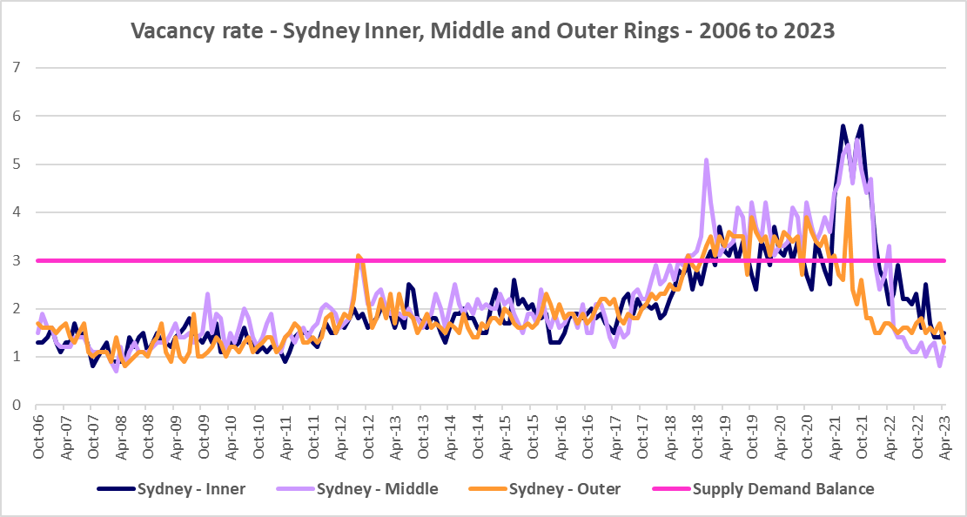

## Affordable Rental

* Since 2001, the general trend across Sydney and NSW has been for a decline in the proportion of rental stock which is affordable for very low, low and moderate income earners.
* This trend is evident in Eastern District, although along with elsewhere in NSW, there were more complex factors at play between 2019 and 2022.
* Across Greater Sydney, the proportion of affordable rental for very low income households increased every year from 2018 to 2021 and then declined between 2021 and 2022.
* In Eastern District, this pattern was more varied. Between 2018 and 2019 rental affordability for very low income households improved in line with the trend in Greater Sydney in Bayside, Canada Bay, Inner West, Randwick, Sydney and Woollahra. It was stable in Waverley (no change) and declined in Burwood and Strathfield.
* Between 2019 and 2020 the proportion affordable for rental by very low income households improved again in line with the trend in Greater Sydney in every Eastern District LGA.
* Between 2020 and 2021 rental affordability improved in every Eastern District LGA with the exception of Waverley, which again had no change.
* Between 2021 and 2022, rental affordability declined in Bayside, Inner West, Randwick, Strathfield and Woollahra in line with the trend in Greater Sydney. Rental affordability was stable in Burwood (no change) and improved in Canada Bay, Sydney and Waverley.
* At June 2022, every Eastern City LGA (excepting Burwood with 13.6% and Inner West with 13.2%), had a lower proportion of affordable rental for very low income households than the Greater Sydney average of 10.7%. Waverley had the lowest proportion with 3.4% affordable rental, followed by Randwick and Canada Bay with 4.0% and Woollahra with 4.3%.
* The table and graph below show the change in the proportion of private rental accommodation affordable to **very low income** households in the Eastern District LGAs and Greater Sydney between 2017 and 2022.

Proportion affordable rental for very low income households 

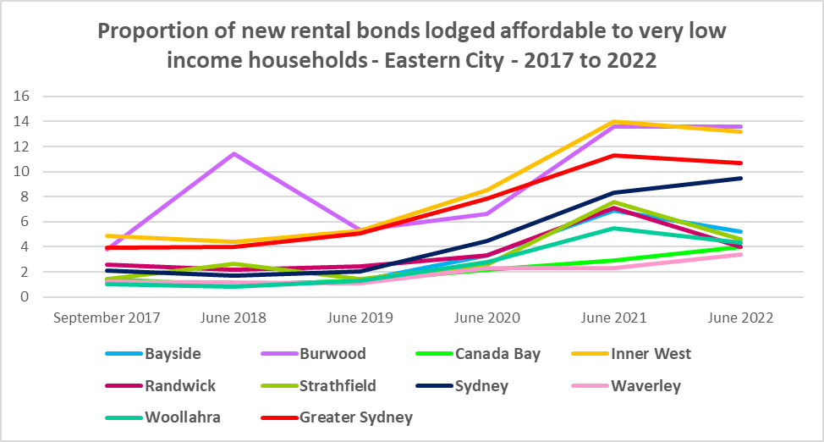

* Between 2018 and 2021 the proportion of rental affordable for **low income** households increased in Greater Sydney from 23.2% to 44.8% before declining to 41.5% in June 2022.
* Again the picture in the Eastern City District was more varied.
* Between 2018 and 2019 affordability improved in Bayside, Canada Bay, Inner West, Randwick, Strathfield and Waverley in line with the trend in Greater Sydney and declined in Burwood, Sydney and Woollahra.
* Between 2019 and 2020 the proportion affordable for rental for low income households increased in every Eastern City LGA in line with the trend in Greater Sydney.
* Between 2020 and 2021 affordable rental for low income households improved in every Eastern City LGA excepting Waverley, which experienced a decline in affordability.
* Then between 2021 and 2022 affordability declined in every Eastern City LGA with the exception of Waverley, where affordability improved slightly.
* At June 2022 every Eastern City LGA, with the exception of Strathfield, has a lower proportion of affordable private rental for low income households than the average of 41.5% for Greater Sydney. Waverley has the lowest proportion with 14.5%, followed by Woollahra with 17.7%, Randwick with 20.5% and Canada Bay with 22.0%.
* The table and graph below show the change in the proportion of private rental accommodation affordable to **low income** households in the Eastern City District and Greater Sydney between 2017 and 2022.

Proportion affordable rental for low income households

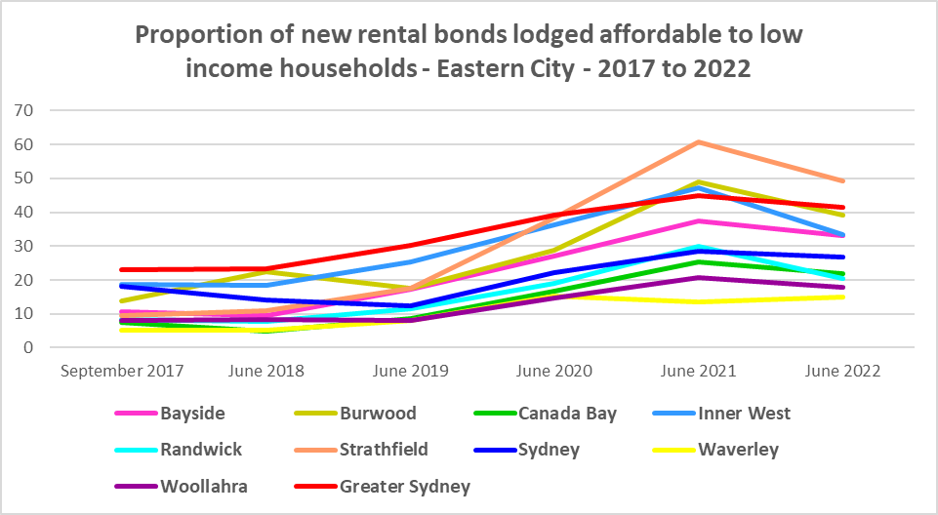

* There is evidence that short term holiday rentals such as Airbnb are impacting the supply of housing, including long term rental and affordable housing in cities and coastal communities.
* An AHURI Policy Evidence summary from November 2018 on “The Airbnb Effect in Sydney and Melbourne” found that “short term letting platforms are probably not significantly worsening rental affordability across our major cities as a whole, but are having an impact on rental properties in high-demand inner city areas with significant tourism appeal.”
* They found a concentration of listings in the eastern suburbs of Sydney, accounting for between 11.2% and 14.8% of rental housing stock.
* They also noted that the “rise in short term lettings is reshaping the market for investment properties.”
* This evidence points to potential impact on affordable rental for longer term residents in parts of the Eastern City District.

## Rental Stress

* Households are regarded as being in rental stress when renting in the private rental market and paying more than 30% of their income in rent. Lower income households in rental stress will struggle to pay for other essential household costs, such as medical or educational expenses, food, transport and energy costs.
* At June 2021 the proportion of very low income households in rental stress in Greater Sydney was 94.0%.
* Within the Eastern City District, the average proportion of very low income households in stress was 97.2%, with the proportion varying from 98.2% in Woollahra to 95.3% in Strathfield. All LGAs in the District had a higher proportion in stress than the average for Greater Sydney.
* For low income households in rental stress at 2021, the average for Greater Sydney was 61.4%, with the Eastern City average significantly higher on 78.1%. Across the region the proportion of low income households in stress ranged from 91.8% in Waverley to 57.7% in Strathfield.
* Every Eastern City LGA had a higher proportion of low income households in rental stress than the Greater Sydney average, with the exception of Strathfield.
* However, while the **proportion** of very low and low income households in stress declined in every Eastern City LGA between 2016 and 2021, in line with the trend in Greater Sydney – the actual number in stress generally increased across the LGAs in the District.
* There were some exceptions – the number of very low income households in stress declined in Canada Bay, Randwick and Sydney, as well as for the Eastern City District as a whole. The number of low income households in stress declined in Randwick and Waverley but increased everywhere else.
* Below is a graph of the proportion of very low and low income households in rental stress in each Eastern City District LGA at 2021, and a table showing the change in the proportion of very low and low income households in stress between 2016 and 2021.

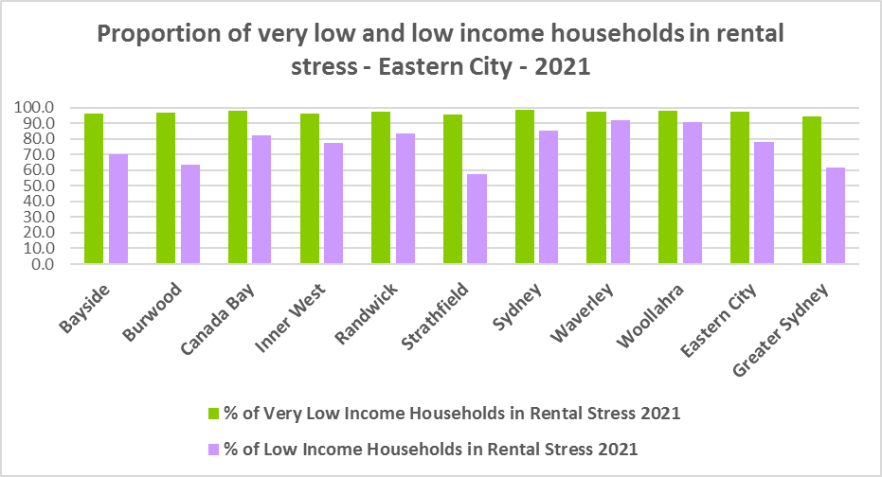

Proportion of very low and low income households in rental stress



* The next table shows the change in the number of very low and low income households in rental stress at 2016 and at 2021.
* A look at CRA (Commonwealth Rent Assistance) recipients in housing stress gives some further information on what has been happening with lower income households in rental stress over this time frame.

Number of very low and low income households in rental stress



* Between 2016 and 2020, the total number of CRA recipients in Eastern City increased as did the number of CRA recipients in rental stress.
* However, between 2020 and 2021, the total number of CRA recipients as well as the number in stress declined.
* Generally across Australia, the number of CRA recipients in housing stress has increased from the June 2020 figures as the temporary Coronavirus Supplement ended on 31 March 2021.
* The Coronavirus Supplement was $550 per fortnight for new and existing recipients of JobSeeker Payment, Parenting Payment, Youth Allowance for jobseekers, Farm Household Allowance and Special Benefit. The temporary supplement almost doubled the maximum payment rate for a JobSeeker Payment recipient. Hence it made rent more affordable for some CRA recipients in June 2020 and resulted in a lower proportion of CRA recipients in rental stress than usual.
* Since the end of Covid restrictions, the number of people in employment has increased, so fewer people are relying on rent assistance from the Commonwealth.
* The two graphs below clearly demonstrate the change in total CRA recipients and CRA recipients in stress between 2016 and 2020 and 2020 and 2021 in Eastern City.

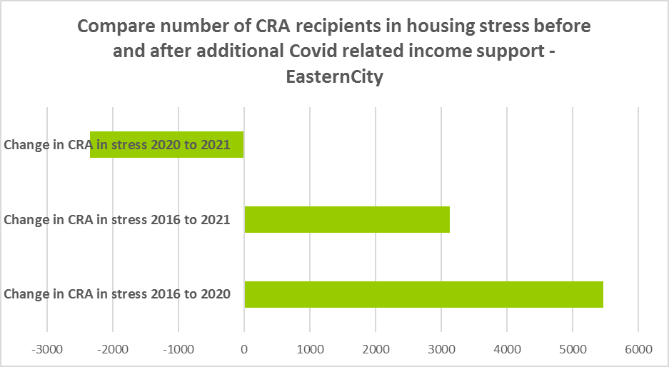

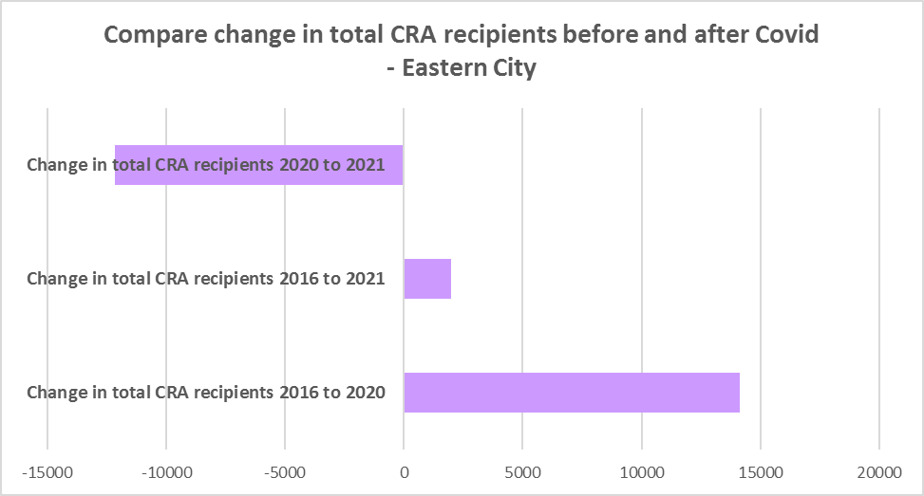

* The table below shows the number and proportion of tenants in the Eastern City District who are in the private rental market, are in receipt of Commonwealth Rent Assistance, and even with this additional income support, are in housing stress.
* There were a total of 26,403 tenants in receipt of CRA and in housing stress across the District in 2021, up from 23,276 in 2016. In 2016, 62.1% of CRA recipients in the Eastern City were in stress, increasing to 66.9% in 2021. This compares to 50.7% CRA recipients in stress in 2016 for Greater Sydney and 56.2% in 2021.
* Every local government areas in the District has a higher proportion of CRA recipients in stress than the average for Greater Sydney. Woollahra has the highest proportion in stress with 81.9%, followed by Waverley with 75.2% and Sydney with 69.5%. Essentially the whole District is unaffordable for lower income tenants.



## Loss of Affordable Housing Stock

* DCJ has calculated the number of new bonds lodged with the Rental Bond Board that were affordable to low income earners in the Eastern City District for 2021 and 2022. The District experienced a 16.2% decline in affordable rental bonds lodged, and consequently loss of affordable private rental housing, in just that 12 month period.
* The table below shows the number of new bonds lodged that were affordable to low income households (including very low income households) in 2021 and 2022 in each of the Eastern City LGAs as well as the total for the District.
* Note that over that 12 month period, Waverley actually registered a small increase in the number of new bonds lodged that were affordable to low income households, while all other LGAs in the District experienced a loss.
* Randwick had the largest loss of stock in percentage terms with 36.4%, followed by Burwood with 33.7% and Canada Bay with 28.6%.
* In numeric terms, Randwick had the greatest loss with 255 fewer affordable bonds lodged, followed by Bayside with 221 and Inner West with 189.

Number of new bonds lodged affordable to low income households



**Impact on Key Workers**

* This loss of affordable housing is having a direct impact on key workers (including teachers, registered nurses, hospitality service workers, accommodation and food service workers, early childhood, police and aged care workers).
* Eastern City in particular has a high number of hospitality, tourism, health care and aged care workers who work in the District, due to the hospital precincts of St Vincent’s, Prince of Wales and the Royal Prince Alfred hospitals, as well as Sydney Hospital, Concord Hospital and Balmain Hospital; the concentration of tourists, restaurants and night life spots; and the concentrations of aged care facilities in Bronte, Bondi and the Inner West.
* In fact, health care and social assistance is the second largest employment sector of residents in Eastern City, employing 11.9% of residents. A further 7.5% are employed in retail trade and another 6.4% in accommodation and food services. Many of these will be lower paid workers.
* Without appropriate affordable housing, these workers will be forced to move from the area, either increasing the commute time for these workers or it may result in a shortage of available workforce.
* Analysis by AHURI (May 2021 Policy Evidence Summary – Housing for Australia’s Key Workers) shows that:
  + In Sydney key workers are more likely than the labour force generally to live in outer suburbs and satellite cities and to commute 30kms or more to work.
  + Around 31,000 key workers in Sydney live in overcrowded homes, with the greatest concentration in inner subregions and among lower paid occupation groups.
  + Over 52,000 key workers in Sydney are living in households that can be classified as being in housing stress, equating to 20 per cent of key workers. Instances of housing stress are significantly higher amongst key workers living in inner subregions.
  + In February 2020, only 2 per cent of new tenancies across Greater Sydney had starting rents that were at or below the affordability threshold for households earning $790 per week gross (broadly indicative of a wage for a laundry worker). Just 5 per cent were affordable to households earning $960 (broadly indicative of wages for a commercial cleaner, delivery driver and entry level firefighter) and 11 per cent were affordable with an income of $1,150 (broadly indicative of the wage for an enrolled nurse, child care worker and ICT support technician).
  + At a weekly income of $1,450/$1,500 (an indicative wage for an early career Registered Nurse), there are generally no LGAs with affordable median unit purchase prices in the inner and middle ring LGAs of Sydney.
* There is clearly demand for affordable housing for lower paid and key workers in the Eastern City District, yet affordable private rental is diminishing and housing costs are rising much faster than incomes.

## *Housing Market – Purchase*

## Sales Price

* Changes in the median sales price of both houses and flats in the Eastern City over the ten years to March 2022 have been upward and generally significantly larger than the increases experienced over the same period for Greater Sydney.
* Strathfield (212.7%), Canada Bay (189.2%) and Woollahra (187.3%) had the largest increase in median sales price for houses over this time frame, while Waverley (290.2%) and Woollahra (160.8%) had the strongest rises in the median sales price for strata properties. This compares to increases of 104.6% for houses and 52.5% for units in Greater Sydney.
* Note due to council amalgamations it is not possible to make these 10 year comparisons for Bayside and Inner West.
* At March 2022, Woollahra had the highest median sales price for houses with $4,985,000, followed by Waverley with $4,469,000 and Randwick with $3,033,000. Waverley had the highest sales price for strata properties with $2,556,000, followed by Woollahra with $2,556,000 and Randwick with $1,201,000.
* The table below shows changes in the median sales price of both houses and flats over the last ten years in the Eastern City District.



* The long term median sales price trend for both houses and flats shows growth across all LGAs.
* The two graphs below show the median sales price trend for houses and for strata properties from 2008 to 2022 in all Eastern City LGAs.

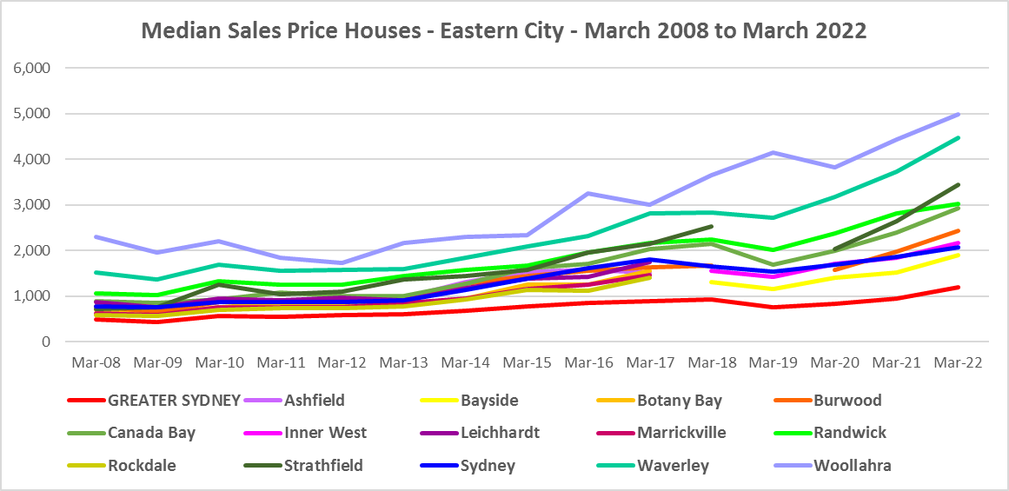

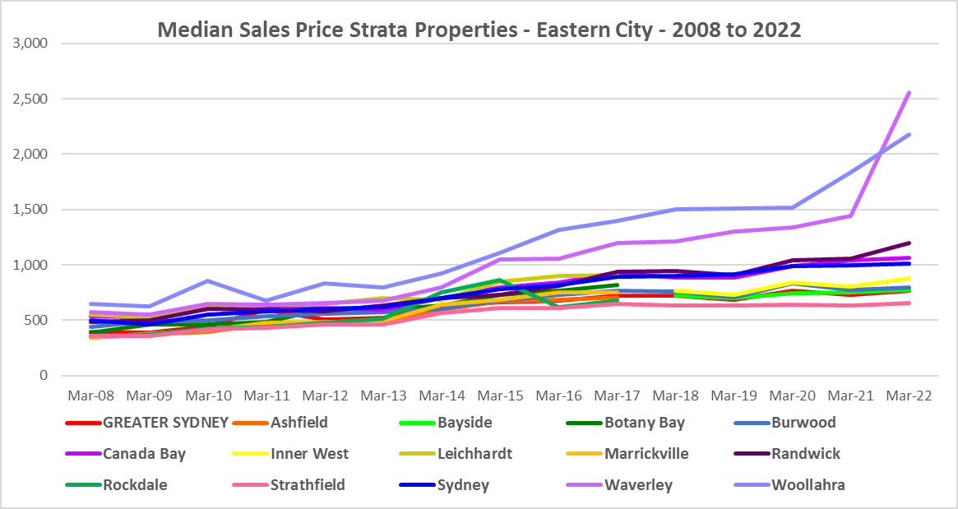

* However, between 2019 and 2022 there were more complex changes in the market, as the graphs above and the two tables below demonstrate. Between March 2019 and March 2020 median house and strata prices declined in most Eastern City LGAs. Changes in the median sales price for houses over that 12 month period ranged between -21.5% in Canada Bay and 13.8% in Woollahra, while for strata the change in the median ranged between -6.9% in Burwood and 7.3% in Waverley.
* Between March 2020 and March 2022 there was strong growth in median house and strata prices across the Eastern City. Increases in the median sales price for houses ranged between 69.0% in Strathfield and 21.4% in Sydney. For strata over the same period, increases ranged between 91.0% in Waverley and -4.2% in Burwood. (Burwood was the only LGA to register a decline in the median sales price in this time frame in the Eastern City.)
* Clearly Covid also had an impact on sales prices in the region.

Median Sales Price Houses



Median Sales Price Strata



## Purchase Affordability

* Purchase affordability for very low income earners has varied only marginally over the period from 2017 to 2021 in Greater Sydney and in the Eastern City.
* At June 2021, all the Eastern City LGAs, along with Greater Sydney, had 0.0% of sales affordable for purchase by very low income households.
* The graph and table below show purchase affordability for very low income households in the Eastern City LGAs and Greater Sydney between 2017 and 2021.

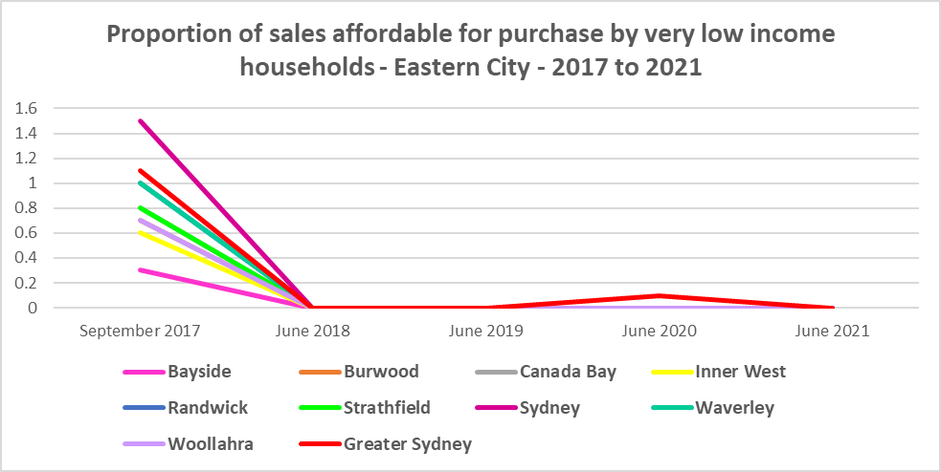

Affordable purchase for very low income households

* Similarly, there was little variation in affordable purchase for low income households in the Eastern City District between 2006 and 2021. Again every Eastern City LGA had 0.0% of housing affordable for purchase by low income households in 2021- all below the average of just 2.3% in Greater Sydney.
* The graph and table below show the change in purchase affordability for low income households in the Eastern City, compared to Greater Sydney, between 2017 and 2021.

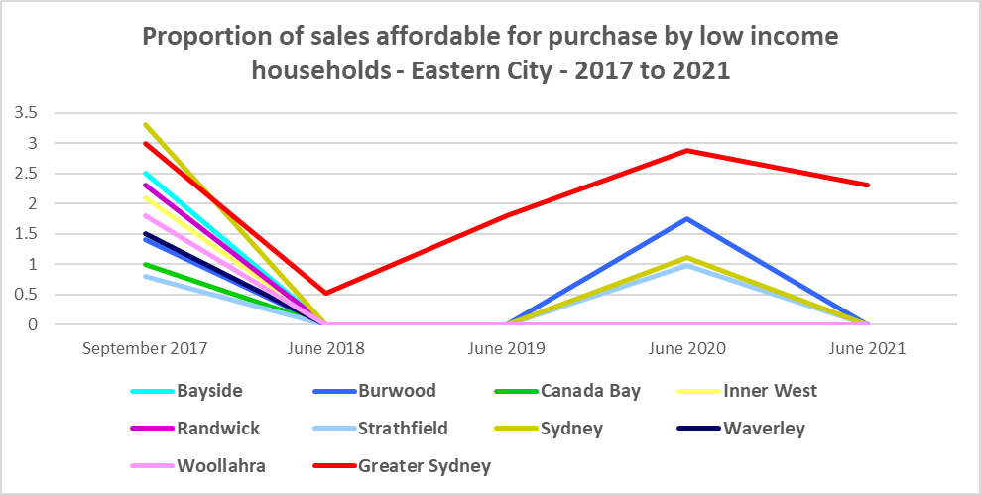

Affordable purchase for low income households

* Purchase affordability for moderate income households is possible in some Eastern City LGAs, with both Strathfield (43.4%) and Bayside (21.9%) having a higher proportion of sales at a price affordable for moderate income households at June 2021 than the average for Greater Sydney of 18.1%.
* Note that both Waverley and Woollahra had 0.0% affordable purchase for moderate income households at June 2021, with Randwick having just 0.6%.
* The graph and the table below show the proportion of sales affordable for purchase by moderate income households in Eastern City and Greater Sydney between 2017 and 2021.

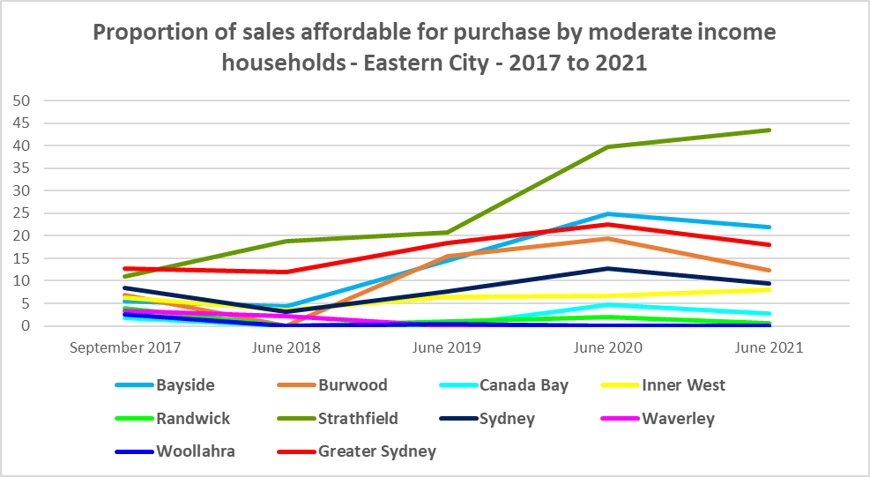

Affordable purchase for moderate income households

**Purchase Stress**

* In 2021 there were 4,954 very low income households and 4,217 low income households purchasing a home and in stress across the Eastern City District – that is, paying more than 30% of their income on their mortgage. This represents 71.2% of very low income purchasers and 53.9% of low income purchasers in the District – a higher proportion than the average for Greater Sydney at 69.3% and 43.8% respectively.
* Strathfield had the highest proportion of very low income purchasers in stress with 78.5%, followed by Sydney with 75.8% and Canada Bay with 74.7%.
* Canada Bay had the highest proportion of low income purchasers in stress with 62.9%, followed by Sydney with 60.5% and Waverly with 58.1%.
* Bayside had the highest number of very low (1,344) and low (2,371) income purchasers in stress, followed by Sydney (882 and 1,071) and Inner West (672 and 1,160).

Very Low and Low Income Households in Purchase Stress



* However the number of very low and low income purchasers in stress is significantly lower than the number of very low and low income renters in stress in the District, as the graph below demonstrates. There is a stronger need for more affordable housing for lower income renters than purchasers in Eastern City.

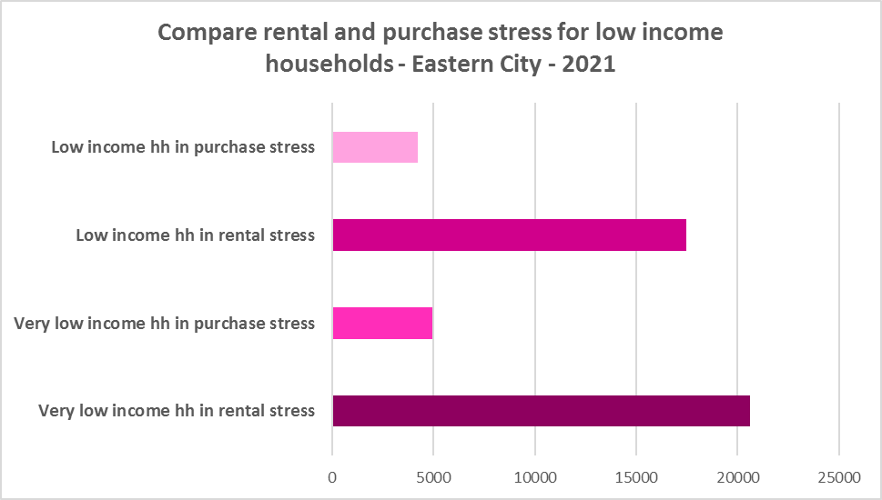

## Additional Data

Additional data on rents and sale prices, including both current and historical data, is available from the Rent and Sales Report and the interactive Dashboard on the Housing NSW website at:

<https://www.facs.nsw.gov.au/resources/statistics/rent-and-sales/dashboard>

More detailed housing data and tables used in this Snapshot are available from the Local Government Housing Kit Database on the DCJ website at:

<https://www.facs.nsw.gov.au/resources/nsw-local-government-housing-kit/chapters/local-government-housing-kit-database>

More information on vacancy rates is available from the Real Estate Institute of NSW website:

<https://www.reinsw.com.au/Web/Web/Members/Property_data/Vacancy_Rates_Survey.aspx>

The Rental Affordability Index is at

<https://sgsep.com.au/projects/rental-affordability-index>