**Far West Region – What’s the Housing Demand?**

This Housing Snapshot looks at aspects of housing demand in the Far West region of NSW, particularly from the 2016 Census to the 2021 Census – including population, age profile, household type, household size, income (change in low, moderate and high income households and low income rental households), homelessness and people with disability.

There have been challenges across Australian and in this region since the 2016 Census, including the pandemic - which have impacted the community and the demand for housing. Population decline, changes to the mining workforce and farming practices as well as ongoing poverty and disadvantage make meeting the housing needs of the residents of this region difficult.

**Population Forecast**

* Changes in population will impact on the demand for housing.
* Between 2016 and 2021, the population of the Far West region declined by -3.7% or -1,638, from 44,636 to 42,998 (using ABS Census population data).
* Every LGA within the Far West region experienced population decline, except for Wentworth, which increased by 9.6%. Declines in the remaining LGAs in the region ranged from -0.87 in Broken Hill to -17.6% in Brewarrina.
* Broken Hill has the largest population of the Far West LGAs with 17,588 (comprising 40.9% of the region’s population), while Unincorporated NSW has the smallest population with 1,016 (comprising 2.4% of the region’s population).
* The Department of Planning and Environment have prepared population projections for every LGA in the region to 2041. Their projections forecast population decline for every LGA in the Far West - Balranald (-1.1% per annum), Bourke (-2.49%), Brewarrina (-2.43%), Broken Hill (-2.32%), Central Darling (-1.6%), Cobar (-2.6%), Walgett (-2.14%) and Wentworth (-0.17%).
* The table below shows the population change for each Far West LGA and the region as a whole from 2016 to 2021.



**Age**

* The age profile of the region and particularly each LGA will impact on housing need and demand, including number of bedrooms, affordability, location, dwelling type as well as demand for aged care.
* The median age of the population of the Far West LGAs at the 2021 Census ranges between 36 years (Brewarrina) and 45 (Unincorporated NSW). Bourke and Cobar (37), like Brewarrina, have a younger median age. None of the LGAs in the Far West has a particularly old median age – for example in the neighbouring Central West and Orana region, the highest median age is 52 in Weddin and in New England North West, Tenterfield has a median age of 55. This compares to the median age for the Rest of NSW (excluding Sydney) of 43 years.
* Generally, most LGAs in the region have higher proportions of 0-4, 5-14, 25-34 and 55-64 year olds and lower proportions of 15-19, 20-24, 35-44, 45-54, 75-84 and 85+ year olds than the average for the Rest of NSW.
* As the largest centre servicing the region, Broken Hill differs from this profile – with lower proportions of age cohorts under 25 years and aged 35-54 and higher proportions of older residents than the Rest of NSW average.
* The graph below show the proportion of the population in each key age cohort in the Far West LGAs, the region and the Rest of NSW.

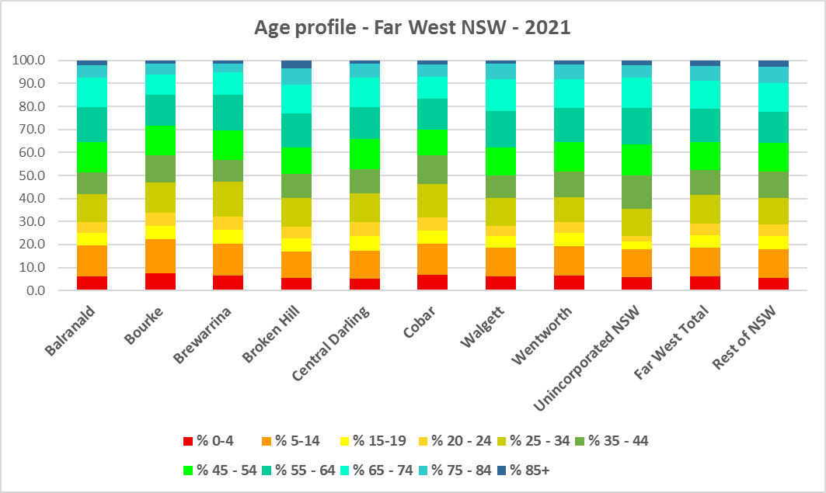

* The table below gives more detail of the breakdown of age cohorts by LGA, by region and for the Rest of NSW.



* The Department of Planning and Environment forecast increases in older age groups to 2041 in every Far West LGA.
* The Department also projects an increase in younger age groups in Wentworth; no change in younger age groups in Balranald, Bourke, Central Darling and Unincorporated NSW; and a decrease in younger age groups in Brewarrina, Broken Hill, Cobar and Walgett.
* The diversity of age groups requires a range of different housing to meet the needs of the community throughout the housing life cycle, including housing to suit older residents, especially as the number in older age groups grows.
* A 2019 study “My Home My Place – Housing Needs of Older People Living in a Rural Community” by Horizon Housing found that (p21):
  + “Older people prefer to stay in their own homes for as long as possible
  + Older people want comfortable and secure housing connected to family, friends and their local community
  + Many homes are not age-friendly causing risk of trips and falls or injury
  + Factors impeding ageing in place included social isolation, tenure insecurity and cost of care
* Key challenges of housing in rural communities included (p21):
  + Shortage of trained professionals or installers
  + Negative perception of accessibility modifications (lack of visual appeal)
  + Lack of awareness
  + Cost of modifications
  + Limitations around modifications.”
* Although the majority of older Australians own their own home, this number is declining. About 15% of older Australians are renters. These people are generally a highly vulnerable and economically disadvantaged group, particularly single person households, with older women being the fastest growing demographic of people experiencing homelessness. There is therefore a need for more adaptable, accessible dwellings, well located, secure, low maintenance and affordable to meet the needs of seniors and frail aged in particular, within their communities. Those most in need are households in the private rental market, who struggle to afford housing on an Aged Pension or inadequate superannuation. (Source: "Housing Decisions of Older Australians" Productivity Commission December 2015).
* In relation to the housing needs of older Indigenous residents, the Australian Institute of Health and Welfare (AIHW) note that Aboriginal and Torres Strait Islander population has a much younger age structure than the non-Indigenous population, due to higher fertility rates and deaths occurring at younger ages. Indigenous Australians have a greater need for care at a younger age compared to non-Indigenous Australians. For this reason, planning for aged care services takes into account the needs of the Indigenous population aged 50 and over and the non-Indigenous population aged 65 and over. However, the indigenous population, like the general population, is ageing.
* Further, the AIHW explain that differences in aged care use exist between Indigenous and non-Indigenous Australians aged 50 and over. With the exception of those aged 65–69 and 75 and over using residential aged care, rates of aged care use were higher for Indigenous Australians than for non-Indigenous Australians.
* In addition, while most Indigenous Australians using aged care services lived in non-remote areas, the proportion of all Australians using aged care who were Indigenous was considerably higher in remote areas. For example, among people using home support in 2019–20, 30% in remote areas were Indigenous, compared with 2.3% in non-remote areas.
* Appropriate, adequate and affordable housing for Indigenous Australians is a significant issue and one requiring cooperation between all levels of government with the community. Indigenous Australians are overrepresented amongst the homeless population, frequently face difficulties accessing private rental and are also overrepresented amongst those seeking housing assistance.

**Household Type**

* A look at household types and average household size gives some insight into the type of housing – particularly number of bedrooms – that is likely to be appropriate to meet the housing needs of the community.
* Household types in the Far West are quite different from the Rest of NSW.
* At the 2021 Census in the Rest of NSW, couple families without children (27.7%) and lone person households (26.1%) are the largest two household types. Couple families with children make up a further significant 24.8%, one parent families 10.9% with group households (3.1%) and other households (6.5%) making up the remainder.
* For the Far West region as a whole, lone person households are the largest household type comprising 28.5%, followed by couple families without children (22.9%), couple families with children (18.4%), other households (16.4%) and one parent families (10.5%). There is a significant proportion of other household types in this region (including multi-family households) – much greater than the Rest of NSW average.
* There is variation within the LGAs of the region with:
  + Balranald (23.5% and 26.1%), Broken Hill (33.8% and 23.6%) and Cobar (26.5% and 21.2%) have lone person and couple only households as the largest two household types;
  + Bourke has lone person (24.9%) and couple family with children (22.0%) as the largest two household types;
  + Brewarrina (28.9% and 22.2%), Central Darling (28.9% and 28.5%) and Walgett (25.7% and 31.5%) have lone person and other households as the largest two household types;
  + Wentworth has couple family without children (29.0%) and couple family with children (25.7%) as the largest two household types; and
  + Unincorporated NSW has couple family without children (23.9%) and other households (24.3%) as the largest two household types.
* There has been a small shift since the 2016 Census, with an increase in the proportion of couple family without children households in the Rest of NSW (0.7%), a decline in the proportion of couple families with children households (-0.6%), a small increase in the proportion of lone person households (0.5%) and a decline in the proportion of other households (-0.6%).
* For the Far West region as a whole, the changes were a little different to the Rest of NSW – with a decline in the proportion of couple family without children households (-0.3%), a larger decline in the proportion of couple family with children households (-1.2%), a small decline in the proportion of lone person households (-0.2%) and a significant increase in other households (3.0%).
* Changes in individual LGAs are not all in line with the changes in the region as a whole:
  + For couple families without children, Balranald, Bourke, Central Darling and Wentworth experienced an increase in the proportion in this household type between 2016 and 2021, while Brewarrina, Broken Hill, Cobar, Walgett and Unincorporated NSW saw a decline in the proportion.
  + For couple families with children, Bourke and Wentworth experienced an increase in the proportion, there was no change in Unincorporated NSW and the remaining LGAs all had an increase.
  + For lone person households, Bourke, Brewarrina, Broken Hill and Cobar all experienced an increase in the proportion of this household type while the remaining LGAs had a decline.
  + For other households, every LGA except Bourke (which declined) had an increase in the proportion of this household type.
* This data should be compared with the data on bedroom numbers to determine if there is a good fit between household types and housing stock.
* Although there should be plenty of housing suitable for families of different sizes, there is also a need for a variety of dwellings with different bedroom numbers to suit couples and single person households.
* The graph and table below show the proportion in each key household type for every Far West LGA, for the region and for the Rest of NSW at the 2021 Census.

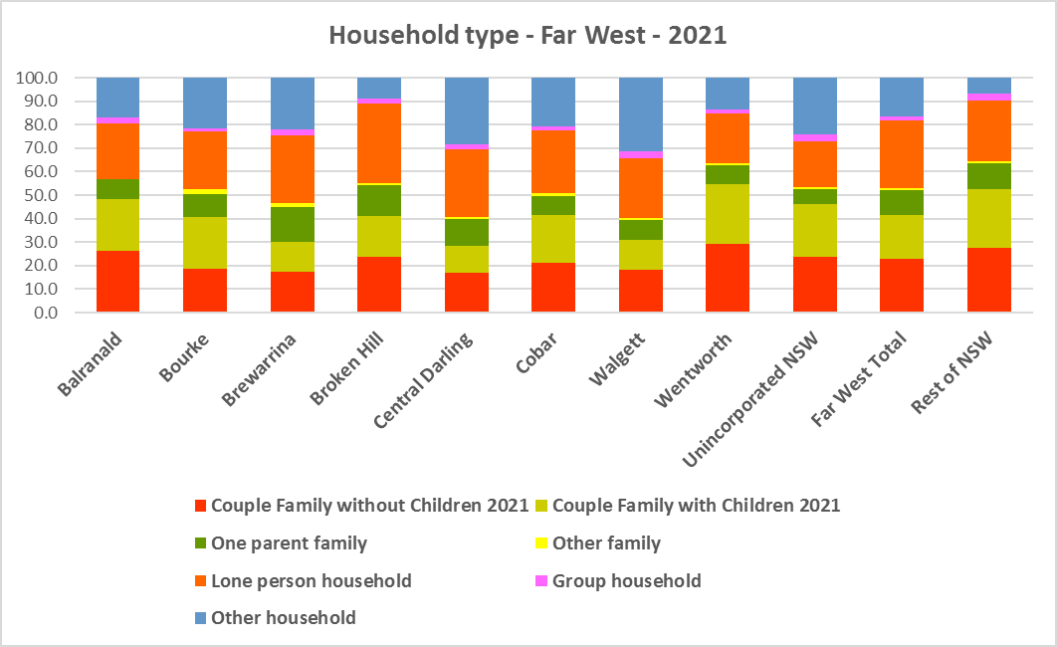



**Household Size**

* At the 2021 Census, the average household size for the Rest of NSW was 2.4 persons per household – unchanged from 2016 and 2011.
* Average household size in the Far West ranges from 2.2 persons per household in Broken Hill and Walgett to 2.5 persons per household in Balranald, Bourke, Wentworth and Unincorporated NSW.
* In line with the trend in the Rest of NSW, between 2016 and 2021, average household size was stable in Balranald, Bourke, Broken Hill and Unincorporated NSW. Brewarrina saw a very strong decline from 2.6 persons per households in 2016 to 2.3 persons per household in 2021. Average household size declined slightly in Central Darling (2.4 to 2.3), Cobar (2.4 to 2.3) and Walgett (from 2.3 to 2.2) and increased slightly in Wentworth (from 2.4 to 2.5).
* The table below gives the average household size in each of the Far West LGAs as well as the Rest of NSW for 2011, 2016 and 2021.



**Income**

* At the 2021 Census, low income households comprise the largest proportion of all households in the Rest of NSW, in the Far West as a whole and in all but two of the region’s LGAs/areas (Cobar and Unincorporated NSW).
* Brewarrina (66.4%), Central Darling (54.6%), Walgett (65.4%) and Wentworth (55.4%) all had higher proportion of low income households than the average for the Rest of NSW (49.3%) and for the Far West region (48.9%).
* Balranald (41.2%), Bourke (46.8%), Broken Hill (46.3%), Cobar (33.5%) and Unincorporated NSW (22.7%) all had a lower proportion of lower income households than the Rest of NSW average.
* Moderate income households in the Rest of NSW comprise 21.5% of all households and 18.2% for the Far West as a whole, while in the LGAs of the region, moderate income households range from 14.2% in Brewarrina to 22.5% in Balranald.
* High income households comprise 29.2% of all households in the Rest of NSW, 32.9% on average across the Far West region and range from 19.4% of households in Brewarrina and Walgett to 51.5% in Cobar.
* The graph and table below show the proportion of low, moderate and high income households in all the Far West LGAs/areas, compared with the region and Rest of NSW at the 2021 Census.

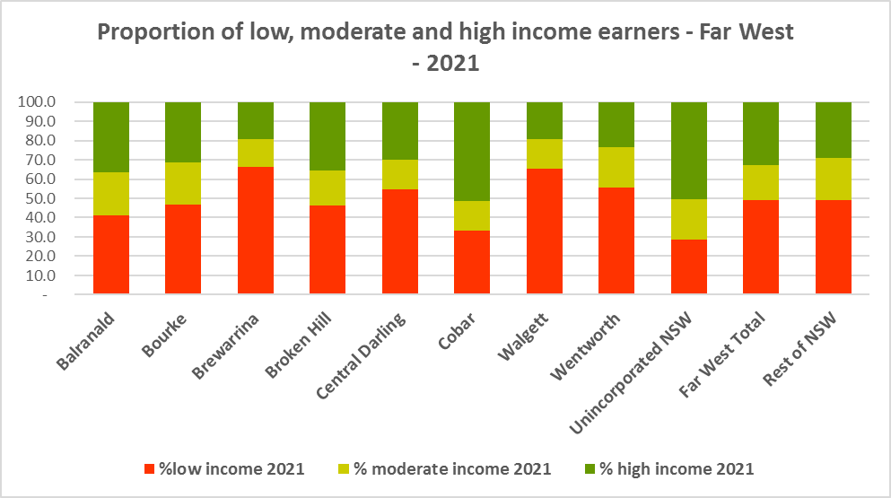



* Between 2016 and 2021 the number of low income households declined in the Far West region and most LGA’s except for Bourke and Wentworth, which both experienced an increase in the number of low income households.
* Over the same period, the number of moderate income households declined in the Far West as a whole and in most LGAs in the region – with an increase only in Broken Hill.
* The number of high income households increased overall in the region and in Balranald, Broken Hill, Central Darling and Unincorporated NSW but declined in Bourke, Brewarrina, Cobar, Walgett and Wentworth.
* The graph below shows the change in the number of low (including very low), moderate and high income households from 2016 to 2021 in the Far West region.

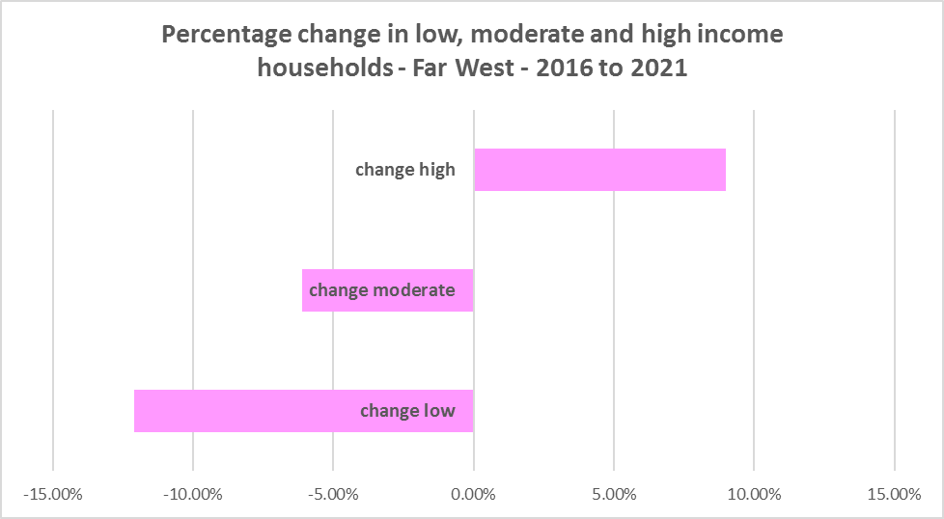

* Along with the decline in the number of low income households between 2016 and 2021, the Far West region as a whole (-26.9%) and every LGA in the region experienced a decline in very low income **rental** households over the same period, varying between a -100.0% decline in Brewarrina and a -16.8% decline in Broken Hill.
* The region as whole experienced a decline in low income **rental** households over the same period (-4.8%), with only Balranald (10.1%), Broken Hill (21.7%) and Central Darling (31.9%) seeing an increase.
* The reduction in both very low (-202) and low income renters (-27) across the Far West region is likely due to the additional Commonwealth financial assistance to renters during the pandemic – which has subsequently been discontinued, as explained in the What’s Happening in the Housing Market” snapshot for Far West. Part of the explanation for the loss of low income earners and lower income renters may be due to population decline in the region.
* It underlines the need to consider tenure as well as price point when considering responses to meet housing need.
* The graph below shows the change in the number of very low and low income **renters** between 2016 and 2021 in the Far West.

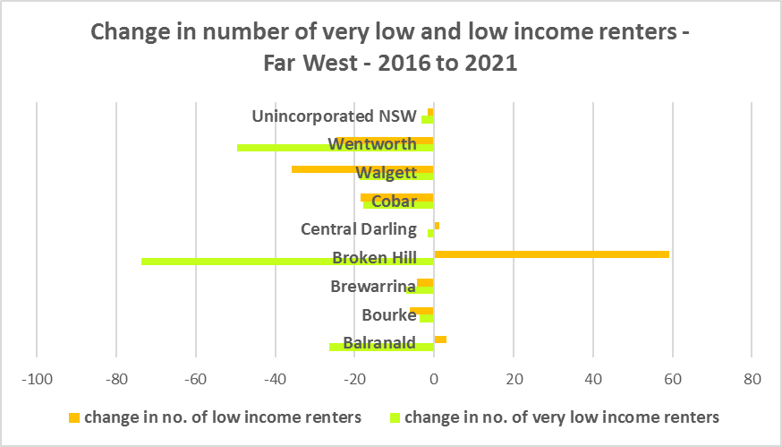

* Bourke, Cobar and Unincorporated NSW have a higher median household weekly income at 2021 than the Rest of NSW ($1,434) while the rest of the LGAs in the Far West region have a lower median household income. Cobar ($1740) has the highest median weekly income in the region while Brewarrina has the lowest ($962) closely followed by Central Darling ($988) and Walgett ($1,001) - all three are well below the Rest of NSW average.



**Homelessness**

* People experiencing homelessness and those at risk of homelessness are among Australia’s most socially and economically disadvantaged. State, Commonwealth and some local governments fund services to support people who are homeless, or at risk of homelessness. Services are delivered mainly by non–government organisations, some of which specialise in delivering services to specific groups (such as young people or people experiencing domestic violence).
* Inadequate income and inability to access affordable housing are significant contributing factors to homelessness, along with individual factors such as experience of family and domestic violence, ill health and disability.
* The ABS identifies someone as homeless “where they do not have suitable accommodation alternatives and their current living arrangement:
  + Is in a dwelling that is inadequate;
  + Has no tenure or their initial tenure is short and not extendable; or
  + Does not allow them to have control of and access to space for social relations.”
* The ABS uses “six operational groups for presenting estimates of people experiencing homelessness on Census night:
  + People living in improvised dwellings, tents or sleeping out
  + People living in supported accommodation for the homeless
  + People staying temporarily with other households
  + People living in boarding houses
  + People in other temporary lodgings
  + People living in ‘severely’ overcrowded dwellings.”
* The ABS “also compiles estimates from Census data for the following three groups of people who may be marginally housed but are not classified as homeless:
  + People living in other crowded dwellings
  + People in other improvised dwellings
  + People marginally housed in caravan parks.”
* The table below shows that ABS 2021 Census data for the Central Coast on the homeless and marginally housed.
* Note that due to additional assistance provided during the pandemic, the number of people counted as homeless on Census night in 2021 is lower than at the 2016 Census. Nevertheless there were 258 people counted as homeless at the 2021 Census in the Far West and a further 353 counted as marginally housed.
* Of those counted as homeless, the largest number (107 or 41.5%) were people living in improvised dwellings, camping or sleeping out. Almost all of these were in Walgett local government area. The next largest group were people staying temporarily with other households (49 or 19.0%), followed by people living in severely overcrowded dwellings (48 or 18.6%).
* Of those counted as marginally housed, the majority were people living in other improvised dwellings (226 or 59.0%).
* This suggests there is insufficient affordable and adequate housing to meet local needs.



* The 2023 NSW street count, the NSW Government’s fourth annual rough sleeping street count, was completed between 2 February and 27 February 2023.
* Over 300 local organisations either consulted in the planning phase or participated in the delivery of street counts. Organisations which partnered with the Department of Communities and Justice (DCJ) included Community Housing Providers, local councils and Specialist Homelessness Services, as well Aboriginal organisations, Local Health Districts, local community groups, and Police.
* 1,623 people were counted sleeping rough during these street counts, a 34% increase from 2022.
* Street counts took place in more than 350 towns in 76 LGAs, compared to 71 LGAs in 2021 and 65 LGAs in 2020.
* The table below gives the street count results for the Far West locations.



## People with Disability

* According to the Australian Institute of Health and Welfare (AIHW) and data from the 2018 Australian Bureau of Statistics (ABS) Survey of Disability, 18% of people in Australia have disability. Another 22% have a long term health condition but not disability.
* Nearly one third (32%) of people with disability have severe or profound disability. This means needing help with daily self-care, mobility or communication activities, having difficulty understanding or being understood by family or friends, or communicating more easily using sign language or other non-spoken forms of communication.
* The survey data shows:
  + 7.6% of children aged 0–14 have disability
  + 9.3% of people aged 15–24 have disability
  + 13% of people aged 15–64 have disability
  + 50% of people aged 65 and over have disability (ABS 2019b).
* For about 3 in 4 (77%) people with disability, the main type of disability is physical, while for the remaining 1 in 4 (23%), the main type of disability is mental or behavioural.
* Clearly housing is a significant factor in the health and wellbeing of people with disability. The availability of affordable, sustainable and appropriate housing helps people with disability to participate in the social, economic and community aspects of everyday life. Someone without access to affordable, secure and appropriate housing is more likely to experience homelessness, poor health, and lower rates of employment and education.
* While most people with disability live at home in the community (96% in private dwellings), some live in cared accommodation.
* Cared accommodation is usually long term and may be institutional in style, including hospitals, residential aged care, cared components of retirement villages, aged care hostels, psychiatric institutions and group homes for people with disability. The more severe a person’s disability is, the more likely they are to live in cared accommodation and the less likely they are to live in the community.
* There has been a significant shift towards supporting people with disability to live in private dwellings, rather than being in institutional care over recent decades. Largely this has been driven by changes for young people with disability.

**Additional Data**

More detailed housing data and tables used in this Snapshot are available from the Local Government Housing Kit Database on the FACS website at:

<https://www.facs.nsw.gov.au/resources/nsw-local-government-housing-kit/chapters/local-government-housing-kit-database>

The Australian Institute of Health and Welfare – Older Australians Housing and Living Arrangements on the AIHW website at:

<https://www.aihw.gov.au/reports/older-people/older-australians/contents/housing-and-living-arrangements>

AIHW Aged care for indigenous Australians

<https://www.aihw.gov.au/reports/australias-welfare/aged-care-for-indigenous-australians>

The Australian Institute of Health and Welfare – People with Disability in Australia

<https://www.aihw.gov.au/reports/disability/people-with-disability-in-australia/contents/people-with-disability/prevalence-of-disability>

and relating to housing needs

<https://www.aihw.gov.au/reports/disability/people-with-disability-in-australia/contents/housing>

The Productivity Commission’s report Housing Decisions of Older Australians is at:

<https://www.pc.gov.au/research/completed/housing-decisions-older-australians>

More detailed information on population, household and dwelling projections is available on the Department of Planning and Environment website at:

<https://www.planning.nsw.gov.au/Research-and-Demography/Population-Projections/Projections>

<https://pp.planningportal.nsw.gov.au/populations>

More data on homelessness, specifically homelessness service data is available on the Homelessness NSW website at:

<https://homelessnessnsw.org.au/resource/specialist-homelessness-service-data/>

And from the AIHW website here:

<https://www.aihw.gov.au/reports/australias-welfare/homelessness-and-homelessness-services>

The 2022 Street Count result is at the FACS website here:

<https://www.facs.nsw.gov.au/reforms/homelessness/premiers-priority-to-reduce-street-homelessness/street-count>

Further information on ABS estimation of homelessness is available at the ABS website:

<https://www.abs.gov.au/statistics/people/housing/estimating-homelessness-census/2021>