**Illawarra Shoalhaven Region – What’s Happening with Housing Supply and does it match Demand?**

This Housing Snapshot looks at aspects of housing supply in the Illawarra Shoalhaven, particularly from the 2016 Census to the 2021 Census – including dwelling type, bedroom mix, tenure, as well as social housing supply and waiting times for public housing. It also looks at aspects of the gap between housing demand and supply, including what’s happening with low income rental households and affordable rental supply, comparing household type with bedroom mix and who needs affordable housing.

Across much of NSW housing supply has not kept pace with demand, with significant outmigration from cities to regional areas during Covid, record levels of migration post Covid, with rapid increases in construction costs and skilled labour shortages contributing to longer term tight rental vacancy rates, insufficient affordable housing and a lack of housing diversity to meet local need. There has also been the impact of bushfires and floods in parts of this region, having adverse impacts on the rental market and communities more broadly.

Although the local government areas of the Illawarra Shoalhaven vary somewhat in their age profile, household structure, income, tenure and housing market conditions, there is little difference within the region in in bedroom mix. Much of the region’s dwelling stock was built a long time ago to suit families and is overwhelmingly three, four or more bedrooms. In Kiama and Shoalhaven in particular, the majority of households now living here are couples or single person households. The housing stock needs to adapt to better match households requirements. Proactive measures are necessary to diversify bedroom mix and increase the supply of studio and one bedroom dwellings in particular to provide housing choice to smaller households.

Infrastructure Australia delivered a report “2022 Regional Strengths and Infrastructure Gaps” which cites housing – the availability, affordability and diversity of housing – as a key infrastructure gap in both the Illawarra and South Coast of NSW.

**Dwelling Type**

* At the 2021 Census there were 180,790 dwellings in the Illawarra Shoalhaven region, up from 166,624 in 2016.
* Of these, 88.2% were occupied (up slightly from 87.8% in 2016), just under the 89.0% average percentage occupied in the Rest of NSW.
* This means that 11.8% were unoccupied (down from 12.2% in 2016) and compared to 11.0% in the Rest of NSW.
* The reasons homes are unoccupied vary and include (according to a report by the Australian Housing and Urban Research Institute “Are there 1 million empty homes and 13 million unused bedrooms?”):
  + homes are being renovated
  + homes being sold as vacant possession
  + newly built or bought homes where no one has moved in yet
  + rental homes awaiting new tenants
  + people living away temporarily from home during the census count (travelling or visiting other homes)
  + homes are deemed unliveable
  + subject to a probate application or other legal proceedings
  + holiday homes
  + homes owned by people currently living overseas
  + homes being land banked, that is held vacant until the local area economics (or personal circumstances) make it more profitable to sell or redevelop the property.

And particularly in rural and regional areas:

* dwellings on rural properties where owners have moved into local towns (particularly as owners age);
  + regional and rural areas which have experienced population decline;
  + and areas where people have a beach or rural retreat house that will only be occupied for short periods of the year
* The graph and table below show the proportion of occupied and unoccupied dwellings in the Illawarra Shoalhaven LGAs at the 2021 Census.

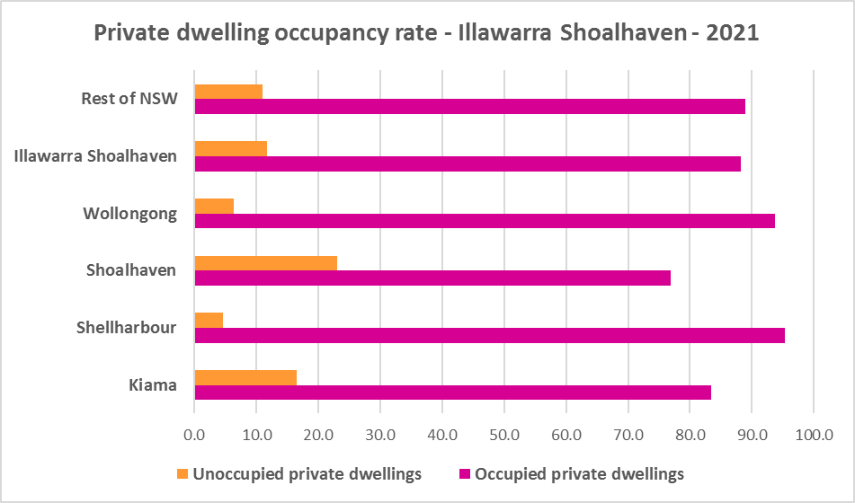

* Note that within the Illawarra Shoalhaven, Shellharbour has the highest proportion of occupied dwellings with 95.3% and Shoalhaven has the lowest with 76.9%.
* At the 2021 Census, the clear majority of occupied dwellings in the Illawarra Shoalhaven were separate houses, comprising 75.8% of all occupied dwellings, compared to 82.5% in the Rest of NSW. The proportion of separate houses within the region ranges from 87.2% in Shoalhaven to 68.4% in Wollongong.
* A further 11.6% of occupied homes in the Illawarra Shoalhaven were semi-detached, terrace or town houses, (compared to 6.3% in the Rest of NSW) and ranging from 14.3% in Kiama and Shellharbour to 8.1% in Shoalhaven.
* 112% of occupied homes in the region were flats (compared to 9.9% in the Rest of NSW), ranging from 18.5% in Wollongong to 2.0% in Shoalhaven.
* While as a whole, the region has greater dwelling diversity than the average for the Rest of NSW, parts of the region lack diversity in dwelling types.
* The graph and table below show the proportion of dwelling types for the Illawarra Shoalhaven LGAs at the 2021 Census.

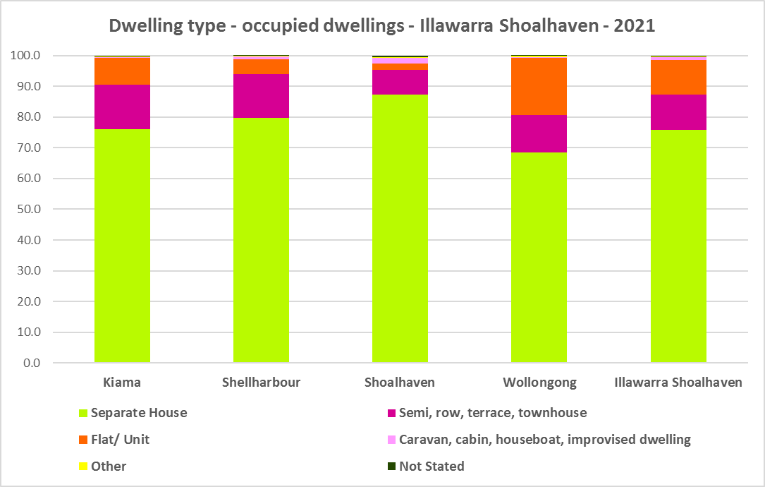



* The next graph compares the proportion of different occupied dwelling types for the Illawarra Shoalhaven with that for the Rest of NSW.

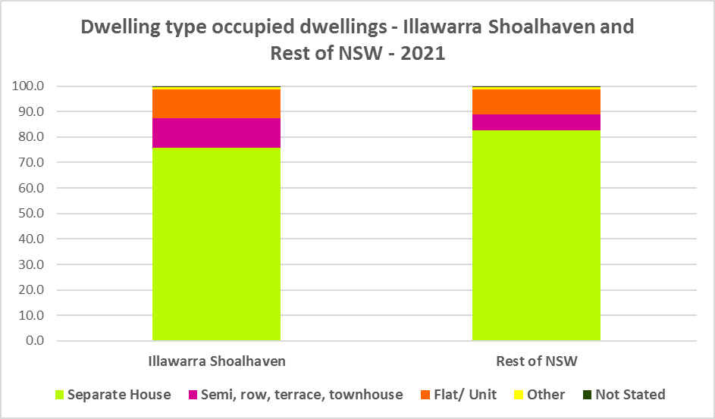

* Other types of dwellings comprised 1.1% of occupied dwellings in the region and include caravans, cabins, houseboats, improvised dwellings and flats attached to shops or offices. Census data shows 420 households living in caravans, 902 living in cabins or houseboats, 10 living in improvised dwellings and 449 in flats attached to shops or offices in the region.
* Note that at the 2021 Census there were a total of 1,322 households living in caravan, cabin/houseboat accommodation, down from 1,529 in 2016. Shoalhaven had the highest number of households living in caravan, cabin/houseboat accommodation with 777 (down from 933 in 2016), followed by Shellharbour with 275 (down from 303 in 2016) and Wollongong with 248 (down from 259).
* While people living in caravans are included in the homeless data in the Census, caravan or residential parks are one of the few remaining affordable housing options for lower income earners. The loss of this accommodation reduces options for lower income households.
* The Census also recorded 10 improvised dwellings in the region. According to the ABS;
  + “Persons in other improvised dwellings are those people who were enumerated on Census night in the dwelling category of an improvised dwelling, tent or sleepers out who reported either being 'at home' on Census night or having no usual address, and are not considered, on balance, to be homeless. Under the ABS definition they are not classified as homeless because they have accommodation alternatives, and in many living situations, the dwelling will be adequate. They are however included in marginal housing and may be at risk of homelessness.”

**Bedroom Mix**

* Just as parts of the Illawarra Shoalhaven lack diversity in dwelling type, parts of the region (and the Rest of NSW generally) also have little variation in the number of bedrooms per dwelling. Across the Illawarra Shoalhaven 41.4% of dwellings have three bedrooms and a further 35.0% have four or more bedrooms. Only 0.3% of homes are studios, 3.9% have one bedroom and 18.1% have two bedrooms.
* This compares to 0.5% of studio homes, 4.0% one bedroom and 17.3% two bedroom in the Rest of NSW.
* There has been little change from 2016, when studios made up just 0.3% of dwellings; one bedroom homes comprised 3.8% and two bedrooms 18.3% of residential stock on average across the Illawarra Shoalhaven – suggesting that the overwhelming majority of new homes built since the 2016 Census have been three, four or more bedrooms.
* Within the region,
  + Kiama, Shoalhaven and Wollongong all have 0.3% studio dwellings while Shellharbour has 0.2%;
  + Wollongong has the highest proportion of one bedroom homes with 4.9% and Shellharbour the lowest with 2.4%;
  + Wollongong has the highest proportion of two bedroom homes with 21.9% and Shellharbour the lowest with 11.5%;
  + Shellharbour has the highest proportion of three bedroom homes with 43.4% and Kiama the lowest with 38.8%; and
  + Kiama has the highest proportion of four or more bedroom homes with 43.0% and Wollongong the lowest with 30.6%.
* The graph and table below show the proportion of studio, one, two, three and four or more bedroom occupied dwellings in the Illawarra Shoalhaven at the 2021 Census.

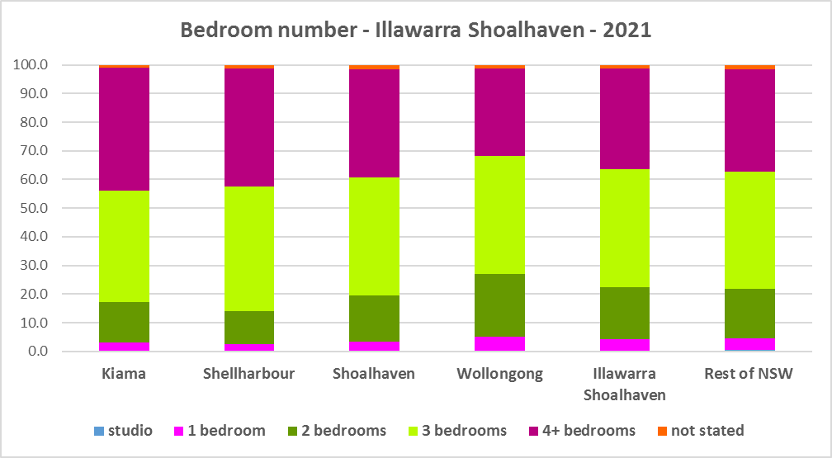



* Given that lone person and couple only households comprised 52.4% of all households in the Illawarra Shoalhaven, the fact that studio and one bedroom homes combined comprise just 4.2% of the housing stock shows a mismatch between household type and dwelling size and a significant lack of housing choice for smaller households. Kiama with 56.0% and Shoalhaven with 58.2% lone person and couple only households and only 3.1% and 2.6% studio and one bedroom dwellings respectively particularly lack housing choice for residents.
* The forecast increase in older age groups in the region is likely to increase the demand for smaller, more manageable and affordable homes.
* Ideally there should be a closer match between household size and bedroom number to offer some housing choice for residents. Two bedroom dwellings in particular offer the most flexibility, given they are also suitable for small families and allow older residents to have family members or carers to stay while giving them a more manageable size home to maintain.

**Tenure**

* At the 2021 Census, the most common tenure type in the Illawarra Shoalhaven was households owning their home outright – comprising 38.5% of all households. Within the region this ranged from 48.7% in Kiama to 34.5% in Shellharbour.
* The next largest tenure type was households with a mortgage – comprising 31.8% of all households. The proportion in this tenure ranged from 37.1% in Shellharbour to 27.5% in Shoalhaven, within the region.
* Rental households comprised a total of 28.3% of all households in the Illawarra Shoalhaven, ranging between 31.6% in Wollongong and 18.4% in Kiama.
* Households renting from a real estate agent comprise 17.0% of all households in the Illawarra Shoalhaven – with Wollongong having the highest proportion at 19.3 and Kiama the lowest with just 12.3% of households renting though a real estate agent.
* The remainder of rental households are comprised of households renting from the state housing authority (4.8% in the region), community housing providers (1.0%) and other landlords (5.5%).
* The graph and table below give the tenure composition for the region and individual LGAs at the 2021 Census.

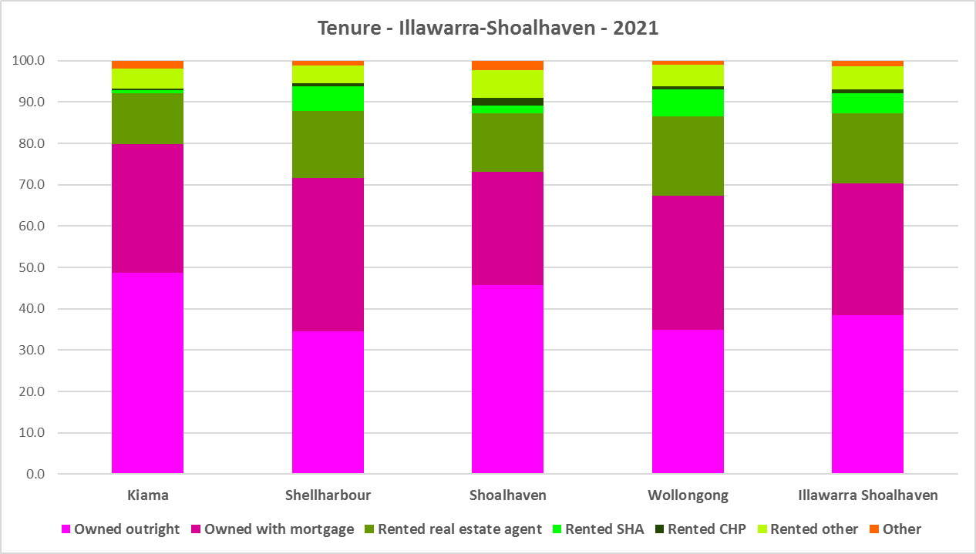



* The general trend is for increasing numbers of households relying on the private rental market as a long term tenure rather than a transitional one between leaving home and buying a home, as housing costs have increased much faster than wages. While the Illawarra Shoalhaven is more affordable than much of Sydney, there has been a growing trend to making a sea or tree change to take advantage of more affordable housing in some coastal and regional areas. In addition, anecdotal evidence indicates that this was particularly pronounced during Covid with the increased flexibility of working remotely/from home.
* Subsequent high interest rates and high inflation levels have made it increasingly difficult for lower income households in particular to manage housing costs.
* Further, the increased popularity and availability of short term rentals have, particularly in coastal parts of NSW, impacted on the availability of long term rental accommodation for renters (see the Housing Snapshot on What’s Happening in the Housing Market).
* This has the potential to bid up housing prices and make it more difficult for locals to afford housing.
* Noting that the rental market in the Illawarra Shoalhaven – and NSW generally – is very tight (see the Housing Snapshot on What’s Happening in the Housing Market) it is therefore important to encourage tenure diversity and a range of price points to meet local needs, including facilitating affordable housing development.

**Social Housing**

* Social housing is secure and affordable rental housing for people on low incomes with housing needs. It includes public, community and Aboriginal housing. Public housing is managed by DCJ while community housing is managed by non-government organisations.
* As at June 2022, there are 154,600 social housing dwellings in NSW, with 96,712 managed by public housing, 48,264 managed by community housing and 9,624 managed exclusively for Aboriginal people – of these the Aboriginal Housing Office (AHO) are responsible for 4,120 and Aboriginal Community Housing Providers (ACHP) manage 5,504.
* The table below shows the number of public housing properties in the Illawarra Shoalhaven region as at June 2022. Please note that Census data on public housing is not totally accurate, as public housing tenure is under reported in the Census. The figures below do not include community housing properties.



* In addition, community housing providers manage a significant number of properties – including social housing, affordable housing, transitional housing and crisis accommodation in the Illawarra Shoalhaven, as indicated in the table below.
* Note that affordable housing is not the same as social housing. Affordable housing is open to a broader range of household incomes than social housing. Households do not have to be eligible for social housing to apply for affordable housing, though people who are eligible for social housing may also be eligible for affordable housing properties.
* Affordable housing is managed more like a private rental property, but there are eligibility criteria and the managers are mostly not for profit community housing providers.



* The next table gives the number of AHO homes and the number managed by ACHPs in the Illawarra Shoalhaven as at June 2022.



* Note that there are 3 types of social housing available for Aboriginal people:
  + Public housing – these properties are managed by the Department of Communities and Justice (DCJ).
  + Aboriginal Housing Office homes – these are properties owned by the Aboriginal Housing Office and managed by DCJ.
  + Community housing properties – these properties are managed by community housing providers and Aboriginal community housing providers.
* The table below shows the expected waiting times for general housing approved social housing applicants (not for priority housing applicants) by bedroom category in the Illawarra Shoalhaven region as at 30 June 2022. It also gives the number of general and priority housing applicants for each allocation zone.



* Information on Expected Waiting Times for Public Housing is available on the FACS website by region at:

<http://www.housingpathways.nsw.gov.au/How+to+Apply/Expected+Waiting+Times/>

## The Gap

* While the Illawarra Shoalhaven has been more affordable for both rental and purchase than neighbouring Sydney, it is more expensive than most regional areas of NSW.
* SGS Economics and Planning in their November 2022 Rental Affordability Index[1] report, point out that regional areas of NSW:
  + have been subject to several natural disasters from widespread bushfires in 2020 to flooding in 2022. These have affected both existing rental stock and new development, limiting supply and increasing rental rates.
  + have seen the combined impact of these factors on renters resulting in homelessness, having to move away from family and support for more affordable housing, moving into poor quality or insecure housing, or having to forgo other essentials.
  + were spared the worst of pandemic response measures. However the impacts of outward-migrating city residents (driven by COVID-19 restriction in capital cities and the ability to work remotely), on housing and rental affordability has caused concern. This is clear in the November 2022 data, which shows that affordability has worsened in the regional areas of every state, even more so than in the capital cities.
  + have became far less affordable to the average rental household over the last year, including inland towns.
* In summary demand for housing increased, supply has been insufficient to meet demand and there have been impacts on affordability, particularly rental affordability, and on lower income tenants.
* There has been a decline in the number of private rental properties which are affordable to low income rental households in the Illawarra Shoalhaven region, as the graph below demonstrates.

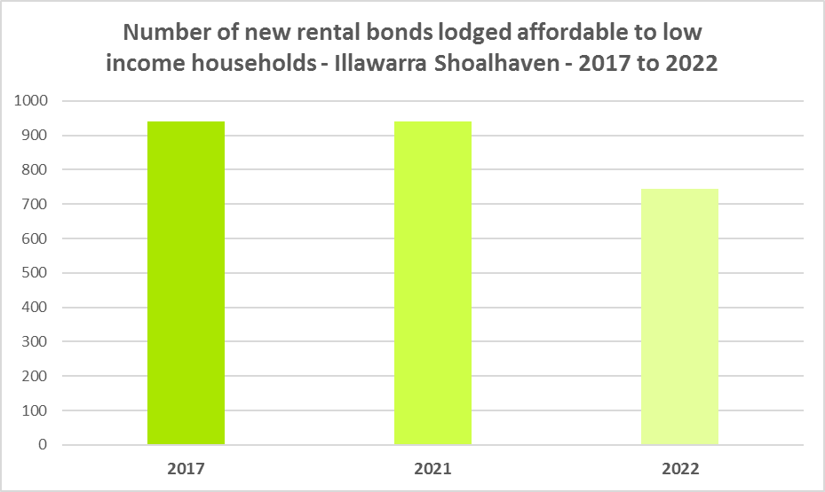

* The decline has not been even across every Illawarra Shoalhaven LGA, as the graph below demonstrates. Every LGA (excepting Kiama, which registered a tiny increase but has such an insignificant number of affordable bonds lodged in any case) experienced a loss of affordable rental between 2017 and 2022. Wollongong had the largest decline from 2017 (416 fewer affordable bonds lodged in 2022 than in 2017) while Shoalhaven had the largest proportional decline (35.9% fewer affordable rental bonds lodged in 2022 than in 2017). Note that both Wollongong and Shellharbour experienced an increase in affordable rentals between 2017 and 2021 and then declined between 2021 and 2022 and this is likely due to the impact of the end of Covid restrictions and supply issues which have driven up rents.

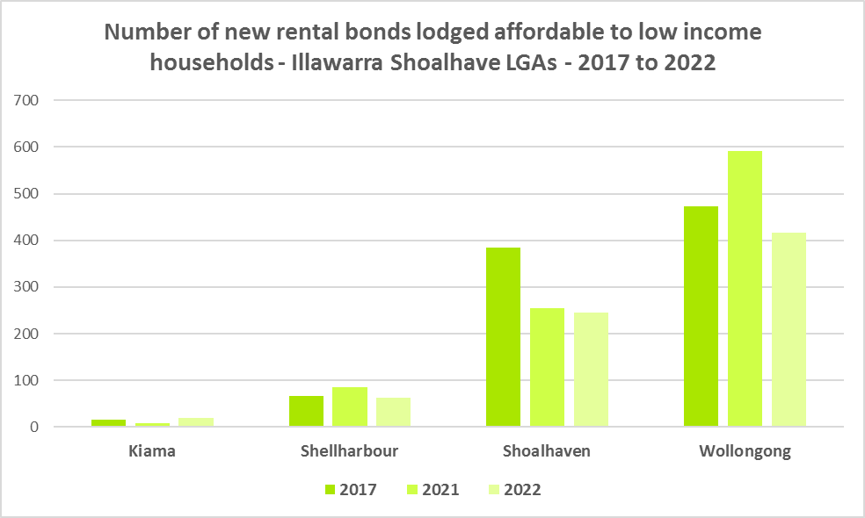

* The next graph compares change in median income with change in median rents and median sales price in the Illawarra Shoalhaven region LGAs between 2016 and 2021 for income and 2017 to 2022 for rent and sales price.

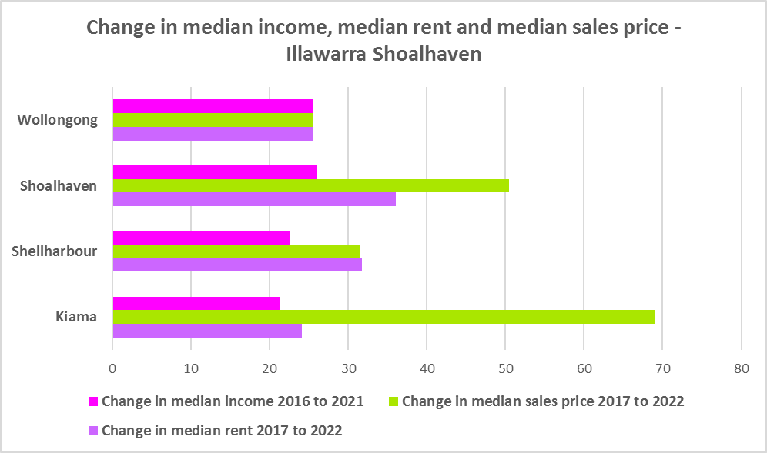

* It demonstrates that housing costs have increased faster than income in every Illawarra Shoalhaven LGA (with the exception of Wollongong) over that time period. This has been the case for decades, with housing costs increasing at a much greater rate than incomes. According to Core Logic “While wages increased 81.7% in the past 20 years, Australian home values have grown 193.1%”[2]
* Note that median sales price have increased at the greatest rate in Kiama and Shoalhaven, which have historically been holiday destinations and which were strongly impacted by the outward migration from Sydney during Covid. Median rents increased at the greatest rate in Shoalhaven and Shellharbour, while median incomes increased at the greatest rate in Wollongong and Shellharbour.
* Low income households are the dominant income group across the Illawarra Shoalhaven and in every LGA in the region excepting Kiama, comprising 46.7% of all households in the region (below the Rest of NSW average of 49.3%) and ranging from 29.4% in Kiama to 49.6% in Shellharbour.
* Furthermore, the number of low income households is increasing across the region – by 11.0% between 2016 and 2021. The graph below shows the change in the number of low income households in each of the Illawarra Shoalhaven LGAs between 2016 and 2021. Note that both Kiama and Shoalhaven experienced a reduction in the number of low income households – likely due to the impact of bushfires (for Shoalhaven) as well as outmigration from Sydney during the pandemic which potentially led to displacement of low income households. At the same time both Shellharbour and Wollongong experienced an increase in low income households.

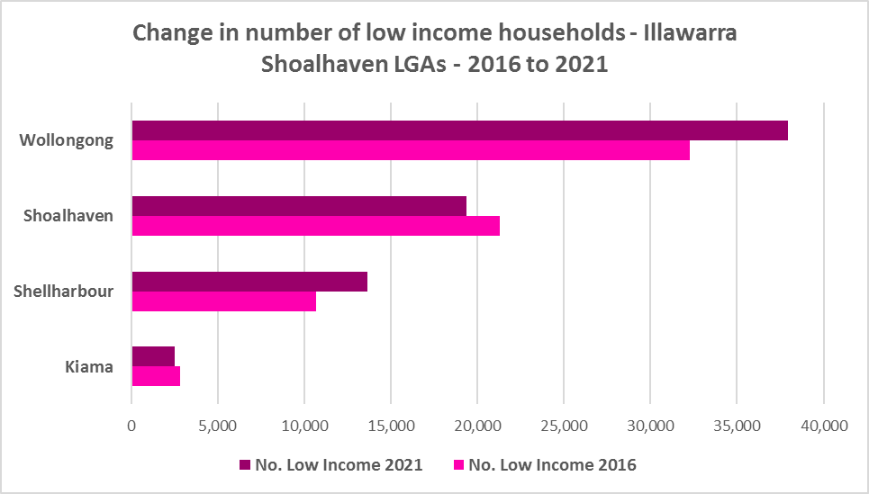

* Due to the changes to income assistance during and subsequent to the COVID-19 pandemic, it is difficult to see what has happened with renters and low income renters in particular between 2016 and 2021. However, it is clear that overall in the region, rents have increased faster than incomes and that the supply of affordable private rental is declining.
* There is a clear need for more affordable rental accommodation to begin to address the demand supply imbalance, particularly for lower income households and the increasing number of seniors and frail aged.
* The vacancy rate in the Illawarra Shoalhaven has been tight for over a year, indicating a chronic shortage of rental accommodation. At April 2023 the vacancy rate was just 1.3% in Wollongong, 1.7% in the rest of the Illawarra and 2.1% for the South Coast.
* Considered together, the strong increase in rental levels, decline in rental affordability for lower income earners and decline in affordable rental properties, combined with the increase in and displacement of low income households, demonstrates the need to increase the supply of affordable rental housing for long term tenants. In some LGAs the impact of Airbnb has been significant and increased the difficulty for lower income households to afford either rental or purchase.
* As well as the gap between supply and demand for affordable rental, there is a significant gap between dwelling size (bedroom numbers) and household size, particularly for smaller households. The graph below compares the number of smaller household types - lone person and couple only – with the amount of studio and one bedroom accommodation available in the Illawarra Shoalhaven. It is clear that if smaller households wished to live in smaller housing, they have very little opportunity to do so. While 52.4% of households in the Illawarra Shoalhaven are lone person or couple only (a little below the 53.8% average for the Rest of NSW), only 4.2% of dwelling stock is studio or one bedroom (below the 4.5% on average in the Rest of NSW and well below the 9.0% in Greater Sydney).
* This mismatch can impact on affordability, with smaller households required to consume more housing than they need or to share housing because of lack of choice.
* It also limits the opportunity for empty nesters or older single households to downsize to smaller more manageable homes within their communities. This can impact on the independence of older residents and their ability to age in place. This will become progressively more important as the population of the Illawarra Shoalhaven is forecast to have an increase in older age groups.

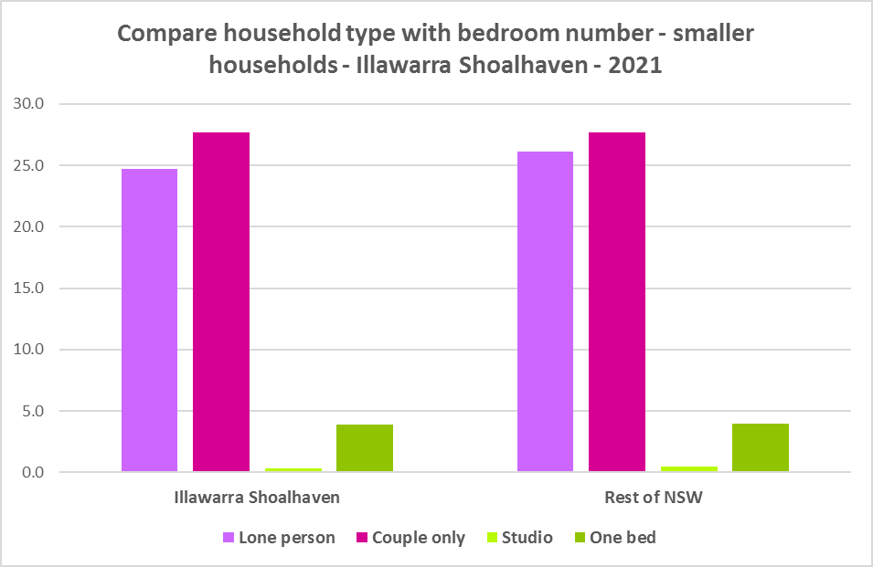

* The Illawarra Shoalhaven actually experienced a small decline in the number of studio dwellings between 2016 and 2021. In addition the relatively small increases in one and two bedroom homes is significantly outweighed by the enormous increase in the number of four plus bedroom homes, as seen in the graph below. This shows that the diversity of housing is actually declining in the region, with significant increases in the number of large homes.

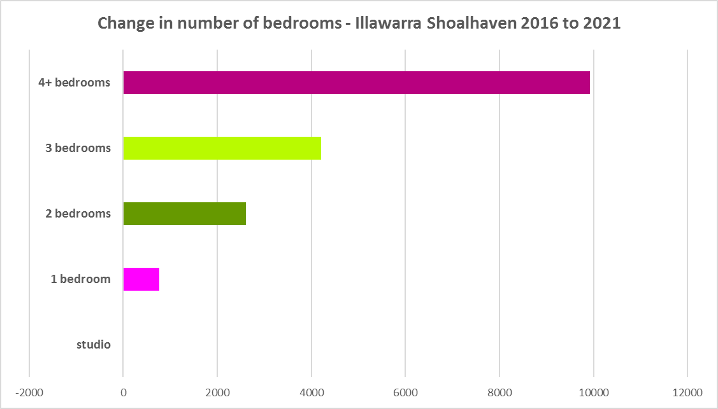

* A proactive approach is required to encourage an increase in studio, one and two bedroom homes.
* This is important given that annually the addition of new dwellings represents around 1% of the total dwelling stock – so change occurs very slowly. There is also a need to take into account the impact of alterations and additions to existing stock, for example, adding extra bedrooms to two and three bedroom houses. Given the current overwhelming supply of three and four bedroom homes and the significant increase in three and particularly four plus bedroom homes since 2016, strong incentives/requirements would need to be put in place to ensure a better balance and more diversity to meet housing need.
* Two bedroom homes are the most flexible as they suit lone person and couple households as well as small family and group households. They allow older residents to have family members or carers to stay while giving them a more manageable size home to maintain.
* New generation boarding houses would also help fulfil some of this demand – particularly as they cannot be subdivided and must provide rental accommodation. This type of accommodation is suitable for single people and also couples, for key workers and students. Note that the NSW Community Housing Industry Association has an Affordable Housing Tool Kit to help deal with community resistance to affordable housing, which is available on their website. They also have a couple of excellent vimeos showcasing new generation boarding house developments and their tenants.
* The next graph compares larger household types – couple family with children, one parent family and group households – with the amount of two, three and four or more bedroom accommodation available. It is clear that there is a more than adequate supply of larger homes for families and group households in the Illawarra Shoalhaven.

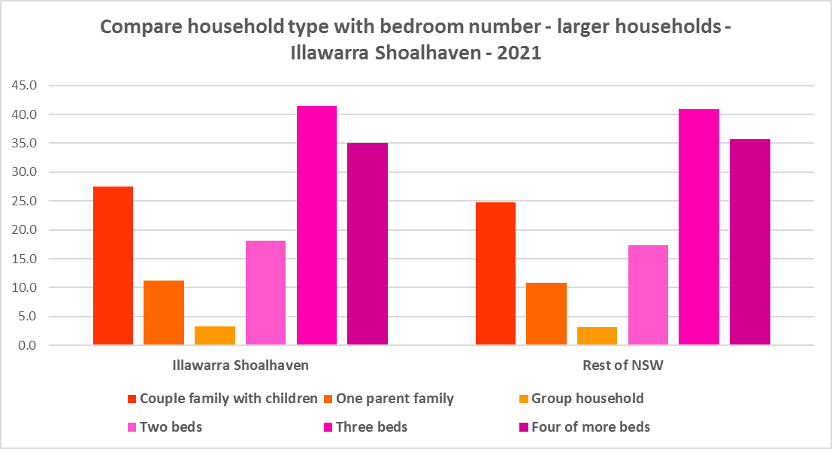

* As couple only households comprise 27.7% of all households in the Illawarra Shoalhaven, it is important to continue to encourage provision of one and two bedroom stock as well as studios, new generation boarding houses and secondary dwellings, to maintain a balance to meet local need, particularly where there are higher proportions of seniors and frail aged. This will give older residents opportunity to downsize into more manageable and appropriate homes.
* Enabling the provision of more semi-detached, terrace and town houses could help fulfil some of this demand.
* Also, secondary dwellings suit a range of groups including small households, young people, frail aged and people with disability needing support from family. They may be readily encouraged on larger lots with reasonable access to centres providing a range of services and facilities.

**Who needs affordable housing?**

* A wide range of people need affordable housing. Single income earners who fall into the low income category include aged care and disability workers, retail sales assistants, production workers, receptionists and early career child care workers.
* People working in accommodation and food services comprise 7.6% of the workforce living in the Illawarra Shoalhaven and are amongst the lowest paid workers. Similarly retail trade employs 9.3% of workers living in the Illawarra Shoalhaven. Health care and social assistance is the largest employment sector of residents in the Illawarra Shoalhaven (employing 16.9%). A 2017 survey of NSW Nurses and Midwives Association (NSWMA) members showed that thirty six per cent of respondents moved home or changed jobs in the previous 12 months because of housing affordability issues.
* For example:
  + Households earning $790 per week gross (broadly indicative of a wage for a laundry worker) could afford to pay just $237 per week in rent before being in housing stress.
  + Households earning $960 (broadly indicative of wages for a commercial cleaner, delivery driver and entry level firefighter) could afford to pay just $288 per week in rent before being in housing stress.
  + Households with an income of $1,150 (broadly indicative of the wage for an enrolled nurse, child care worker and ICT support technician) can afford to pay just $345 per week in rent before being in housing stress.
  + At a weekly income of $1,450/$1,500 (an indicative wage for an early career Registered Nurse), a household could afford to pay $435 to $450 per week in rent before being in housing stress.
* At March 2023, there were insufficient new bonds lodged to calculate a median rent for studio dwellings in any LGA in the Illawarra Shoalhaven, or to calculate a median rent for one bedroom homes in Kiama – which speaks to lack of supply.
* At March 2023, the median rent for a one bedroom home ranged between $270 per week in Shoalhaven and $410 per week in Shellharbour; for a two bedroom home ranged between $420 per week in Shoalhaven and $550 per week in Kiama; for a three bedroom home ranged between $500 per week in Shoalhaven and $685 per week in Kiama and for a four or more bedroom home ranged between $600 per week in Shoalhaven and $850 per week in Kiama.
* This demonstrates that lower income households would struggle to find affordable private rental housing in the region.
* Single income households in particular are less able to compete in the housing market.
* Increasing numbers of older single women are homeless or at risk of homelessness due to the lack of available affordable rental housing. In fact they are the fastest growing cohort of the homeless population.
* Partnering or collaborating with community housing providers is one effective way to meet some of the local need for appropriate affordable housing. Not for profit community housing providers are owners, managers and developers of affordable rental housing for lower income households and residents with specific housing needs. They work with partners, investors and government to provide housing and deliver support for tenants. For more information about community housing providers, see the NSW Community Housing Industry Association website and also the NSW Registrar of Community Housing website.

**Additional Data**

Housing data and tables used in this Snapshot are available from the Local Government Housing Kit Database on the Housing NSW website at:

<https://www.facs.nsw.gov.au/resources/nsw-local-government-housing-kit/chapters/local-government-housing-kit-database>

More information on Expected Waiting Times for Public Housing is available on the DCJ/FACS website by region at:

<https://www.facs.nsw.gov.au/housing/help/applying-assistance/expected-waiting-times>

Additional data on social housing dwellings and delivery is available on the FACS website at:

<https://www.facs.nsw.gov.au/resources/statistics/social-housing-residential-dwellings/facs-quarterly-statistics-social-housing-dwellings>

or go straight to the dashboard:

<https://public.tableau.com/app/profile/facs.statistics/viz/Social_Housing_Residential_Dwellings/Dashboard>

and

<https://www.facs.nsw.gov.au/resources/statistics/social-housing-delivery2/interactive-dashboard>

The Australian Housing and Urban Research Institute (AHURI) has written a paper explaining the reasons for unoccupied homes:

<https://www.ahuri.edu.au/research/brief/are-there-1-million-empty-homes-and-13-million-unused-bedrooms>

The SGS Economics and Planning Rental Affordability Index is here:

<https://sgsep.com.au/projects/rental-affordability-index>

More information about community housing providers is available on the NSW CHIA (Community Housing Industry Association) website:

NSW CHIA Snapshot of the Community Housing Sector in NSW:

<https://communityhousing.org.au/wp-content/uploads/2022/08/Community-Housing-Snapshot-2022.pdf>

Data on community housing properties is available from the NSW CHIA Dashboard at:

<https://communityhousing.org.au/our-impact/data-dashboard/>

CHIA NSW affordable housing tool kit. The Tool Kit is based on extensive research about reasons for community resistance to affordable housing, and effective ways of building support for affordable housing:

https://communityhousing.org.au/toolkit/theplatform.html

The NSW Registrar of Community Housing website is here:

<https://www.rch.nsw.gov.au/>

1. <https://sgsep.com.au/projects/rental-affordability-index>
2. <https://www.corelogic.com.au/news-research/news/archive/how-much-has-house-price-growth-outstripped-growth-in-wages#:~:text=Comparing%20the%20wage%20price%20index,193.1%25%20(figure%202)>.