**Central Coast Region – What’s Happening with Housing Supply and does it match Demand?**

This Housing Snapshot looks at aspects of housing supply in the Central Coast, particularly from the 2016 Census to the 2021 Census – including dwelling type, bedroom mix, tenure, as well as social housing supply and waiting times for public housing. It also looks at aspects of the gap between housing demand and supply, including what’s happening with low income rental households and affordable rental supply, comparing household type with bedroom mix and who needs affordable housing.

Across much of NSW housing supply has not kept pace with demand, with significant outmigration from cities to regional areas during Covid, record levels of migration post Covid, with rapid increases in construction costs and skilled labour shortages contributing to longer term tight rental vacancy rates, insufficient affordable housing and a lack of housing diversity to meet local need.

The Central Coast has little diversity in housing type or bedroom mix, with three and four bedroom homes comprising the overwhelming majority of housing stock. While family households make up a significant proportion of Central Coast households, lone person households are the next largest household type and more than half of households are either lone person or couple only households. In addition, residents aged over 65 are forecast to increase in the Central Coast to 2041, so more housing suitable for older residents will be required.

Infrastructure Australia delivered a report “2022 Regional Strengths and Infrastructure Gaps” which cites housing – the availability, affordability and diversity of housing – as a key infrastructure gap in the Central Coast.

**Dwelling Type**

* At the 2021 Census there were 146,248 dwellings in the Central Coast, up from 138,266 in 2016.
* Of these 90.1% were occupied, (up from 87.5% in 2016), above the 89.0% average percentage occupied in the Rest of NSW and below the 92.0% occupied in Greater Sydney.
* Consequently 9.9% were unoccupied (down from 12.5% in 2016), compared to 11.0% in the Rest of NSW and 8.0% in Greater Sydney.
* The reasons homes are unoccupied vary and include (according to a report by the Australian Housing and Urban Research Institute “Are there 1 million empty homes and 13 million unused bedrooms?”):
  + homes are being renovated
  + homes being sold as vacant possession
  + newly built or bought homes where no one has moved in yet
  + rental homes awaiting new tenants
  + people living away temporarily from home during the census count (travelling or visiting other homes)
  + homes are deemed unliveable
  + subject to a probate application or other legal proceedings
  + holiday homes
  + homes owned by people currently living overseas
  + homes being land banked, that is held vacant until the local area economics (or personal circumstances) make it more profitable to sell or redevelop the property.

And particularly in rural and regional areas:

* dwellings on rural properties where owners have moved into local towns (particularly as owners age);
  + regional and rural areas which have experienced population decline;
  + and areas where people have a beach or rural retreat house that will only be occupied for short periods of the year
* The graph below shows the proportion of occupied and unoccupied dwellings in the Central Coast, Rest of NSW and Greater Sydney at the 2021 Census.

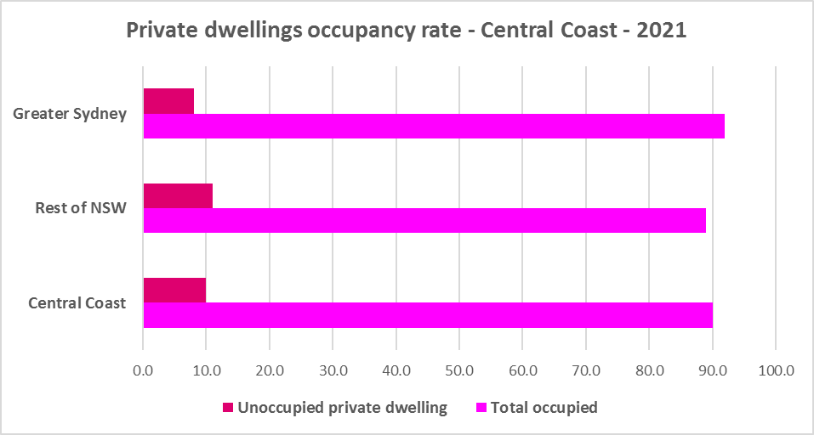

* At the 2021 Census, the clear majority of occupied dwellings in the Central Coast were separate houses, comprising 78.4% of all occupied dwellings, compared to 82.5% in the Rest of NSW and 55.4% in Greater Sydney.
* A further 12.0% of occupied homes in the Central Coast were semi-detached, terrace or town houses (down from 12.4% in 2016), compared to 6.3% in the Rest of NSW and 31.0% in Greater Sydney.
* 8.7% of occupied homes in the Central Coast were flats (up from 7.8% in 2016), compared to 9.9% in the Rest of NSW and 12.9% in Greater Sydney.
* While there has been an increase in the proportion of flats in the region, the proportion of semi-detached, terrace and townhouses has declined and a greater diversity of housing is needed to suit different household types and age cohorts.
* The two graphs below show firstly the proportion of dwelling types for the Central Coast at the 2021 Census and secondly the proportion of dwelling types in the Central Coast compared to the Rest of NSW and to Greater Sydney.

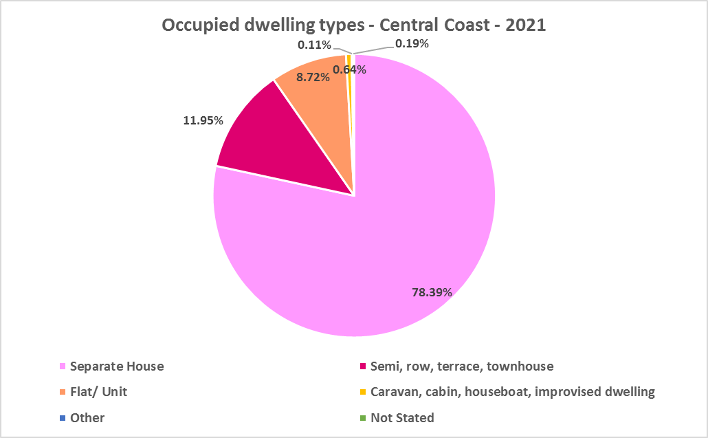

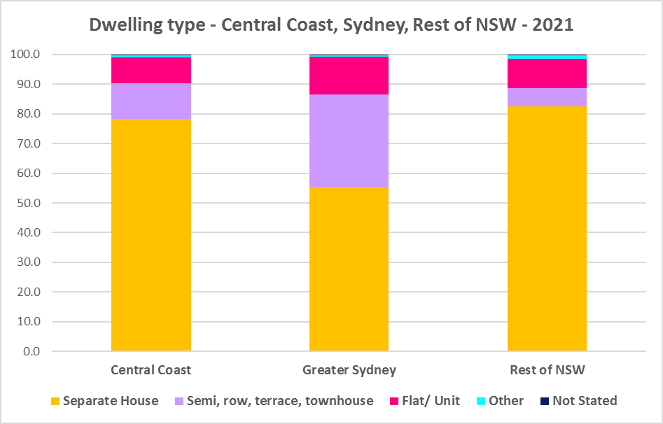

* Other types of dwellings comprised 0.7% of occupied dwellings in the region at the 2021 Census and include caravans, cabins, houseboats, improvised dwellings and flats attached to shops. Census data shows 345 households living in caravans, 487 living in cabins or houseboats, 8 living in improvised dwellings and 148 in flats attached to shops or offices in the region.
* Note that at the 2021 Census there were 832 household living in caravan, cabin/houseboat accommodation, down from 919 in 2016. This is down again from 1,157 at the 2011 Census.
* While people living in caravans are included in the homeless data in the Census, caravan or residential parks are one of the few remaining affordable housing options for lower income earners. The loss of this accommodation reduces options for lower income households and is another indicator of the loss of affordable housing.
* The table below gives the proportion of dwelling types for occupied dwellings for the Central Coast at the 2021 Census.



**Bedroom Mix**

* The Central Coast (like the Rest of NSW generally) also has insufficient variation in the number of bedrooms per dwelling, with 38.7% of dwellings having three bedrooms and a further 36.7% having four or more bedrooms. Only 0.4% of homes are studios, 3.6% have one bedroom and 19.1% have two bedrooms in the Central Coast.
* This compares to 0.5% of studio homes, 4.0% one bedroom and 17.3% two bedroom in the Rest of NSW and 0.9% studios, 8.1% one bedroom and 25.9% two bedroom homes in Greater Sydney.
* It is important to note that this is an improvement from 2016, when studios in the Central Coast made up just 0.1% of dwellings; one bedroom homes comprised 0.9% and two bedrooms 12.2% of residential stock on average across the region.
* The two graphs below show firstly the breakdown in the proportion of bedrooms for the Central Coast and secondly the proportion of studio, one, two, three and four or more bedroom occupied dwellings in the Central Coast, Rest of NSW and Greater Sydney at the 2021 Census.

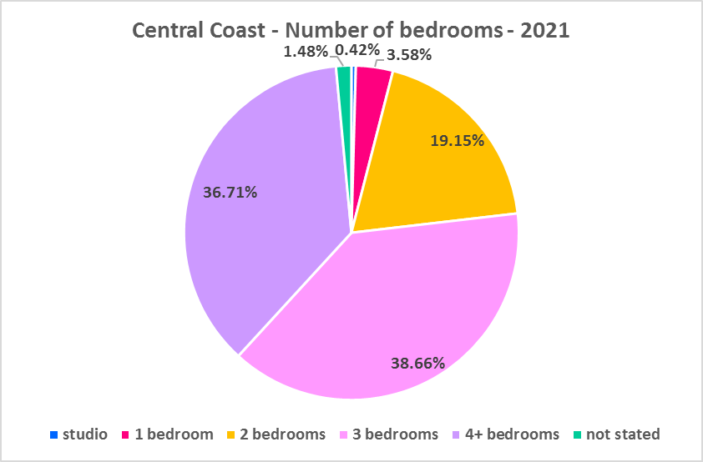

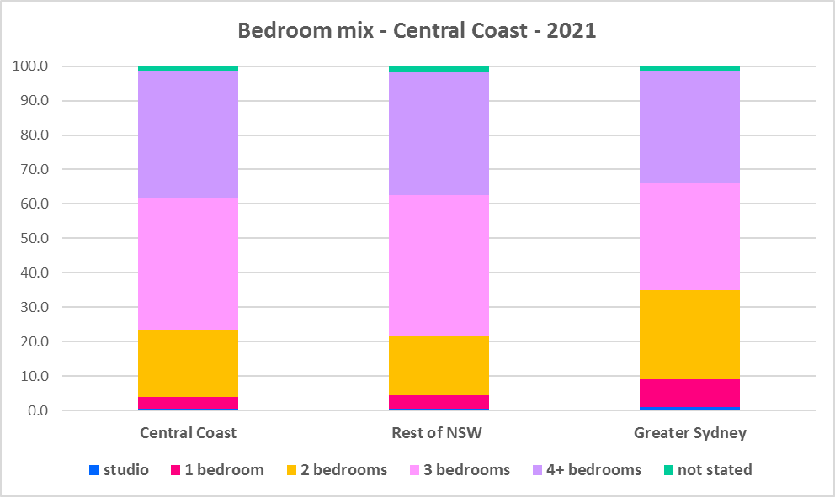

* The table below gives a breakdown of the proportions of bedrooms by LGA compared to the Rest of NSW and Greater Sydney.



* Clearly three and four bedroom homes predominate, together comprising 75.4% of all dwellings, compared to 63.8% in Sydney and 76.6% in the Rest of NSW.
* Given that lone person and couple only households comprised 53.1% of all households in the Central Coast (up from 50.3% in 2016), the fact that studio and one bedroom homes combined comprise just 4.0% of the housing stock means there is a significant mismatch between household type and bedroom number. There are insufficient housing options for smaller households.
* The forecast increase in older age groups in the Central Coast is likely to increase the demand for smaller, more manageable and affordable homes.
* The following graph shows the increase in bedroom numbers between 2016 and 2021 on the Central Coast. While there has been a significant increase in two, three and four bedroom homes, there has been only a small increase in one bedroom homes and little change in the number of studio dwellings. Nevertheless, the increase in two bedroom homes is encouraging, as they are the most flexible, being suitable for lone person, couples, small family and small share households.

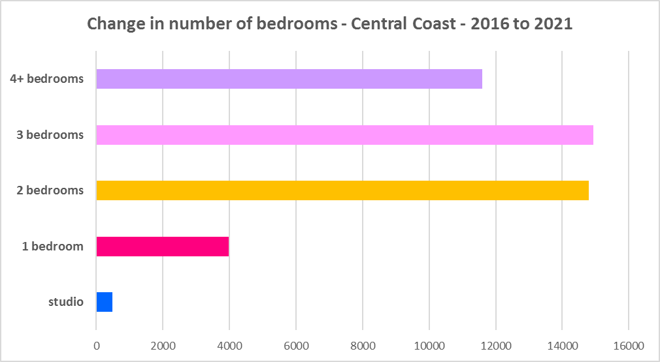

* Ideally there should be a bigger increase in the number of studio and one and bedroom homes as well as a continued increase in two bedroom homes to suit these household types and offer some housing choice.
* It is worth noting that new dwelling construction comprises around 1% of total dwellings (depending on the location and stage in the residential development cycle) with the remaining 99% of homes being existing established dwellings. Alterations and additions to existing stock can have a significant impact on the bedroom mix and long term suitability of housing stock to meet housing need, including household size and affordability. For example, conversions of garages to additional bedrooms or addition of new bedrooms to existing two and three bedrooms homes will increase the number of larger bedroom homes - potentially more quickly than new built residential stock can be added.

**Tenure**

* At the 2021 Census, the most common tenure type in the Central Coast was households owning their home outright – comprising 35.3% of all households.
* The next largest tenure type was households with a mortgage – comprising 34.5% of all households.
* Rental households comprised a total of 28.0% of all households in the Central Coast.
* Households renting from a real estate agent constitute just 19.2% of all households in the Central Coast.
* The remainder of rental households are comprised of households renting from the state housing authority (2.6% in the region), community housing providers (0.9%) and other landlords (5.4%).
* The graph and table below give the tenure composition for the Central Coast at the 2021 Census.

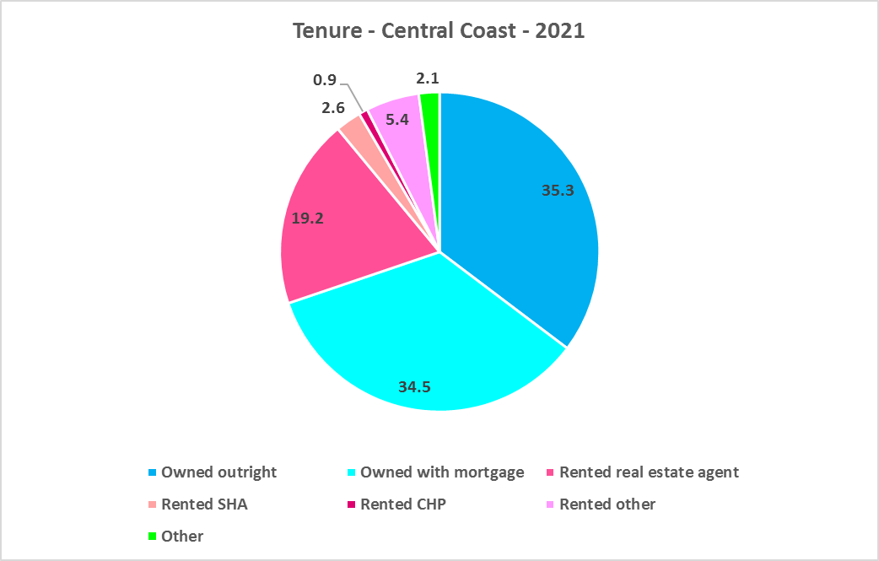



* The general trend is for increasing numbers of households relying on the private rental market as a long term tenure rather than a transitional one between leaving home and buying a home, as housing costs have increased much faster than wages. While the Central Coast is more affordable than much of Sydney, there has been a growing trend to making a sea or tree change to take advantage of more affordable housing in some coastal and regional areas. In addition, anecdotal evidence indicates that this was particularly pronounced during Covid with the increased flexibility of working remotely/from home.
* Further, the increased popularity and availability of short term rentals have, particularly in coastal parts of NSW, impacted on the availability of long term rental accommodation for renters (see the Housing Snapshot on What’s Happening with Demand).
* This has the potential to bid up housing prices and make it more difficult for locals to afford housing.
* Noting that the rental market in the Central Coast – and NSW generally – is very tight (see the Housing Snapshot on What’s Happening in the Housing Market) it is therefore important to encourage tenure diversity and a range of price points to meet local needs.

**Social Housing**

* Social housing is secure and affordable rental housing for people on low incomes with housing needs. It includes public, community and Aboriginal housing. Public housing is managed by DCJ while community housing is managed principally by non-government organisations.
* As at June 2022, there are 154,600 social housing dwellings in NSW, with 96,712 managed by public housing, 48,264 managed by community housing and 9,624 managed exclusively for Aboriginal people – of these the Aboriginal Housing Office (AHO) are responsible for 4,120 and Aboriginal Community Housing Providers (ACHP) manage 5,504.
* The table below shows the number of public housing properties in the Central Coast as at June 2022. Please note that Census data on public housing is not totally accurate, as public housing tenure is under reported in the Census. The figures below do not include community housing properties.



* In addition, community housing providers manage a significant number of properties – including social housing, affordable housing, transitional housing and crisis accommodation in the Central Coast, as outlined in the table below.
* Note that affordable housing is not the same as social housing. Affordable housing is open to a broader range of household incomes than social housing. Households do not have to be eligible for social housing to apply for affordable housing, though people who are eligible for social housing may also be eligible for affordable housing properties.
* Affordable housing is managed more like a private rental property, but there are eligibility criteria and the managers are mostly not for profit community housing providers.



* The next table gives the number of AHO homes and the number managed by ACHPs in the Central Coast as at June 2022.



* Note that there are 3 types of social housing available for Aboriginal people:
  + Public housing – these properties are managed by the Department of Communities and Justice (DCJ).
  + Aboriginal Housing Office homes – these are properties owned by the Aboriginal Housing Office and managed by DCJ.
  + Community housing properties – these properties are managed by community housing providers and Aboriginal community housing providers.
* The table below shows the expected waiting times for general housing approved social housing applicants (not for priority housing applicants) by bedroom category in the Central Coast as at 30 June 2022. It also gives the number of general and priority housing applicants for each allocation zone.



* Information on Expected Waiting Times for Public Housing is available on the FACS website by region at:

<https://www.facs.nsw.gov.au/housing/help/applying-assistance/expected-waiting-times>

## The Gap

* Historically the Central Coast has been more affordable for both rental and purchase than neighbouring Sydney. Yet there is a large and growing gap between the increasing number of low income earners in the private rental market and the declining number of private rental properties that are affordable for low income households. There is also extremely limited opportunity for low income households to affordably purchase in the Central Coast.
* Low income (including very low income) households predominate across the region and have increased by 7.4% between 2016 and 2021 (from 62,921 to 67,602). Over the same time period, low income **rental** households have increased by 12.7% in the Central Coast. Clearly low income rental households are increasing at a faster rate than low income households generally on the Central Coast.
* The graph below shows the change in the number of low income households in the Central Coast between 2011 and 2021.

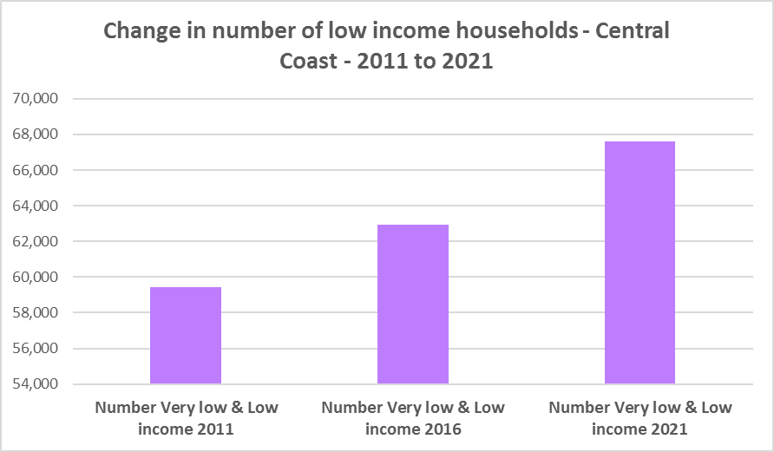

* At the same time there has been a decline in the availability of affordable private rental housing, as the graph below shows. This underscores the need to consider tenure as well as price point when considering responses to meet housing needs in the Central Coast.

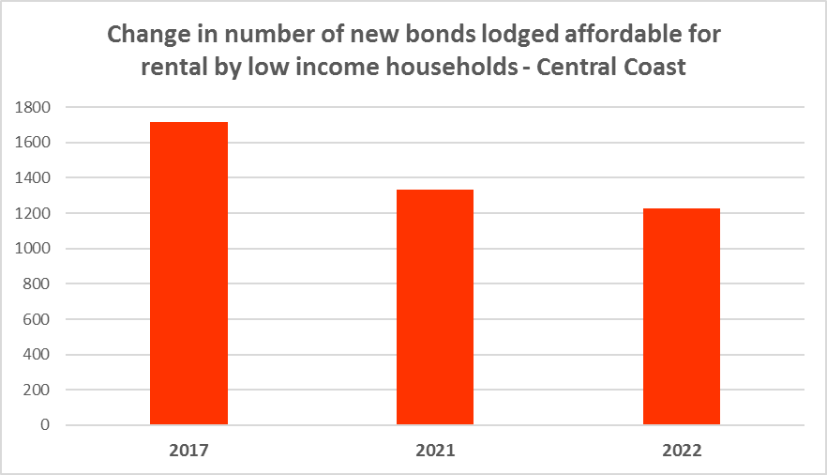

* There is a clear need for more affordable rental accommodation to begin to address the significant demand supply imbalance, particularly for lower income households and the increasing number of seniors and frail aged.
* The vacancy rate in the Central Coast, neighbouring Sydney and regional areas of NSW has been tight for over a year, indicating a chronic shortage of rental accommodation. At April 2023 the vacancy rate was just 1.7% in the Central Coast.
* The strong increase in rental levels, decline in rental affordability for lower income earners and significant loss of affordable rental properties, combined with the very high proportion and increase in both low income and low income rental households, further demonstrates the need to increase the supply of private rental housing and more particularly, affordable rental housing for long term tenants.
* The next graph compares changes in population, income, renters and housing stress between 2016 and 2021. While the population has increased, the number of low income households increased at a faster rate between 2016 and 2021 in the Central Coast. Low income rental households increased at a greater rate again over the same period. Of note also is that the number of CRA recipients are growing more quickly than the population generally, and CRA recipients in housing stress are increasing more rapidly than low income rental households in the Central Coast.

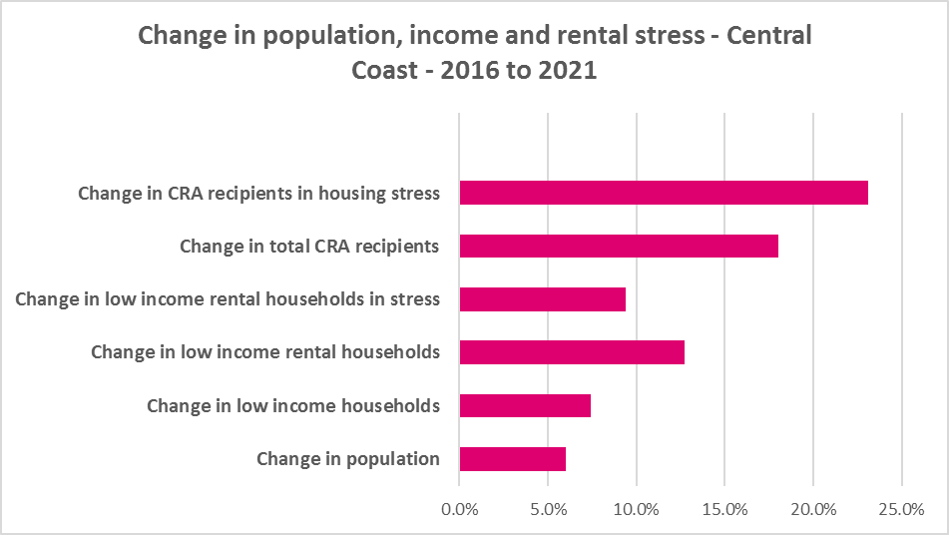

* This demonstrates the increase in demand and need for affordable rental housing in the Central Coast.
* As well as the gap between supply and demand for affordable rental, there is a significant gap between dwelling size (bedroom numbers) and household size, particularly for smaller households. The graph below compares the number of smaller household types - lone person and couple only – with the amount of studio and one bedroom accommodation available. It is clear that if smaller households wished to live in smaller housing, they have very little opportunity to do so. While 51.8% of households in the Central Coast are lone person or couple only (above the 45.5% average in Greater Sydney and below the 53.8% average for the Rest of NSW), only 4.0% of dwelling stock is studio or one bedroom (well below the 9.0% average in Greater Sydney and below the 4.5% on average in the Rest of NSW).
* This mismatch can impact on affordability, with smaller households required to consume more housing than they need or to share housing because of lack of choice.
* It also limits the opportunity for empty nesters or older single households to downsize to smaller more manageable homes within their communities. This can impact on the independence of older residents and their ability to age in place. This will become increasingly important as the population of the Central Coast is forecast to have an increase in older age groups.

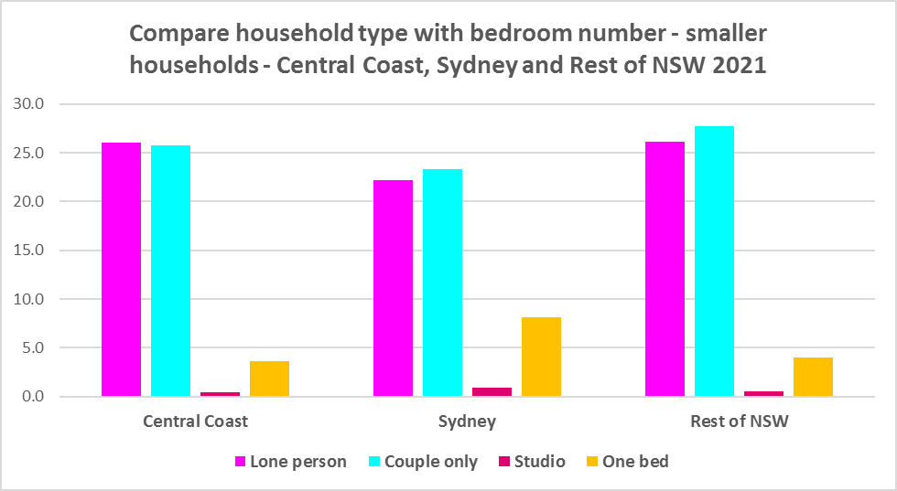

* While there has been an increase in studio and one bedroom homes since the 2016 Census, the number is significantly outweighed by the enormous increase in the number of three and four and more bedroom homes, as seen in the graph below. Of note however, is the substantial increase in two bedroom homes, which potentially suit both single person and couple only households as well as smaller families and small group households.



* A proactive stance is required to encourage an increase in studio, one and two bedroom properties.
* This is important given that annually the addition of new dwellings represents around 1% of the total dwelling stock – so change occurs very slowly. There is also a need to take into account the impact of alterations and additions to existing stock, for example, adding extra bedrooms to two and three bedroom houses. Given the current overwhelming supply of and increase in three and four plus bedroom homes, strong incentives/requirements would need to be put in place to ensure a better balance and more diversity to meet housing need. Continuing to encourage development of two bedroom homes is helpful.
* New generation boarding houses would also help fulfil some of this demand – particularly as they cannot be subdivided and must provide rental accommodation. Note that the NSW Community Housing Industry Association has an Affordable Housing Tool Kit to help deal with community resistance to affordable housing, which is available on their website. They also have a couple of excellent vimeos showcasing new generation boarding house developments and their tenants.
* The next graph compares larger household types – couple family with children, one parent family and group households – with the amount of three and four or more bedroom accommodation available. It is clear that there is more than adequate supply of larger homes for families and group households in the Central Coast.

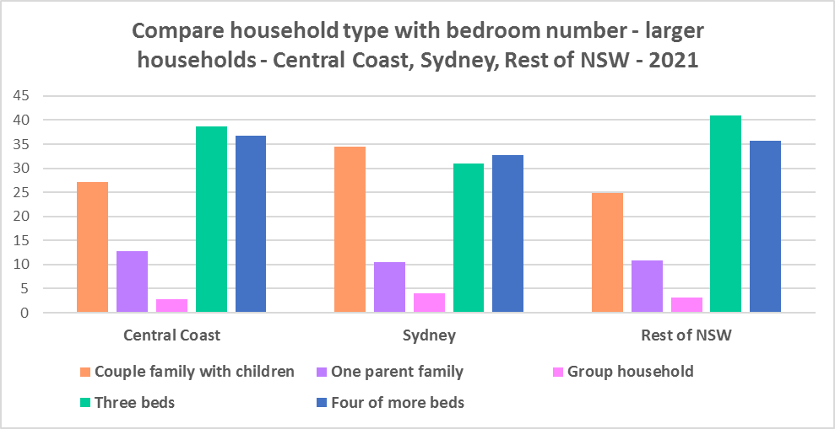

* As couple only households comprise a little over a quarter of all households in the Central Coast, it is important to continue to encourage provision of one and two bedroom stock as well as studios, new generation boarding houses and secondary dwellings, to maintain a balance to meet local need, particularly where there are higher proportions of seniors and frail aged. This will give older residents opportunity to downsize into more manageable and appropriate homes.
* Enabling the provision of more semi-detached, terrace and town houses could help fulfil some of this demand.

**Who needs affordable housing**

* A wide range of people need affordable housing. Single income earners who fall into the low income category include aged care and disability workers, retail sales assistants, production workers, receptionists and early career child care workers.
* People working in accommodation and food services comprise 7.0% of the workforce living in the Central Coast and are amongst the lowest paid workers. Similarly retail trade employs 10.2% of workers living in the Central Coast.
* Health care and social assistance is the largest employment sector of residents in the Central Coast (employing 17.8%). A 2017 survey of NSW Nurses and Midwives Association (NSWMA) members showed that thirty six per cent of respondents moved home or changed jobs in the previous 12 months because of housing affordability issues.
* For example, households earning $790 per week gross (broadly indicative of a wage for a laundry worker) could afford to pay just $237 per week in rent before being in housing stress. Households earning $960 (broadly indicative of wages for a commercial cleaner, delivery driver and entry level firefighter) could afford to pay just $288 per week in rent before being in housing stress. Households with an income of $1,150 (broadly indicative of the wage for an enrolled nurse, child care worker and ICT support technician) can afford to pay just $345 per week in rent before being in housing stress.
* At a weekly income of $1,450/$1,500 (an indicative wage for an early career Registered Nurse), a household could afford to pay $435 to $450 per week in rent before being in housing stress.
* At December 2022, there were insufficient new bonds lodged to calculate a median rent for studio dwellings in the Central Coast – which speaks to lack of supply.
* At December 2022, the median rent for a one bedroom home in the Central Coast was $350 per week; for a two bedroom home was $450 per week; for a three bedroom was $550 per week; and for a four or more bedroom home was $700 per week.
* Single income households in particular are less able to compete in the housing market.
* Increasing numbers of older single women are homeless or at risk of homelessness due to the lack of available affordable rental housing. In fact they are the fastest growing cohort of the homeless population.
* Partnering or collaborating with community housing providers is one effective way to meet some of the local need for appropriate affordable housing. Not for profit community housing providers are owners, managers and developers of affordable rental housing for lower income households and residents with specific housing needs. They work with partners, investors and government to provide housing and deliver support for tenants. For more information about community housing providers, see the NSW Community Housing Industry Association website.

**Additional Data**

Housing data and tables used in this Snapshot are available from the Local Government Housing Kit Database on the Housing NSW website at:

<https://www.facs.nsw.gov.au/resources/nsw-local-government-housing-kit/chapters/local-government-housing-kit-database>

More information on Expected Waiting Times for Public Housing is available on the DCJ/FACS website by region at:

<https://www.facs.nsw.gov.au/housing/help/applying-assistance/expected-waiting-times>

Additional data on social housing dwellings and delivery is available on the FACS website at:

<https://www.facs.nsw.gov.au/resources/statistics/social-housing-residential-dwellings/facs-quarterly-statistics-social-housing-dwellings>

or go straight to the dashboard:

<https://public.tableau.com/app/profile/facs.statistics/viz/Social_Housing_Residential_Dwellings/Dashboard>

and

<https://www.facs.nsw.gov.au/resources/statistics/social-housing-delivery2/interactive-dashboard>

The Australian Housing and Urban Research Institute (AHURI) has written a paper explaining the reasons for unoccupied homes:

<https://www.ahuri.edu.au/research/brief/are-there-1-million-empty-homes-and-13-million-unused-bedrooms>

The SGS Economics and Planning Rental Affordability Index is here:

<https://sgsep.com.au/projects/rental-affordability-index>

More information about community housing providers is available on the NSW CHIA (Community Housing Industry Association) website:

NSW CHIA Snapshot of the Community Housing Sector in NSW:

<https://communityhousing.org.au/wp-content/uploads/2022/08/Community-Housing-Snapshot-2022.pdf>

Data on community housing properties is available from the NSW CHIA Dashboard at:

<https://communityhousing.org.au/our-impact/data-dashboard/>

(Note that this is not a full data set as CHIA does not represent all community housing providers in NSW).

CHIA NSW affordable housing tool kit. The Tool Kit is based on extensive research about reasons for community resistance to affordable housing, and effective ways of building support for affordable housing:

https://communityhousing.org.au/toolkit/theplatform.html

The NSW Registrar of Community Housing website is here:

<https://www.rch.nsw.gov.au/>