**Far West Region – What’s Happening with Housing Supply and does it match Demand?**

This Housing Snapshot looks at aspects of housing supply in the Far West, particularly from the 2016 Census to the 2021 Census – including dwelling type, bedroom mix, tenure, as well as social housing supply and waiting times for public housing. It also looks at aspects of the gap between housing demand and supply, including what’s happening with low income rental households and affordable rental supply, comparing household type with bedroom mix and who needs affordable housing.

Across much of NSW housing supply has not kept pace with demand, with significant outmigration from cities to regional areas during Covid, record levels of migration post Covid, with rapid increases in construction costs and skilled labour shortages contributing to longer term tight rental vacancy rates, insufficient affordable housing and a lack of housing diversity to meet local need.

The majority of households in the Far West Region are lone person or couple households (comprising 51.4% of all households), yet the housing stock is overwhelmingly detached homes with three or four bedrooms. This housing was built at a time when families were the predominant household type. Generally the region has insufficient diversity in housing type or bedroom mix and the consequently there is little housing choice for households requiring smaller homes.

**Dwelling Type**

* At the 2021 Census there were 19,728 dwellings in the Far West region, down from 21,351 in 2016.
* Of these, 80.3% were occupied (up from 78.0% in 2016), well under the 89.0% average percentage occupied in the Rest of NSW.
* This means 19.7% were unoccupied (down from 21.9% in 2016) and compared to 11.0% in the Rest of NSW.
* The reasons homes are unoccupied vary and include (according to a report by the Australian Housing and Urban Research Institute “Are there 1 million empty homes and 13 million unused bedrooms?”):
  + homes are being renovated
  + homes being sold as vacant possession
  + newly built or bought homes where no one has moved in yet
  + rental homes awaiting new tenants
  + people living away temporarily from home during the census count (travelling or visiting other homes)
  + homes are deemed unliveable
  + subject to a probate application or other legal proceedings
  + holiday homes
  + homes owned by people currently living overseas
  + homes being land banked, that is held vacant until the local area economics (or personal circumstances) make it more profitable to sell or redevelop the property.

And particularly in rural and regional areas:

* dwellings on rural properties where owners have moved into local towns (particularly as owners age);
  + regional and rural areas which have experienced population decline;
  + and areas where people have a beach or rural retreat house that will only be occupied for short periods of the year
* The graph and table below show the proportion of occupied and unoccupied dwellings in the Far West LGAs at the 2021 Census.

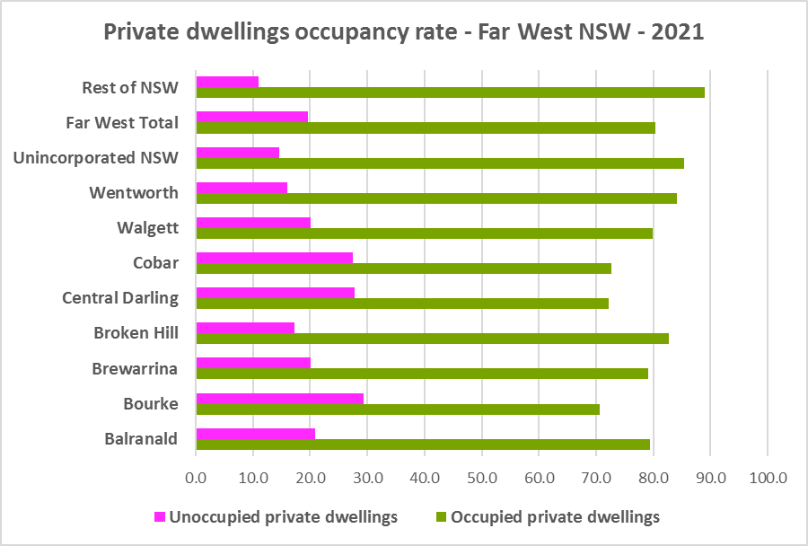



* Note that within Far West, Unincorporated NSW has the highest proportion of occupied dwellings with 85.5% and Bourke has the lowest with 70.7%.
* At the 2021 Census, the vast majority of occupied dwellings in the Far West were separate houses, comprising 90.5% of all occupied dwellings, compared to 82.5% in the Rest of NSW. The proportion of separate houses within the region ranges from 94.6% in Broken Hill to 75.4% in Walgett.
* Just 3.1% of occupied homes in the Far West were semi-detached, terrace or town houses, (compared to 6.3% in the Rest of NSW) and ranging from 7.6% in Brewarrina to 1.3% in Bourke.
* 3.1% of occupied homes in the region were flats (compared to 9.9% in the Rest of NSW), ranging from 4.8% in Cobar to 0.6% in Brewarrina.
* The region lacks diversity in dwelling types.
* The graph below shows the proportion of dwelling types for the Far West LGAs at the 2021 Census.

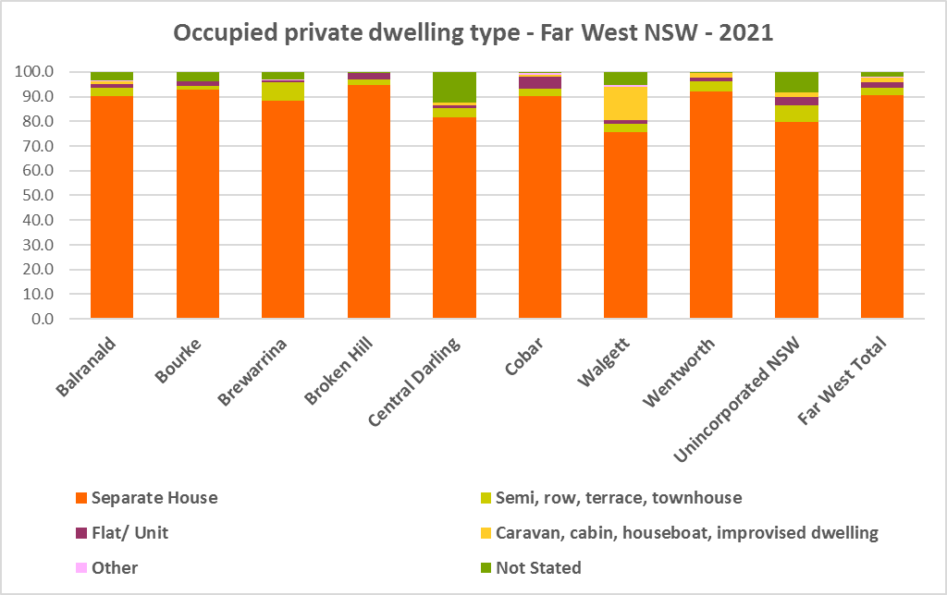

* The next graph compares the proportion of different occupied dwelling types for the Far West with that for the Rest of NSW. While regional NSW also lacks diversity in dwelling types, it generally has greater diversity than the Far West.

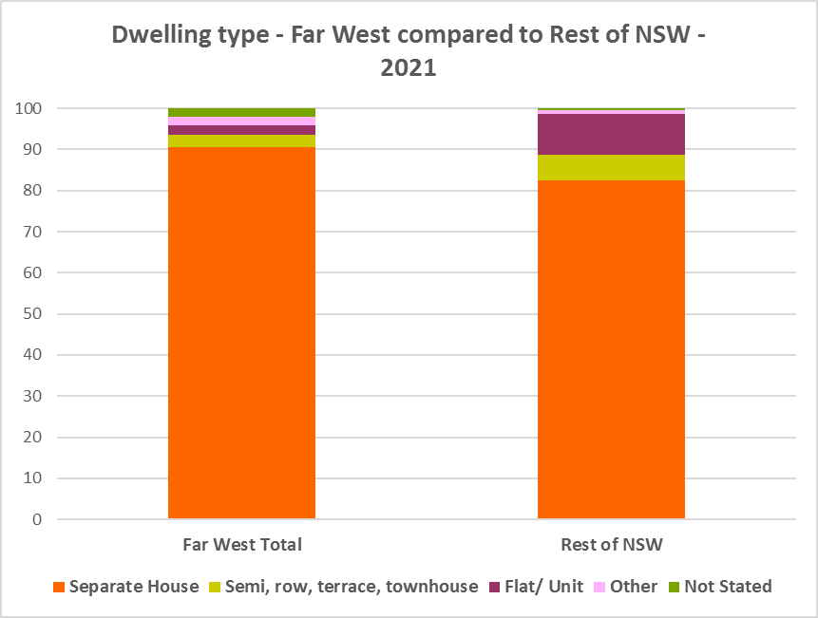

* Other types of dwellings comprised 2.0% of occupied dwellings in the region and include caravans, cabins, houseboats, improvised dwellings and flats attached to shops. Census data shows 94 households living in caravans, 12 living in cabins or houseboats, 208 living in improvised dwellings and 30 in flats attached to shops in the region.
* Note that at the 2021 Census there were 106 households living in caravan, cabin/houseboat accommodation, down from 151 in 2016. This is down from 437 at the 2006 Census.
* While people living in caravans are included in the homeless data in the Census, caravan or residential parks are one of the few remaining affordable housing options for lower income earners. The loss of this accommodation reduces options for lower income households and reduces flexibility to deal with seasonal workers and changes in mining workforces. Wentworth (42) had the highest remaining numbers of caravan, cabin/ houseboat dwellings in the region at 2016, followed by Walgett (26).
* The region also has an unusually high number of people living in improvised dwellings. According to the ABS;
  + “Persons in other improvised dwellings are those people who were enumerated on Census night in the dwelling category of an improvised dwelling, tent or sleepers out who reported either being 'at home' on Census night or having no usual address, and are not considered, on balance, to be homeless. Under the ABS definition they are not classified as homeless because they have accommodation alternatives, and in many living situations, the dwelling will be adequate. They are however included in marginal housing and may be at risk of homelessness.”

**Quality of housing for Aboriginal Households**

* According to the Australian Institute of Health and Welfare (AIHW), in 2018–19:
  + “1 in 5 (20%) Indigenous households were living in dwellings that did not meet an acceptable standard – defined in the National Aboriginal and Torres Strait Islander Health Survey (NATSIHS) as having at least 1 basic household facility that was unavailable or having more than 2 major structural problems
  + 33% of Indigenous households were living in dwellings with at least 1 major structural problem. Indigenous households in remote areas were more likely to live in dwellings with structural problems than those in non-remote areas (46% and 31%, respectively)
  + 9.1% of Indigenous households had no access to working facilities for food preparation, 4.5% had no access to working facilities to wash clothes and bedding and 2.8% had no access to working facilities to wash household residents (AIHW & NIAA 2020).”

**Bedroom Mix**

* As well as a lack of diversity in dwelling type, the region (and the Rest of NSW generally) has little variation in the number of bedrooms per dwelling, with 46.8% of dwellings having three bedrooms and a further 26.6% having four or more bedrooms. Only 0.5% of homes are studios, 5.1% have one bedroom and 17.9% have two bedrooms in the Far West.
* This compares to 0.5% of studio homes, 4.0% one bedroom and 17.3% two bedroom in the Rest of NSW – so the Far West has higher proportions of one and two bedroom homes than the average for the Rest of NSW.
* Within the region,
  + Central Darling and Walgett had the highest proportion of studio dwellings with 1.7% and Bourke and Brewarrina the lowest with 0.0%;
  + Walgett has the highest proportion of one bedroom homes with 11.8% and Balranald the lowest with 3.1%;
  + Walgett has the highest proportion of two bedroom homes with 22.4% and Cobar the lowest with 11.6%;
  + Broken Hill has the highest proportion of three bedroom homes with 54.1% and Unincorporated NSW the lowest with 34.8%; and
  + Unincorporated NSW has the highest proportion of four or more bedroom homes with 38.0% and Broken Hill the lowest with 19.9%.
* The graph and table below show the proportion of studio, one, two, three and four or more bedroom occupied dwellings in the Far West at the 2021 Census.

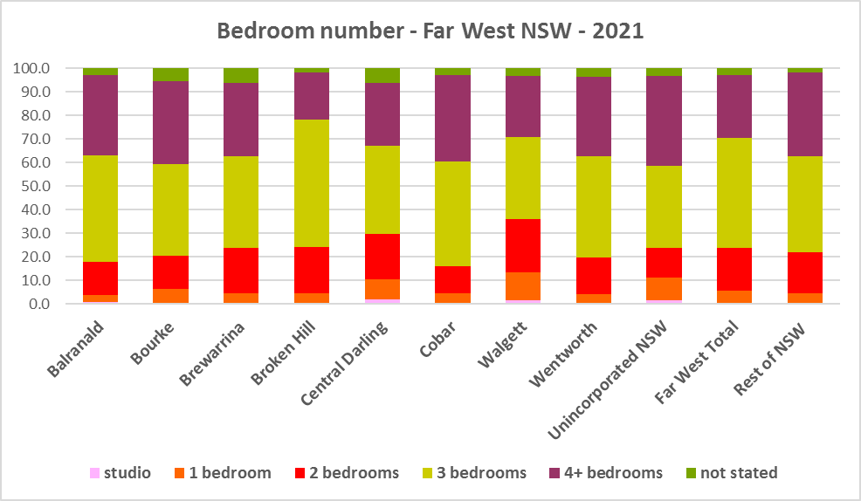



* Ideally there should be a closer match between household size and bedroom number to offer some housing choice for residents. At the 2021 Census, 47.0% of all households were single person or couple households.
* The forecast increase in older age groups in the Far West means that there is likely to be more demand for smaller, more manageable dwellings. Two bedroom dwellings in particular offer the most flexibility, given they are also suitable for small families and allow older residents to have family members or carers to stay while giving them a more manageable size home to maintain.

**Tenure**

* At the 2021 Census, the most common tenure type in the Far West was households owning their home outright – comprising 41.7% of all households. Within the region this ranged from 51.2% in Unincorporated NSW to 27.7% in Brewarrina.
* Unlike other parts of NSW where households with a mortgage constitute the second highest proportion of households, in Far West NSW the second largest proportion was households renting – comprising 28.2% of all households, with Brewarrina having the highest proportion with 54.4% and Wentworth having the lowest proportion with 21.3%.
* Households renting from a real estate agent comprise just 8.3% of all households in the Far West – with Cobar having the highest proportion at 11.2% and Unincorporated NSW the lowest with no households renting though a real estate agent.
* The remainder of rental households in the Far West include households renting from the state housing authority (3.6% in the region), community housing providers (2.5%) and other landlords (13.7%).
* The next largest tenure type in Far West NSW was households with a mortgage – comprising 26.3% of all households. Within the region the proportion in this tenure ranged from 34.1% in Wentworth to 7.9% in Central Darling.
* The graph and table below give the tenure composition for the region and individual LGAs at the 2021 Census.

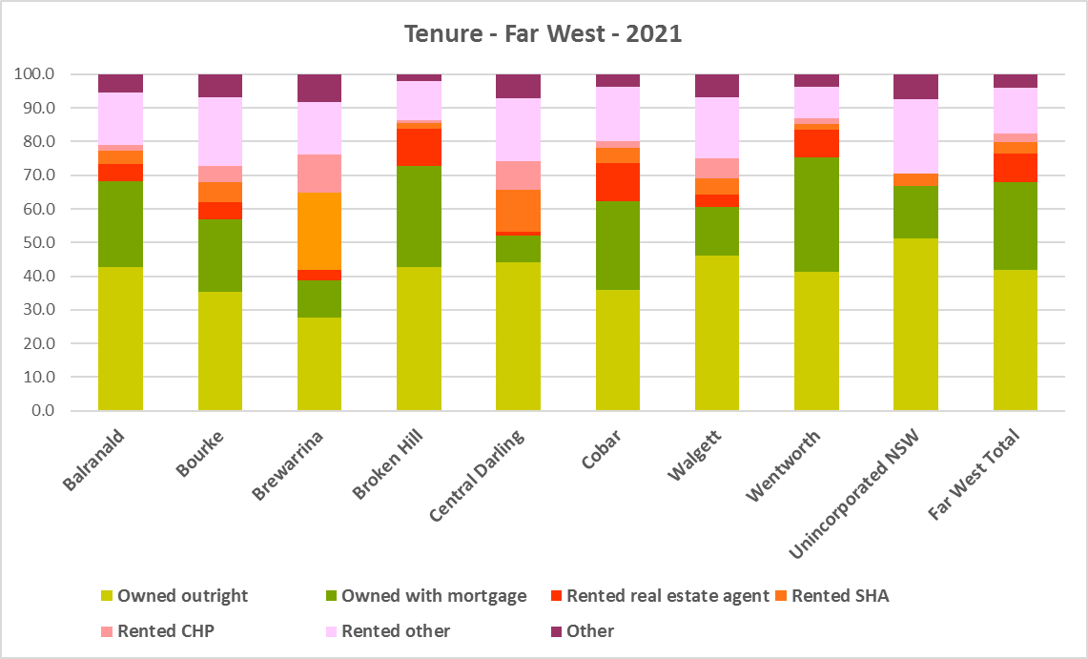



* The general trend is increasing numbers of households relying on the rental market as a long term tenure rather than a transitional one between leaving home and buying a home, as housing costs have increased much faster than wages.
* Noting that the rental market in NSW generally is very tight (see the Housing Snapshot on What’s Happening in the Housing Market) it is therefore important to encourage tenure diversity and a range of price points to meet local needs.

**Social Housing**

* Social housing is secure and affordable rental housing for people on low incomes with housing needs. It includes public, community and Aboriginal housing. Public housing is managed by DCJ while community housing is managed by non-government organisations.
* As at June 2022, there are 154,600 social housing dwellings in NSW, with 96,712 managed by public housing, 48,264 managed by community housing and 9,624 managed exclusively for Aboriginal people – of these the Aboriginal Housing Office (AHO) are responsible for 4,120 and Aboriginal Community Housing Providers (ACHP) manage 5,504.
* The table below shows the number of public housing properties in the Far West region as at June 2022. Please note that Census data on public housing is not totally accurate, as public housing tenure is under reported in the Census. The figures below do not include community housing properties.



* In addition, community housing providers manage a number of properties in the Far West region – including social housing, affordable housing, transitional housing and crisis accommodation, as outlined in the table below.
* Note that affordable housing is not the same as social housing. Affordable housing is open to a broader range of household incomes than social housing. Households do not have to be eligible for social housing to apply for affordable housing, though people who are eligible for social housing may also be eligible for affordable housing properties.
* Affordable housing is managed more like a private rental property, but there are eligibility criteria and the managers are mostly not for profit community housing providers.



* The next table gives the number of homes managed by ACHPs in the Far West as at June 2022.



* Note that there are 3 types of social housing available for Aboriginal people:
  + Public housing – these properties are managed by the Department of Communities and Justice (DCJ).
  + Aboriginal Housing Office homes – these are properties owned by the Aboriginal Housing Office and managed by DCJ.
  + Community housing properties – these properties are managed by community housing providers and Aboriginal community housing providers.
* The table below shows the expected waiting times for general housing approved social housing applicants (not for priority housing applicants) by bedroom category in the Far West Region as at 30 June 2022. It also gives the number of general and priority housing applicants by allocation zone.



* Information on Expected Waiting Times for Public Housing is available on the FACS website by region at:

<https://www.facs.nsw.gov.au/housing/help/applying-assistance/expected-waiting-times>

## The Gap

* Historically the Far West has been and continues to be more affordable for rent and for purchase by lower income households than the average for the Rest of NSW.
* However, a NSW Council of Social Service study released in April 2023 (Mapping Economic Disadvantage in NSW – 2021[1]) found that in 2021 Far West NSW had the second highest rate of poverty in regional NSW – with 24.8% of the population being in poverty:
  + The poverty rate for households with a home mortgage was particularly high around the Far West
  + For households living in private rental properties, the highest rates of poverty (above 50%) were in the Far West
  + The Far West also had the highest rate of poverty in NSW for people in full time employment (17.6%) and also part-time employment (25.0%)
  + In the Far West 45% of Aboriginal and Torres Strait Islander people live in a low income household. Widespread and structural socioeconomic disadvantage in terms of intergenerational poverty, racism, reduced options for income generation, employment and housing, as well as social and health inequalities all contribute to this ongoing experience of disadvantage.
* Infrastructure Australia delivered a report “2022 Regional Strengths and Infrastructure Gaps” which cited growth in employment in mining, energy and tourism for the Far West:
  + Expansions in mining operations present significant opportunities for regional employment growth in the mining industry, as well as supporting sub-sectors such as manufacturing and services.
  + The Far West’s high levels of solar radiation, large open spaces and presence of transmission infrastructure represent significant growth opportunities for the renewable energy sector. This is supported by the development of the Silverton Wind Farm and Broken Hill Solar Plan, which can power up to 20,000 and 137,000 Australian homes respectively.
  + Tourism has become an important sector experiencing an average of 5.7% annual growth in visitor numbers from 2010 to 2019. Complementing existing industries, agritourism offerings such as farm stays and farmers markets will enable the sector to continue maturing, while the region’s natural assets support cultural tourism and ecotourism

opportunities. (p113 of NSW report)

* + While they see opportunities for growth they did not cite housing as an infrastructure issue, unlike some other regions in NSW.
* Nevertheless, there has been a decline in the number of private rental properties which are affordable to low income rental households in the Far West, as the graph below demonstrates.

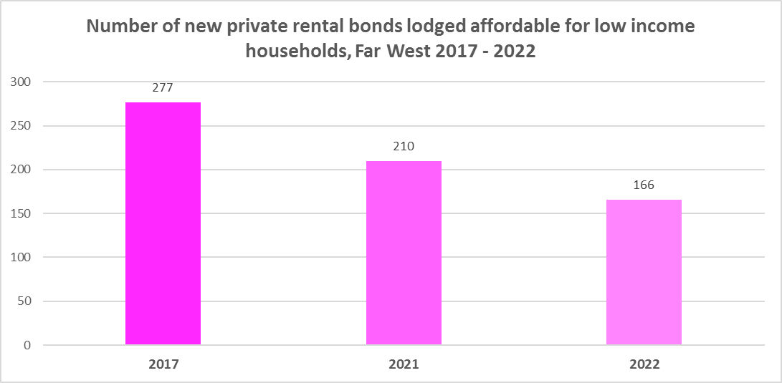

* The next graph compares change in median income with change in median rents and median sales price in the Far West LGAs between 2016 and 2021 for income and 2017 to 2022 for rent and sales price. Unfortunately there is not a full data set available for every LGA – with median rents only able to be calculated for Broken Hill, Cobar and Wentworth and median sales price only for Broken Hill, Cobar, Walgett and Wentworth.
* Generally, across Australia, housing costs have increased much faster than incomes. For both Broken Hill and Wentworth it is clear that the increase in median sales price far outstrips any increase in median income. In Cobar, the increase in median rent far outweighs the increase in median income.

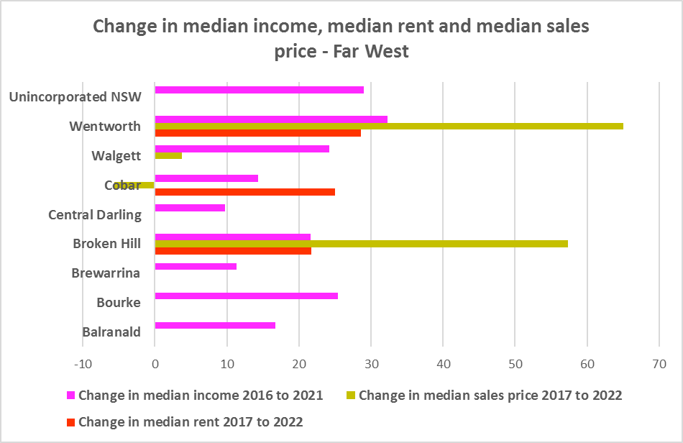

* Low income households are the dominant income group across the Far West and in almost every LGA in the region (excepting Cobar and also Unincorporated NSW), comprising 48.9% of all households in the region (just below the Rest of NSW average of 49.3%) and ranging from 28.7% in Unincorporated NSW to 66.4% in Brewarrina.
* Due in part to population decline between 2016 and 2021, the number of low income earners declined in every Far West LGA except for Bourke and Wentworth, as the graph below depicts. Note that Broken Hill lost far more low income earners than total population.

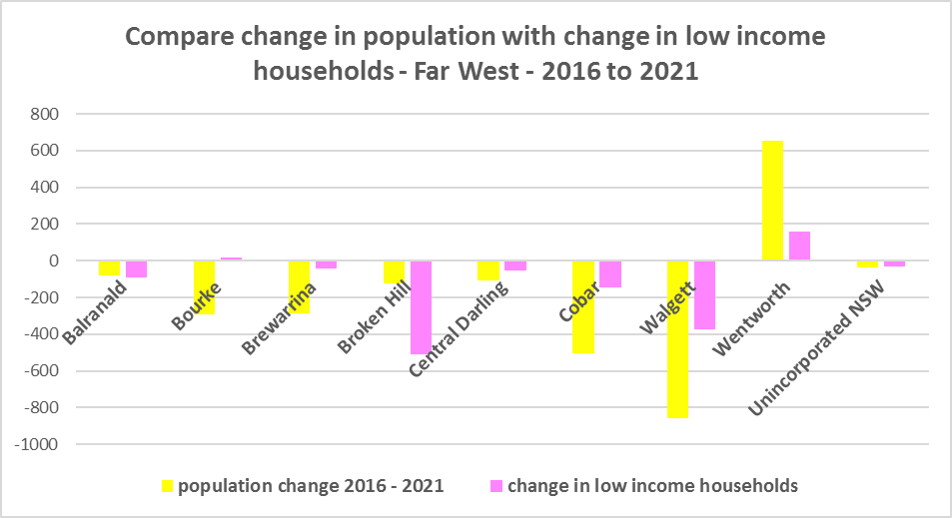

* Due to the changes to income assistance during and subsequent to the COVID-19 pandemic, it is difficult to see what has happened with renters and low income renters in particular between 2016 and 2021. However, it is clear the supply of affordable private rental is declining and in Cobar at least, rents have increased much faster than income.
* Given the rate of poverty in the Far West and the level of disadvantage amongst Aboriginal and Torres Strait Islander residents, there is a need for more affordable rental housing for lower income households in this region.
* As well as the gap between supply and demand for affordable rental, there is a significant gap between dwelling size (bedroom numbers) and household size, particularly for smaller households. The graph below compares the number of smaller household types - lone person and couple only – with the amount of studio and one bedroom accommodation available in the Far West. It is clear that if smaller households wished to live in smaller housing, they have very little opportunity to do so. While 51.4% of households in the Far West are lone person or couple only (below the 53.8% average for the Rest of NSW), only 5.6% of dwelling stock is studio or one bedroom (above the 4.5% on average in the Rest of NSW).
* This mismatch can impact on affordability, with smaller households required to consume more housing than they need or to share housing because of lack of choice.
* It also limits the opportunity for empty nesters or older single households to downsize to smaller more manageable homes within their communities. This can impact on the independence of older residents and their ability to age in place. This will become increasingly important as the population of the Far West is forecast to have an increase in older age groups.

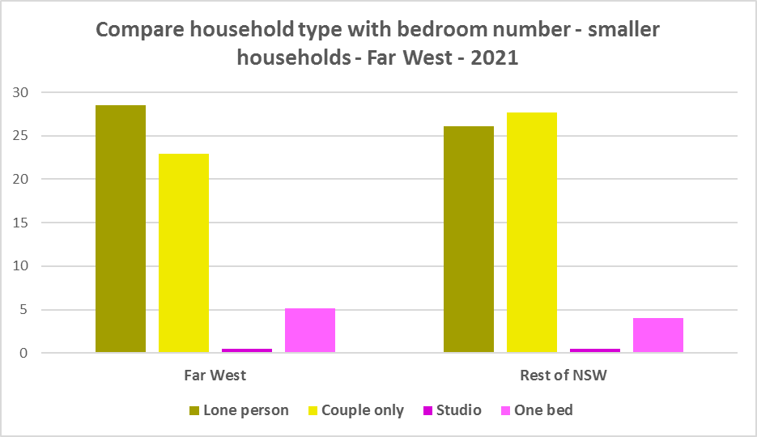

* There has been a loss in every bedroom category of occupied private dwellings, except for four bedroom homes, in the Far West between the 2016 and 2021 Census. By far the greatest loss has been in studio dwellings, as the graph below shows. As this is a measure of the number of bedrooms in occupied private dwellings – this is not so much a loss as a measure of population decline and the fact that some dwellings are no longer occupied as a result.

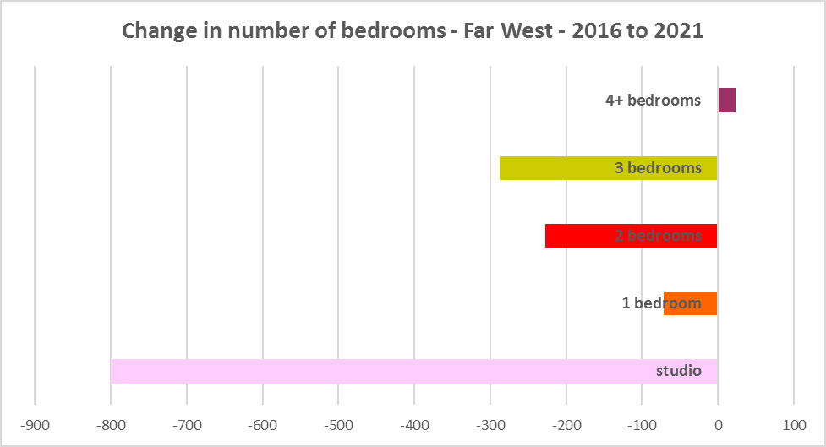

* The next graph compares larger household types – couple family with children, one parent family and group households – with the amount of three and four or more bedroom accommodation available. It is clear that there is more than adequate supply of larger homes for families and group households in the Far West region.

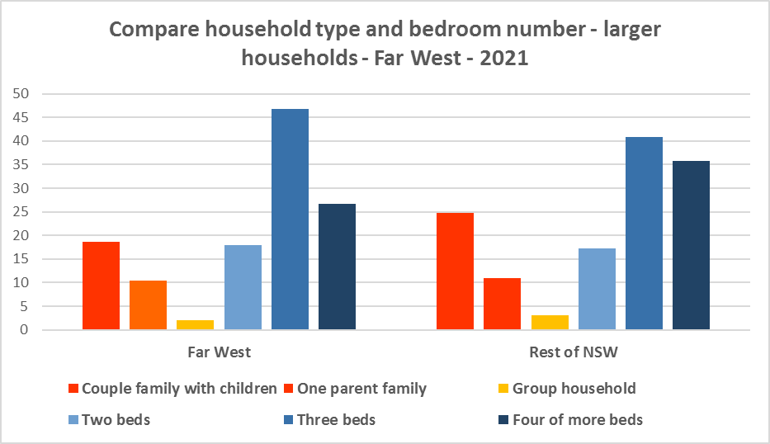

* Older age cohorts are forecast to increase in the Far West. This suggests a need for housing that meets the need of older residents.
* There is already a significant mismatch between household type and bedroom number across the region. With an increase in smaller households likely through the ageing of the population, this disparity will only worsen unless proactive measures are taken to increase the supply of studio, one and two bedroom homes. This will enable some measure of choice to smaller households and give older residents some options to downsize.
* Secondary dwellings suit a range of groups including small households, young people, frail aged and people with disability needing support from family. They may be readily encouraged on larger lots with reasonable access to centres providing a range of services and facilities.
* New generation boarding houses would also help fulfil some of this demand – particularly as they cannot be subdivided and must provide rental accommodation. This type of accommodation is suitable for single people and also couples, for key workers and students. It also has potential to assist in providing accommodation/meeting additional housing demand for seasonal workers and mine workers.
* It is important to encourage the provision of more diverse housing, more smaller dwellings, to maintain a balance to meet local need, particularly where there are higher proportions of seniors and frail aged. This will give older residents opportunity to downsize into more manageable and appropriate homes.
* Two bedroom homes are the most flexible as they suit single person, couple and small family households and also allow smaller households to have space for visitors or live in carers.

**Who needs affordable housing**

* A wide range of people need affordable housing. Single income earners who fall into the low income category include aged care and disability workers, retail sales assistants, production workers, receptionists and early career child care workers.
* People working in accommodation and food services comprise 7.6% of the workforce living in the Far West and are amongst the lowest paid workers. Similarly retail trade employs 8.5% of workers living in the Far West and as noted above retail sales assistants are low income earners. Health care and social assistance is the largest employment sector of residents in the Far West (employing 15.0%) and agriculture is the second largest employment sector of residents (employing 12.6%).
* As examples of rental costs relative to income:
  + Households earning $790 per week gross (broadly indicative of a wage for a laundry worker) could afford to pay just $237 per week in rent before being in housing stress.
  + Households earning $960 (broadly indicative of wages for a commercial cleaner, delivery driver and entry level firefighter) could afford to pay just $288 per week in rent before being in housing stress.
  + The average farmhand salary in Australia is $57,311 per annum or $1,102 per week. A household on that salary could afford to pay $330 per week in rent before being in housing stress.
  + Households with an income of $1,150 (broadly indicative of the wage for an enrolled nurse, child care worker and ICT support technician) can afford to pay just $345 per week in rent before being in housing stress.
  + At a weekly income of $1,450/$1,500 (an indicative wage for an early career Registered Nurse), a household could afford to pay $435 to $450 per week in rent before being in housing stress.
* At March 2023, there were insufficient new bonds lodged to calculate a median rent for studio dwellings in any LGA in the Far West, Broken Hill was the only LGA with sufficient new bonds lodged to calculate a median rent for one bedroom and four bedroom homes, only Broken Hill and Wentworth had a median rent for two bedroom homes, only Broken Hill and Cobar had a median rent for three bedroom homes and Walgett only had a median rent for all dwellings (including all bedroom types) – which speaks to lack of supply in the rental market.
* At March 2023, the median rent for a one bedroom home in Broken Hill was $180 per week; for a two bedroom home was $245 in Wentworth and $260 in Broken Hill; for a three bedroom home was $275 in Cobar and $330 in Broken Hill; and for a four or more bedroom home was $450 per week in Broken Hill. The median rent in Walgett was $270 per week.
* The lack of new bonds lodged suggests that while rents may be generally affordable, households looking to rent a property may struggle to find much or even any choice. Low income families may also struggle to find affordable rental in Broken Hill. Note that there are significant proportions of the population living in poverty in the Far West and this includes people on a full time wage.
* Homelessness and marginal housing is an issue in this region and Aboriginal residents are overrepresented in the homeless population.
* Partnering or collaborating with community housing providers is one effective way to meet some of the local need for appropriate affordable housing. Not for profit community housing providers are owners, managers and developers of affordable rental housing for lower income households and residents with specific housing needs. They work with partners, investors and government to provide housing and deliver support for tenants. For more information about community housing providers, see the NSW Community Housing Industry Association website.

**Additional Data**

Housing data and tables used in this Snapshot are available from the Local Government Housing Kit Database on the Housing NSW website at:

<https://www.facs.nsw.gov.au/resources/nsw-local-government-housing-kit/chapters/local-government-housing-kit-database>

More information on Expected Waiting Times for Public Housing is available on the DCJ/FACS website by region at:

<https://www.facs.nsw.gov.au/housing/help/applying-assistance/expected-waiting-times>

Additional data on social housing dwellings and delivery is available on the FACS website at:

<https://www.facs.nsw.gov.au/resources/statistics/social-housing-residential-dwellings/facs-quarterly-statistics-social-housing-dwellings>

or go straight to the dashboard:

<https://public.tableau.com/app/profile/facs.statistics/viz/Social_Housing_Residential_Dwellings/Dashboard>

and

<https://www.facs.nsw.gov.au/resources/statistics/social-housing-delivery2/interactive-dashboard>

The Australian Housing and Urban Research Institute (AHURI) has written a paper explaining the reasons for unoccupied homes:

<https://www.ahuri.edu.au/research/brief/are-there-1-million-empty-homes-and-13-million-unused-bedrooms>

The Australian Institute of Health and Welfare (AIHW) information on the quality of Indigenous Housing:

<https://www.aihw.gov.au/reports/australias-welfare/indigenous-housing>

NSW Council of Social Service study April 2023 Mapping Economic Disadvantage in NSW – 2021 is here:

<https://www.ncoss.org.au/policy-advocacy/policy-research-publications/mapping-economic-disadvantage-in-nsw/>

The SGS Economics and Planning Rental Affordability Index is here:

<https://sgsep.com.au/projects/rental-affordability-index>

More information about community housing providers is available on the NSW CHIA (Community Housing Industry Association) website:

NSW CHIA Snapshot of the Community Housing Sector in NSW:

<https://communityhousing.org.au/wp-content/uploads/2022/08/Community-Housing-Snapshot-2022.pdf>

Data on community housing properties is available from the NSW CHIA Dashboard at:

<https://communityhousing.org.au/our-impact/data-dashboard/>

(Note that this is not a full data set as CHIA does not represent all community housing providers in NSW).

CHIA NSW affordable housing tool kit. The Tool Kit is based on extensive research about reasons for community resistance to affordable housing, and effective ways of building support for affordable housing:

https://communityhousing.org.au/toolkit/theplatform.html

The NSW Registrar of Community Housing website is here:

<https://www.rch.nsw.gov.au/>

1. <https://www.ncoss.org.au/wp-content/uploads/2023/04/NCOSS_final-report-25-Apr-2023.pdf>