**South and East Tablelands – What’s Happening in the Housing Market?**

This Housing Snapshot looks at aspects of the housing market in the South and East Tablelands, particularly from the 2016 Census to the 2021 Census – including rents, vacancy rate, affordable private rental for very low and low income households, rental stress for low income households, number of new bonds lodged affordable to low income households, sales price, purchase affordability for very low and low income households and purchase stress for low income households.

The South and East Tablelands region covers the nine local government areas of Bega Valley, Eurobodalla, Goulburn Mulwaree, Hilltops, Queanbeyan-Palerang, Snowy Monaro Regional, Upper Lachlan, Wingecarribee and Yass Valley. The region adjoins both Sydney and Canberra and is impacted by those city housing markets and in addition the housing markets of the coastal LGAs and Snowy Monaro are particularly impacted by tourism. Consequently housing market conditions and rent and purchase affordability varies significantly within the region and in some locations by season. The region has also been impacted by bushfires and by outmigration from the cities during Covid and the increased capacity to work remotely. Nevertheless there are commonalities, with declining numbers of affordable rental properties despite the increase in low income rental households in housing stress.

# ***Housing Market - Rental***

**Rents**

* Looking at all residential dwelling median rentals combined together, there have been strong increases in median rents in the South East and Tablelands region, particularly since the mid 2000’s, as indicated in the graph below.
* Note that the median rents for Snowy River and Snowy Monaro Regional fluctuate more than other LGAs in the region due to strong impact from tourism.
* The graph below shows the long term trend in median rents (from 1990 to 2022) in all the South and East Tableland LGAs.

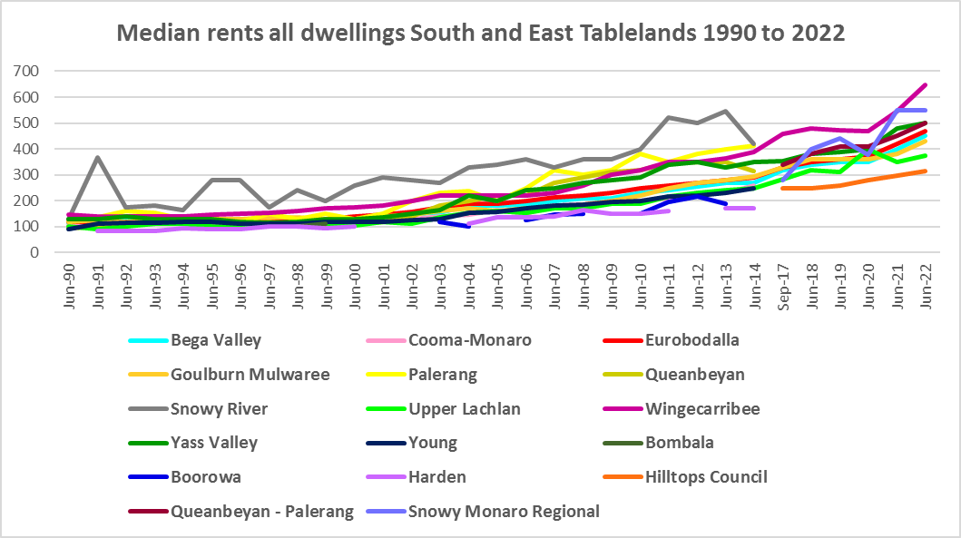

* Between 2017 and 2022, median rents increased by between 28.0% in Hilltops and 78.6% in Snowy Monaro Regional, as the table below shows.



* However, changes in rents over this time frame were more complex. Between 2019 and 2020 when Covid lockdowns were introduced, there were generally lower increases, and in some cases significant decreases in median rents. Given the impact on tourism during lockdown, this is not surprising in this region. Snowy Monaro Regional (-19.4% for one bed, -21.1% for two bed, -12.6% for three bed and -8.0% for four) and Wingecarribee (-15.2% for one bedroom) had the most signigicant declines in median rentals over this period.
* At the same time both Bega Valley and Eurobodalla experienced strong median rental increases for one bedroom properties (19.0% and 25.0% respectively) while in Goulburn Mulwaree there was no change at all in median rents.
* The table below gives the weekly median rents in dollar terms and the changes between 2019 and 2020 for South and East Tablelands LGAs.



* Between June 2020 and June 2022 a different pattern emerges, with all LGAs experiencing strong increases in median rents as the table below shows.
* Over this time frame, Queanbeyan Palerang, Snowy Monaro Regional, Wingecarribee and Yass Valley experienced the strongest increases in both dollar and percentage terms, with Bega Valley and Eurobodalla also having robust increases. Between 2020 and 2022 median rents for three bedroom dwellings in Snowy Monaro Regional increased by $285 or 75%; in Wingecarribee by $200 or 44.4%, by $115 or 29.9% in Eurobodalla, by $107 or 21.7% in Queanbeyan, by $100 in both Bega Valley (25.0%) and Yass Valley (25.0%).



* At June 2022, median rents for one, two and three bedroom dwellings were highest in Snowy Monaro Regional ($448, $500 and $665) and highest in Wingecarribee for four bedroom ($800).
* At March 2023, median rents for all dwellings (and all bedrooms) in the region ranged from $330 per week in Hilltops to $650 per week in Wingecarribee.

**Vacancy Rate**

* A vacancy rate of 3% is understood to represent a balance between supply and demand in the rental market. Vacancy rates below 3% represent a tight rental market while longer term vacancy rates below 2% represent a chronic undersupply of rental housing.
* According to REINSW data, vacancy rates in this region have shown periods of both over and undersupply, but since April 2020 have been mostly below 3% in both the South Coast and South Eastern regions of NSW. This indicates a tight rental market in both areas. However, generally there is strong seasonal variation in vacancy rates in both regions, with increases in tourists in both coastal and mountain areas in different seasons.
* According to Real Estate Institute of NSW (REINSW) data, the vacancy rate in South Coast at April 2023 is 2.1% while for South Eastern NSW is 3.6% (up from 1.7% in January) - the only region in NSW with a vacancy rate above 3%. Note that the REINSW attribute this to fluctuation due to seasonal variation.
* Anecdotally there are reports of the difficulties tenants are experiencing finding and retaining rental accommodation – strong competition for properties, rent bidding and significant increases in rents, tenants paying too much of their income in rent, facing eviction and potential homelessness.
* The graph below shows the long term vacancy rate for the South Coast and South Eastern NSW, using REINSW data.

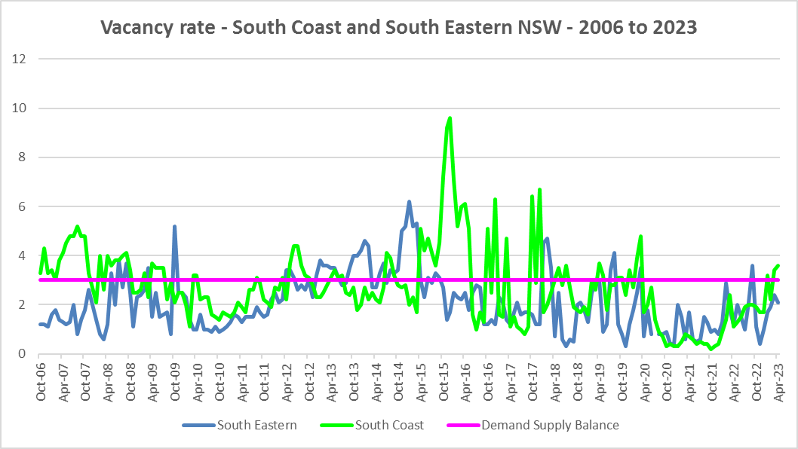

**Affordable Rental**

* The general trend across Sydney and NSW has been for a decline in the proportion of rental stock which is affordable for very low and low income earners.
* This has been the trend also in South and East Tablelands, although along with elsewhere in NSW, there were more complex factors at play between 2019 and 2022.
* Across the Rest of NSW, the proportion of affordable rental for very low income households stayed at the 2018 level of 22.0% for 2019, improved slightly to 21.7% in 2020 and again to 21.9% in 2021 then declined in line with the longer term trend to 17.0% in 2022.
* In South and East Tablelands, this pattern was more varied. Between 2018 and 2019 rental affordability for very low income households improved in Eurobodalla, Hilltops and Queanbeyan Palerang and declined in all other LGAs in the region.
* Between 2019 and 2020 the proportion affordable for rental by very low income households declined in every LGA with the exception of Wingecarribee.
* Between 2020 and 2021 rental affordability improved in Bega Valley, Goulburn Mulwaree, Hilltops and Yass Valley and declined everywhere else.
* Between 2021 and 2022 rental affordability for very low income households declined in every South and East Tablelands LGA in line with the trend in the Rest of NSW.
* At June 2022, every South and East Tablelands LGA (excepting for Hilltops), had a lower proportion of affordable rental for very low income households than the Rest of NSW average of 17.0%. Wingecarribee had the lowest proportion with 2.8%, followed by Bega Valley with 7.8% and Queanbeyan Palerang with 8.0%.
* The table and graph below show the change in the proportion of private rental accommodation affordable to **very low income** households in the South and East Tablelands and Rest of NSW between 2017 and 2022.

Affordable rental for very low income households – June 2017 to June 2022



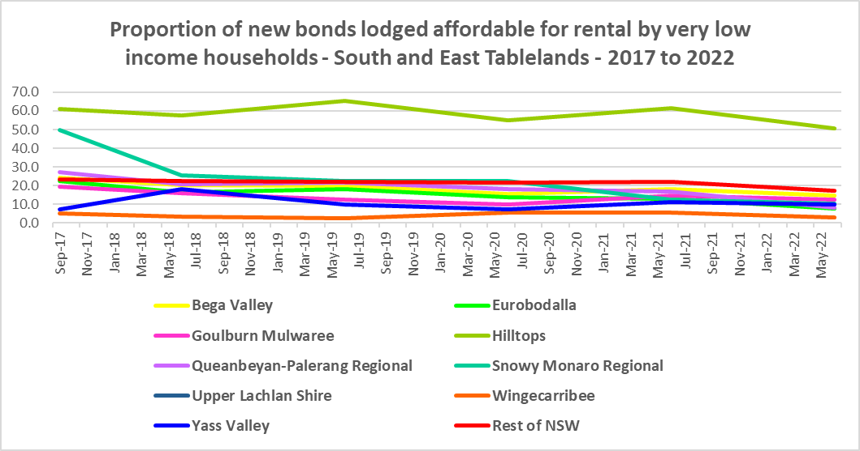

* The proportion of rental affordable for **low income** households has also declined in the region and the more recent trend for rental affordability is a little different from that for very low income households.
* Between 2018 and 2020 the proportion of rental affordable for low income households increased gently from 54.1% to 55.2% and then declined again to 45.4% in June 2022 in the Rest of NSW.
* Most LGAs in South and East Tablelands experienced a continuous decline in the proportion of affordable rental over the same period. The exceptions were Bega Valley (increasing from 68.3% in 2018 to 71.4% in June 2019, declining rapidly to 47.4% in June 2022), Hilltops (increasing from 96.0% in 2018 to 96.7% in 2019, declining to 90.1% in 2022) and Wingecarribee (increasing from 18.5% in June 2020 to 18.8% in June 2021, declining to 14.9% in June 2022).
* The table and graph below show the change in the proportion of private rental accommodation affordable to **low income** households in the South and East Tablelands and Rest of NSW between 2017 and 2022.

Affordable rental for low income households – June 2001 to June 2022



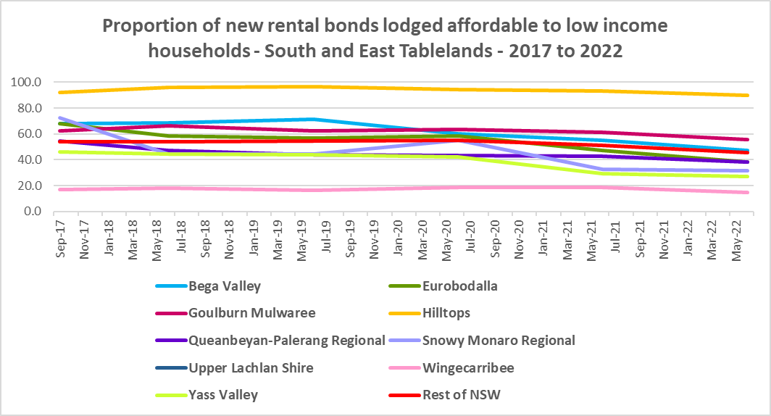

* At June 2022, Wingecarribee (14.9%), Yass Valley (26.9%), Snowy Monaro Regional (31.7%), Eurobodalla (38.3%) and Queanbeyan Palerang (38.4%) had a lower proportion of affordable rental for low income households than the Rest of NSW average of 45.4%
* There is evidence that short term holiday rentals such as Airbnb are impacting the supply of housing, including long term rental and affordable housing in and adjacent to cities and in coastal communities.
* The University of Sydney Urban Housing Lab undertook a study and prepared a report for the Australian Coastal Councils on short term holiday rentals: “Planning responses to online short term holiday rental platforms” - Research Project for Australian Coastal Councils Association Inc. September 2018 by Nicole Gurran, Yuting Zhang, Pranita Shrestha, Catherine Gilbert.
* The study found (p7) “that there has been a rapid growth in online holiday rental listings overall and in coastal Australia in particular. Since Airbnb was launched in Australia, the number of listings has risen to over 130,000 properties, amounting to 3.5% of rental accommodation. In coastal communities, the rate is much higher.
* Further (p7) “the majority of these listings are whole houses, and more than half appear to be frequently available holiday lets rather than permanent residences. Considered as part of the rental housing stock, these whole houses, frequently available, amount to 19.7% of the rental housing stock in Kiama…and 48.3% of the rental housing stock in Byron.
* The study also identified a new class of investor purchasing specifically to provide short term holiday rental accommodation. This is impacting communities in a number of ways – by increasing competition for purchase, purchase prices are increasing as are rents. This impacts both home purchasers and long term renters, with evidence of lower income renters being priced out of some communities.
* Eurobodalla was one of the coastal councils included in the study. The study found that (p62) “growing demand for holiday homes has exacerbated the shortage of affordable rental supply” in Eurobodalla.
* The study also identified impact to communities within a 3 hour radius of capital cities. Parts of the South and East Tablelands Region fall into this category – with Wingecarribee adjacent to Sydney and Queanbeyan-Palerang and Yass Valley adjacent to Canberra. This report, in discussing the implications for local housing markets, noted that (p36) “Many, but not all, of the case study communities report that lower income residents and local workers face barriers in securing affordable rental housing or entering home ownership”
* More recently, research by SQM showed that between July 2019 and July 2020 Yass Valley Council had an increase of 11% in Airbnb listings, Wingecarribee by 9%, Tumut by 2%, while Goulburn Mulwaree and Cooma Monaro had no change, Bega Valley declined by -1%, Eurobodalla by -2%, and Palerang by -8%.
* Since 2020 it is likely that Airbnb listings have picked up again in the South and East Tablelands.

**Rental Stress**

* Households regarded as being in rental stress are renting in the private rental market and paying more than 30% of their income in rent. Lower income households in rental stress will struggle to pay for other essential household costs, such as medical or educational expenses, food, transport and energy costs.
* At June 2021 the proportion of very low income households in rental stress in the Rest of NSW (that is, excluding Sydney) was 91.7%. Within the South and East Tablelands the average was 92.2%, with the proportion varying from 100% in Yass Valley to 73.5% in Upper Lachlan Shire.
* Five of the South and East Tablelands LGAs had a higher proportion of very low income households in rental stress than the average for the Rest of NSW – in addition to Yass Valley, Eurobodalla (95.9%), Wingecarribee (94.6%), Queanbeyan Palerang (93.4%) and Goulburn Mulwaree (93.3%).
* For the Rest of NSW at 2021 the proportion of low income households in rental was 68.3%, with South and East Tablelands marginally higher on 68.7%. Across the region the proportion of low income households in stress ranged from 84.2% in Wingecarribee to 38.6% in Upper Lachlan Shire.
* Four LGAs in South and East Tablelands had a higher proportion of low income households in rental stress than the Rest of NSW – in addition to Wingecarribee, Eurobodalla (72.4%) as well as Bega Valley and Queanbeyan Palerang (both 70.2%).
* However, while the proportion of very low and low income households in stress increased in every LGA in South and East Tablelands between the 2016 and 2021 Census (with the exception of Upper Lachlan), the actual numbers in stress have declined in every LGA.
* Below is a graph of the proportion of very low and low income households in rental stress in each South and East Tablelands LGA at 2021 and a table showing the change in the proportion of very low and low income households in stress between 2016 and 2021.

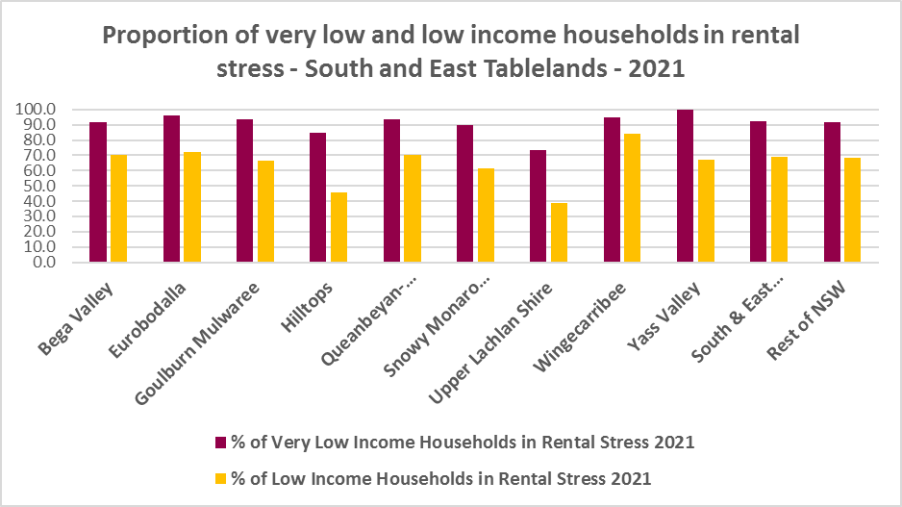

* Below is a table comparing the proportion of very low and low income households in rental stress in South and East Tablelands in 2016 and 2021.



* The next table shows the change in the number of very low and low income households in rental stress at 2016 and at 2021.
* Again Covid has had an impact on the rental market and on tenants.
* A look at CRA (Commonwealth Rent Assistance) recipients in housing stress gives some further information on what has been happening with lower income households in rental stress over this time frame.



* In line with other parts of NSW, between 2016 and 2020, the total number of CRA recipients in the South and East Tablelands increased significantly, while the number in stress actually declined. However, between 2020 and 2021 the number of CRA recipients declined while the number in stress increased.
* The number of CRA recipients in housing stress has increased from the June 2020 figures as the temporary Coronavirus Supplement ended on 31 March 2021.
* The Coronavirus Supplement was $550 per fortnight for new and existing recipients of JobSeeker Payment, Parenting Payment, Youth Allowance for jobseekers, Farm Household Allowance and Special Benefit. The temporary supplement almost doubled the maximum payment rate for a JobSeeker Payment recipient. Hence it made rent more affordable for some CRA recipients in June 2020 and resulted in a lower proportion of CRA recipients in rental stress than usual.
* Since the end of Covid restrictions, the number of people in employment has increased, so fewer people are relying on rent assistance from the Commonwealth.
* The two graphs below clearly demonstrate this experience in South and East Tablelands.

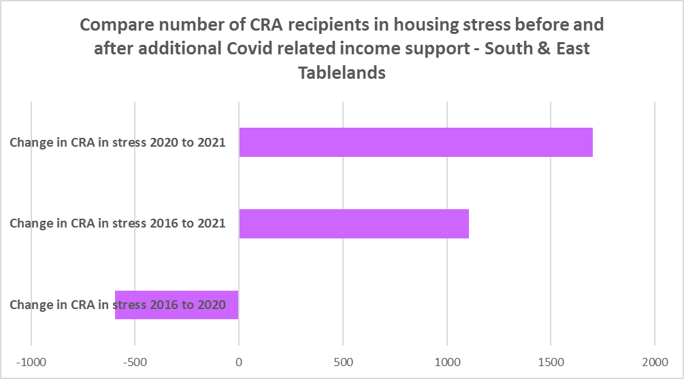

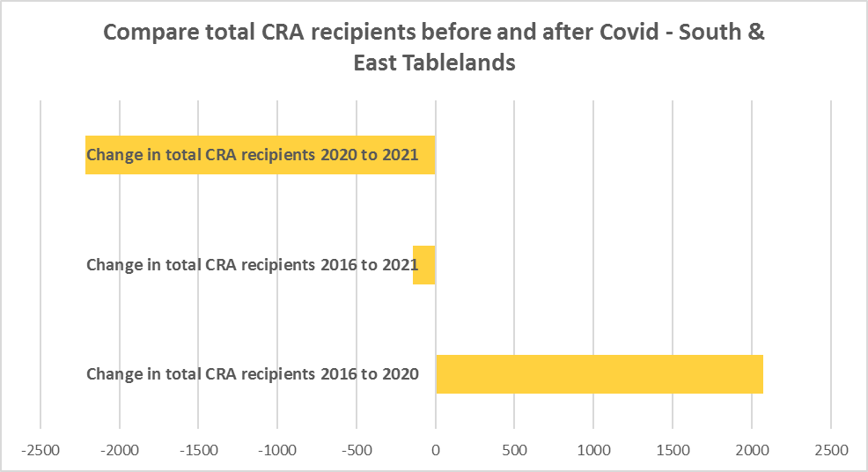

* The table below shows the number and proportion of tenants in the South and East Tablelands region who are in the private rental market, are in receipt of Commonwealth Rent Assistance, and even with this additional income support, are in housing stress.
* There were a total of 6,174 tenants in receipt of CRA and in housing stress across the region in 2021, up from 5,068 in 2016. In 2016, 32.4% of CRA recipients in South and East Tablelands were in stress, increasing to 39.8% in 2021.
* This indicates that this region is becoming increasingly unaffordable for lower income tenants.
* South East Tablelands as a whole has a slightly higher proportion of CRA recipients in housing stress than the Rest of NSW average (39.2%). There are five local government areas in the region with a higher proportion in stress than the Rest of NSW – Wingecarribee, Queanbeyan Palerang, Goulburn Mulwaree, Eurobodalla and Yass Valley. Wingecarribee has the highest proportion with 45.5%. These areas in particular are less affordable for lower income tenants.



**Loss of Affordable Housing Stock**

* DCJ has calculated the number of new bonds lodged with the Rental Bond Board that were affordable to low income earners in the South and East Tablelands region in 2017, 2021 and 2022. The region experienced a decline in affordable bonds lodged, and consequently loss of affordable housing between 2017 and 2022 – with 463 fewer affordable bonds lodged. This represents a decline of -40.9% in new bonds lodged that were affordable to lower income households and consequently loss of affordable private rental stock.
* The table below shows the number of new bonds lodged that were affordable to low income households (including very low income households) in 2017, 2021 and 2022 in each of the South and East Tablelands LGAs as well as the total for the Region.
* It is clear from the table that Yass Valley (-64.1%) and Eurobodalla (-57.3%) experienced the greatest proportional decline in stock, while numerically the largest losses occurred in Eurobodalla (-118) and Queanbeyan-Palerang (-86). Note that Yass Valley had only 14 new bonds lodged which were affordable to low income households at 2022 and Upper Lachlan had too few bonds lodged to enable the calculation to be made. It would be very difficult for lower income households to find affordable rental accommodation, particularly in these two local government areas.

Number of affordable rental properties (new bonds lodged) affordable to low income households



* These are significant losses and together with the increase in the number of low income rental households and lower income rental households in housing stress, demonstrates the need for provision of affordable rental housing.

# ***Housing Market - Purchase***

**Sales Price**

* The trend in the median sales price of both houses and flats over the ten years to March 2022 has shown variation but has overall been upward.
* Due to Council amalgamations over the intervening period, there is no comparative data for Hilltops, Queanbeyan Palerang and Snowy Monaro Regional. For the remaining LGAs Wingecarribee (74.8%) and Bega Valley (73.4%) had the strongest increases in median sales price for houses between March 2012 and March 2022.
* For strata properties, data was only available for Bega Valley and Eurobodalla which both experienced robust increases (98.2% and 122.8% respectively) over the same time frame.
* At March 2022, Wingecarribee had the highest median sales price for houses with $1,433,000, followed by Queanbeyan Palerang with $1,043,000 and $918,000 in Yass Valley. Eurobodalla had the highest median sales price for flats at March 2022 with $571,000, followed by Bega Valley with $545,000.
* The table below shows changes in the median sales price of both houses and flats over the last ten years in the South and East Tablelands region.



* However, between 2019 and 2022 there were clear impacts from Covid, creating more complex changes in the market, as the table below demonstrates.
* Between March 2019 and 2020 median house and strata prices experienced relatively low growth in most LGAs in the region, with Snowy Monaro Regional actually seeing a fall in median house prices over that year. Changes in the median sales price for houses ranged between -4.5% in Snowy Monaro Regional and 11.8% in Hilltops, with the largest increase in dollar terms being $54,000 in Yass Valley.
* Between March 2021 and March 2022 there was strong growth in median house prices. Increases in the median sales price for houses ranged between 41.5% in Snowy Monaro Regional and 20.5% in Yass Valley, with the biggest increase in dollar terms being the $410,000 increase in the median in Wingecarribee.



* The long term median sales price trend for houses and flats shows growth across all LGAs.
* The two graphs below show the median sales price trend for houses and for strata properties from 1991 to 2022 in all South and East Tablelands LGAs. It is clear that the median sales price for houses are highest in Wingecarribee, Queanbeyan Palerang and Yass Valley.

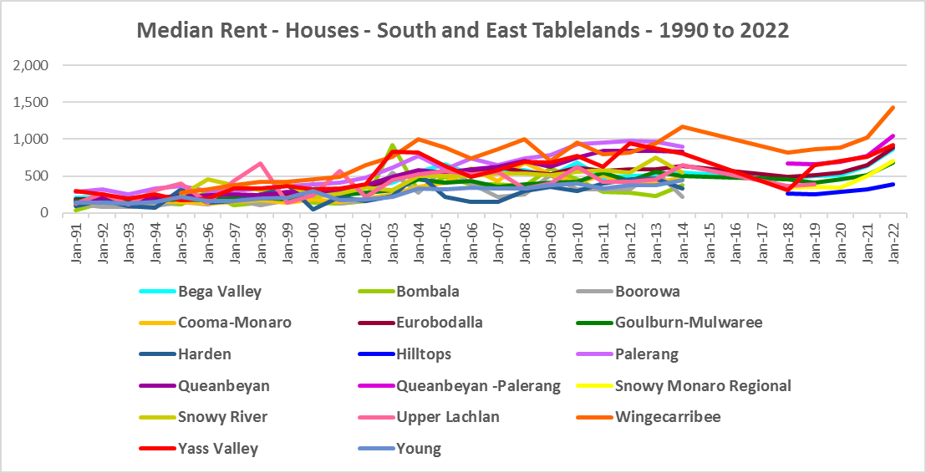

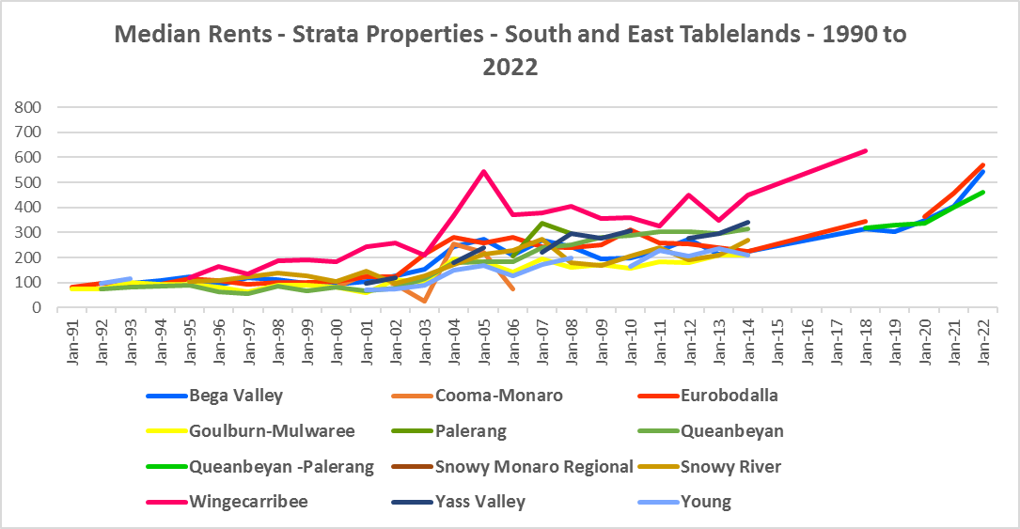

**Purchase Affordability**

* Purchase affordability for very low income earners has varied over the period from 2017 to 2021.
* This is not the case in the South and Eastern Tablelands. Purchase affordability has declined in every LGA in the region, with three LGAs having 0% affordable purchase at 2021 (Goulburn Mulwaree, Wingecarribee and Yass Valley) and two more having less than 1% (Bega Valley and Snowy Monaro Regional).
* At June 2021, all the South and Eastern Tablelands LGAs, with the exception of Hilltops and Upper Lachlan Valley, had a lower proportion of affordable purchase for very low income households than the average for the Rest of NSW of 7.5%
* The graph and table below shows purchase affordability for very low income households in the South and East Tablelands LGAs and the Rest of NSW between 2001 and 2017.

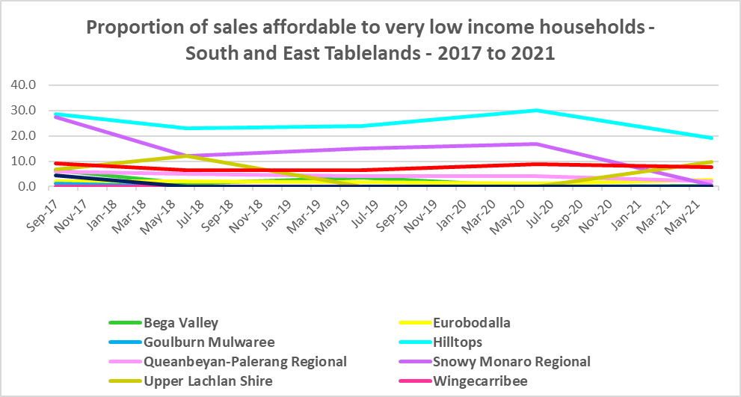

Proportion affordable purchase for very low income households



* With the exception of Queanbeyan Palerang, all the South and East Tablelands LGAs had a decline in the proportion of housing affordable for purchase by low income households over the last few years.
* At June 2021, Wingecarribee had 0% affordable purchase for low income households, with Eurobodalla (8.0%), Yass Valley (9.9%), Bega Valley (12.8%), Goulburn Mulwaree (15.0%) and Queanbeyan Palerang (18.1%) all having a lower proportion affordable for purchase than the average for the Rest of NSW at 23.8%.
* The graph and table below show the change in purchase affordability for low income households in the South and East Tablelands, compared to the Rest of NSW, between 2001 and 2017.

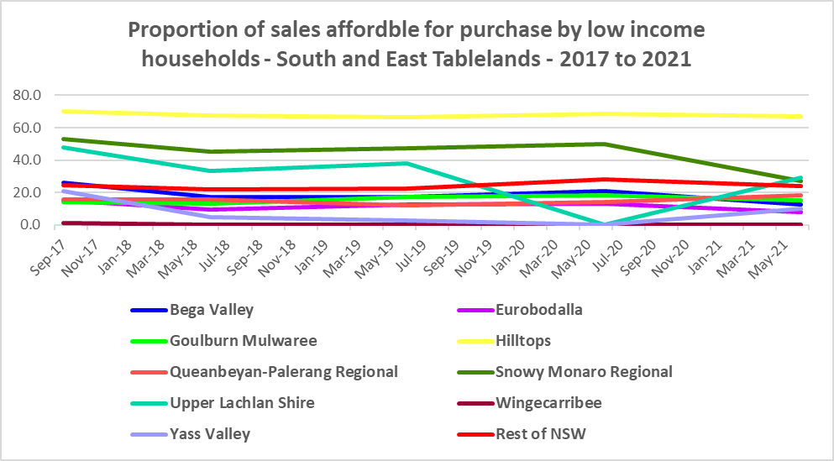

Proportion affordable rental for low income households



**Purchase Stress**

* In 2021 there were 1,155 very low income households and 1,223 low income households purchasing a home and in stress across the region – that is, paying more than 30% of their income on their mortgage. This represents 45.6% of very low and low income purchasers in South and East Tablelands – a slightly higher proportion than the average for the Rest of NSW at 43.9%.
* Queabeyan Palerang had the highest proportion with 56.4%, followed by Wingecarribee with 53.8%, while Eurobodalla had the highest number with 916, followed by Wingecarribee with 906 and Bega Valley with 902.



* However the number of very low and low income purchasers in stress is significantly lower than the number of very low and low income renters in stress in the region, as the graph below demonstrates.

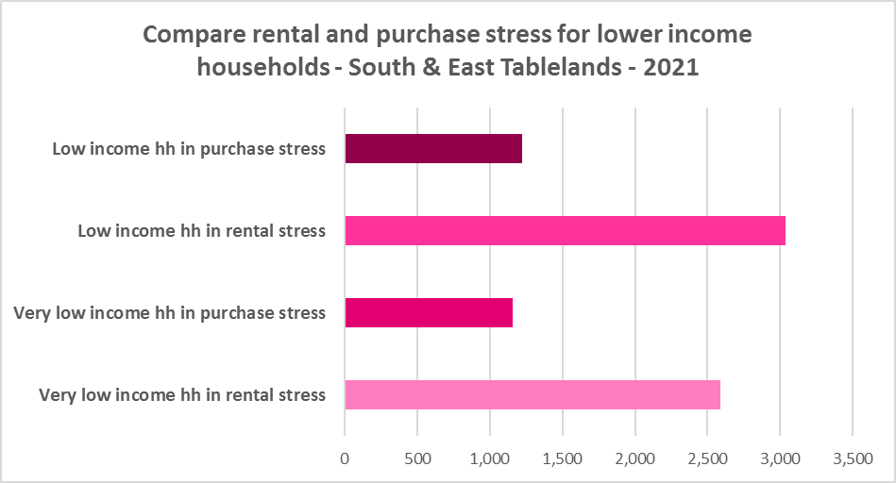

**Additional Data**

Additional data on rents and sale prices, including both current and historical data, is available from the Rent and Sales Report on the Housing NSW website at:

<http://www.housing.nsw.gov.au/About+Us/Reports+Plans+and+Papers/Rent+and+Sales+Reports/>

More detailed housing data and tables used in this Snapshot are available from the Local Government Housing Kit Database on the Housing NSW website at:

<http://www.housing.nsw.gov.au/Centre+For+Affordable+Housing/NSW+Local+Government+Housing+Kit/Local+Government+Housing+Kit+Database/>

More information on vacancy rates is available from the Real Estate Institute of NSW website (see their media releases on vacancy rates):

<https://www.reinsw.com.au/>