**Illawarra Shoalhaven Region – What’s Happening in the Housing Market?**

This Housing Snapshot looks at aspects of the housing market in the Illawarra Shoalhaven, particularly from the 2016 Census to the 2021 Census – including rents, vacancy rate, affordable private rental for very low and low income households, rental stress for low income households, number of new bonds lodged affordable to low income households, sales price, purchase affordability for very low and low income households and purchase stress for low income households.

The Illawarra Shoalhaven region comprises four local government areas to the south of Sydney on the coast, including the city of Wollongong and significant regional centres. While there are differences across the region in median rent and house prices and rent and house price growth, there has been a reduction in rental affordability in every LGA in the region, along with a loss of affordable rental housing and an increase in the number of low income rental households in housing stress.

There have been changes across the Illawarra Shoalhaven since the 2021 Census, with Covid having an impact on the housing market. Recent additional cost of living pressures, including rising inflation and interest rates with continued low wage growth, have created further difficulties for lower income earners and their capacity to manage housing costs.

**Illawarra Shoalhaven Region – What’s Happening in the Housing Market?**

# ***Housing Market - Rental***

**Rents**

* There have been strong increases in median rents in all bedroom categories in the Illawarra Shoalhaven region for over two decades, as the graph below demonstrates. It tracks the change in median rent (for all dwellings, including all bedroom categories) for each of the Illawarra Shoalhaven LGAs from June 1990 to June 2022.

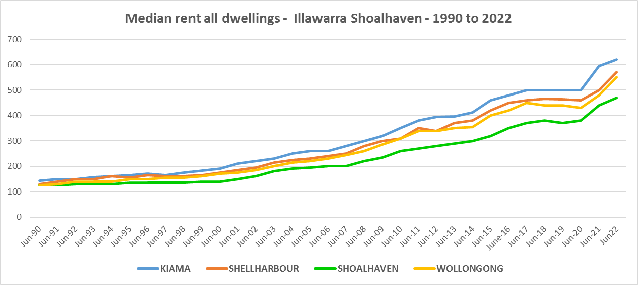

* Between 2019 and 2020 when Covid lockdowns were introduced, median rents in the Illawarra Shoalhaven region local government areas were fairly stable – with no change, slight increases or slight decreases in median rents - as the table below demonstrates. This is in line with the trend elsewhere in NSW.
* During that period, the largest percentage decline in median rents occurred in Kiama LGA for one bedroom homes (-7.5%), while the biggest increase was for three bedroom homes in Kiama (5.8%). As is evident from the table below most LGAs had no increase in median rents over that year in at least one bedroom category.



* However, between 2020 and 2022 when Covid restrictions were relaxed, there were strong increases in median rents across the region, as the table below shows and is also evident in the graph above.
* The largest increases in median rents in dollar terms over that period were in Kiama ($300 for 4 bedroom homes), Shellharbour ($122 for 2 bedroom and $118 for 3 bedroom) and Wollongong ($60 for 1 bedroom). Shoalhaven also experienced strong increases in median rents over this time frame.
* In percentage terms, increases in median rents were robust across all local government areas and bedroom categories in the Illawarra Shoalhaven.
* Overall the highest percentage increase in median rents between June 2020 and June 2022 occurred for one bedroom homes in Wollongong (20.7%), for two bedroom homes in Shellharbour (33.2%), for three bedroom homes in Shoalhaven (26.3%) and four bedroom homes in Kiama (50.0%).
* At June 2022, median rents for one bedroom homes ranged between $293 (Shoalhaven) and $400 per week (Kiama); for two bedroom homes between $410 (Shoalhaven) and $530 per week (Kiama); for three bedroom homes between $480 (Shoalhaven) and $650 per week (Kiama); and for four or more bedroom homes from $600 (Shoalhaven) and $900 per week (Kiama).



* Such strong recent increases in median rents will have a significant impact on lower income tenants in particular.

**Vacancy Rate**

* A vacancy rate of 3% is understood to represent a balance between supply and demand. According to REINSW data, vacancy rates were below 3% for Wollongong and the Illawarra, for most of the period from 2006 through to 2022. Vacancy rates on the South Coast (which includes Shoalhaven) have been more volatile. Vacancy rates below 2% indicate a chronic shortage of rental housing.
* At April 2023 the vacancy rate in Wollongong was 1.3%, in the rest of the Illawarra was 1.7% and for the South Coast was 2.1%. This compares to 1.7% in the Central Coast, 1.3% in Sydney, 1.8% in Newcastle and 2.0% in the rest of the Hunter.
* Anecdotally there are stories of tenants struggling to find rental accommodation, with strong competition for places, rent bidding, significant increases in rents and tenants facing eviction and potential homelessness .
* The two graphs below show the vacancy rate from 2006 to 2023 in the Wollongong and Illawarra and also the South Coast of NSW, using REINSW data.

**Affordable Rental**

* The general trend across Sydney and NSW has been for a decline in the proportion of rental stock which is affordable for very low, low and moderate income earners.
* This trend to decline in affordable rental is also evident in the Illawarra Shoalhaven region. Although along with elsewhere in NSW, there were more complex factors at play between 2019 and 2022.
* Across the Rest of NSW, the proportion of affordable rental for very low income households stayed at the 2018 level of 22.0% for 2019, improved slightly to 21.7% in 2020 and again to 21.9% in 2021 then declined in line with the longer term trend to 17.0% in 2022.
* In the Illawarra Shoalhaven, this pattern was more varied. Between 2018 and 2019 rental affordability for very low income households improved in Kiama, Shoalhaven and Wollongong and declined in Shellharbour.
* Between 2019 and 2020 the proportion affordable for rental by very low income households declined in Kiama but increased in Shellharbour, Shoalhaven and Wollongong.
* Between 2020 and 2021 rental affordability improved in Kiama, Shoalhaven and Wollongong and declined in Shellharbour.
* Between 2021 and 2022 rental affordability for very low income households improved in Kiama and Shellharbour and declined in Shoalhaven and Wollongong.
* At June 2022, every Illawarra Shoalhaven LGA had a much lower proportion of affordable rental for very low income households than the Rest of NSW average of 17.0%. Kiama had the lowest proportion with 3.0%, followed by Shellharbour with 3.3%, Wollongong with 5.3% and Shoalhaven with 8.2%.
* The table and graph below show the change in the proportion of private rental accommodation affordable to **very low income** households in the Illawarra Shoalhaven LGAs and Rest of NSW between 2001 and 2022.
* Given the predominance of low income households in the Illawarra Shoalhaven region, the declining proportion of private rental accommodation affordable for lower income earners is of concern.
* This suggests a growing gap between demand and supply, which is borne out by other evidence in the graph below, which shows the change in the proportion of private rental accommodation that is affordable for very low income households in the Illawarra Shoalhaven LGAs. Clearly from 2016 onwards the proportion of private rental that was affordable to very low income households declined and has remained fairly tight, particularly in comparison to the Rest of NSW

Proportion affordable rental for very low income households



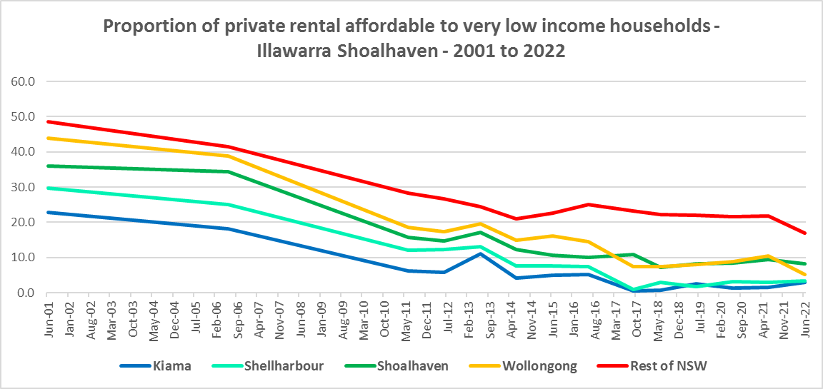

* There has been a similar decline in rental affordability for low income households in the region, with every LGA having a significantly lower proportion of affordable rental for low income households in 2022 than in 2001.
* In the Rest of NSW, between 2018 and 2020 the proportion of rental affordable for low income households increased gently from 54.1% to 55.2% and then declined again to 45.4% in June 2022.
* As for very low income households, the picture in the Illawarra Shoalhaven was more varied.
* Between 2018 and 2019 affordability improved in every Illawarra Shoalhaven LGA.
* Between 2019 and 2020 the proportion affordable for rental for low income households increased in Shellharbour, Shoalhaven and Wollongong and declined in Kiama.
* Between 2020 and 2021 affordable rental for low income households declined in Kiama, Shoalhaven and Wollongong and improved in Shellharbour.
* Then between 2021 and 2022 affordability declined in every Illawarra Shoalhaven LGA with the exception of Kiama (which had a significant increase in the proportion affordable rental for low income households).
* At June 2022 all four Illawarra Shoalhaven LGAs have a lower proportion of affordable private rental for low income households than the average of 45.4% for the Rest of NSW. Shellharbour has the lowest proportion with 13.8%, followed by Kiama with 14.2%, Wollongong with 26.5% and Shoalhaven with 37.5%.
* Since June 2020 Shoalhaven has had the most significant decline in affordable private rental in the region (from 52.9% to 37.5%) and much greater than the average for the Rest of NSW (which declined from 55.2% to 45.4%).
* The table and graph below show the change in the proportion of private rental accommodation affordable to **low income** households in the Illawarra Shoalhaven and Rest of NSW between 2001 and 2022.

Proportion affordable rental for low income households



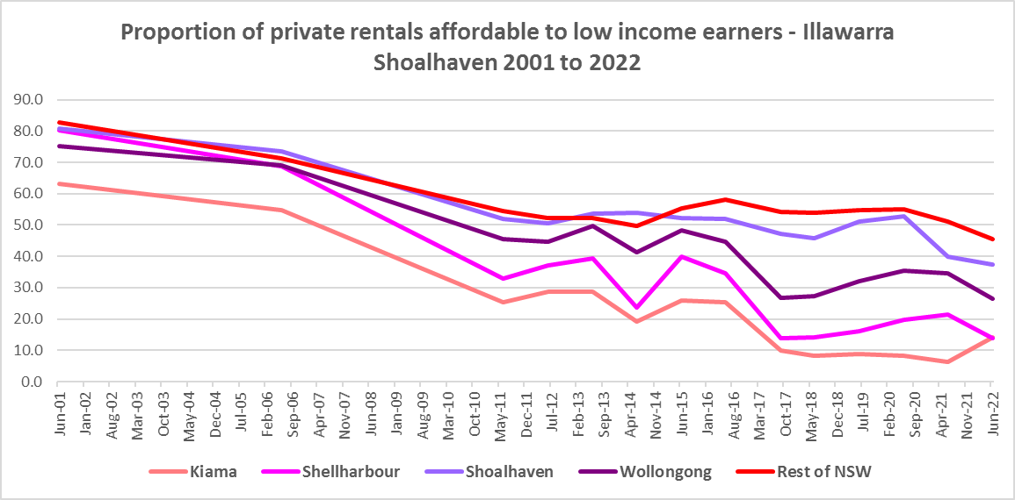

* There is evidence that short term holiday rentals such as Airbnb are impacting the supply of housing, including long term rental and affordable housing in cities and coastal communities.
* The University of Sydney Urban Housing Lab undertook a study and prepared a report for the Australian Coastal Councils on short term holiday rentals: “Planning responses to online short term holiday rental platforms” - Research Project for Australian Coastal Councils Association Inc. September 2018 by Nicole Gurran, Yuting Zhang, Pranita Shrestha, Catherine Gilbert.
* The study found (p7) “that there has been a rapid growth in online holiday rental listings overall and in coastal Australia in particular. Since Airbnb was launched in Australia, the number of listings has risen to over 130,000 properties, amounting to around 0.2% of the housing stock nationwide. If holiday rentals are considered to be part of the rental housing stock (a smaller proportion of Australian homes), then Airbnb listings for whole homes represent around 3.5% of rental accommodation. In coastal communities, the rate is much higher. Across the communities in this study, between 0.3% (Moreton Bay) and 17.6 % (Byron) of the total housing stock is listed on Airbnb.”
* Further (p7) “ the majority of these listings are whole houses, and more than half appear to be frequently available holiday lets rather than permanent residences. Considered as part of the rental housing stock, these whole houses, frequently available, amount to 19.7% of the rental housing stock in Kiama…” and (p23) 21.6% in Shoalhaven. The report states that (p23) “Airbnb listings…is equivalent to around a fifth of the rental housing stock in Kiama (and) Shoalhaven…”
* The study notes that (p25) “There has been rapid growth in Airbnb listings across many of the 12 case study communities, particularly between December 2016 and December 2017…Listings grew fivefold in Shoalhaven…”
* While Kiama and Shoalhaven are traditional tourist destinations, the rapid growth in on line listings and loss of affordable rental accommodation are likely connected, with tourist accommodation outcompeting longer term renting for locals, particularly in Kiama. Shellharbour and Wollongong did not participate in this study, so the impact of Airbnb on those LGAs is not known. However, it offers a partial explanation for the loss of both affordable rental homes and low income rental households in the region.
* More recently, research by SQM showed that between July 2019 and July 2020 Shellharbour had an increase of 23% in Airbnb listings, Shoalhaven by 9%, Wollongong by 4% and Kiama by 1%.
* Since 2020 it is likely that Airbnb listings have picked up again in the Illawarra Shoalhaven.

**Rental Stress**

* Households are regarded as being in rental stress when renting in the private rental market and paying more than 30% of their income in rent. Lower income households in rental stress will struggle to pay for other essential household costs, such as medical or educational expenses, food, transport and energy costs.
* At June 2021 the proportion of very low income households in rental stress in the Rest of NSW (that is, excluding Sydney) was 91.7%.
* All Illawarra Shoalhaven LGAs had a higher proportion of very low income households in rental stress than the average for the Rest of NSW. Wollongong had the highest proportion with 96.4%, followed by Kiama and Shellharbour with 95.9% and Shoalhaven with 95.6%.
* For low income households at 2021 the proportion in rental stress for the Rest of NSW was 68.3%.
* Again all the Illawarra Shoalhaven LGAs had a higher proportion of low income households in rental stress than the Rest of NSW average. Kiama had the highest proportion with 83.7%, followed by Shellharbour with 83.1%, Wollongong with 81.2% and Shoalhaven with 73.8%.
* However, while the **proportion** of very low and low income households in stress generally increased in the Illawarra Shoalhaven LGAs between the 2016 and 2021 Census, the actual numbers in stress tell a different story.
* The **number** of very low income households in stress have declined in every Illawarra Shoalhaven LGA over this time frame.
* The picture for low income households in rental stress is the exact opposite, with numbers increasing between 2016 and 2021 in every Illawarra Shoalhaven LGA with the exception of Kiama.
* Below is a graph of the proportion of very low and low income households in rental stress in each Illawarra Shoalhaven LGA at 2021 and a table showing the change in the proportion of very low and low income households in stress between 2016 and 2021.

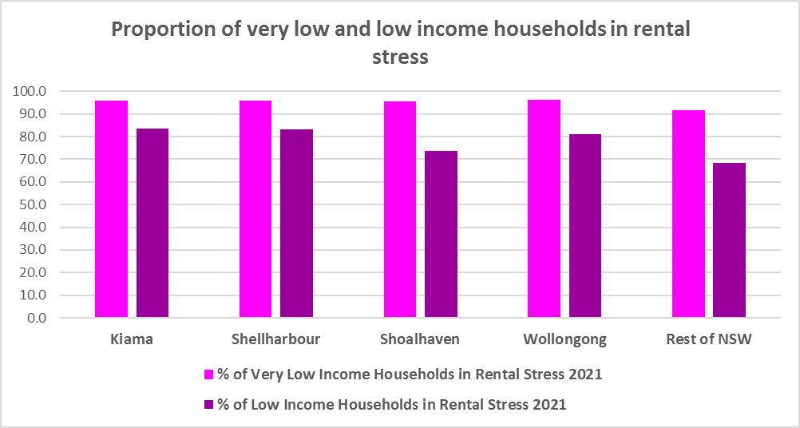



* The next table shows the change in the number of very low and low income households in rental stress at 2016 and at 2021.
* Again Covid has had an impact on the rental market and on tenants.
* A look at CRA (Commonwealth Rent Assistance) recipients in housing stress gives some further information on what has been happening with lower income households in rental stress over this time frame.



* In line with other parts of NSW, between 2016 and 2020, the total number of CRA recipients in the Illawarra Shoalhaven increased significantly, while the number in stress actually declined. However, between 2020 and 2021 the number of CRA recipients declined while the number in stress increased.
* The number of CRA recipients in housing stress has increased from the June 2020 figures as the temporary Coronavirus Supplement ended on 31 March 2021.
* The Coronavirus Supplement was $550 per fortnight for new and existing recipients of JobSeeker Payment, Parenting Payment, Youth Allowance for jobseekers, Farm Household Allowance and Special Benefit. The temporary supplement almost doubled the maximum payment rate for a JobSeeker Payment recipient. Hence it made rent more affordable for some CRA recipients in June 2020 and resulted in a lower proportion of CRA recipients in rental stress than usual.
* Since the end of Covid restrictions, the number of people in employment has increased, so fewer people are relying on rent assistance from the Commonwealth.
* The two graphs below clearly demonstrate this experience in the Illawarra Shoalhaven.

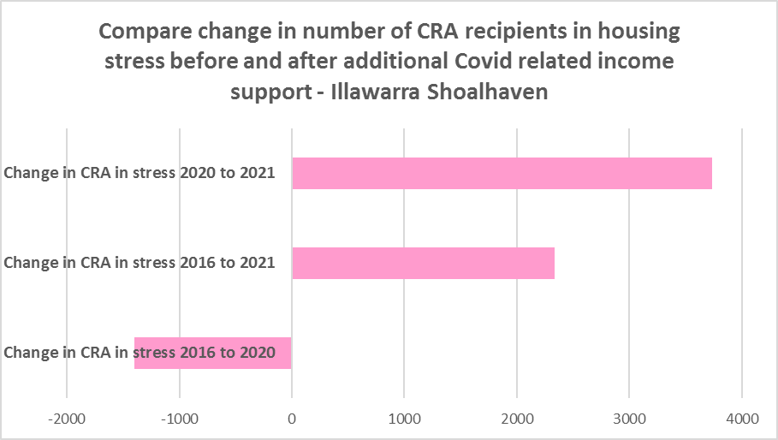

* The table below shows the number and proportion of tenants in the Illawarra Shoalhaven region who are in the private rental market, are in receipt of Commonwealth Rent Assistance, and even with this additional income support, are in housing stress.
* There were a total of 13,060 tenants in receipt of CRA and in housing stress across the region in 2021, up from 10,723 in 2016. In 2016, 40.9% of CRA recipients in the Illawarra Shoalhaven were in stress, increasing to 46.5% in 2021. This compares to 35.1% CRA recipients in stress in 2016 for the Rest of NSW and 39.2% in 2021.
* Like the Rest of NSW, the Illawarra Shoalhaven is becoming increasingly unaffordable for lower income tenants.
* There are three local government areas in the region with a higher proportion of CRA recipients in stress than the Rest of NSW – Wollongong has the highest with a significant 53.7%, followed by Kiama with 50.4% and Shellharbour with 48.0%.
* While Shoalhaven has historically been more affordable for rental than other parts of the region, this LGA is becoming increasingly unaffordable. This is indicated by significant recent declines in the proportion of new bonds lodged which are affordable for lower income households. .



**Loss of Affordable Housing Stock**

* DCJ has calculated the number of new bonds lodged with the Rental Bond Board that were affordable to low income earners in the Illawarra Shoalhaven in 2017, 2021 and 2022. The region experienced a significant decline in affordable bonds lodged, and consequently loss of affordable housing between 2017 and 2022 –representing a loss of 20.8% of affordable stock, mostly in Shoalhaven.
* The table below shows the number of new bonds lodged that were affordable to low income households (including very low income households) in 2017, 2021 and 2022 in each of the Illawarra Shoalhaven LGAs as well as the total for the Region.
* Note that while there has been some variability (rises and falls) in the number of new bonds lodged which are affordable to low income households in these LGAs, there are remarkably few affordable private rentals – particularly in Kiama and Shellharbour and the loss in Shoalhaven has been significant.

**Number of new bonds lodged affordable to low income households**



# ***Housing Market - Purchase***

**Sales Price**

* The median sales price of both houses and flats in the Illawarra Shoalhaven over the ten years to March 2022 have shown strong increases.
* Shoalhaven had the largest proportional increase in median sales price for houses over this period with 207.7%, followed by Kiama (188.8%) then Shellharbour (149.4%) and Wollongong (143.5%).
* For strata properties, Shoalhaven (132.5%) again had the largest proportional increase in median sales price over the ten year time frame, followed by Shellharbour (122.4%) and Wollongong (111.3%). Note Kiama had insufficient strata sales for the March quarter 2022 to calculate the median sales price and determine the change from 2012.
* At March 2022, Kiama had the highest median sales price for houses with $1,641,000, followed by $1,097,000 in Wollongong, $1,021,000 in Shoalhaven and $984,000 in Shellharbour.
* Wollongong had the highest median sales price for flats at March 2022 with $755,000, followed by Shellharbour with $665,000 and Shoalhaven with $616,000.
* The table below shows changes in the median sales price of both houses and flats over the last ten years in the Illawarra Shoalhaven region.



* The long term median sales price trend for houses shows growth across all LGAs, particularly from around 2002. The long term trend for strata properties is similar.
* The two graphs below show the median sales price trend for houses and for strata properties from 1991 to 2022 in all Illawarra Shoalhaven LGAs. It is clear that more recently the median sales prices have increased dramatically.

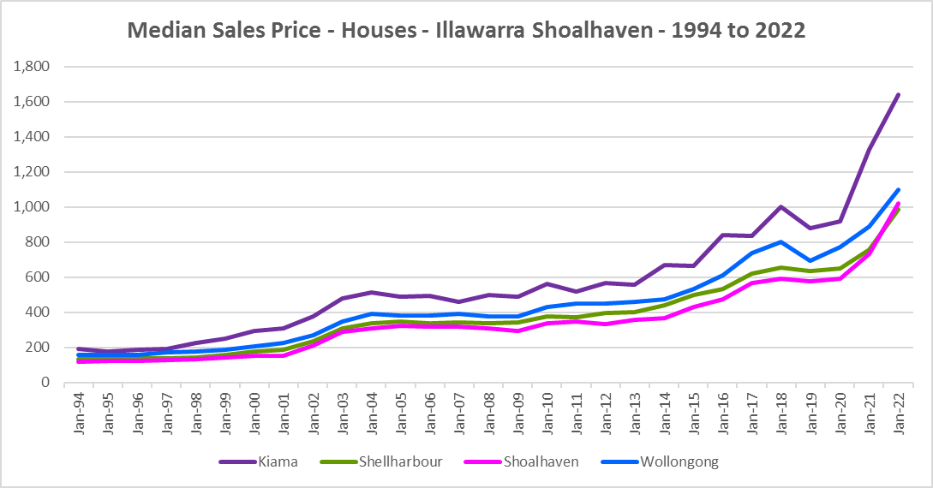

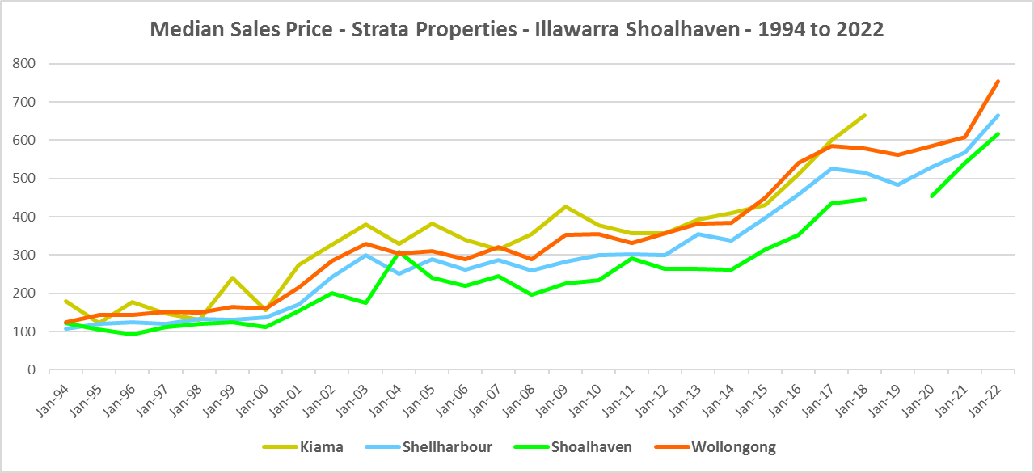

* However, between 2019 and 2022 there were more complex changes in the market, as the two tables below demonstrate.
* Generally, between March 2019 and 2020 median house and strata prices experienced relatively low growth in the Illawarra Shoalhaven.
* Increases in the median sales price for houses ranged from 2.1% in Shoalhaven to 4.0% in Kiama, with Wollongong the outlier on 11.4%.
* For strata increases in median sales price ranged from 4.3% in Wollongong to 9.9% in Shellharbour – with insufficient sales in both Kiama and Shoalhaven to calculate the median.
* Between March 2021 and March 2022 there was strong growth in median house and strata prices across the Illawarra Shoalhaven. Increases in the median sales price for houses ranged between 39.1% in Shoalhaven and 23.3% in Wollongong. For strata over the same period, increases ranged between 24.0% in Wollongong and 13.9% in Shoalhaven, with Kiama having insufficient sales to make the calculation.
* Clearly Covid also had an impact on sales prices in the region.





**Purchase Affordability**

* Purchase affordability for very low income earners has varied over the period from 2001 to 2021 and in the Rest of NSW the proportion of sales affordable to purchase by very low income households is actually slightly higher in 2021 than in 2001.
* This is not the case in the Illawarra Shoalhaven. Purchase affordability at 2021 is 0.0% in every Illawarra Shoalhaven LGA – in every case a lower proportion than in 2001.
* All LGAs in this region had a lower proportion of affordable purchase for very low income households than the average for the Rest of NSW of 7.5%
* The graph and table below show purchase affordability for very low income households in the Illawarra Shoalhaven LGAs and the Rest of NSW between 2001 and 2021.

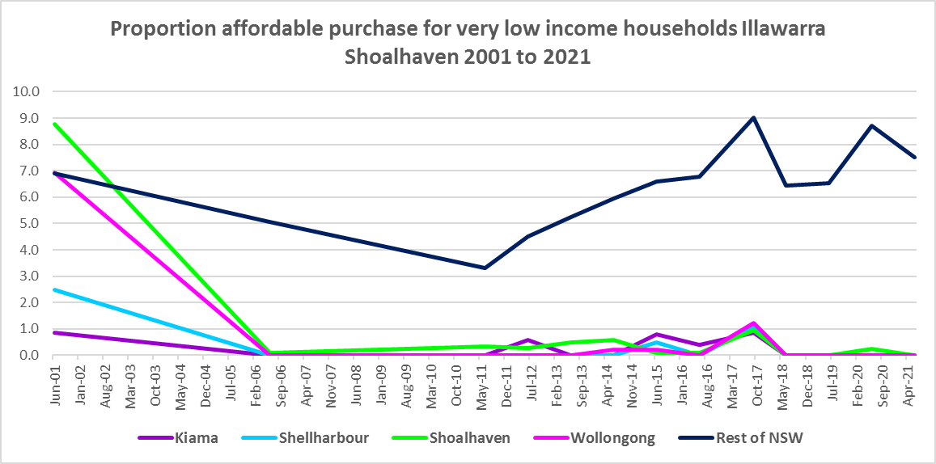

Proportion affordable purchase for very low income households



* Likewise, every Illawarra Shoalhaven LGA had a lower proportion of housing affordable for purchase by low income households in 2021 than in 2001. There has been some volatility in affordable purchase over this time frame, with all LGAs seeing a decline in affordability since 2020.
* At June 2021, all the Illawarra Shoalhaven LGAs had a lower proportion of housing affordable for purchase by low income households than the Rest of NSW average of 23.8%.
* Both Shellharbour and Wollongong had 0.0% affordable purchase for low income households, with Kiama having just 0.9% and Shoalhaven 3.2%.
* The graph and table below show the change in purchase affordability for low income households in the Illawarra Shoalhaven, compared to the Rest of NSW, between 2001 and 2021.

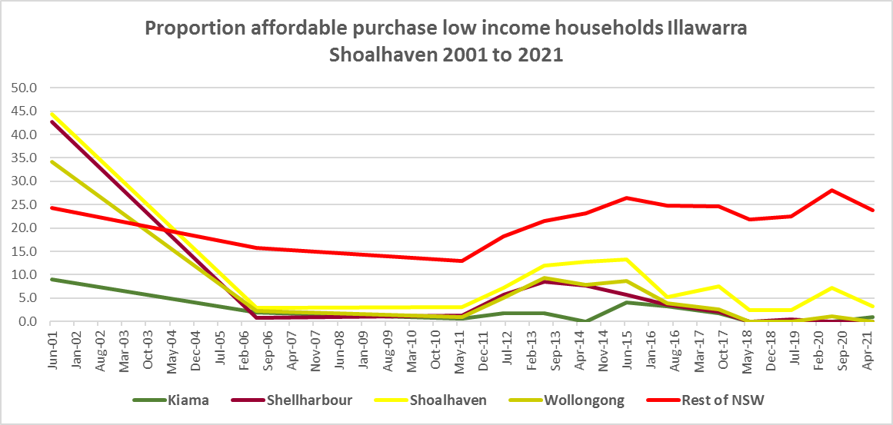



**Purchase Stress**

* In 2021 there were 1,526 very low income households and 1,958 low income households purchasing a home and in stress across the Illawarra Shoalhaven – that is, paying more than 30% of their income on their mortgage. This represents 50.3% of very low and low income purchasers in the region – a higher proportion than the average for the Rest of NSW at 43.9%.
* Wollongong had the highest proportion with 54.4%, followed by Shellharbour with 51.2%, then Kiama with 49.4% and Shoalhaven with 45.2%.
* Wollongong had the highest number of very low and low income purchasers in stress with 2,881, followed by Shoalhaven with 2,468, Shellharbour with 1,304 and Kiama with 271.



* However the number of very low and low income purchasers in stress is significantly lower than the number of very low and low income renters in stress in the region, as the graph below demonstrates.
* This indicates that there is a stronger need for more affordable housing for lower income renters than purchasers in the Illawarra Shoalhaven.

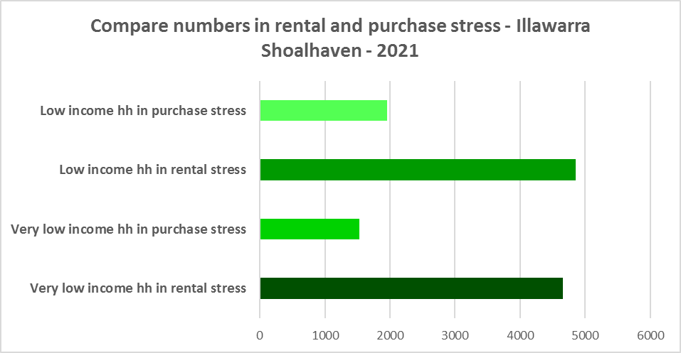

**Additional Data**

Additional data on rents and sale prices, including both current and historical data, is available from the Rent and Sales Report on the Housing NSW website at:

<http://www.housing.nsw.gov.au/About+Us/Reports+Plans+and+Papers/Rent+and+Sales+Reports/>

More detailed housing data and tables used in this Snapshot are available from the Local Government Housing Kit Database on the Housing NSW website at:

<http://www.housing.nsw.gov.au/Centre+For+Affordable+Housing/NSW+Local+Government+Housing+Kit/Local+Government+Housing+Kit+Database/>

More information on vacancy rates is available from the Real Estate Institute of NSW website (see their media releases on vacancy rates):

<https://www.reinsw.com.au/>