# **Central City District – What’s the Housing Demand**

This Housing Snapshot looks at aspects of housing demand in Central City, particularly from the 2016 Census to the 2021 Census – including population, age profile, household type, household size, income (change in low, moderate and high income households and low income rental households), homelessness and people with disability.

There have been challenges across Australia and in this region since the 2016 Census, including the pandemic and subsequent surge in immigration - which have impacted the community and the demand for housing.

## Population

* Changes in population will impact on the demand for housing.
* Between 2016 and 2021, the population of Central City grew by 15.4% or 144,384, from 936,436 to 1,080,820 (using ABS Census population data).
* However, not every LGA in the District has grown at the same rate.
* Changes in population between 2016 and 2021 within Central City ranged from a 9.0% increase in Cumberland to a 22.0% increase in The Hills Shire.
* In terms of numbers, Blacktown had the largest increase with an additional 59,816 people, followed by The Hills with 34,633, then Parramatta with 30,576 and Cumberland with 19,359.
* Note that The Hills and Blacktown had the second and third largest percentage increase in population in the state between 2016 and 2021, only behind Camden with a huge 52.5% increase. In numeric terms, Blacktown ranked first in the state with the largest total increase in population, followed by Camden and then The Hills.
* Blacktown has the largest population in the District with 381,996 and The Hills has the smallest population with 189,930.
* The Department of Planning and Environment have prepared population projections for every LGA in the district, and every LGA in Central City is forecast to have a higher growth rate than the average for NSW of 0.95% per annum – Blacktown 1.28% per annum, Cumberland 1.13%, Parramatta 2.03 and The Hills Shire is predicted to have the fastest growth rate with 2.2% per annum.
* Numerically the largest increase in population forecast to 2041 is predicted for Parramatta (129,351), followed by Blacktown (110,245), The Hills (100,361) and Cumberland (61,184).
* These are significant population increases – compared for example with Ryde in North District which is forecast to have a growth rate of 1.52% per annum (the only LGA in North District predicted to have a higher growth rate than the average for NSW) with an additional population of 46,981 to 2041.
* The table below shows the population change for each Central City LGA and the district as a whole from 2016 to 2021 using ABS Census data.



## Age

* The age profile of the region and particularly each LGA will impact on housing need and demand, including number of bedrooms, affordability, location (for example, in relation to services and facilities) and dwelling type.
* The median age of the population of the Central City LGAs at the 2021 Census is generally much younger than the average for Greater Sydney of 37 years, and ranges between 34 years (Blacktown and Cumberland) and 38 (The Hills Shire). This compares with a median age of, for example 42 in Ku-ring-gai and 41 in Hornsby.
* The table below gives the median age for all the Central City LGAs and Greater Sydney.



* There is similarity in the age profiles of the Central City LGAs.
* Not unexpectedly, given the youthful median age of the Central City LGAs, there is generally a higher proportion of cohorts aged under 45 years and a lower proportion of cohorts aged 45 and over.
* However, there are also differences in the age profiles of LGAs in the District, compared to the District as a whole and Greater Sydney.
  + The Hills Shire has lower proportions of 0-4, 20-24 and 25-34 year age cohorts and also has a higher proportion of 65-74 year olds than the average for both the District and Greater Sydney.
  + Parramatta has a lower proportion of the 5-14 and 15-19 year cohorts than the average for the District and Greater Sydney.
  + Cumberland has a lower proportion of the 15-19 year cohort than the average for the District and Greater Sydney.
* The graph below shows the proportion of the population in each key age cohort in the Central City LGAs as well as the District and Greater Sydney.

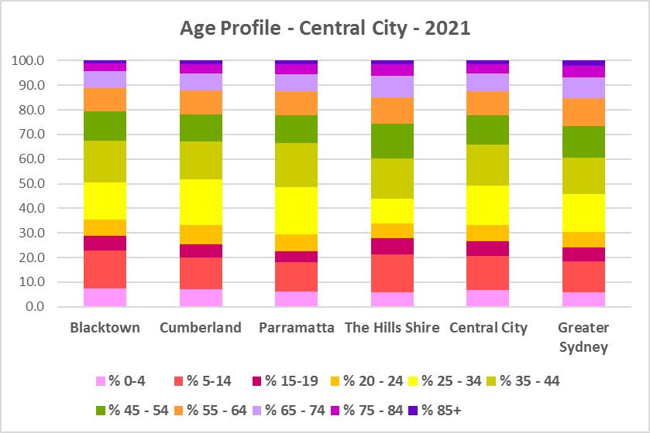

* The table below gives more detail of the breakdown of age cohorts by LGA, for Central City and for Greater Sydney.



* The Department of Planning and Environment forecast increases in both younger and older residents in every Central City LGA to 2041.
* The diversity of age groups requires a range of different housing to meet the needs of the community throughout the housing life cycle.
* Although the subregion has a younger age profile than the average for Sydney, there will be an increasing need for housing to suit seniors and frail aged residents as the number of residents in these age groups grows.
* As the Australian Institute for Health and Welfare (AIHW) note:

Many older Australians prefer to age in place, meaning they wish to stay in their local home or community. However, their capacity to do so can be influenced by:

* + the appropriateness and quality of their home (for example, size, layout)
  + their ability to modify their home to suit their functional requirements
  + the cost and availability of suitable housing
  + their need for formal care and assistance
  + their proximity to services and social support.
* Although the majority of older Australians own their own home, this number is declining. About 15% of older Australians are renters. These people are generally a highly vulnerable and economically disadvantaged group, particularly single person households, with older women being the fastest growing demographic of people experiencing homelessness. There is therefore a need for more adaptable, accessible dwellings, well located, secure, low maintenance and affordable to meet the needs of seniors and frail aged in particular, within their communities. Those most in need are households in the private rental market, who struggle to afford housing on an Aged Pension or inadequate superannuation. (Source: "Housing Decisions of Older Australians" Productivity Commission December 2015).
* There are significant numbers of low income households and lower income rental households in this District. Therefore affordability is a key issue for all age groups, including older residents, and particularly tenants.
* The Australian Housing and Urban Research Institute (AHURI) has undertaken research on “What is the ideal home for older Australians?”
  + “Older Australians and the housing aspirations gap” and
  + “Understanding the housing aspirations of older Australians”
* This research is part of a broader study on “Housing aspirations and constraints for lower income Australians.” AHURI’s research demonstrates that one of the most valued aspects of older residents housing is the location – that the neighbourhood feels safe and secure; that there is good (including walkable) access to services such as health, shopping, recreational amenities, public open space; and that it is close to family and friends.

## Household Type

* A look at household types and average household size gives some insight into the type of housing – particularly number of bedrooms – that is likely to be appropriate to meet the housing needs of the community.
* At the 2021 Census in Greater Sydney, couple families with children are the largest household type, comprising 34.4% of all households, followed by couple family without children households (23.3%) and lone person households (22.2%). One parent family households (10.5%), other family households (1.2%), group households (4.0%) and other households (4.3%) make up the remainder.
* Household types in Central City conform to the pattern of the average for Greater Sydney, with couple families with children being the largest household type, followed by couple families without children and lone person households. However, there is some variation.
* Central City as a District has lower proportions of couple families without children (20.6%), much higher proportions of couple families with children (42.2%) and lower proportions of lone person households (17.0%) than the average for Greater Sydney. Central City District also has slightly higher proportions of one parent families (10.8%) and other family types (1.4%), as well as other household types (4.6%) (which include multi-family households) and lower proportions of group households (3.6%) than the average for Greater Sydney.
* Individual LGAs in the District differ somewhat from this pattern.
  + While both Blacktown and Cumberland have much lower proportions of couple families without children than the average for Greater Sydney both Parramatta and The Hills have slightly higher proportions of this household type than the Greater Sydney average.
  + The Hills and Blacktown have very high proportions of couple families with children – much higher than Cumberland and Parramatta and also than the average for the District and Greater Sydney.
  + Blacktown and the Hills also have much lower proportions of lone person households than Cumberland and Parramatta as well as the District and average for Greater Sydney.
  + Cumberland and Parramatta have higher proportions of group households than the average for Greater Sydney, while Blacktown and The Hills have lower proportions.
  + Cumberland and Blacktown have higher proportions of other household types than the Greater Sydney average while Parramatta has the same proportion and The Hills has a much lower proportion.
  + Blacktown and Cumberland have higher proportions of one parent families while Parramatta and The Hills have lower proportions than the average for Greater Sydney.
* There has been a shift in the proportions of different household types since the 2016 Census, with an increase in the proportion of lone person households in Greater Sydney (1.8%) and couple family without children households (0.9%), and declines in the proportion of couple family with children households (-0.9%), other household types (-1.3%) and group households (-0.5%).
* The changes in household type from 2016 to 2021 in Central City District were a little different, with a larger decline in the proportion of couple family with children households (-1.7%), smaller increases in the proportion of couple family without children (0.6%) and lone person households (1.3%), a decline in the proportion of one parent families (-0.5%), no change in the proportion of other family households (0.0%) and slight increases in the proportion of group household (0.2%) and other household types (0.3%).
* Changes in individual LGAs are not all in line with this trend:
  + Cumberland (-3.3%) and Parramatta (-2.8%) both had much stronger declines in the proportion of couple families with children than the other LGAs in the District, the District as a whole and Greater Sydney.
  + Parramatta (1.1%) was the only LGA in Central City to have a stronger increase in the proportion of couple families without children than the average for Greater Sydney.
  + Parramatta (1.2%) was also the only LGA in Central City to have a stronger increase in the proportion of lone person households than the average for Greater Sydney.
  + The Hills (0.3%) was the only LGA in the District to have an increase in the proportion of one parent families while Blacktown (-1.2%), Cumberland (-0.5%) and Parramatta (-0.2%) all had declining proportions.
  + Cumberland (1.6%) and Blacktown (0.6%) had increases in the proportion of other household types – against the trend in Greater Sydney and unlike Parramatta (-1.1%) and The Hills (-0.5%).
* This data on household types and changes in household types between the last two Census should be compared with the data on bedroom numbers to determine if there is a good fit between household types and housing stock and what the future housing needs are likely to be.
* Although there should be plenty of housing suitable for families of different sizes, there is also a need for a variety of dwellings with different bedroom numbers to suit couples and single person households.
* The graph and table below show the proportion in each key household type for every Central City LGA, for the District and for Greater Sydney at the 2021 Census.

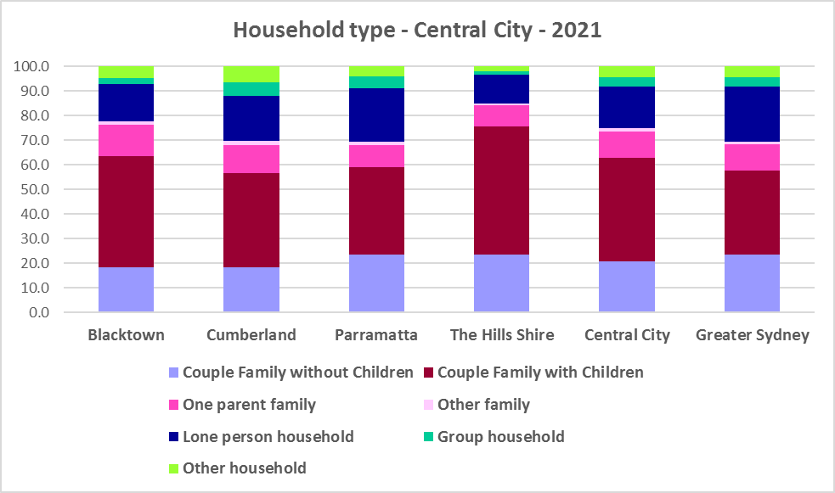



## Household Size

* At the 2021 Census, the average household size for Greater Sydney was 2.7 persons per household – down from 2.8 persons per household in 2016 and the same as 2.7 persons per household in 2011.
* Average household size in Central City ranges from 2.6 persons per household in Parramatta to 3.1 persons per household in Blacktown and The Hills. Cumberland (3.0) also has a larger average household size than the average for Greater Sydney.
* These are large average household sizes – for example, at the other end of the scale City of Sydney has an average household size of 1.9 persons per household and North Sydney is 2.0.
* Average household size declined in every Central City LGA between 2016 and 2021.
* The table below gives the average household size in each of the Central City LGAs as well as Greater Sydney for 2011, 2016 and 2021.



## Income

* At the 2021 Census, high income households comprise the largest proportion of all households in Greater Sydney – unlike the Rest of NSW, where low income households predominate.
* However, unlike the average for Greater Sydney, Central City has a much higher proportion of low income households (37.9% compared to 32.1%), higher proportions of moderate income households (22.7% compared with 18.2%) and much lower proportions of high income households (39.6% compared to 49.7%).
* The Hills Shire does not conform to this pattern, with a lower proportion of low income households (27.7%) and a higher proportion of high income households (51.5%) than the average for Greater Sydney.
* Blacktown has the highest proportion of low income (42.1%) and moderate income households (24.9%) in the District.
* The graph and table below show the proportion of low, moderate and high income households in all the Central City LGAs, compared with the District and Greater Sydney at the 2021 Census.

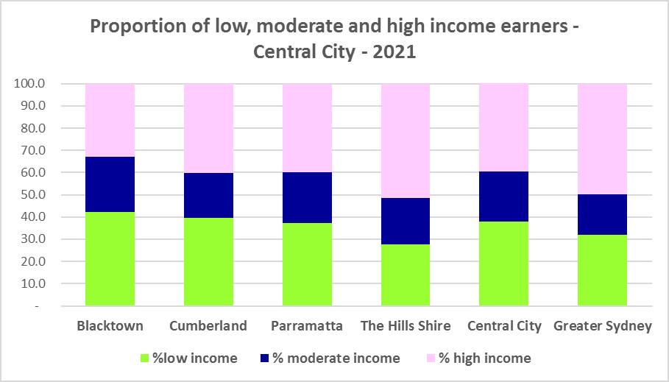



* Between 2016 and 2021 the number of low income households increased in Central City as a whole (by 7.0%) and every LGA except Cumberland (-6,890 or -19.6%), which experienced a significant decline in the number of low income households.
* Over the same period, the number of moderate (19.5%) and high income households (33.8%) also increased in Central City as a whole and in every LGA in the District.
* The two graphs below show the change in the number of low (including very low), moderate and high income households from 2016 to 2021 in Central City as a District and then in the individual LGAs in the District.

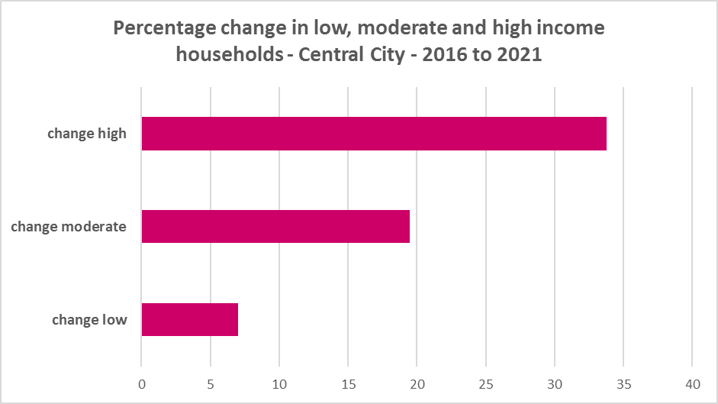

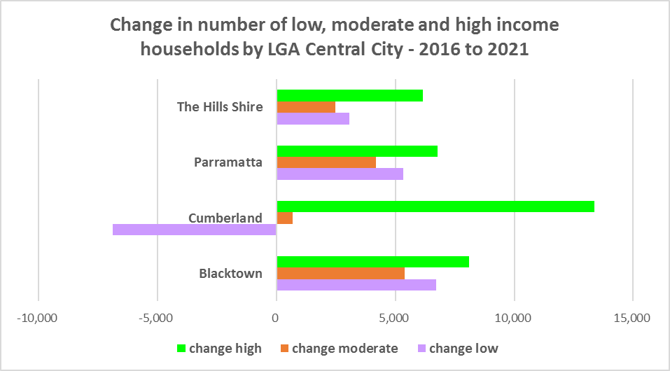

* Over the same period, the number of very low income **renters** and low income **renters** increased in Central City as a whole by 12.6% and 22.1% respectively.
* Notably, although Cumberland experienced a decline in low income households, it experienced strong increases in very low and low income renters between 2016 and 2021, along with all the other LGAs in the District.
* The increase in very low income **renters** ranged from 37.3% in The Hills to 9.3% in Cumberland and for low income **renters** from 63.4% in The Hills to 19.1 in Cumberland.
* The increase in very low (4,083) and low income **renters** (5,866) across Central City underlines the need to consider tenure as well as price point when considering responses to meet housing need.
* The graph below shows the change in the number of very low and low income **renters** between 2016 and 2021 in Central City LGAs.

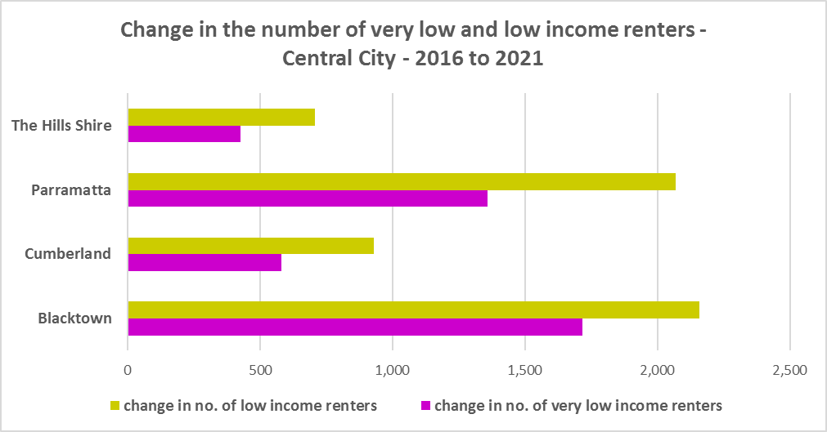

* Blacktown and The Hills have a higher median household weekly income at 2021 than the average for Greater Sydney ($2,077), while Cumberland and Parramatta have a lower median income. The Hills ($2,831) has the highest median weekly income in the District while Cumberland has the lowest ($1,678).



## Homelessness

* People experiencing homelessness and those at risk of homelessness are among Australia’s most socially and economically disadvantaged. State, Commonwealth and some local governments fund services to support people who are homeless, or at risk of homelessness. Services are delivered mainly by non–government organisations, some of which specialise in delivering services to specific groups (such as young people or people experiencing domestic violence).
* Inadequate income and inability to access affordable housing are significant contributing factors to homelessness, along with individual factors such as experience of family and domestic violence, ill health and disability.
* The ABS identifies someone as homeless “where they do not have suitable accommodation alternatives and their current living arrangement:
  + Is in a dwelling that is inadequate;
  + Has no tenure or their initial tenure is short and not extendable; or
  + Does not allow them to have control of and access to space for social relations.”
* The ABS uses “six operational groups for presenting estimates of people experiencing homelessness on Census night:
  + People living in improvised dwellings, tents or sleeping out
  + People living in supported accommodation for the homeless
  + People staying temporarily with other households
  + People living in boarding houses
  + People in other temporary lodgings
  + People living in ‘severely’ overcrowded dwellings.”
* The ABS “also compiles estimates from Census data for the following three groups of people who may be marginally housed but are not classified as homeless:
  + People living in other crowded dwellings
  + People in other improvised dwellings
  + People marginally housed in caravan parks.”
* The table below shows that ABS 2021 Census data for Central City on the homeless and marginally housed.
* Note that due to additional assistance provided during the pandemic, the number of people counted as homeless on Census night in 2021 is lower than at the 2016 Census. Nevertheless, there were 4,843 people counted as homeless in Central City at the 2021 Census and a further 6,659 who were counted as marginally housed.
* Of those who were counted as homeless, the largest number were people living in severely overcrowded dwellings (3,393 or 70.1%), followed by people in supported accommodation for the homeless (517 or 10.7%), then people living in boarding houses (487 or 10.1%). Of those who were counted as marginally housed, the overwhelming majority were people living in other crowded dwellings (6,545 or 99.8%).
* This clearly indicates the need for more affordable rental housing.



* The 2023 NSW street count, the NSW Government’s fourth annual rough sleeping street count, was completed between 2 February and 27 February 2023.
* Over 300 local organisations either consulted in the planning phase or participated in the delivery of street counts. Organisation which partnered with the Department of Communities and Justice (DCJ) included Community Housing Providers, local councils and Specialist Homelessness Services, as well Aboriginal organisations, Local Health Districts, local community groups, and Police.
* 1,623 people were counted sleeping rough during these street counts, a 34% increase from 2022.
* Street counts took place in more than 350 towns in 76 LGAs, compared to 71 LGAs in 2021 and 65 LGAs in 2020.
* The table below gives the street count results for the Central City district locations.



## People with Disability

* According to the Australian Institute of Health and Welfare (AIHW) and data from the 2018 Australian Bureau of Statistics (ABS) Survey of Disability, 18% of people in Australia have disability. Another 22% have a long term health condition but not disability.
* Nearly one third (32%) of people with disability have severe or profound disability. This means needing help with daily self-care, mobility or communication activities, having difficulty understanding or being understood by family or friends, or communicating more easily using sign language or other non-spoken forms of communication.
* The survey data shows:
  + 7.6% of children aged 0–14 have disability
  + 9.3% of people aged 15–24 have disability
  + 13% of people aged 15–64 have disability
  + 50% of people aged 65 and over have disability (ABS 2019b).
* For about 3 in 4 (77%) people with disability, the main type of disability is physical, while for the remaining 1 in 4 (23%), the main type of disability is mental or behavioural.
* Clearly housing is a significant factor in the health and wellbeing of people with disability. The availability of affordable, sustainable and appropriate housing helps people with disability to participate in the social, economic and community aspects of everyday life. Someone without access to affordable, secure and appropriate housing is more likely to experience homelessness, poor health, and lower rates of employment and education.
* While most people with disability live at home in the community (96% in private dwellings), some live in cared accommodation.
* Cared accommodation is usually long term and may be institutional in style, including hospitals, residential aged care, cared components of retirement villages, aged care hostels, psychiatric institutions and group homes for people with disability. The more severe a person’s disability is, the more likely they are to live in cared accommodation and the less likely they are to live in the community.
* There has been a significant shift towards supporting people with disability to live in private dwellings, rather than being in institutional care over recent decades. Largely this has been driven by changes for young people with disability.

## Additional Data

More detailed housing data and tables used in this Snapshot are available from the Local Government Housing Kit Database on the FACS website at:

<https://www.facs.nsw.gov.au/resources/nsw-local-government-housing-kit/chapters/local-government-housing-kit-database>

More information on the housing needs of older Australians and people with disability:

The Australian Institute of Health and Welfare – Older Australians Housing and Living Arrangements on the AIHW website at:

<https://www.aihw.gov.au/reports/older-people/older-australians/contents/housing-and-living-arrangements>

The Australian Institute of Health and Welfare – People with Disability in Australia

<https://www.aihw.gov.au/reports/disability/people-with-disability-in-australia/contents/people-with-disability/prevalence-of-disability>

and relating to housing needs

<https://www.aihw.gov.au/reports/disability/people-with-disability-in-australia/contents/housing>

The Productivity Commission’s report Housing Decisions of Older Australians is at:

<https://www.pc.gov.au/research/completed/housing-decisions-older-australians>

More detailed information on population, household and dwelling projections is available on the Department of Planning and Environment website at:

<https://www.planning.nsw.gov.au/Research-and-Demography/Population-Projections/Projections>

<https://pp.planningportal.nsw.gov.au/populations>

More data on homelessness, specifically homelessness service data is available on the Homelessness NSW website at:

<https://homelessnessnsw.org.au/resource/specialist-homelessness-service-data/>

And from the AIHW website here:

<https://www.aihw.gov.au/reports/australias-welfare/homelessness-and-homelessness-services>

The 2023 Street Count result is at the DCJ/ FACS website here:

<https://www.facs.nsw.gov.au/reforms/homelessness/premiers-priority-to-reduce-street-homelessness/street-count>

Further information on ABS estimation of homelessness is available at the ABS website:

<https://www.abs.gov.au/statistics/people/housing/estimating-homelessness-census/2021>