**Far West – What’s Happening in the Housing Market?**

This Housing Snapshot looks at aspects of the housing market in the Far West, particularly from the 2016 Census to the 2021 Census – including rents, vacancy rate, affordable private rental for very low and low income households, rental stress for low income households, number of new bonds lodged affordable to low income households, sales price, purchase affordability for very low and low income households and purchase stress for low income households.

The Far West Region covers eight local government areas as well as Unincorporated NSW, with Broken Hill the strategic centre. The region covers a vast and diverse area, which has historically been more affordable for rent and for purchase than is the case generally in non-metropolitan NSW. Nevertheless, there are still affordability issues here, with high levels of poverty and disadvantage.

**Far West Region – What’s Happening in the Housing Market?**

# ***Housing Market - Rental***

**Rents**

* Looking at all residential rentals combined together, there has been some variability but generally the Far West LGAs have seen strong increases in median rents, since around 2010. However, the period from 2019 to 2022 has been more varied and complex.
* The graph below shows the increase in median rents for all dwellings (including all bedroom categories) in each Far West LGA and area from June 1990 to June 2022, wherever there is sufficient data to calculate median rents.

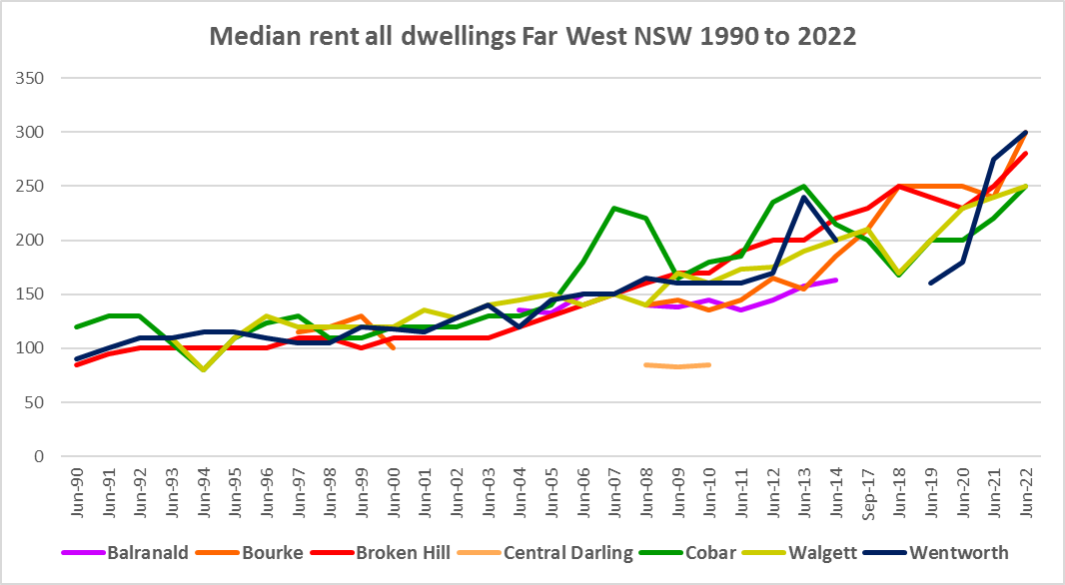

* The table below shows the change in median rents for all dwellings(and all bedroom numbers) between 2013 and 2022 in the Far West LGAs.



* Unfortunately there were insufficient new bonds lodged to calculate a median rent at 2022 for Balranald and Central Darling. Although Cobar experienced changes in the median rent in the intervening period, at June 2022 the median rent was exactly the same as at June 2013 – no change registered. However, at the other end of the spectrum, Bourke experienced a 93.5% increase in median rent over the same period.
* Between 2019 and 2020 when Covid lockdowns were introduced, there were generally lower increases, and in most cases decreases in median rents. Broken Hill (-4.5% for two bedroom homes), Wentworth and Cobar (-16.7% and -10.0% respectively for three bedroom homes) along with Cobar (-18.0% for four bedroom homes) experienced declines in median rentals over this period.
* Nevertheless, over the same period Wentworth experienced strong median rental increases particularly for four bedroom properties (18.2%), along with Cobar for two bedroom properties (11.1) and a more moderate increase of 4.0% in Broken Hill for three bedroom rental properties.
* The table below gives the weekly median rents in dollar terms and the changes between 2019 and 2020 for the Far West LGAs with sufficient data to calculate median rents.



* Between June 2020 and June 2022 a different pattern emerges, with all LGAs in Far West (for which there is sufficient data to calculate the changes in median rents) experiencing strong increases in median rents as the table below shows.
* Between 2020 and 2022 median rents for two bedroom homes increased by 28.6% in Broken Hill and 25.0% in Cobar; and for three bedroom dwellings by 33.3% in Cobar, 28.0% in Wentworth and 15.4% in Broken Hill.



* At June 2022, median rents for two and four bedroom homes were highest in Broken Hill ($300 and $415 respectively) while for three bedroom homes the median rent was highest in Wentworth ($320).

**Vacancy Rate**

* A vacancy rate of 3% is understood to represent a balance between supply and demand in the rental market. REINSW data doesn’t give the vacancy rate in the Far West of NSW at April 2023 – the most recent vacancy rate for the Far West was for January 2023 at 3.2%. Generally NSW is experiencing a very tight rental market – although the REINSW reported a vacancy rate of 3.6% on the South Coast of NSW at April 2023 – the only anomaly.
* In neighbouring Orana at April 2023 the vacancy rate was 1.4%, in Riverina it was 0.9% and in New England it was 2.1%, indicating an undersupply of private rental in those regions.

**Affordable Rental**

* The general trend across Sydney and NSW has been for a decline in the proportion of rental stock which is affordable for very low and low income earners.
* Affordability of private rental has been variable in Far West NSW, although along with elsewhere in NSW, there were more complex factors at play between 2019 and 2022.
* Across the Rest of NSW, the proportion of affordable rental for very low income households stayed at the 2018 level of 22.0% for 2019, improved slightly to 21.7% in 2020 and again to 21.9% in 2021 then declined in line with the longer term trend to 17.0% in 2022.
* In the Far West, this was also the general pattern, at least from 2019 on. Affordability improved in the Far West LGAs (where sufficient data was available) between 2019 and 2021, then declined between 2021 and 2022.
* At June 2022, none of the Far West LGAs, had a lower proportion of affordable rental for very low income households than the Rest of NSW average of 17.0%. Broken Hill had 66.1% (down from 81.4% in 2021) and Cobar had 88.2% (down from 91.8% in 2021).
* The table and graph below show the change in the proportion of private rental accommodation affordable to **very low income** households in the Far West between 2001 and 2022. Note there are not always sufficient new bonds lodged in a local government area to reliably calculate the proportion – so no data will be recorded where this is the case.

Proportion private rental affordable for very low income households



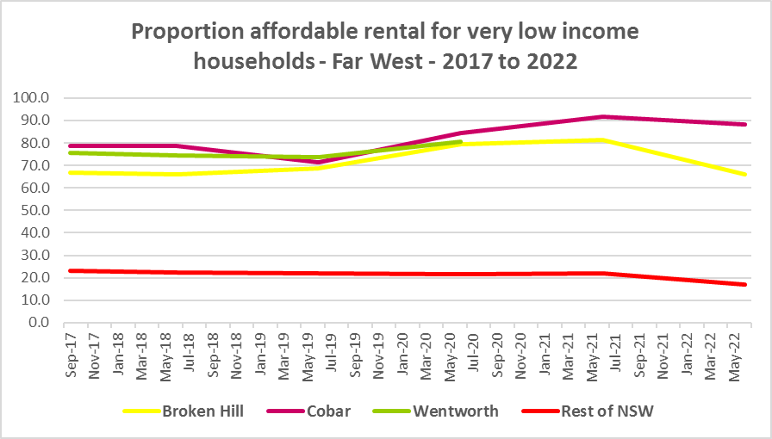

* The proportion of rental affordable for **low income** households followed a similar pattern.
* Between 2018 and 2020 the proportion of rental affordable for low income households increased gently from 54.1% to 55.2% and then declined again to 45.4% in June 2022 in the Rest of NSW.
* In Far West NSW, a full set of data is only available for Broken Hill and Cobar. Both these LGAs experienced an improvement in affordability for low income households between 2018 and 2020, both essentially saw no change in affordability between 2020 and 2021 and then a decline in affordability between 2021 and 2022.
* At 2022 Broken Hill had 88.5% of new bonds lodged affordable to low income households while Cobar had 98.0% - both well above the Rest of NSW average.
* The table and graph below show the change in the proportion of private rental accommodation affordable to **low income** households in the Far West and Rest of NSW between 2001 and 2022 – again where data is available.

Proportion private rental affordable for low income households



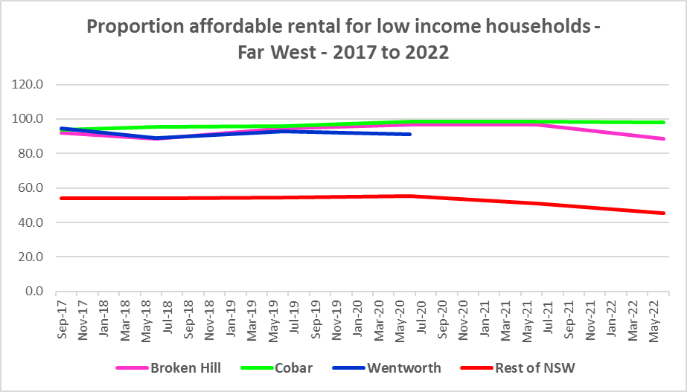

* The University of Sydney Urban Housing Lab undertook a study and prepared a report for the Australian Coastal Councils on short term holiday rentals: “Planning responses to online short term holiday rental platforms” - Research Project for Australian Coastal Councils Association Inc. September 2018 by Nicole Gurran, Yuting Zhang, Pranita Shrestha, Catherine Gilbert.
* The study found (p7) “that there has been a rapid growth in online holiday rental listings overall and in coastal Australia in particular. Since Airbnb was launched in Australia, the number of listings has risen to over 130,000 properties, amounting to 3.5% of rental accommodation. In coastal communities, the rate is much higher.
* More recently, research by SQM showed that between July 2019 and July 2020 Broken Hill had a 65% increase in Airbnb listings, Walgett had a 55% increase, while Wentworth had a -5% decline.
* Since 2020 it is likely that Airbnb listings have picked up again in the Far West region as there is more freedom to travel post lockdowns.
* There is potential for short term tourist rentals to disrupt the housing market and make it difficult for tenants to find long term rental accommodation in Far West NSW, although this is highly unlikely to be to the extent that it has in coastal areas of NSW.

**Rental Stress**

* Households regarded as being in rental stress are renting in the private rental market and paying more than 30% of their income in rent. Lower income households in rental stress will struggle to pay for other essential household costs, such as medical or educational expenses, food, transport and energy costs.
* At 2021 the proportion of very low income households in rental stress in the Rest of NSW (that is, excluding Sydney) was 91.7%. Within the Far West the average was 77.2%, with the proportion varying from 100.0% in Bourke to 0.0% in Brewarrina and Central Darling.
* Bourke was the only Far West LGA with a higher proportion of very low income households in rental stress than the average for the Rest of NSW. Cobar was the next highest with 84.4%
* For the Rest of NSW at 2021 the proportion of low income households in rental was 68.3%, with Far West on average much lower with 38.7%. Across the region the proportion of low income households in stress ranged from 48.2% in Bourke to 0.0% in Brewarrina and Central Darling. None of the LGAs in Far West had a higher proportion of low income households in rental stress than the Rest of NSW.
* The proportion of very low and low income households in rental stress increased in the majority of LGAs in the Far West (Brewarrina, Central Darling and Unincorporated NSW were exceptions, while Wentworth had an increase in the proportion of low income renters in stress but a decline in the proportion of very low income renters in stress
* Over the same period the actual numbers in stress have declined in most LGAs in the region (the exceptions being increases in the number of low income households in rental stress in Broken Hill, Wentworth, Balranald and Bourke). The decline in the numbers in stress is not dissimilar to the trend in the Rest of NSW, where there was a decline in very low income rental households in stress and an increase in low income rental households in stress.
* Below is a graph of the proportion of very low and low income households in rental stress in the Far West LGAs and Rest of NSW at 2021.

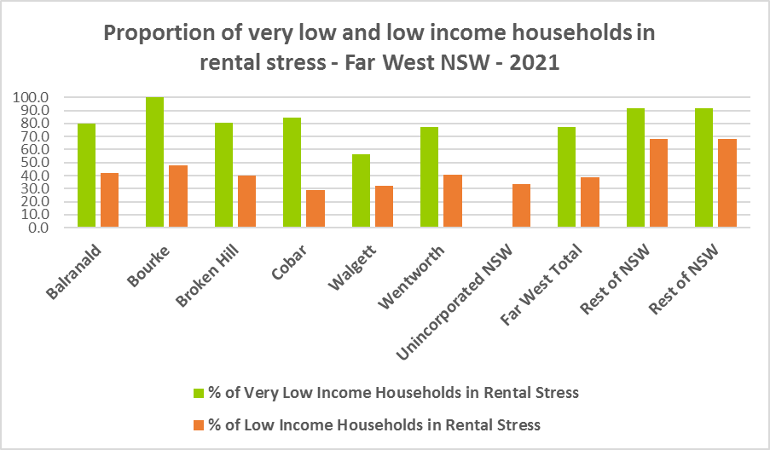

* Below is a table comparing the proportion of very low and low income households in rental stress in Far West NSW in 2016 and 2021.



* The next table shows the change in the number of very low and low income households in rental stress at 2016 and at 2021.
* Again Covid has had an impact on the rental market and on tenants, with overall the number of very low income households in rental stress declining while the number of low income households in rental stress increased between 2016 and 2021 in the Far West.



* A look at CRA (Commonwealth Rent Assistance) recipients in housing stress gives some further information on what has been happening with lower income households in rental stress over this time frame.
* In line with other parts of NSW, between 2016 and 2020, the total number of CRA recipients in the Far West increased, while the number in stress actually declined. However, between 2020 and 2021 the number of CRA recipients declined while the number in stress increased.
* The number of CRA recipients in housing stress has increased from the June 2020 figures as the temporary Coronavirus Supplement ended on 31 March 2021.
* The Coronavirus Supplement was $550 per fortnight for new and existing recipients of JobSeeker Payment, Parenting Payment, Youth Allowance for jobseekers, Farm Household Allowance and Special Benefit. The temporary supplement almost doubled the maximum payment rate for a JobSeeker Payment recipient. Hence it made rent more affordable for some CRA recipients in June 2020 and resulted in a lower proportion of CRA recipients in rental stress than usual.
* Since the end of Covid restrictions, the number of people in employment has increased, so fewer people are relying on rent assistance from the Commonwealth.
* The two graphs below clearly demonstrate this experience in Far West NSW.

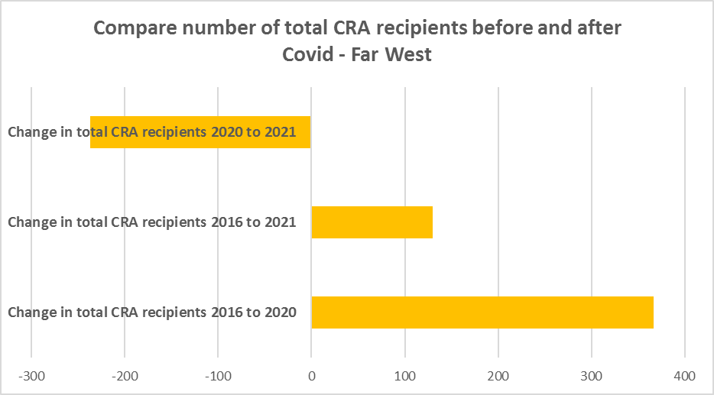

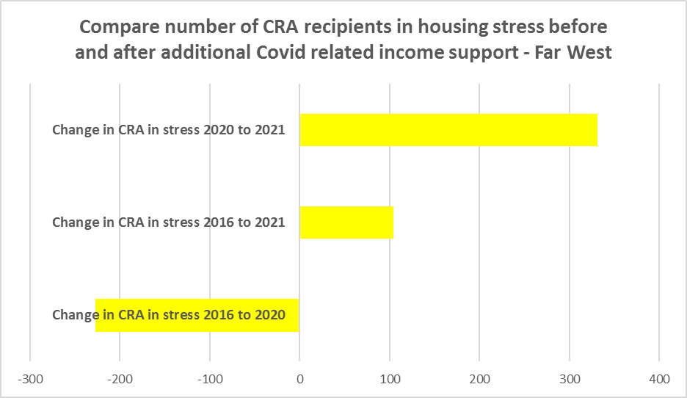

* The table below shows the number and proportion of tenants in the Far West NSW region who are in the private rental market, are in receipt of Commonwealth Rent Assistance, and even with this additional income support, are in housing stress.
* There were 642 tenants in receipt of CRA and in housing stress across the region in 2021, up from 538 in 2016. In 2016, 16.7% of CRA recipients in Far NSW were in stress, increasing to 19.2% in 2021.
* Far West NSW as a whole (19.2%) has a lower proportion of CRA recipients in housing stress than the Rest of NSW average (39.2%). Broken Hill clearly has the largest number of CRA recipients in housing stress (313) in the Far West, comprising close to half of those in stress across the region.



**Loss of Affordable Housing Stock**

* DCJ has calculated the number of new bonds lodged with the Rental Bond Board that were affordable to low income earners in Far West NSW in 2017, 2021 and 2022. The region experienced a significant decline in affordable bonds lodged, and consequently loss of affordable housing between 2017 and 2022 – with 40.1% fewer affordable bonds lodged and only 166 new rental bonds lodged which were affordable to low income households in 2022.
* The table below shows the number of new bonds lodged that were affordable to low income households (including very low income households) 2017, 2021 and 2022 in the Far West Region.

Number of affordable rental properties (new bonds lodged) affordable to low income households



# ***Housing Market - Purchase***

**Sales Price**

* Broken Hill is the only LGA in Far West NSW with sufficient data on sales to determine the change in the median sales price over a longer time frame.
* Between 2012 and 2022 the median sales price for all dwellings in Broken Hill increased by 39.3%.
* The table below shows changes in the median sales price of all dwellings (including both houses and flats) since 2014, where data is available in the Far West region.
* Like other parts of NSW, Broken Hill experienced a drop in median sales price between 2018 and 2020 and a strong increase in the median sales price, between 2021 and 2022, when lockdown/Covid restrictions were eased.
* At March 2022, the median sales price for all dwellings in Broken Hill was $188,000.

Median Sales Price – all dwellings



* The table below shows the change in median sales price for Broken Hill over the last ten years.

Change in Median Sales Price – Broken Hill



* The graph below shows the median sales price for all dwellings from 1991 to 2022 in the Far West of NSW.

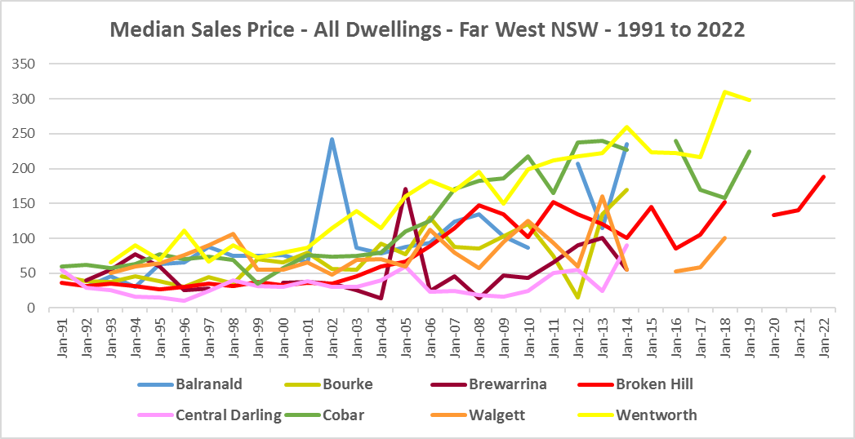

**Purchase Affordability**

* Purchase affordability for very low income earners has not varied much over the period from 2017 to 2021 in either the Far West of NSW or the Rest of NSW.
* In 2021, 80.3% of sales at 2021 were affordable for purchase in Broken Hill compared to just 7.5% on average in the Rest of NSW. Clearly purchase affordability for lower income households is more feasible in Far Western NSW.
* The graph and table below show purchase affordability for very low income households in Broken Hill and the Rest of NSW between 2001 and 2021.

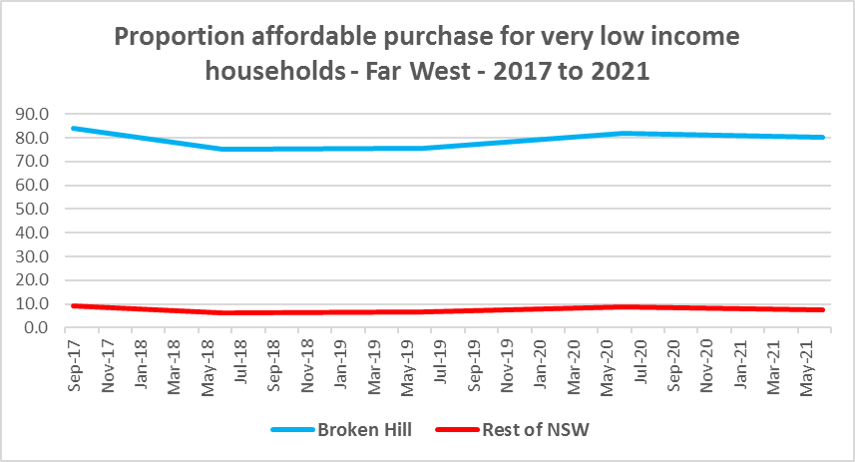



* In the Rest of NSW, the proportion of affordable purchase for low income households was 23.8% in 2021 down from 28.0% just 12 months previously in 2020.
* Purchase affordability for low income households in Broken Hill is significantly better than the average for the Rest of NSW.
* At June 2021, 100.0% of sales in Broken Hill were affordable for low income households, well up from 86.9% just 12 months prior in 2020.
* The graph and table below show the change in purchase affordability for low income households in the Broken Hill compared to the Rest of NSW, between 2017 and 2021.

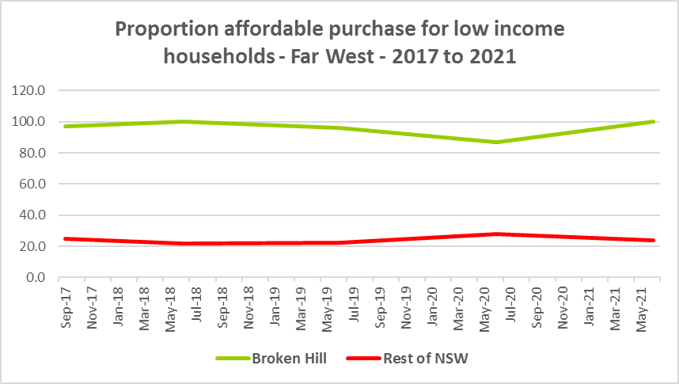



**Purchase Stress**

* In 2021 there were 139 very low income households and 89 low income households purchasing a home and in stress across the region – that is, paying more than 30% of their income on their mortgage. This represents 26.6% of very low and low income purchasers in Far West NSW – well below the proportion for the average for the Rest of NSW at 43.9%.
* Balranald had the highest proportion with 38.9%, followed by Walgett with 33.7%, Wentworth with 28.5% and Cobar with 25.8%.
* Broken Hill had the highest number in stress with 106 very low and low income purchasers paying more than 30% of their income in housing costs.
* The table below shows the number and proportion of very low and low income households in purchase stress for the Far West LGAs, the region and the Rest of NSW at 2021.



* However the number of very low and low income purchasers in stress in Far West NSW is significantly lower than the number of very low and low income renters in stress in the region, as the graph below demonstrates.

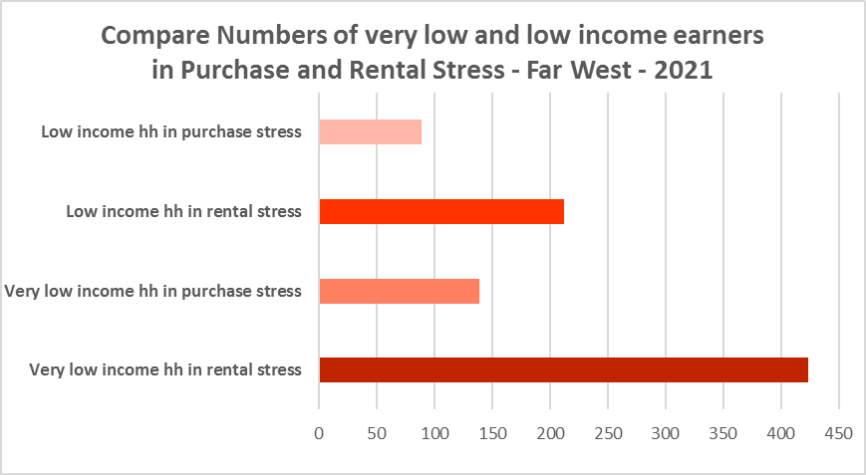

**Additional Data**

Additional data on rents and sale prices, including both current and historical data, is available from the Rent and Sales Report and the interactive Dashboard on the Housing NSW website at:

<https://www.facs.nsw.gov.au/resources/statistics/rent-and-sales/dashboard>

More detailed housing data and tables used in this Snapshot are available from the Local Government Housing Kit Database on the Housing NSW website at:

<https://www.facs.nsw.gov.au/resources/nsw-local-government-housing-kit/chapters/local-government-housing-kit-database>

More information on vacancy rates is available from the Real Estate Institute of NSW website:

<https://www.reinsw.com.au/Web/Web/Members/Property_data/Vacancy_Rates_Survey.aspx>

The Rental Affordability Index is at

<https://sgsep.com.au/projects/rental-affordability-index>