**South and East Tablelands Region – What’s Happening with Housing Supply and does it match Demand?**

This Housing Snapshot looks at aspects of housing supply in the South and East Tablelands, particularly from the 2016 Census to the 2021 Census – including dwelling type, bedroom mix, tenure, as well as social housing supply and waiting times for public housing. It also looks at aspects of the gap between housing demand and supply, including what’s happening with low income rental households and affordable rental supply, comparing household type with bedroom mix and who needs affordable housing.

Across much of NSW housing supply has not kept pace with demand, with significant outmigration from cities to regional areas during Covid, record levels of migration post Covid, with rapid increases in construction costs and skilled labour shortages contributing to longer term tight rental vacancy rates, insufficient affordable housing and a lack of housing diversity to meet local need.

The majority of households in the South and Easts Tablelands are couple or single person households, yet the housing stock is primarily comprised of three or four bedroom detached homes. Much of this housing was built at a time when families were the predominant household type, yet this is no longer the case in this Region. The housing stock needs to adapt to better match households requirements. Proactive measures are necessary to diversify bedroom mix and increase the supply of studio and one bedroom dwellings in particular to provide housing choice to smaller households.

Infrastructure Australia delivered a report “2022 Regional Strengths and Infrastructure Gaps” which cites housing – the availability, affordability and diversity of housing – as a key infrastructure gap in both the Southern Inland and South Coast of NSW.

**Dwelling Type**

* At the 2021 Census there were 131,813 dwellings in the South and East Tablelands region, up from 122,626 in 2016.
* Of these, 84.4% were occupied (up from 81.6% in 2016), well under the 89.0% average percentage occupied in the Rest of NSW.
* This means that 15.7% were unoccupied (down from 18.4% in 2016) compared to 11.0% in the Rest of NSW.
* The reasons homes are unoccupied vary and include (according to a report by the Australian Housing and Urban Research Institute “Are there 1 million empty homes and 13 million unused bedrooms?”):
  + homes are being renovated
  + homes being sold as vacant possession
  + newly built or bought homes where no one has moved in yet
  + rental homes awaiting new tenants
  + people living away temporarily from home during the census count (travelling or visiting other homes)
  + homes are deemed unliveable
  + subject to a probate application or other legal proceedings
  + holiday homes
  + homes owned by people currently living overseas
  + homes being land banked, that is held vacant until the local area economics (or personal circumstances) make it more profitable to sell or redevelop the property.

And particularly in rural and regional areas:

* dwellings on rural properties where owners have moved into local towns (particularly as owners age);
  + regional and rural areas which have experienced population decline;
  + and areas where people have a beach or rural retreat house that will only be occupied for short periods of the year.
* The graph below shows the proportion of occupied and unoccupied dwellings in the South and East Tablelands LGAs at the 2021 Census.

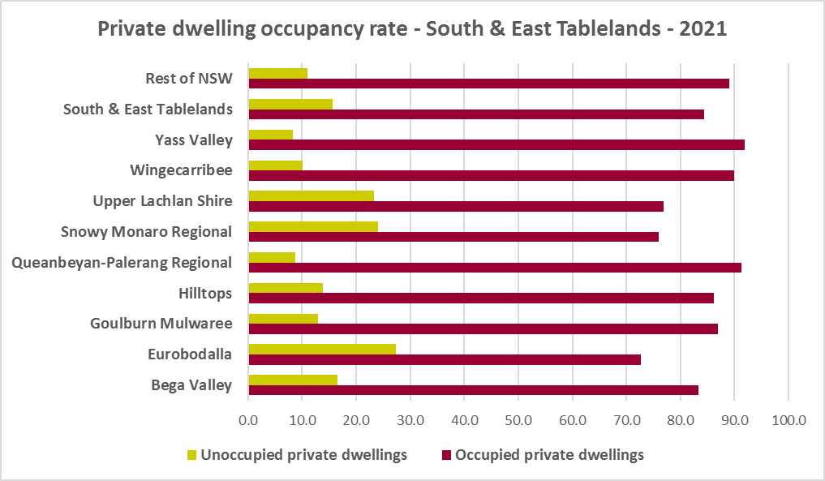

* Note that within the South and East Tablelands, Yass Valley has the highest proportion of occupied dwellings with 91.8% and Eurobodalla the lowest with 72.7%.
* At the 2021 Census, the clear majority of occupied dwellings in the South and East Tablelands were separate houses, comprising 85.0% of all occupied dwellings, compared to 82.5% in the Rest of NSW. The proportion of separate houses within the region ranges from 96.6% in Upper Lachlan to 73.9% in Queanbeyan-Palerang.
* A further 8.4% of occupied homes in the South and East Tablelands were semi-detached, terrace or town houses, (compared to 6.3% in the Rest of NSW) and ranging from 14.1% in Queanbeyan-Palerang to 1.8% in Upper Lachlan Shire.
* 5.3% of occupied homes in the region were flats (compared to 9.9% in the Rest of NSW), ranging from 11.5% in Queanbeyan-Palerang to 0.4% in Upper Lachlan Shire.
* Although Queanbeyan-Palerang has greater diversity than the average for the Rest of NSW, generally the region lacks diversity in dwelling types.
* The graph and table below show the proportion of dwelling types for the South and East Tablelands LGAs at the 2021 Census.

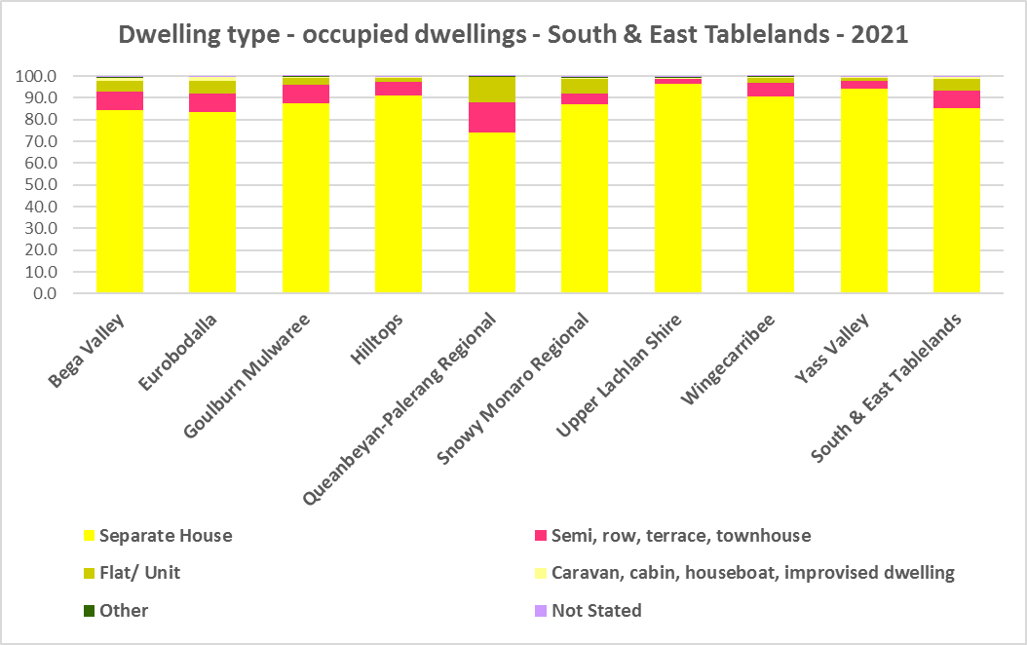



* The next graph compares the proportion of different occupied dwelling types for the South and East Tablelands with that for the Rest of NSW.

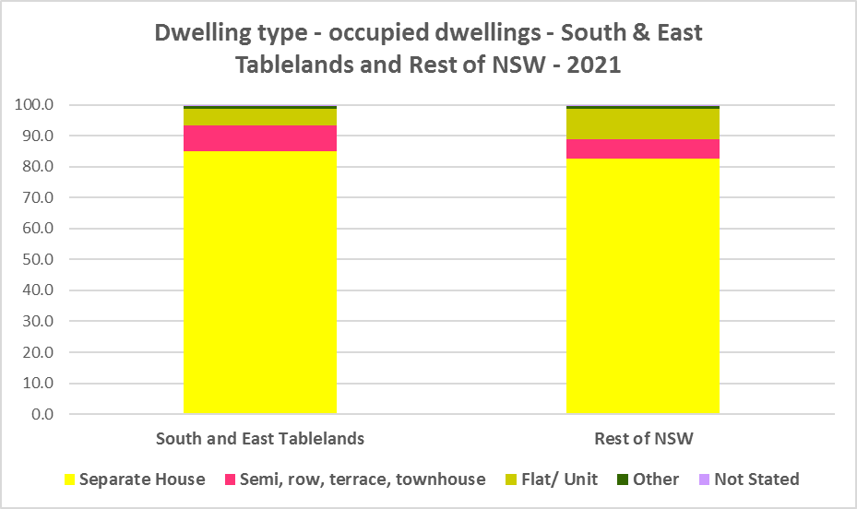

* Other types of dwellings comprised just 0.7% of occupied dwellings in the region and include caravans, cabins, houseboats, improvised dwellings and flats attached to shops or offices. Census data shows 285 households living in caravans, 477 living in cabins or houseboats, 28 living in improvised dwellings and 219 in flats attached to shops or offices in the region.
* Note that at the 2021 Census there were a total of 762 households living in caravan, cabin/houseboat accommodation, down from 799 in 2016. Eurobodalla had the highest number of households living in caravan, cabin/houseboat accommodation in 2021 with 299 (up from 284 in 2016), followed by Bega Valley with 219 (up from 184 in 2016) and Wingecarribee with 95 (up from 89 in 2016). The losses in this category between 2016 and 2021 occurred in Goulburn-Mulwaree, Queanbeyan-Palerang, Snowy Monaro Regional, Upper Lachlan and Yass Valley, resulting in an overall decline in such accommodation in the region.
* While people living in caravans are included in the homeless data in the Census, caravan or residential parks are one of the few remaining affordable housing options for lower income earners. The loss of this accommodation reduces options for lower income households and reduces flexibility to deal with seasonal workers.
* The region also has 28 improvised dwellings. According to the ABS;
  + “Persons in other improvised dwellings are those people who were enumerated on Census night in the dwelling category of an improvised dwelling, tent or sleepers out who reported either being 'at home' on Census night or having no usual address, and are not considered, on balance, to be homeless. Under the ABS definition they are not classified as homeless because they have accommodation alternatives, and in many living situations, the dwelling will be adequate. They are however included in marginal housing and may be at risk of homelessness.”

**Bedroom Mix**

* The overwhelming majority of housing in the region would have been built at a time when couple families with children were the dominant household type. Now smaller households (couples and single person households) predominate and are likely to increase across the region, particularly as the population ages.
* Consequently the South and East Tablelands (and the Rest of NSW generally) also has little variation in the number of bedrooms per dwelling. Across the region 38.4% of dwellings have three bedrooms and a further 39.1% have four or more bedrooms, totalling 77.5% with three or more bedrooms. Only 0.5% of homes are studios, 4.2% have one bedroom and 16.2% have two bedrooms.
* This compares to 0.5% of studio homes, 4.0% one bedroom 17.3% two bedroom, 40.9% three bedroom and 35.7% four or more bedrooms in the Rest of NSW.
* Although Quenbeyan-Palerang had a little more diversity in dwelling type, this is not really evident in the mix of bedrooms in the LGA – with 74.1% having three or more bedrooms. Bega Valley has more variation in bedroom numbers with 72.2% of homes with three or more bedrooms. Yass Valley (85.9%) and Wingecarribee (83.9%) have the highest proportions of three or more bedroom homes in the region and therefore the least housing choice for residents.
* Within the region,
  + Bega Valley the highest proportion of studio dwellings with 1.0% and Wingecarribee the lowest with 0.3%;
  + Queanbeyan-Palerang Regional has the highest proportion of one bedroom homes with 6.0% and Yass Valley the lowest with 2.1%;
  + Bega Valley has the highest proportion of two bedroom homes with 20.2% and Yass Valley the lowest with 10.3%;
  + Bega Valley has the highest proportion of three bedroom homes with 43.1% and Queanbeyan-Palerang the lowest with 31.2%; and
  + Wingecarribee has the highest proportion of four or more bedroom homes with 47.9% and Bega Valley the lowest with 29.1%.
* The graph and table below show the proportion of studio, one, two, three and four or more bedroom occupied dwellings in the South and East Tablelands at the 2021 Census.

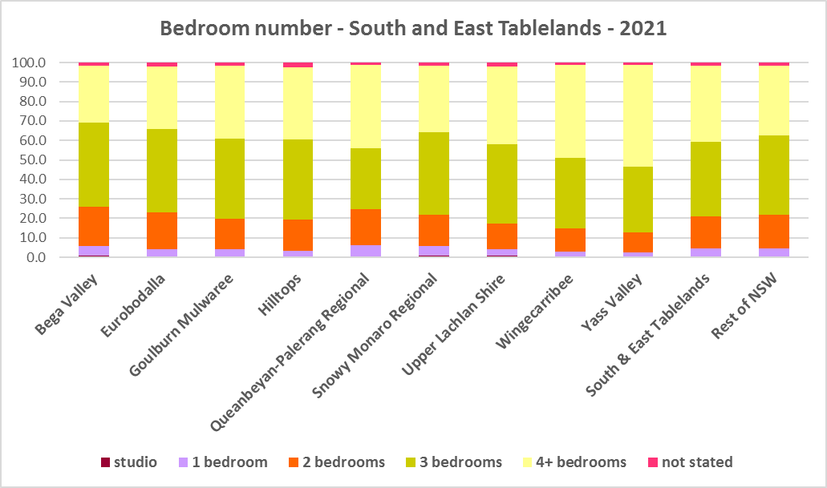



* Given that lone person and couple only households comprised 50.9% of all households in the South and East Tablelands, the fact that studio and one bedroom homes combined comprise just 4.7% of the housing stock shows a mismatch between household type and dwelling size and a significant lack of housing choice for smaller households.
* The forecast increase in older age groups in the region is likely to increase the demand for smaller, more manageable and affordable homes. It is important for older residents to be able to downsize from larger family dwellings to smaller dwellings that are easier to manage and in which they may retain their independence.
* There needs to be a closer match between household size and bedroom number to offer some housing choice for residents, with additional studio, one and two bedroom homes. Two bedroom dwellings in particular offer the most flexibility, given they are also suitable for small families and allow older residents to have family members or carers to stay while giving them a more manageable size home to maintain.
* It is worth noting that new dwelling construction comprises around 1% of total dwellings (depending on the location and stage in the residential development cycle) with the remaining 99% of homes being existing established dwellings. Additions to existing stock can have a significant impact on the bedroom mix and long term suitability of housing stock to meet housing need, including household size and affordability.

**Tenure**

* At the 2021 Census, the most common tenure type in the South and East Tablelands was households owning their home outright – comprising 41.4% of all households – a higher proportion than other regions in NSW. Within the region this ranged from 51.2% in Upper Lachlan to 28.3% in Queanbeyan Palerang.
* The next largest tenure type was households with a mortgage – comprising 33.0% of all households. The proportion in this tenure ranged from 43.8% in Queanbeyan Palerang to 23.9% in Eurobodalla, within the region.
* Rental households comprised a total of 23.4% of all households in the South and East Tablelands, ranging between 29.4% in Goulburn Mulwaree and 13.0% in Upper Lachlan.
* Households renting from a real estate agent comprise 13.0% of all households in the South and East Tablelands – with Goulburn Mulwaree having the highest proportion at 18.0% and Upper Lachlan the lowest with just 4.5% of households renting though a real estate agent.
* The remainder of rental households are comprised of households renting from the state housing authority (1.9% in the region), community housing providers (0.9%) and other landlords (7.5%).
* The graph and table below give the tenure composition for the region and individual LGAs at the 2021 Census.

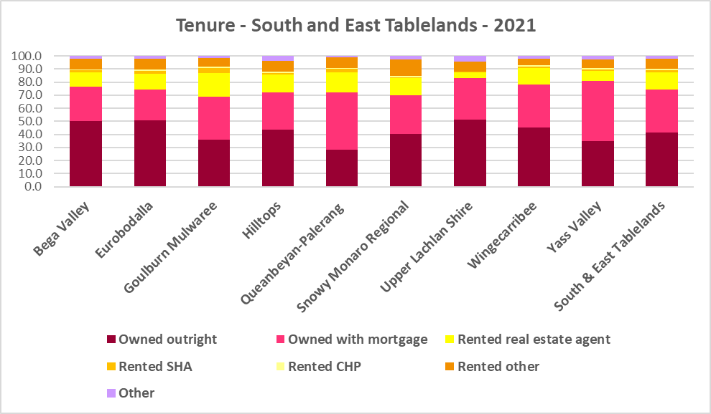



* The general trend is for increasing numbers of households relying on the private rental market as a long term tenure rather than a transitional one between leaving home and buying a home, as housing costs have increased much faster than wages. While the South and East Tablelands is more affordable than much of Sydney, there has been a growing trend to making a sea or tree change to take advantage of more affordable housing and lifestyle/amenity in some coastal and regional areas. In addition, anecdotal evidence indicates that this was particularly pronounced during Covid with the increased flexibility of working remotely/from home.
* Subsequent high interest rates and high inflation levels have made it increasingly difficult for lower income households to manage housing costs.
* Further, the increased popularity and availability of short term rentals have, particularly in coastal parts of NSW, impacted on the availability of long term rental accommodation for renters (see the Housing Snapshot on What’s Happening with Demand).
* This has the potential to bid up housing prices and make it more difficult for locals to afford housing.
* Noting that the rental market in the South and East Tablelands – and NSW generally – is very tight (see the Housing Snapshot on What’s Happening in the Housing Market – while the South Coast vacancy rate had eased at January 2023, it is an anomaly in NSW currently) it is therefore important to encourage tenure diversity and a range of price points to meet local needs, including facilitating affordable housing development.
* Given the lower provision of private rental generally and the impact of short term rentals on at least some of the LGAs in this region (Snowy Monaro Regional, Bega Valley and Eurobodalla particularly), it is important to encourage provision of more long term rental accommodation for lower income households.
* Queanbeyan-Palerang is strongly impacted by the housing market in Canberra and provides relatively more affordable accommodation for the Canberra workforce. Provision of more targeted affordable rental housing would also assist residents of this LGA struggling to compete for private rental accommodation.

**Social Housing**

* Social housing is secure and affordable rental housing for people on low incomes with housing needs. It includes public, community and Aboriginal housing. Public housing is managed by DCJ while community housing is managed by non-government organisations.
* As at June 2022, there are 154,600 social housing dwellings in NSW, with 96,712 managed by public housing, 48,264 managed by community housing and 9,624 managed exclusively for Aboriginal people – of these the Aboriginal Housing Office (AHO) are responsible for 4,120 and Aboriginal Community Housing Providers (ACHP) manage 5,504.
* The table below shows the number of public housing properties in the South and East Tablelands Region LGAs as at June 2022. Please note that Census data on public housing is not particularly accurate, as public housing tenure is under reported in the Census. The figures below do not include community housing properties.



* In addition, community housing providers manage a number of properties – including social housing, affordable housing, transitional housing and crisis accommodation in the South and East Tablelands, as outlined in the table below.
* Note that affordable housing is not the same as social housing. Affordable housing is open to a broader range of household incomes than social housing. Households do not have to be eligible for social housing to apply for affordable housing, though people who are eligible for social housing may also be eligible for affordable housing properties.
* Affordable housing is managed more like a private rental property, but there are eligibility criteria and the managers are mostly not for profit community housing providers.



* The next table gives the number of AHO homes and the number managed by ACHPs in Southern NSW as at June 2022.



* Note that there are 3 types of social housing available for Aboriginal people:
  + Public housing – these properties are managed by the Department of Communities and Justice (DCJ).
  + Aboriginal Housing Office homes – these are properties owned by the Aboriginal Housing Office and managed by DCJ.
  + Community housing properties – these properties are managed by community housing providers and Aboriginal community housing providers.
* The table below shows the expected waiting times for general housing approved social housing applicants (not for priority housing applicants) by bedroom category in the South and East Tablelands Region as at 30 June 2022. It also gives the number of general and priority housing applicants for each allocation zone.



* Information on Expected Waiting Times for Public Housing is available on the FACS website by region at:

<https://www.facs.nsw.gov.au/housing/help/applying-assistance/expected-waiting-times>

## The Gap

* While the South and East Tablelands has been more affordable for both rental and purchase than neighbouring Sydney and Canberra, it has become increasingly more expensive to purchase and to rent housing in this region.
* SGS Economics and Planning in their November 2022 Rental Affordability Index[1] report, point out that regional areas of NSW:
  + have been subject to several natural disasters from widespread bushfires in 2020 to flooding in 2022. These have affected both existing rental stock and new development, limiting supply and increasing rental rates.
  + have seen the combined impact of these factors on renters resulting in homelessness, having to move away from family and support for more affordable housing, moving into poor quality or insecure housing, or having to forgo other essentials.
  + were spared the worst of pandemic response measures. However, the impacts of outward-migrating city residents (driven by COVID-19 restrictions in capital cities and the ability to work remotely), on housing and rental affordability has caused concern. This is clear in the November 2022 data, which shows that affordability has worsened in the regional areas of every state, even more so than in the capital cities.
  + have become far less affordable to the average rental household over the last year, including inland towns.
* In summary demand for housing increased, supply has been insufficient to meet demand and there have been impacts on affordability, particularly rental affordability, and on lower income tenants.
* There has been a decline in the number of private rental properties which are affordable to low income rental households in the South and East Tablelands, as the graph below demonstrates.

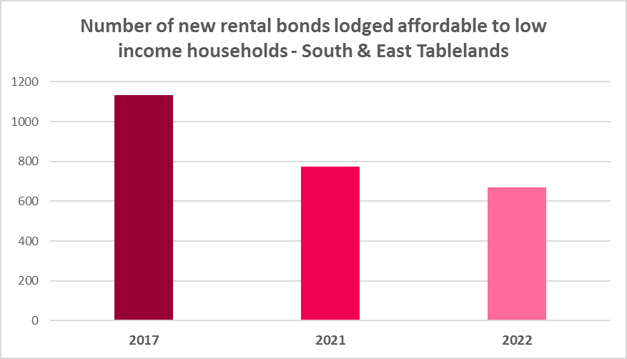

* The graph below shows the decline in the number of new rental bonds lodged which are affordable to low income households in each of the regions LGAs. Every LGA experienced a loss of affordable private rental between 2017 and 2022. Eurobodalla had the largest numerical decline from 2017 (118 fewer affordable bonds lodged in 2022 than in 2017) while Yass Valley had the largest proportional decline (64.1% fewer affordable rental bonds lodged in 2022 than in 2017).

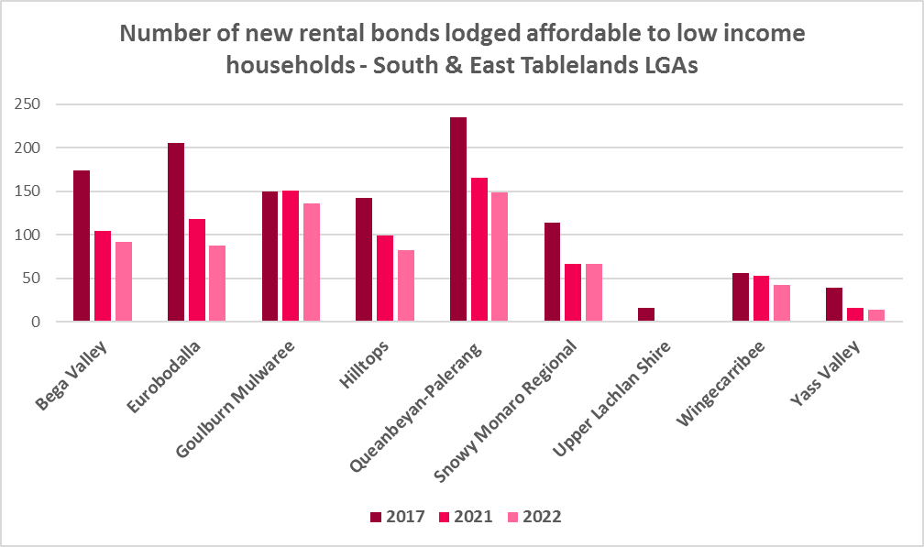

* The next graph compares change in median income with change in median rents and median sales price in the South and East Tablelands LGAs between 2016 and 2021 for income and 2017 to 2022 for rent and sales price.

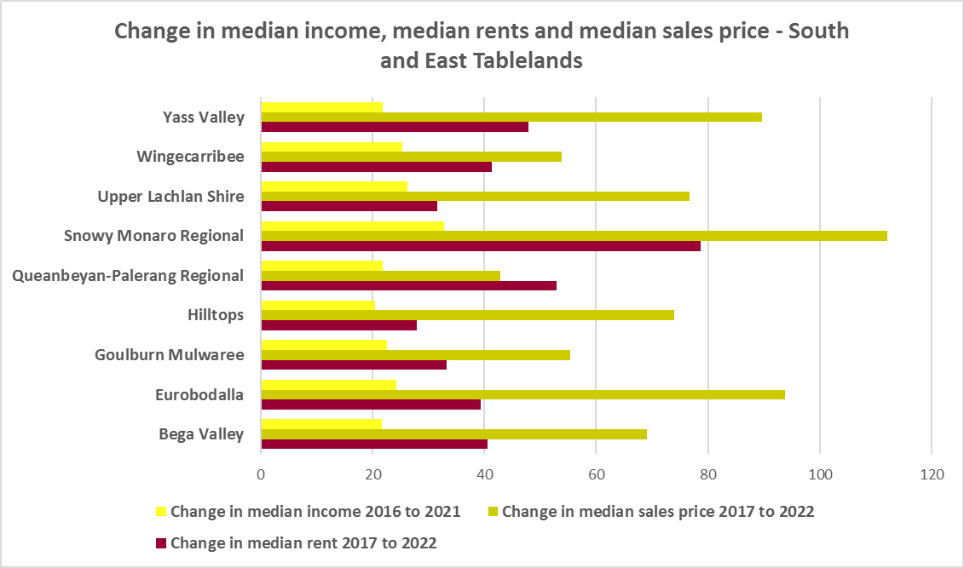

* It demonstrates that housing costs have increased faster than income in every South and East Tablelands LGA over that time period. This has been the case for decades, with housing costs increasing at a much greater rate than incomes. According to Core Logic “While wages increased 81.7% in the past 20 years, Australian home values have grown 193.1%”[2]
* Median rents have increased most strongly in Snowy Monaro Regional, Queanbeyan-Palerang Regional, Yass Valley and Wingecarribee, while sales prices have increased at the greatest rate in Snowy Monaro Regional, Eurobodalla, Yass Valley and Upper Lachlan and median income in Snowy Monaro Regional, Upper Lachlan, Wingecarribee and Eurobodalla. These changes can be at least partly attributed to outward migrating residents of Sydney and Canberra and as noted above could be contributing to housing affordability issues for lower income residents.
* Low income households are the dominant income group across the South and East Tablelands and in every single LGA in the region (excepting Queanbeyan –Palarang Regional), comprising 40.4% of all households in the region (below the Rest of NSW average of 49.3%) and ranging from 19.4% in Queanbeyan-Palerang Regional to 61.8% in Hilltops.
* Furthermore, the number of low income households is increasing across the region – by 2.6% between 2016 and 2021. The graph below shows the change in the number of low income households in each of the South and East Tablelands LGAs between 2016 and 2021. The majority of LGAs in the region had an increase in low income households over this period, while generally those with the strongest increases in median income and median sales price lost low income households.

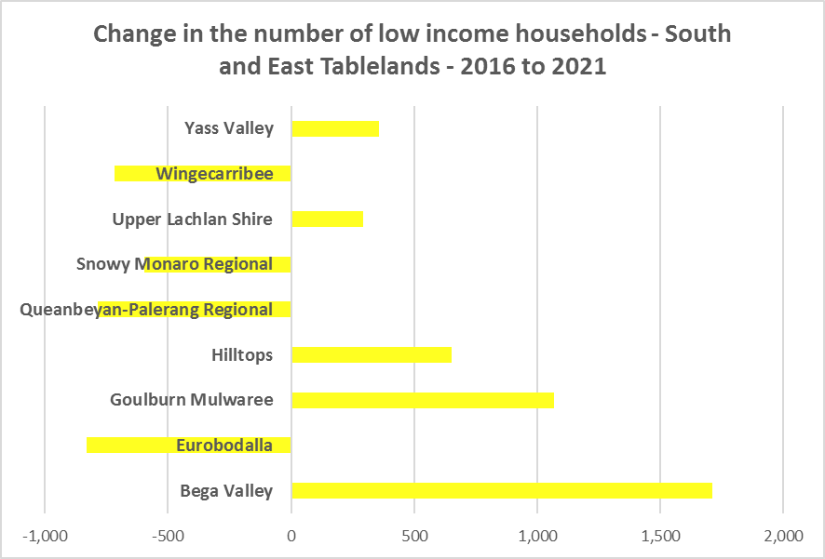

* Due to the changes to income assistance during and subsequent to the COVID-19 pandemic, it is difficult to see what has happened with renters and low income renters in particular between 2016 and 2021. However, it is clear that rents have increased faster than incomes and that the supply of affordable private rental is declining.
* There is a clear need for more affordable rental accommodation to begin to address the demand supply imbalance, particularly for lower income households and the increasing number of seniors and frail aged.
* The vacancy rate in the South and East Tablelands has generally been tight for over a year, indicating a chronic shortage of rental accommodation but has been a little more volatile over the last few months. At April 2023 the vacancy rate was just 2.1% in the South Coast and although it was 3.6% in South Eastern it was 0.4% here in November 2022.
* Considered together, the strong increase in rental levels, decline in rental affordability for lower income earners and decline in affordable rental properties, combined with the increase in low income households (or displacement of low income households), demonstrates the need to increase the supply of affordable rental housing for long term tenants.
* As well as the gap between supply and demand for affordable rental, there is a significant gap between dwelling size (bedroom numbers) and household size, particularly for smaller households. The graph below compares the number of smaller household types - lone person and couple only – with the amount of studio and one bedroom accommodation available in the South and East Tablelands. It is clear that if smaller households wished to live in smaller housing, they have very little opportunity to do so. While 55.7% of households in the South and East Tablelands are lone person or couple only (above the 53.8% average for the Rest of NSW), only 4.7% of dwelling stock is studio or one bedroom (just above the 4.5% on average in the Rest of NSW).
* This mismatch can impact on affordability, with smaller households required to consume more housing than they need or to share housing because of lack of choice.
* It also limits the opportunity for empty nesters or older single households to downsize to smaller more manageable homes within their communities. This can impact on the independence of older residents and their ability to age in place. This will become increasingly important as the population of the South and East Tablelands is forecast to have an increase in older age groups.

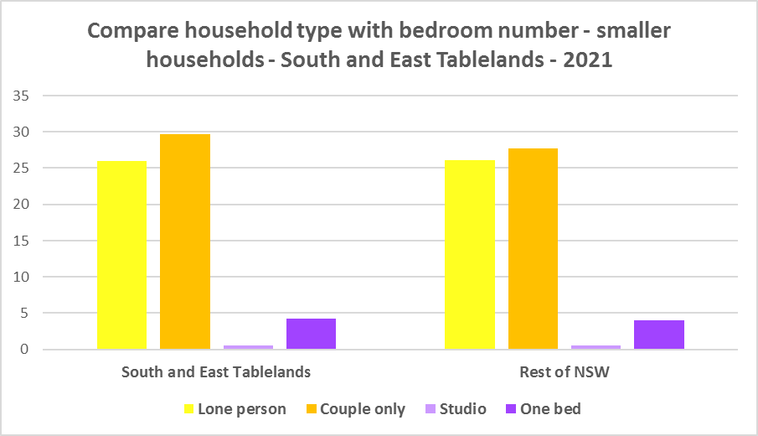

* While there has been a small increase in studio and one bedroom homes since the 2016 Census, the number is significantly outweighed by the enormous increase in the number of three and four plus bedroom homes, as seen in the graph below. However, there has also been a strong increase in the number of two bedroom homes. These potentially suit both single person and couple only households as well as smaller families and small group households and consequently provide some flexibility in the housing stock.

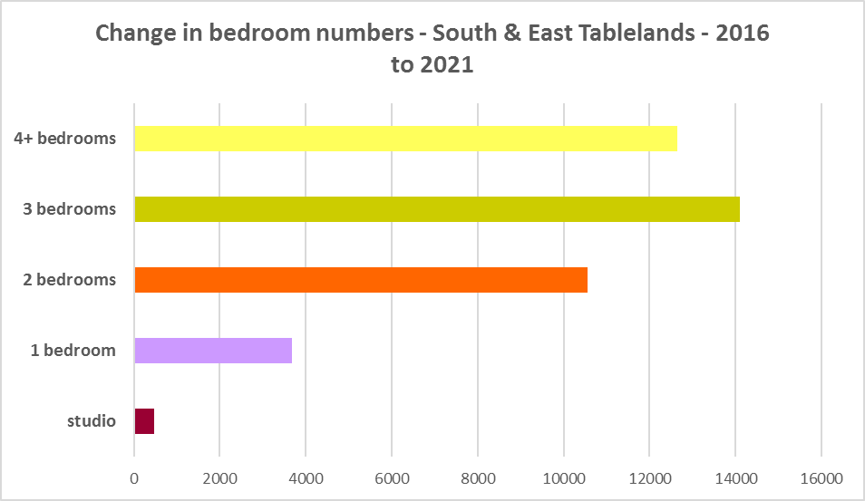

* A proactive approach is required to encourage an increase in studio and one and bedroom properties and to continue to encourage the provision of two bedroom homes.
* This is important given that annually the addition of new dwellings represents around 1% of the total dwelling stock – so change occurs very slowly. There is also a need to take into account the impact of alterations and additions to existing stock, for example, adding extra bedrooms to two and three bedroom houses. Given the current overwhelming supply of three and four bedroom homes and the significant increase in three and four plus bedroom homes since 2016, strong incentives/requirements would need to be put in place to ensure a better balance and more diversity to meet housing need.
* New generation boarding houses would also help fulfil some of this demand – particularly as they cannot be subdivided and must provide rental accommodation. This type of accommodation is suitable for single people and also couples, for key workers and students. It also has potential to assist in providing accommodation/meeting additional housing demand for seasonal workers. Note that the NSW Community Housing Industry Association has an Affordable Housing Tool Kit to help deal with community resistance to affordable housing, which is available on their website. They also have a couple of excellent vimeos showcasing new generation boarding house developments and their tenants.
* The next graph compares larger household types – couple family with children, one parent family and group households – with the amount of two, three and four or more bedroom accommodation available. It is clear that there is a more than adequate supply of larger homes for families and group households in the South and East Tablelands.

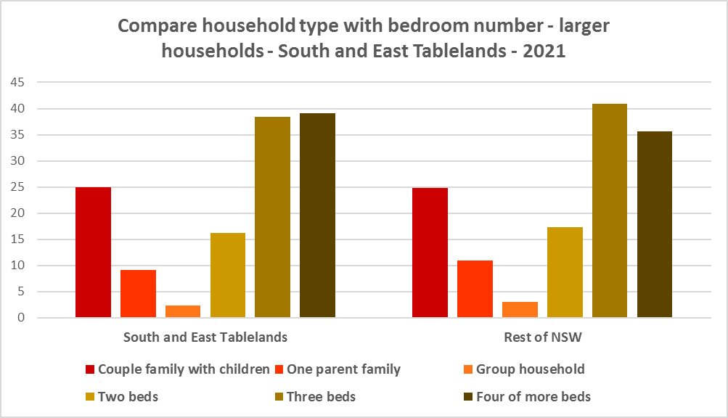

* As couple only households comprise 29.7% of all households in the South and East Tablelands, it is important to continue to encourage provision of one and two bedroom stock as well as studios, new generation boarding houses and secondary dwellings, to maintain a balance to meet local need, particularly where there are higher proportions of seniors and frail aged. This will give older residents opportunity to downsize into more manageable and appropriate homes.
* Enabling the provision of more semi-detached, terrace and town houses could help fulfil some of this demand.
* Also, secondary dwellings suit a range of groups including small households, young people, frail aged and people with disability needing support from family. They may be readily encouraged on larger lots with reasonable access to centres providing a range of services and facilities.

**Who needs affordable housing**

* A wide range of people need affordable housing. Single income earners who fall into the low income category include aged care and disability workers, retail sales assistants, production workers, receptionists and early career child care workers.
* People working in accommodation and food services comprise 7.6% of the workforce living in the South and East Tablelands and are amongst the lowest paid workers. Similarly retail trade employs 8.8% of workers living in the region. Health care and social assistance is the second largest employment sector of residents in the South and East Tablelands (employing 12.4%). A 2017 survey of NSW Nurses and Midwives Association (NSWMA) members showed that thirty six per cent of respondents moved home or changed jobs in the previous 12 months because of housing affordability issues.
* For example:
  + Households earning $790 per week gross (broadly indicative of a wage for a laundry worker) could afford to pay just $237 per week in rent before being in housing stress.
  + Households earning $960 (broadly indicative of wages for a commercial cleaner, delivery driver and entry level firefighter) could afford to pay just $288 per week in rent before being in housing stress.
  + Agriculture employs a further 5.4% of residents in this region (24.3% in Upper Lachlan, 19.6% in Hilltops, 8.6% in Snowy Monaro, 7.0% in Yass Valley and 6.6% in Bega Valley). The average farmhand salary in Australia is $57,311 per annum or $1,102 per week. A household on that salary could afford to pay $330 per week in rent before being in housing stress.
  + Households with an income of $1,150 (broadly indicative of the wage for an enrolled nurse, child care worker and ICT support technician) can afford to pay just $345 per week in rent before being in housing stress.
  + At a weekly income of $1,450/$1,500 (an indicative wage for an early career Registered Nurse), a household could afford to pay $435 to $450 per week in rent before being in housing stress.
* At March 2023, there were insufficient new bonds lodged to calculate a median rent for studio dwellings in any LGA in the South and East Tablelands, or to calculate a median rent for one bedroom homes in Hilltops, Upper Lachlan or Yass Valley – which speaks to lack of supply.
* At March 2023, the median rent for a one bedroom home ranged between $290 per week in Snowy Mountains Regional and $300 per week in Queanbeyan- Palerang Regional; for a two bedroom home ranged between $280 per week in Hilltops and $500 per week in Wingecarribee; for a three bedroom home ranged between $350 per week in Hilltops and $630 per week in both Queanbeyan-Palerang and Wingecarribee and for a four or more bedroom home ranged between $450 per week in Hilltops and $800 per week in Queanbeyan-Palerang. Note that Upper Lachlan only had sufficient bonds lodged to calculate the median rent for all dwellings combined ($400 per week).
* This demonstrates that lower income households would struggle to find affordable rental housing in many, if not most LGAs in the region.
* Single income households in particular are less able to compete in the housing market.
* Increasing numbers of older single women are homeless or at risk of homelessness due to the lack of available affordable rental housing. In fact they are the fastest growing cohort of the homeless population.
* Partnering or collaborating with community housing providers is one effective way to meet some of the local need for appropriate affordable housing. Not for profit community housing providers are owners, managers and developers of affordable rental housing for lower income households and residents with specific housing needs. They work with partners, investors and government to provide housing and deliver support for tenants. For more information about community housing providers, see the NSW Community Housing Industry Association website.

**Additional Data**

Housing data and tables used in this Snapshot are available from the Local Government Housing Kit Database on the Housing NSW website at:

<https://www.facs.nsw.gov.au/resources/nsw-local-government-housing-kit/chapters/local-government-housing-kit-database>

More information on Expected Waiting Times for Public Housing is available on the DCJ/FACS website by region at:

<https://www.facs.nsw.gov.au/housing/help/applying-assistance/expected-waiting-times>

Additional data on social housing dwellings and delivery is available on the FACS website at:

<https://www.facs.nsw.gov.au/resources/statistics/social-housing-residential-dwellings/facs-quarterly-statistics-social-housing-dwellings>

or go straight to the dashboard:

<https://public.tableau.com/app/profile/facs.statistics/viz/Social_Housing_Residential_Dwellings/Dashboard>

and

<https://www.facs.nsw.gov.au/resources/statistics/social-housing-delivery2/interactive-dashboard>

The Australian Housing and Urban Research Institute (AHURI) has written a paper explaining the reasons for unoccupied homes:

<https://www.ahuri.edu.au/research/brief/are-there-1-million-empty-homes-and-13-million-unused-bedrooms>

The SGS Economics and Planning Rental Affordability Index is here:

<https://sgsep.com.au/projects/rental-affordability-index>

More information about community housing providers is available on the NSW CHIA (Community Housing Industry Association) website:

NSW CHIA Snapshot of the Community Housing Sector in NSW:

<https://communityhousing.org.au/wp-content/uploads/2022/08/Community-Housing-Snapshot-2022.pdf>

Data on community housing properties is available from the NSW CHIA Dashboard at:

<https://communityhousing.org.au/our-impact/data-dashboard/>

CHIA NSW affordable housing tool kit. The Tool Kit is based on extensive research about reasons for community resistance to affordable housing, and effective ways of building support for affordable housing:

https://communityhousing.org.au/toolkit/theplatform.html

The NSW Registrar of Community Housing website is here:

<https://www.rch.nsw.gov.au/>

1. <https://sgsep.com.au/projects/rental-affordability-index>
2. <https://www.corelogic.com.au/news-research/news/archive/how-much-has-house-price-growth-outstripped-growth-in-wages#:~:text=Comparing%20the%20wage%20price%20index,193.1%25%20(figure%202)>.