**Hunter Region – What’s the Housing Demand?**

This Housing Snapshot looks at aspects of housing demand in the Hunter, particularly from the 2016 Census to the 2021 Census – including population, age profile, household type, household size, income (change in low, moderate and high income households and low income rental households), homelessness and people with disability.

There have been significant challenges to this region since the 2016 Census, including natural disasters and unexpectedly high additional inmigration – in part due to the desire for sea and tree changes and increased ability to work remotely - which have impacted the community and the demand for housing.

**Population Forecast**

* Changes in population will impact on the demand for housing.
* Between 2016 and 2021, the population of the Hunter grew by 9.25% or 65,460, from 707,675 to 773,135 (using ABS Census population data).
* On an individual LGA basis, population growth ranged from 16.7% in Maitland to 0.8% in Upper Hunter. In terms of numbers, Lake Macquarie had the largest increase with an additional 16,472, followed by Newcastle with 13,461 and Maitland with 12,919.
* Note that Maitland and Cessnock rank 4th and 5th respectively in the state in terms of percentage population increase between 2016 and 2021, behind Camden (52.54%), The Hills (22.03%) and Blacktown 17.75%.
* Lake Macquarie has the largest population of the Hunter LGAs with 213,845 (comprising 27.7% of the Hunter region’s population), while Dungog has the smallest population with 9,541 (comprising 1.2% of the region’s population).
* NSW Planning have prepared population projections for every LGA in the region. Their projections indicate that all of the LGAs in the region are anticipated to increase in population to 2041, with the exception of Singleton and Upper Hunter. NSW Planning also anticipates that Maitland, Dungog and Cessnock will have the strongest growth rates at 2.41% per annum, 1.9% and 1.81% per annum respectively – the only LGAs in the Hunter predicted to have a stronger annual growth rate than the average for NSW of 0.95% per annum.
* However, numerically the largest increases in population to 2041 is predicted for Maitland, followed by Newcastle and Lake Macquarie.
* The table below shows the population change for each Hunter LGA and the region as a whole from 2016 to 2021, using ABS Census data.



**Age**

* The age profile of the region and particularly each LGA will impact on housing need and demand, including number of bedrooms, affordability, location and dwelling type.
* The median age of the population of the Hunter LGAs at the 2021 Census ranges between 36 years (Maitland) and 54 (Mid Coast). Most of the Hunter LGAs have a much younger median age than Mid Coast – with Cessnock, Muswellbrook, Newcastle and Singleton all having a median age of 37 and the highest median age after Mid Coast being Dungog with 46 years. This compares to the median age for the Rest of NSW (excluding Sydney) of 43 years.
* There is variation in the age profiles of the Hunter LGAs. Generally Maitland, Cessnock, Muswellbrook and Singleton have younger age profiles, while Mid Coast, Port Stephens and Dungog tend to have older age profiles:
  + Maitland, Cessnock, Muswellbrook, Singleton and Lake Macquarie all have above NSW average proportions of 0-4 year olds (5.5%);
  + Every Hunter LGA excepting Mid Coast, Newcastle and Port Stephens has a higher proportion of 5-14 year olds than the NSW average of 12.4%;
  + Singleton, Muswellbrook, Maitland and Cessnock are the only Hunter LGAs to have a higher proportion of 15-19 year olds than the NSW average of 5.8%;
  + Newcastle, Singleton, Cessnock and Maitland have higher proportions of 20-24 year olds than the NSW average (5.9%);
  + Newcastle, Maitland, Cessnock, Muswellbrook and Singleton have higher proportions of 25-34 year olds (12.4%);
  + Mid Coast, Port Stephens and Dungog are the only LGAs with lower proportions of 35-44 year olds (11.9%);
  + Mid Coast, Cessnock, Maitland and Newcastle are the only LGAs with lower proportions of 45-54 year olds (12.3%);
  + Maitland, Newcastle, Cessnock and Muswellbrook are the only LGAs with lower proportions of 55-64 year olds (12.8%);
  + Mid Coast, Port Stephens, Dungog and Lake Macquarie are the only LGAs with higher proportions of 65-74 year olds (11.7%) and 75-84 year olds (6.8%);
  + Mid Coast, Lake Macquarie and Upper Hunter are the only LGAs with higher proportions of 85+ year olds (2.6%).
* The graph and table below show the proportion of the population in each key age cohort in the Hunter LGAs, the region and the Rest of NSW.

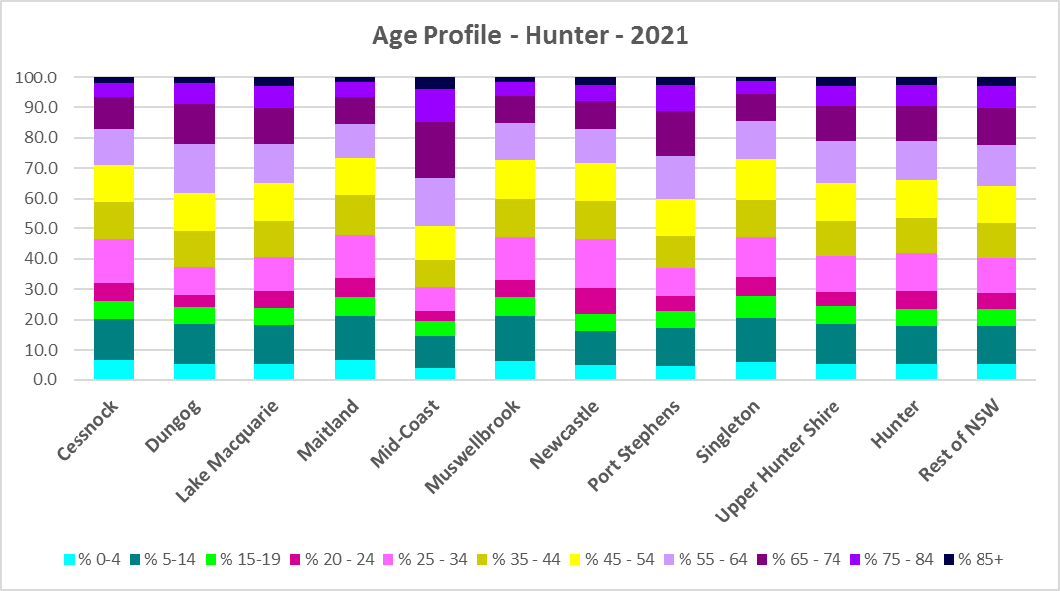

Proportion of population in each age cohort at the 2021 Census for the Hunter



* NSW Planning forecast increases in residents aged over 65 to 2041 in every Hunter LGA, as well as an increase in younger age groups in Cessnock, Dungog and Maitland and a decline in younger age groups in Muswellbrook and Upper Hunter.
* The diversity of age groups requires a range of different housing to meet the needs of the community throughout the housing life cycle. However the higher median age and higher proportions of older age cohorts indicates that there is a need for housing to suit older residents in Mid Coast, Port Stephens, Lake Macquarie and also Upper Hunter. Increasingly this will be the case in all the Hunter LGAs as the number in older age groups grows.
* As the Australian Institute for Health and Welfare (AIHW) note:

Many older Australians prefer to age in place, meaning they wish to stay in their local home or community. However, their capacity to do so can be influenced by:

* + the appropriateness and quality of their home (for example, size, layout)
  + their ability to modify their home to suit their functional requirements
  + the cost and availability of suitable housing
  + their need for formal care and assistance
  + their proximity to services and social support.
* Although the majority of older Australians own their own home, this number is declining. About 15% of older Australians are renters. These people are generally a highly vulnerable and economically disadvantaged group, particularly single person households, with older women being the fastest growing demographic of people experiencing homelessness. There is therefore a need for more adaptable, accessible dwellings, well located, secure, low maintenance and affordable to meet the needs of seniors and frail aged in particular, within their communities. Those most in need are households in the private rental market, who struggle to afford housing on an Aged Pension or inadequate superannuation. (Source: "Housing Decisions of Older Australians" Productivity Commission December 2015).
* The Australian Housing and Urban Research Institute (AHURI) has undertaken research on “What is the ideal home for older Australians?”
  + “Older Australians and the housing aspirations gap” and
  + “Understanding the housing aspirations of older Australians”
* This research is part of a broader study on “Housing aspirations and constraints for lower income Australians.” AHURI’s research demonstrates that one of the most valued aspects of older residents housing is the location – that the neighbourhood feels safe and secure; that there is good (including walkable) access to services such as health, shopping, recreational amenities, public open space; and that it is close to family and friends.

**Household Type**

* A look at household types and average household size gives some insight into the type of housing – particularly number of bedrooms – that is likely to be appropriate to meet the housing needs of the community.
* Household types in the Hunter vary between the LGAs and generally differ from the average for NSW.
* At the 2021 Census in the Rest of NSW, couple families without children (27.7%) and lone person households (26.1%) are the largest two household types.
* In the Hunter, Mid Coast (32.9% and 28.7% respectively) and Upper Hunter (29.1% and 26.8%) have couple families without children and lone person households as the largest two household types, in line with the Rest of NSW average.
* Cessnock (25.3% and 28.0%), Dungog (31.6% and 29.2%), Lake Macquarie (28.0% and 29.2%), Maitland (26.2% and 32.7%), Port Stephens (31.2% and 24.9%) and Singleton (26.0% and 33.5%) have couple families without children and couple families with children as the largest two household types.
* Muswellbrook (26.2% and 26.4%) and Newcastle (24.8% and 28.3%) have couple family with children and lone person households as the largest two household types.
* Cessnock (15.3%) and Maitland (13.1%) have the highest proportion of one parent families in the region, while Newcastle has the highest proportion of group households (6.7%) and Muswellbrook has the highest proportion of other households (7.6%).
* There has been a small shift since the 2016 Census, with an increase in couple family without children households in the Rest of NSW (0.7%), a decline in couple families with children households (-0.6%) and a small increase in lone person households (0.5%).
* Changes in some Hunter LGAs have been more pronounced:
  + Couple family without children households increased by 1.9% in Upper Hunter, 1.7% in Port Stephens, 1.2% in Dungog, 1.0% in Newcastle, 0.9% in Singleton and 0.8% in Cessnock (with the remaining Hunter LGAs less than or equal to the Rest of NSW average);
  + Couple family with children households declined by -1.8% in Muswellbrook, -1.3% in Mid Coast and Port Stephens, -1.1% in Lake Macquarie and -0.8% in Newcastle and Upper Hunter, with the remaining LGAs having a lower decrease than the Rest of NSW – with Dungog actually having a small increase in the proportion of couple family with children households.
  + Lone person households increased by 1.5% in Muswellbrook and Port Stephens, 1.0% in Mid Coast, 0.7% in Maitland and Upper Hunter, and 0.6% in Lake Macquarie and Singleton. The remaining Hunter LGAs had a smaller increase than the Rest of NSW with Cessnock the anomaly with a small decline.
* The graph and table below show the proportion in each key household type for every Hunter region LGA and Rest of NSW at the 2021 Census.

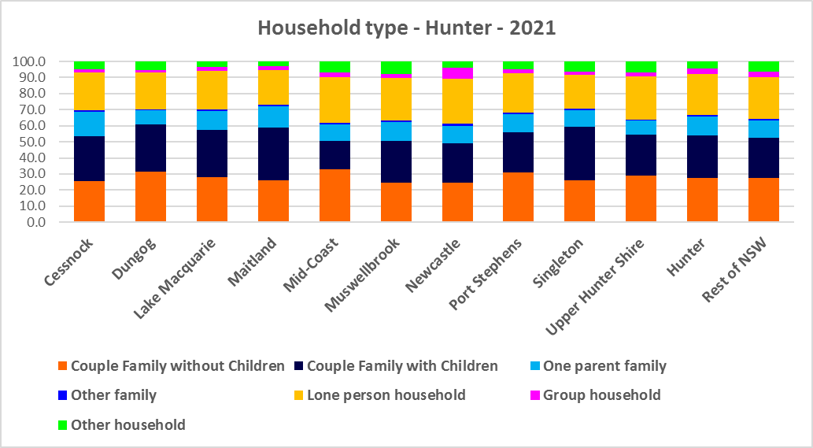



* Given the number of lone person and couple only households, it is important to ensure that housing choice in the community reflects this through availability of studio, one and two bedroom homes.

**Household Size**

* At the 2021 Census, the average household size for the Rest of NSW was 2.4 persons per household – unchanged from 2016 and 2011.
* Average household size in the Hunter ranges from 2.2 persons per household in Mid Coast to 2.7 persons per household in Maitland and Singleton. Six of the 10 Hunter LGAs have a larger average household size than the average for the Rest of NSW.
* In line with the trend in the Rest of NSW, between 2016 and 2021, average household size was stable in every Hunter LGA, with the exception of Port Stephens which declined from 2.5 to 2.4 persons per household.
* The table below gives the average household size in each of the Hunter LGAs as well as the Rest of NSW for 2011, 2016 and 2021.



**Income**

* At the 2021 Census, low income households comprise the largest proportion of all households in the Rest of NSW, in the Hunter region as a whole and each Hunter LGA, with the exception of Cessnock.
* Port Stephens (55.6%), Mid Coast (52.4%), Dungog (52.3%) and Upper Hunter (51.3%) are the only Hunter LGAs to have a higher proportion of low income households than the average for the Rest of NSW (49.3%). Across the region the proportion of low income households ranges from 39.3% in Cessnock to 55.6% in Port Stephens. The Hunter as a whole has an average of 47.3% low income households, somewhat below the Rest of NSW average.
* Moderate income households in the Rest of NSW comprise 21.5% of all households and 22.0% for the Hunter region as a whole, while in the Hunter LGAs they range from 20.9% in Muswellbrook to 23.8% in Maitland.
* High income households comprise 29.2% of all households in the Rest of NSW, 30.7% on average across the Hunter region and range from 22.7% of households in Port Stephens to 39.6% in Cessnock.
* The graph and table below show the proportion of low, moderate and high income households in all the Hunter LGAs, compared with the region and Rest of NSW at the 2021 Census.

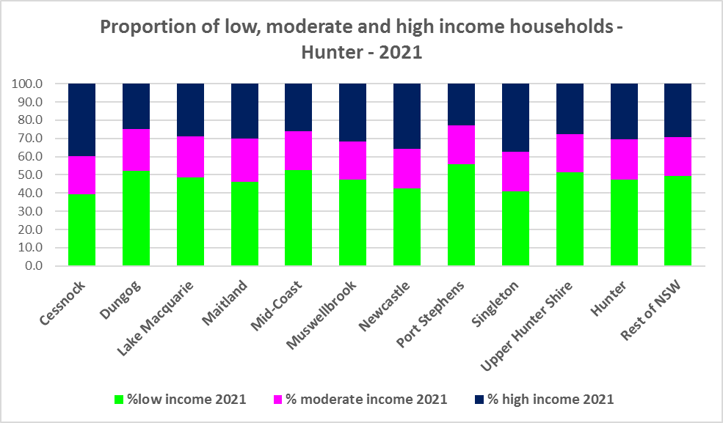



* Between 2016 and 2021 while the number of low income households increased in the Hunter region as a whole, the number of low income households increased in every Hunter LGA except for Cessnock and Mid Coast, which both experienced a decline in the number of low income households.
* Over the same period, the number of moderate income households increased in every Hunter LGA.
* While the number of high income households increased overall in the region, the number of high income households declined in every Hunter LGA except for Cessnock and Mid Coast, which both experienced an increase in high income households.
* The graph below shows the change in the number of low (including very low), moderate and high income households from 2016 to 2021 in the Hunter region.

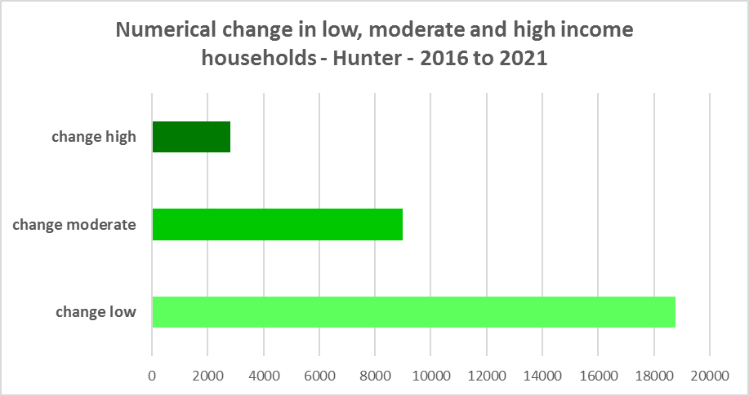

* However, despite the increase in the number of low income households between 2016 and 2021, all the Hunter LGAs experienced a very strong decline in very low income **rental** households over the same period, varying between a -51.7% decline in Muswellbrook and a -15.5% decline in Cessnock.
* Most also had declines in low income **rental** households over the same period, with Muswellbrook again having the largest proportional decline of -16.8%. A few LGAs experienced small increases in low income rental households – Cessnock had an increase of 7.9%, Upper Hunter 2.2%, Dungog 1.5% and no change in Port Stephens.
* The reduction in both very low (-3,619) and low income renters (-267) across the Hunter region is likely due to the additional Commonwealth financial assistance to renters during the pandemic and is therefore likely to be temporary – as this assistance has subsequently been discontinued, as explained in the What’s Happening in the Housing Market” snapshot for the Hunter. It is also likely that at least some lower income rental households have been priced out of the region and/or impacted by the loss of long term rental to short term rental or home purchase/ownership.
* These changes underline the need to consider tenure as well as price point when considering responses to meet housing need.
* The graph below shows the change in the number of very low and low income **renters** between 2016 and 2021 in the Hunter.

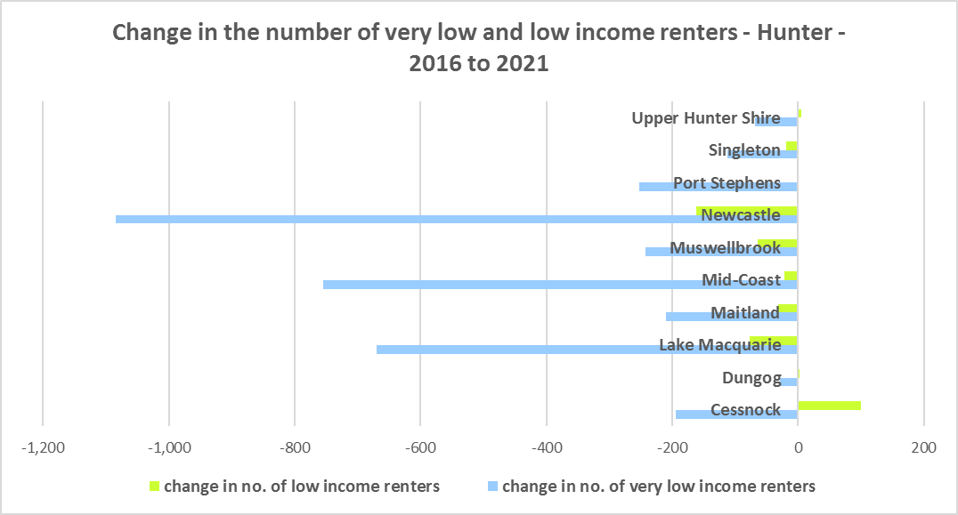

* Singleton ($2,016), Maitland ($1,766), Newcastle ($1,760), Muswellbrook ($1,628), Lake Macquarie ($1,623), Cessnock ($1,493) and Dungog ($1,485) all have a higher median household weekly income at 2021 than the Rest of NSW ($1,434).
* The table below shows the change in median household weekly income in each Hunter LGA along with the Rest of NSW from the 2011, 2016 and 2021 Census.



**Homelessness**

* People experiencing homelessness and those at risk of homelessness are among Australia’s most socially and economically disadvantaged. State, Commonwealth and some local governments fund services to support people who are homeless, or at risk of homelessness. Services are delivered mainly by non–government organisations, some of which specialise in delivering services to specific groups (such as young people or people experiencing domestic violence).
* Inadequate income and inability to access affordable housing are significant contributing factors to homelessness, along with individual factors such as experience of family and domestic violence, ill health and disability.
* The ABS identifies someone as homeless “where they do not have suitable accommodation alternatives and their current living arrangement:
  + Is in a dwelling that is inadequate;
  + Has no tenure or their initial tenure is short and not extendable; or
  + Does not allow them to have control of and access to space for social relations.”
* The ABS uses “six operational groups for presenting estimates of people experiencing homelessness on Census night:
  + People living in improvised dwellings, tents or sleeping out
  + People living in supported accommodation for the homeless
  + People staying temporarily with other households
  + People living in boarding houses
  + People in other temporary lodgings
  + People living in ‘severely’ overcrowded dwellings.”
* The ABS “also compiles estimates from Census data for the following three groups of people who may be marginally housed but are not classified as homeless:
  + People living in other crowded dwellings
  + People in other improvised dwellings
  + People marginally housed in caravan parks.”
* The table below shows ABS 2021 Census data for the Hunter on the homeless and marginally housed.
* Note that due to additional assistance provided during the pandemic, the number of people counted as homeless on Census night in 2021 is lower than at the 2016 Census across Australia. Nevertheless there were 2,464 people counted as homeless at the 2021 Census in the Hunter and a further 1,752 counted as marginally housed.
* Of those counted as homeless, the largest number (634 or 25.7%) were people living in severely crowded dwellings, followed by people staying temporarily with other households (571 or 23.2%), then people living in boarding houses (549 or 22.3%).
* Of those counted as marginally housed the majority (1,266 or 72.3%) were people living in other crowded dwellings.
* This clearly implies the need for more affordable rental housing.



* The 2023 NSW street count, the NSW Government’s fourth annual rough sleeping street count, was completed between 2 February and 27 February 2023.
* Over 300 local organisations either consulted in the planning phase or participated in the delivery of street counts. Organisations which partnered with the Department of Communities and Justice (DCJ) included Community Housing Providers, local councils and Specialist Homelessness Services, as well Aboriginal organisations, Local Health Districts, local community groups, and Police.
* 1,623 people were counted sleeping rough during these street counts, a 34% increase from 2022.
* Street counts took place in more than 350 towns in 76 LGAs, compared to 71 LGAs in 2021 and 65 LGAs in 2020.
* The table below gives the street count results for the Hunter locations.



## People with Disability

* According to the Australian Institute of Health and Welfare (AIHW) and data from the 2018 Australian Bureau of Statistics (ABS) Survey of Disability, 18% of people in Australia have disability. Another 22% have a long term health condition but not disability.
* Nearly one third (32%) of people with disability have severe or profound disability. This means needing help with daily self-care, mobility or communication activities, having difficulty understanding or being understood by family or friends, or communicating more easily using sign language or other non-spoken forms of communication.
* The survey data shows:
  + 7.6% of children aged 0–14 have disability
  + 9.3% of people aged 15–24 have disability
  + 13% of people aged 15–64 have disability
  + 50% of people aged 65 and over have disability (ABS 2019b).
* For about 3 in 4 (77%) people with disability, the main type of disability is physical, while for the remaining 1 in 4 (23%), the main type of disability is mental or behavioural.
* Clearly housing is a significant factor in the health and wellbeing of people with disability. The availability of affordable, sustainable and appropriate housing helps people with disability to participate in the social, economic and community aspects of everyday life. Someone without access to affordable, secure and appropriate housing is more likely to experience homelessness, poor health, and lower rates of employment and education.
* While most people with disability live at home in the community (96% in private dwellings), some live in cared accommodation.
* Cared accommodation is usually long term and may be institutional in style, including hospitals, residential aged care, cared components of retirement villages, aged care hostels, psychiatric institutions and group homes for people with disability. The more severe a person’s disability is, the more likely they are to live in cared accommodation and the less likely they are to live in the community.
* There has been a significant shift towards supporting people with disability to live in private dwellings, rather than being in institutional care over recent decades. Largely this has been driven by changes for young people with disability.

## Additional Data

More detailed housing data and tables used in this Snapshot are available from the Local Government Housing Kit Database on the FACS website at:

<https://www.facs.nsw.gov.au/resources/nsw-local-government-housing-kit/chapters/local-government-housing-kit-database>

More information on the housing needs of older Australians and people with disability:

The Australian Institute of Health and Welfare – Older Australians Housing and Living Arrangements on the AIHW website at:

<https://www.aihw.gov.au/reports/older-people/older-australians/contents/housing-and-living-arrangements>

The Australian Institute of Health and Welfare – People with Disability in Australia

<https://www.aihw.gov.au/reports/disability/people-with-disability-in-australia/contents/people-with-disability/prevalence-of-disability>

and relating to housing needs

<https://www.aihw.gov.au/reports/disability/people-with-disability-in-australia/contents/housing>

The Productivity Commission’s report Housing Decisions of Older Australians is at:

<https://www.pc.gov.au/research/completed/housing-decisions-older-australians>

More detailed information on population, household and dwelling projections is available on the Department of Planning and Environment website at:

<https://www.planning.nsw.gov.au/Research-and-Demography/Population-Projections/Projections>

<https://pp.planningportal.nsw.gov.au/populations>

More data on homelessness, specifically homelessness service data is available on the Homelessness NSW website at:

<https://homelessnessnsw.org.au/resource/specialist-homelessness-service-data/>

And from the AIHW website here:

<https://www.aihw.gov.au/reports/australias-welfare/homelessness-and-homelessness-services>

The 2023 Street Count result is at the DCJ/ FACS website here:

<https://www.facs.nsw.gov.au/reforms/homelessness/premiers-priority-to-reduce-street-homelessness/street-count>

Further information on ABS estimation of homelessness is available at the ABS website:

<https://www.abs.gov.au/statistics/people/housing/estimating-homelessness-census/2021>