# Central City District – What’s happening in the Housing Market

This Housing Snapshot looks at rents, vacancy rate, affordable rental, rental stress, loss of affordable rental stock, impact on key workers, sales price, purchase affordability and purchase stress in Western City – particularly changes between 2016 and 2021.

## There have been changes across the District since the 2021 Census, with Covid having an impact on the housing market. Recent additional cost of living pressures, including rising inflation and interest rates with continued low wage growth, have created further difficulties for lower income earners and their capacity to manage housing costs. Since the Census there have been falls in sales prices and strong hikes in rents, with a chronic shortage of rental properties in Sydney.

## Wage growth has lagged well behind house price growth for decades. In 1984 the average Australian could buy a home that costs 3.3 times their annual income. By 2022 the average Australian needed 10 times their income to buy a home. Further, the real value of wages declined by 4.5% in 2022, the largest documented deterioration. With annual inflation running at 7.8 per cent, wages need to be growing by 7.8 per cent to maintain their purchasing power.

Consequently households are increasingly struggling with housing costs – saving a deposit, taking on a mortgage, competing for rental properties, paying rising rents – as well as a wide range of other goods, such as food, energy, medication, education, transport. There are many anecdotal reports of tenants having to choose between paying the rent and paying for medication, their education or food as well as rising homelessness.

## *Housing Market – Rental*

## Rents

* There has been strong growth in median rents for all dwellings (including all housing types and all bedroom categories) in Central City for a couple of decades, as the graph below shows. It tracks the change in median rent (for all dwellings) for all the Central City LGAs as well as for Greater Sydney from June 1990 to June 2022.
* Note from the graph that median rents stabilised or declined in the Central City LGAs (and Greater Sydney) between 2017 and 2018, then again between 2019 and 2021, before a strong recent recovery.

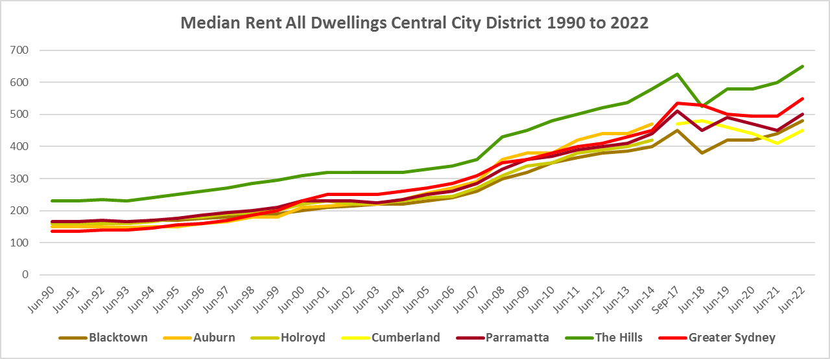

* The table below shows the change in median rent for all dwellings from September 2017 (post council amalgamations) to June 2023 (latest available data). Blacktown has experienced the strongest increase in median rents with 24.4%, closely followed by Parramatta (23.5%) and Cumberland (23.4%). Parramatta had the strongest increase in dollar terms with a rise of $120 per week over that time frame, closely followed by both Blacktown and Cumberland with increases of $110 per week.
* At June 2023 The Hills had the highest median rent with $720 per week, followed by Parramatta with $630.



* However, changes in median rents over this period were more varied than those increases suggest.
* Between 2019 and 2020 when Covid lockdowns were introduced, median rents in most NSW local government areas dropped. This pattern is also evident in Central City.
* During that period, the largest percentage falls in median rents for one bedroom homes occurred in Parramatta (-6.7%) and Cumberland (-5.7%).
* For two bedroom homes the largest drop in median rents was in Cumberland with -7.0%.
* Blacktown had the largest decline for three bedroom homes with -2.4% and Parramatta had the largest fall for four or more bedroom homes with -2.9%. Note that Blacktown had a significant 15.4% increase in the median rent for one bedroom homes and The Hills had a small increase of 2.2% in the median rent for four bedroom homes – the only increases in median rents in Central City over this period.
* The table below shows changes in median rents by bedroom category between 2019 and 2020 in the Central City LGAs.



* However, between 2020 and 2022 when Covid restrictions were relaxed, there were strong increases in median rents across Central City, (with no decreases experienced) as the table below shows.
* Across the District, the strongest increase in median rents over this period occurred in Blacktown for four (21.8%) and three bedroom homes (17.1%), followed by The Hills for four (16.8%), three (16.1%), two (15.8%) and one bedroom homes (12.5%).
* At June 2022, median rents for one bedroom homes ranged between $460 per week in Parramatta and $330 in Blacktown; for two bedroom homes between $550 in The Hills and $400 in Blacktown; for three bedroom homes between $650 in The Hills and $480 in Blacktown; and for four or more bedroom properties between $800 in The Hills and $670 in Blacktown. Note there were insufficient new bonds lodged for bedsit/studio dwellings to calculate the median rents in the Central City LGAs, which speaks to lack of supply.



## Vacancy Rate

* A vacancy rate of 3% is understood to represent a balance between supply and demand. Vacancy rates below 3% represent a tight rental market while longer term vacancy rates below 2% represent a chronic undersupply of rental housing.
* According to REINSW data, vacancy rates were below 3% for the inner, middle and outer rings of Sydney for almost all of the period from 2006 through to 2018.
* At April 2023 the vacancy rate in the inner ring of Sydney was 1.5%, for the middle ring was 1.2% and for the outer ring was 1.3%, indicating a tight rental market across Sydney and most particularly in the middle ring.
* Vacancy rates are tight across almost all of NSW. At April 2023, the vacancy rate on the Central Coast was 1.7%, in Wollongong was 1.3%, for the Illawarra was 1.7%, in the Newcastle was 1.8%, in the rest of the Hunter was 2.0% and in the Central West was 1.6%.
* Anecdotal information on the current vacancy rate underlines the difficulty tenants are facing finding and retaining rental accommodation - the fierce competition for rental housing, rent bidding and the rapid increase in rents– with tenants facing eviction, homelessness, overcrowding and paying too much of their income in rent.
* The graph below shows the vacancy rate for the inner, middle and outer rings of Sydney for the period from 2006 to 2023, using data from the Real Estate Institute of NSW. Note that Cumberland and Parramatta are in the Middle Ring and Blacktown and The Hills Shire are part of the Outer Ring.

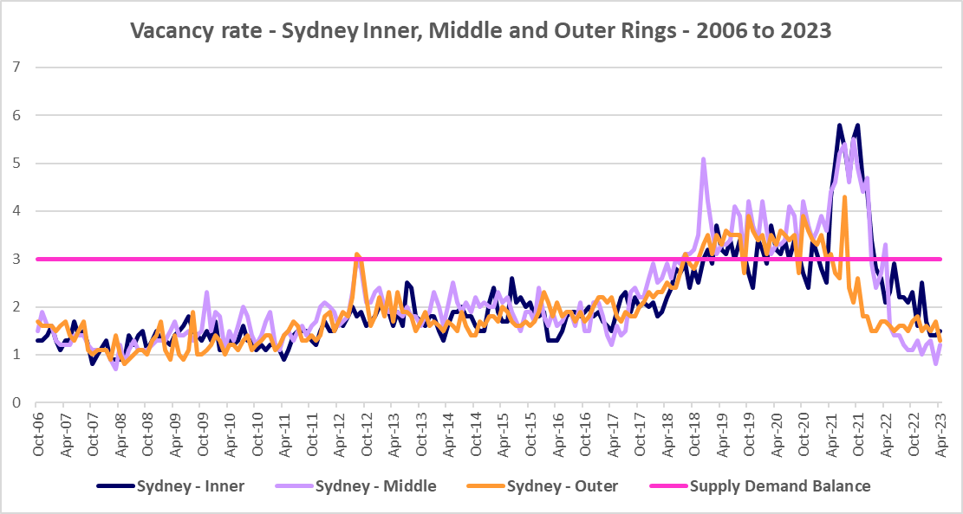

## Affordable Rental

* Since 2001, the general trend across Sydney and NSW has been for a decline in the proportion of rental stock which is affordable for very low, low and moderate income earners.
* This trend is evident in Central City, although along with elsewhere in NSW, there were more complex factors at play between 2019 and 2022.
* Across Greater Sydney, the proportion of affordable rental for very low income households increased every year from 2018 to 2021 and then declined between 2021 and 2022.
* This pattern held true for Central City – with one small variation – in Parramatta the proportion affordable for rental for very low income households declined between 2018 and 2019.
* At June 2022, The Hills Shire (2.0%) was the only LGA in Central City which had a lower proportion of affordable rental for very low income households than the Greater Sydney average of 10.7%. Parramatta was just above with 11.0%, while Blacktown had 13.4% and Cumberland 18.0%. All still very low proportions of private rental affordable to very low income households.
* The table and graph below show the change in the proportion of private rental accommodation affordable to **very low income** households in the Central City LGAs and Greater Sydney between 2017 and 2022.

Proportion affordable rental for very low income households



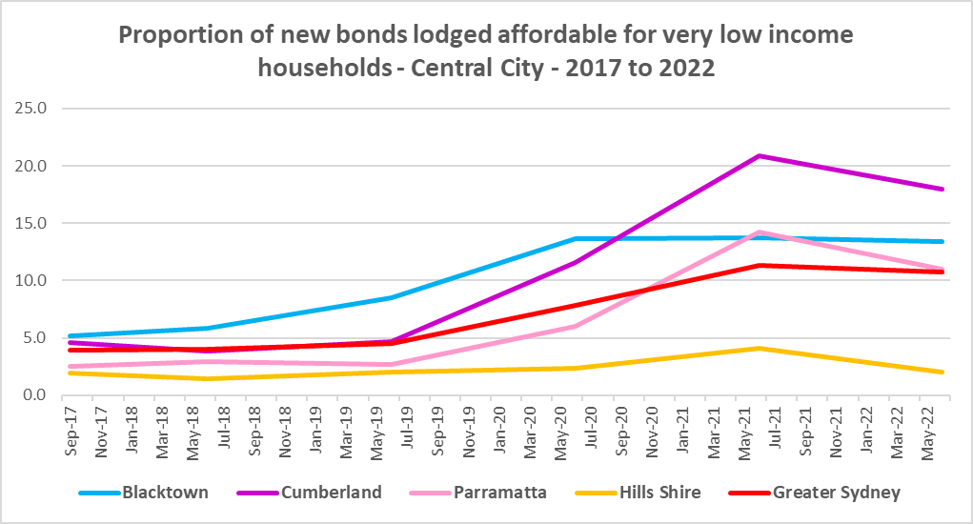

* Between 2018 and 2021 the proportion of rental affordable for **low income** households increased in Greater Sydney from 23.2% to 44.8% before declining to 41.5% in June 2022.
* Again Central City followed this trend with one variation – the proportion of rental affordable to low income households in Blacktown increased to 2020 then declined.
* At June 2022, The Hills (20.3%) was the only Central City LGA with a lower proportion of affordable private rental for low income households than the average of 41.5% for Greater Sydney. Parramatta was the next lowest with 51.1%, followed by Blacktown with 58.2% and Cumberland with 67.2%.
* The table and graph below show the change in the proportion of private rental accommodation affordable to **low income** households in Central City and Greater Sydney between 2017 and 2022.

Proportion affordable rental for low income households



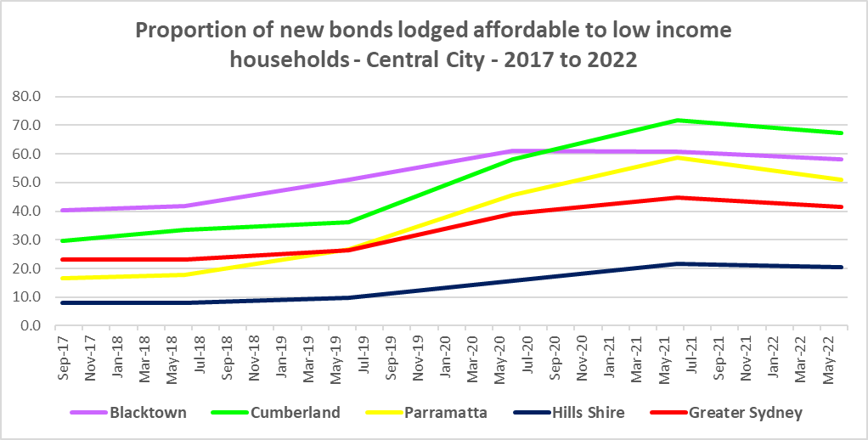

## Rental Stress

* Households are regarded as being in rental stress when renting in the private rental market and paying more than 30% of their income in rent. Lower income households in rental stress will struggle to pay for other essential household costs, such as medical or educational expenses, food, transport and energy costs.
* At June 2021 the proportion of very low income households in rental stress in Greater Sydney was 94.0%.
* Within Central City, the average proportion of very low income households in stress was slightly lower at 93.0%, with the proportion varying from 97.7% in The Hills Shire to 89.9% in Blacktown. Both The Hills Shire and Parramatta (96.0%) had a higher proportion in stress than the average for Greater Sydney, while both Cumberland (92.6%) and Blacktown had a lower proportion.
* For low income households in rental stress at 2021, the average for Greater Sydney was 61.4%, with the Central City average lower on 53.3%. Across Central City the proportion of low income households in stress ranged from 73.1% in The Hills Shire to 42.6% in Blacktown.
* The Hills Shire was the only Central City LGA with a higher proportion of low income households in rental stress than the Greater Sydney average, with Parramatta just under on 60.4%.
* However, while the **proportion** of very low and low income households in stress declined in every Central City LGA between 2016 and 2021, in line with the trend in Greater Sydney – the actual number of very low income households in stress increased in every Central City LGA.
* The number of low income households in stress increased in every Central City LGA except for Cumberland over the same period.
* Below is a graph of the proportion of very low and low income households in rental stress in each Central City LGA at 2021, and a table showing the change in the proportion of very low and low income households in stress between 2016 and 2021.

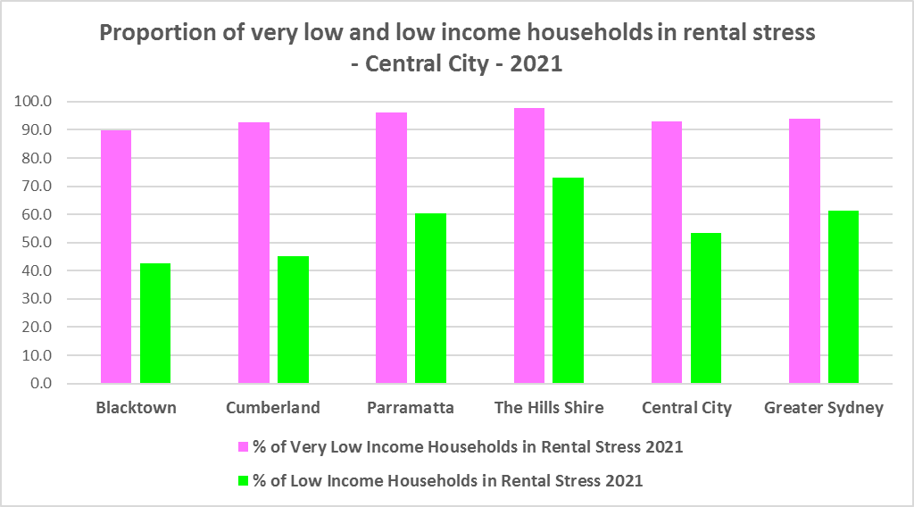

Proportion of very low and low income households in rental stress



* The next table shows the change in the number of very low and low income households in rental stress between 2016 and at 2021.

Number of very low and low income households in rental stress



* A look at CRA (Commonwealth Rent Assistance) recipients in housing stress gives some further information on what has been happening with lower income households in rental stress over this time frame.
* Between 2016 and 2020, the total number of CRA recipients in Central City increased much more significantly than the increase in the number of CRA recipients in rental stress.
* However, between 2020 and 2021, the total number of CRA recipients declined while the number in stress increased in Central City. The same pattern is evident in Western City.
* This is a bit different to the trend in regional NSW, where between 2016 and 2020, the total number of CRA recipients increased significantly, while the number in stress actually declined. However, between 2020 and 2021 the number of CRA recipients declined while the number in stress increased.
* This is different also from the trend in Eastern City and North District, where between 2016 and 2020, the total number of CRA recipients increased as did the number of CRA recipients in rental stress. However, between 2020 and 2021, the total number of CRA recipients as well as the number in stress declined in Eastern City and North District.
* Generally across Australia, the number of CRA recipients in housing stress has increased from the June 2020 figures as the temporary Coronavirus Supplement ended on 31 March 2021.
* The Coronavirus Supplement was $550 per fortnight for new and existing recipients of JobSeeker Payment, Parenting Payment, Youth Allowance for jobseekers, Farm Household Allowance and Special Benefit. The temporary supplement almost doubled the maximum payment rate for a JobSeeker Payment recipient. Hence it made rent more affordable for some CRA recipients in June 2020 and resulted in a lower proportion of CRA recipients in rental stress than usual.
* Since the end of Covid restrictions, the number of people in employment has increased, so fewer people are relying on rent assistance from the Commonwealth.
* The two graphs below clearly demonstrate the change in total CRA recipients and CRA recipients in stress between 2016 and 2020 and 2020 and 2021 in Central City.

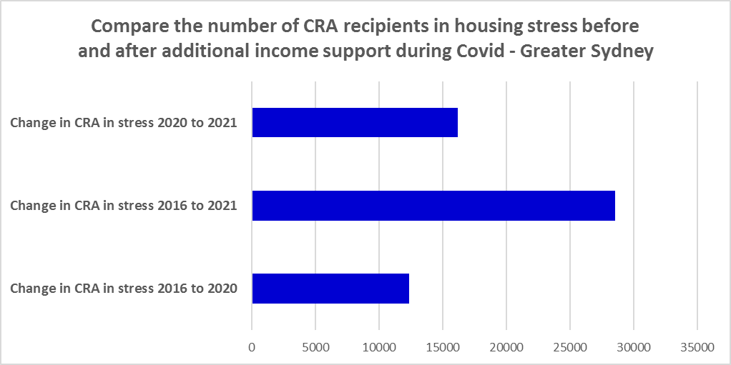

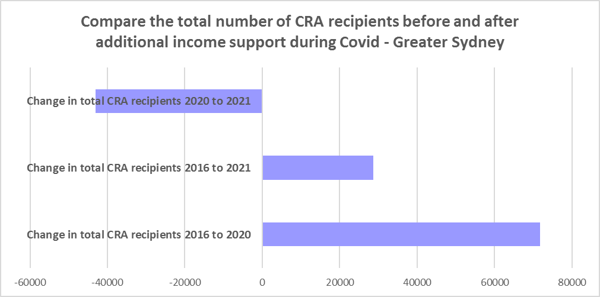

* The table below shows the number and proportion of tenants in Central City who are in the private rental market, are in receipt of Commonwealth Rent Assistance, and despite this additional income support, are in housing stress.
* There were a total of 28,507 tenants in receipt of CRA and in housing stress across Central City in 2021, up from 22,484 in 2016. In 2016, 49.5% of CRA recipients in Central City were in stress, increasing to 56.6% in 2021. This compares to 50.7% CRA recipients in stress in 2016 for Greater Sydney and 56.2% in 2021. Note that now Central City has a higher proportion of CRA recipients in housing stress than the average for Greater Sydney.
* At 2021, Parramatta had the highest proportion of CRA recipients in stress in Central City with 62.3% while Blacktown had the highest number with 10,036.



## Loss of Affordable Housing Stock

* DCJ has calculated the number of new bonds lodged with the Rental Bond Board that were affordable to low income earners in Central City in 2021 and 2022. The District experienced a -7.7% decline in affordable bonds lodged, and consequently loss of affordable private rental housing, in just that 12 month period.
* Over that 12 month period, Blacktown (9 properties) and The Hills (12 properties) registered a small increase in new bonds lodged that were affordable to low income households, while Parramatta (-414) and Cumberland (-93) experienced substantial losses.
* Parramatta’s loss comprised 85% of the total loss of affordable rental for Central City between 2021 and 2022.
* The table below shows the number of new bonds lodged that were affordable to low income households (including very low income households) in 2021 and 2022 in each of the Central City LGAs as well as the total for the District.

Number of new bonds lodged affordable to low income households



**Impact on Key Workers**

* This loss of affordable housing is having a direct impact on key workers (who are often low paid) who live and work in the District.
* Key low income earners include teachers, registered nurses, retail sales workers, Police and aged care workers. These are important occupations and provide necessary services and assistance to the wider District community. In performing their roles in services, education, public health and safety, key workers significantly influence the social and economic wellbeing of their local areas.
* Central City in particular has a high number of police, health care and aged care workers who work in the District, due to the Police headquarters in Parramatta, the Westmead and Cumberland hospitals and surrounds and the large concentrations of aged care in Parramatta.
* Analysis by AHURI (May 2021 Policy Evidence Summary – Housing for Australia’s Key Workers) shows that:
  + In Sydney key workers are more likely than the labour force generally to live in outer suburbs and satellite cities and to commute 30kms or more to work.
  + Around 31,000 key workers in Sydney live in overcrowded homes, with the greatest concentration in inner subregions and among lower paid occupation groups.
  + Over 52,000 key workers in Sydney are living in households that can be classified as being in housing stress, equating to 20 per cent of key workers.
  + In February 2020, only 2 per cent of new tenancies across Greater Sydney had starting rents that were at or below the affordability threshold for households earning $790 per week gross (broadly indicative of a wage for a laundry worker). Just 5 per cent were affordable to households earning $960 (broadly indicative of wages for a commercial cleaner, delivery driver and entry level firefighter) and 11 per cent were affordable for those with an income of $1,150 (broadly indicative of the wage for an enrolled nurse, child care worker and ICT support technician).
* Without appropriate affordable housing, these workers will be forced to choose whether to live in overcrowded, unaffordable housing or move from the area, increasing their commute time and potentially resulting in a shortage of available workforce.

## *Housing Market – Purchase*

## Sales Price

* Changes in the median sales price of both houses and flats in Central City over the ten years to March 2022 have generally been upward. Although most LGAs experienced a drop in the median sales price of houses and strata properties between 2018 and 2019/2020, they have all subsequently recovered and increased.
* Note there was an anomalously high median sales price for strata for Parramatta in 2019. Also due to council amalgamations there is no data for Cumberland prior to 2017 and the data for Parramatta is not strictly comparable.
* All the Central City LGAs had larger increases in median sales price for houses than Greater Sydney (104.6%) between 2012 and 2022, with The Hills having the largest proportional increase (377.6%)
* Again all the Central City LGAs had higher increases in median sales price for strata properties than Greater Sydney (52.5%) with Blacktown having the largest increase at 95.3%.
* At March 2022, both The Hills ($1,982,000) and Parramatta ($1,753,000) had a median sales price for houses above the Greater Sydney median of $1,203,000. Cumberland ($1,126,000) and Blacktown ($1,056,000) were a little below.
* The Hills also had the highest median sales price for strata properties with $967,000, and was the only Central City LGA with a higher median sales price for strata properties than the average for Greater Sydney of $770,000.
* The table below shows changes in the median sales price of both houses and flats over the last ten years in Central City.



* The long term median sales price trend for both houses and flats shows growth across all LGAs.
* The two graphs below show the median sales price trend for houses and for strata properties from 2008 to 2022 in all Central City LGAs and Greater Sydney.

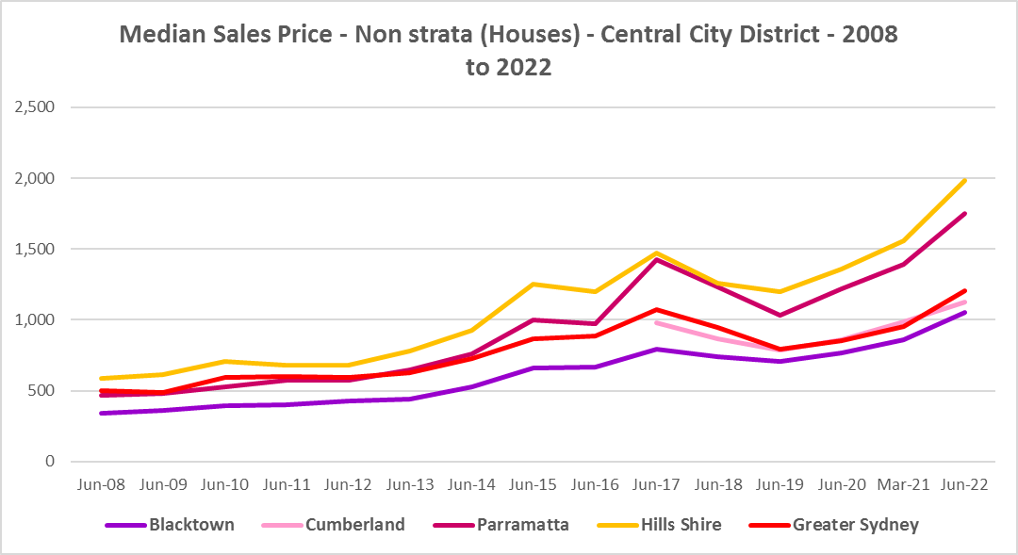

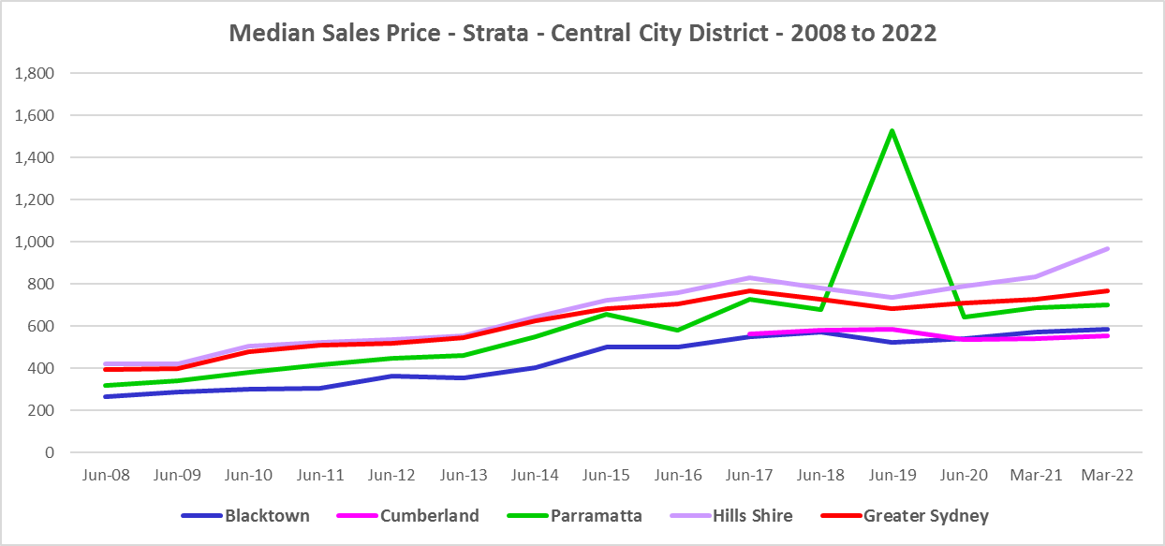

* However, between 2019 and 2022 there were more complex changes in the market, as the graphs above and the two tables below demonstrate. Between March 2019 and March 2020 median house prices declined in every Central City LGA and median strata prices declined in most LGAs.
* Changes in the median sales price for houses over that 12 month period ranged between -16.2% in Parramatta and -4.3% in Blacktown. For strata the change in the median ranged between -8.2% in Blacktown and the anomalous 124.7% increase in Parramatta.
* This compares to a decline of -18.4% for houses and -5.5% for strata properties in Greater Sydney.
* Then between March 2020 and March 2022 there was strong growth in median house and strata prices across Central City. Increases in the median sales price for houses ranged between 46.2% in The Hills and 30.8% in Cumberland. For strata over the same period, increases ranged between 22.7% in The Hills and 3.9% in Cumberland.
* This compares to a 43.0% increase in the median sales price of houses and 5.8% for strata in Greater Sydney.
* Clearly Covid also had an impact on sales prices in the region.

Median Sales Price Houses



Median Sales Price Strata



## Purchase Affordability

* Purchase affordability for very low income earners has varied only marginally over the period from 2017 to 2021 in Greater Sydney and in Central City. Over that period it has never been higher than 2.5% anywhere in the District.
* At June 2021, all the Central City LGAs, along with Greater Sydney, had 0.0% of sales affordable for purchase by very low income households.
* The graph and table below show purchase affordability for very low income households in the Central City LGAs and Greater Sydney between 2017 and 2021.

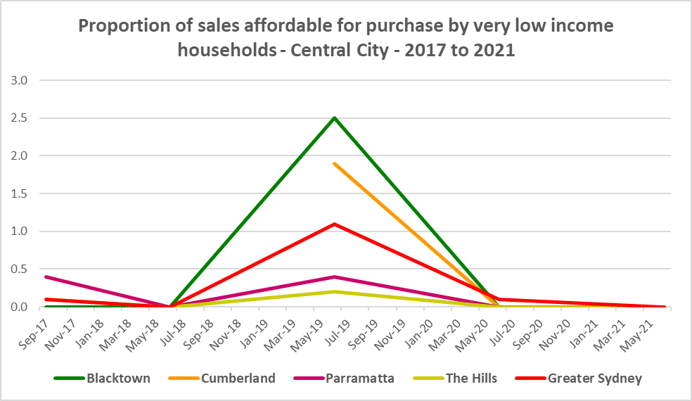

Proportion of sales affordable for purchase by very low income households

* There was a little more variation in affordable purchase for low income households in Central City between 2017 and 2021. The proportion of housing affordable for purchase by low income households in 2021 in Central City ranged between 0.0% in The Hills and 9.1% in Cumberland. Parramatta (1.2%) had a lower proportion affordable for purchase than the average of just 2.3% in Greater Sydney, while Blacktown was a little above with 3.4%.
* The graph and table below show the change in purchase affordability for low income households in Central City, compared to Greater Sydney, between 2017 and 2021.

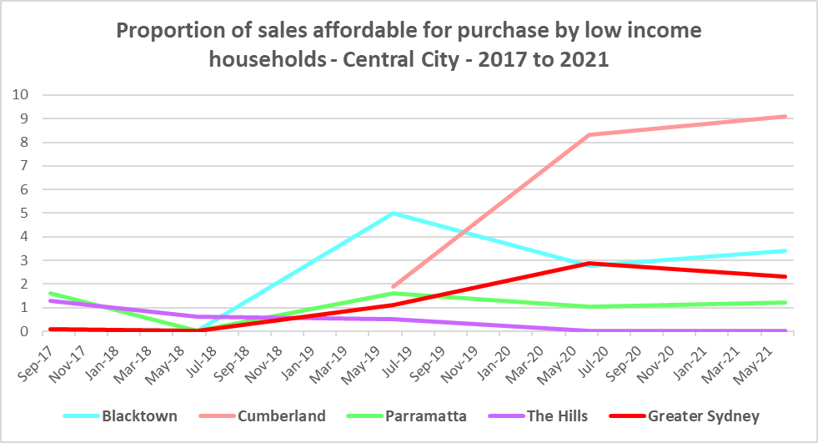

Proportion of sales affordable for purchase by low income households

* Purchase affordability for moderate income households is generally easier in Central City than for Greater Sydney as a whole, however The Hills (5.7%) is well below the Greater Sydney average of 18.1%.
* Cumberland has the most opportunities for moderate income households with 34.1% affordable for purchase by moderate income households, followed by Blacktown with 27.8% and Parramatta with 25.3% at June 2021.
* The graph and the table below show the proportion of sales affordable for purchase by moderate income households in Central City and Greater Sydney between 2001 and 2021.

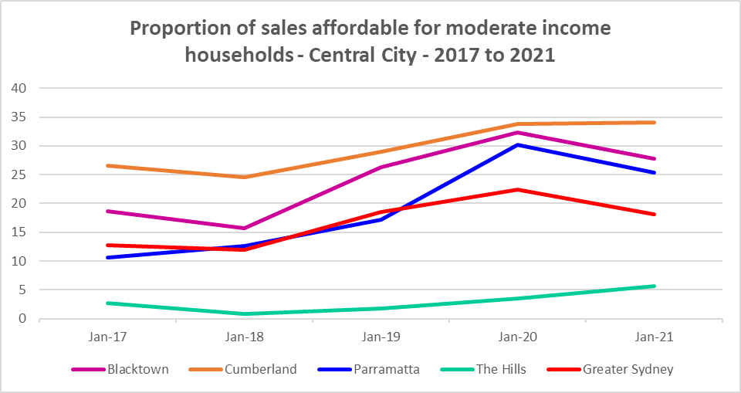

Proportion of sales affordable for purchase by moderate income households

**Purchase Stress**

* In 2021 there were 9,229 very low income households and 12,571 low income households purchasing a home and in stress across Central City – that is, paying more than 30% of their income on their mortgage. This represents 73.4% of very low income purchasers and 46.3% of low income purchasers in the District – higher proportions than the average for Greater Sydney at 69.3% and 43.8% respectively.
* Parramatta (78.4%) had the highest proportion of very low income purchasers in stress, followed by The Hills (75.3%). Every Central City LGA had a higher proportion in stress than the Greater Sydney average.
* Parramatta also had the highest proportion of low income purchasers in stress with 55.2%, followed by The Hills with 52.7% and Cumberland with 46.3%. These three Central City LGAs had a higher proportion of low income purchasers in stress than the average for Greater Sydney, with Blacktown just under on 41.3%.
* Blacktown had the highest number of very low income purchasers in stress (3,178), followed by Cumberland (2,617).
* Blacktown also had the largest number of low income purchasers in stress (3,255), followed by Parramatta (1,982).

Very Low and Low Income Households in Purchase Stress

* However, the number of very low income purchasers in stress is significantly lower than the number of very low income renters in stress in the District, as the graph below demonstrates. There is less difference between low income renters and purchasers in stress, although there are still more renters in stress than purchasers. This suggests that there is a stronger need for more affordable housing for lower income renters than purchasers in Central City.

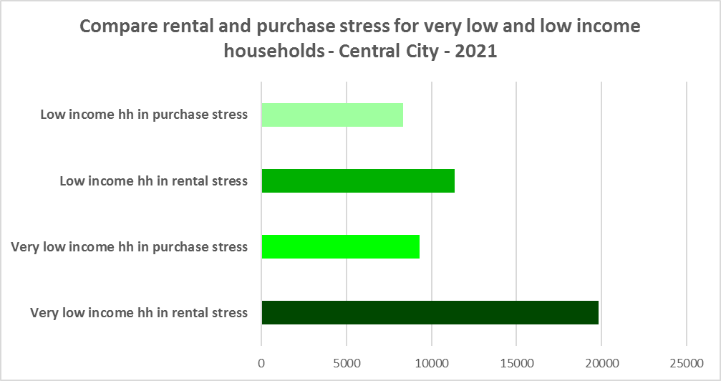

## Additional Data

Additional data on rents and sale prices, including both current and historical data, is available from the Rent and Sales Report and the interactive Dashboard on the Housing NSW website at:

<https://www.facs.nsw.gov.au/resources/statistics/rent-and-sales/dashboard>

More detailed housing data and tables used in this Snapshot are available from the Local Government Housing Kit Database on the DCJ website at:

<https://www.facs.nsw.gov.au/resources/nsw-local-government-housing-kit/chapters/local-government-housing-kit-database>

More information on vacancy rates is available from the Real Estate Institute of NSW website:

<https://www.reinsw.com.au/Web/Web/Members/Property_data/Vacancy_Rates_Survey.aspx>

The Rental Affordability Index is at

<https://sgsep.com.au/projects/rental-affordability-index>