# **South District – What’s the Housing Demand**

This Housing Snapshot looks at aspects of housing demand in South District, particularly from the 2016 Census to the 2021 Census – including population, age profile, household type, household size, income (change in low, moderate and high income households and low income rental households), homelessness and people with disability.

There have been challenges across Australia and in this district since the 2016 Census, including the pandemic and subsequent surge in immigration - which have impacted the community and the demand for housing. Subsequent cost of living pressures, including inflation, rising interest rates and tightening of the rental market also have significant impacts on the demand for housing.

## Population

* Changes in population will impact on the demand for housing.
* Between 2016 and 2021, the population of South District increased by 5.9% or 41,888, from 711,603 to 753,491 (using ABS Census population data).
* However, not every LGA in the District has grown at the same rate.
* Changes in population between 2016 and 2021 within South District ranged from a 7.2% increase in Canterbury-Bankstown to a 3.6% increase in Georges River.
* In terms of numbers, Canterbury-Bankstown had the largest increase with an additional 24,830 people, while Georges River had the smallest increase with 5,312.
* Canterbury-Bankstown has the largest population in the District in 2021 with 371,006.
* The Department of Planning and Environment have prepared population projections for each LGA in the district. None of the LGAs in South District are forecast to have a higher growth rate than the average for NSW of 0.95% per annum, with Canterbury-Bankstown (0.79%), Georges River (0.64%) and Sutherland (0.51%) projected to have lower growth rates.
* Numerically the largest increase in population forecast to 2041 is predicted for Canterbury-Bankstown (65,034), followed by Sutherland (24,994), and Georges River (21,672).
* The table below shows the population change for each South District LGA and the district as a whole from 2016 to 2021, using ABS Census data.



## Age

* The age profile of the District and particularly each LGA will impact on housing need and demand, including number of bedrooms, affordability, location (for example, in relation to services and facilities) and dwelling type.
* The median age of the population of the South District LGAs at the 2021 Census ranges between 36 years in Canterbury-Bankstown and 41 in Sutherland, compared to the average of 37 for Greater Sydney. Georges River has a slightly higher median age than the Greater Sydney average with 38.
* The table below gives the median age for all the Western City LGAs and Greater Sydney.



* Generally, South District has slightly higher proportions of 0-4, 5-14, 15-19, 55-64, 65-74, 75-84 and 85+ year olds, the same proportion of 45-54 year olds and lower proportions of 25-34 and 35-44 year olds than the average for Greater Sydney.
* However, there is variation in the age profiles of the South District LGAs:
  + Canterbury-Bankstown is the only LGA in the District with a higher proportion of 0-4 year olds and a lower proportion of 65-74 and 75-84 year olds than the Greater Sydney average.
  + Georges River is the only LGA in the District with a lower proportion of 5-14 and 15-19 year olds and a higher proportion of 25-34 year olds than the Greater Sydney average.
  + Sutherland is the only LGA in the District with a lower proportion of 20-24 year olds and a higher proportion of 45-54 year olds than the Greater Sydney average.
* The table below gives more detail of the breakdown of age cohorts by LGA, for South District and for Greater Sydney.

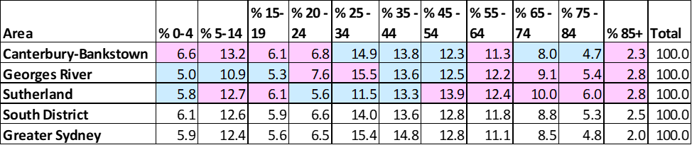

* The graph below shows the proportion of the population in each key age cohort in the South District LGAs as well as the District and Greater Sydney.

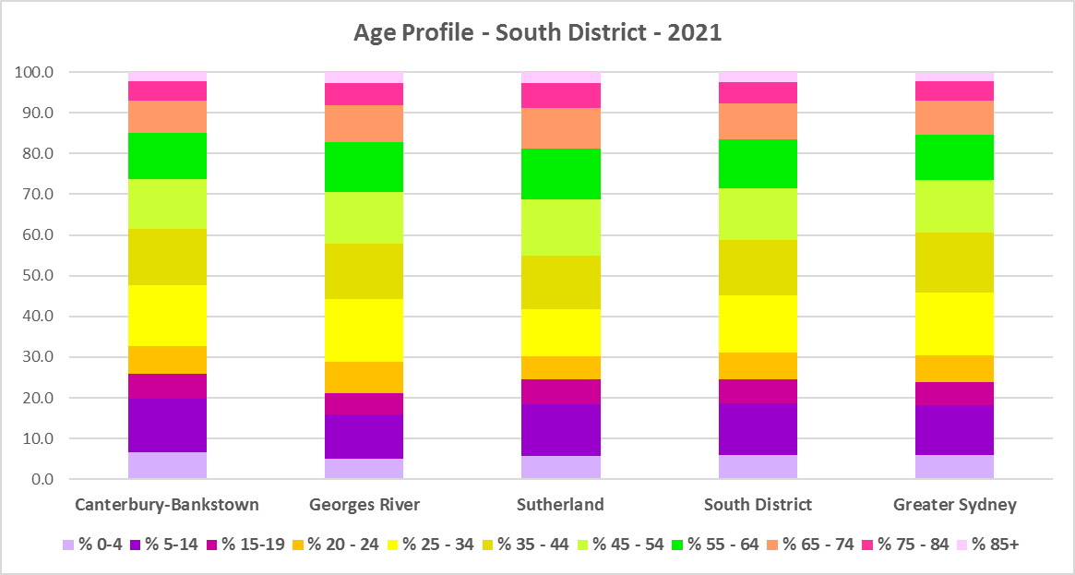

* The Department of Planning and Environment forecast increases in older age groups and no change in younger age groups in every South District LGA to 2041.
* The diversity of age groups requires a range of different housing to meet the needs of the community throughout the housing life cycle.
* There will be an increasing need for housing to suit seniors and frail aged residents as the number of residents in these age groups grows.
* As the Australian Institute for Health and Welfare (AIHW) note:

Many older Australians prefer to age in place, meaning they wish to stay in their local home or community. However, their capacity to do so can be influenced by:

* + the appropriateness and quality of their home (for example, size, layout)
  + their ability to modify their home to suit their functional requirements
  + the cost and availability of suitable housing
  + their need for formal care and assistance
  + their proximity to services and social support.
* Although the majority of older Australians own their own home, this number is declining. About 15% of older Australians are renters. These people are generally a highly vulnerable and economically disadvantaged group, particularly single person households, with older women being the fastest growing demographic of people experiencing homelessness. There is therefore a need for more adaptable, accessible dwellings, well located, secure, low maintenance and affordable to meet the needs of seniors and frail aged in particular, within their communities. Those most in need are households in the private rental market, who struggle to afford housing on an Aged Pension or inadequate superannuation. (Source: "Housing Decisions of Older Australians" Productivity Commission December 2015).
* There are significant numbers of low income households and lower income rental households in this District. Therefore affordability is a key issue for all age groups, including older residents, and particularly tenants.
* The Australian Housing and Urban Research Institute (AHURI) has undertaken research on “What is the ideal home for older Australians?”
  + “Older Australians and the housing aspirations gap” and
  + “Understanding the housing aspirations of older Australians”
* This research is part of a broader study on “Housing aspirations and constraints for lower income Australians.” AHURI’s research demonstrates that one of the most valued aspects of older residents housing is the location – that the neighbourhood feels safe and secure; that there is good (including walkable) access to services such as health, shopping, recreational amenities, public open space; and that it is close to family and friends.

## Household Type

* A look at household types and average household size gives some insight into the type of housing – particularly number of bedrooms – that is likely to be appropriate to meet the housing needs of the community.
* At the 2021 Census in Greater Sydney, couple families with children are the largest household type, comprising 34.4% of all households, followed by couple family without children households (23.3%) and lone person households (22.2%). One parent family households (10.5%), other family households (1.2%), group households (4.0%) and other households (4.3%) make up the remainder.
* Household types in the South District as a whole conform to the pattern of the average for Greater Sydney, with couple families with children being the largest household type, followed by couple families without children and lone person households. However, there is some variation in individual LGAs in the District.
* South District as a whole has slightly lower proportions of couple families without children (22.1%), lone person households (20.6%), group households (2.1%) and other households (which include multi-family households, 2.6%) and somewhat higher proportions of couple family with children households (37.0%), one parent families (11.6%) and other families (1.3%).
* Individual LGAs in the District differ somewhat from this pattern:
  + Georges River and Sutherland have higher proportions of couple families without children than the Greater Sydney average.
  + Sutherland has a lower proportion of one parent families and other families than the Greater Sydney average.
  + Canterbury-Bankstown has a higher proportion of other households than the Greater Sydney average.
* The table and graph below show the proportion in each key household type for every South District LGA, for the District and for Greater Sydney at the 2021 Census.



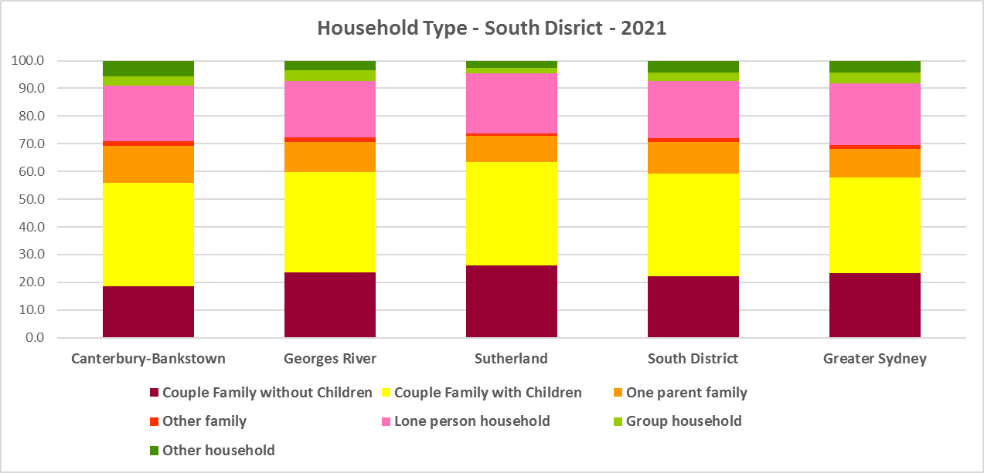

* There has been a shift in the proportions of different household types since the 2016 Census, with an increase in the proportion of lone person households in Greater Sydney (1.8%) and couple family without children households (0.9%), and declines in the proportion of couple family with children households (-0.9%), other household types (-1.3%) and group households (-0.5%).
* The changes in household type from 2016 to 2021 in South District were a little different, with a larger decline in the proportion of couple family with children households (-1.9%), smaller increases in the proportion of couple family without children (0.7%) and lone person households (1.4%), slightly larger increase in the proportion of one parent families (0.2%), same change in other households (-0.1%), and a lower decrease in the proportion of group households (-0.1%).
* Changes in individual LGAs are not all in line with this trend:
  + Canterbury-Bankstown had larger declines in the proportion of couple families with children than the Greater Sydney average.
  + Sutherland had larger increases in the proportion of couple family without children and one parent families.
  + Canterbury Bankstown had increases in the proportion of group households and other households, against the trend.
  + Georges River had a larger increase in the proportion of lone person households.
* This data on household types and changes in household types between the last two Census should be compared with the data on bedroom numbers to determine if there is a good fit between household types and housing stock and what the future housing needs are likely to be.
* Although there should be plenty of housing suitable for families of different sizes, there is also a need for a variety of dwellings with different bedroom numbers to suit couples and single person households.

## Household Size

* At the 2021 Census, the average household size for Greater Sydney was 2.7 persons per household – down from 2.8 persons per household in 2016 and the same as 2.7 persons per household in 2011.
* Average household sizes in South District are at or above the Greater Sydney average, with Canterbury-Bankstown the largest at an average of 2.9 persons per household, followed by Georges River with 2.8 and Sutherland with 2.7.
* Average household size declined in Canterbury-Bankstown and Georges River between 2016 and 2021, while remaining stable in Sutherland.
* The table below gives the average household size in each of the South District LGAs as well as Greater Sydney for 2011, 2016 and 2021.



## Income

* At the 2021 Census, high income households comprise the largest proportion of all households in Greater Sydney – unlike the Rest of NSW, where low income households predominate.
* South District has a slightly higher proportion of low income households (33.2% compared to 32.1%), exactly the same proportion of moderate income households (18.2%) and slightly lower proportions of high income households than the Greater Sydney average (48.6% compared to 49.7%).
* There is considerable variation within the District and not all LGAs in South District conform to this pattern.
  + Canterbury-Bankstown has a much higher proportion of low income households (42.0%), while Georges River has a slightly lower proportion (30.0%) and Sutherland a much lower proportion (22.8%) than the Greater Sydney average.
  + Sutherland has a much lower proportion of moderate income households (15.9%) while Canterbury-Bankstown and Georges River have higher proportions (19.6% and 18.7% respectively) than the Greater Sydney average
  + Canterbury-Bankstown has a much lower proportion of high income households (38.3%), while Georges River has a slightly higher proportion (51.3%) and Sutherland a much higher proportion (61.3%) of high income households than the average for Greater Sydney.
* The graph and table below show the proportion of low, moderate and high income households in all the South District LGAs, compared with the District and Greater Sydney at the 2021 Census.

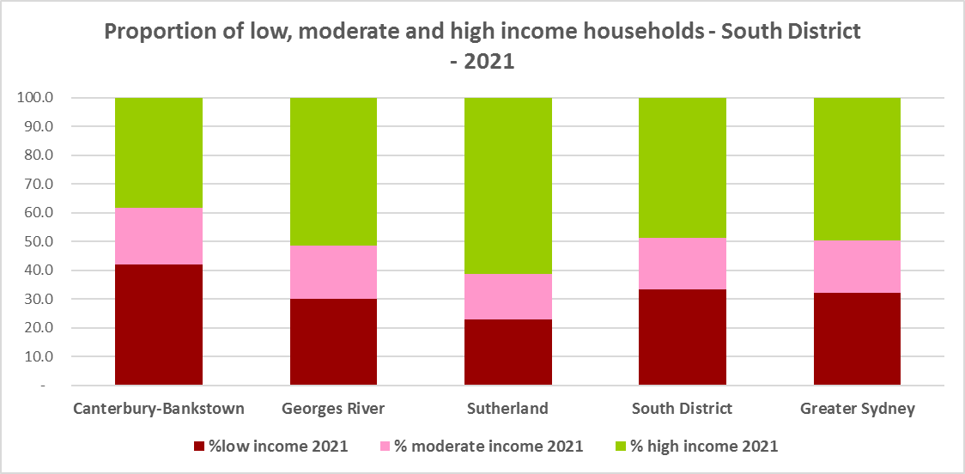



* Between 2016 and 2021 the number of low income households declined in South District as a whole (by -20.7% or -21,894) and in every LGA in the District. Low income households declined by -11,160 or -18.5% in Canterbury-Bankstown; by -5,147 or -24.7% in Georges River; and by -5,587 or -22.7% in Sutherland.
* Over the same period, the number of moderate income households declined in the District (-22.7% or -13,487) and also in every LGA. Moderate income households declined by -4,682 or -16.9% in Canterbury-Bankstown; by -2,881 or -22.8% in Georges River; and by -5,924 or 30.9% in Sutherland.
* High income households increased in South District as a whole by 44,708 or 57.2% and in every LGA in the District. High income households increased by 19,297 or 75.4% in Canterbury-Bankstown; by 9,758 or 56.9% in Georges River; and by 15,653 or 44.2% in Sutherland.
* The two graphs below show the change in the number of low (including very low), moderate and high income households from 2016 to 2021 in South District as a whole and then in the individual LGAs in the District.

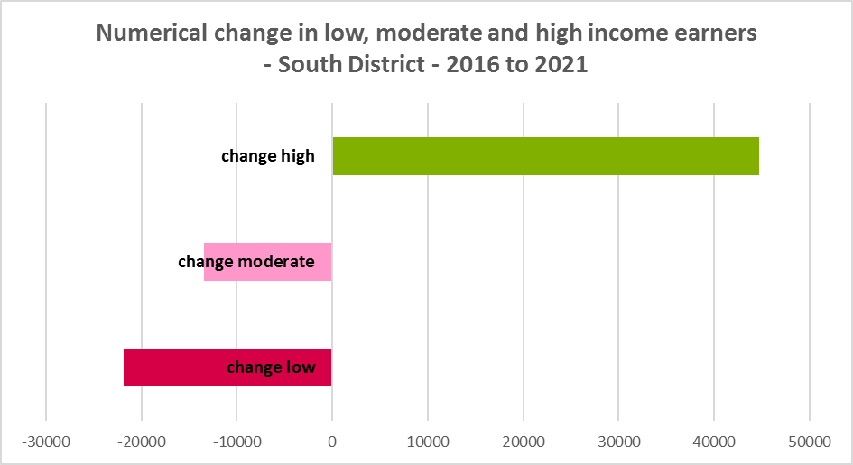

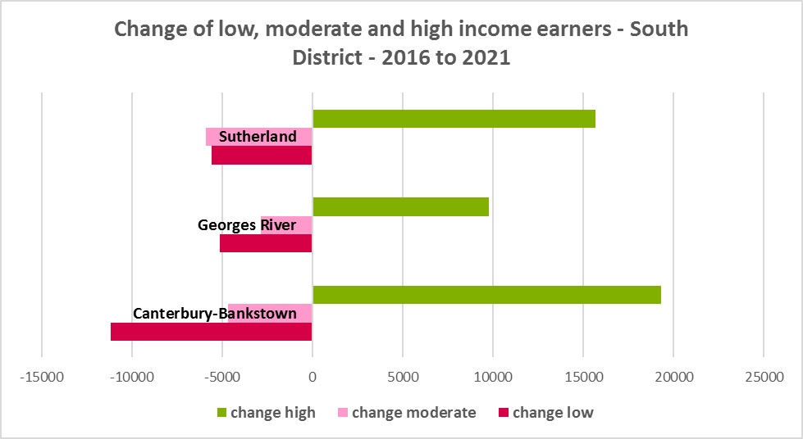

* Over the same period, the number of very low income **renters** and low income **renters** increased in South District as a whole by 12.6% and 16.6% respectively, as well as increasing in each LGA in the District, with the exception of very low income **renters** in Georges River.
* Very low income **renters** increased by 15.0% in Canterbury-Bankstown and 26.6% in Sutherland but declined by -3.0% in Georges River.
* Low income **renters** increased by 17.9% in Canterbury-Bankstown, 13.5% in Georges River and 16.7% in Sutherland.
* The increase in very low (1,808) and low income **renters** (2,004) across South District between 2016 and 2021 when low income earners declined in the District, underlines the need to consider tenure as well as price point when considering responses to meet housing need.
* The graph below shows the change in the number of very low and low income **renters** between 2016 and 2021 in South District LGAs.

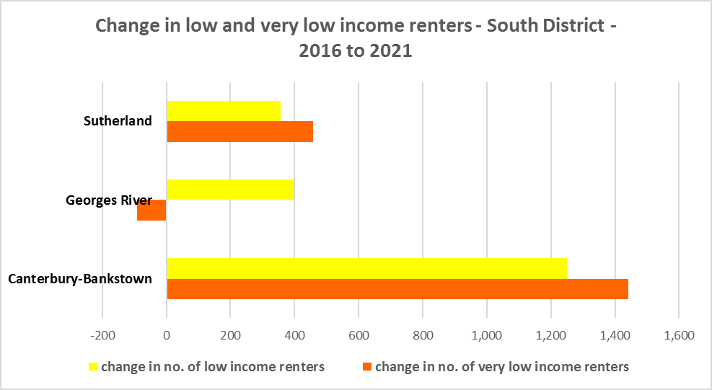

* Sutherland ($2,288) has a higher median household weekly income at 2021 than the average for Greater Sydney ($2,077), while both Canterbury-Bankstown and Georges River have a lower median income, as can be seen in the table below.



## Homelessness

* People experiencing homelessness and those at risk of homelessness are among Australia’s most socially and economically disadvantaged. State, Commonwealth and some local governments fund services to support people who are homeless, or at risk of homelessness. Services are delivered mainly by non–government organisations, some of which specialise in delivering services to specific groups (such as young people or people experiencing domestic violence).
* Inadequate income and inability to access affordable housing are significant contributing factors to homelessness, along with individual factors such as experience of family and domestic violence, ill health and disability.
* The ABS identifies someone as homeless “where they do not have suitable accommodation alternatives and their current living arrangement:
  + Is in a dwelling that is inadequate;
  + Has no tenure or their initial tenure is short and not extendable; or
  + Does not allow them to have control of and access to space for social relations.”
* The ABS uses “six operational groups for presenting estimates of people experiencing homelessness on Census night:
  + People living in improvised dwellings, tents or sleeping out
  + People living in supported accommodation for the homeless
  + People staying temporarily with other households
  + People living in boarding houses
  + People in other temporary lodgings
  + People living in ‘severely’ overcrowded dwellings.”
* The ABS “also compiles estimates from Census data for the following three groups of people who may be marginally housed but are not classified as homeless:
  + People living in other crowded dwellings
  + People in other improvised dwellings
  + People marginally housed in caravan parks.”
* The table below shows that ABS 2021 Census data for South District on the homeless and marginally housed.
* Note that due to additional assistance provided during the pandemic, the number of people counted as homeless on Census night in 2021 is lower than at the 2016 Census. Nevertheless, there were 3,466 people counted as homeless in South District at the 2021 Census and a further 4,898 who were counted as marginally housed.
* Of those who were counted as homeless, the largest number were people living in severely crowded dwellings (2,606 or 75.2%), followed by people living in boarding houses (418 or 12.1%), then people in supported accommodation for the homeless (246 or 7.1%). Of those who were counted as marginally housed, the overwhelming majority were people living in other crowded dwellings (4,898 or 99.1%).
* This clearly indicates the need for more affordable rental housing.



* The 2023 NSW street count, the NSW Government’s fourth annual rough sleeping street count, was completed between 2 February and 27 February 2023.
* Over 300 local organisations either consulted in the planning phase or participated in the delivery of street counts. Organisation which partnered with the Department of Communities and Justice (DCJ) included Community Housing Providers, local councils and Specialist Homelessness Services, as well Aboriginal organisations, Local Health Districts, local community groups, and Police.
* 1,623 people were counted sleeping rough during these street counts, a 34% increase from 2022.
* Street counts took place in more than 350 towns in 76 LGAs, compared to 71 LGAs in 2021 and 65 LGAs in 2020.
* The table below gives the street count results for the South District locations.

## 

## People with Disability

* According to the Australian Institute of Health and Welfare (AIHW) and data from the 2018 Australian Bureau of Statistics (ABS) Survey of Disability, 18% of people in Australia have disability. Another 22% have a long term health condition but not disability.
* Nearly one third (32%) of people with disability have severe or profound disability. This means needing help with daily self-care, mobility or communication activities, having difficulty understanding or being understood by family or friends, or communicating more easily using sign language or other non-spoken forms of communication.
* The survey data shows:
  + 7.6% of children aged 0–14 have disability
  + 9.3% of people aged 15–24 have disability
  + 13% of people aged 15–64 have disability
  + 50% of people aged 65 and over have disability (ABS 2019b).
* For about 3 in 4 (77%) people with disability, the main type of disability is physical, while for the remaining 1 in 4 (23%), the main type of disability is mental or behavioural.
* Clearly housing is a significant factor in the health and wellbeing of people with disability. The availability of affordable, sustainable and appropriate housing helps people with disability to participate in the social, economic and community aspects of everyday life. Someone without access to affordable, secure and appropriate housing is more likely to experience homelessness, poor health, and lower rates of employment and education.
* While most people with disability live at home in the community (96% in private dwellings), some live in cared accommodation.
* Cared accommodation is usually long term and may be institutional in style, including hospitals, residential aged care, cared components of retirement villages, aged care hostels, psychiatric institutions and group homes for people with disability. The more severe a person’s disability is, the more likely they are to live in cared accommodation and the less likely they are to live in the community.
* There has been a significant shift towards supporting people with disability to live in private dwellings, rather than being in institutional care over recent decades. Largely this has been driven by changes for young people with disability.

## Additional Data

More detailed housing data and tables used in this Snapshot are available from the Local Government Housing Kit Database on the FACS website at:

<https://www.facs.nsw.gov.au/resources/nsw-local-government-housing-kit/chapters/local-government-housing-kit-database>

More information on the housing needs of older Australians and people with disability:

The Australian Institute of Health and Welfare – Older Australians Housing and Living Arrangements on the AIHW website at:

<https://www.aihw.gov.au/reports/older-people/older-australians/contents/housing-and-living-arrangements>

The Australian Institute of Health and Welfare – People with Disability in Australia

<https://www.aihw.gov.au/reports/disability/people-with-disability-in-australia/contents/people-with-disability/prevalence-of-disability>

and relating to housing needs

<https://www.aihw.gov.au/reports/disability/people-with-disability-in-australia/contents/housing>

The Productivity Commission’s report Housing Decisions of Older Australians is at:

<https://www.pc.gov.au/research/completed/housing-decisions-older-australians>

More detailed information on population, household and dwelling projections is available on the Department of Planning and Environment website at:

<https://www.planning.nsw.gov.au/Research-and-Demography/Population-Projections/Projections>

<https://pp.planningportal.nsw.gov.au/populations>

More data on homelessness, specifically homelessness service data is available on the Homelessness NSW website at:

<https://homelessnessnsw.org.au/resource/specialist-homelessness-service-data/>

And from the AIHW website here:

<https://www.aihw.gov.au/reports/australias-welfare/homelessness-and-homelessness-services>

The 2023 Street Count result is at the DCJ/ FACS website here:

<https://www.facs.nsw.gov.au/reforms/homelessness/premiers-priority-to-reduce-street-homelessness/street-count>

Further information on ABS estimation of homelessness is available at the ABS website:

<https://www.abs.gov.au/statistics/people/housing/estimating-homelessness-census/2021>