**Hunter – What’s Happening in the Housing Market?**

This Housing Snapshot looks at aspects of the housing market in the Hunter, particularly from the 2016 Census to the 2021 Census – including rents, vacancy rate, affordable private rental for very low and low income households, rental stress for low income households, number of new bonds lodged affordable to low income households, sales price, purchase affordability for very low and low income households and purchase stress for low income households.

The Hunter has a strong regional economy with projected continued population growth, high amenity and environmental diversity and is also close enough to Sydney to be impacted by the housing market there. This region has seen strong price growth in both rents and sales, prolonged tight vacancy rates indicating an undersupply of private rental, a significant loss of affordable rental housing supply yet strong demand from the significant number of low income residents, with many residents in housing stress.

There have been changes across the Hunter since the 2021 Census, with Covid having an impact on the housing market. Recent additional cost of living pressures, including rising inflation and interest rates with continued low wage growth, have created further difficulties for lower income earners and their capacity to manage housing costs.

**Hunter Region – What’s Happening in the Housing Market?**

# ***Housing Market - Rental***

**Rents**

* There has been strong growth in median rents for all dwellings (including all housing types and all bedroom categories) in the Hunter region for a long time, as the graph below shows. It tracks the change in median rent (for all dwellings) for all the Hunter LGAs from June 1990 to June 2022 (from 2017 for Mid Coast).
* The table below gives change in median rent for all dwellings, from 2017 to 2022 for each Hunter LGA.



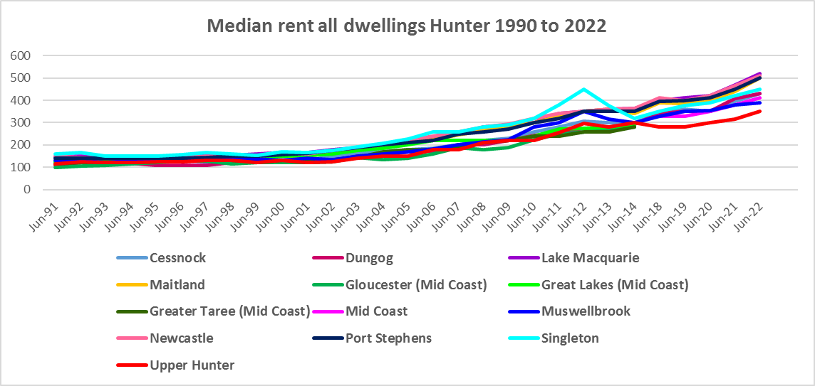

* However, there was no even progression in the increase of median rents over the last five years.
* Between 2019 and 2020 when Covid lockdowns were introduced, median rents in the Hunter region local government areas were fairly stable – with no change, slight increases or slight decreases in median rents as the table below demonstrates.
* During that period, the largest percentage drop in median rents occurred in Singleton LGA for three bedroom homes (-6.0%) while the biggest increase was for two bedroom homes in Upper Hunter (8.7%). As is evident from the table below many LGAs had no increase in median rents over that year.



* However, between 2020 and 2022 when Covid restrictions were relaxed, there were strong increases in median rents across the region, as the table below shows.
* Generally Newcastle ($160 for 4 bedroom), Lake Macquarie ($130 for 4 bedroom) and Port Stephens ($120 for 4 and $120 for 3 bedroom) experienced the largest increases in rents in dollar terms. Maitland, Cessnock, Mid Coast and Singleton also experienced hefty dollar increases in median rents over this period.
* In percentage terms, increases in median rents were robust across all local government areas and bedroom categories in the Hunter.
* Overall the highest percentage increase in median rents between June 2020 and June 2022 were for one bedroom homes in Maitland (36.4%) and Mid Coast (34.6%), followed by two bedroom homes in Port Stephens (31.3%) and three bedroom homes in Dungog (30.4%).
* At June 2022, median rents for one bedroom homes ranged between $270 (Cessnock) and $330 per week (Port Stephens); for two bedroom homes between $320 (Upper Hunter) and $500 per week (Newcastle); for three bedroom homes between $380 (Upper Hunter) and $580 per week (Newcastle); and for four or more bedroom homes from $460 (Muswellbrook) and $690 per week (Newcastle).



**Vacancy Rate**

* A vacancy rate of 3% is understood to represent a balance between supply and demand. According to REINSW data, vacancy rates were below 3% for Newcastle and the rest of the Hunter for most of the period from 2006 through to 2022 and consistently since 2015. For much of that time the vacancy rate has been below 2% - indicating a chronic shortage.
* At April 2023 the vacancy rate in Newcastle was 1.8%. In the rest of the Hunter the vacancy rate was 2.0% and on the Mid North Coast was 1.4%. This compares with 1.3% in Sydney and Wollongong, 1.7% on the Central Coast, 2.1% in New England and 1.6% in the Central West of NSW.
* Vacancy rates are tight across almost all of NSW, indicating a significant undersupply of rental accommodation. Anecdotally, tenants are struggling to secure accommodation, with strong competition for rental properties, rent bidding, strong rental increases, more tenants paying more than 50% of their income in rent and some potentially facing homelessness.
* The two graphs below show the long term vacancy rate for Newcastle, the rest of the Hunter and the Mid North Coast.

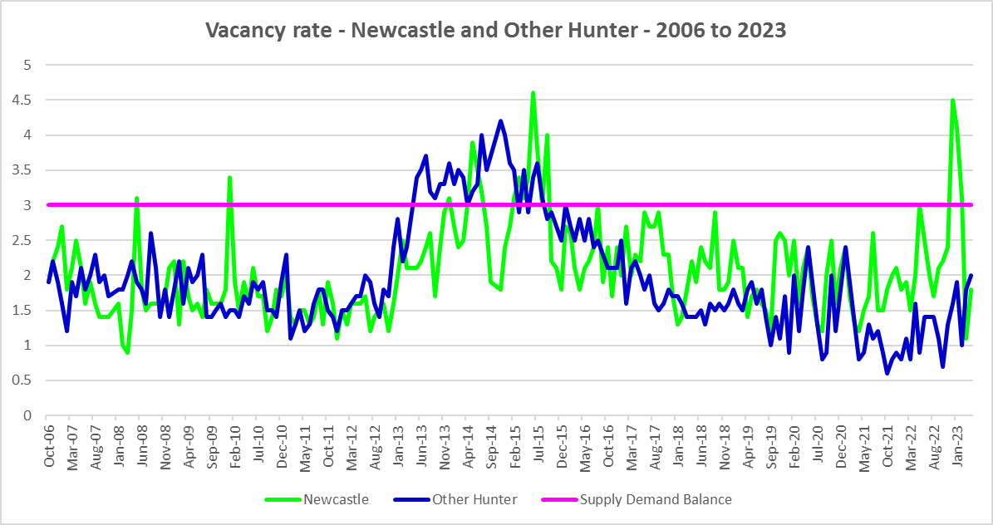

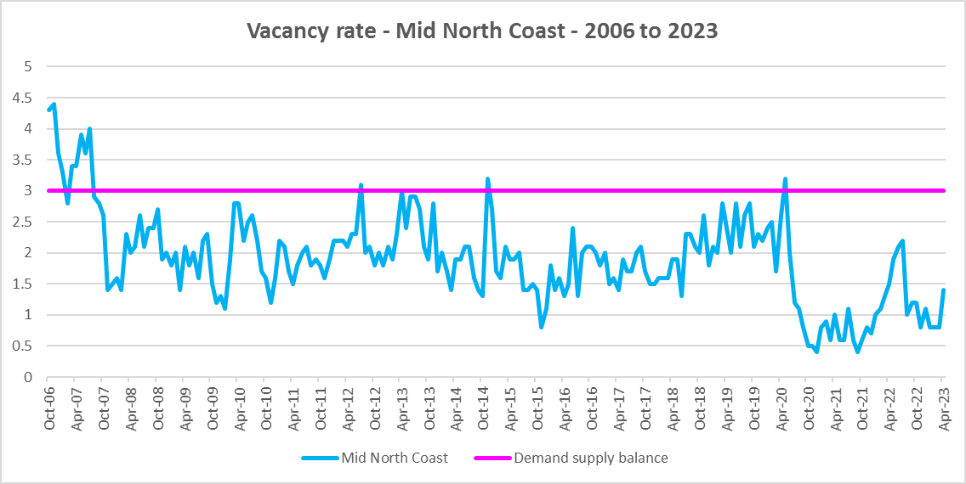

**Affordable Rental**

* The general trend across Sydney and NSW has been for a decline in the proportion of rental stock which is affordable for very low, low and moderate income earners. Although this region is more affordable than Sydney, the reduction in the proportion of rental housing that is affordable has been concerning.
* The trend to decline in affordable rental is also apparent in the Hunter, although along with elsewhere in NSW, there were more complex factors at play between 2019 and 2022.
* Across the Rest of NSW, the proportion of affordable rental for very low income households stayed at the 2018 level of 22.0% for 2019, improved slightly to 21.7% in 2020 and again to 21.9% in 2021 then declined in line with the longer term trend to 17.0% in 2022.
* In the Hunter, this pattern was more varied. Between 2018 and 2019 rental affordability for very low income households improved in Lake Macquarie, Maitland, Mid Coast, Newcastle and Upper Hunter and declined in Cessnock, Muswellbrook, Port Stephens and Singleton. (Note there was insufficient data in Dungog to determine the proportion of affordable rental for very low income households in 2018, 2020 and 2021. However, the proportion of affordable rental has clearly declined between 2017 and 2019 and again to 2022.)
* Between 2019 and 2020 the proportion affordable for rental by very low income households declined in most Hunter LGAs – excepting Cessnock, Mid Coast and Port Stephens.
* Between 2020 and 2021 rental affordability improved in Lake Macquarie, Muswellbrook, Newcastle and Singleton and declined everywhere else.
* Between 2021 and 2022 rental affordability for very low income households declined in every Hunter LGA in line with the trend in the Rest of NSW, with the exception of Cessnock, Muswellbrook and Port Stephens.
* At June 2022, every Hunter LGA (excepting Upper Hunter and Muswellbrook), had a lower proportion of affordable rental for very low income households than the Rest of NSW average of 17.0%. Lake Macquarie had the lowest proportion with 6.2%, followed by Maitland with 7.7% and Port Stephens with 7.8%.
* The table and graph below show the change in the proportion of private rental accommodation affordable to **very low income** households in the Hunter LGAs and Rest of NSW between 2017 and 2022.

Proportion affordable rental for very low income households



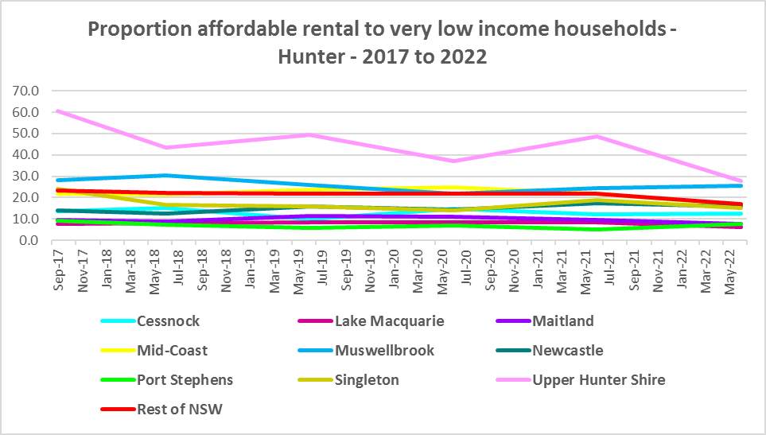

* The proportion of rental affordable for **low income** households has also declined in the Hunter, with every LGA having a lower proportion of affordable rental for low income households in 2022 than in 2017.
* Between 2018 and 2020 the proportion of rental affordable for low income households increased gently from 54.1% to 55.2% and then declined again to 45.4% in June 2022 in the Rest of NSW.
* Again the picture in the Hunter was more varied.
* Between 2018 and 2019 affordability improved in Lake Macquarie, Maitland, Mid Coast, Newcastle, Port Stephens and Upper Hunter and declined in Cessnock, Muswellbrook and Singleton. (Note the proportion affordable rental is not available for Dungog for 2018, 2020 and 2021. However the proportion affordable rental for low income households in Dungog increased between 2017 and 2019 and declined to 2022).
* Between 2019 and 2020 the proportion affordable for rental for low income households increased in Cessnock, Lake Macquarie, Muswellbrook and Port Stephens and declined everywhere else.
* Between 2020 and 2021 affordable rental for low income households declined in every Hunter LGA excepting Singleton and Upper Hunter.
* Then between 2021 and 2022 affordability declined in every Hunter LGA with the exception of Muswellbrook.
* At June 2022 four Hunter LGAs have a lower proportion of affordable private rental for low income households than the average of 45.4% for the Rest of NSW – Lake Macquarie, Maitland, Port Stephens and Newcastle.
* The table and graph below show the change in the proportion of private rental accommodation affordable to **low income** households in the Hunter and Rest of NSW between 2001 and 2022.

Proportion affordable rental for low income households



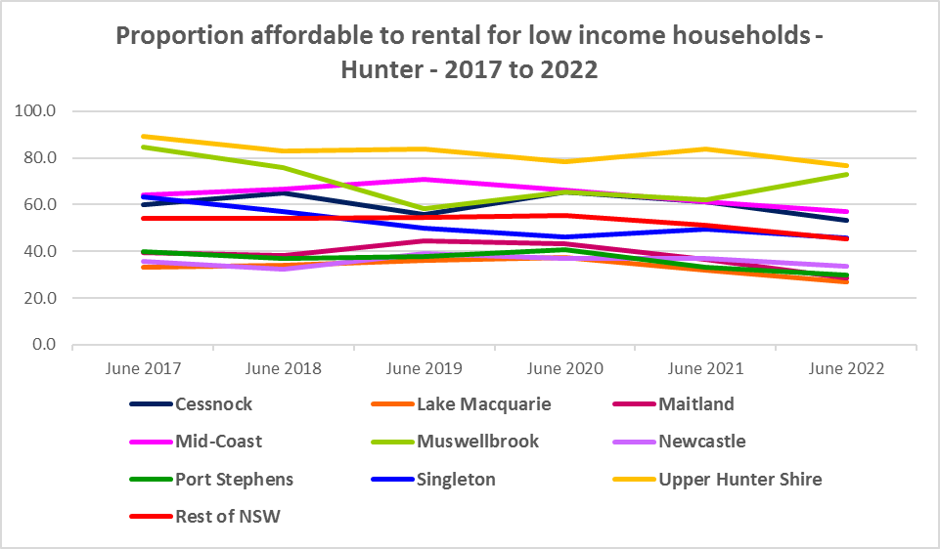

* There is evidence that short term holiday rentals such as Airbnb are impacting the supply of housing, including long term rental and affordable housing in cities and coastal communities.
* The University of Sydney Urban Housing Lab undertook a study and prepared a report for the Australian Coastal Councils on short term holiday rentals: “Planning responses to online short term holiday rental platforms” - Research Project for Australian Coastal Councils Association Inc. September 2018 by Nicole Gurran, Yuting Zhang, Pranita Shrestha, Catherine Gilbert.
* The study found (p7) “that there has been a rapid growth in online holiday rental listings overall and in coastal Australia in particular. Since Airbnb was launched in Australia, the number of listings has risen to over 130,000 properties, amounting to around 0.2% of the housing stock nationwide. If holiday rentals are considered to be part of the rental housing stock (a smaller proportion of Australian homes), then Airbnb listings for whole homes represent around 3.5% of rental accommodation. In coastal communities, the rate is much higher. Across the communities in this study, between 0.3% (Moreton Bay) and 17.6 % (Byron) of the total housing stock is listed on Airbnb.”
* Further (p7) “the majority of these listings are whole houses, and more than half appear to be frequently available holiday lets rather than permanent residences. Considered as part of the rental housing stock, these whole houses, frequently available, amount to 19.7% of the rental housing stock in Kiama…and 48.3% of the rental housing stock in Byron”. The report states that (p23) “Airbnb listings…is equivalent to around a fifth of the rental housing stock in Kiama (and) Shoalhaven…”
* None of the coastal communities in the Hunter were included in the 10 case study communities examined in the study. Nevertheless, the study identified impact to communities within a 3 hour radius of capital cities. Much of the Hunter falls into this category. This report, in discussing the implications for local housing markets, noted that (p36) “Many, but not all, of the case study communities report that lower income residents and local workers face barriers in securing affordable rental housing or entering home ownership”.
* The rapid growth in on line listings and loss of affordable rental accommodation are likely connected, with tourist accommodation outcompeting longer term renting for locals, particularly in Hunter coastal communities. This may go some way to explaining the decline in low income **rental** households in Mid Coast and Port Stephens.
* In addition, the report for the Australian Coastal Councils on short term holiday rental platforms states (p33) “the income from online holiday rentals is comparable to up to 170% of the income derived from existing permanent rental properties, making them an attractive proposition for investors. Indeed, interviewees on the NSW South Coast… advised that they had observed the rise of a new type of investor who purchased homes solely for the purpose of operating a holiday rental.”[1]
* This may help explain some of the decline in low income households in Lake Macquarie, Newcastle and Port Stephens.
* More recently, research by SQM showed that between July 2019 and July 2020 Muswellbrook Council had an increase of 191% in Airbnb listings, Cessnock by 13%, Maitland by 8%, Greater Taree by 5%, Dungog by 1%, while Lake Macquarie experienced no change and Great Lakes declined by -3%, Singleton by -5%, Gloucester by -18%, Newcastle and Upper Hunter by -32% and Port Stephens by -42%
* Since 2020 it is likely that Airbnb listings have picked up again in the Hunter.

**Rental Stress**

* Households are regarded as being in rental stress when renting in the private rental market and paying more than 30% of their income in rent. Lower income households in rental stress will struggle to pay for other essential household costs, such as medical or educational expenses, food, transport and energy costs.
* At June 2021 the proportion of very low income households in rental stress in the Rest of NSW (that is, excluding Sydney) was 91.7%. Within the Hunter, the average was higher than the Rest of NSW at 94.9%, with the proportion varying from 96.6% in Maitland to 84.7% in Upper Hunter.
* Six of the Hunter LGAs had a higher proportion of very low income households in rental stress than the average for the Rest of NSW – in addition to Maitland, Newcastle (96.4%), Lake Macquarie (95.9%), Port Stephens (95.2%), Cessnock (94.5%) and Mid Coast (93.0%).
* For the Rest of NSW at 2021 the proportion of low income households in rental was 68.3%, with the Hunter average significantly higher on 73.6%. Across the region the proportion of low income households in stress ranged from 79.7% in Newcastle to 48.4% in Upper Hunter.
* Five Hunter LGAs had a higher proportion of low income households in rental stress than the Rest of NSW – in addition to Newcastle, Lake Macquarie (77.9%), Port Stephens (76.2%), Maitland (70.9%) and Mid Coast with (69.5%).
* However, while the **proportion** of very low and low income households in stress increased in most Hunter LGAs between the 2016 and 2021 Census (Dungog and Singleton increased for low income households but declined marginally for very low), the actual numbers in stress tell a different story.
* The **number** of very low income households in stress have declined in every Hunter LGA over this time frame.
* The picture for low income households in rental stress is the exact opposite, with numbers increasing between 2016 and 2021 in every Hunter LGA.
* Below is a graph of the proportion of very low and low income households in rental stress in each Hunter LGA at 2021 and a table showing the change in the proportion of very low and low income households in stress between 2016 and 2021.

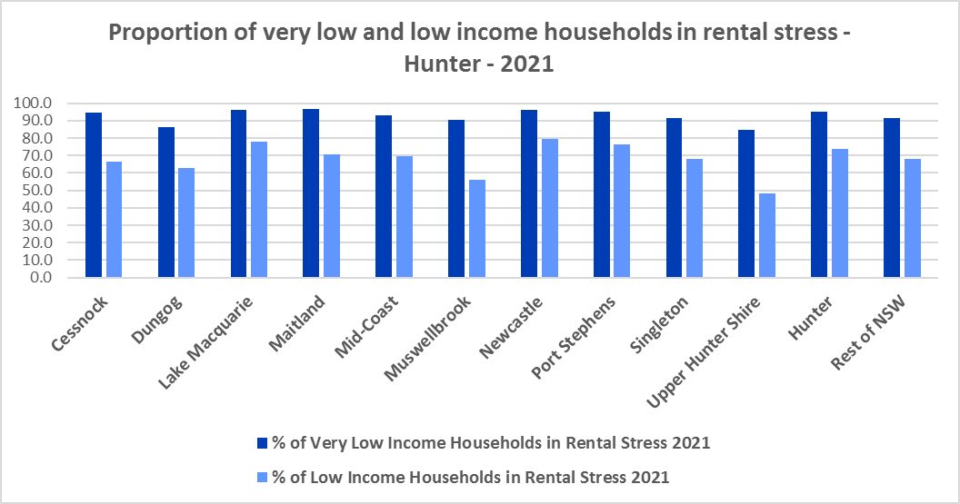



* The next table shows the change in the number of very low and low income households in rental stress at 2016 and at 2021.
* Again Covid has had an impact on the rental market and on tenants.
* A look at CRA (Commonwealth Rent Assistance) recipients in housing stress gives some further information on what has been happening with lower income households in rental stress over this time frame.



* In line with other parts of NSW, between 2016 and 2020, the total number of CRA recipients in the Hunter increased significantly, while the number in stress actually declined. However, between 2020 and 2021 the number of CRA recipients declined while the number in stress increased.
* The number of CRA recipients in housing stress has increased from the June 2020 figures as the temporary Coronavirus Supplement ended on 31 March 2021.
* The Coronavirus Supplement was $550 per fortnight for new and existing recipients of JobSeeker Payment, Parenting Payment, Youth Allowance for jobseekers, Farm Household Allowance and Special Benefit. The temporary supplement almost doubled the maximum payment rate for a JobSeeker Payment recipient. Hence it made rent more affordable for some CRA recipients in June 2020 and resulted in a lower proportion of CRA recipients in rental stress than usual.
* Since the end of Covid restrictions, the number of people in employment has increased, so fewer people are relying on rent assistance from the Commonwealth.
* The two graphs below clearly demonstrate this experience in the Hunter.

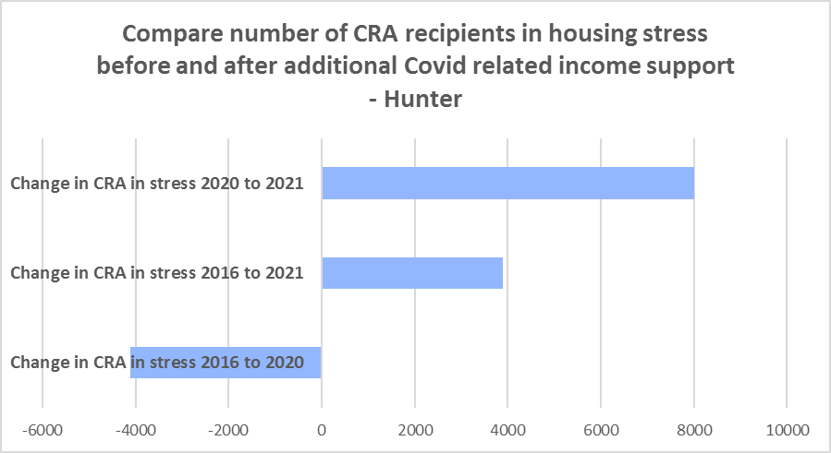

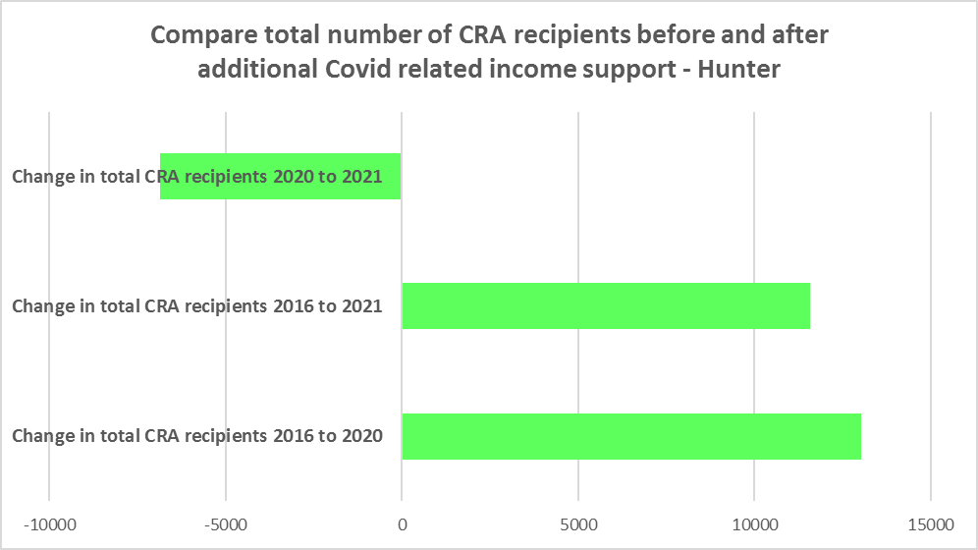

* The table below shows the number and proportion of tenants in the Hunter region who are in the private rental market, are in receipt of Commonwealth Rent Assistance, and even with this additional income support, are in housing stress.
* There were a total of 24,490 tenants in receipt of CRA and in housing stress across the region in 2021, up from 20,605 in 2016. In 2016, 39.4% of CRA recipients in the Hunter were in stress, increasing to 41.9% in 2021. This compares to 35.1% CRA recipients in stress in 2016 for the Rest of NSW and 39.2% in 2021.
* Like the Rest of NSW, the Hunter region is becoming increasingly unaffordable for lower income tenants – although clearly affordability is much tighter in some LGAs than others.
* There are three local government areas in the region with a higher proportion of CRA recipients in stress than the Rest of NSW – Newcastle has the highest with a huge 55.0%, followed by Lake Macquarie with 43.4% and Dungog with 40.0%. These areas in particular are less affordable for lower income tenants.



**Loss of Affordable Housing Stock**

* DCJ has calculated the number of new bonds lodged with the Rental Bond Board that were affordable to low income earners in the Hunter region in 2017, 2021 and 2022. The region experienced a significant decline in affordable bonds lodged, and consequently loss of affordable housing between 2017 and 2022 – with 699 fewer affordable bonds lodged – representing a reduction of 25.0% in affordable rental stock.
* The table below shows the number of new bonds lodged that were affordable to low income households (including very low income households) in 2017, 2021 and 2022 in each of the Hunter LGAs as well as the total for the Region.
* It is clear from the table that Mid Coast (-140), Lake Macquarie (-104), Cessnock (-101), Maitland (-94), Newcastle (-91) and Port Stephens (-88) had the largest numeric losses. Proportionately, Singleton experienced the largest decline (-48.0%), followed by Port Stephens (-38.9%), then Cessnock (-36.3%), Maitland (-35.2%) and Upper Hunter (-33.3%).

Number of affordable rental properties (new bonds lodged) affordable to low income households



# ***Housing Market - Purchase***

**Sales Price**

* Changes in the median sales price of both houses and flats in the Hunter over the ten years to March 2022 have been upward.
* Dungog (197.2%), Port Stephens (137.0%), Newcastle (136.5%) and Lake Macquarie (134.3%) had the largest proportional increase in median sales price for houses over this period.
* For strata properties, Port Stephens (145.6%) and Newcastle (101.2%) had the largest proportional increase in median sales price over the ten year time frame.
* At March 2022, Newcastle had the highest median sales price for houses with $955,000, followed by $919,000 in Lake Macquarie, $910,000 in Port Stephens and $847,000 in Dungog. Port Stephens had the highest median sales price for flats at March 2022 with $415,000, followed by Newcastle with $339,000.
* The table below shows changes in the median sales price of both houses and flats over the last ten years in the Hunter region.



* The long term median sales price trend for houses and flats shows growth across all LGAs, particularly from around 2002. The long term trend for strata properties is similar.
* The two graphs below show the median sales price trend for houses and for strata properties from 1991 to 2022 in all Hunter LGAs. It is clear that the median sales prices are highest in Newcastle, Lake Macquarie and Port Stephens.

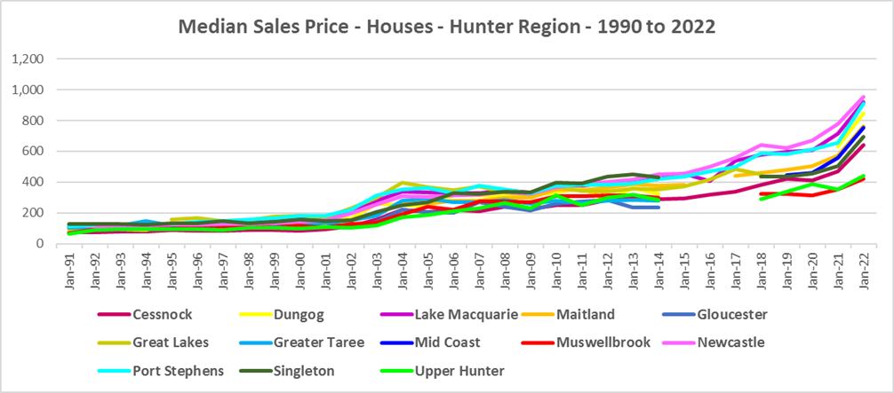

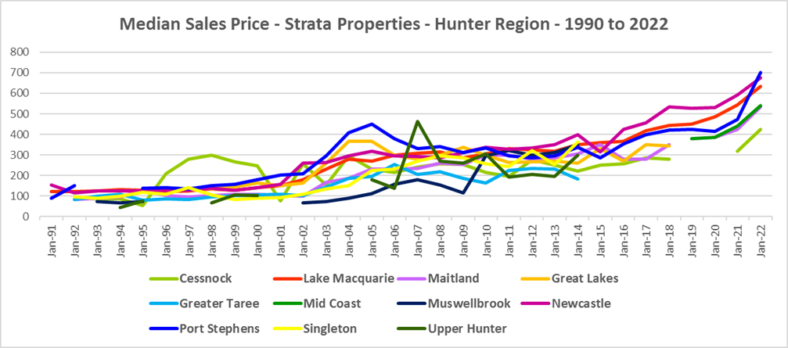

* However, between 2019 and 2022 there were more complex changes in the market, as the two tables below demonstrate. Between March 2019 and 2020 median house and strata prices experienced relatively low growth in most Hunter LGAs, with Cessnock and Muswellbrook actually seeing a fall in median house prices over that year. Changes in median sales price for houses ranged between -3.1% in Muswellbrook and 15.4% in Upper Hunter, while for strata the change in the median ranged between -2.1% in Port Stephens and 7.3% in Lake Macquarie.
* Between March 2021 and March 2022 there was strong growth in median house and strata prices across the Hunter. Increases in the median sales price for houses ranged between 39.1% in Port Stephens and 19.2% in Muswellbrook. For strata over the same period, increases ranged between 47.7% in Port Stephens and 14.0% in Newcastle.
* Clearly Covid also had an impact on sales prices in the region.



* At March 2022, median sales price for houses ranged between $423,000 in Muswellbrook and $955,000 in Newcastle, while for strata properties, the median sales price ranged between $425,000 in Cessnock and $700,000 in Port Stephens.



**Purchase Affordability**

* Purchase affordability for very low income earners has varied over the period from 2017 to 2021 in the Rest of NSW and the Hunter generally.
* At June 2021, all the Hunter LGAs, with the exception of Upper Hunter and Muswellbrook, had a lower proportion of affordable purchase for very low income households than the average for the Rest of NSW of 7.5%.
* Dungog, Lake Macquarie, Maitland, Newcastle and Port Stephens all had no sales affordable for purchase by very low income households at June 2021.
* Upper Hunter is the only LGA in the region to have a higher proportion of sales affordable for purchase by very low income households in 2021 than in 2017. All other Hunter LGAs have seen a decline in purchase affordability for very low income households over this period.
* The graph and table below show purchase affordability for very low income households in the Hunter LGAs and the Rest of NSW between 2017 and 2021.

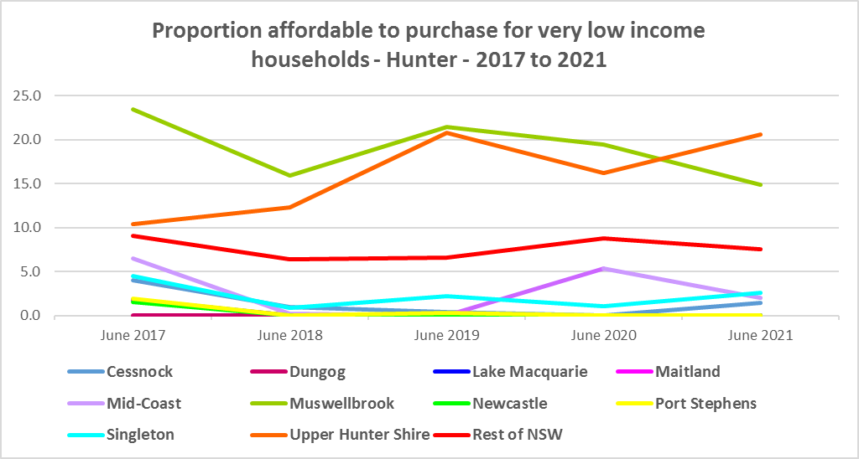

Affordable purchase for very low income households 2001 to 2021



* With the exception of Muswellbrook and Upper Hunter, all the Hunter LGAs had a lower proportion of housing affordable for purchase by low income households in 2021 than in 2017. Again there has been some volatility in affordable purchase affordability over this time frame, with all LGAs excepting Upper Hunter seeing a decline in affordability since 2020.
* At June 2021, six LGAs in the Hunter had a lower proportion of housing affordable for purchase by low income households than the Rest of NSW average of 23.8% (Newcastle, Lake Macquarie, Maitland, Port Stephens, Dungog and Cessnock).
* Newcastle had the lowest proportion of affordable purchase for low income households with just 0.9%, followed by Lake Macquarie with 1.4%, while Muswellbrook had the highest proportion with 80.1%.
* The graph and table below show the change in purchase affordability for low income households in the Hunter, compared to the Rest of NSW, between 2017 and 2021.

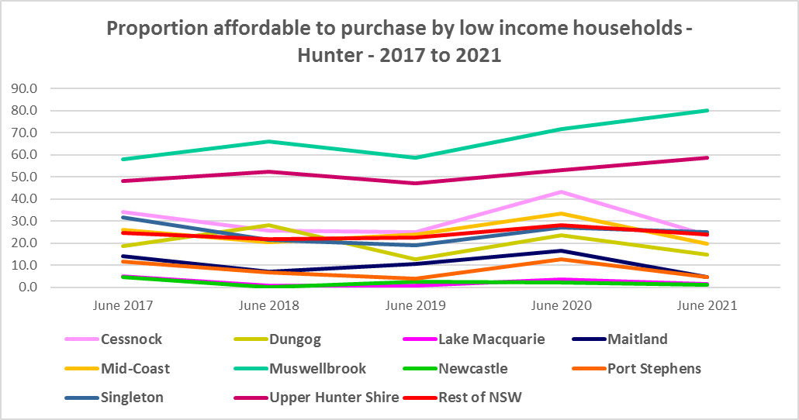

Affordable purchase for low income households 2001 to 2021



**Purchase Stress**

* In 2021 there were 2,750 very low income households and 3,047 low income households purchasing a home and in stress across the Hunter – that is, paying more than 30% of their income on their mortgage. This represents 47.2% of very low and low income purchasers in the region – a higher proportion than the average for the Rest of NSW at 43.9%.
* Singleton had the highest proportion with 52.7%, followed by Dungog with 50.5%.
* Lake Macquarie had the highest number of very low and low income purchasers in stress with 3,582, followed by Mid Coast with 2,567, Newcastle with 1,977 and Port Stephens with 1,487.



* However the number of very low and low income purchasers in stress is significantly lower than the number of very low and low income renters in stress in the region, as the graph below demonstrates. There is a stronger need for more affordable housing for lower income renters than purchasers in the Hunter.

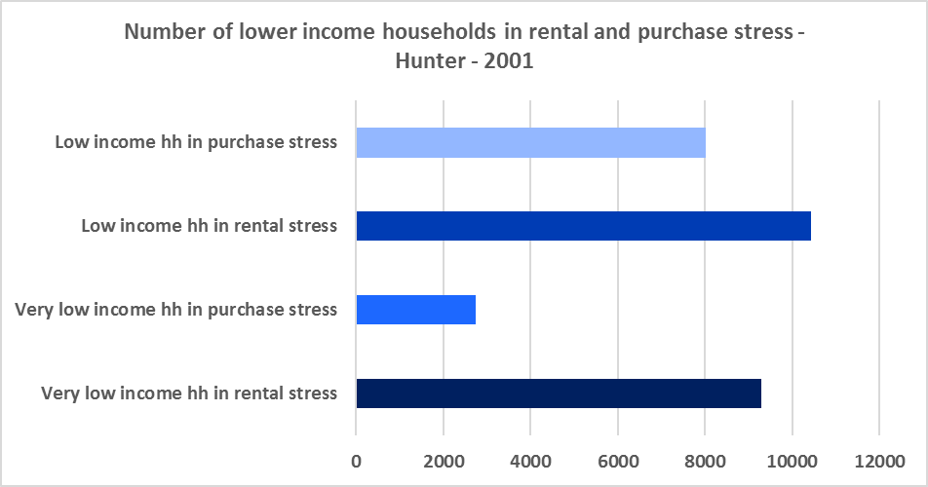

**Additional Data**

Additional data on rents and sale prices, including both current and historical data, is available from the Rent and Sales Report and the interactive Dashboard on the Housing NSW website at:

<https://www.facs.nsw.gov.au/resources/statistics/rent-and-sales/dashboard>

More detailed housing data and tables used in this Snapshot are available from the Local Government Housing Kit Database on the Housing NSW website at:

<https://www.facs.nsw.gov.au/resources/nsw-local-government-housing-kit/chapters/local-government-housing-kit-database>

More information on vacancy rates is available from the Real Estate Institute of NSW website:

<https://www.reinsw.com.au/Web/Web/Members/Property_data/Vacancy_Rates_Survey.aspx>

The Rental Affordability Index is at

<https://sgsep.com.au/projects/rental-affordability-index>

1. The University of Sydney Urban Housing Lab report “Planning responses to online short term holiday rental platforms” - Research Project for Australian Coastal Councils Association Inc. September 2018 by Nicole Gurran, Yuting Zhang, Pranita Shrestha, Catherine Gilbert