Workshop supports Aboriginal Community members to develop Local Advisory Groups

The Local Advisory Group (LAG) Development Workshop brought together Aboriginal Community members from across the state to talk about establishing groups to strengthen the participation of Aboriginal Community in child protection decision making.
Held over 2 days, 6 and 7 April 2017 in Newcastle at Noahs on the Beach, the first LAG Development Workshop brought Aboriginal Community members, Aboriginal service providers and Family and Community Services (FACS) staff together to meet, discuss and plan for establishing a LAG in their communities.
The Guiding Principles for strengthening the participation of local Aboriginal community in child protection decision making, was developed by the Grandmothers Against Removal NSW (GMAR NSW) with the NSW Ombudsman’s Office and the Hunter New England FACS District and were launched by the Minister on 9 November 2015 in Tamworth. The Guiding Principles provide a framework for the establishment of Local Advisory Groups (LAGs), if sought by the Aboriginal community, to participate with FACS in decision making around care and protection of Aboriginal children.
Throughout November and December 2016, GMAR NSW held meetings with various communities and FACS districts to promote the Guiding Principles, to discuss establishing Local Advisory Groups (LAGs) and to learn from communities who have made progress in this area. The workshop was a result of these meetings and aimed to bring together communities from across the state to provide further support for establishing LAGs in their local areas.
Communities represented at the workshop included Ballina, Kempsey, Wyong, Moree, Nowra, Mount Druitt, South Western Sydney, South Eastern Sydney, Northern Sydney, and Sydney.
Facilitated by Andrew Smith, CEO of Worimi Local Aboriginal Land Council, and hosted by Suellyn Tighe, Deb Swan and Jen Swan of GMAR NSW, the workshop involved opportunities for attendees to plan for establishing a working group, identify members, and prepare for the first LAG meeting. Resources to support the local community in establishing a LAG are being established and will be provided.
Members of the Guiding Principles Yarning Circle (GPYC), the State Wide Advisory group, including GMAR NSW, AbSec, the NSW Ombudsman’s Office, Aboriginal Legal Service (ALS), and FACS were also part of a panel discussion on “Working Together to Support Aboriginal Families”.
Further support will be provided to these communities as they set about establishing their own LAG and as more communities across the state are engaged, more workshops may be held.

More information:
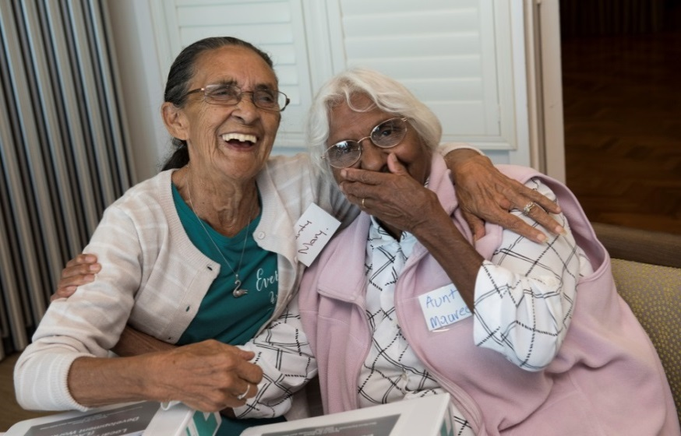
Nicole Yade, Project Manager on 9716 3447 or nicole.yade@facs.nsw.gov.au
