**Hunter Region – What’s Happening with Housing Supply and does it match Demand?**

This Housing Snapshot looks at aspects of housing supply in the Hunter, particularly from the 2016 Census to the 2021 Census – including dwelling type, bedroom mix, tenure, as well as social housing supply and waiting times for public housing. It also looks at aspects of the gap between housing demand and supply, including what’s happening with low income rental households and affordable rental supply, comparing household type with bedroom mix and who needs affordable housing.

Across much of NSW housing supply has not kept pace with demand, with significant outmigration from cities to regional areas during Covid, record levels of migration post Covid, with rapid increases in construction costs and skilled labour shortages contributing to longer term tight rental vacancy rates, insufficient affordable housing and a lack of housing diversity to meet local need. There has also been the impact of floods in parts of this region, having adverse impacts on the rental market and communities more broadly.

The majority of households in the Hunter are couple or single person households, yet the housing stock is primarily comprised of three or four bedroom detached homes. This housing was built at a time when families were the predominant household type, yet this is no longer the case in this Region. The housing stock needs to adapt to better match households requirements. Proactive measures are necessary to diversify bedroom mix and increase the supply of studio and one bedroom dwellings in particular to provide housing choice to smaller households.

Infrastructure Australia delivered a report “2022 Regional Strengths and Infrastructure Gaps” which cites housing – the availability, affordability and diversity of housing – as a key infrastructure gap in the Hunter.

**Dwelling Type**

* At the 2021 Census there were 324,654 dwellings in the Hunter region, up from 298,527 in 2016.
* Of these, 90.6% were occupied (up from 85.7% in 2016), just over the 89.0% average percentage occupied in the Rest of NSW.
* This means that 9.4% were unoccupied (down from 12.3% in 2016) and compared to 11.0% in the Rest of NSW.
* The reasons homes are unoccupied vary and include (according to a report by the Australian Housing and Urban Research Institute “Are there 1 million empty homes and 13 million unused bedrooms?”):
  + homes are being renovated
  + homes being sold as vacant possession
  + newly built or bought homes where no one has moved in yet
  + rental homes awaiting new tenants
  + people living away temporarily from home during the census count (travelling or visiting other homes)
  + homes are deemed unliveable
  + subject to a probate application or other legal proceedings
  + holiday homes
  + homes owned by people currently living overseas
  + homes being land banked, that is held vacant until the local area economics (or personal circumstances) make it more profitable to sell or redevelop the property.

And particularly in rural and regional areas:

* dwellings on rural properties where owners have moved into local towns (particularly as owners age);
  + regional and rural areas which have experienced population decline;
  + and areas where people have a beach or rural retreat house that will only be occupied for short periods of the year
* The graph below shows the proportion of occupied and unoccupied dwellings in the Hunter LGAs at the 2021 Census.

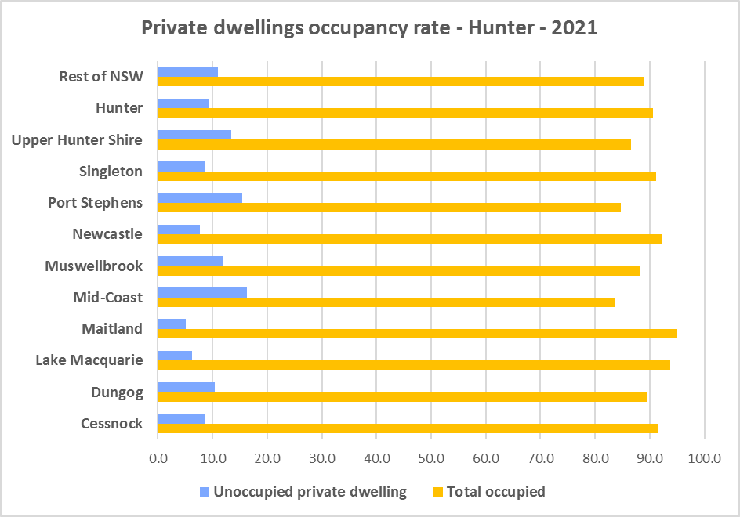

* Note that within the Hunter, Maitland has the highest proportion of occupied dwellings with 94.9% and Mid Coast has the lowest with 83.7%.
* At the 2021 Census, the clear majority of occupied dwellings in the Hunter were separate houses, comprising 81.8% of all occupied dwellings, compared to 82.5% in the Rest of NSW. The proportion of separate houses within the region ranges from 97.0% in Dungog to 69.0% in Newcastle.
* A further 11.0% of occupied homes in the Hunter were semi-detached, terrace or town houses, (compared to 6.3% in the Rest of NSW) and ranging from 16.2% in Newcastle to 1.5% in Dungog.
* 6.2% of occupied homes in the region were flats (compared to 9.9% in the Rest of NSW), ranging from 14.2% in Newcastle to 0.2% in Dungog.
* Parts of the region lack diversity in dwelling types.
* The graph and table below show the proportion of dwelling types for the Hunter LGAs at the 2021 Census.

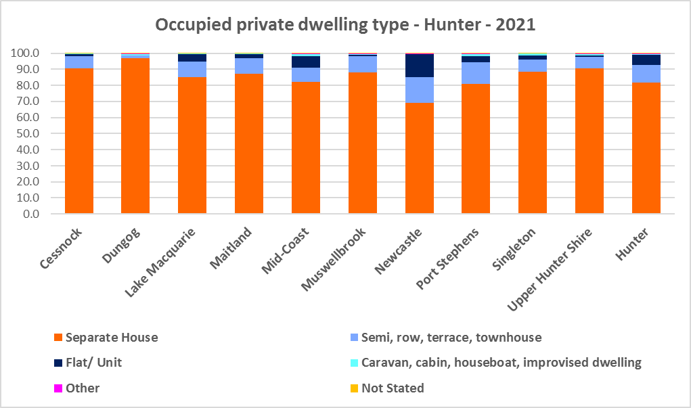

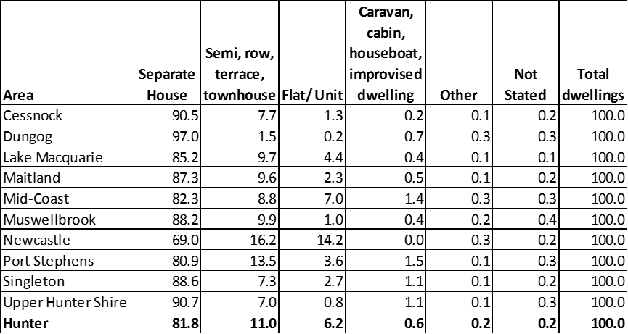

* The next graph compares the proportion of different occupied dwelling types for the Hunter with that for the Rest of NSW.

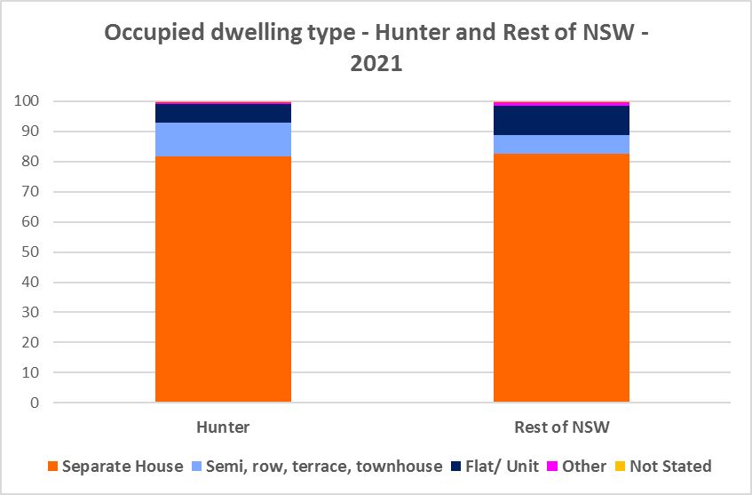

* Other types of dwellings comprised just 0.2% of occupied dwellings in the region and include caravans, cabins, houseboats, improvised dwellings and flats attached to shops. Census data shows 726 households living in caravans, 957 living in cabins or houseboats, 61 living in improvised dwellings and 565 in flats attached to shops in the region.
* Note that at the 2021 Census there were a total of 1,683 households living in caravan, cabin/houseboat accommodation, down from 1,880 in 2016. Mid Coast had the highest number of households living in caravan, cabin/houseboat accommodation with 529 (down from 570 in 2016), followed by Port Stephens with 418 (down from 529 in 2016) and Lake Macquarie with 315 (down from 511).
* While people living in caravans are included in the homeless data in the Census, caravan or residential parks are one of the few remaining affordable housing options for lower income earners. The loss of this accommodation reduces options for lower income households and reduces flexibility to deal with seasonal workers and changes in mining workforces.
* The region also has 61 improvised dwellings. According to the ABS;
  + “Persons in other improvised dwellings are those people who were enumerated on Census night in the dwelling category of an improvised dwelling, tent or sleepers out who reported either being 'at home' on Census night or having no usual address, and are not considered, on balance, to be homeless. Under the ABS definition they are not classified as homeless because they have accommodation alternatives, and in many living situations, the dwelling will be adequate. They are however included in marginal housing and may be at risk of homelessness.”

**Bedroom Mix**

* Just as parts of the Hunter lack diversity in dwelling type, parts of the region (and the Rest of NSW generally) also have little variation in the number of bedrooms per dwelling. Across the Hunter 41.2% of dwellings have three bedrooms and a further 35.3% have four or more bedrooms. Only 0.4% of homes are studios, 4.1% have one bedroom and 17.7% have two bedrooms.
* This compares to 0.5% of studio homes, 4.0% one bedroom and 17.3% two bedroom, 40.9% three bedroom and 35.7% four or more bedrooms in the Rest of NSW.
* It is important to note that this is an improvement from 2016, when studios made up just 0.1% of dwellings; one bedroom homes comprised 1.1% and two bedrooms 12.0% of residential stock on average across the Hunter.
* Within the region,
  + Newcastle has the highest proportion of studio dwellings with 0.6% and Maitland the lowest with 0.2%;
  + Newcastle has the highest proportion of one bedroom homes with 6.8% and Maitland the lowest with 2.5%;
  + Newcastle has the highest proportion of two bedroom homes with 24.9% and Maitland the lowest with 11.5%;
  + Cessnock has the highest proportion of three bedroom homes with 43.5% and Maitland the lowest with 36.6%; and
  + Maitland has the highest proportion of four or more bedroom homes with 48.1% and Newcastle the lowest with 23.8%.
* The graph and table below show the proportion of studio, one, two, three and four or more bedroom occupied dwellings in the Hunter at the 2021 Census.

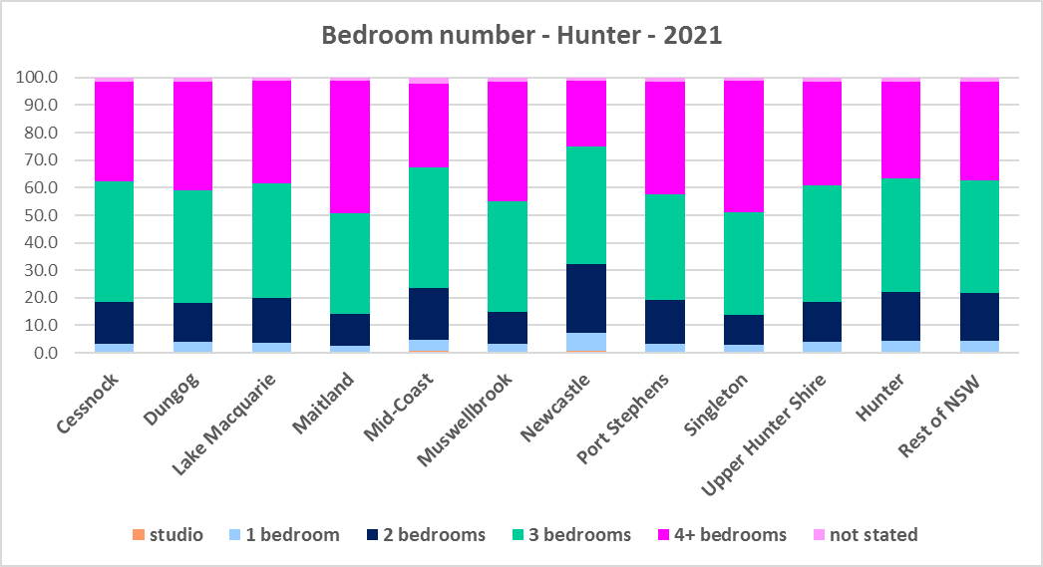



* Given that lone person and couple only households comprised 51.8% of all households in the Hunter, the fact that studio and one bedroom homes combined comprise just 4.5% of the housing stock shows a mismatch between household type and dwelling size and a significant lack of housing choice for smaller households.
* The forecast increase in older age groups in the region is likely to increase the demand for smaller, more manageable and affordable homes.
* While it is encouraging that there have been increases in the proportion of studio, one and two bedroom homes between the 2016 and 2021 Census, ideally there should be a closer match between household size and bedroom number to offer some housing choice for residents. Two bedroom dwellings in particular offer the most flexibility, given they are also suitable for small families and allow older residents to have family members or carers to stay while giving them a more manageable size home to maintain.

**Tenure**

* At the 2021 Census, the most common tenure type in the Hunter was households owning their home outright – comprising 36.2% of all households. Within the region this ranged from 49.7% in Mid Coast to 28.3% in Maitland.
* The next largest tenure type was households with a mortgage – comprising 33.8% of all households. The proportion in this tenure ranged from 41.1% in Singleton to 24.5% in Mid Coast, within the region.
* Rental households comprised a total of 28.1% of all households in the Hunter, ranging between 37.2% in Newcastle and 15.1% in Dungog.
* Households renting from a real estate agent comprise just 17.8% of all households in the Hunter – with Newcastle having the highest proportion at 24.4% and Dungog the lowest with just 8.0% of households renting though a real estate agent.
* The remainder of rental households are comprised of households renting from the state housing authority (3.3% in the region), community housing providers (1.0%) and other landlords (6.0%).
* The graph and table below give the tenure composition for the region and individual LGAs at the 2021 Census.

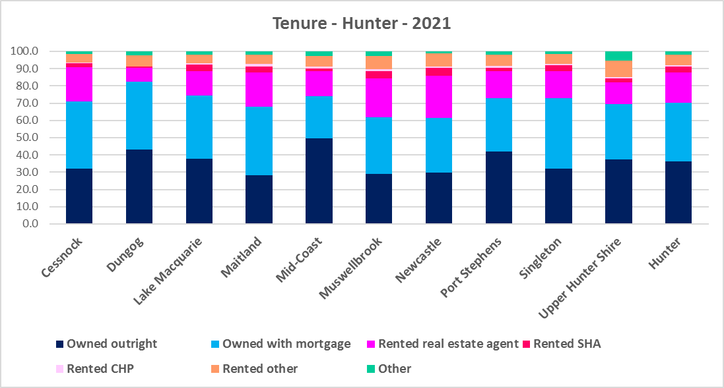



* The general trend is for increasing numbers of households relying on the private rental market as a long term tenure rather than a transitional one between leaving home and buying a home, as housing costs have increased much faster than wages. While the Hunter is more affordable than much of Sydney, there has been a growing trend to making a sea or tree change to take advantage of more affordable housing in some coastal and regional areas. In addition, anecdotal evidence indicates that this was particularly pronounced during Covid with the increased flexibility of working remotely/from home.
* Subsequent high interest rates and high inflation levels have made it increasingly difficult for lower income households in particular to manage housing costs.
* Further, the increased popularity and availability of short term rentals have, particularly in coastal parts of NSW, impacted on the availability of long term rental accommodation for renters (see the Housing Snapshot on What’s Happening with Demand).
* This has the potential to bid up housing prices and make it more difficult for locals to afford housing.
* Noting that the rental market in the Hunter – and NSW generally – is very tight (see the Housing Snapshot on What’s Happening in the Housing Market) it is therefore important to encourage tenure diversity and a range of price points to meet local needs, including facilitating affordable housing development.

**Social Housing**

* Social housing is secure and affordable rental housing for people on low incomes with housing needs. It includes public, community and Aboriginal housing. Public housing is managed by DCJ while community housing is managed by non-government organisations.
* As at June 2022, there are 154,600 social housing dwellings in NSW, with 96,712 managed by public housing, 48,264 managed by community housing and 9,624 managed exclusively for Aboriginal people – of these the Aboriginal Housing Office (AHO) are responsible for 4,120 and Aboriginal Community Housing Providers (ACHP) manage 5,504.
* The table below shows the number of public housing properties in the Hunter region LGAs as at June 2022. Please note that Census data on public housing is not particularly accurate, as public housing tenure is under reported in the Census. The figures below do not include community housing properties.



* In addition, community housing providers manage a significant number of properties – including social housing, affordable housing, transitional housing and crisis accommodation in the Hunter, as outlined in the table below.
* Note that affordable housing is not the same as social housing. Affordable housing is open to a broader range of household incomes than social housing. Households do not have to be eligible for social housing to apply for affordable housing, though people who are eligible for social housing may also be eligible for affordable housing properties.
* Affordable housing is managed more like a private rental property, but there are eligibility criteria and the managers are mostly not for profit community housing providers.



* The next table gives the number of AHO homes and the number managed by ACHPs in the Hunter as at June 2022.



* Note that there are 3 types of social housing available for Aboriginal people:
  + Public housing – these properties are managed by the Department of Communities and Justice (DCJ).
  + Aboriginal Housing Office homes – these are properties owned by the Aboriginal Housing Office and managed by DCJ.
  + Community housing properties – these properties are managed by community housing providers and Aboriginal community housing providers.
* The table below shows the expected waiting times for general housing approved social housing applicants (not for priority housing applicants) by bedroom category in the Hunter Region as at 30 June 2022. It also gives the number of general and priority housing applicants in each allocation zone.



* Information on Expected Waiting Times for Public Housing is available on the FACS website by region at:

<https://www.facs.nsw.gov.au/housing/help/applying-assistance/expected-waiting-times>

## The Gap

* While the Hunter has been more affordable for both rental and purchase than neighbouring Sydney, it is more expensive than most regional areas of NSW.
* SGS Economics and Planning in their November 2022 Rental Affordability Index[1] report, point out that regional areas of NSW:
  + have been subject to several natural disasters from widespread bushfires in 2020 to flooding in 2022. These have affected both existing rental stock and new development, limiting supply and increasing rental rates.
  + have seen the combined impact of these factors on renters resulting in homelessness, having to move away from family and support for more affordable housing, moving into poor quality or insecure housing, or having to forgo other essentials.
  + were spared the worst of pandemic response measures. However the impacts of outward-migrating city residents (driven by COVID-19 restriction in capital cities and the ability to work remotely), on housing and rental affordability has caused concern. This is clear in the November 2022 data, which shows that affordability has worsened in the regional areas of every state, even more so than in the capital cities.
  + have became far less affordable to the average rental household over the last year, including inland towns.
* In summary demand for housing increased, supply has been insufficient to meet demand and there have been impacts on affordability, particularly rental affordability, and on lower income tenants.
* There has been a decline in the number of private rental properties which are affordable to low income rental households in the Hunter region, as the graph below demonstrates.

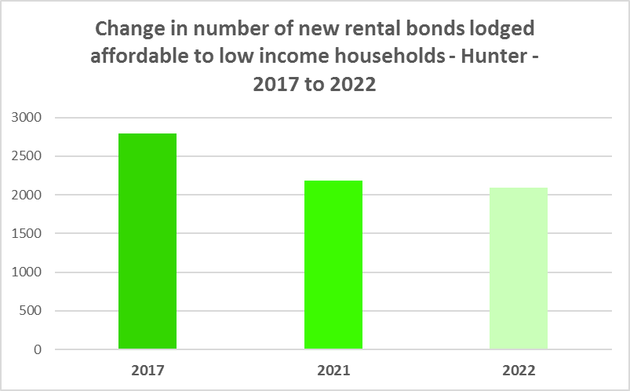

* The decline has not been even across every Hunter LGA, as the graph below demonstrates. Every LGA (excepting Dungog and Muswellbrook which both registered a tiny increase) experienced a loss of affordable rental between 2017 and 2022. Mid Coast had the largest decline from 2017 (140 fewer affordable bonds lodged in 2022 than in 2017) while Singleton had the largest proportional decline (48.0% fewer affordable rental bonds lodged in 2022 than in 2017).

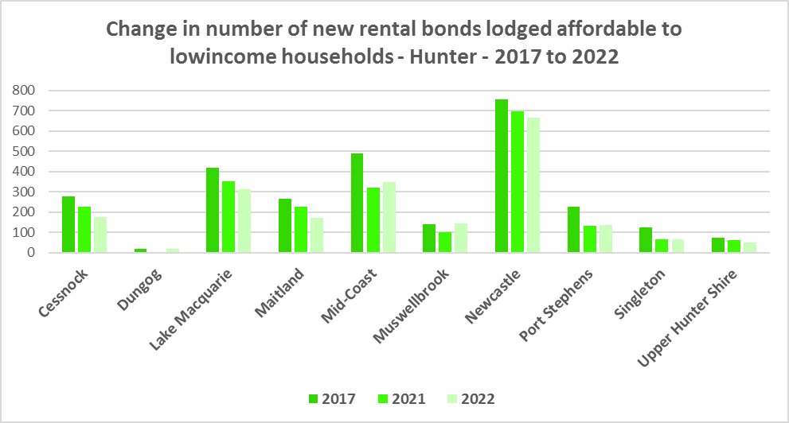

* The next graph compares change in median income with change in median rents and median sales price in the Hunter region LGAs between 2016 and 2021 for income and 2017 to 2022 for rent and sales price.

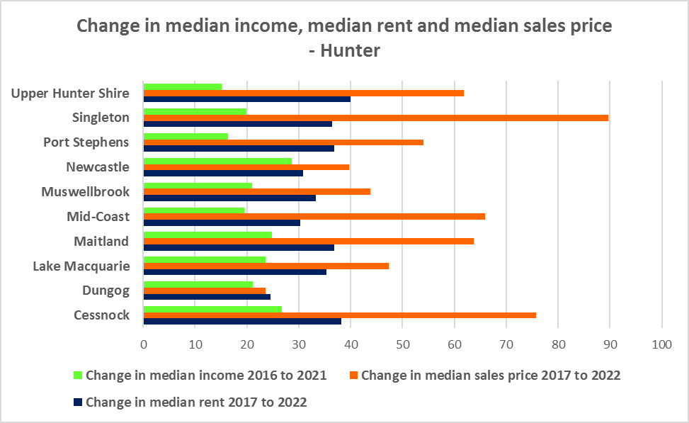

* It demonstrates that housing costs have increased faster than income in every Hunter LGA over that time period. This has been the case for decades, with housing costs increasing at a much greater rate than incomes. According to Core Logic “While wages increased 81.7% in the past 20 years, Australian home values have grown 193.1%”[2]
* Note that median rents and sales prices have increased at the greatest rate in Hunter LGAs which have historically been somewhat more affordable – Upper Hunter, Singleton and Cessnock. In both Upper Hunter and Singleton, the median income is also much lower, potentially making it much harder for residents in those LGAs to find affordable rental and purchase. Port Stephens and Mid Coast, which both have lower median incomes and higher retired populations have also seen significant increases in median rents and sales price far outpacing changes in income.
* Low income households are the dominant income group across the Hunter and in every single LGA in the region (excepting Cessnock), comprising 47.3% of all households in the region (below the Rest of NSW average of 49.3%) and ranging from 39.3% in Cessnock to 55.6% in Port Stephens.
* Furthermore, the number of low income households is increasing across the region – by 15.6% between 2016 and 2021. The graph below shows the change in the number of low income households in each of the Hunter LGAs between 2011 and 2021. The majority of LGAs in the region had an increase in low income households over this period.

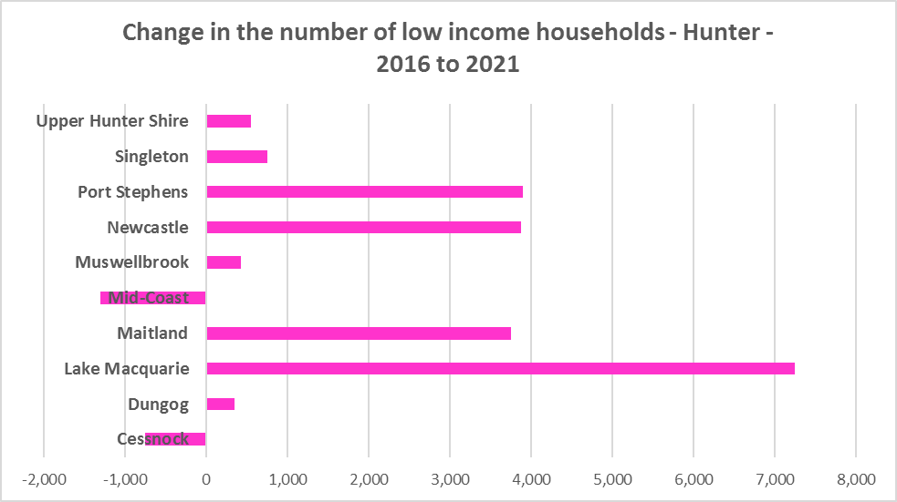

* Due to the changes to income assistance during and subsequent to the COVID-19 pandemic, it is difficult to see what has happened with renters and low income renters in particular between 2016 and 2021. However, it is clear that rents have increased faster than incomes and that the supply of affordable private rental is declining.
* There is a clear need for more affordable rental accommodation to begin to address the demand supply imbalance, particularly for lower income households and the increasing number of seniors and frail aged.
* The vacancy rate in the Hunter has been tight for over a year, indicating a chronic shortage of rental accommodation. In Newcastle the vacancy rate has been more volatile over the last twelve months. At April 2023 the vacancy rate was just 1.8% in Newcastle and 2.0% in the rest of the Hunter.
* Considered together, the strong increase in rental levels, decline in rental affordability for lower income earners and decline in affordable rental properties, combined with the increase in low income households, demonstrates the need to increase the supply of affordable rental housing for long term tenants.
* As well as the gap between supply and demand for affordable rental, there is a significant gap between dwelling size (bedroom numbers) and household size, particularly for smaller households. The graph below compares the number of smaller household types - lone person and couple only – with the amount of studio and one bedroom accommodation available in the Hunter. It is clear that if smaller households wished to live in smaller housing, they have very little opportunity to do so. While 53.1% of households in the Hunter are lone person or couple only (just below the 53.8% average for the Rest of NSW), only 4.5% of dwelling stock is studio or one bedroom (the same as the 4.5% on average in the Rest of NSW).
* This mismatch can impact on affordability, with smaller households required to consume more housing than they need or to share housing because of lack of choice.
* It also limits the opportunity for empty nesters or older single households to downsize to smaller more manageable homes within their communities. This can impact on the independence of older residents and their ability to age in place. This will become increasingly important as the population of the Hunter is forecast to have an increase in older age groups.

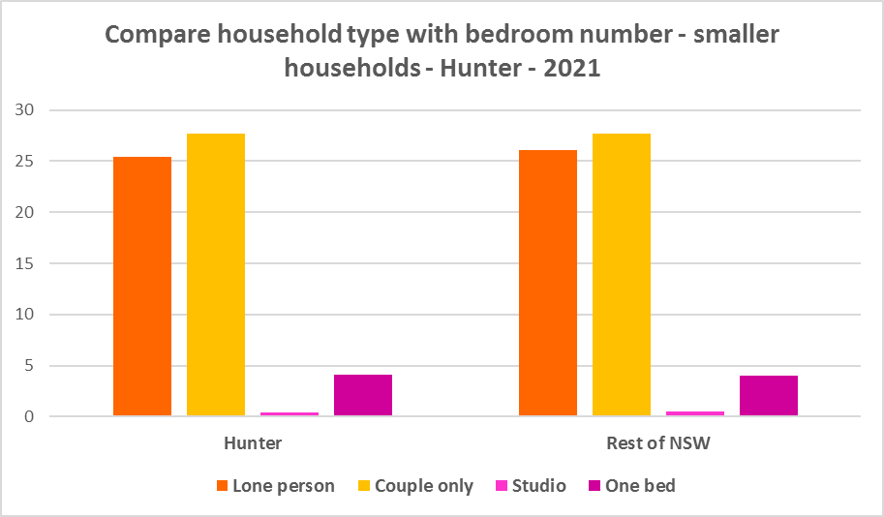

* While there has been a small increase in studio and one bedroom homes since the 2016 Census, the number is significantly outweighed by the enormous increase in the number of three and four plus bedroom homes, as seen in the graph below. However, there has also been a strong increase in the number of two bedroom homes. These potentially suit both single person and couple only households as well as smaller families and small group households and consequently provide some flexibility in the housing stock.

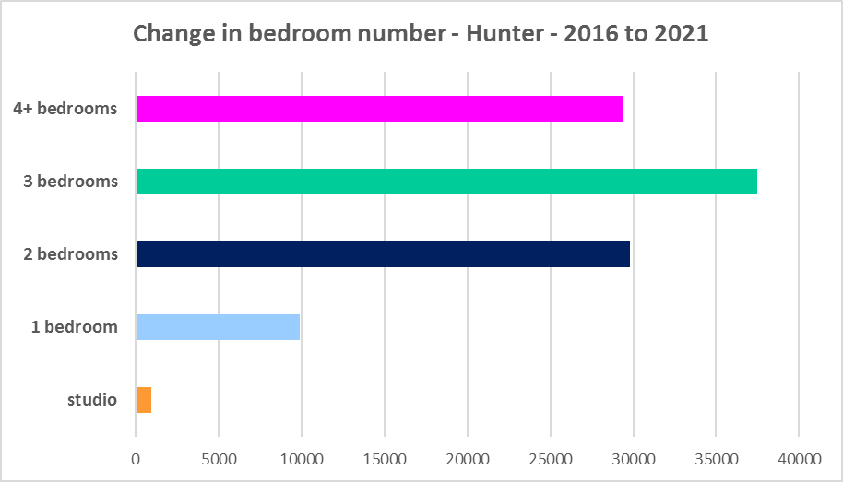

* A proactive approach is required to encourage an increase in studio and one and bedroom properties and to continue to encourage the provision of two bedroom homes.
* This is important given that annually the addition of new dwellings represents around 1% of the total dwelling stock – so change occurs very slowly. There is also a need to take into account the impact of alterations and additions to existing stock, for example, adding extra bedrooms to two and three bedroom houses. Given the current overwhelming supply of three and four bedroom homes and the significant increase in three and four plus bedroom homes since 2016, strong incentives/requirements would need to be put in place to ensure a better balance and more diversity to meet housing need.
* New generation boarding houses would also help fulfil some of this demand – particularly as they cannot be subdivided and must provide rental accommodation. This type of accommodation is suitable for single people and also couples, for key workers and students. It also has potential to assist in providing accommodation/meeting additional housing demand for seasonal workers and mine workers. Note that the NSW Community Housing Industry Association has an Affordable Housing Tool Kit to help deal with community resistance to affordable housing, which is available on their website. They also have a couple of excellent vimeos showcasing new generation boarding house developments and their tenants.
* The next graph compares larger household types – couple family with children, one parent family and group households – with the amount of two, three and four or more bedroom accommodation available. It is clear that there is a more than adequate supply of larger homes for families and group households in the Hunter.

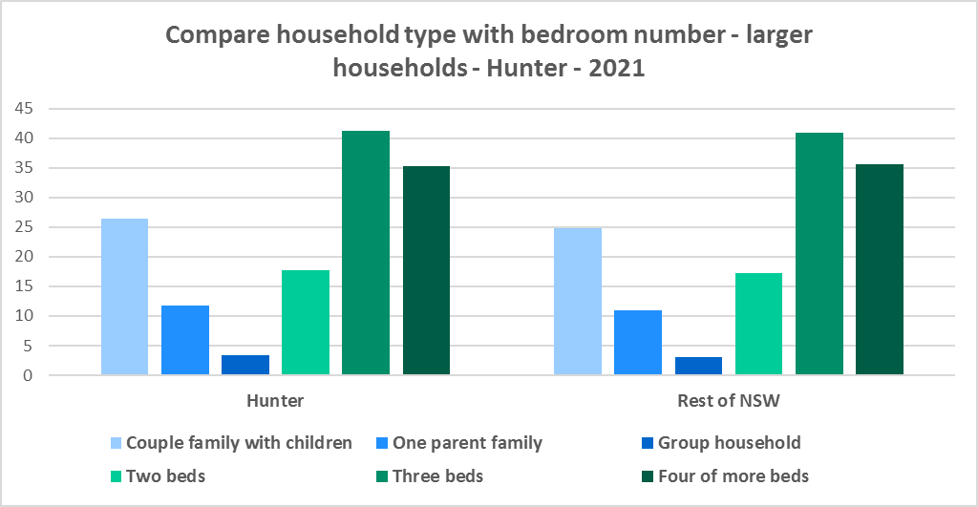

* As couple only households comprise 27.7% of all households in the Hunter, it is important to continue to encourage provision of one and two bedroom stock as well as studios, new generation boarding houses and secondary dwellings, to maintain a balance to meet local need, particularly where there are higher proportions of seniors and frail aged. This will give older residents opportunity to downsize into more manageable and appropriate homes.
* Enabling the provision of more semi-detached, terrace and town houses could help fulfil some of this demand.
* Also, secondary dwellings suit a range of groups including small households, young people, frail aged and people with disability needing support from family. They may be readily encouraged on larger lots with reasonable access to centres providing a range of services and facilities.

**Who needs affordable housing**

* A wide range of people need affordable housing. Single income earners who fall into the low income category include aged care and disability workers, retail sales assistants, production workers, receptionists and early career child care workers.
* People working in accommodation and food services comprise 7.5% of the workforce living in the Hunter and are amongst the lowest paid workers. Similarly retail trade employs 9.4% of workers living in the Hunter. Health care and social assistance is the largest employment sector of residents in the Hunter (employing 17.5%). A 2017 survey of NSW Nurses and Midwives Association (NSWMA) members showed that thirty six per cent of respondents moved home or changed jobs in the previous 12 months because of housing affordability issues.
* For example:
  + Households earning $790 per week gross (broadly indicative of a wage for a laundry worker) could afford to pay just $237 per week in rent before being in housing stress.
  + Households earning $960 (broadly indicative of wages for a commercial cleaner, delivery driver and entry level firefighter) could afford to pay just $288 per week in rent before being in housing stress.
  + Agriculture employs a further 1.8% of residents in this region (4.9% in Mid Coast and 17.3% in Upper Hunter). The average farmhand salary in Australia is $57,311 per annum or $1,102 per week. A household on that salary could afford to pay $330 per week in rent before being in housing stress.
  + Households with an income of $1,150 (broadly indicative of the wage for an enrolled nurse, child care worker and ICT support technician) can afford to pay just $345 per week in rent before being in housing stress.
  + At a weekly income of $1,450/$1,500 (an indicative wage for an early career Registered Nurse), a household could afford to pay $435 to $450 per week in rent before being in housing stress.
* At March 2023, there were insufficient new bonds lodged to calculate a median rent for studio dwellings in any LGA in the Hunter, or to calculate a median rent for one bedroom homes in Dungog and Upper Hunter – which speaks to lack of supply.
* At March 2023, the median rent for a one bedroom home ranged between $250 per week in Newcastle and $350 per week in Port Stephens; for a two bedroom home ranged between $340 per week in Upper Hunter and $520 per week in Newcastle; for a three bedroom home ranged between $430 per week in Upper Hunter and $620 per week in Newcastle and for a four or more bedroom home ranged between $560 per week in Upper Hunter and $700 per week in Newcastle. Note that Dungog only had sufficient bonds lodged to calculate the median rent for all dwellings combined.
* This demonstrates that lower income households would struggle to find affordable rental housing in many LGAs in the region.
* Single income households in particular are less able to compete in the housing market.
* Increasing numbers of older single women are homeless or at risk of homelessness due to the lack of available affordable rental housing. In fact they are the fastest growing cohort of the homeless population.
* Partnering or collaborating with community housing providers is one effective way to meet some of the local need for appropriate affordable housing. Not for profit community housing providers are owners, managers and developers of affordable rental housing for lower income households and residents with specific housing needs. They work with partners, investors and government to provide housing and deliver support for tenants. For more information about community housing providers, see the NSW Community Housing Industry Association website.

**Additional Data**

Housing data and tables used in this Snapshot are available from the Local Government Housing Kit Database on the Housing NSW website at:

<https://www.facs.nsw.gov.au/resources/nsw-local-government-housing-kit/chapters/local-government-housing-kit-database>

More information on Expected Waiting Times for Public Housing is available on the DCJ/FACS website by region at:

<https://www.facs.nsw.gov.au/housing/help/applying-assistance/expected-waiting-times>

Additional data on social housing dwellings and delivery is available on the FACS website at:

<https://www.facs.nsw.gov.au/resources/statistics/social-housing-residential-dwellings/facs-quarterly-statistics-social-housing-dwellings>

or go straight to the dashboard:

<https://public.tableau.com/app/profile/facs.statistics/viz/Social_Housing_Residential_Dwellings/Dashboard>

and

<https://www.facs.nsw.gov.au/resources/statistics/social-housing-delivery2/interactive-dashboard>

The Australian Housing and Urban Research Institute (AHURI) has written a paper explaining the reasons for unoccupied homes:

<https://www.ahuri.edu.au/research/brief/are-there-1-million-empty-homes-and-13-million-unused-bedrooms>

The SGS Economics and Planning Rental Affordability Index is here:

<https://sgsep.com.au/projects/rental-affordability-index>

More information about community housing providers is available on the NSW CHIA (Community Housing Industry Association) website:

NSW CHIA Snapshot of the Community Housing Sector in NSW:

<https://communityhousing.org.au/wp-content/uploads/2022/08/Community-Housing-Snapshot-2022.pdf>

Data on community housing properties is available from the NSW CHIA Dashboard at:

<https://communityhousing.org.au/our-impact/data-dashboard/>

CHIA NSW affordable housing tool kit. The Tool Kit is based on extensive research about reasons for community resistance to affordable housing, and effective ways of building support for affordable housing:

https://communityhousing.org.au/toolkit/theplatform.html

The NSW Registrar of Community Housing website is here:

<https://www.rch.nsw.gov.au/>

1. <https://sgsep.com.au/projects/rental-affordability-index>
2. <https://www.corelogic.com.au/news-research/news/archive/how-much-has-house-price-growth-outstripped-growth-in-wages#:~:text=Comparing%20the%20wage%20price%20index,193.1%25%20(figure%202)>.