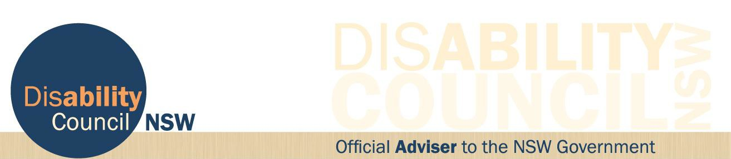

29 June 2017

Communique

Locked Bag 4001, Ashfield NSW 1800 (02) 8879 9100
www.disabilitycouncil.nsw.gov.au disabilitycouncil@facs.nsw.gov.au

