Policy Name | Disability Inclusion Action Plan, 2015-2018.
Policy No. | POL06-7
Department File No. | F
Business Unit | Operations & Sustainability
Officer Responsible | General Manager  Operations & Sustainability
Approving Officer | Chief Executive Officer
Date of Approval | November 2015

Version | Review | Date | Approved By
A | To include Disability Inclusion Act-2014 | November 2015 | G. Syme

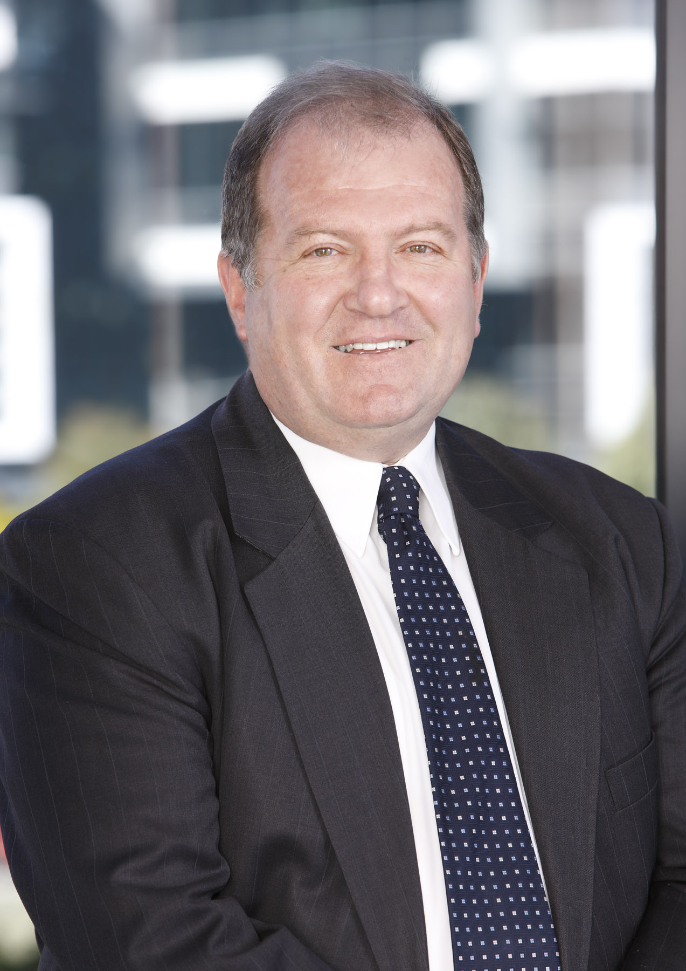
From the Chief Executive Officer

Sydney Olympic Park Authority (the Authority) is committed to the sustainable development and promotion of Sydney Olympic Park as Sydney’s premier destination for entertainment, leisure, business, tourism, sport and lifestyle activities. The Authority works to facilitate commercial and residential opportunities for the benefit of users of the Park and the wider community.

With an aging population in New South Wales and an increase of people having a long-term disability that restricts their everyday activities, the Authority seeks to ensure that all people are able to participate in activities at Sydney Olympic Park with dignity and equity. This focus is primarily to provide provisions so that people with disability can access general support and services available within Sydney Olympic Park, also how they are able to participate fully within the local community.

Sydney Olympic Park Authority’s Disability Inclusion Action Plan, 2015-2018 (DIAP) has been prepared in accordance with the legal requirements set out in Part 2 of the Disability Inclusion Act 2014 and recognises the need for a “Local Inclusion” approach to effectively work towards maintaining and enhancing the existing accessible environment for visitors, residents and workers throughout Sydney Olympic Park. I would like to acknowledge the Authority’s Access Advisory Committee and the community who have contributed to this Plan, ensuring that it meets the needs of the Park community.

The adoption and implementation of this Disability Inclusion Action Plan demonstrates the Authority’s commitment to implementing the strategies contained in the NSW Disability Inclusion Plan- 2015 within Sydney Olympic Park.

The Authority strongly supports the commitment of the New South Wales Government to meet the needs of people with a disability through good accessible design and services.

Inclusion is not a choice – it is a right.

Alan Marsh Date November 2015
Chief Executive Officer

Contents

Introduction 4
Scope and Use of the Disability Inclusion Action Plan 4
Overview of Sydney Olympic Park Authority 6
Our Vision 6
Our Mission 6
Our Objectives 6

Data Profile 7
Workforce Profile 7
Community Profile 7

Community Consultation – Disability Access 8
Methodology 10
Promotion and Dissemination 10
Priority Areas for Action 11
Review Mechanisms 12
Reporting Requirements 12
Appendix A 37
Appendix B 38
Appendix C 39
Appendix D 40
Appendix E 41
Appendix F 42
Appendix G 43
Appendix H 44
Appendix I 45

Introduction

Persons with disabilities have the same rights as other members of society. They also have the right to expect that their specific needs will be met. Sydney Olympic Park Authority is committed to ensuring that, as far as possible, the needs of people with a disability are met through attitudes and services that are available to the entire population. Achieving an inclusive society is a long term vision that will require consistent efforts from all levels of government and the wider community.

The Authority, with the assistance to the Access Advisory Committee, has produced this Disability Inclusion Action Plan (DIAP) to provide clear performance indicators for the period 2015-2018 inclusive.

This DIAP recognises the importance of adequate and effective community consultation and communication strategies for public stakeholders, service users, management and staff, and is:

- supported by the Authority’s Executive

- incorporated into the Authority’s strategic, budget and operational planning processes.

- dynamic and able to evolve in response to processes which are inclusive, accountable and transparent, and

- based on the broadest possible interpretation of disability and to acknowledge, respect and take into account the diversity of people with disabilities.

Scope and Use of the Disability Inclusion Action Plan

Sydney Olympic Park Authority’s Disability Inclusion Action Plan (DIAP) has been developed to be consistent with the New South Wales (NSW) Government’s Disability Inclusion Plan (DIP), which is published under the requirements of the Disability Inclusion Act 2014 (The Act) and Regulation 2014. The State Disability Inclusion Plan translates into action the Government’s commitment to improving the opportunities for people with disabilities to share fully in and be included into community life. Central to this is the opportunity to access Government services, facilities, information and employment opportunities on an equitable basis through the delivery of better services that promote fairness and opportunity for all citizens. NSW Government agencies are required under the Act to prepare and submit to the NSW Disability Council a current DIAP and to report against progress made on these plans in the annual agency reports.

This DIAP provides an opportunity for Sydney Olympic Park Authority to measure and record its achievements and to demonstrate its ongoing commitment to community consultation, equity and providing good access practices in all aspects of service to the community.

The Authority identifies itself as a provider within three tiers of access service delivery. This includes planning for the universal mainstream services within Sydney Olympic Park (the Park), planning that will assist and influence other organisations within the Park, as well as planning for specialist and adapted services at events and activities held within the Park.

As required by the NSW Government’s DIP and Ready Together: a better future for people with disability in NSW, Stronger Together 2: A new direction for disability services in NSW 2011–2016, this DIAP will identify and demonstrate the procedures on how the Authority will undertake to increase social inclusion, access to services and support the employment of people with a disability. This DIAP also identifies tangible and measurable actions on a range of nominated priority areas that have the greatest potential to provide good access to the majority of public services and information.

This DIAP is focused on people with a disability. This includes a long-term physical, psychiatric, intellectual or sensory impairment that, in interaction with various barriers, may hinder the person’s full and effective participation in the community on an equal basis with others as defined by the Disability Inclusion Act 2014.

This definition is not exhaustive and may include other members of the public as defined in the future.

This DIAP will include the groups that are most vulnerable, which are:

- women and children with disability.

- Aboriginal and Torres Strait Islander people with disability

- people with disability from culturally and linguistically diverse backgrounds

This DIAP sets the agenda for inclusion of disability requirements in the planning, development and management of Sydney Olympic Park. The tasks identified in ‘Priority Areas for Action’ set clear and achievable priorities for the period 2015-2018 inclusive. Successful implementation of these areas for action will integrate good access into the Authority’s strategic, budget, community consultation and operational planning processes.

The Authority recognises and accepts that it has no jurisdiction over the staging of the V8 Supercar Race held annually within Sydney Olympic Park, under the provisions of the Homebush Motor Racing (Sydney 400) Act-2008 which falls under the responsibility of Destination NSW.

Overview of Sydney Olympic Park Authority

Sydney Olympic Park Authority (the Authority) was established as a statutory Authority in July 2001 under the Sydney Olympic Park Authority Act-2001. The Authority is responsible for the management of the public assets that make up Sydney Olympic Park, its 640 hectares of open space, venues, parklands, development areas and maintenance of these assets as a lasting Olympic Legacy for the people of NSW. The legislation focuses on ensuring the best use and management of this large, unique, iconic area as a world-renowned destination in the geographical heart of Sydney.

Over 10 million people visit Sydney Olympic Park each year to play sport, picnic in the parklands, ride a bicycle, attend festivals, conferences or exhibitions, take part in one of many educational programs offered, attend a concert or to be a spectator at a sporting event. The Authority is committed to providing a diverse and a unique range of activities for Sydneysiders and visitors of all backgrounds and abilities to enjoy.

Our Vision

Our vision is that Sydney Olympic Park is an internationally recognised place with world-class events, venues, parklands and a great place to live and work, built on its Olympic legacy in a sustainable way.

Our Mission

Our mission is to lead the sustainable development and management of Sydney Olympic Park.

Our Objectives

In accordance with the Sydney Olympic Park Authority Act 2001 , the objectives of the Authority are to ensure that:

- Sydney Olympic Park becomes an active and vibrant town centre within metropolitan Sydney

- Sydney Olympic Park becomes a premium destination for cultural, entertainment, recreation and sporting events

- any new development complies with best practice accessibility, environmental and town planning standards and

- the natural heritage of the parklands is protected and enhanced.

Data Profile

Workforce Profile

The Authority employs some 90 employees comprising executive and full time, part time, contract and casual staff. Authority staff is critical to the success of the Authority.

Staff appointments are on the basis of merit to ensure the best people are recruited and promoted. A strong emphasis is placed on staff involvement in the operation of the Authority through participation, teamwork and effective communication.

The Authority works to ensure employees enjoy equality of opportunity and a work environment free from harassment and discrimination.

The Authority does provide induction and ongoing training for staff on best practices for serving and working with patrons that have a disability. The areas of focus include:

- treat people that have a disability with respect and consideration

- patience, optimism, and a willingness to find a way to communicate are your best tools

- smile, relax, and keep in mind that people that have disabilities want to experience helpful customer service

- don’t make assumptions about what type of disability or disabilities a person has

- some disabilities are not visible. Take the time to get to know your customers’ needs

- be patient.

People with some kinds of disabilities may take a little longer to understand and respond.

The Authority has a current Equal Opportunity Employment Policy number which guides the recruitment process when obtaining staff to work within the Authority.

Community Profile

The Sydney Olympic Park community includes local residents, workers and students who are at the Park each and every day, events patrons to visit the Park’s major sporting and entertainment venues, delegates attending business events, those that come to play sport (train and compete) or use the parklands and venues for leisure and recreation.

In 2015, the daily community at Sydney Olympic Park is more than 20,000 residents, workers and students and there are over 10 million visitors who come for events, sport, business, education, leisure and recreation. These numbers will increase substantially as further commercial and residential development is carried, as guided by Sydney Olympic Park Master Plan 2030.

Master Plan 2030 is the blueprint for the future sustainable development of Sydney Olympic Park, based on a community of 14,000 residents, 31,500 workers, 5,000 students, 20,000 visitors while retaining the capacity for major events for 250,000 people.

Community Consultation – Disability Access

The Authority consults and collaborates with the community in a number of ways. In relation to disability access, the Authority seeks guidance and advice from an Access Advisory Committee, which reports to the Chief Executive Officer and to the Authority’s Board of Directors. This Committee is drawn from a large cross section of the community and are considered to be experts in the area of providing good access. Membership of the Access Advisory Committee currently comprises:

- Association of Consultants in Access, Australia.
- Council on the Ageing (NSW) Inc
- Independent Access Consultants & Mentors
- Visionary Access Consultancy
- Disability Council of NSW
- Guide dogs NSW/ACT

The responsibilities of the Access Advisory Committee are to:

- provide expert advice to the Authority through the Chief Executive Officer, on the functional access arrangements and requirements for people with disabilities throughout the Sydney Olympic Park precinct

- assist the Authority in monitoring and reviewing the implementation of the relevant Australian Standards, the Sydney Olympic Park Access Guidelines and other mechanisms adopted by the Authority to facilitate access

- to consult with and also represent the community on any matters that are raised by the public in regards to any type of access issues or requirements

- provide expert advice to the Authority which may be adopted for the purpose of guiding other Government agencies responsible for managing arrangements to enable access to persons with disabilities and

- recommend areas requiring further investigation and study including advice on the commissioning of reports and on issues relating to access by persons with disabilities within Sydney Olympic Park.

External parties wishing to gain access to the minutes of the Access Advisory Committee meetings may do so through the Authority’s website (www.sopa.nsw.gov.au) and provide comment for the Committee to review and then make comment.

The Authority’s website has the capacity to receive any type of feedback, complaints or suggestions on any type of access issue that may require attention or maintenance within the precinct. Any received issues are then either acted upon to rectify the situation or are forwarded onto the Access Advisory Committee to give expert access advice to the Authority as required on a case by case basis.

In addition, the following community consultation processes were used to gain input from the community into this DIAP:

- An online survey was developed and promoted as the main avenue to provide input into the DIAP. The survey targeted people with disability, carers or family members of a person with disability and disability organisations or advocacy groups. The survey was available to the public for approximately one month. This survey was promoted through a range of channels:

  - Sydney Olympic Park Blog
  - Sydney Olympic Park What’s On Database
  - Sydney Olympic Park Community Database
  - Auburn Pictorial Review
  - Sydney Olympic Park Authority website
  - Auburn City Council
  - Facebook and Twitter social media posts which received support through a number of disability organisations and advocates
  - Sydney Olympic Park Business Association Newsletter (SOPBiz)
  - Direct emails to key stakeholders and previous venue hirers of the Sydney Olympic Park sports venues
  - Access Advisory Committee Channels

- Information flyer and link to online survey distributed to parkland visitors via Park Rangers

- Direct email to Sydney Olympic Park Authority Staff seeking feedback

Feedback from community consultation indicated that overall Sydney Olympic Park was a stand out location for accessibility, where people with a disability are generally able to do what they want, feel safe and also included as part of the community.

There were areas identified for improvement, which the action items contained in this plan sets out to address.

Methodology

The Building Services Unit within the Operations and Sustainability Division of the Authority coordinates the preparation, promotion, dissemination, evaluation, implementation, monitoring and measurement of the DIAP.

The following have been completed in order to produce the DIAP:

- review of the Authority’s programs and initiatives

- liaison with relevant senior executives, senior management and operational line managers

- endorsement by senior executives

- review and endorsement by the Access Advisory Committee including any comments provided to the Authority by the public and

- review and endorsement by the Chief Executive Officer.

Promotion and Dissemination

The DIAP will be promoted and disseminated as follows:

- summary and copies to be circulated to senior management within the Authority and available for general distribution to all staff, with the full document being available through the Authority’s website in an accessible large print format

- making copies available to all stakeholders, with alternative formats available on request and in a timely manner (minimum font size 12 with a high contrast with background, plain English)

- distribution to the NSW Disability Council and the Australian Human Rights Commission

- report on implementation to be included within the Authority’s annual report

Senior management are required to ensure that all policies/practices comply with applicable anti-discrimination as well as work health and safety legislation and to promote the establishment of equal employment opportunity, also to adherence to the Charter of Principles for a culturally diverse society in accordance with Government policy.

The Authority’s Manager of Building Services Unit will take responsibility for the evaluation, review and monitoring of the DIAP on behalf of the Executive Management.

Priority Areas for Action
In line with the NSW Disability Inclusion Act 2014 and DIP, this DIAP will address nine (9) priority areas for action for services across the three tiers (universal, adapted and specialist services).
NSW DIP  Areas of Focus | Sydney Olympic Park Authority’s DIAP Priority Areas for Action
AF1: Systems and processes – removing the barriers imposed on people with disability in navigating access to services and information. | PA1: Integrate key principles relating to people with disability into the Authority’s working practices.
 | PA2: Provide information in a range of formats that are accessible to people with a disability.
 | PA3: Establish appropriate complaints procedures and actions.
AF2: Attitudes and behaviors – identifying the approaches for creating positive public attitudes towards disability inclusion. | PA4: Encourage and promote dignified access to buildings, events and facilities within Sydney Olympic Park.
 | PA5: Consult with people that have disability to participate in planning and to apply to be on advisory boards and committees.
AF3: Employment and financial security – maximising the opportunity of people with disability to obtain and retain meaningful employment and enjoy the financial security, independence and self-esteem that comes with this. | PA6: Increase employment participation and support of people with a disability within the Authority.
AF4: Liveable communities – working with community partners to create accessible, liveable environments in which everyone would want to live, work and play. | PA7: Encourage and create opportunities for people with disability to access the full range of services and activities available to the community by the Authority.
 | PA8: Provide quality specialist and adaptive services to areas within the Park where unique circumstances exist to accommodate people with disability.
 | PA9: Support the goals of the NSW Disability Inclusion Plan.
The ‘Priority Areas for Action’ identifies key performance indicators and timeframes that relate to strategies for overcoming those barriers identified. The success of this DIAP will be determined by measuring achievement against these performance indicators and commitments made within the body of this document. Details on these actions are presented in the priority outcome sheets that comprise the balance of this DIAP.

Review Mechanisms

Ongoing consultation with the Access Advisory Committee, as well as the appropriate use of access advisers, will enable amendments and adjustments to the DIAP in response to a review.

The consultation model adopted will:

- seek feedback on the DIAP from the community. To then make DIAP adjustments or amendments to be in line with any suggestions or opinions received if necessary

- enable participation in monitoring and reviewing the DIAP from the Access Advisory Committee on any new or upcoming legislation or access requirements

- become the vehicle for consultation with management, staff with disabilities, service users, the community, consumer organisations and the disability sector, and

- ensure that the Authority reviews and reports the actions identified in the DIAP annually.

Reporting Requirements

The NSW Disability Inclusion Act 2014 sets parameters within which NSW Government agencies measure and report on their progress in creating access for people with disabilities. As part of its requirements under Section 13 of the Act, the Authority will give account on progress made against the DIAP in its annual report. A copy of the report will also be provided to the Minister, NSW Disability Council and the Australian Human Rights Commission at the appropriate times.

This annual report will be a summary of progress of actions that will be provided to the Minister for Disability and made publicly available.

The report will include progress on:

- implementation of the National Disability Strategy in NSW.
- implementation of Disability Inclusion Action Planning.
- oversight activity undertaken by the Disability Council NSW as part of its increased responsibility for reporting and monitoring.
PA1: Integrate key principles relating to people with disability into the Authority’s working practices.
Goal/outcome: Maximised opportunity and to provide inclusion for people with disabilities to experience Sydney Olympic Park fully (through removing or minimising barriers in the working practices).

Identified barriers:
- Construction activity may disrupt accessible travel paths and prevent access through the public domain.
- Size of site itself attracts a diverse array of users from all communities who have differing access requirements.
- To constantly monitor and maintain benchmarks in providing best access practices in all working practices.

Tasks | Positions / division responsible | Key performance indicators | Timeframe
- To provide guidance to architects, designers, venue and event operators, developers and others involved in the design, fit-out, planning and operation of venues and developments within Sydney Olympic Park to ensure an accessible environment. To maintain the currency of the SOPA Access Guidelines. | - Manager Building Services. | Design compliance with Australian Standards, the Authority’s Access Guidelines and Access Advisory Committee. | Six monthly reviews.
- Staff involved in the assessment of Development and Construction Certificate approvals to address the needs of people with disabilities. | - Planning Unit.  - Manager Building Services. | Approvals meet the requirements of Australian Standards and SOPA’s Access Guidelines. | Six monthly reviews.
- Design staff to ensure the requirements of people with disabilities is included in all relevant public domain designs. | - Manager Public Domain Design. | Designs meet the requirements of Australian Standards and the Authority’s Access Guidelines. | Six monthly reviews.

Tasks | Positions / division responsible | Key performance indicators | Timeframe
- The Authority’s existing Access Guidelines reflect contemporary legislation and access principles. | - Manager Building Services. | Updated Access Guidelines in 2014. DIA-2014.  Updated to capture new statutory access requirements. | New Access Guidelines produced in 2014.
- To ensure all prospective visitors, tenants and employees with a disability have access to information in appropriate formats about facilities, services and physical restrictions prior to and during their relationship within the Sydney Olympic Park environment. | - General Manager, Commercial and Corporate.  - Executive Manager Sydney Olympic Park Sports Venues.  - Executive Manager, Marketing Communications.  - Education Programs Manager.  - Executive Manager, Communications and Community Engagement. | Employees, visitors and tenants with disabilities are aware of access issues pertinent to Sydney Olympic Park, evidenced by positive feedback being provided in the Authority’s marketing surveys and employee satisfaction surveys. | Twelve monthly reviews.
- To ensure the Authority is advised on a broad range of matters including recommendations for appropriate strategies and actions, relating to the assessment and management of access for persons with a disability at Sydney Olympic Park. | - Manager Building Services.  - Access Advisory Committee. | Satisfactory updates at regular Access Advisory Committee meetings. | At each Access Advisory Committee meeting.
- To provide information on how to meet the needs of event, facility and venue managers including advice on planning, marketing and evaluating events so that they are accessible and thereby capture the widest possible audience. To encourage the use of the SOPA Access Guidelines, Part 2, Temporary Overlay for Events. | - Manager, Events & Precinct Operations.  - Executive Manager Sydney Olympic Park Sports Venues.  - Manager Building Services. | Events are well attended by a diverse group and any complaints are followed up with remedial action taken where necessary. | Six monthly reviews.
- To ensure that the continuous thoroughfare network and facilities in Sydney Olympic Park precincts are safe, accessible and meet the Authority’s obligations under the Disability Discrimination Act (1992) and are appropriately reflected in new lease agreements. | - General Manager Operations and Sustainability.  - Manager Building Services.  - Planning Unit. | All new public access ways and shade structures meet the Authority’s access guidelines.  Existing Tactile Ground Surface Indicators (TGSI’s) to be audited and all identified defects to be repaired in a rolling program. | Six monthly reviews.  Ongoing.

Tasks | Positions / division responsible | Key performance indicators | Timeframe
- To provide access for people with disabilities to all appropriate areas of new Authority buildings, resources, facilities and services. | - Manager Building Services. | Compliance with the current Building Code of Australia, Australian Standards and the Authority’s Access Guidelines.  Appointment of accredited access consultants where necessary. | Compliance prior to occupation of new building works.
- To ensure people with disabilities feel that disclosing their disability to the Authority staff will not prejudice their privacy or inhibit their experience as a visitor, tenant or employee. | - General Manager Commercial and Corporate. | Staff Training and Induction provide to all SOPA & related staff on how to provide good accessible customer experience practices. | Ongoing.
- To provide adequate numbers of accessible and affordable parking spaces within Sydney Olympic Park. | - Planning Unit.  - Manager Building Services. | Design and installation of car parking spaces to comply with the Authority’s Access Guidelines. | Compliance prior to occupation of buildings.

Tasks | Positions / division responsible | Key performance indicators | Timeframe
- To ensure the Authority’s emergency and evacuation procedures cater for people with disabilities. | - General Manager Commercial and Corporate.  - Executive Manager Sydney Olympic Park Sports Venues.  - Manager Building Services. | All staff is aware of evacuation procedures.  Emergency evacuation training undertaken to familiarise all staff with emergency procedures. | At all induction courses and fire drills.
- Service excellence and quality monitoring. | - Executive Manager, Marketing.  - Executive Manager Sydney Olympic Park Sports Venues.  - Manager Building Services. | To carry out regular monitoring on customer service quality. To promote service that caters for all patrons. | 6 monthly reviews.
- Use of Technology. | - General Manager Commercial and Corporate.  - Manager Building Services. | To update systems and services as technology changes and becomes more accessible. | 12 monthly reviews.
- Staff Training. | - Manager, Human Resources.  - Manager Building Services. | To provide staff training on providing accessible service. To provide accessible staff induction training. | Ongoing.

PA2: Provide information in a range of formats that are accessible to people with disability.

Goal/outcome: Information is accessible to clients with disabilities by using a range of media and formats.

Identified barriers:
- Printed information resources and materials produced by the Authority are not available in alternative accessible formats.
- The currency of the Authority’s access map needs to be undated and maintained as accessible.

Tasks | Positions / division responsible | Key performance indicators | Timeframe
- To ensure that information about Sydney Olympic Park is provided in a variety of appropriate media and formats as may be required under legislation to cater for the specific needs of persons with disabilities. | - Executive Manager, Community Engagement & Communications.  - Manager Building Services. | To demonstrate best practices in delivering information to customers and patrons. Information is conveyed in a variety of formats, both in electronic form and hard copy. | Six monthly reviews.
- Identify key information resources for publishing in alternative formats, especially for people with sight impairment. | - Executive Manager, Community Engagement & Communications. | The Authority’s website to conform to W3C (World-Wide Web Consortium) Accessibility Guidelines. | Ongoing.

PA3: Establish appropriate complaints procedures.

Goal/outcome: Complaints procedures are in place and effectively managed in a timely manner by the appropriate level of management.
Identified barriers:
- Staff, contractors, tenants and visitors may not be aware of complaints procedures.

Tasks | Positions / division responsible | Key performance indicators | Timeframe
- To ensure that people with disabilities, including Authority staff, have access to appropriate communication and information on complaints procedures. | - General Manager, Commercial and Corporate.  - Executive Manager, Sydney Olympic Park Sports Venues.  - Executive Manager, Community Engagement & Communications. | Appropriate complaints communication and procedures are appropriately promoted. | Six monthly reviews.
- To ensure the Authority’s grievance and complaint procedures are adequately promoted and accessible to people who may wish to complain of discrimination on the grounds of having a disability within Sydney Olympic Park. | - Executive Manager, Community Engagement & Communications. | Complaints received are actioned promptly, with a response provided to the complainant.  Complaints resolved satisfactorily. | Response is provided within 10 working days of receipt.

PA4: Provide access to buildings, events & facilities.

Goal/outcome: To provide easy and dignified entry as well as movement for all persons within the community in and around all Government buildings within Sydney Olympic Park. This includes access into facilities and also events that are held within Sydney Olympic Park.

Identified barriers:
- Limited funding for conversions of existing buildings to cater for people with a disability.
- Limited staff knowledge of the requirements of persons with a disability using Government buildings.
- Limited commitment from event organisers.

Tasks | Positions / division responsible | Key performance indicators | Timeframe
- Develop and conduct disability awareness training for Authority staff and associated staff to improve understanding of disability needs as well as participation requirements. | - Manager Building Services. | Staff made aware through training and induction process of their responsibilities under Disability Discrimination Act 1992 and where applicable, receive specialised training to effectively deal with access related issues. | Ongoing.
- To ensure all Authority staff recruitment, induction and orientation programs, performance appraisal, promotion, redundancy and redeployment procedures are fully inclusive of people with disabilities. | - All Managers. | Nil justifiable complaints received. | Ongoing.

Tasks | Positions / division responsible | Key performance indicators | Timeframe
- Survey staff that have been identified as having a disability and are in agreement with being surveyed to determine their training and development needs. | - All Managers. | Staff receive appropriate training and development as identified through performance review process. | Ongoing.
- To ensure that all relevant SOPA buildings and public domain accommodate people with a disability within approved Budgets. Suitable consultants to be engaged to advise on the areas that require upgrading. | - Executive Manager Major Projects.  - Manager Building Services. | Suitable consultants to do an audit of all Government buildings and to advise priority areas for upgrading. | Ongoing.
- To ensure that new development buildings within Sydney Olympic Park are compliant with the Australian Access Standards and the current SOPA Access Guidelines. | - Planning Unit.  - Manager Building Services. | To include compliance with the SOPA Access Guidelines as a statutory condition of all development consents issued under the EP&A Act-1979. | Ongoing compliance.
- Human Rights and a social model. | - Manager Building Services. | To promote a Local Community where all persons feel comfortable and welcome. | Ongoing promotion.

Tasks | Positions / division responsible | Key performance indicators | Timeframe
- To gain Executive support for on-going commitments to strive to provide a better Access focused culture within the Authority. | - Assistant General Manager, Operations & Sustainability  - Executive Manager, Community  Engagement & Communications.  - Manager Building Services. | To have commitments in place from the Executive level to provide funding and support to promote better practices in Access within the culture of the Authority. | Ongoing promotion.
- To provide Corporate Leadership on Access issues and requirements with the venues, businesses and residences within Sydney Olympic Park. | - Assistant General Manager, Operations & Sustainability  - Executive Manager, Community Engagement & Communications.  - Manager Building Services. | To provide leadership within Sydney Olympic Park and to provide support to internal and external stakeholders on Access requirements within Sydney Olympic park. | Ongoing promotion.

PA5: Consult with people with disability to participate in planning and to apply to be on advisory boards and committees

Goal/outcome: Demonstrated inclusiveness of people with disabilities to participate on Government advisory boards and committees.

Identified barriers:
- Lack of participation of community representatives in the planning of the Sydney Olympic Park to assist people with a disability.
- Lack of involvement of the Community in access decision making processes.

Tasks | Positions / division responsible | Key performance indicators | Timeframe
- To ensure that when positions are available within the Access Advisory Committee that equal opportunity exists for knowledgeable/experienced people with disabilities to be attracted for membership and participation. | - Chief Executive Officer.  - Manager Building Services. | Strong representation on Access Advisory Committee of various aspects of disability awareness. | Ongoing.
- To ensure the Authority’s Access Advisory Committee membership consists of adequate community representatives, to embrace all public submissions and to review such submissions. | - Chief Executive Officer.  - Manager Building Services. | Access Advisory Committee to analyse any public submissions during their periodic meetings. | Six monthly reviews.

Tasks | Positions / division responsible | Key performance indicators | Timeframe
- To encourage the Community to engage with the Access Advisory Committee to put forward access considerations for discussion and to then make any recommendations to the Authority on any merits. | - Chief Executive Officer.  - Manager Building Services. | To encourage the Access Advisory Committee to consult with the wider community and to also consider all matters raised by the public through this process. | Ongoing.
- To ensure that the Authority has on-going practices and procedures that engage with the local community as well as the Access Committee on access requirements. | - Executive Manager, Community  - Engagement & Communications.  - Manager Building Services. | To ensure that the Authority has input and is influenced to carry out and consider any type of Access request that may be put forward by a person. To engage in the process on listening to Community and Access Experts that may provide sound Access advice. | Ongoing.
- To develop publications that feature options for people with accessible needs, including accessible paths of travel through Sydney Olympic Park. | - Executive Manager, Community  - Engagement & Communications.  - Manager Building Services. | To produce Accessible publications available to all Park users which identifies accessible characteristics within the precinct, including accessible paths of travel. | Ongoing.
- To provide guidance and support to other agencies, venues and external stakeholders on best practices in supporting good access throughout Sydney Olympic Park. | - Executive Manager, Community  - Engagement & Communications.  - Manager Building Services. | To ensure that the Authority becomes a major driver in the delivery of good Access practices through out Sydney Olympic Park. To encourage and to provide support to these stakeholders in providing god access to events functions and work practices. | Ongoing.

PA6: Increase employment participation and support of people with disability within the Authority.

Goal/outcome: Equal opportunity for people with disabilities is demonstrated in the recruitment and selection processes, work environment, personal and professional development and promotion.

Identified barriers:
- Design of job activities to accommodate persons with disabilities.
- Low numbers of people with a disability in workforce reinforces stereotypes and low workforce understanding.
- Cost of providing an accessible work area.

Tasks | Positions / division responsible | Key performance indicators | Timeframe
- Recruitment advertisements and information packages to candidates affirm the Authority’s commitment to equal employment opportunity principles including equity of access and the removal of discriminatory practices. Disability specific tasks /actions are included in position descriptions, where appropriate. All recruitment and induction processes to be in accordance with the SOPA Equal Employment Opportunity Policy. | - General Manager, Commercial and Corporate.  - Executive Manager, Sydney Olympic Park Sports Venues.  - Manager Human, Resources. | All position advertisements and information packages to provide appropriate information.  Consider issues raised in contemporary Australian Human Rights Commission reports in respect of people with disability employment. | Ongoing.

Tasks | Positions / division responsible | Key performance indicators | Timeframe
- The Authority does allow employment applications to be received in a number of formats. These include hard copy, electronic copy format. Special circumstances may exist where the Authority may decide on an accessible method to receive a particular application on a case by case basis. | - Manager Human, Resources. | The Authority is committed to having an existing Equal Employment Opportunity Policy which allows the Authority discretion on how to best allow and encourage all potential recruits to submit an application for employment. | Ongoing.
- To ensure all employment and administrative policies and procedures which may be relevant to people with a disability, are monitored and reviewed. | - General Manager Commercial and Corporate. | All employees and administrative policies and procedures are regularly reviewed. | Ongoing.
- Maintain and evaluate data to chart the extent and characteristics of the workforce as it relates to people with disabilities and older workers. | - General Manager Commercial and Corporate. | Consistent and accurate records are maintained. | Ongoing.
- To ensure employment and administrative policies and procedures, which may be relevant to people with a disability, are monitored and reviewed. | - General Manager Commercial and Corporate. | All employee and administrative policies and procedures are regularly reviewed. | Ongoing.

Tasks | Positions / division responsible | Key performance indicators | Timeframe
- To ensure that all staff induction and orientation procedures are inclusive of Access requirements and considerations. This includes both staff that have a disability as well as catering for patrons and customers that have a disability. | - Manager Human, Resources. | The Authority does currently provide staff induction programs on how to best cater for the needs of persons that  may have a disability. | Ongoing.
- To ensure that the Authority does carry out reasonable accessible adjustments to work areas and practices as required allowing employees with a disability work to their full capacity while carrying out their duties on behalf of the Authority. | - Manager Human, Resources. | The Authority has a current Policy for Adjustment for Person with Disability working for the Authority. This Policy is updated as required by changing legislation. This Policy outlines the commitment to carry out adjustments as required on a case by case basis. | Ongoing.
- To ensure that employees with a disability feel comfortable with their corresponding Manager about their particular disability. This must be an ongoing support process between employee and manager. The Manager must have consideration to any type of feedback or requirements provided to them from the employee. | - Manager Human, Resources. | The Authority carries out two performance reviews each calendar your, this provides an opportunity for both employee and manager to communicate any type of requirements, adjustments or practices that may be adopted to better accommodate an employee that has a disability. | Ongoing.
- To ensure the Authority has current Policies in place to cater for the need of employees that may have a disability. To be committed to carry out the assurances contained in these Policies. | - Manager Human, Resources. | The Authority has current Policies that cater for Aboriginal Cultural Protocols, Feedback and Complaints, Equal Employment Opportunity, Advertising Recruitment, Adjustment for Persons with a disability. | Ongoing.
- To provide a commitment to provide an accessible physical work environment including, amenities, kitchens, toilets, transport and parking. | - Chief Executive Officer. | To provide an accessible work environment where required in accordance with the SOPA Adjustment Policy for Persons with a Disability. | Ongoing.

PA7: Encourage and create opportunities for people with disability to access the full range of services and activities available in the community

Goal/outcome: To encourage the various organisations, businesses and venues within Sydney Olympic Park to provide good access to all their activities and events held on their behalf or at their venue.

Identified barriers:
- To explain the importance, significance and legal requirements of the various organisations and venues to provide access to all facilities, events and activities within Sydney Olympic Park.
- To cater for all persons with all needs to capture the widest possible audience.

Tasks | Positions / division responsible | Key performance indicators | Timeframe
- To remind all organisations and venues to be aware of the importance of providing good access to all events and activities held within the Sydney Olympic Park. | - General Manager, Commercial and Corporate.  - Executive Manager, Sydney Olympic Park Sports Venues. | Appropriate communication and information systems are widely promoted within Sydney Olympic Park. | Six monthly reviews.

Tasks | Positions / division responsible | Key performance indicators | Timeframe
- To Condition all Development Consents approved with Sydney Olympic Park to be in accordance with the SOPA Access Guidelines. | - Planning Unit.  - Manager Building Services. | The Authority currently practices making compliance with the SOPA Access Guidelines a Condition of Development Consent on all Developments being carried out within the Precinct. This then has in inbuilt mechanism to ensure that all built environment infrastructure is Access compliant. | Ongoing.
- To explain the legal requirements and responsibilities that each and every venue has to ensure access is always a priority when planning activities within the Sydney Olympic Park. | - General Manager, Commercial and Corporate.  - Executive Manager, Sydney Olympic Park Sports Venues. | All senior officials at the venues within the Park are informed of their legal requirements in planning for access in their procedures and operations. | The Authority to hold information meetings to inform the venues of their legal responsibilities.

Tasks | Positions / division responsible | Key performance indicators | Timeframe
- To ensure that all parts and precincts of the Town Centre are connected together with accessible paths of travel. To provides adequate accessible way finding signage throughout the town centre as well as the Parklands. To make as many areas of the Parklands as Accessible as possible, this may not be possible in some areas due to the steep natural topography of the land. | - Executive Manager, Community Engagement & Communications.  - Manager Building Services.  - Planning Unit. | To ensure that as far as possible there are accessible paths of travel that all connect the town centre to better assist persons with a disability to move and travel around the precinct as required. To enable as far as possible all persons to have the ability to enjoy the Parklands, those areas that are not accessible may be experience by persons with a disability at other locations that have a similar victors experience attached. | Ongoing.

PA8: Provide quality specialist and adaptive services to areas within the park where unique circumstances exist to accommodate people with disability.

Goal/outcome: To use customer feedback and complaints to monitor for areas that require extra attention and resources to better cater for the access needs of a particular area, activity or circumstance.

Identified barriers:
- The Authority’s Access Guidelines, including Temporary Overlays for events are not implemented by some event organisers.
- Failure to provide extra access recourses if and when required for a particular special or unique purpose.

Tasks | Positions / division responsible | Key performance indicators | Timeframe
- To encourage people and venues within the Park to organise all scheduled activities to be in accordance with the Authority’s Access Guidelines (Part 2, Temporary Accessible Overlays for Major Events). | - General Manager, Commercial and Corporate.  - Manager, Building Services. | The Authority’s Access Guidelines are promoted and applied. | Six monthly reviews.
- The Authority to update the Access Guidelines at regular intervals to promote state-of-the-art access provisions. | - General Manager, Commercial and Corporate.  - Manager, Building Services. | The Access Guidelines are to be updated to accessible legislation reforms. | Six monthly reviews.

Tasks | Positions / division responsible | Key performance indicators | Timeframe
- To gather suggestions and feedback through community consultation on how to better make Sydney Olympic Park as accessible as possible. | - Executive Manager, Community  Engagement & Communications.  - Manager Building Services. | To use the Access Committee as a conduit to the Community to promote Access requirements within Sydney Olympic Park. To have the Community influence practices, procedures and development within Sydney Olympic Park to capture the Community expectations and needs for good Access. | Ongoing.
- To engage with the community and to forge partnerships that can provide advice and feedback to the Authority on Accessible needs within Sydney Olympic Park. | - Executive Manager, Community  Engagement & Communications.  - Manager Building Services. | To encourage the Community to interact with the Access Committee and have this Committee promote Accessible needs on the Community behalf. | Ongoing.

Tasks | Positions / division responsible | Key performance indicators | Timeframe
- That the Authority has Accessible Emergency Evacuation Procedures available to cater for all staff from the various offices and Venues that are under the Control of the Authority. To encourage other External Stakeholders to provides Accessible practices and procedures into Emergency Evacuation and Safety. | - General Manager, Commercial and Corporate.  - Executive Manager, Sydney Olympic Park Sports Venues. | The Authority has a current Emergency Evacuation Policy that captures the requirements for Accessible requirements. To promote safe Accessible Emergency Evacuation into the SOPA Access Guidelines. | Six monthly reviews.

PA9: Supporting the Goals of the State Disability Inclusion Plan.

Goal/outcome: To ensure that the SOPA Disability Inclusion Action Plan compliments and helps promote the technical access requirements and attitudes as contained in the NSW Government, State Disability Inclusion Plan, (DIP).

Identified barriers:
- The Authority does not capture and adequately promote the requirements contained in the NSW Government, State Disability Inclusion Plan (DIP).

Tasks | Positions / division responsible | Key performance indicators | Timeframe
- To ensure the Authority does make adjustments to the Disability Inclusion Action Plan, (DIAP) in a timely manner to reflect any changes to the State Disability Inclusion Plan, (DIP). | - Manager, Building Services. | Maintain updates and implement changes if required by the State Disability Inclusion Plan. | Response to be actioned within 14 working days of receipt of any changes.

Appendix A

Boundary Creek Precinct, Sydney Olympic Park Indicative Accessible Paths of Travel Maps

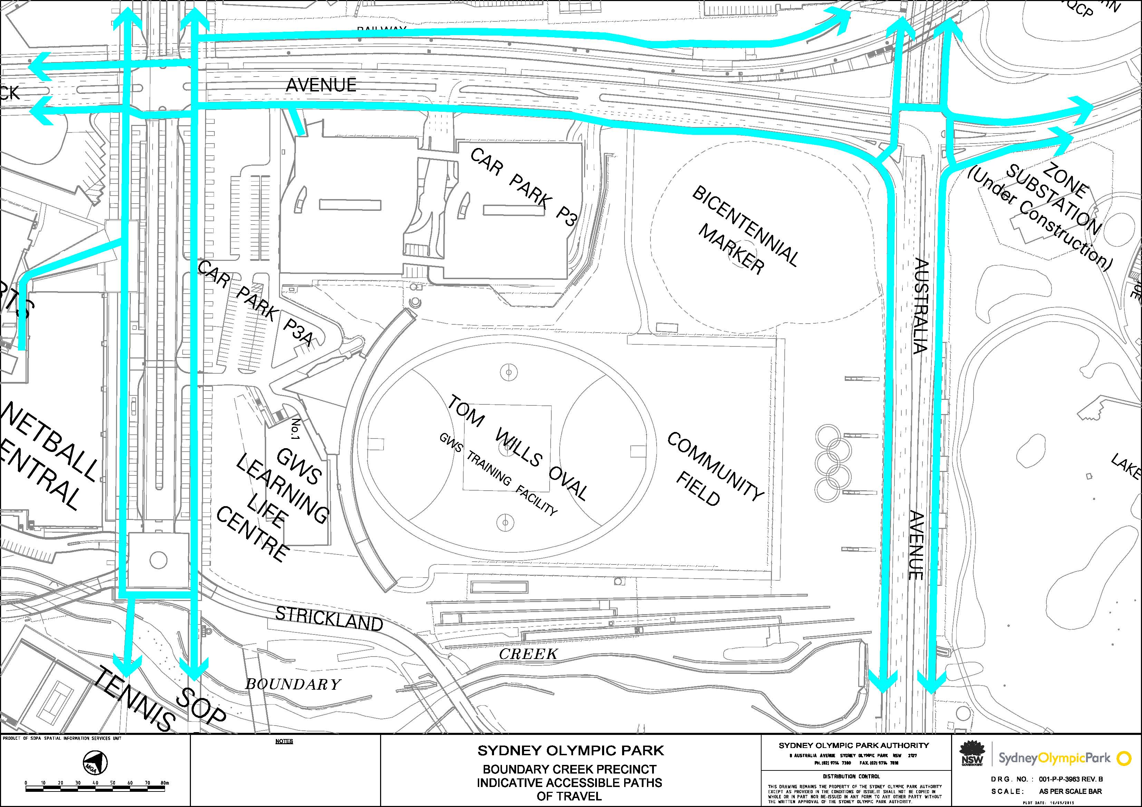

Appendix B

Central Precinct, Sydney Olympic Park Indicative Accessible Paths of Travel Maps

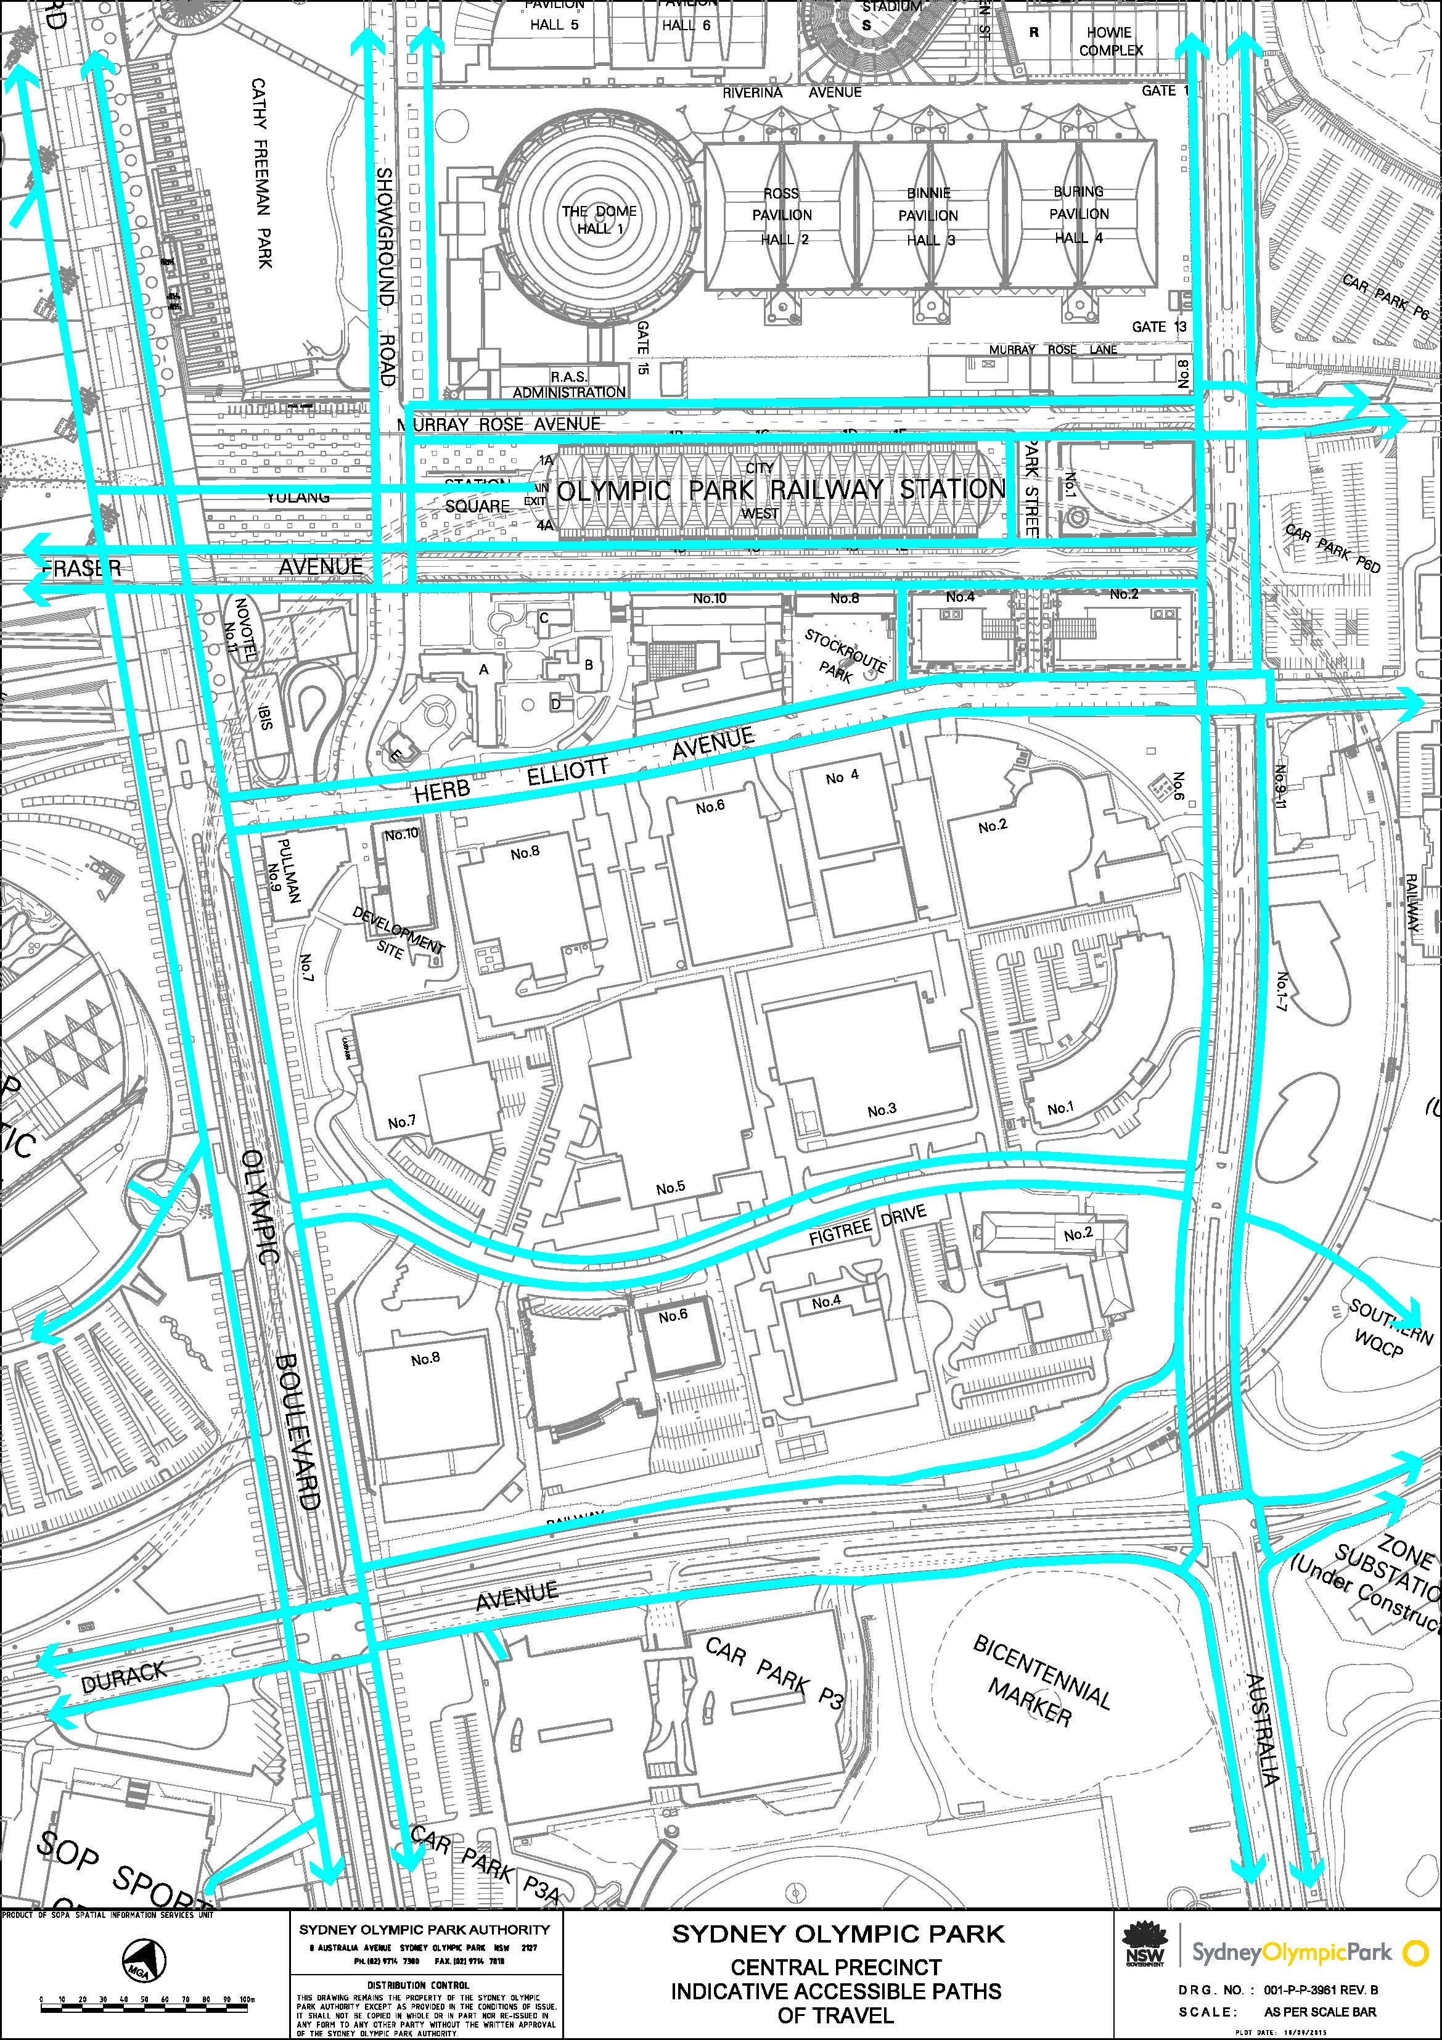

Appendix C

Haslams Precinct, Sydney Olympic Park Indicative Accessible Paths of Travel Maps
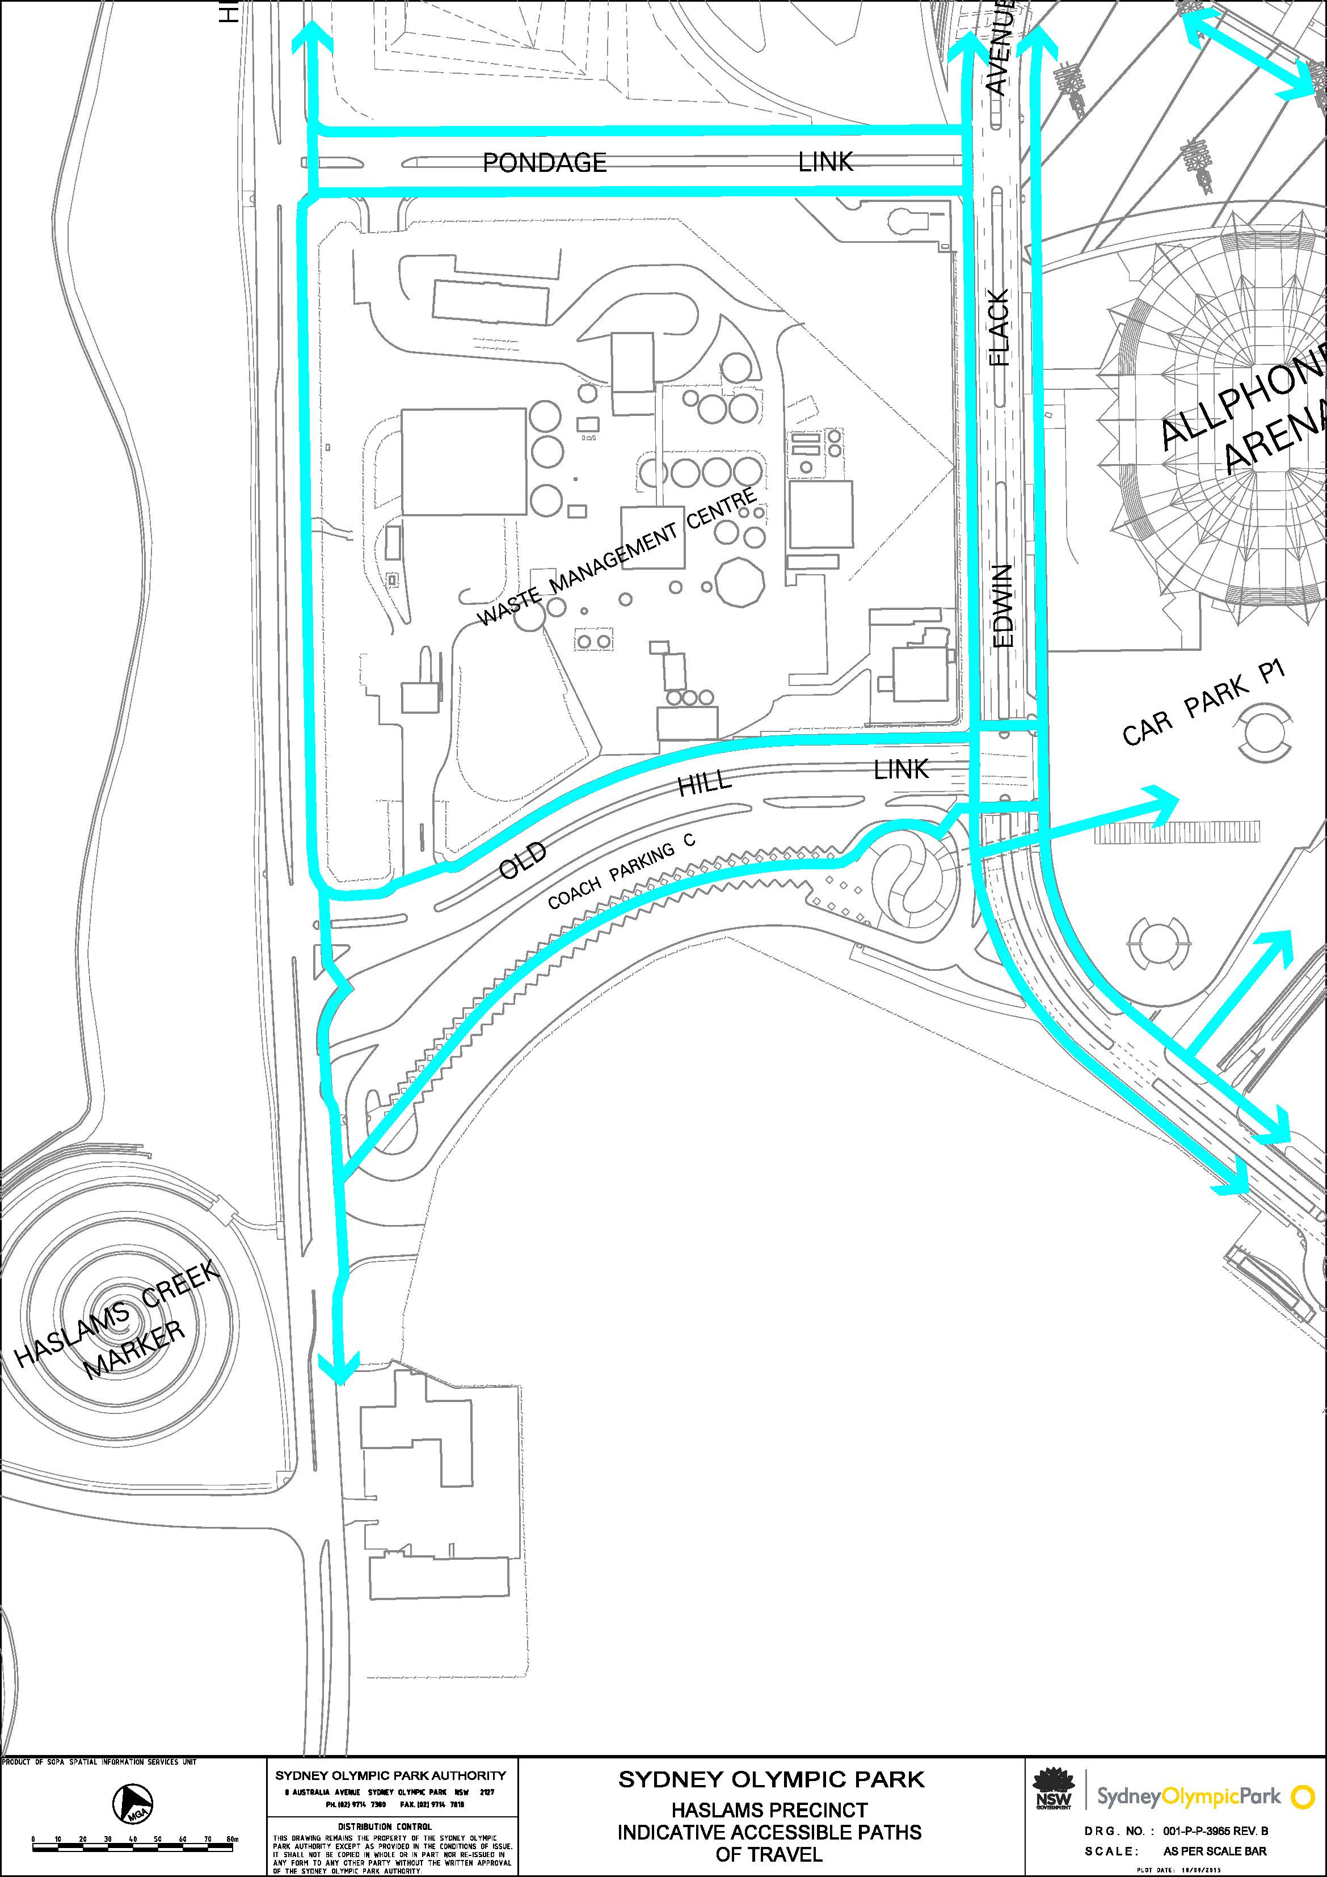

Appendix D

Parkview Precinct, Sydney Olympic Park Indicative Accessible Paths of Travel Maps

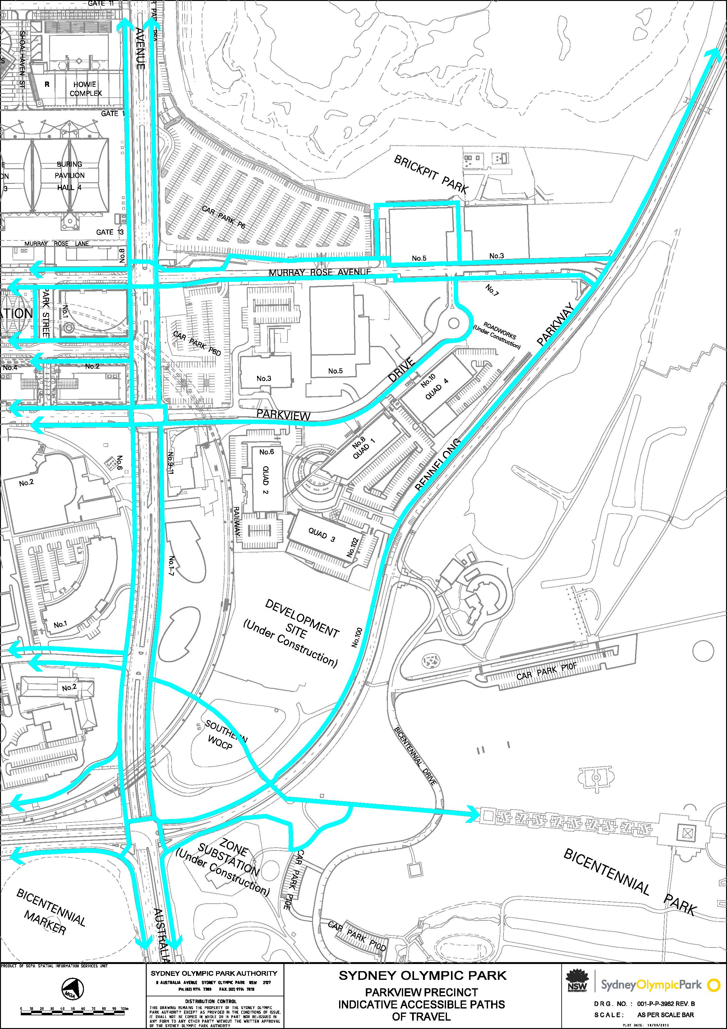

Appendix E

Showground Precinct, Sydney Olympic Park Indicative Accessible Paths of Travel Maps
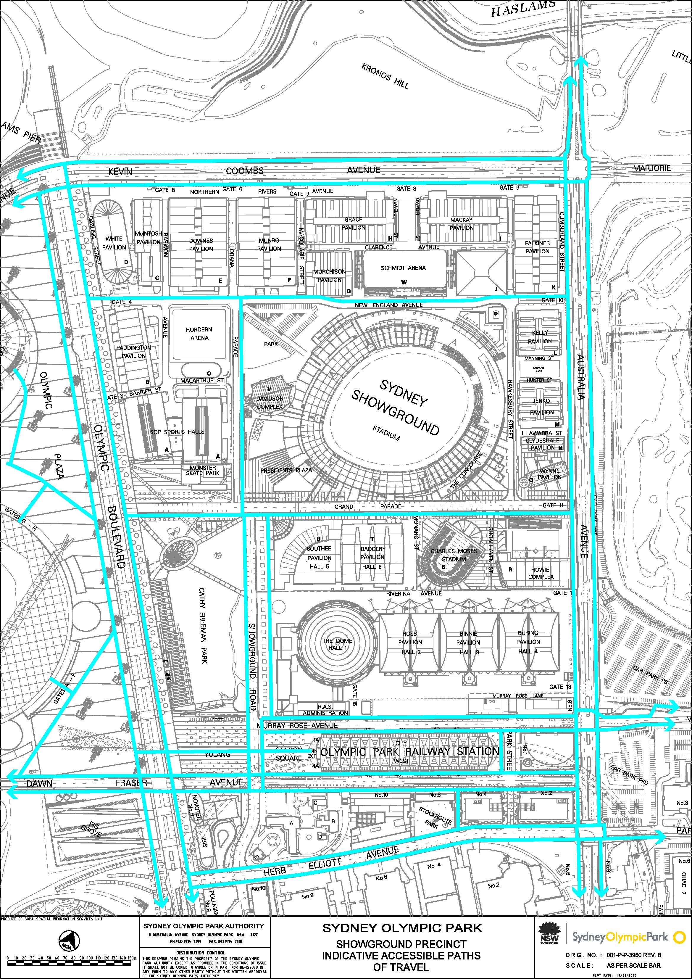

Appendix F

Southern Sports Precinct, Sydney Olympic Park Indicative Accessible Paths of Travel Maps

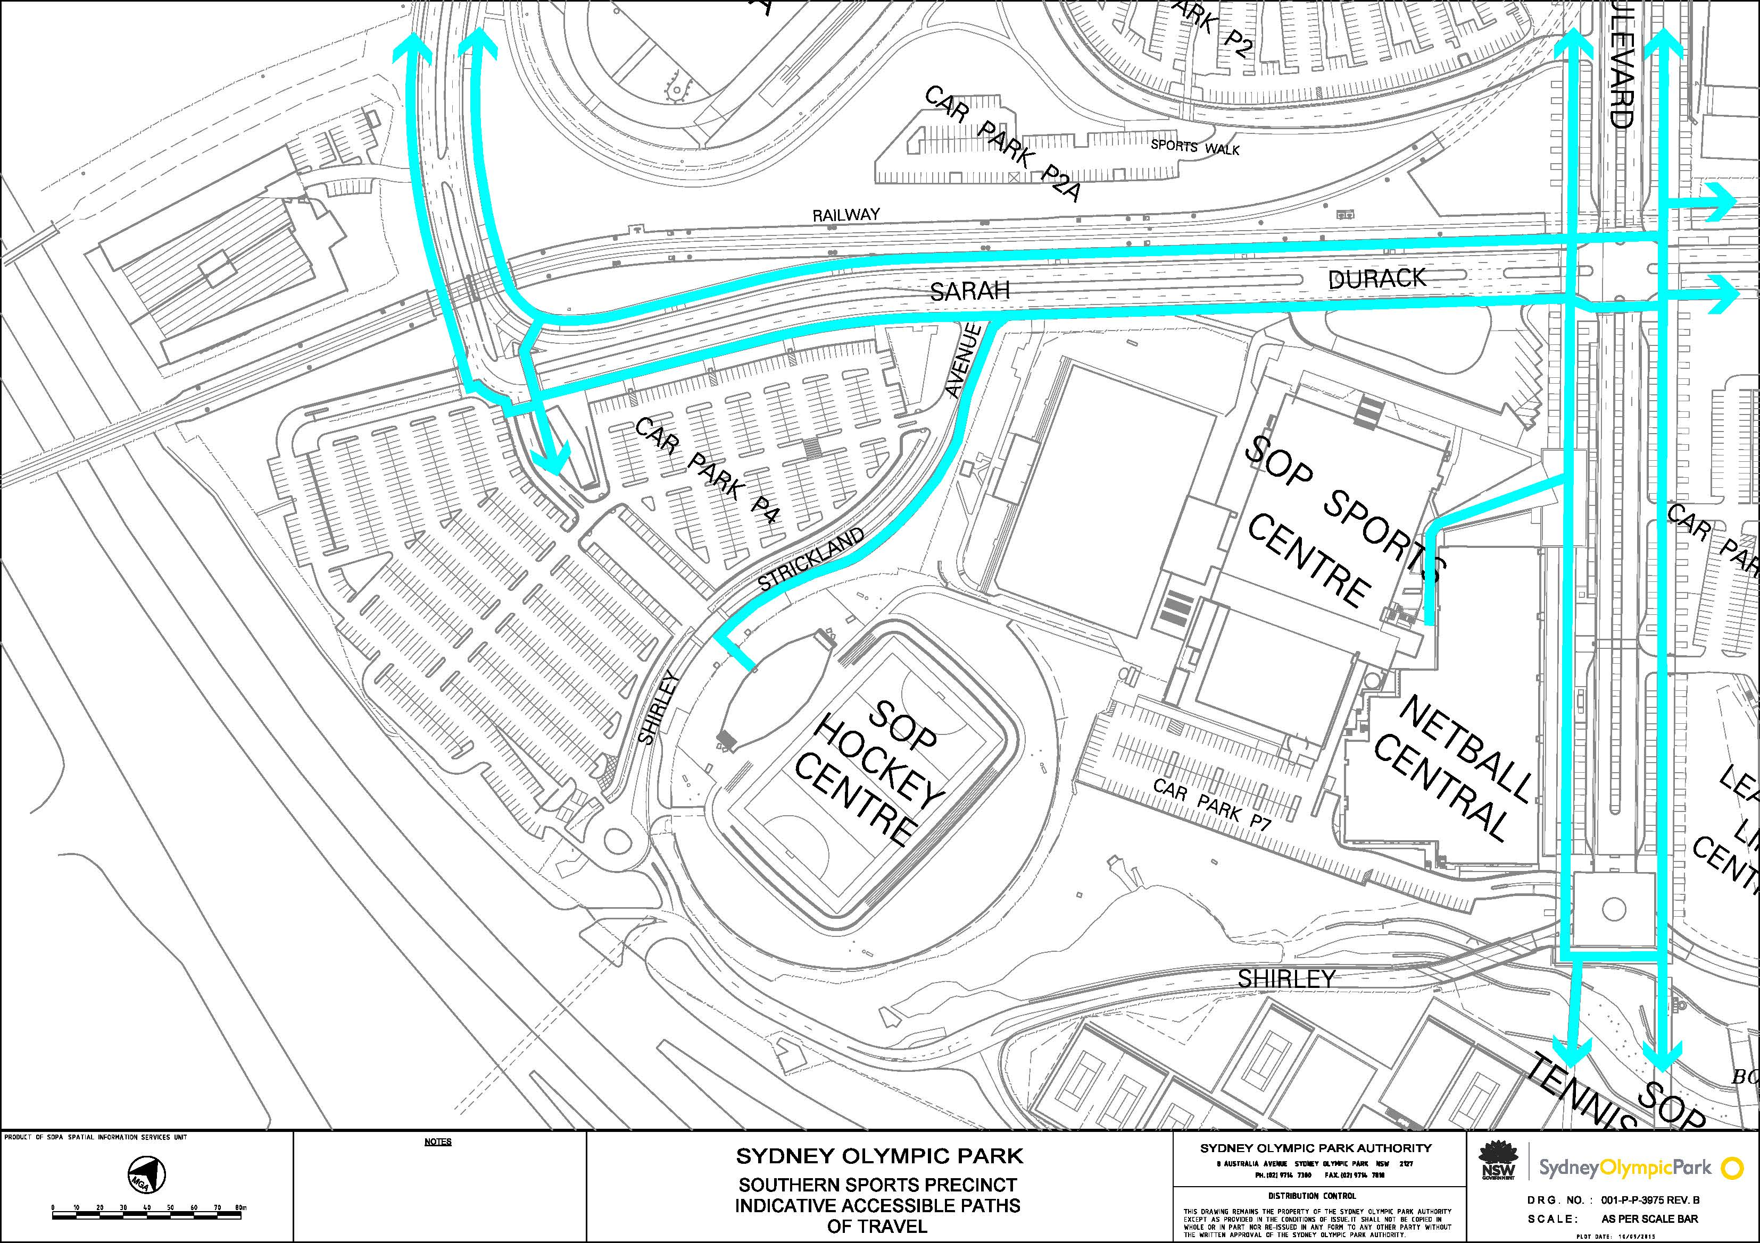

Appendix G

Sports and Education Precinct, Sydney Olympic Park Indicative Accessible Paths of Travel Maps
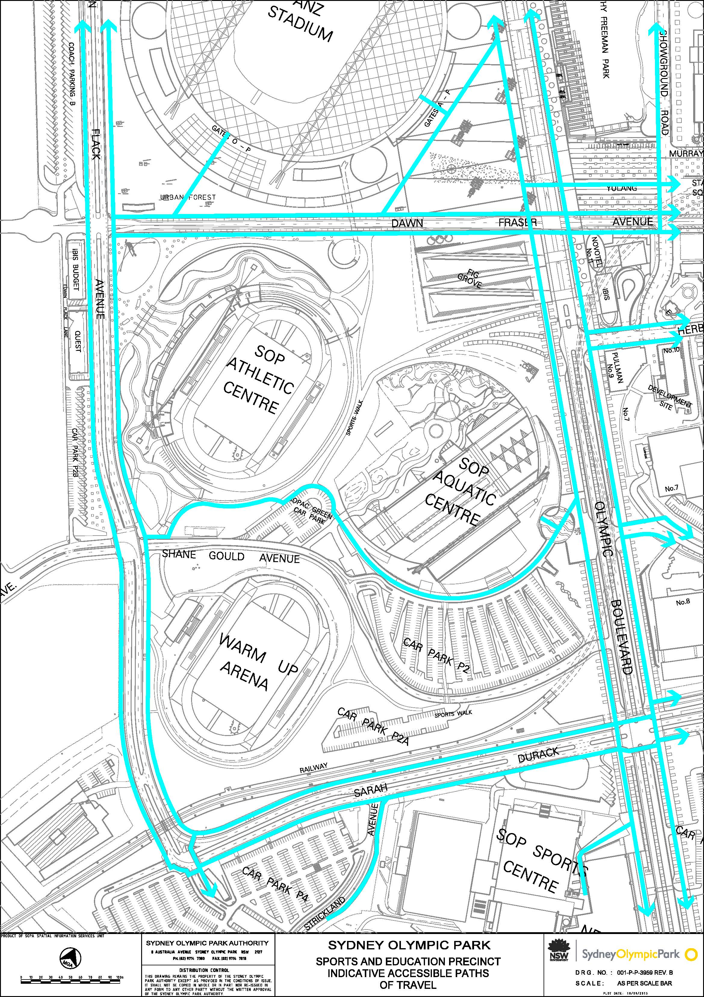

Appendix H

Stadia Precinct, Sydney Olympic Park Indicative Accessible Paths of Travel Maps

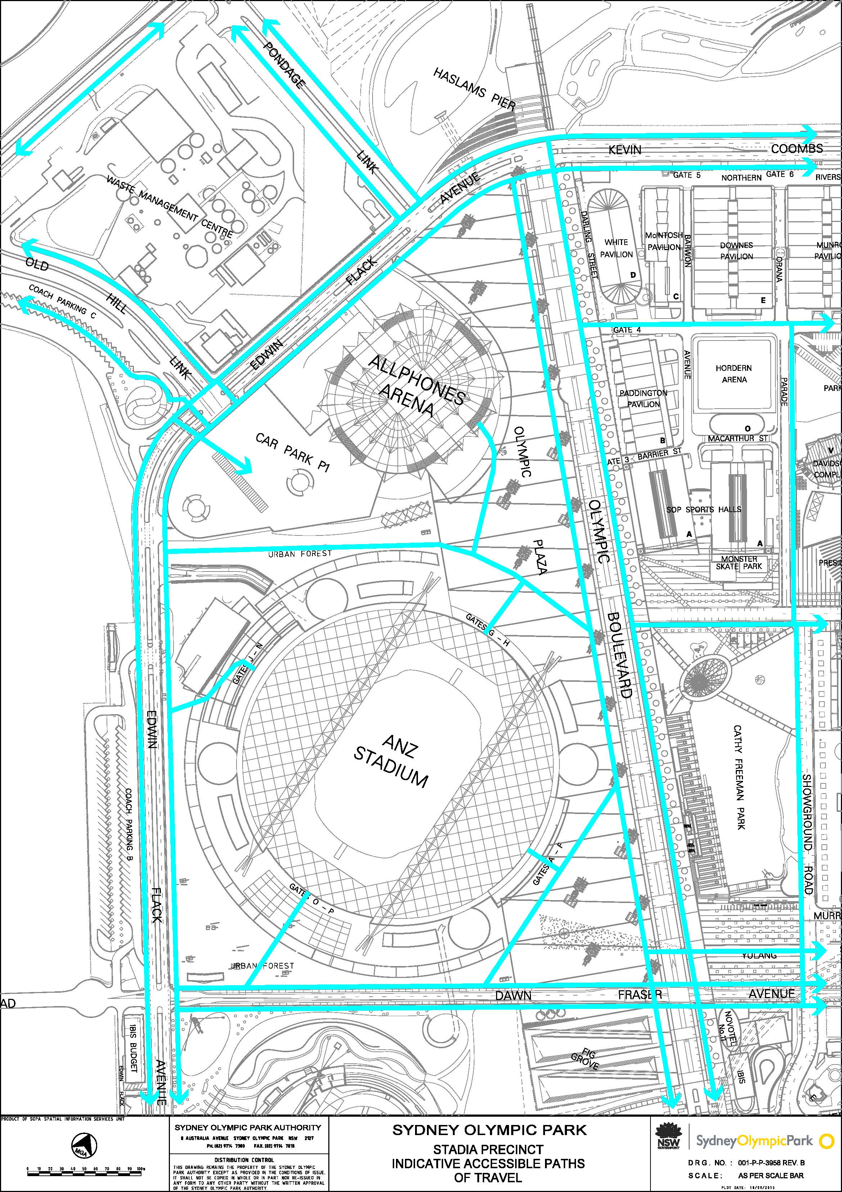

Appendix I

Tennis Precinct, Sydney Olympic Park Indicative Accessible Paths of Travel Maps



