NSW
Disability Inclusion Plan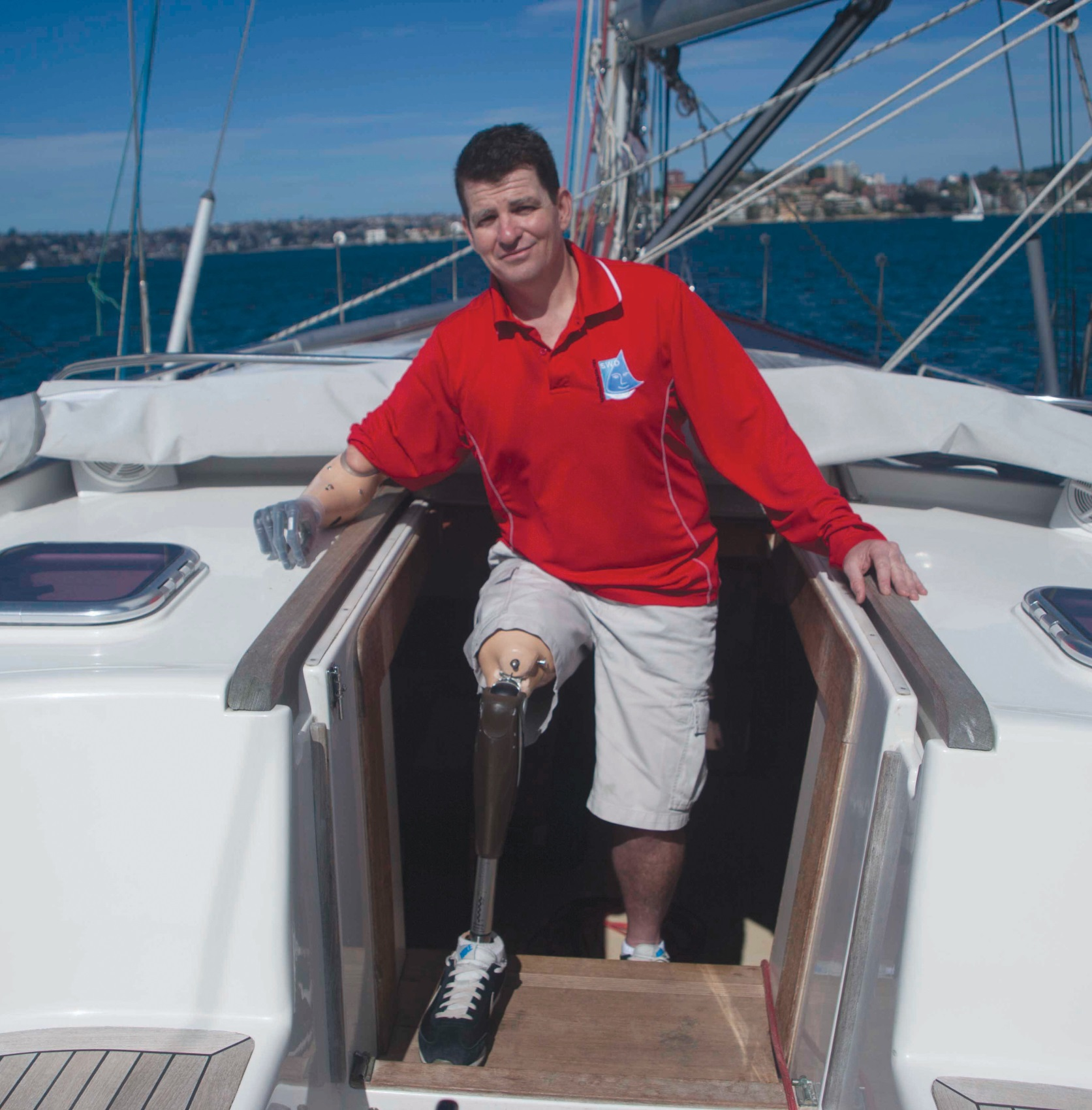

Minister’s foreword
It is with great pleasure that I present the NSW Disability Inclusion Plan.

The plan is the next step along the journey of improving the lives of people with disability in NSW and moves us closer to a fully inclusive society for all.

No one should be excluded from the opportunities that are available to us in NSW, but unfortunately every day people with disability face barriers to participation.

In 2014, the NSW Parliament passed the Disability Inclusion Act, which sets out the need for the NSW Disability Inclusion Plan. This plan is about ensuring government and the rest of the community now make the choices to consult, to involve and to plan with consideration of those living with disability to ensure a fully inclusive society.

It marks a new direction in focus for NSW at a time of great change in the disability sector. We are moving away from a model which centred on what people with disability cannot do, to one which seeks to remove the obstacles created by society and empowers people to achieve their full potential and experience all that life has to offer.

I asked for the plan to set a clear direction for progress over the next four years and beyond, to tackle the sometimes difficult and slow process of change and set an example in access and inclusion for others to follow.
In drafting this plan, people with disability were involved at all stages of development, and this document combines research and review of the extensive consultation undertaken across the sector over the past few years.

But it will not finish there. This plan will be dynamic – a document that will adapt to a changing environment, react to new challenges and grow from feedback provided by its stakeholders.

This is a unique plan, one which aims to map out a path to a fully inclusive society for all people in NSW. It also has the full support and ongoing commitment of the NSW Government.

Inclusion is not a choice – it is a right.

The Hon. John Ajaka
Minister for Disability Services

February 2015

Contents
The NSW Disability Inclusion Plan 4
The case for inclusion 5
The NSW Disability Inclusion Plan 6
How we will implement the plan? 7
How we will know that progress is being made? 8
The four focus areas 9
Developing positive community attitudes and behaviours 10
Creating liveable communities 13
Supporting access to meaningful employment 16
Improving access to mainstream services through better
systems and processes 20
For more information 23

The NSW Disability Inclusion Plan
The NSW Disability Inclusion Plan supports the NSW Government’s commitment to remove systemic and attitudinal barriers so that people with disability have a better opportunity to live a meaningful life and enjoy the full benefits of membership in the community. Achieving an inclusive society is a long term vision that will require consistent efforts from government and the wider community.

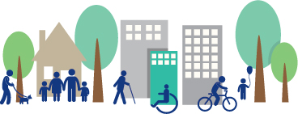

The case for inclusion

‘Inclusion means I can do stuff and help my family, because my family has helped me a lot. It will feel great to be able to do stuff and be on similar levels as people that don’t have disability.’
(Don’t DIS my Ability ambassador 2014)

In NSW there are over 1.3 million people living with disability. Disability may be acquired at birth or early in life, or may be the result of accident, illness or injury throughout life. Disability rates increase substantially as people age, with close to 40% of people having some form of disability by the time they are 70 years old. People experience a range of impacts due to disability, with over 6% of the population experiencing profound or severe disability.

Disability is caused by a range of conditions, including intellectual, physical, cognitive, sensory, neurological impairments or mental illness. What they have in common is the disadvantage and discrimination that many experience as a result.

In recent years there have been significant changes in disability policies in Australia. At the heart of these changes is recognition that people with disability have the right to full and effective participation in an inclusive society.

An inclusive society does not only benefit people with disability. There is a strong case based on research showing how inclusion benefits everyone:

As a community, we are stronger with a diverse range of viewpoints and perspectives, and as a whole we are enriched through activities that promote inclusion.
Inclusion reduces disadvantage, isolation and discrimination. It has far reaching positive impacts across all aspects of life, including health, welfare, education and employment. These impacts are felt beyond the individual, with families and the broader community all being positively impacted by an inclusive society.
There are strong economic reasons for increasing the inclusiveness of our society. Analysis indicates that there are significant financial gains for both individuals and for the economy by moving people into productive and fulfilling employment.

Although the need for a more inclusive NSW is now better recognised and the benefits for individuals, families, carers and the community increasingly understood, we still have a long way to go. It is time for government, community, businesses and people with disability to work together to make
an inclusive NSW a reality.

The NSW Disability Inclusion Plan
The start of the journey toward this NSW Disability Inclusion Plan was Australia’s ratification of the United Nations Convention on the Rights of Persons with Disabilities (UNCRPD) in 2008. This signified a commitment by all levels of government to eradicate obstacles faced by people with disability. This was followed in 2010 by the Australian National Disability Strategy which set out a 10 year national plan for implementing the obligations under the UNCRPD and improving life for Australians with disability, their families and carers. These commitments have driven a reform agenda designed to create a shift in attitudes across governments and communities to move beyond charity and take a rights-based response to the diverse needs of people with disability in accessing all aspects of society.

The NSW Implementation Plan 2012-2014 was the first step in implementing the priorities of the National Disability Strategy in this state. This was further strengthened by the passing of the Disability Inclusion Act 2014 (‘the Act’) by parliament in August 2014 which provides a legislative framework for the development and implementation of a state plan to drive disability access and inclusion. The Act requires:

That the Department of Family and Community Services (FACS) prepares a state Disability Inclusion Plan which:
sets out the whole of government goals that support the inclusion in the community of people with disability and to improve access to mainstream services and community facilities for people with disability
provides for collaboration and co-ordination among government departments, local councils and other entities in the provision of supports and services
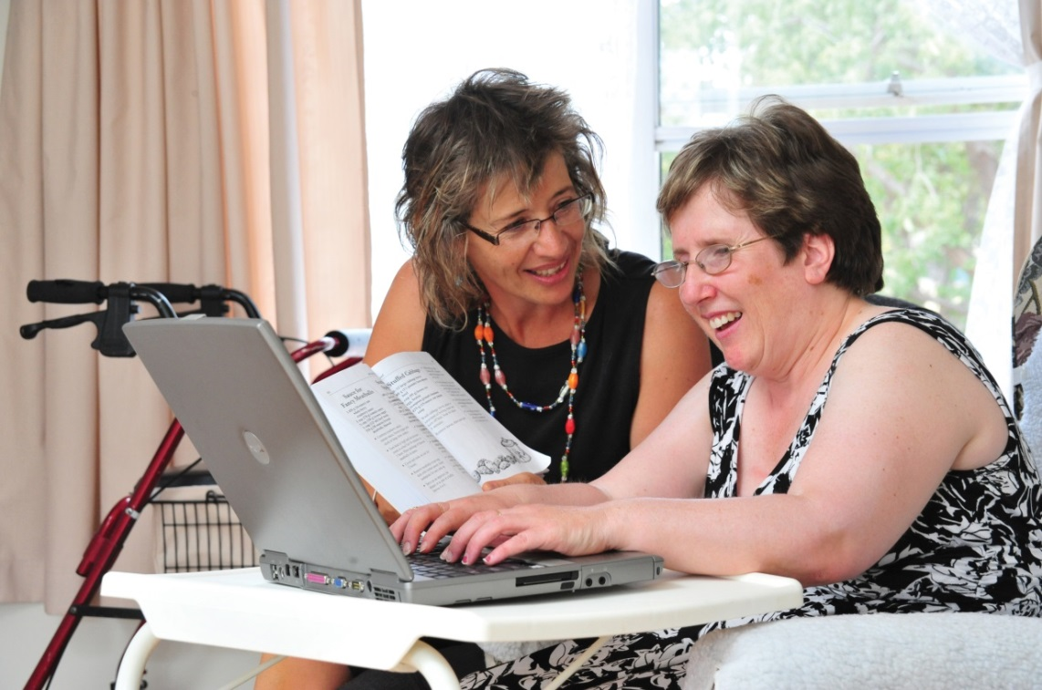

The NSW Disability Inclusion Plan provides direction to government and sets a framework for continued consultation and partnership with people with disability, key agencies and members of the community. It will work alongside the National Disability Insurance Scheme (NDIS) by increasing the accessibility of mainstream services and community facilities in NSW.

This plan sets out the government’s objectives to work towards:

the development of positive community attitudes and behaviours towards people with disability
the creation of more liveable communities for people with disability
the achievement of a higher rate of meaningful employment participation by people with disability through inclusive employment practices
more equitable access to mainstream services for people with disability through better systems and processes

How we will implement the plan?
Achieving the objectives requires a whole of government and whole of community approach. There will be a staged process to develop actions beyond the first 12 months as they will require consultation and agreement with key partners across the government, business and community sectors, and most importantly, with people with disability.

Detailed actions, timeframes, important progress measures and outcome indicators will be finalised progressively, with the first set to be published in mid-2015.

FACS will convene a Disability Plan Implementation Committee with membership drawn from NSW Government departments, the Disability Council NSW, local government and relevant external stakeholders. This committee will help to drive implementation of the plan.

Ongoing engagement with people with disability is an essential component of the NSW Disability Inclusion Plan. This engagement adds to the transparency and accountability of the plan’s actions and provides a mechanism for refreshing and updating actions in response to changing needs. This will occur through partner organisations, including representative bodies, the Disability Council NSW, and those who register interest through the Disability Inclusion Plan website.

The Act also requires NSW Government departments, and specified public authorities, to develop, implement and report on their own Disability Inclusion Action Plan. These plans must be in place by the end of 2015. Local councils are also required to include disability inclusion action planning in the development of their Integrated Community Planning and Reporting (specifically in their delivery program and operational plans) by 2017.

Agency and council plans will support the overall vision and objectives of the NSW Disability Inclusion Plan and will play a vital role in addressing barriers within government departments and local communities.

Disability crosses all areas of our society and it is therefore important to recognise, respect and embrace differences in culture, gender, sexuality, age, religion, community identity and connection to the land as we build collaborative approaches to inclusion. It must also be recognised that some with disability experience multiple disadvantage or are particularly vulnerable to exploitation or abuse. For example, women with disability are 37% more likely to experience violence from a partner than women without disability, three out of four people from culturally and linguistically diverse backgrounds with disability have difficulty accessing disability supports, and levels of disability in some Aboriginal communities can be twice that of the broader population.

FACS will work closely with our partners in government and the broader community to ensure the experience and needs of these members of the community and other groups are actively considered as we develop and implement actions.

How we will know that progress is being made?
Annual reporting on the progress of the NSW Disability Inclusion Plan is a requirement under the Act. The report will be provided to the Minister for Disability Services and made publicly available. The Minister will also table a report in parliament at the end of each four year period of the plan’s implementation.

The NSW Government will develop a governance, reporting and evaluation framework in consultation with the Disability Plan Implementation Committee. This framework will outline how the government will measure and report on the progress of actions under the NSW Disability Inclusion Plan. It will build on the progress indicators of the National Disability Strategy NSW Implementation Plan 2012-2014 and align with the National Disability Strategy reporting.

Ultimately, the success of the Disability Inclusion Plan will be evident by the impact it has on the lives of people with disability. Therefore, there must be opportunities for people with disability to provide feedback about its effectiveness. To support this engagement, FACS is creating a website and other resources under the guidance of our accessibility working group. This will enable people with disability and the general community to see the progress of implementation and provide comment, feedback, case studies and suggestions.

The four focus areas
The NSW Disability Inclusion Plan focuses on four areas for concentrated action identified by people with disability, the NSW Government and community stakeholders. They are:

developing positive community attitudes and behaviours
creating liveable communities
supporting access to meaningful employment
improving access to mainstream services through better systems and processes

These areas have been mapped against the priorities of the National Disability Strategy to ensure consistency between all levels of government.

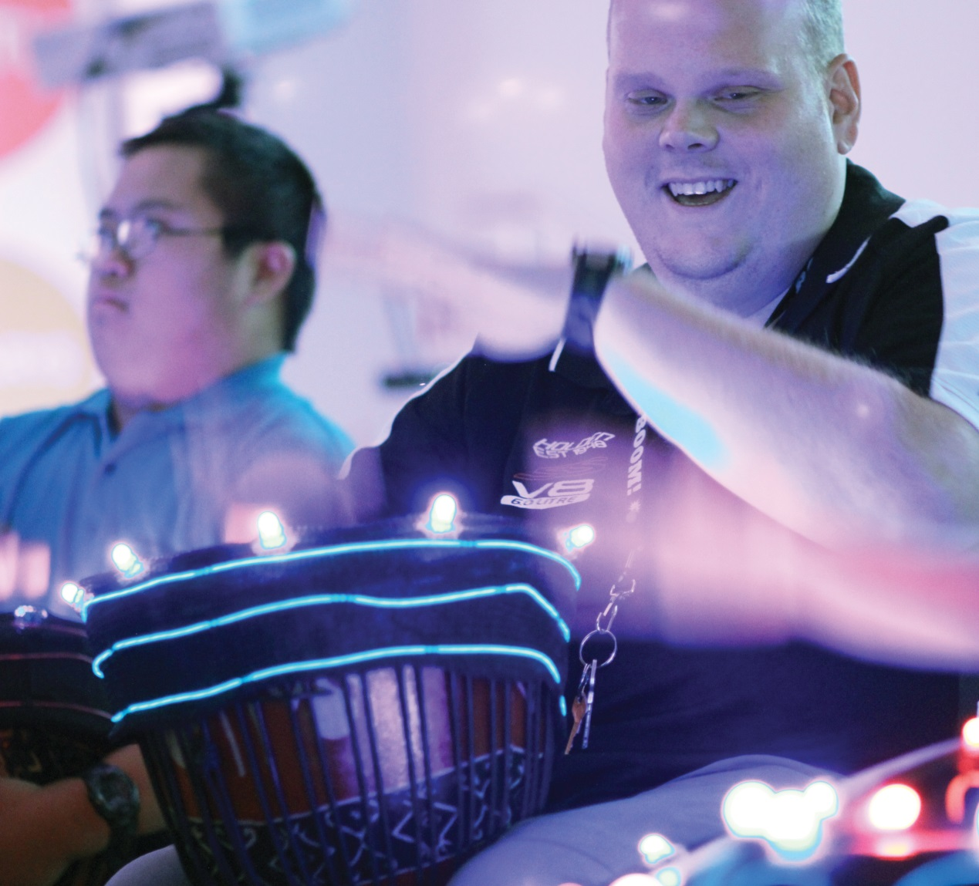

Developing positive community attitudes and behaviours
Light Rhythm Plays, NSW Arts and Disability Partnership, 2014. Photo courtesy of Penrith City Council

AIM: To build community awareness of the rights and abilities of people with disability, and to support the development of positive attitudes and behaviour towards people with disability.

The attitudes and behaviours of the general community towards people with disability have been described as the single greatest barrier to full access and inclusion. Research has found that negative attitudes towards people with disability have significant impacts on people’s major life areas, such as education, employment, health, and community participation. Community attitudes can also be influenced by particular characteristics of the person with disability, such as gender, age, ethnicity, or the type of disability itself. This can lead to greater discrimination and disadvantage for women with disability, or Aboriginal people with disability, for example.

Public attitude is determined by the community’s experience and knowledge of disability. Consultation to date has identified that attitudes towards people with disability are often determined by ignorance, fear or lack of opportunity to interact. Developing positive community attitudes involves increasing public awareness and creating opportunities for interaction.

While it is important to identify specific actions to assist in the development of positive attitudes and behaviours, actions under the other three focus areas will also contribute to developing inclusive attitudes.

‘People don’t always mean to discriminate against people with disabilities but it’s one of those things that does occur. I think the challenge is to make people aware of the types of discrimination and how to overcome that, without being hostile or anything like that. I’m quite happy to point out to people ways of going about it that’s the right way of doing stuff without offending people.’ (Don’t DIS my ABILITY ambassador 2014)

First steps
The following actions will be undertaken in 2015 to support the development of positive community attitudes and behaviours:

Action 1.1 Public awareness campaign on disability inclusion
Outcome: Raise community awareness and improve inclusive practices.

The NSW Government will raise community awareness and recognition of the benefits of access, equality and human rights for people with disability through the provision of an expanded public information and awareness campaign. FACS will continue the Don’t DIS my Ability campaign to support broader public awareness.

FACS will also work with partners across government and the non-government sector to build new methods of reaching people with the message of inclusion. This will include grass roots initiatives, working with key community groups such as school communities, community organisations and sporting clubs. This will provide opportunities for people with disability and community groups to work together in creating cultural change at a local level.
In addition, NSW public sector agencies will be asked to review the way they currently portray disability across their organisation and in their public communications, and to identify opportunities to build the visibility and accurate public perception of people with disability and the positive contributions they make to society.

The aim of these initiatives will be to increase public awareness of the barriers and opportunities for people with disability and to reinforce the responsibility of the general community to take action to promote inclusion.

Action 1.2 Human rights learning and development resource
Outcome: Better understanding of rights that underpin inclusion across the NSW public sector and the broader community.

FACS and the Australian Human Rights Commission (the Commission) will develop education resources to support the NSW public sector and the broader community to better understand the fundamental human rights issues that underpin inclusion. The Commission will develop and deliver an initial round of training based on the resource in early 2015.

Areas for further development
Future actions to support positive changes in community attitudes and behaviour will include:

raising public awareness of disability through the media and by supporting and developing leaders within the disability community
developing public sector employee understanding and skills in disability inclusion
engaging business and community leaders to speak up about inclusive attitudes and behaviours

Who will be involved in further development?
Some of the key partners who have been involved in the development of actions to date and who will be involved in ongoing consultations as part of this focus area include:

people with disability
FACS
Australian Human Rights Commission
Don’t DIS my Ability ambassadors
Living Life My Way ambassadors and champions
disability policy leaders
local governments
advisory groups and peak agencies
National Disability Insurance Agency and NDIS in NSW
media organisations and advertisers
community campaign and public health campaigners
Ability Links

Creating liveable communities

AIM: To increase participation of people with disability in all aspects of community life, through targeted approaches to address barriers in housing, learning, transport, health and wellbeing.

Liveable communities are places in which people have the opportunity to exercise their rights, to live, learn, work and play, to feel safe, to belong, to raise a family and to grow old. We know that people with disability experience fewer opportunities to engage with their community as a result of barriers in the built environment, transport, housing and local supports. We also know that creating liveable communities is about more than just increasing physical accessibility. It includes creating opportunities for social engagement, improving the quality of personal, social and business interactions and the way in which information is provided.

‘Getting my license was wonderful….just having a new seat and not having to sit in a wheelchair. If I want to get out of the wheelchair I can just get in the car and drive all day – how wonderful. Being able to go where I want to go and do what I want to do. It’s so freeing to choose what you want to do each day.’ (Don’t DIS my ABILITY ambassador 2014)

First steps
The following actions will be undertaken in 2015 to support the development of liveable communities.

Action 2.1 Liveable communities competition
Outcome: Creative solutions are developed that support liveable communities.
The NSW Government has invited local governments in NSW to submit projects and pilots that contribute to liveable communities across NSW. Successful projects will be announced in February 2015 and will include upgrades to public spaces and partnerships with local businesses. Over the coming 12 months, the projects’ successes and challenges will be shared across local governments. The effectiveness of this initial round of grants will be reviewed to inform subsequent funding rounds.

Action 2.2 Coordinated planning for access and inclusion
Outcome: Coordinated planning improves access and inclusion across local councils and NSW Government.
NSW Government and Local Government NSW will convene another disability planning forum in 2015 to bring together people with disability, government agencies and other stakeholders to identify issues and share ideas to improve local planning and access. Emerging trends and successful approaches to inclusion will be highlighted and promoted across government.

Action 2.3 Cross-sector local partnerships in key areas
Outcome: Adoption of innovative models of community engagement and involvement of new partners to address community focused issues.

The NSW Government will work with business and community partners through innovative models such as ‘The Collective NSW’, a model that supports collaboration and activates funding and other resources such as time and talent from government, community and private sector. It encourages new ways of working to tackle social disadvantage and develop creative solutions to social policy issues including promotion of inclusive practice for people with disability. Projects will be identified to support disability inclusion: 1) in an Aboriginal community setting, 2) in a rural setting 3) in a place based setting such as a housing estate, and 4) supporting those coming into contact with the criminal justice system.

Areas for further development
Beyond these initial activities, we will work with our partners to identify, develop and refine actions to increase accessibility and inclusion within the community. These will include:

supporting the successful implementation of the NDIS
increasing the availability and accessibility of public and private transport options for people with disability, including people living in regional and rural areas, and ongoing implementation of existing transport access plans
increasing the accessibility of public spaces including bus stops, outdoor paths of travel and footpaths, ramps, stairs, curb ramps, rest areas and accessible pedestrian signals
increasing the accessibility and appropriateness of housing for people with disability across the public, private and social housing sectors
increasing the availability, accessibility, relevance and distribution of information about mainstream services, public spaces, local events and activities and in culturally appropriate and accessible formats
identifying and addressing key areas of multiple disadvantage, including with Aboriginal people, people with culturally and linguistically diverse backgrounds and people who identify as lesbian, gay, bisexual, transgender and intersex
adopting measures to create a safer community for people with disability, including women with disability and children with disability
working with government and non-government justice agencies and community groups to build on existing programs that redirect young people with disability away from the criminal justice system and into community options and employment

Who will be involved in further development?
Some of the key partners who have been involved in the development of actions to-date and who will be involved in ongoing consultations as part of this focus area include:

people with disability
disability sector organisations and peak bodies
members of the Ministerial Advisory Committee on Ageing,
NSW Carers Advisory Council
FACS, including Women NSW
experts in universal design principles and practice, and urban design and planning
experts in community development
key state government agencies, including Transport for NSW, Arts NSW, the Department of Planning and Environment and the Ministry of Health
National Disability Insurance Agency and NDIS in NSW
local governments and Local Government NSW
groups with a vested interest in liveable communities such as older people, carers, young families and others

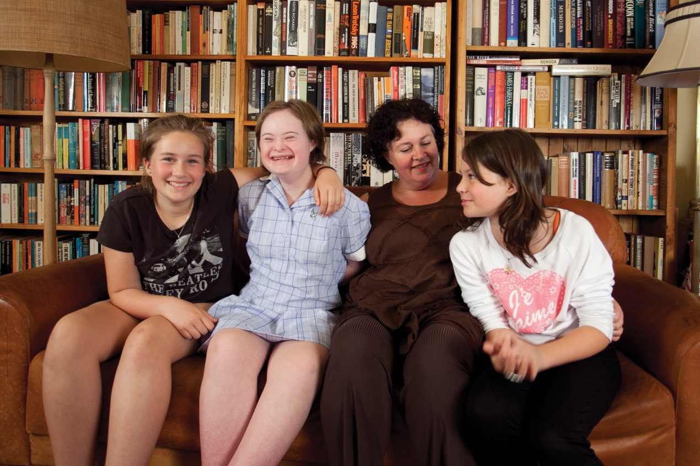
Supporting access to meaningful employment

AIM: To increase the number of people with disability in meaningful employment, thereby enabling people with disability to plan for their future and exercise choice and control as a result of economic security.

Employment rates for people with disability are significantly lower than those without disability across all sectors. The employment rate of women with disability is also lower than their male counterparts, mirroring the gender gap that exists between men and women without disability.

Employment is an area of great challenge. In February 2014, the UN Special Rapporteur stated that efforts to create disability-inclusive societies had been least successful in the area of employment. NSW Government research indicates that there has been a decline in representation of people with disability in the NSW public sector workforce over the last few years. The government continues to develop initiatives, such as the Employment Enablement Strategy, to reverse this decline, both centrally and within individual agencies.

People with disability have said that they experience barriers in accessing information on job opportunities and the recruitment processes, reasonable adjustments to support them to meet their job requirements and career development opportunities once in a job.

A number of employers have misconceived and inaccurate perceptions that employing a person with disability will cost more, require more effort, increase occupational health and safety risks or require major adjustments to the workplace. Progress will be achieved only when these beliefs are corrected.

‘I am an active firefighter with the Rural Fire Service and I’m on trucks. Initially some people thought that I shouldn’t be out in the field and they didn’t know how to handle someone with a disability. They automatically thought “that guy has a disability he can’t handle that, I might be putting him in danger”. While there is a risk factor, and you definitely need to take safety into account, there are ways around these challenges and I know what I am capable of and I will give 100% to be part of the brigade.’ (Don’t DIS my ABILITY ambassador 2014)

First steps
The following actions will be undertaken in 2015 to support increased access
to meaningful employment for people with disability:

Action 3.1 NSW Government agencies plan for workforce diversity
Outcome: Increased workforce diversity across the NSW Government.

The NSW Public Service Commission (PSC) will continue to promote a workforce that reflects the diversity of the wider community. The PSC is working with all NSW Government departments and agencies to integrate diversity into their workforce planning. This includes the use of more sophisticated analytics to inform planning.

This approach emphasises diversity as an essential element of high performing teams, as well as an ethical responsibility. This will encourage action by senior leaders to address barriers to success in employment for people with disability.

Action 3.2 Cross sector disability employment forum
Outcome: Identification of strategies and partners across NSW Government, business and the broader community to support employment of people with disability.

A forum will be held in 2015 to engage employers from various sectors including NSW Government, local government, the Commonwealth Government and leaders in the private sector to identify and develop global strategies to support accessible employment. It will seek cross-sector commitment to take forward these strategies.

Action 3.3 Disability employee networks
Outcome: Improved engagement and support for people with disability in public sector workplaces.

The NSW Government will further develop networks of employees with a keen interest in improving the attraction, retention and career development of people with disability in the workplace. These networks will be established within departments, as well as across departments in particular locations. The networks will serve as key stakeholders on initiatives on employment for people with disability, as well as a source of peer support.

Areas for further development
In addition to these initial activities, we will work with our partners to identify, develop and refine activities that focus on:

utilising NSW Government procurement processes to promote inclusive employment practices in the private sector
improving workplace support for people with disability to allow them to reach their potential and do their job effectively
promoting a culture of inclusion within organisations and businesses, including highlighting NSW employers that demonstrate best practice employment practices
promoting diversity and accessibility in vocational training
improving transition support to achieve better employment outcomes for young people with disability leaving statutory care
improving transition supports for students with disability leaving school
improving transition supports for people with disability leaving the criminal justice system

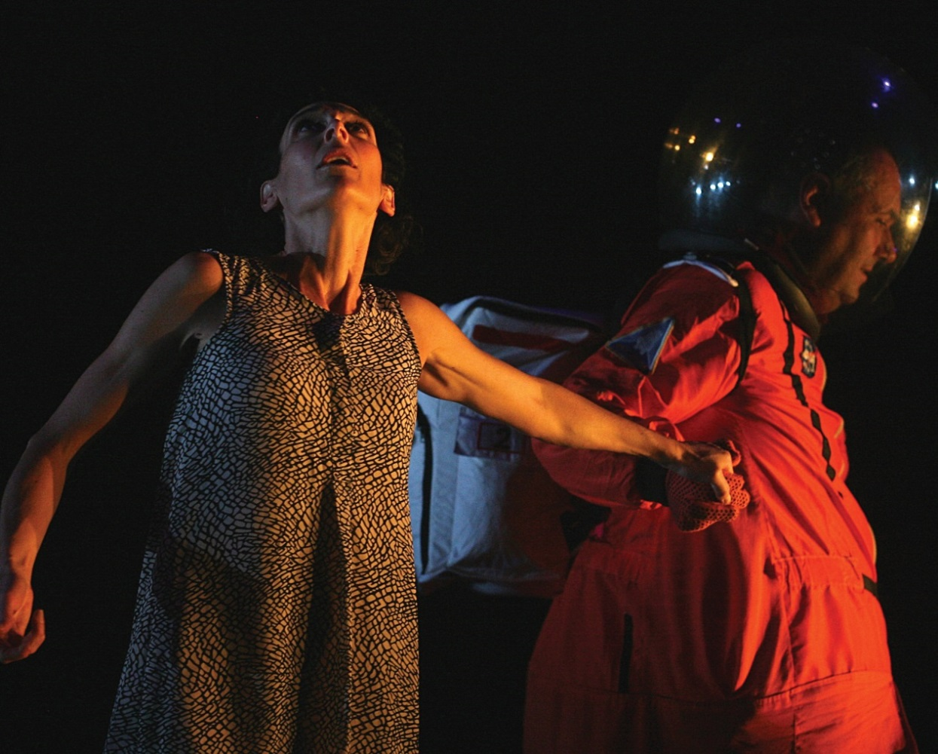
Who will be involved in further development?
Illawarra Disability Trust’s ‘Altogether Drama’ and Merrigong Theatre Company, part of the NSW Arts and Disability Partnership, 2014. Photo courtesy of Penrith City Council.
Some of the key partners who have been involved in the development of actions to date and who will be involved in ongoing consultations as part of this focus area include:

people with disability
NSW Public Service Commission
NSW Government agencies
FACS Disability Employee Network
peak organisations and employment services
local governments
the business community, chambers of commerce, recruitment agencies and training providers
Commonwealth Government agencies, National Disability Insurance Agency and the Australian Human Rights Commission

Improving access to mainstream services through better systems and processes

AIM: To ensure that people with disability are able to make informed choices about available services and to easily and efficiently access mainstream government services and other opportunities in the community.

A common issue for people with disability is the difficulty in navigating the systems and processes required to access the services and supports they need in the community. Services in this context include everything from obtaining a driver’s licence through to accessing local health services.

People experience major barriers including a lack of accessible information, inflexible processes, and limited opportunities for feedback and input. People with disability and their family and carers frequently face a confusing and inaccessible path to specialist and mainstream services. These barriers can stem from the lack of training and experience of front line personnel, or rigid systems put in place by poor service design.

The plan recognises that it is the responsibility of NSW Government agencies and other community and business organisations to review and change the way they do business to ensure people with disability can have equal access to information and services.

‘The teacher that runs it is absolutely amazing. She made a point when I went to the information session that she would be there to help out in any way she could. And I’ve also seen that there’s another blind chap and there’s been people with vision impairment go through this course with astounding success.’ (Don’t DIS my ABILITY ambassador, 2014)

First steps
The following actions will be undertaken in 2015 to improve access to mainstream services:

Action 4.1 Accessibility Working Group
Outcome: More accessible processes for ongoing consultation and feedback.

FACS will convene and resource the NSW Disability Inclusion Plan Accessibility Working Group. Members will be drawn from across the government and community sectors and include specialists in information accessibility. The working group will help develop a set of practical knowledge and resources to support NSW Government agencies to make their information, processes and activities more accessible. The focus will be on the provision of information to people with disability and the engagement of people with disability in providing comment and feedback. The core aim of this initiative is to ensure that people with disability in NSW find it easier to access information, and to contribute to policy and service development and improvement.

Action 4.2 Implementation of Disability Inclusion Action Plans to improve system navigation
Outcome: Create seamless pathways through the service system.

NSW Government agencies will use Disability Inclusion Action Plans as a tool to improve system navigation, not just by ensuring information is accessible, but to ensure that there is a seamless pathway through the service system where needed. This includes a focus on key system transition points, such as people leaving the justice system.

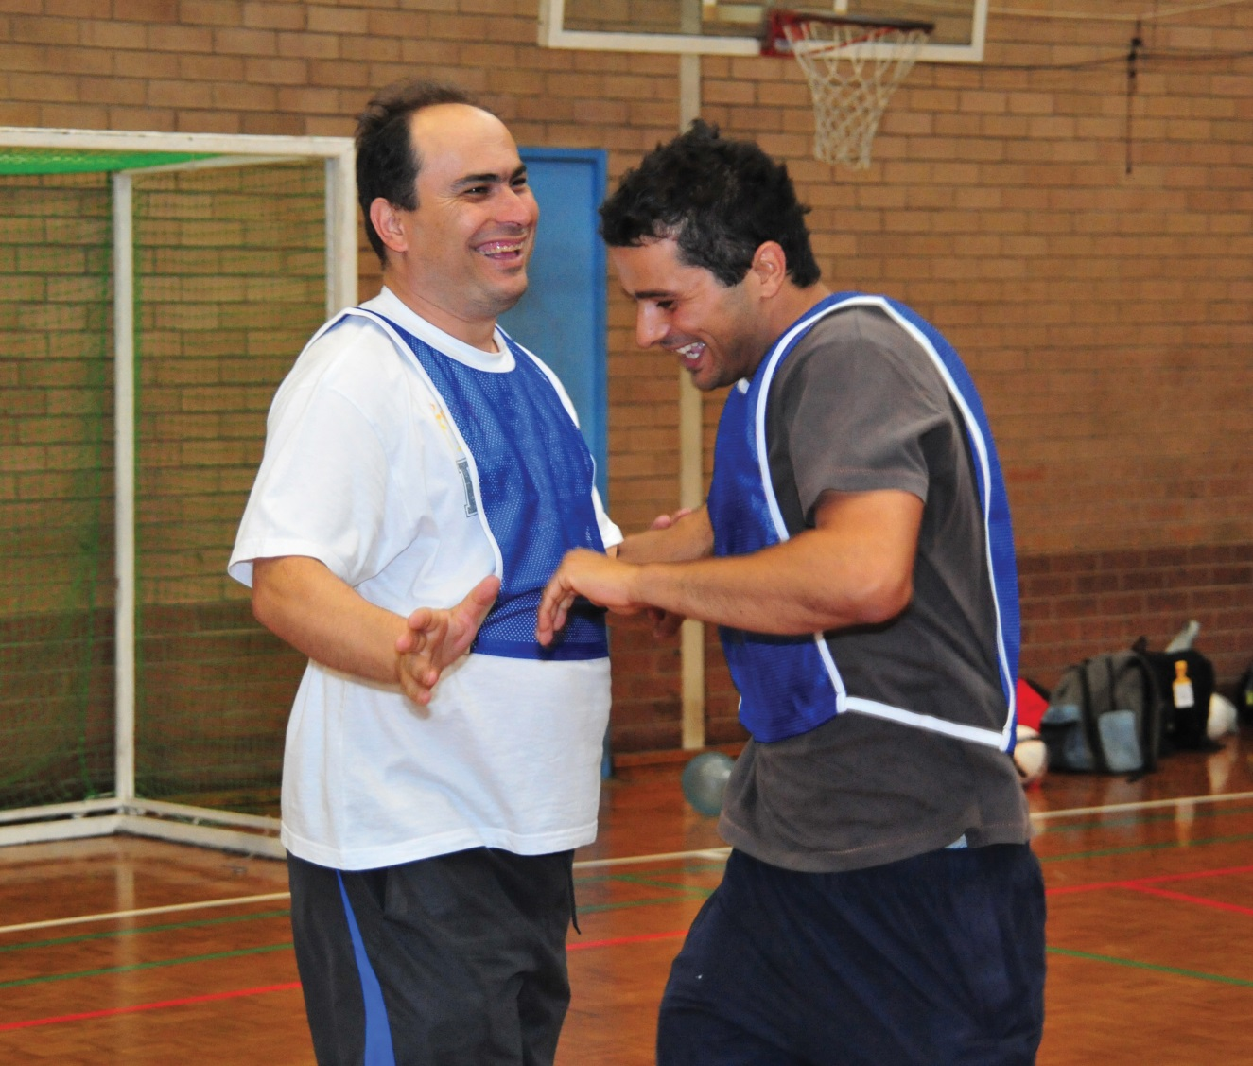

Areas for further development
Future actions will focus on:

ensuring that information provided by the government to the NSW community is accessible for people with disability
coordinated approaches across state, local and commonwealth governments to reduce service access barriers for people with disability
clarifying the roles and responsibilities of each level of government in regard to the provision of services to ensure people with disability access the support they need
ensuring other whole of government reforms consider disability, such as the NSW Government’s Multicultural Policies and Services Program, to embed a holistic approach in the mainstream service system
working with business to improve systems and services delivered by the private sector
promoting reasonable adjustment across government agencies in the way they provide services and information, including the provision of resources to assist good practice

Who will be involved in further development?
Some of the key partners who have been involved in the development of actions to-date and who will be involved in ongoing consultations as part of this focus area include:

people with disability
disability policy leaders
NSW Government agencies, including the NSW Customer Service Commissioner, Premier and Cabinet, and the NSW Ombudsman
local governments
advisory groups and peak agencies
academics and other experts

For more information
More information and accessible versions of the NSW Disability Inclusion Plan are available at:
http://www.facs.nsw.gov.au/dip

To comment on the plan or find out how to get involved, please contact the Department of Family and Community Services by:

Email NSWDIP@facs.nsw.gov.au

Phone 1800 782 306

National Relay Service SPEAK & LISTEN 1300 555 727
FREECALL 1800 555 660

Post
C/O Disability Access and Inclusion
Strategic Policy, Family and Community Services
233 Liverpool Road, Ashfield, NSW 2131
Translation and Interpreting Service 131 450

NSW Government agencies contributing to the NSW Disability Inclusion Plan
NSW Department of Premier and Cabinet
NSW Department of Family and Community Services
NSW Department of Trade and Investment, Regional Infrastructure and Services
NSW Treasury
NSW Department of Education and Communities
NSW Ministry of Health
Transport for NSW
NSW Department of Justice
NSW Department of Planning and Environment

Case study contributions
Don’t DIS my ABILITY ambassadors- Paul Stone, Yvette Smith, Darien Brown
Bec Ho from the Touched by Olivia Foundation

Acknowledgements
The authors would like to acknowledge the contribution of people who provided submissions, attended workshops and other meetings, and responded to surveys. We would also like to express appreciation for the advice of the members of the Disability Council NSW and the NSW National Disability Strategy Interdepartmental Implementation Committee. We would particularly like to thank those with disability, whose persistence and voice has been the driving force for this plan. The continued involvement and feedback of people with disability will be our gauge of success.

Australian Bureau of Statistics 4430.0 - Disability, Ageing and Carers, Australia: Summary of Findings, 2012.
The Economic Benefits of Increasing Employment for People with Disability (2011): Deloitte Access Economics – at www.and.org.au/data/Conference/DAE_Report_8May.pdf
Document on Violence against Women with Disabilities (2010): Women with Disability Australia – at wwda.org.au/wp-content/uploads/2013/12/inwwdviol2010.pdf
Disability Services Utilisation fact sheet (2013): National Ethnic Disability Alliance - at www.neda.org.au/index.php/reports/item/disability-services-utilisation?category_id=6
Australian Bureau of Statistics, Aboriginal and Torres Strait Islander People with a Disability, 2012, released 01/12/2014
Community attitudes to people with disability: scoping project report (2014): Department of Social Services – at - www.dss.gov.au/about-the-department/publications-articles/research-publications/occasional-paper-series/number-39-community-attitudes-to-people-with-disability-scoping-project
ibid
WWDA (2008) Submission to the Parliamentary Inquiry into pay equity and associated issues related to increasing female participation in the workforce. wwda.org.au/papers/subs/subs2006/
UN Special Rapporteur Report of the Special Rapporteur to the 52nd Session of the Commission for Social Development: Note by the Secretary-General on monitoring of the implementation of the Standard Rules on the Equalization of Opportunities for Persons with Disabilities United Nations February 2014 (E/CN.5/2014/7)
NSW Public Service Commission - Disabling The Barriers – key findings exposure draft at- www.psc.nsw.gov.au/ArticleDocuments/417/DAB%20Key%20findings_FORMATTED%20DP%20and%20OM%20FINAL.pdf.aspx

